Video Games
Brandon Santos
Northern Marianas College

English 101
Kimberly Bunts-Anderson
November 25, 2016

VIDEO GAMES
Brandon Santos
Northern Marianas College

English 101
Kimberly Bunts-Anderson
November 25, 2016

Abstract
This research paper portrays a sequence of events of research that was conducted on the topic of whether or not video games enhance or diminish a person’s capabilities. The paper will be addressing the controversy of whether video games are good or bad. The information provided are from academic and non-academic sources. They were gathered by online sites using google scholar, surveys conducted online and in person. The reason for the selection of this topic was personal, mostly it was to truly find out if this hobby had negative or positive effects. Upon completing this paper, its purpose is to persuade the readers that video-games enhance people’s capabilities.

Introduction
Has curiosity ever struck about whether video games had positive or negative effects on a person’s abilities? There has been research that supports the idea of video games enhancing capabilities such as memory, critical thinking and motor skills. On the other hand, there are also research that states video games cause negative correlations in emotion and attitude. Examples are anger management, increased stress and violent tendencies.
Background
There is a controversy on whether video games are good or bad. In this case it is all about perspective on which video games a person plays. Video games can be used as entertainment and sometimes even learning purposes. They have a certain objective and depending on the type of video game a person plays will determine what they will get out of it. It is important to take note because some video games are not healthy. Violent categories of video games such as first person shooters, battle arenas, horror games and others that contain content that should be optional for restriction.
There are two sides to video games. The people who support video games and think they have a benefit to a person’s capabilities and the other people who think they diminish it. Video games are good because they can increase a person’s cognition and perception. Games that have an objective makes a person think and it increases what they can see in the moment.(Simons, J. 2011) On the other hand, video games that have content inappropriate content such as gore, blood and sexual content can diminish a person’s capabilities. These types of video games can start bad habits and can create different attitudes. People who play games that are violent can start violent tendencies. Some examples are anger management, poor cooperation and violence.(Wendling, P. 2007)
Literature Review
Do video games enhance or diminish a person’s capabilities? This is a question asked by some adults, parents and non-gamers. However, this essay will be about how sources that a student writer chose for his research project support and refute the project. He searched for more resources, both academic and non-academic to show the relevance of it to the topic. The student writer chose topics to show that video games can enhance a person’s capabilities by increasing hand-eye coordination, critical thinking and memory.
Two academic sources that the student writer will add on to his research paper is:
· “Do action video games improve perception and cognition?”- Walter R. Boot, Daniel P. Blakely and Daniel J. Simons
· “Violent Video Games as Exemplary Teachers: A Conceptual Analysis”- Douglas A. Gentile and J. Ronald Gentile

These sources will support his essay because both talk about how video games enhance and diminish a person’s capabilities. The first source talks about how “Action” video games can increase a person’s perception and cognition. The second source talks about how people who play “Action” video games can pick up violent tendencies more than people who don’t play them. The relevance of the two sources to his topic is the type of video games. There are only certain types of video games that a person needs to play to enhance or diminish a person’s capabilities. He makes it clear in the research paper.
The two non-academic resources are:
· “Violent Video Games Affect Brain, MRIs Show”- Patrice Wendling

· “Do Video Games Need to Be Better Regulated?”-Barrie Gunter
The first source talks about how video games affect our brain for the good and the bad. It talks about how video games that are proactive can be beneficial to your learning and violent video games with excessive profanity will ruin your learning. The second source talks about the benefits of video games that can enhance spatial skills like third person games. The video games that allow you to see your character and the world around him/ her to keep them safe and living to fulfill their purpose. These sources relate to his topic because they talk about the types of video games that can enhance or diminish a person’s capabilities. How do all these sources add up to the original topic?
The way that the academic and non-academic sources are similar is in content. They all showcase the positive and negative effects of playing certain types of video games. Not all types of video games were discussed but based on the most played genres. All 4 sources were important to the original topic because it helped showcase the different perspective people have about video games. It will hint out to readers what side the student writer is on. The student writer finds the second source of the academic sources most informative for his essay because it backs up its details with evidence and stats of information that has been tested.
The sources have researched and tested their information before they released to the public. All of these sources were received from “Google Scholar”, a search engine made for information that was researched and tested first hand. These sources can be seen as credible.
In conclusion, the student writer found topics that could support and refute his research paper. He explained the relevance and importance of each topic. He also gave a short description of what each source was about. The student writer chose topics to show that video games can enhance a person’s capabilities by increasing hand-eye coordination, critical thinking and memory.

How I collected Information
About a couple weeks ago, I was given an assignment where I had to create a survey. I tested the survey with peers and did multiple adjustments. I kept doing this till I had a survey that could ask questions related to my research question. Do video games diminish or enhance a person’s capabilities? Sample questions are provided in Appendix A and Appendix B. I tried to collect information regarding this question by giving this survey to NMC students, posting it on Facebook and interviewing a controlled group.
I first distributed the survey to NMC students. I had to do some test runs and one of the requirements of the assignment was to revise my survey based on feedback. I did exactly that. I had 9 responses to my survey on SurveyMonkey (A site where I created and tested the survey). Some examples of my questions were:
1. Do you think video games are a good investment? Explain.
2. How often would you play a videogame that enhanced skills such as teamwork, critical thinking and problem solving?

3. Do you agree that video games alone cause negative correlations like low grades in school?

After I was done testing it out on my peers I decided to try it and release it to the public and see what were my results. I did not succeed with my attempt of trying to get participants from Facebook. I wasn’t able to get any views. However, I did not stop there. I went to my last option.

I printed out the questions on sheets of paper and went around my high school asking if anyone wanted to take a few minutes of their time to take the survey. I was able to convince 8 people to take the survey and got feedback on how the survey was formed and what I could possibly do better. I looked over the information and found something that could be useful. The age range of my survey was from 17-29. No one older or younger took the survey.

So in the end, I was able to collect information on my question. Based on the results, majority of who took my survey either didn’t know what to think about video games. Some thought that they were good for educational purposes and others didn’t. Overall, most of my attempts to collect data were good because I was able to distribute my survey and succeed.

Analysis
In order to gather data to come up with a reasonable conclusion, I created surveys. I first tested the surveys out on fellow peers at NMC. After, I revised some questions to try and make the survey much more precise and clear of what it was asking. Most of the questions were open-ended and some were multiple-choice. After I made final revisions I released my survey to the public to gather more data. I will compare the differences of female and male responses to my survey.
In terms of which gender were gamers and which were not, the males were the gamers and most females were not. The males that did play ranged from 17 years of age to 20 years. They specified themselves playing at least 1-4 hours a day. The females that did play were from 17 years of age and 34 years of age. They specified themselves playing at least 4-8 hours a day.
When comparing which gender approved of video games being put into workplaces and schools it was the females. There were 6 out of 10 responses from the females that wanted video games in the workplace and school. Percentage wise, the males had 100% vote for games being in the workplace and schools vs a 60% from the females.
Overall, the females had most of the say in this survey because I had more females than males. They accounted for 77% of my survey while the males had a 23%. In conclusion, I was able to collect data to see what was the perspective that was favored by the public. In the end it was negative, but there are always chances to change it.

Findings
One thing that I noticed was that the questions regarding video games being placed into work and school were not recommended. The question clearly stated that it was going to be for educational purposes. My assumption is that they misunderstood the question. That was merely one thing I found about the survey.
Another observation that I found was that the age range for my survey was taken by someone 17 years of age to 20 years. The responses to the survey from these people were even in terms of video games being negative or positive. Three people said that video games were good. The other three said they were bad.
The last thing that I noticed was that most of my participants were contradicting themselves. They would answer one question like, “Yes, video games are a good investment,” and other responses would be like, “No, video games should not be included in workplaces and school because it would be distracting”. This happened frequently throughout the survey.
Discussion
During the survey there were many interesting and useful findings. However, more stood out than others and had data that was the most useful. Based on the survey the data was pretty even with responses being negative or positive. I will discuss the importance and relevance of the data that was collected throughout the survey with literature support. The responses were mostly positive but just by a sliver.
Most of the negative responses were to my question: “Should video games be included in educational facilities and workplaces? Explain”. I had 8 out of 13 responses that said they shouldn’t be included in work or school because they would be distracting. One of my sources (Wendling, P. 2007) talks about how video games can be distracting in certain situations. It can also develop bad habits such as procrastination. This information from the literature review is relevant to the data collected because it talks about how video games can be distracting, just like the responses to the survey.
Most of the positive responses were to my question: “Would you recommend people to play video games? Why”? 7 out of 13 of the responses were positive. Some of the reasons the participants stated for their responses were because it “increased speed thinking, teamwork, focus and critical thinking”. According to (Simons, J. 2011) his article talked about how video games could increase skills such as critical thinking, cooperation, teamwork and memory. MOst of these skills were included in the explanation of the participants. This information relates to the data based on the similarities of the skills that are stated to be enhanced if video games are played.
In the end, the data collected from the survey was useful. There were some parts that had more useful things that I could collect and relate to my literature sources. The side that supported video games enhancing a person’s capabilities won in perspective. In the survey there were more positive responses than negative. Overall, the survey was positive by a sliver.

Future Plans
The results of the essay were mostly positive. All the data will be used to further find out the favored side of the controversy on video games. Do video games enhance or diminish a person’s capabilities? This is the question that the survey was trying to find data for. What are the future plans for the data collected? It will be used to refute and explain how videogames can enhance a person’s capabilities.
The data will be used to further explain how video games can enhance a person’s capabilities by revealing the data taken from the survey. The survey shows what age group, gender and “type” of gamer sides with video games enhancing capabilities. The survey is still currently released to the public so anyone can take it. The results may change because of this but as of data collected for now, video games have a positive effect.
The results of the essay were mostly positive, thus backing up the side of video games enhancing a person’s capabilities. The main question that was researched was successfully answered. Do video games enhance or diminish a person’s capabilities. Based on the results, Video games enhance a person’s capabilities.
Conclusion
So has curiosity ever struck about whether video games had positive or negative effects? There are two perspectives on this topic which are video games enhance a person’s capabilities and the other side is video games diminish a person’s capabilities. In order to collect the information I needed to answer this question I developed a survey. Once I did that I tested, revised and did a final distribution to the public. Data was collected and most of it was positive. The survey is still active and final statements on which side is favored more is still questionable. However, based on the survey’s data, videogames enhance a person’s capabilities.

References
Boot, W. R., Blakely, D. P., & Simons, D. J. (2011). Do Action Video Games Improve
Perception and Cognition? Frontiers in Psychology Front. Psychology, 2. doi:10.3389/fpsyg.2011.00226
Gentile, D. A., & Gentile, J. R. (2007). Violent Video Games as Exemplary Teachers: A
Conceptual Analysis. Journal of Youth and Adolescence, 37(2), 127-141. doi:10.1007/s10964-007-9206-2
Wendling, P. (2007). Violent Video Games Affect Brain, MRIs Show. Pediatric News,
41(1), 34. doi:10.1016/s0031-398x(07)70033-4
Gunter, B. (2016). Do Video Games Need to Be Better Regulated? Does Playing Video
Games Make Players More Violent?, 261-281. doi:10.1057/978-1-137-57985-0_11

Appendix A: Pilot Survey on Video Games
This survey was used to conduct tests and to gather information that would be useful to help revise it. After this was revised the final copy was released to the public. Very few changes were implemented, such as a title change.
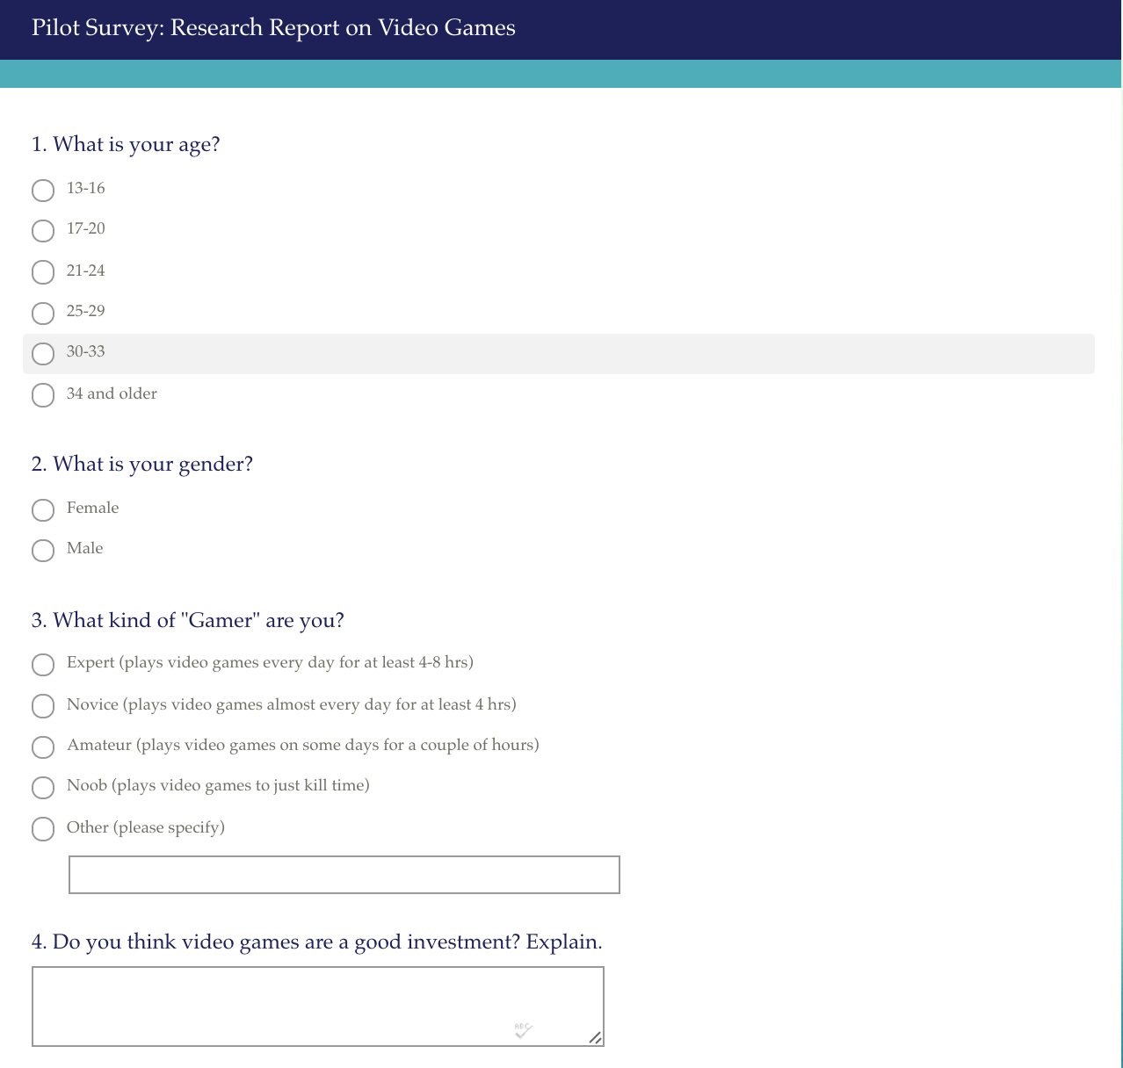

Appendix A (Continued)

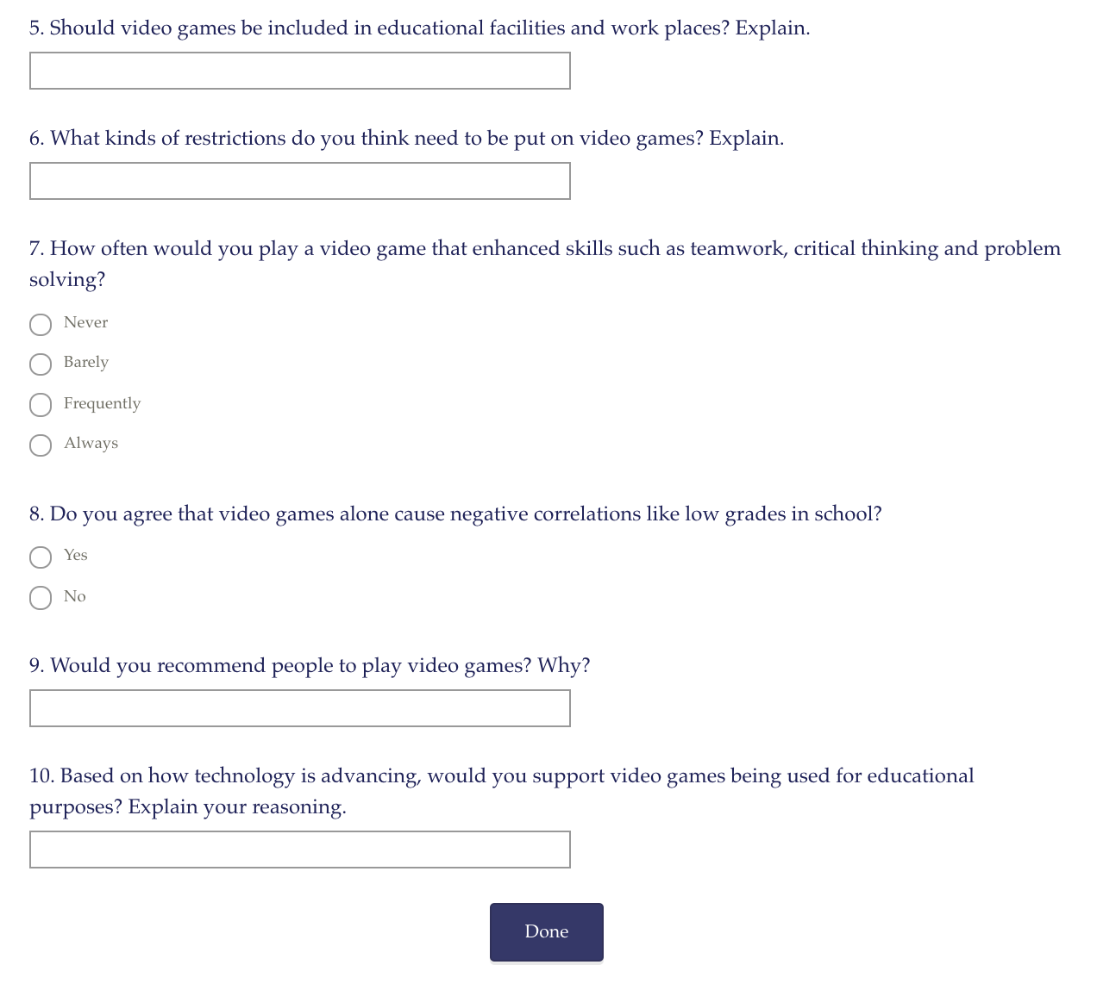

Appendix B: Analyzation of Results
Most responses from the survey appeared positive in feedback. Basically, positive meaning the responses were with “video games enhance a person’s capabilities” side. Some examples are provided below.
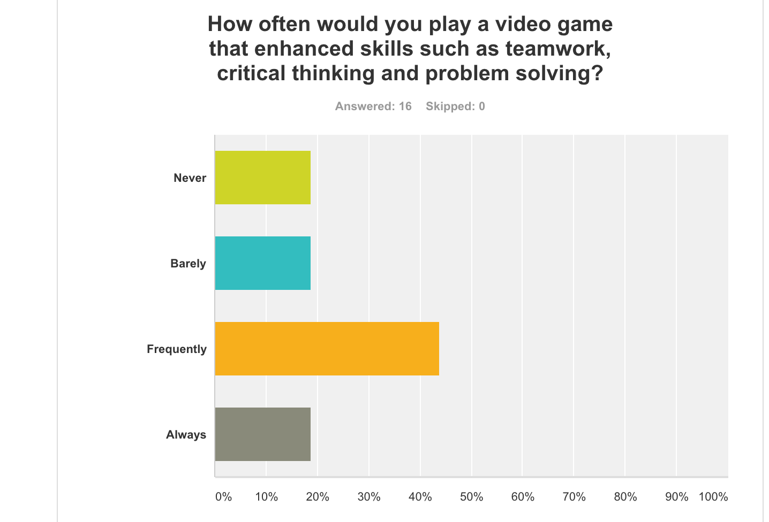

Appendix B (Continued)
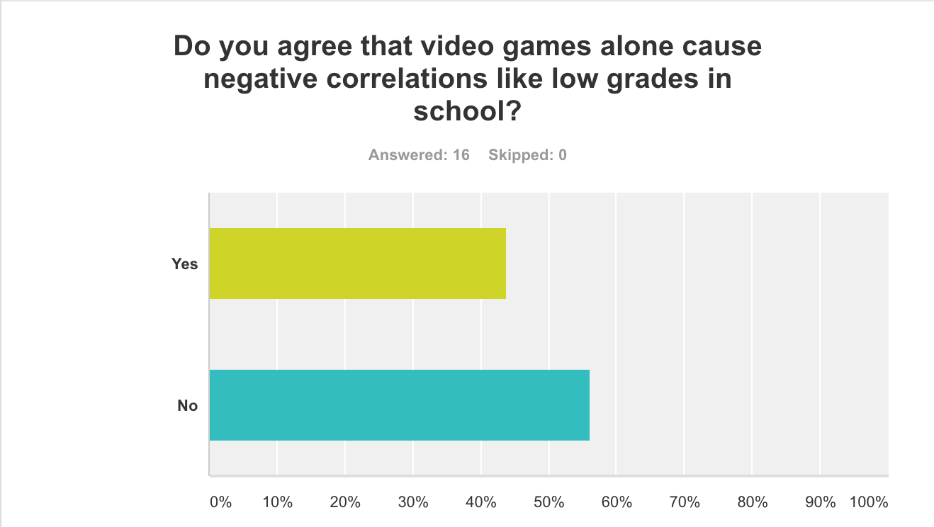

Reading Notes 1
Reading Notes to fill out when reading course and outside reading materials for assignment Note Taking Sheet: Reading # __3__ Name: Brandon Santos ________________________________________________Course ENCOURSE NAME EN 101
Section _____________ With many sources to read and evaluate, you need a way to keep track of the material you may use in your research paper. You need to record where you have looked, what you have found, and how to find each piece of information again (this is for your bibliography). Directions: Fill in the information below, and keep with all of your resources. This will help you when it is time to write both your outline, paper, and annotated bibliography.
1. Author’� s Name: Rosser, J.C
2. Author’� s Credentials: Dr. James C. Rosser
Degree: Doctor of Medicine
Appointment level: Professor
3. Publisher [or title of organization]: Arch Surg Archives of Surgery
4. Heading of Section [title of reading]: The Impact of Video Games on Surgeons in the 21st century
5. Year Written: February 14, 2007
6. Pages: 1
7.Website URL: https://www.ncbi.nlm.nih.gov/pubmed/17309970
Main Ideas/Points Important
● There is a potential link between video game play and surgical skill.
Quotations
● “Anecdotal observations of young surgeons suggest that video game play contributes to performance excellence in laparoscopic surgery.”
Supporting Details
● People who played video games showed 37% fewer errors and 27% faster completion.
Relevance to Your Assignment
● Video games help out with skills that are required in jobs.

In this article, is it possible that any of the authors might have a bias about the subject matter? No, the reason being is because they tested their hypothesis on real people with multiple trials. They had hard evidence to back up their conclusion for their research.
Is the article timely or a bit outdated ? Outdated, it was 9 years ago. Was it published in a reputable source? No, it is an academic source.

Reading Notes 2
Sources:
This source has a document that talks about the dietary characteristics of the cnmi. Its related to my topic because one of the characteristics are video games. http://scholarspace.manoa.hawaii.edu/handle/10125/33956
This other article has a section called “The Videos” that’s when the author talks about how she uses games to interact with kids in the cnmi
https://books.google.com/books?hl=en&lr=&id=uUobAAAAQBAJ&oi=fnd&pg=PT18&dq=cnmi+video+games&ots=39vVo39vVH&sig=NJWX0QXXbZY34j9Aby0rmuvaLMg#v=onepage&q=CNMI%20video%20games&f=false
First Draft of Research Proposal
This research proposal presents a plan to determine whether playing video games enhances or diminishes a person’s capabilities. Various studies have shown that some video games can actually improve memory, critical thinking skills, problem solving, and teamwork. The significance of this topic is that video games can provide many benefits to people that they might not realize. The positive benefits of video game play include increased performance on eye-hand coordination tasks and neuropsychological tests and better reaction time, spatial visualization, and mental rotation. On the other hand, there are also disturbing negative correlations with video game play, which include lower grades in school; aggressive thoughts, emotions, and actions (including physical fights); and decreasing positive pro-social behaviors. However, these negative notions can be controlled if video game use is in moderation.
According to (Rosser, 2007), 94% of adolescents play video games for an average of 9 h/wk (13 h/wk for adolescent boys), and many of the same people who began playing video games in the 1980s have continued to play, making the average age of a video gamer 29 years old. Stated by (Blumberg 1998), second- and fifth-graders played a video game for ten minutes and then were asked questions about the game features that they paid attention to while playing, and about specific game and attention strategies that they would recommend to a novice player. Older children and children identified as frequent players showed better performance. Expert gamers and non-gamers differed on a number of basic cognitive skills: experts could track objects moving at greater speeds, better detected changes to objects stored in visual short-term memory, switched more quickly from one task to another, and mentally rotated objects more efficiently. Strikingly, extensive video game practice did not substantially enhance performance for non-gamers on most cognitive tasks, although they did improve somewhat in mental rotation performance (Boot 2016).

In order for information to be gathered examples of questions will be: How many hours do you spend playing video games daily, weekly and monthly? What sorts of skills have you noticed that improved by playing video games? Can video games also be a distraction? What can prevent over use of video games? Research that will be gathered in this proposal are from articles and journals. Over the first couple of weeks, the research, first draft and revision of the proposal will be completed. After, the final draft of the proposal will be drafted. Surveys and Questionnaires will be conducted from September 26-October 2. The targeted audience of this proposal is from ages 13-29.
In conclusion, this research proposal will further study whether playing video games enhances or diminishes a person’s capabilities. Video games can provide positive benefits like memory, critical thinking skills, problem solving, and teamwork. On the other hand cause bad habits like lower grades in school; aggressive thoughts, emotions, and actions (including physical fights); and decreasing positive pro-social behaviors. However, these negative notions can be controlled if video game use is in moderation.

Final Draft of Research Proposal and Reading Writing Schedule
The controversy of whether video games are good or bad are still a matter of opinion right now. Many different studies however have shown that some video games can actually improve the body such as memory. Crazy thing to think about, isn’t it? That the technology people not from this generation dislike the fact that most and not all the “young ones” are constantly using it. The current technology can actually be a lot of help. It all depends. Some technology is good and some are bad. The student writer is going to reveal the good parts about a specific type of technology, which is video games. The following information is something that the average person may not know. Spoiler alert to all the non-gamers reading this.
The information that he found is simply sites that he read and skimmed through to create this research paper. He has taken the information from the sites and has put them into his own words. Some of the information that is provided is from personal experience. However, all data that is shown is strictly from the sites that will be cited at the bottom of the essay. The approaches he took to create this essay was reading articles and stories from the sites. He also watched a video on one of the sites. Both websites will be posted at the bottom of the essay.
So what is the good side about video games? According to Dr. Ananya Mandal, it all starts with a part of the brain called the hippocampus. What is that exactly? The hippocampus is thought to be the center of emotion, memory and the nerve system. Most video games that involve adventure, problem-solving, decision making and timing improve their memory, hand-eye coordination and multitasking ability while playing video games that have these fundamentals. According to “Fortune.com” there was an experiment that was conducted at The University of California, Irvine on 171 college age students to play two separate video games in order to see which was better for memory improvement. The two games were “Angry Birds” and “Super Mario 3D World”. They conducted the research for two weeks and at the end the people who played “Angry Birds” made no improvement in memory whatsoever. The people who played the “other game” however made a 12% increase in memory at the end of the second week. What’s the explanation?
The reason being is because “Angry Birds” is a game that has simple mechanics. Not a lot of brainpower is required to know how to operate and win in the objectives of the game. If a person were to fail a certain map they could always restart with little to no increase in difficulty. “Super Mario 3D World” is a game that is complex. There are so many objectives that you need to complete, items you need to find in a certain amount of time. Did Student Writer also mention that you only have a limited amount of lives? The more complex the game the better your chances are at improving your memory and other functions of your body. You just need to find the right game. So if a complex game like “Super Mario 3D World” improves memory, are there other games that improve different skills? The answer would be yes.
What other skills can a person get besides memory from a video game? They can either learn new ones or improve on the ones they already have. Some examples would be hand-eye coordination, multitasking, problem-solving, decision making, timing, precision. As the student writer stated in the previous paragraph, “You just need to find the right game”. A game that has been suggested by “Medicaldaily.com” is “Cut the Rope”. Other games that he would suggest is “Halo 5, Smite, NeverWinter, Rocket League and Clash Royale”.
The student writer stated that there is no fact that videogames are good or bad. There are only opinions. His opinion is that if someone plays video games that are complex and require them to think then they are good if played in moderation. Video games do not destroy a child’s mind or make them violent. The child grows up and learns things like that on their own. He has seen many articles on video games causing children to be more aggressive, violent and ill-behaved. The reason for this is because they have the mindset to aspire to be what they play. The student writer has played violent 18+ videogames since he was three years old. He hasn’t gotten into trouble,nor cause it. The person chooses whether or not to act the way.
Video games are an inspiration and a creative way for a person to have fun while learning. Anyone can learn something that a “quality” game has to offer. Quality in gaming terms needs to follow this criteria:
1. Has multiple objectives throughout each level of the game.
2. Involves critical thinking skills and timing by implementing timers on some challenges.
3. Game further progresses in difficulty as you gain higher levels.
4. Has the “Fun” aspect any game would provide.
Of course these are his own things that he would look for in a video game. In conclusion, the unknown side to a video game is that some are actually good for a person. If you play the right ones and control your time you will improve in select skills.
Writing and Research Schedule:
Starting date: September 9, 2016
Research and writing dates: September 10-15 2016
Finished product: September 16, 2016
Brainstorm
-4 paragraph essay on survey
-intro to what the essay will portray along with explanation of topic
-intro should hook reader to follow up more on the text
-body paragraphs will show steps of making, distributing and testing out survey
-each body paragraph will show examples and have a detailed explanation of the step
make sure steps are in order and have enough information
-develop conclusion that summarizes whole essay
-re-emphasize on information that reader could get confused on

Process Essay Outline
1.Intro
-Attention getter
-thesis statement/topic sentence
-details to follow up into next paragraph
2.Body1
-How I first developed the survey
-smaller details to back up
-examples
-lead off to next body
3.Body2
-How I tested it out
-smaller details
-examples
-lead off to next paragraph
4.Body3
-How I gave out the survey
-smaller details
-examples
-lead off to conclusion
5.Conclusion
-Short paragraph rephrasing my essay
Reflection
During the beginning of this class, I was worried that I wouldn’t do so well. English 101 was definitely not what I expected. Throughout this semester I have freshened up my skills as a writer, listener and a student. Our 4 papers worried me the most since they counted as 40% of our grade. One of our papers where we had to write about our topic gave me the most problems. Instructions were not as clear as they should’ve been and I had to restart multiple times. Overall, that wasn’t the toughest part.
After that first research proposal paper we had more. 3 more papers to write to tie all the information into one project that would basically determine if you passed or failed the class. They were moderately easy but time consuming. It was harder trying to figure out the instructions than it was doing the assignment. To be honest, I felt bad asking questions over and over again to gain clarity. However, my experience wasn’t all that bad.
Before this class I never used APA format in my papers. This is a skill that I am going to find very useful in my future. The information that was given to help me study it was well put together and easy to understand. This was probably the most helpful information to me in this class. The reason being is because APA formatting was more complex to me than any other formatting so it pushed me to try and perfect it.
In conclusion, this class has given me information that I can be able to use in my future. I can be able to search for sources that are reliable much easier. I can now format in APA instead of the usual MLA. I can be able to extract information and be able to use them in my future essays properly. I can reference and cite texts better and have more experience. I have learned many things that can help me in my future.

