"A Few Good Men" (1992)
Colonel Nathan R. Jessep Addresses the Court on "Code Red"
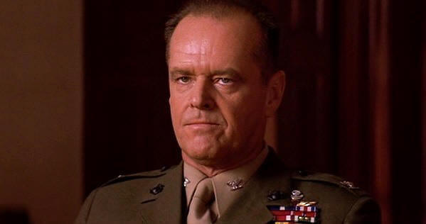
In this courtroom drama, two Marines are accused of murdering a fellow Marine of their unit, PFC William Santiago, at the Guantanamo Bay Naval Base in Cuba, which is under the command of Col. Nathan R. Jessep (Jack Nicholson). It is suspected that Jessep ordered the two Marines to carry out a “code red” on Santiago – a euphemism for a violent extrajudicial punishment. Lawyer Daniel Kaffee (Tom Cruise) directly accuses Jessep of this in the courtroom and, heavily under pressure and tangled in his own lies, Jessep makes a furious declaration.

Col Jessep: You want answers?
LTJG Kaffee: I think I'm entitled to them.
Col Jessep: You want answers?!
LTJG Kaffee: I want the truth!
Col Jessep: You can't handle the truth!
Son, we live in a world that has walls, and those walls have to be guarded by men with guns. Who's gonna do it? You? You, Lieutenant Weinberg? I have a greater responsibility than you can possibly fathom. You weep for Santiago, and you curse the Marines. You have that luxury. You have the luxury of not knowing what I know -- that Santiago's death, while tragic, probably saved lives; and my existence, while grotesque and incomprehensible to you, saves lives.
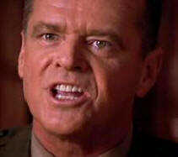 | You don't want the truth because deep down in places you don't talk about at parties, you want me on that wall -- you need me on that wall.  We use words like "honor," "code," "loyalty." We use these words as the backbone of a life spent defending something. You use them as a punch line.

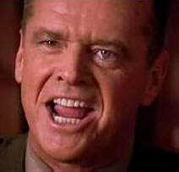 | I have neither the time nor the inclination to explain myself to a man who rises and sleeps under the blanket of the very freedom that I provide and then questions the manner in which I provide it.  I would rather that you just said "thank you" and went on your way. Otherwise, I suggest you pick up a weapon and stand the post. Either way, I don't give a DAMN what you think you're entitled to!

LTJG Kaffee: Did you order the "code red?"  Col Jessep: I did the job I was sent to do-  LTJG Kaffee: -- Did you order the "code red?!" | 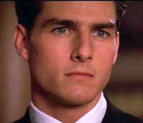
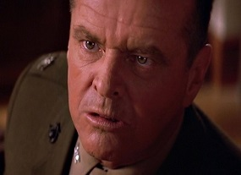
Col Jessep: You're god damn right I did!!!

