Appendices
Dolores Deena Sablan
Northern Marianas College
EN202-ON01
Kimberly Bunts-Anderson

Appendix A - Pilot Study

Number of Researchers: 1
Number of Survey Responses: 16
Demographics: NMC students between the ages of 18-26 / 5 males & 11 females
Type of Survey: Survey of Convenience
Survey Questions:
- Are you currently employed, previously employed or unemployed?
- How long have you been working in your current or previous job?
- Would you honestly say that you are/were hardworking in your current or previous job? Explain why.
- How satisfied are/were you with your job?
- If you could change something about your current or previous job to meet your satisfaction, what would it be?
- Are relationships with those you work important in a job? Explain why.

What are/were your strengths and weaknesses when employed? Ex: Punctuality is a strength and Under pressure is a weakness.
- What do you desire or value most when employed? For former workers, what do you value most in your previous job? For those unemployed, what would you desire most if you were to have a job? Check all that apply.

Whether employed or not, do you believe that satisfaction and motivation affects employee performance and productivity? Why or Why not?

Appendix B - Pilot Study Results

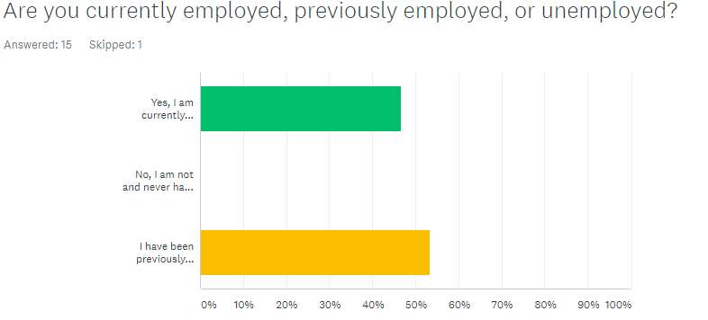

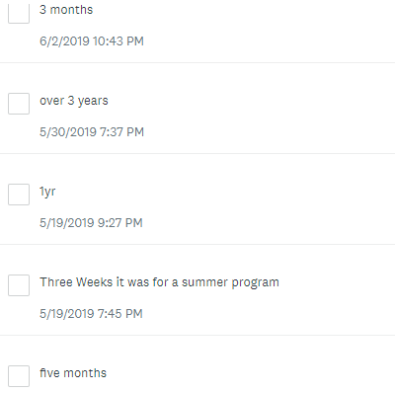

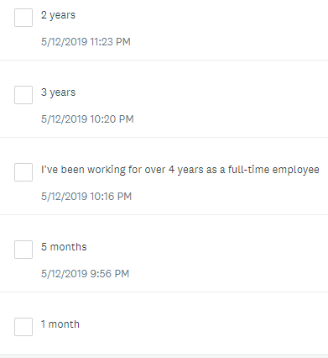

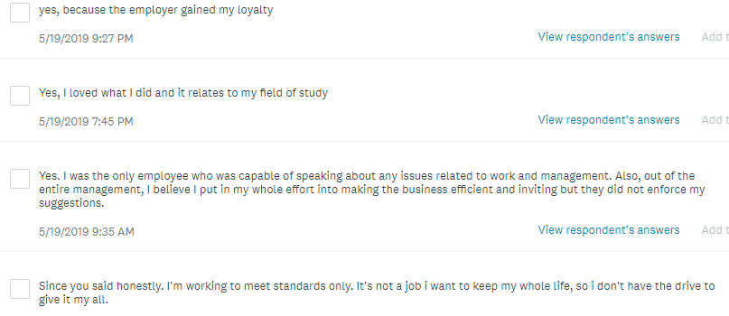

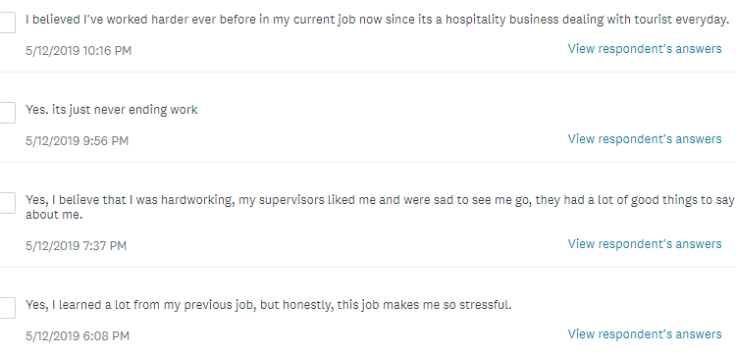

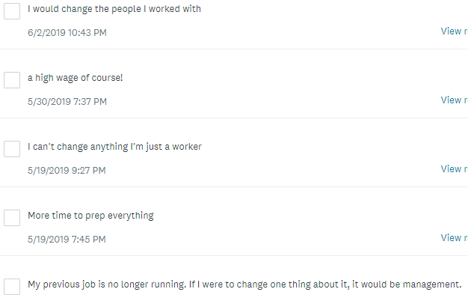

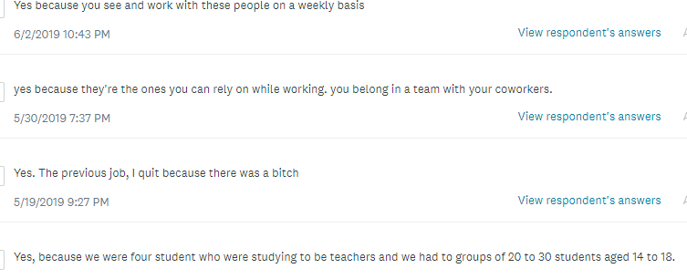

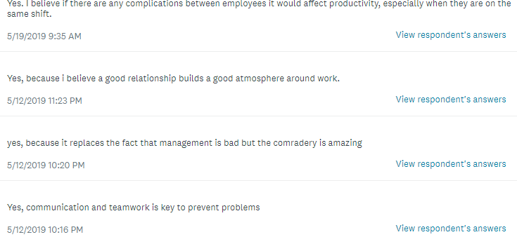

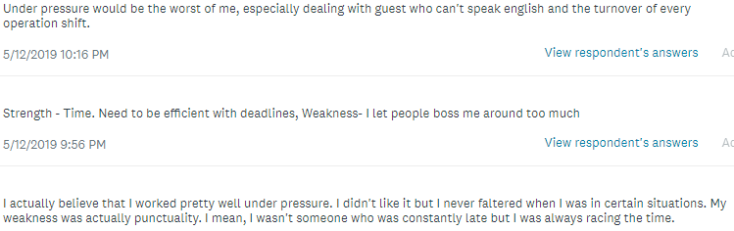

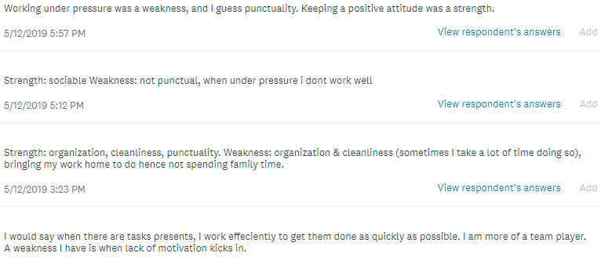

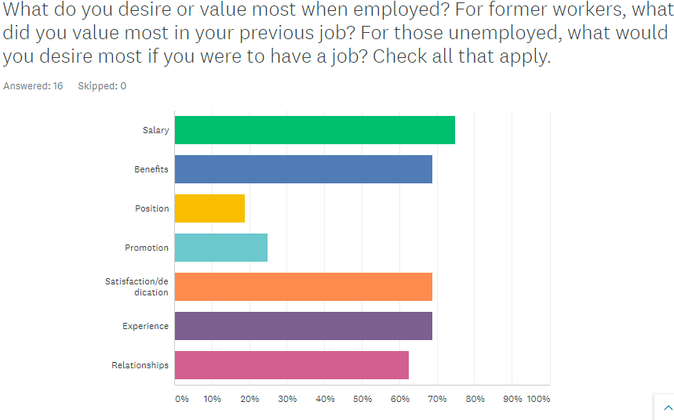

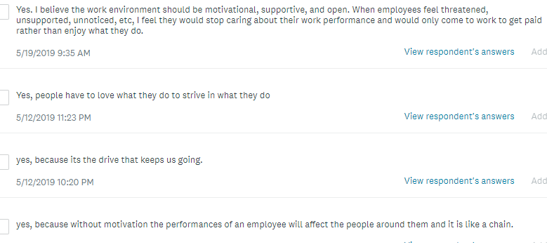
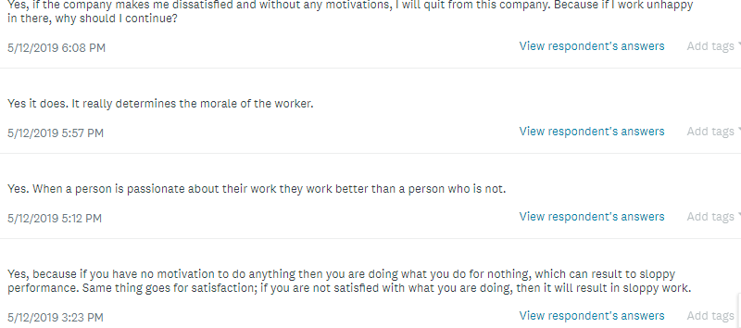

Appendix C - Electronic Employee Interviews

Number of Researchers: 1
Number of Interview Responses: 5
Demographics: Positions of a stocker, librarian assistant, Air Force airman, polynesian dancer, and family partner advocate
Interview Questions:
- How long have you been working in that position?
- Are the relationships with those you work with important? Why or why not?
- What do you desire/prioritize most when employed? (Ex. Salary/position)
- On a scale of 1-4, how satisfied are you with your job? (1=not at all, 4=very satisfied)
- Do you believe you put in all your effort when working? Explain your reason.
- Do you believe that job satisfaction affects employee performance and productivity? Explain.

Appendix D - Employee Responses

