Mr. Mitchell stood up for Martin after Martin admitted his secrets. Mr. Mitchell clapped for martin after not being expelled. “Mr. Mitchell and others clapped loudly as Martin hugged his mother.”

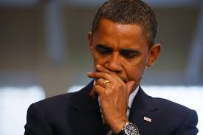

Mr. Mitchell cares for his students but the way he approached Vicky was very bad. Vicky and martin just met and “he is concerned about what he sees.”

Mr. Mitchell tells Vicky “Make sure you don’t get in over your head with him okay? You’re a good student. Keep it up, and collages will be happy to accept you in a few years. I don’t want to see you mess that up. I’ve seen too many talented girl in this school run into trouble with boys. Some get serious with a boyfriend and stop paying attention to their grades. Others had gotten pregnant and dropped out.” He obviously does not want martin and Vicky together because he feels that martin will ruin her future.