Glengela Guiang

**In the end of the Chapter, we see how *Martin’s character changes for the better*. Before, he would not care about anybody else and would always get into trouble. But now, we see he has becoming more caring and loyal. He has decided to make better choices, stay and help Vicky no matter what.**

***By Karyn Langhorne Folan & Paul Langan***

**CHARACTER: Martin Luna**

**An argument happened between Vicky, him and Steve. Martin ‘s old self of losing his patience to beating someone up is coming back. He is jealous and thinks Vicky still has feelings for Steve. Martin almost fought Steve, but the he had self control. *Martin knew better not to get into trouble once again*.**





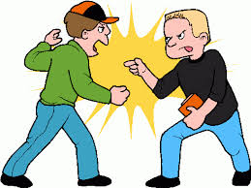

**Martin “admitted his mistakes” (page 9), apologizes for the bad things he’s done and promises to make better choices. He asks the council for one more chance to make things right. In conclusion, Mr. Gates decides not to expel Martin from Bluford. *Martin is now a changed person.***

**Because of Martin’s previous bad behaviors, he was about to get expelled, but with the help of Vicky, Mr. Mitchell and some friends, they defended Martin. *Martin realizes his mistakes and decides he wants to “live a better life for his brother.”* (page 9)**

**In the beginning of this story, *Martin always got into trouble such as skipping class, fighting, cutting school, etc.* (page 8) “He was about to get expelled. He shoved a teacher..”**