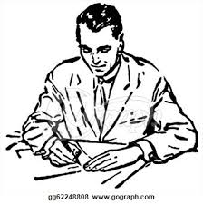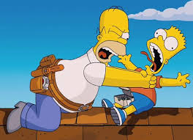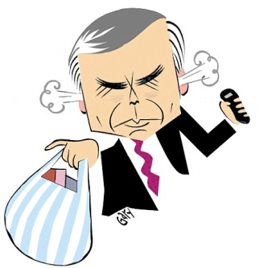

Michael then realizes that he is being immature about leaving his family without saying a word, so he mansup and writes a letter stating the truth on why they’re in debt. He felt **STRONG** writing that letter. HE GAINED HIS STRENGTH TO LOVE AGAIN!

“Vicky finds a note from her dad explaining that he lost thousands of dollars betting on sports and that their house is going into foreclosure”

In the beginning, Michael shows a bad example as a father, ignoring his kids, and arguing with his wife about them being in debt. He reveals his attitude as a **RUDE** father. His love (strength) for his family did not exist.

Michael can’t handle his depression anymore so he decides to beat up his son Danny. Due to his depression he became a **VIOLENT** (weakness) father.

“Early Saturday morning, Vicky awakens to the sound of her dad on the phone pleading with a bill collector. He storms out carrying some bags and boxes.”