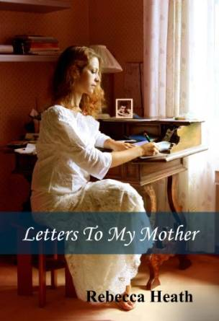

My eyes met his. “Yes, that’s … something I can do myself.” He looked at me for a moment, then turned away abruptly and walked over to his desk where the typing lay.

“This is excellent work,” he said leafing through a couple of pages. I know your first name’s Catherine, but Frank tells me you’d rather be called Kate. May I call you that?”

“Yes … certainly.”

"I can tell you’ve taken great care with this, Kate.

As I entered the elevator, Frank waved. “Ciao, Miss Collins. That’s terribly formal; I’ll bet your first name is very romantic.”

“It’s Catherine, but call me Kate.”

“Franco, but call me Frank. Are people always saying, “Kiss me, Kate?”

I’ve finished the coursework for my Ph.D. and passed the orals; the research I’m doing with David is the basis of my dissertation.

When Kate gets a campus job as David's typist, they discover they're both mistaken. Letters to My Mother is the story of a May-December romance set in 1950s Seattle

“I’m from no place, really. Because my father’s in the navy, I’ve lived everywhere from Hawaii to the Middle East. That’s how I happened to learn Spanish. The Navy transferred Daddy to Turkey in 1949; there weren’t enough dependents in Ankara for the American government to provide teachers for the children, so my parents decided to send me to a boarding school in Spain.”

Kate is a college junior, a gifted student who skipped two grades in school, a naval officer's daughter who's lived in more places than she can remember. Shy and bookish, she's never had a boyfriend, let alone been kissed or gone on a date. Kate thinks falling in love is something that only happens to other girls.