Jasmine Hedson
Demonstration Speech
CO210- 02
Topic: Two methods in solving quadratic equation
Audience: College students
Purpose: To demonstrate
- Introduction:
- AG: Math, as google defines it to be “the abstract science of number, quantity, and space.” And majority of people defines it to be something they hate. In mathematics, there’s the quadratic equation. There are three methods in solving quadratic equation and I’m only going to demonstrate/teach/show you two methods.
- Two main points:
        - Factoring Quadratic Equations
        - Quadratic Formula

- Body:
- First, I will go through the steps for method #1( factorizing)
STEP 1: Write the equation in standard form (ax^2 + bx + c = 0).
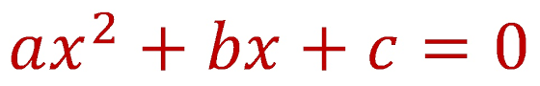
STEP 2: Factor completely.
STEP 3: Apply the zero product rule.
STEP 4: Solve linear equation in step 3.

- Now that I showed you method #1, I will now show you method #2(quadratic formula).
STEP 1: Write original equation in standard form.
STEP 2: Quadratic Formula
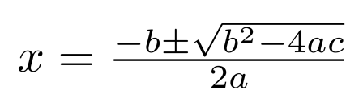
STEP 3: Substitute a, b, and c with the coefficients
STEP 4: Simplify
- Conclusion:
- Review of main points:
        - Today I showed you how to solve a quadratic equation with two methods (Factorizing and The Quadratic Formula).
- Closing:
        - After today, you’ll be able to solve mostly any quadratic equation with the two methods that we just went through.

