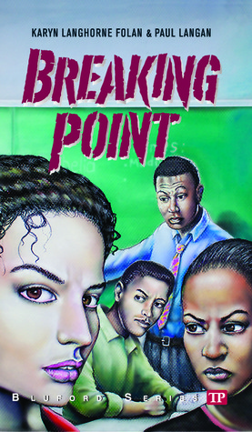

Fallon had lost his job and was struggling to provide for his family and pay the bills. He was overwhelmed and he kept arguing with his family, but he was still there. He was willing to make sacrifices for his family. “Dad also offered to sleep in the living room but Vicky disagreed.” He would give up comfort for Vicky.“I’ve been all over town looking for work,” he told his wife. “Sorry Princess” he tells Vicky.

*Character Chart: Michael Fallon*

*By: Lorielyn Lacay*

Fallon abandons his family in a time of distress; he leaves a letter and box for Vicky to find. The box contains the things he stole from them. Though he cares for them he leaves them. “I’m sorry, but you know its better this way. Love always, Dad”

Fallon begins stealing from his family. “Look I’m doing everything I can, things I never dreamed I’d do to raise money…” whispers Fallon on the phone.

Fallon loses control and pushes Abuelo, he also throws Danny against the wall. “Sending Danny slamming against the wall” Then Fallon abandons his family.

Though the book Introduces Michael Fallon as a neglecting father, in a flashback before he lost his job he was actually a very loving father. In the flashback he tells Danny “I won’t let anything happen to you…”



