E-Portfolio
EN202-03
Angelah Magofna
Dr. Kimberly Bunts-Anderson
Northern Marianas College
Fall 2019

Could the Implementation of a Sugar Tax on Saipan Decrease Consumption of Sugary Beverages and Improve Health?
EN202-03
Angelah Magofna
Dr. Kimberly Bunts-Anderson
Northern Marianas College
24 November 2019

Table of Contents
Abstract…………………………………………………………………………………..……3
Introduction……………………………………………………………………………………4
Literature Review………………….…………………………………………………………..4
Research Questions……………………………………………………………………………7
Methodology………………………………………………………………………...………...8
Results………………………………………………………………………………….…….10
Discussion……………………………………………………………………………..……..15
Conclusion………………………………………………………………………..…………..18
References…………………………………………………………………………..………..19
Appendices……………………………………………………………………………..…….21

Abstract
A Northern Marianas College student describes an original, 14-week study conducted to find out whether implementing a sugar tax on the island of Saipan could decrease consumption of sugary drinks and improve health. Magofna wanted to find out what the people of Saipan as well as medical professionals think about applying a sugar tax on the island by conducting surveys, sending letters, and organizing informal interviews. From the results of two 16-person Northern Marianas College students survey and a 55-person general public survey, Magofna has gathered that the majority of people on Saipan are either neutral or in agreement with the implementation of a sugar tax. Letters from two local dieticians and one local diabetes educator were all in agreement that a sugar tax could potentially improve health on the island if additional healthier lifestyle habits are employed. This study is important because a large percentage of citizens in Saipan are either overweight or obese due to unhealthy habits and a sugar beverage tax could potentially be a way to alleviate the situation.

Could Implementing a Sugar Tax on Saipan Decrease Consumption of Sugary Beverages and Improve Health?
Saipan has a problem with the consumption of sugar-sweetened beverages, and this is affecting the health of the citizens. The intake of sugary drinks can quickly pile on the calories, which is why most people forego these types of drinks in favor of water when going on a diet. However, though water is the healthiest drink option, that does not particularly mean it is the most popular. In a survey conducted in 2016, it was found that in the CNMI, about 75 percent of adults consume one or more sugar-infused drinks per day (Dela Cruz & Cash, 2016, p. 1). This behavior is startling and a major health risk for multiple health problems such as obesity and diabetes. By imposing a tax on sugary drinks, the expectation is that the percentage of consumption will significantly drop, thus improving health. This academic essay will emphasize the importance of implementing a sugar tax on Saipan and discuss whether or not the tax can decrease consumption and improve health by explaining literature found on local, national, and international levels, discussing the methodologies used in order to gather qualitative as well as quantitative data, analyzing the findings of the student researcher, and discussing what those findings mean.
Literature Review
Taxes have always been a rather sensitive subject for citizens, no one can be fully satisfied with them. Add the fact that sugar-sweetened beverage taxes are made in order to promote healthier habits, i.e. “tell citizens how to live their lives,” and the whole situation becomes a recipe for disaster. In a Saipan Tribune article about the proposal of a sugar tax, a citizen named Glen Hunter voiced concerns over the “astronomical” price increase of sodas the tax would bring about and how the taxation cost will be more than anything that has been taxed on the island (Villanueva-Dizon, 2016). Nevertheless, it should be noted that Glen Hunter worked as a director for the providers of both Pepsi and Coca-Cola on Saipan, which may lead to a potential biased opinion. Though, it should also be noted that many citizens on Saipan share his opinion as many comments on the articles about the sugar tax proposal heavily criticized the tax, calling it worthless and useless. In a similar opinion, citizens from the United Kingdom are also not in favor of a sugar beverage tax, with many citizens citing that the tax was “unfair,” “an excessive intrusion into individual’s lives,” asserting that people should be in charge of their own health, and mentioning that they do not trust the motives behind the tax (Thomas-Meyer, Mytton, & Adams, 2017, p. 6-10). Thus, it seems that the common consensus among citizens is that the sugar beverage tax is something they would rather not have. However, in direct contradiction to this, a study in Berkeley found that in 2014, 3 out of 4 people voted in support of enacting a sugar tax (UC Berkeley, 2019). This information will be useful to the student researcher, as it reveals common opinions about the public’s view on the application of a sugar tax.
Although the opinions of the people are important, it is equally important to discern how businesses feel about a sugar tax as they would be the ones most impacted by it. Just as Saipan Tribune talked about a citizen’s concern about a sugar tax, the newspaper also discussed businesses’ concerns about the tax. Two concerning matters include how increased prices will burden customers and how businesses would be forced to lay off workers and potentially even close down (Villanueva-Dizon, 2016). These are common arguments businesses would bring up with the intention of convincing the government that a sugar tax would be disastrous for the community. In fact, the beverage industry feels strongly about this and spend upwards of millions of dollars in order to lobby at the state and local levels to discourage sugar taxes from being implemented (Powell, Wada, Persky, & Chaloupka, 2014, p. 672). Despite this, in a study conducted by Powell, Wada, Perksy, and Chaloupka, it was found in the states of California and Illinois a 20-percent tax on sugar actually resulted in a rise of about 4,400 jobs in Illinois and about 6,600 jobs in California respectively (2014). This shows that while a sugar tax may result in the loss of jobs relating to sugary drinks, it may also result in an increase of jobs as consumers would begin to spend money elsewhere. Literature on the business’ perspectives will be relevant to the student researcher’s report as it highlights the concerns of the most negatively impacted demographic.
Despite the importance of the perspectives of citizens and businesses, the people whose opinions matter the most are experts. In various studies and analysis conducted by professionals, it has been found that sugar beverage taxes can lower purchasing and consumption rates. The law of supply and demand states that as the price of an item grows, the demand plunges. Thus, as a sugar tax causes the price of sugar-infused drinks to increase, the consumption rate of these drinks would fall. However, just because the rate of consumption decreases, that does not necessarily mean that the tax results in improved health. In actuality, an analysis done by Maria Escobar, Lennert Veerman, Melanie Bertram, Stephen Tollman, and Karen Hofman found that sugar taxes could potentially result in “modest” weight loss within the population (2013). This is because although sugary drinks are a part of the equation when it comes to obesity, it is not the biggest contributor to obesity, hence why it only results in modest weight reduction. Nevertheless, numerous studies indicate that reducing intake of sugar-infused drinks can lead to better weight control, especially among those who are overweight (The Nutrition Source, 2019). Furthermore, many medical professionals, including Walter Willet, a nutrition researcher, insist that people should focus on consuming healthier beverages (Willet, 2009). This information will be relevant to Magofna’s research as many experts within the nutrition field believe that implementing sugar taxes could be beneficial to the people.
Along with the various perspectives found on sugar taxes, Magofna additionally found a case study on taxing sugar-infused beverages conducted in Philadelphia. The authors, Purtle, Langellier, and Lê-Scherban, conducted the study in order to gain qualitative research on the reason why the sugar tax proposal was able to pass, focusing on key-informant interviews on the subject (2018). From their research, the authors gathered that the bill passed with relative ease because it was not framed in a way that made it look like the government was trying to control citizens’ lives. Policymakers disclosed exactly where the revenue gained from the tax would go, which many citizens appreciated and ultimately was what led many of them into voting in favor of the tax. The tax revenue was to be used for funding universal pre-kindergarten, which held prevalent support among the majority, helping the proposal to gain popularity. It was only until towards the end of the process of implementing the tax when health started coming into the conversation. At that point, it did not seem like a “the government is intervening in citizens’ lives” situation, but a “this tax will make prekindergarten free and comes with health benefits” situation. The tax that at first everyone disliked soon became the tax that everyone was pushing for. This case study will be especially convenient for the student researcher, as it shows that people will be on board with a sugar tax so long as the money is spent on something worthwhile.
Research Questions
Utilizing the literature found and during the process of personal investigation, the student researcher hopes to answer this preliminary question:
- Could implementing a sugar tax on Saipan decrease consumption of sugary beverages and improve health?
and these additional questions:
- What are the links between a sugar tax and obesity?
- Which demographic is the most against a sugar tax?
- If a sugar tax is to be implemented, what would the people want the revenue gathered from the tax to be spent on?
Methodology
If a sugar tax were to be implemented, the people most impacted by it would be college students as research has shown that this particular demographic struggles with money the most. To find out what college students think of the tax, Magofna distributed a ten-question survey to approximately 45 Northern Marianas College, English Composition students in the fall semester of 2019. Demographic questions were asked in order to gather more background information on the subjects. The survey contained multiple choice, short answer, and open-ended questions in order to gather both quantitative and qualitative data on the topic. The survey was first piloted and then distributed amongst 10 people with about one week to reply (see Appendix A). The second survey was then distributed among all students within the English Composition class and students were given three weeks to respond (see Appendix B). As of November 13, 2019, both the pilot and final survey received 16 participants each, totaling at 32 out of 45 NMC students who have taken surveys.
Along with the opinions of college students, the student researcher additionally aimed to gather opinions on the general public’s stance on a sugar beverage tax. Magofna created a simple six-question survey that was distributed among 55 random people through WhatsApp. Magofna sent the link to the survey through the messaging app and each person who took it would then distribute it to others to take the survey. If a person did not know what a sugar beverage tax was, Magofna would then proceed to explain so there would be no confusion when the survey was taken. Questions were quantitative, focused on gathering numbers and percentages instead of in depth, personal opinions. Two demographic questions were asked on people’s age, gender, and ethnicity. The third question asked the survey taker whether or not they drank sugar-infused beverages, in order to gather data on how many people on Saipan drink these types of drinks. The next question, going off from the third, asked the person if they could give up sugary drinks if they really wanted to or not. The final two questions asked if a person would still purchase sugary drinks if a tax were to be applied and if the person would want a sugar tax to be enacted on-island (see Appendix C).
Although surveys are a good way of gathering quantitative data, they lack the ability to gather a significant amount of qualitative data. Interviews are a better way to do this as it helps researchers to understand how certain topics impact a person’s life, making research paper more compelling to audiences (Ballenger, 2017, p. 67). To gather such data, Magofna conducted an informal interview with a college student from Oakland, California, a place where a sugar tax has been applied (see Appendix D). Questions that were asked included the student’s stance on the tax and why, if the tax affected their buying habits, and whether or not the sugar tax was a hindrance due to increased prices. Additionally, the student was asked if their drinking habits changed because of the tax, if the tax is popular or unpopular amongst their peers, and if the college student believes the tax is successful or just a cash grab. The reason for the student researcher choosing this method was to find out what college students from places where a sugar tax was applied personally feel about the tax. It is one thing to think about the possibility of one, but a completely different thing to actually live in the reality of the tax. Along with interviewing a college student from Oakland, the student researcher additionally interviewed a local woman from Saipan who considers herself an avid lover of soda (see Appendix E). The interview focused on qualitative data, asking about the woman’s weight, drinking habits, and personal opinion on the idea of a tax on sugary drinks. The interviewee was asked a question about their weight in order to determine if weight plays a role in the consumption of sugary beverages. Additional questions asked were similar to the questions asked in the surveys sent to NMC students. Magofna wanted to find out what people who have an addiction to drinks affected by the tax would feel if one were to be enacted on the island.
While gathering information from the most impacted demographic is essential, it is equally important to consult with experts on their opinions of the sugar beverage tax. The student researcher sent out five letters to experts on-island and five letters to experts off-island. For on-island opinions, Magofna sent two letters to dieticians, two letters to Representatives Angel Demapan and Felicidad Ogumoro, and one letter to the Hardt Eye Clinic and Diabetes Center. Letters sent to the dieticians and diabetes center aimed at gathering information on the general health of patients who come in and a medical professional’s personal opinion on the tax (see Appendices F & H). The letters sent to two representatives focused on qualitative data to figure out what went wrong with the proposed sugar tax bill and why it was so unpopular amongst citizens (see Appendix G). For off-island opinions, Magofna sent two letters to authors whose articles were reviewed in the paper and three letters to medical professionals in Oakland, San Francisco, and Portland. Letters sent to authors asked about the results of the research the authors gathered, while letters to medical professionals asked qualitative questions about how successful the tax was and if the people there are healthier because of the tax (see Appendices I, J, & K). As of November 14, 2019, the two dieticians and Dr. Don Hardt from Hardt Eye Clinic have responded, while no off-island experts have attempted to make contact.
Results and Findings
Surveys
In combination of all three surveys, Magofna found that 62 out of the 87 respondents were either neutral or in agreement a sugar tax on-island whereas the remaining 25 respondents were not. Further analysis of these results discovered that of those 25 participants, 17 were age 34 and younger and eight were age 35 and older.
NMC Surveys. As of November 5, 2019, both surveys have gathered 32 responses in total, with 16 going to the pilot survey and 16 going to the main survey. The results of both surveys found that 90% of participants actively consume sugar-infused beverages, while about 10% do not consume sugar-infused drinks at all (see Appendix A & B for survey results). Both surveys show that when asked if a sugar tax would affect the regularity of the participant’s drink buying 37.5% reported yes, 15.6% reported no, 37.5% reported that it “sort of” will, and 9.6% reported that they do not consume sugary beverages. When asked the reasoning behind the participant’s answers, common explanations involved the participants saying a tax would not stop them from drinking a sugary drink, a tax would make them buy sugary drinks less often, and the tax would lead to them stopping their purchases of the drinks immediately. Participants were questioned on whether or not they believed a sugar tax could improve health on the island with 50% in agreement, 25% in disagreement, and 25% stating “maybe”. Some arguments in agreement include how the tax would decrease purchasing rate and incentivize healthier habits. Arguments in disagreement include how sugar is known to be addictive and it would not stop people and how they believe it is not necessary to “change” a person’s lifestyle. When asked if participants believed if a sugar tax would be fair to businesses and citizens, the total average number of both surveys came out to be 105 out of 200, falling into the neutral category. Survey takers were additionally asked what they would want done with the revenue gained from the tax, with common answers being: improving healthcare, using it to better the island/economy, and helping the public-school system. Both surveys found that on the topic of implementing a sugar tax on Saipan, about 34% think it is a good idea, about 6% think it is a bad idea, and about 59% are neutral.
General Public Survey. By the time the general public survey closed on November 10, 2019, the student researcher had acquired 55 responses. About 23% of those responses came from males between the ages of 15 to 54, while about 78% came from females between the ages of 18 to 64. Of the survey takers, 69% were Chamorro, 7% were Carolinian, 14% were Filipino, about 1.8% were Asian, 1.8% were Caucasian, and 5.54% classified themselves as “other.” The results of the survey found that about 85% of participants actively consume sugary drinks while about 15% do not. Of the 85%, there were 32 replies from Chamorros, six replies from Filipinos, and full replies from all other ethnic groups. When asked if participants could give up on sugar-sweetened beverages, about 85% said “yes,” about 4% said “no,” and approximately 11% said that they “do not consume sugar-sweetened drinks.” Participants were additionally questioned if they would still buy drinks with added sugars if a sugar tax were to be enacted on island with about 23% stating “yes,” about 27% stating “no,” and about 49% stating “sometimes.” When asked if participants would want a sugar tax to be implemented on the island, about 58% were in favor of the tax, while approximately 41% were not in favor of the tax. Participants who were not in favor of the tax include 14 Chamorros, five Filipinos, two ethnic groups that fall under the “other” category, one Carolinian, and one Asian.
Interviews
College student from Oakland. By November 9, 2019, the student researcher had received answers to the interview questions sent to a college student in an area where a sugar tax has been implemented. Magofna found that, at least in California, the sugar tax does not charge the people, rather it charges the distributor of the sugar-sweetened beverages (see Appendix D). The purpose of the tax was to stop the high distribution of sugary drinks and to help prevent childhood obesity. The interviewee, Amberlyn Palacios, when asked for an opinion on the sugar tax, stated that the tax does not directly affect her as it charges the distributors of sugar-infused drinks. However, Palacios pointed out that businesses could find a loophole in the tax by charging customers extra to regain lost profit, but the interviewee does not know this for a fact. Palacios declared that the tax did not change any current drinking habits because the added amount is so small, it is hardly noticeable, but stated that if the price were heftier, it would affect her drinking habits. As a college student, Palacios felt as though the tax was not meant to be unfair but meant to be a way to promote healthier habits. The student points out that she does not personally know anyone who is significantly impacted by the tax and asserted a belief that college students there barely even notice the added price. When questioned about the purpose of the tax, Palacios’s personal opinion is that the tax is not fulfilling its role “as it does not deter young people to stop buying beverages containing sugary drinks or stopping distributors from bringing sugary drinks into the city. Those were the two main groups of people it was aimed at and it is not having its desired effect nor do I think it will.” When asked if the student believed if sugar taxes should be implemented elsewhere, Palacios affirmed that it is not useful as it does not decrease the sale or consumption of sugary drinks.
Avid soda lover. On November 13, 2019, Magofna conducted a last-minute interview on a self-proclaimed soda lover (see Appendix E). The student researcher found that the interviewee would categorize themselves as overweight and would frequently drink soda or other sugar-infused beverages within a day. The interviewee does not feel as though they are addicted to sugary drinks but does proclaim hatred for water. When asked if a sugar tax would affect the regularity of the interviewee’s drink buying, the interviewee asserted that it would not. The respondent declared that they would be upset at spending extra on these types of drinks and stop purchasing them for a while, but that eventually, the interviewee would get over it and start buying those drinks again. The interviewee does not believe that a sugar tax would be unfair to the businesses, believing that locals would not stop buying sugar-infused drinks even if the price went up. When asked what the respondent would want the revenue for the tax to be spent on, the interviewee stated that it should be spent on fixing Hopwood. Magofna found that the interviewee is not in favor of implementing a tax on the island, however, if the government were to use the tax revenue to improve the island, i.e. fixing Hopwood, the respondent would be “onboard” with the idea.
Letters to Experts
As of November 14, 2019, three of the ten letters that were sent to experts have been answered with all of them being from on-island medical professionals.
Dieticians. In the two letters sent to Dieticians Maribeth Manibusan and Erin Camacho, Magofna found that they believe the overall health of the citizens on Saipan is “somewhat poor”, and “need to be improved significantly” (see Appendix F). The two attributed the reasonings for this being conditions like diabetes, hypertension, and obesity. When asked if Manibusan and Camacho believed that a sugar tax could improve health on the island, both were in agreement. Camacho asserts that cutting back on the consumption of sugary drinks will significantly improve health on the island as it is a source of a lot of empty calories. However, Manibusan affirms that while a sugar tax can improve health, other lifestyle changes must be made if one wanted to improve their health significantly. On the question of the high consumption of sugar alluding to an addiction, both stated that it can be seen as an addiction “in a way.” Camacho said that sugar can give a person “high” or good feelings for a short term, so in a way it is almost like an addiction. Manibusan, however, feels as though using the word addiction is misleading and that a person could break out of their sugar-craze if strongly motivated and supported by friends, family, and healthcare providers.
Hardt Eye Clinic. In the letter sent to Hardt Eye Clinic, the student researcher found that Dr. Don Hardt, a certified diabetes educator, believes that a significant tax on sugary beverages would over time decrease the percentage of people with diabetes (see Appendix H). When asked if sugar ingestion can cause diabetes, Hardt asserts that “the causes of diabetes are very complex.” Dr. Hardt states that sugar ingestion alone is not the cause of diabetes and that eating too much sugar by itself does not generally cause diabetes. However, Hardt affirms that increased sugar consumption is linked with obesity, which is highly associated with diabetes. Hardt additionally declares that the best way to prevent diabetes is simply through a healthy lifestyle.
Discussion
Taxes on sugar-sweetened drinks are a controversial issue, one that many do not agree with as there are many disadvantages that come with the benefits. This study was conducted primarily to discern whether implementing a tax on drinks with added sugars could decrease consumption as well as improve the health of citizens on Saipan. The study was additionally directed to find the links between a sugar tax and obesity, which demographic would be the most against a sugar tax, and what would citizens want revenue gained from the sugar tax to be spent on.
Obesity and diabetes are among the biggest health issues on the island, with about 2 out of 3 adults in the CNMI being either overweight or obese and the prevalence for diabetes being higher than in the entirety of the United States. (Dela Cruz & Cash, 2016). Earlier research suggests that a sugar tax may result in moderate weight loss within a population as well as assist in controlling weight (Escobar, et al., 2013; The Nutrition Source, 2019). Furthermore, a letter sent to Dr. Don Hardt, a certified diabetes educator, reveals that obesity and diabetes are linked and that implementing a sugar tax could simultaneously lower obesity and diabetes rates. Letters from dieticians also support this theory, with both dietitians believing that a tax on sugar could encourage better health choices. Additionally, high prices are associated with low demand, highlighting that the sugar tax could potentially prevent consumers from purchasing drinks with added sugars. This theory is supported by a study conducted in Berkeley, California, where it was found that after a sugar tax has been enacted, consumption rate of sugary drinks went down about 50% (UC Berkeley, 2019). The results from both the 32-person Northern Marianas College students survey as well as the 55-person general public survey also support this idea, with 66 of 87 participants declaring it would negatively impact the frequency of their purchasing.
All three surveys also found that 62 out of the 87 respondents were either neutral or in agreement a sugar tax on-island whereas the remaining 25 respondents were not. These results were rather surprising, as people usually do not like the idea of taxes. Further analysis of these results discovered that of those 25 participants, 17 were age 34 and younger and eight were age 35 and older. This suggests that younger citizens are less likely to want a sugar tax to be implemented on the island than older citizens. Perhaps this is because the younger demographic usually makes less money than those of the older generation and thus would not want to spend extra on items. The results of the survey are further supported by an interview with a college student from Oakland, a place where a sugar tax has been implemented. The interviewee, Amberlyn Palacios, is not in support of sugar taxes being applied elsewhere as Palacios feels as though the tax does not do anything to improve health or stop consumption.
Results from the NMC student surveys found that the most common things citizens would want revenue gained from a sugar tax to be spent on would be improving the island/ fixing the economy, improving healthcare, or helping the public-school system. While analyzing results from the surveys, Magofna found that while a few respondents would skip the open-ended questions, almost none skipped the open-ended question that dealt with the tax revenue issue. This highlights that most participants believed that the question is important and felt the need to voice an opinion on it. In the interview with the soda lover, the interviewee asserted the desire for the revenue to be spent on fixing Hopwood, a place where the interviewee’s little sister goes to school. The person declared that they were not in favor of a sugar tax but would not mind if one were to be enacted on Saipan if the government spent the tax revenue on fixing Hopwood. This mentality is mirrored in a case study conducted in the United Kingdom, where it was found that citizens were more agreeable to the sugar tax when it was found out that the money from the tax would be spent on universal kindergarten, something that help prevalent support within the community (Purtle, Langellier, & Lê-Scherban, 2018). These two findings suggest that citizens could be persuaded to favor a sugar tax if the government spends the money on something majority of the community would want.
To summarize, this study found that a tax on sugary beverages has the potential to decrease consumption and improve health on Saipan. Results from surveys, literature sources, and letters from experts all support this hypothesis. However, experts do mention that additional lifestyle changes must be made for the tax to truly improve health. Results from surveys as well as an interview found that the demographic that would be the most against a sugar tax would be the younger generation. Furthermore, studies as well as personally conducted surveys and interviews indicate that citizens would be in agreement with a sugar tax so long as the money on the tax would be spent on something to benefit the community.
Limitations in Study
This study contains limitations. The student researcher only surveyed 87 people, which is not even 1% of the total population of Saipan so some results may differ if future research were to be done on a higher number of participants. Additionally, of those 87 people, majority of them were Chamorro, which is not the dominant population demographic in the CNMI. For future studies, Magofna recommends that surveys should comprise of about 1,000 or more individuals for results to be qualitative. Also, the student researcher suggests that the weight of individuals should additionally be taken into account.
Conclusion
The poor health of the citizens in the CNMI is a troubling issue, one that could potentially be solved by the implementation of a tax on drinks with added sugars. By analyzing literature, discussing methodologies, examining results, and discussing findings, Magofna found that a sugar tax could decrease consumption and improve health on the island. Several medical professionals are in agreement, but assert that other, healthier lifestyle changes must be made in order for the tax to truly work. Obesity and diabetes are quite common within the CNMI; however, it has been shown that sugar taxes may result in modest weight loss within a population, proving that a tax on sugar could contribute to alleviating the obesity epidemic. Additionally, obesity and diabetes are linked so it can be said that if the rate of obesity goes down, the rate of diabetes on the island would go down as well. Furthermore, surveys conducted found that the majority of participants would be onboard with a sugar tax, so long as the government spends the tax revenue on bettering the island, mirroring a similar result in a study conducted in the United Kingdom. Taxes may be a controversial and unpopular, however, it cannot be denied that it is there to help, not to hinder.

References
Ballenger, B. P. (2017, January 10). The curious researcher: a guide to writing research papers (9th ed.). Hoboken, NJ: Pearson.
Dela Cruz, R. & Cash, H. (2016). Commonwealth of the Northern Marianas Islands Non-communicable Diseases & Risk Factor Hybrid Survey Report. Retrieved from http://i2io42u7ucg3bwn5b3l0fquc.wpengine.netdna-cdn.com/wp-content/uploads/2017/04/CNMI-NCD-Survey-Report-FINAL-2017.pdf
Escobar, M. A. C., Veerman, J. L., Bertram, M. Y., Tollman, S. M., & Hofman, K. J. (2013). Evidence that a tax on sugar sweetened beverages reduces the obesity rate: a meta-analysis. BMC Public Health, 13(1), 1–20. https://doi.org/10.1186/1471-2458-13-1072
Powell, L. M., Wada, R., Persky, J. J., & Chaloupka, F. J. (2014). Employment Impact of Sugar-Sweetened Beverage Taxes. American Journal of Public Health, 104(4), 672–677. https://doi.org/10.2105/AJPH.2013.301630
Purtle, J., Langellier, B., & Lê-Scherban, F. (2018). A case study of the Philadelphia sugar-sweetened beverage tax policymaking process: implications for policy development and advocacy. Journal of Public Health Management and Practice, 24(1), 4-8.
The Nutrition Source. (2019, May 22). Sugary Drinks. Retrieved from https://www.hsph.harvard.edu/nutritionsource/healthy-drinks/sugary-drinks/
Thomas-Meyer, M., Mytton, O., & Adams, J. (2017). Public responses to proposals for a tax on sugar-sweetened beverages: A thematic analysis of online reader comments posted on major UK news websites. PLoS ONE, 12(11), 1–18. https://doi.org/10.1371/journal.pone.0186750
UC Berkeley. (2019, February 21). Three years into soda tax, sugary drink consumption down more than 50 percent in Berkeley: Taxes may be a promising new tool in the fight again obesity, cardiovascular disease and diabetes. ScienceDaily. Retrieved October 26, 2019 from www.sciencedaily.com/releases/2019/02/190221172056.htm
Willet, W. [Harvard T.H. Chan School of Public Health]. (2009, May 19). Time to Focus on Healthier Beverages. Retrieved October 26, 2019, from https://www.youtube.com/watch?v=9S9wfbFIea4&feature=youtu.be
Villanueva-Dizon, F. (2016, April 21). Businesses, Chamber against sugar tax - Saipan News, Headlines, Events, Ads: Saipan Tribune. Retrieved from https://www.saipantribune.com/index.php/businesses-chamber-sugar-tax/

Appendix A
Pilot Survey Results
Number of Survey Responses: 16
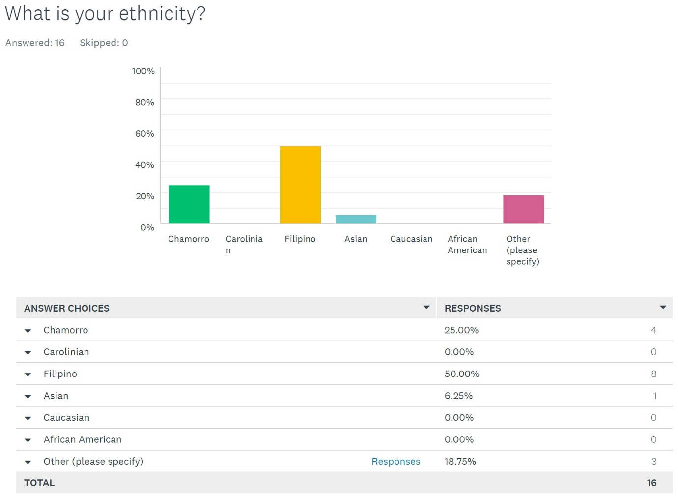
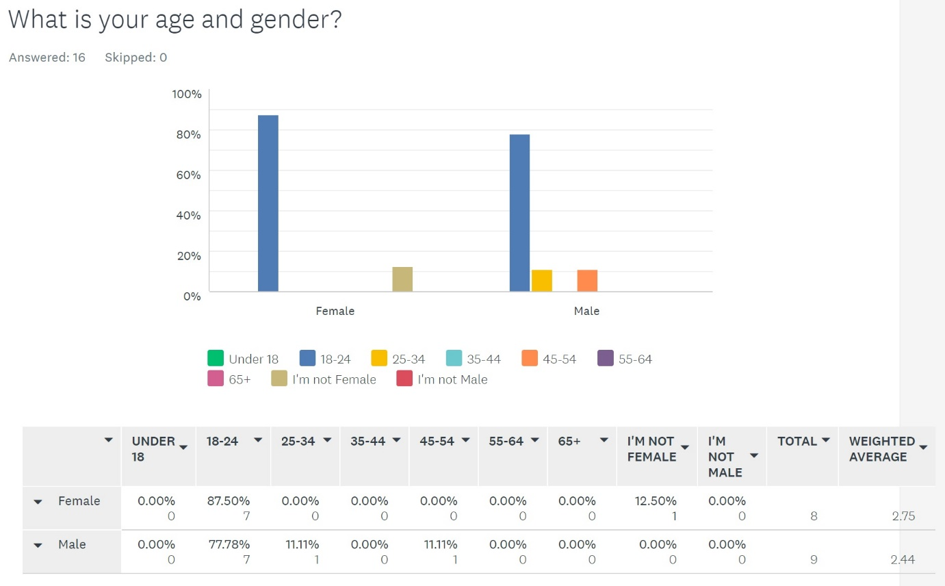

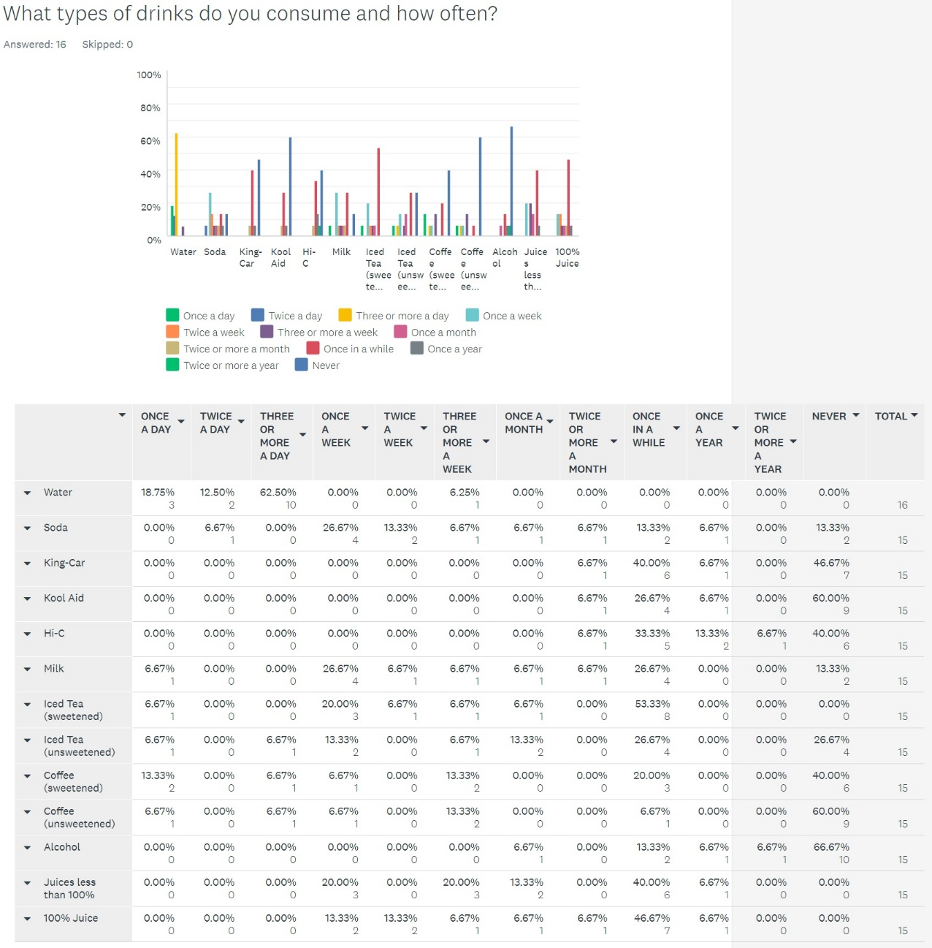
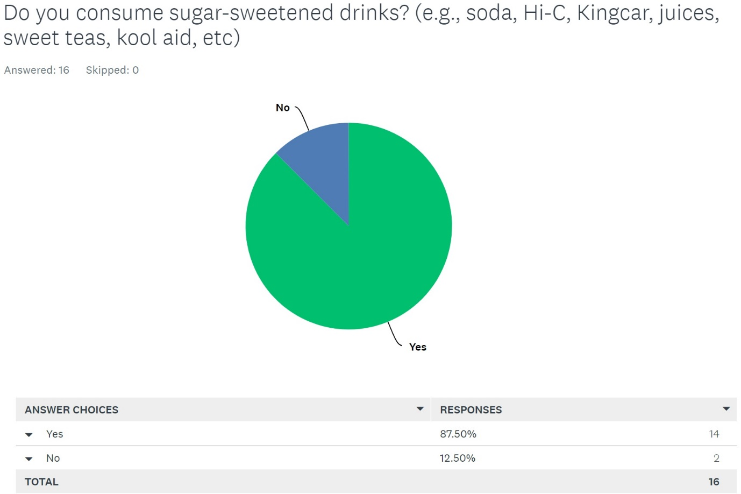

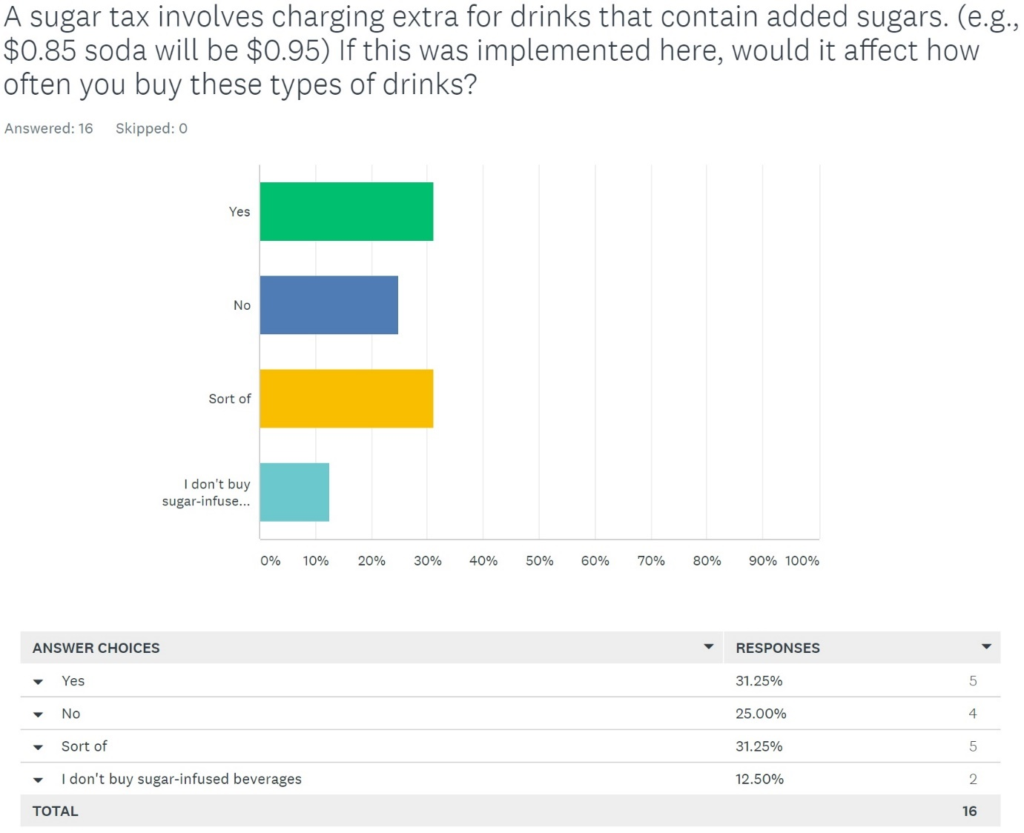
Explanations
  - because it's more expensive when you drink with different flavor or maybe once a year it changes.
  - I would not buy it anymore because I don’t care for added sugars.
  - It won't really affect because I don't purchase many sugar-infused drinks often.
  - I chose no because I don't drink sugar drinks everyday, so it would not affect me that much.
  - Although, I don't drink sugary drinks, it would still effect me from buying it because who wants to pay tax just to drink sugary drinks, not me.
  - I would have to slow down on my consumption.
  - I don't like sugar so only drink when there isn't another option. Unfortunately a lot of places only give the options of water, soda or caffeen.
  - If it means better for the community im totally agreed to it.
  - It depends on how much the tax will cost.
  - I'd go the extra mile to buy a sugary drink
  - I believe my cravings wouldn't stop me from purchasing it.
  - I would not want to spend more on drinks that will increase my sugar so I would rather drink more water instead
  - I made a personal choice to not buy sweetened drinks.
  - I'm cheap, so I tend to go for a cheap drink at the store. But if I really liked the drink, like coffee for example. I think I'd just buy it a little less.
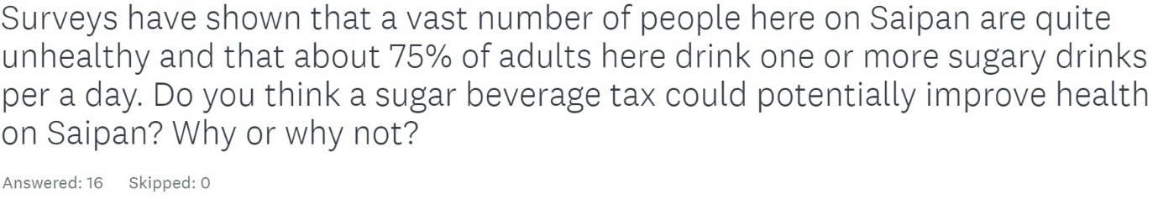
Answers
- yes it can because when people buy drinks it can help them save money and to stop them from drinking the same thing once in a while.
- Yes, maybe people would buy it less often, especially kids.. and start drinking water.
- I don't think it would improve much because there are other things people can consume that deteriorates their health.
- I would say yes because there would be less people who are obese.
- I think it will because with tax in mind while buying these kinds of drinks may cause them to rethink especially when it is human nature to find something free or cheaper.
- Maybe, if the person do not have enough money, they won't buy alot of drinks.
- Yes, I think more options might open up or appear affordable.
- Yes because too many people in Saipan buys sugary drinks.
- Possibly
- Yes, it would. It would incentivize buying healthier options.
- I think it is not that necessary to change peoples style of living. If they want to improve their health it is up to the individual to decide that, and that there shouldn't be a need for too much government regulation.
- I personally believe that the implementation of a tax on sugary drinks would make such a small impact in lessening the obesity/diabetic epidemic.
- Probably not because sugar drinks are known to be addictive. Most people would most likely purchase it no matter what.
- yes, because people would realize that theyre spending a lot on drinks.
- I don't think so, for some people, sugary drinks are needed.
- Well, no. Because as a person who LOVES green juices. They're quite expensive at the store, they can go from $3 to straight up $5 for one bottle. They definitely break the bank and as much as I enjoy consuming them, I can't buy them as often as I would unhealthy drinks. Unhealthy drinks on their own are quite inexpensive, ranging from .60 cents to $1. So adding an additional couple cents won't do much of a difference, and it certainly won't compare to prices that of a Green Juice. So people will still reach for the unhealthy drinks either way. The most the tax will do is just lessen profit. But by a small amount.

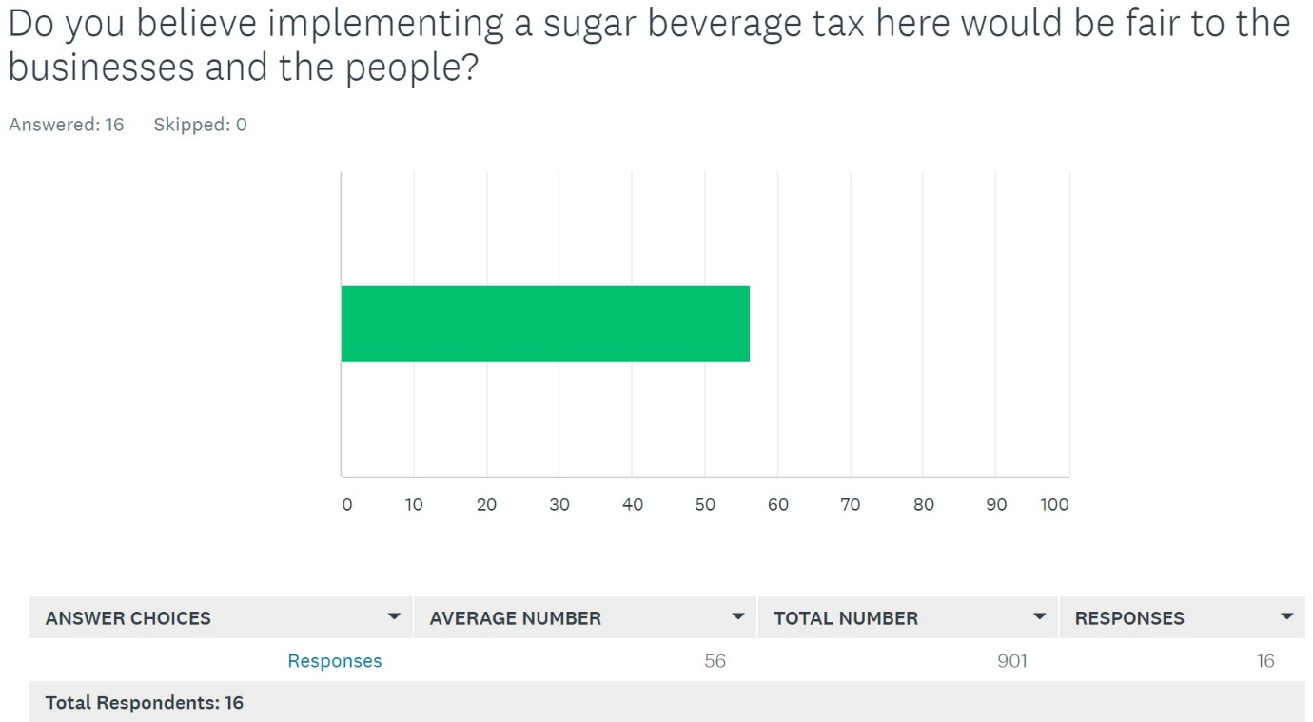
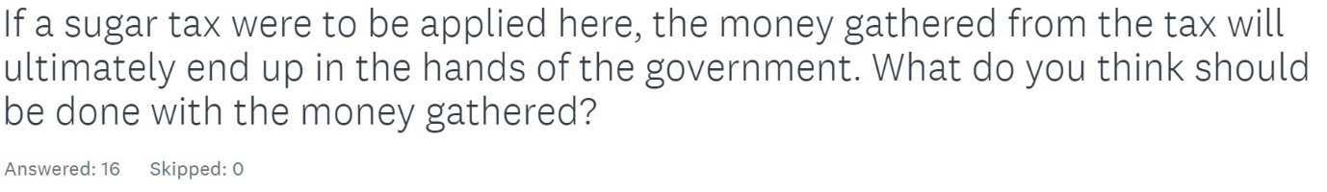
Answers
- Tax on sugary drinks will make children and the budget healthier, and When discussing the 2019 budget in the coming weeks, the Government of Malaysia and MPs will face a challenging equation in times of austerity: how to save taxpayer’s money while promoting the well-being of citizens? A tax on sugary drinks is a solution that provides both fiscal and health benefits.
- It should be used for something that’ll benefit/help the community.
- I think with the money gathered it can be used for better uses, such as things regarding the island.
- It should be used on the abandoned building here in Saipan. They should use it to re-build those abandoned buildings.
- It should be put to use immediately instead of it going to the government. It should be either be donated to places that need the money or to help rebuild and fix buildings.
- Give it to the hospital because they need money.
- Used to treat sugar related illnesses and also go to general medical budget.
- Focus more on rebuilding schools.
- General Health Other Industry/area that need finance (Recycling?)
- Probably towards health care.
- That it should be invested to education programs to help aid financially struggling students that are planning to further their education.
- The money should go to the school to fund certain programs and activities.
- If it does happen, the money should be used to give back all the teachers' cut.
- I think that the money should not go to the government because they don't know how to handle the money. Instead the money should go to sick patients like those who are diabetic because this could be a good pay back
- Help improve the economy
- Returned to the employees who got 10% salary cut, or used to make Saipan look pretty, TO SCHOOLS oof
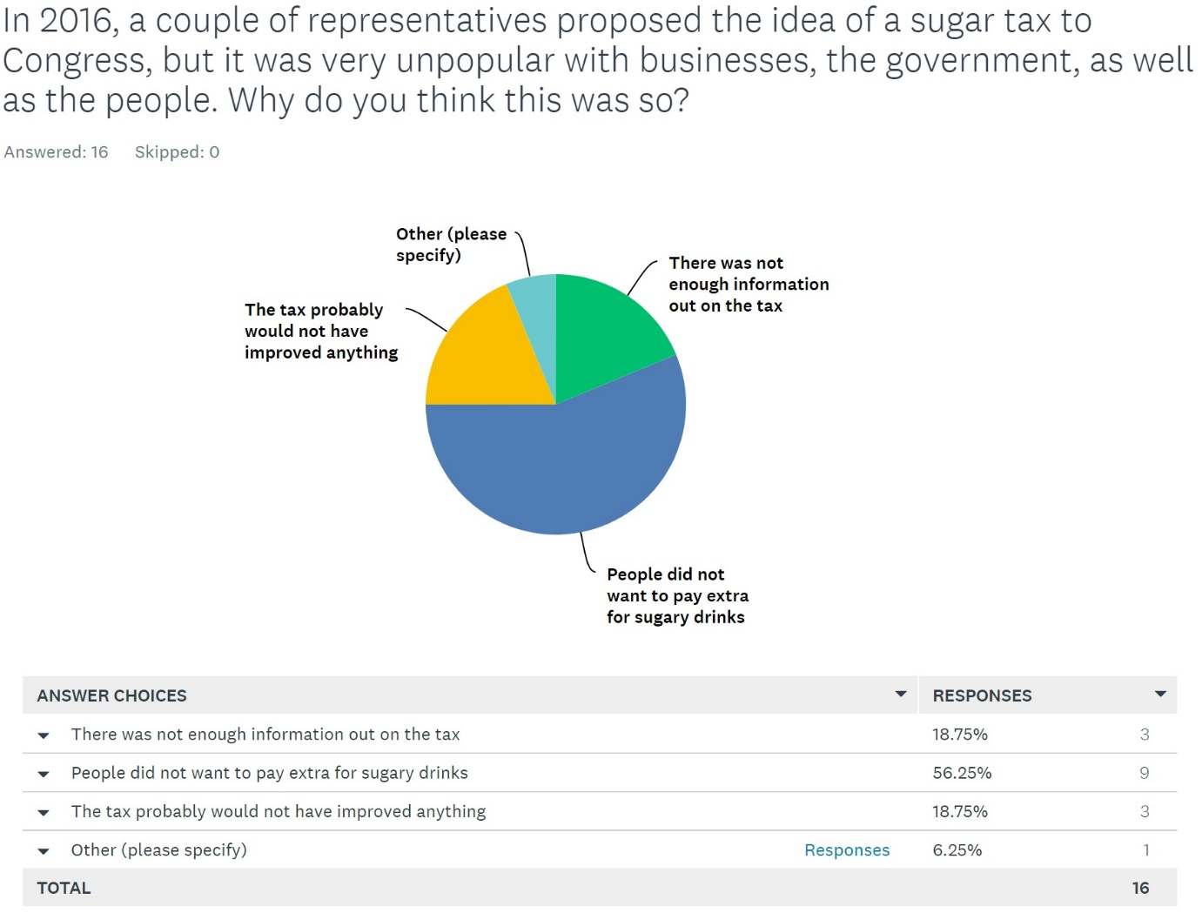
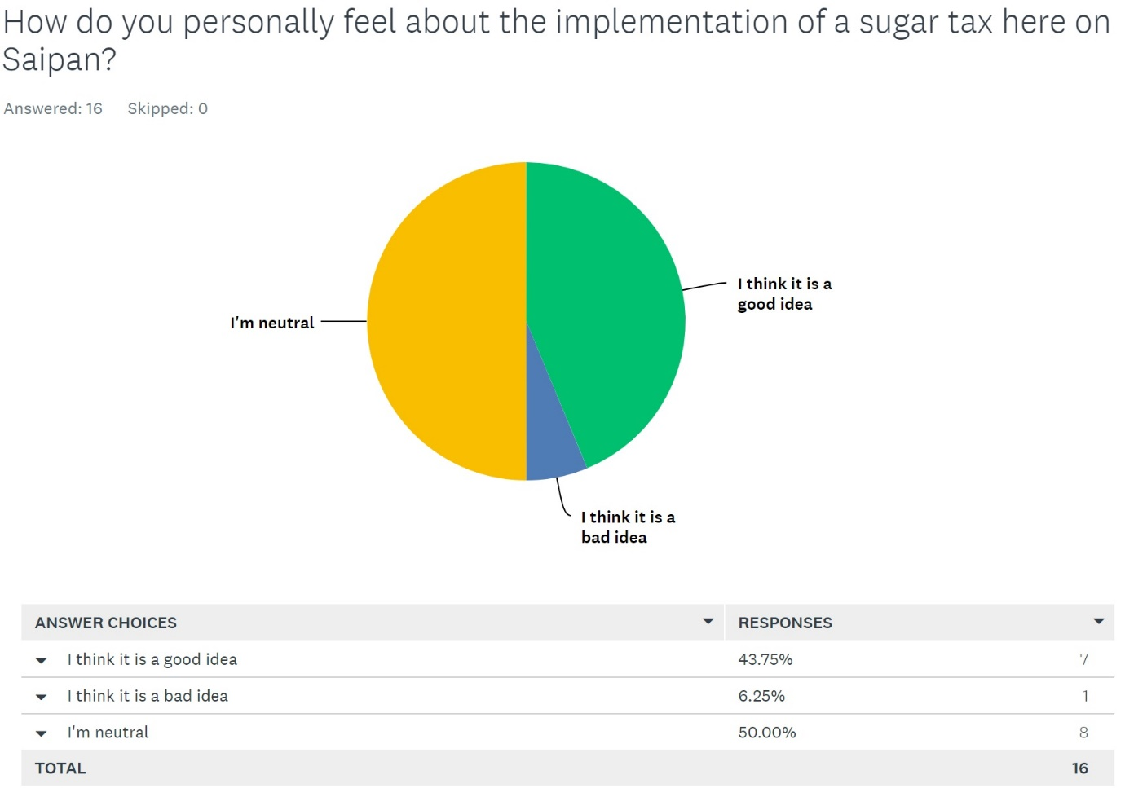
Appendix B
Sugar Beverage Tax Survey Results
Number of Survey Responses: 16
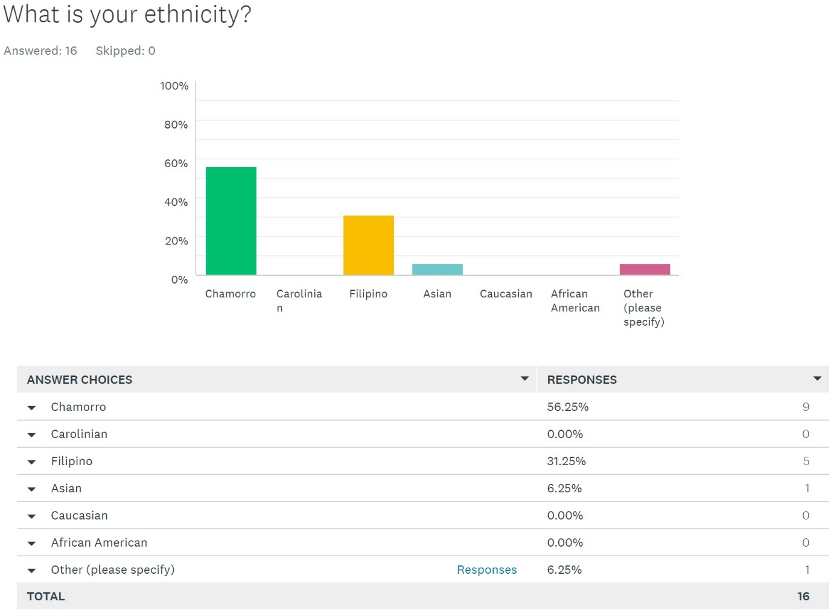
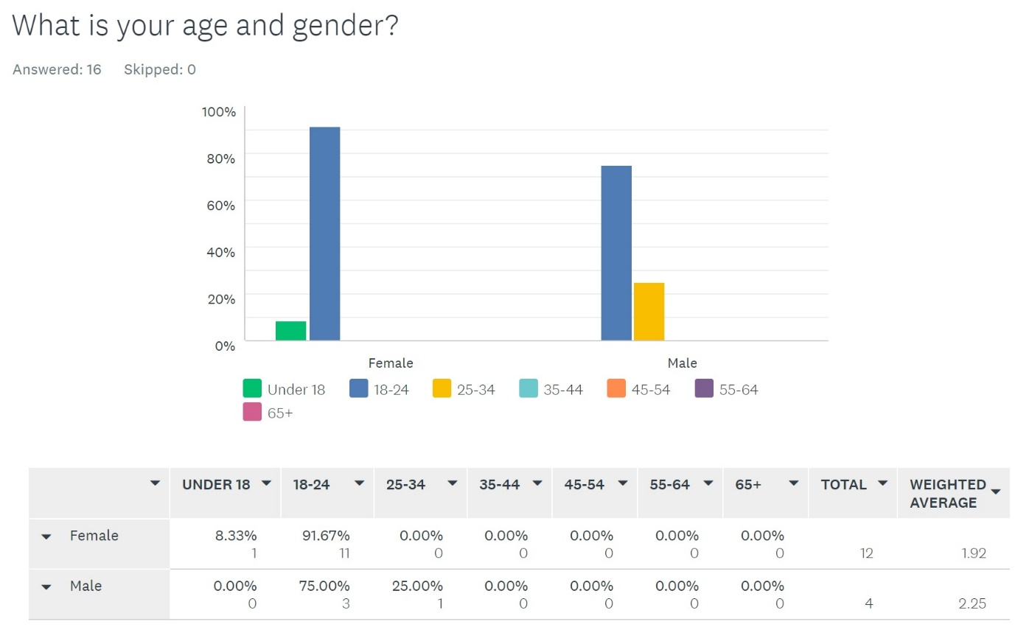

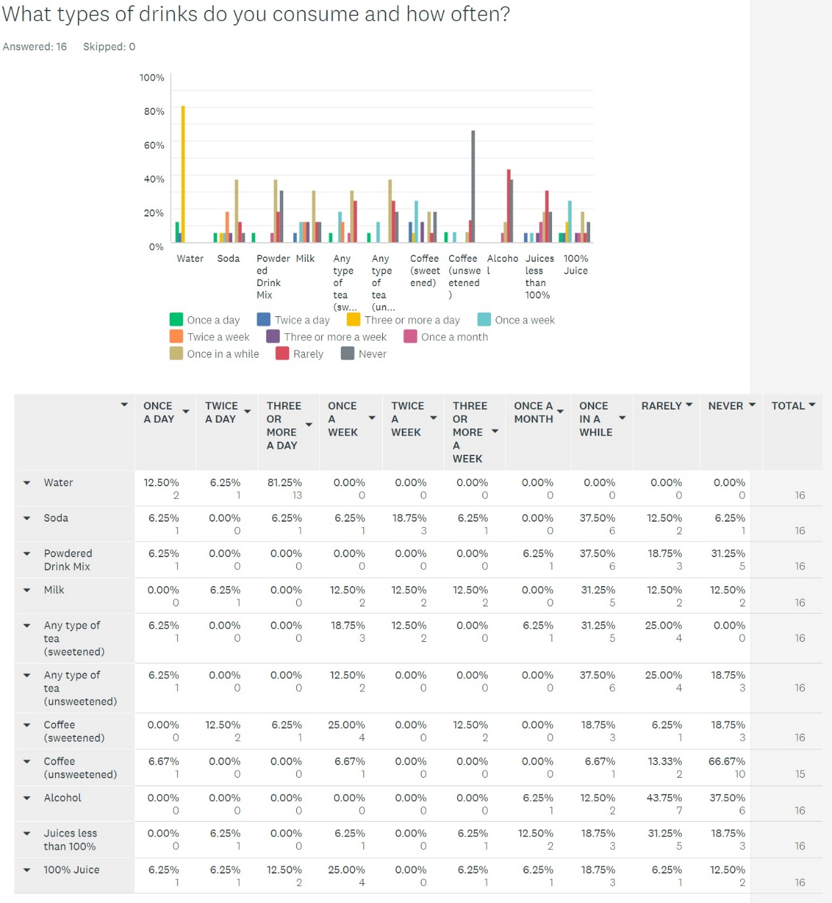
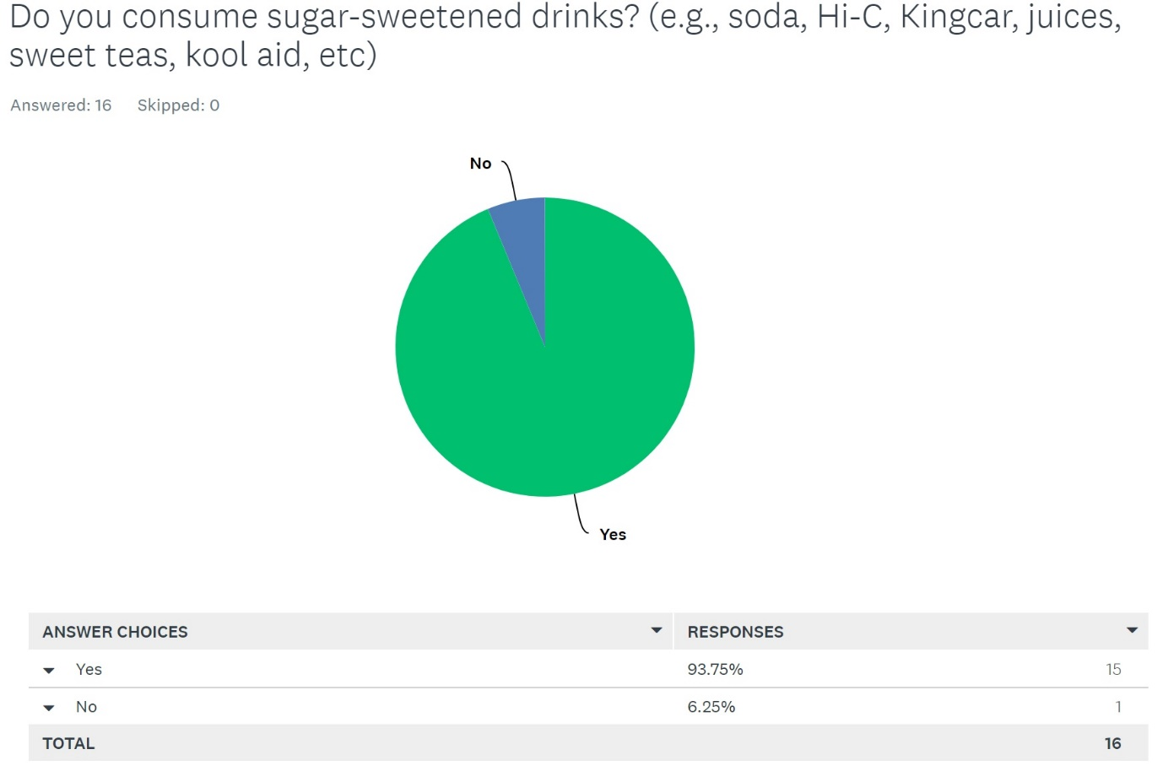

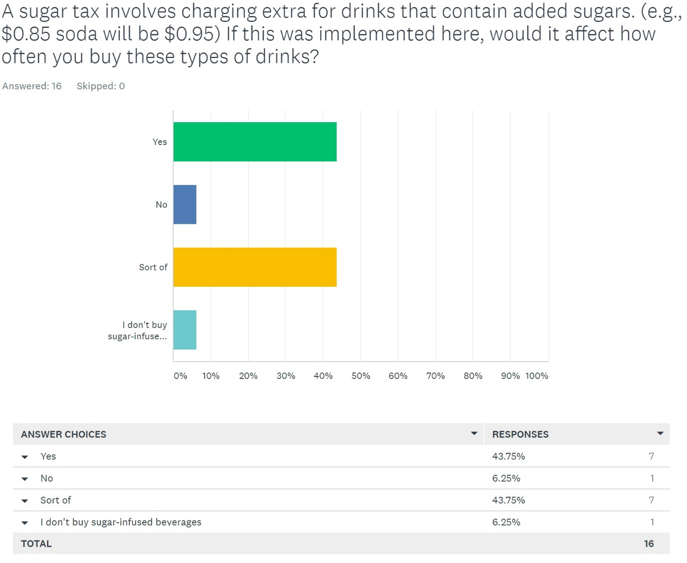
Explanations
- I wouldn't want to spend so much for an item that is unhealthy for me
- Usually people buy sweet drinks because it is cheaper. Raising the prices would force people to get alternative options.
- Usually people buy sweet drinks because it is cheaper. Raising the prices would force people to get alternative options.
- Usually when I crave for something, I get it no matter what
- I'd buy drinks less often and maybe make lemonade.
- My parents buy the groceries, so I think maybe. It depends on them.
- I need to save money.
- It would definitely affect how often I buy these types of drinks because although I don't drink these kinds of drinks every day, it would discourage my purchase the next time I decide to buy one.
- It would especially if it continues to be raising even further but this could stop me from buying more sweetened drinks.
- others would cut down on buying drinks
- I rarely buy these type of drinks so I think the sugar tax is okay.
- If there is an increase in cost then I would not like to purchase something that would just be taking a bigger bite out of my wallet
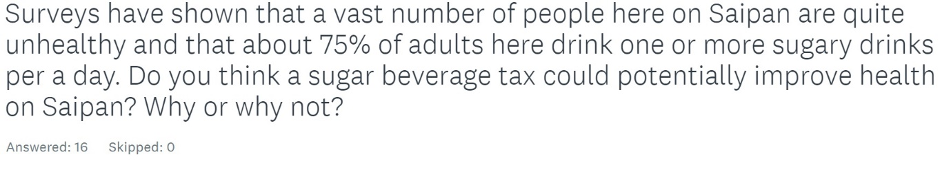
Answers
- Not really, because it already becomes their routine
- Yes. That is why some people turn away from healthier meal options - some healthier ingredients are more expensive than their unhealthier alternative. Making sugary beverages more expensive would definitely deter people from purchasing and consuming them.
- Yes, because people wouldn't want to spend that much money on such small items
- Potentially, it would discourage the people from buying them because of the increased price.
- Yes, might help people get a better diet.
- No, not really. Because, again, sugary options are already dirt cheap because of the ingredients and manufacturing. Adding 10% to the prices of drinks that are only cost a few cents at the store won't compare to that of a 5 dollar green machine juice.
- Not really. Many people here have food stamp and is basically free money that they can use to buy anything they want. Especially if that person receiving food stamp receives a lot of it.
- Yes, but I think that a lot of stores will shutdown because of it, which is a bad thing in my opinion.
- Maybe. People might buy less sugary drinks. Or they might still find other ways to get around it. Or they might just buy it regardless of price, especially if they are addicted. I think it can go either way
- Yes, people will need to save money
- No, just like cigarettes, even though it is horrible for your health people still choose to purchase it despite how expensive it becomes and disregard the consequences.
- Yes because usually get sugary drinks because its cheap
- Yes. I definitely think this could help make more people on Saipan a bit healthier. The more it is difficult to obtain sugary foods/beverages, I feel like they would have to lean more on healthier snacks.
- yes, because they will not buy as much as they usually do
- I don't think so because as long as its affordable then people will still purchase sugar beverages.
- It really depends on the type of person who is consuming the drink, to begin with. If they are okay with an increase in cost then there won't really be much change to the number of unhealthy individuals. Whereas people who are cheap would either cut down on drinks like that or find alternatives.
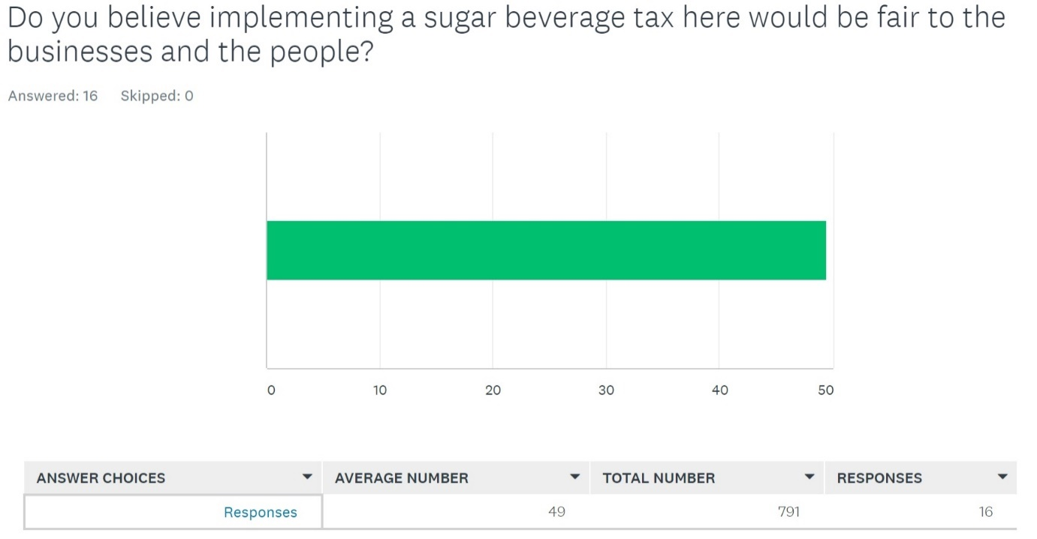
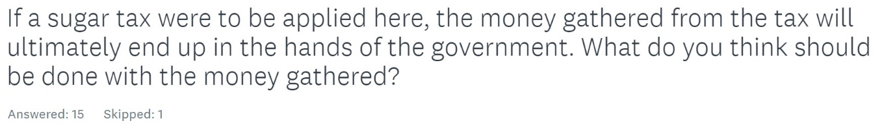
Answers
- Improving hospital: 4
  - 2 say specifically for diabetes patients
- Anything that is not corrupt
- I’m not sure
- Healthier options in stores: 1
- Healthy outreach programs: 1
- Help the economy/ develop the community: 4
- Yutu recovery and to help schools: 2
  - Schools only: 1
- Payback money owed to federal government: 1

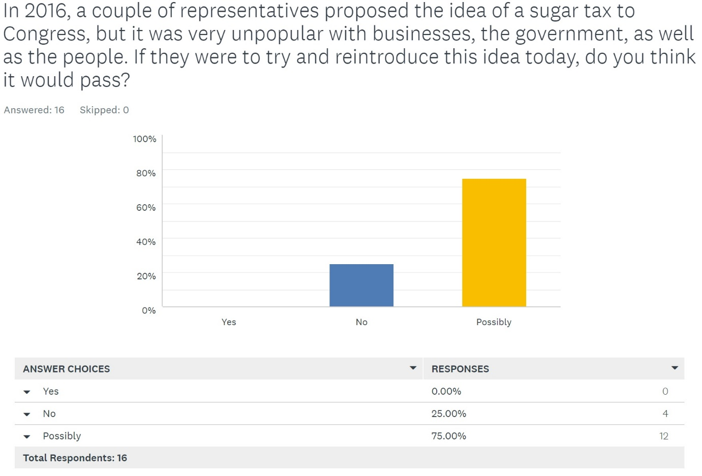
Explanations
  - People are struggling with money as is since the typhoon and austerity.
  - Because nowadays people lean towards the healthy side more
  - It might because of all the people who are sick now
  - There's a possibility. The only thing that's keeping me from saying yes is perhaps the fact that people want their cheap drinks to remain dirt cheap.
  - The people of Saipan just enjoy their sugary drinks too much.
  - Maybe. People won't like it. But they might support it for health. Buisness could go either way. Government would want the taxes and might support it.
  - Maybe if they want health to improve, they would pass it.
  - It is a difficult subject with both sides having its fair share of information.
  - I feel like senators would be bribed not too #corrupt
  - It is possible considering the amount of percent of people with certain issues of controlling themselves towards unhealthy food and beverages
  - because not everyone is for this issue
  - People and concepts change. As living healthy becomes more popular, I think the idea would be implemented.
  - Having a bill becomes law is complicated therefore it will just go through an endless cycle of debate on whats good and not good
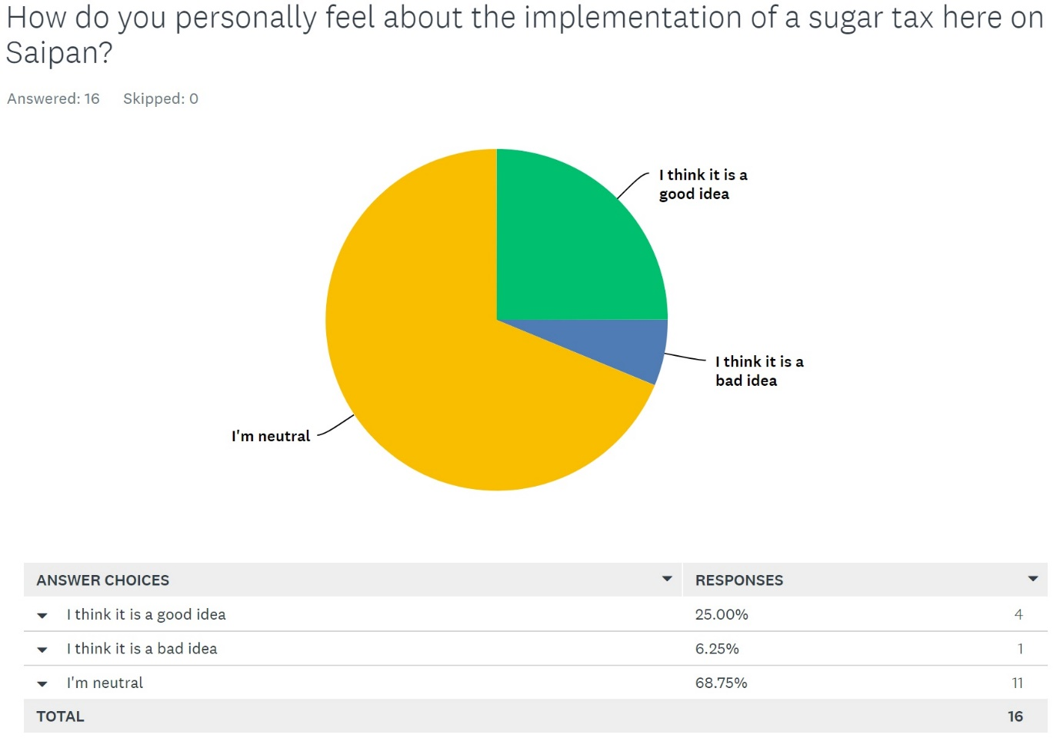

Appendix C
General Public Survey Questions
Number of Survey Responses: 55
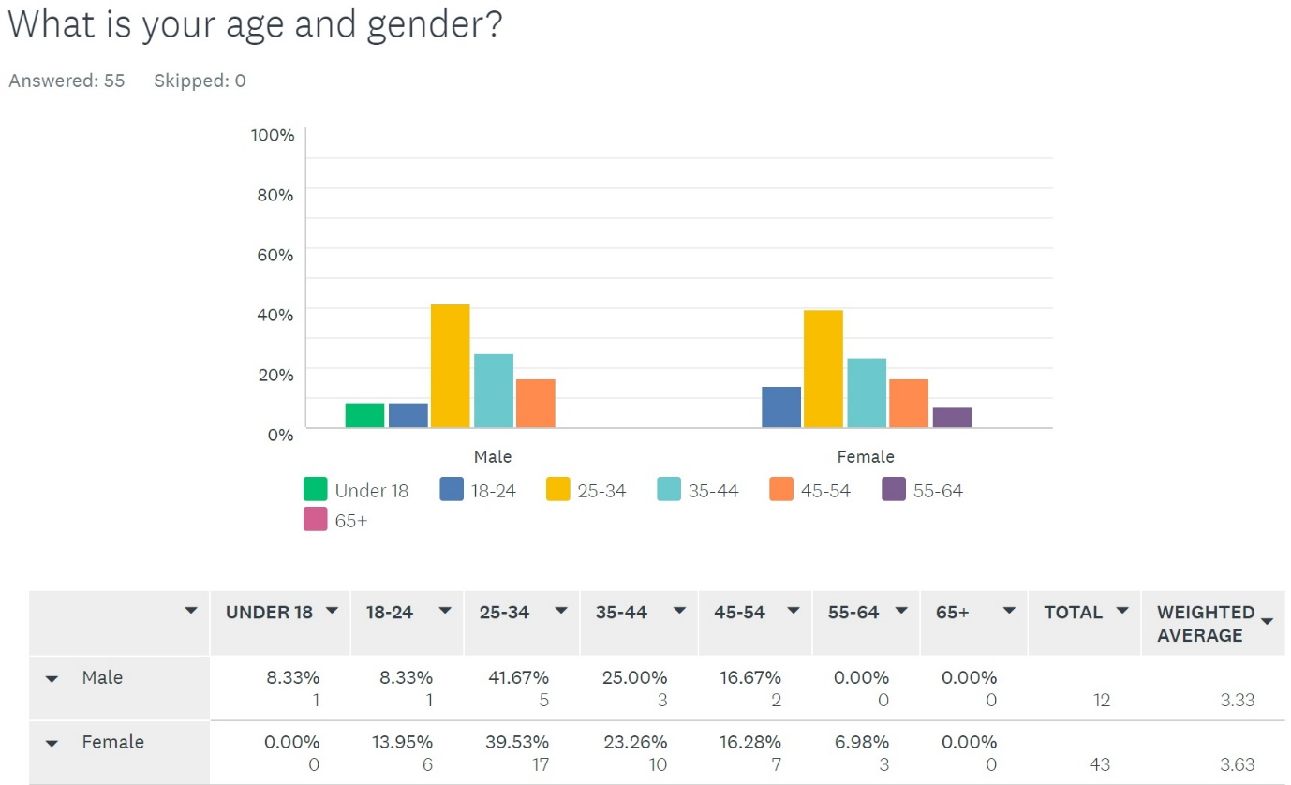
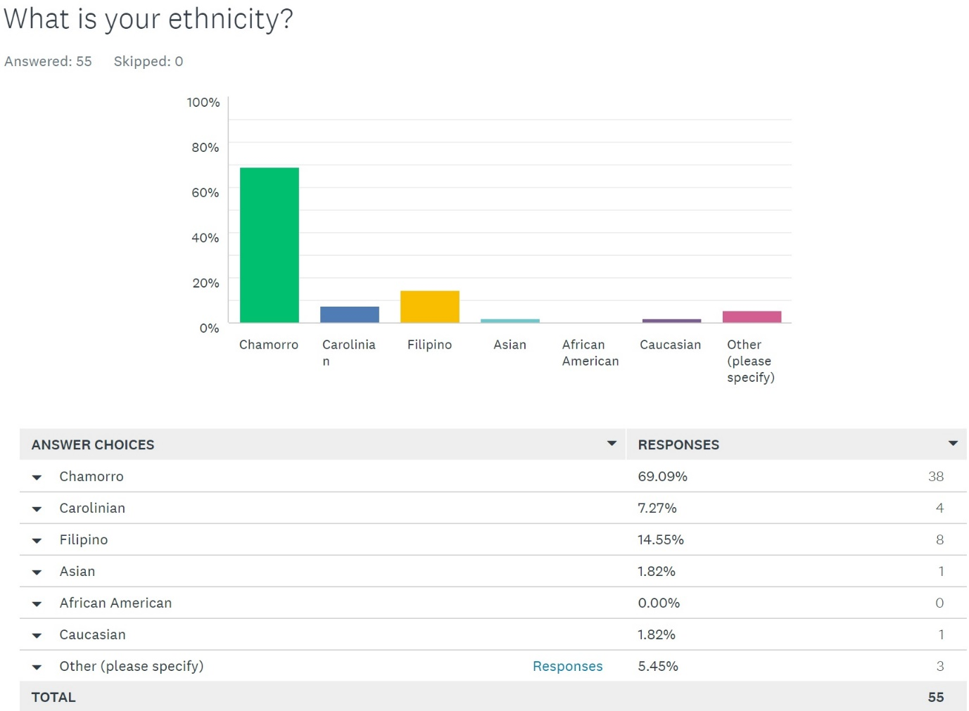

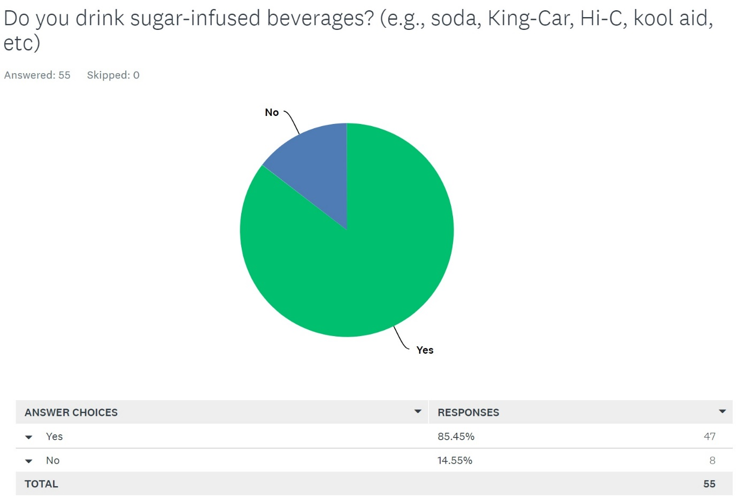
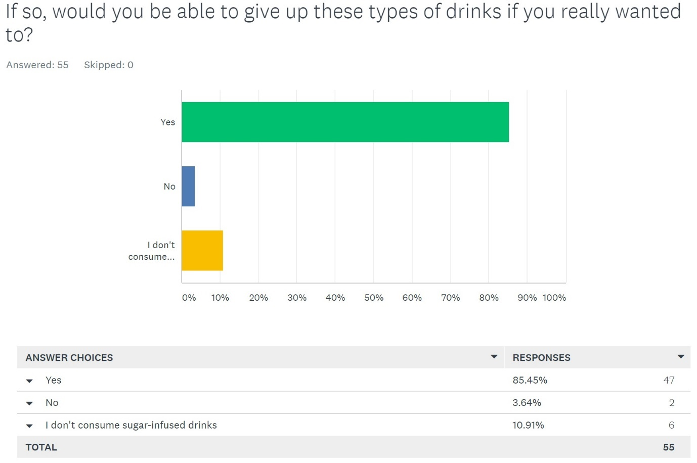

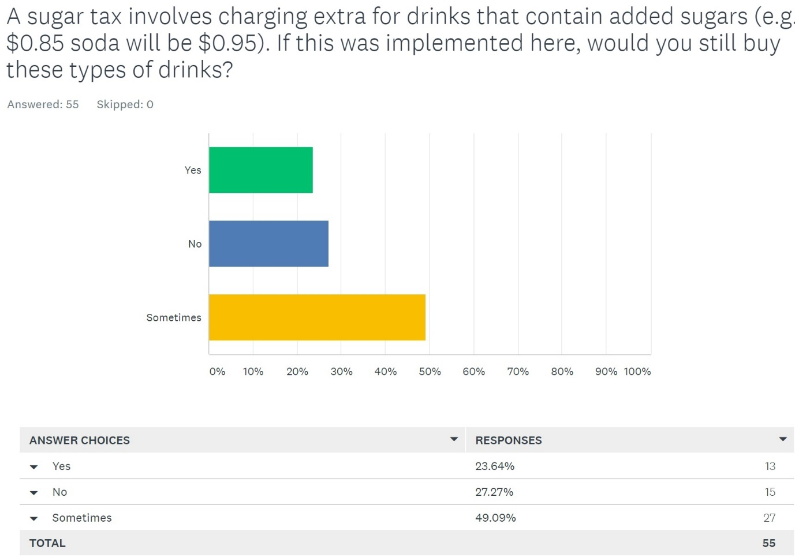
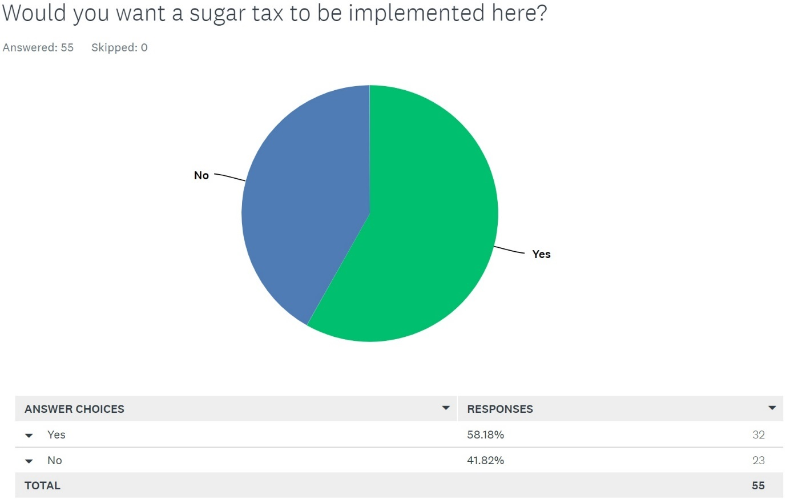

Appendix D
Interview with College Student from Oakland, California
- Hi. What is your name?
Amberlyn Palacios
- Just for the record, would you be okay with your name being used? If not, your name will be redacted.
Yes
- Can you tell me where you’re from?
Oakland, California
- You guys have a sugar tax there, is this true?
Yes, there is a sugar tax implemented on sugared drinks with preadded sugars, excluding certain products.
- Can you explain to me what the sugar tax does and how much it increases the price of drinks with added sugars?
Essentially the sugar tax purpose here is to deter the sale of sugary drinks and directly charges the distributors that bring in the sodas into Oakland. Those distributors are known to also charge secondhand distributors such as Safeway or liquor stores that distribute sodas and other sugary beverages in the area. There is a charge of $0.01 per ounce on sugar-sweetened beverages. It also has to be paid BEFORE the sale of the beverages.
- What was the purpose of your government implementing the tax?
The purpose was to stop the high distribution of sugary-drinks, I believe. I know that in the beginning of advocation for the tax, a strong argument was that the purpose was to help prevent childhood obesity which was on a steady incline.
- Personally, are you for or against the sugar tax? Please explain why or why not.
Personally, the sugar tax does not really directly affect me since it is more for the distributors, but it is really easy to find a loophole and charge more without citing it as the sugar tax to make up for their lost charges. If it were to directly affect me, I am not sure I would feel any different as the charge is a smaller amount. We already have a CRV tax placed on recyclable containers here regardless of sugary drinks. These are more in place to try and find a way to help the public or environment as opposed to a blatant money grab.
- Did the implementation of the sugar tax affect your buying habits? Your drinking habits?
It did not affect my drinking habits, honestly. I am not sure many people notice when they are being charged extra, (as seen with the plastic tax: many people do not even know they are being charged extra $0.10). If they charged a more hefty amount to me directly, I am sure my drinking habits would change.
- As a college student, do you feel like the sugar tax is unfair to college students? Please explain.
I feel as if the sugar tax is not implemented here to be unfair, but it is implemented to help public health and avoid drinking sugary drinks. It should be noted, however, that I do not know anyone who is affected by the tax so it is hard to know if it is helping anyone. It does seem that it is somewhat pointless to have a tax on something that people do not feel strongly about.
- Would you say the tax is popular or unpopular among other college students? Why or why not?
Again, I feel as if students are less aware of what they purchase and the price of the things that they purchase, especially something as trivial as a beverage (excluding financially ill citizens). I do remember, however, that when the prospect of a sugar tax on citizens was first brought up that many people were strongly opposed as it felt similar to the tea tax that caused the Boston Tea Party, but after it was passed, it died down rather quickly. That is why I am unsure that it had the desired effect on the people.
- Whatever the purpose of the tax was, do you personally feel as though the tax is fulfilling that purpose?
It is definitely not fulfilling its purpose as it does not deter young people to stop buying beverages containing sugary drinks or stopping distributors from bringing sugary drinks into the city. Those were the two main groups of people it was aimed at and it is not having its desired effect nor do I think it will.
- Due to your experience with one, would you recommend that a sugar tax be implemented in other places as well?
I do not think that a sugar tax is useful, to be honest. It does not decrease the sale or consumption of sugary beverages which was its main purpose. Until it fulfills that purpose in a significant way, I would not recommend it. However, I do think that a recyclable container tax is useful which is similar but covers a broader area.

Appendix E
Interview with Self-Proclaimed Soda Lover
- Hi, what is your name?
[Redacted]
- Just for the record, would you be okay with your name being used? If not, your name will be redacted.
No. I’m sorry. I would be okay with my name being out there usually, but the topic this interview is about is kind of embarrassing to be honest.
- Would you like to go on with the interview?
Yeah, it’s all good, I just don’t really want my name out there.
- What is your age and gender?
Female and I’m 23 years old.
- What is your ethnicity?
My mom is, like, half-Chamorro, half-Carolinian and my dad is half-Palauan, half-Chamorro. So I guess I’d say I’m half-Chamorro, ¼ Carolinian, and ¼ Palauan.
- If you do not mind me asking, what would you classify your weight as?
Well, obviously looking at me you wouldn’t say I’m skinny, would you? I’m overweight, I don’t wanna give you specifics, but yeah, I’m overweight.
- Do you consume sugary drinks?
Like soda? Yes.
- How often do you consume these types of drinks?
Pretty often. I drink at the very least two or more a day. Usually, I would drink, like, one soda and then I’d drink Kool-Aid to balance it out. I love things like KingCar and Hi-C, even though I know it’s bad. I hate to admit it, but I don’t really like water. I think that when you drink so much sweet then water will start to taste nasty.
- Would you consider yourself addicted to sugary drinks?
I don’t know if I’d say, “addicted,” but I will admit it’s a problem.
- If you really wanted to stop drinking sugary drinks, would you be able to?
No. Like I said, I hate the taste of water. And those drinks that are 100 percent natural juice? Nasty. I tried the Naked Green Machine, like, two weeks ago and I almost threw up.
- You keep mentioning that you hate water. Does this mean that you do not drink water at all?
I mean I’d drink water if it was the only thing around, but no, I don’t drink plain water if I can help it.
- A sugar tax involves charging extra for drinks that contain added sugars (e.g., $0.85 soda will be $0.95). If this was implemented here, would it affect how often you buy these types of drinks? Please explain your answer.
To be perfectly, honest, no it won’t. I mean, I feel like it would in the beginning. Like, I’d be kind of pissed that I would have to pay almost a dollar for soda or like $1.50 for King Car that I’d not buy them out of anger. But then I’d completely get over it and start buying those drinks again. I’m not strong enough to live on only water, man.
- Surveys have shown that a vast number of people here on Saipan are quite unhealthy and that about 75% of adults here drink one or more sugary drinks per a day. Do you think a sugar beverage tax could potentially improve health on Saipan? Why or why not?
No. I feel like us locals here are stubborn and we don’t like being told what to do. I feel like it’s going to be like the whole cigarette situation. No matter how high you raise the price, there are always going to be people who would buy it no matter what.
- Do you believe implementing a sugar beverage tax here would be fair to the businesses and the people?
I’m not sure. I’d like to say yes, only because I know for a fact that businesses here wouldn’t really be affected by it. Like I said earlier, I feel like people would still buy it no matter what.
- If a sugar tax were to be applied here, the money gathered from the tax will ultimately end up in the hands of the government. What do you think should be done with the money gathered?
Oh, yikes, the government gets the money? How are you sure that they’ll actually use the money for whatever they promise they’ll use it for anyway? Sorry. Anyways, I’d want the money to maybe go to PSS to rebuild Hopwood. I have a little sister that goes to school there and I feel bad for her.
- In 2016, a couple of representatives proposed the idea of a sugar tax to Congress, but it was very unpopular with businesses, the government, as well as the people. If they were to try and reintroduce this idea today, do you think it would pass? Please explain your answer.
Oh no, man. There’s no way that bill would pass. People here would riot and be so angry about it. With the whole austerity thing and the FBI raid that just happened recently, I don’t think the people would happy if the government tried to bring this into reality.
- How do you personally feel﻿ about the implementation of a sugar tax here on Saipan? Explain why you think so.
I don’t hate the idea because I know nothing will stop me from drinking soda, but I also don’t like it. I really wouldn’t want to have to pay extra for drinks, especially if I know it won’t stop me. I think if maybe the government were to take the money and spend it on fixing the island, like rebuilding Hopwood, then I’d be onboard. I’d most likely even give them most of their revenue.

Appendix F
Letters to Dieticians and Responses
Dear (Maribeth Manibusan/ Erin Camacho),
Hello. My name is Angelah Magofna and I am a student studying at the Northern Marianas College. I am doing a research project on the idea of implementing a sugar tax on beverages with added sugars here on Saipan. If it is alright, I would like to ask you a few questions about this topic as you are a medical professional with experience in the eating and drinking habits of people.
- In your personal opinion, how do you feel about the overall health of the people on Saipan?
- Do you believe that cutting back on the consumption of sugary drinks could significantly improve health on Saipan? Why or why not?
- Do you believe that the high consumption of sugary drinks can allude to an addiction? Why or why not?
I would like to thank you in advance for taking time out of your busy schedule for answering the questions I have.
Sincerely,
Angelah Magofna
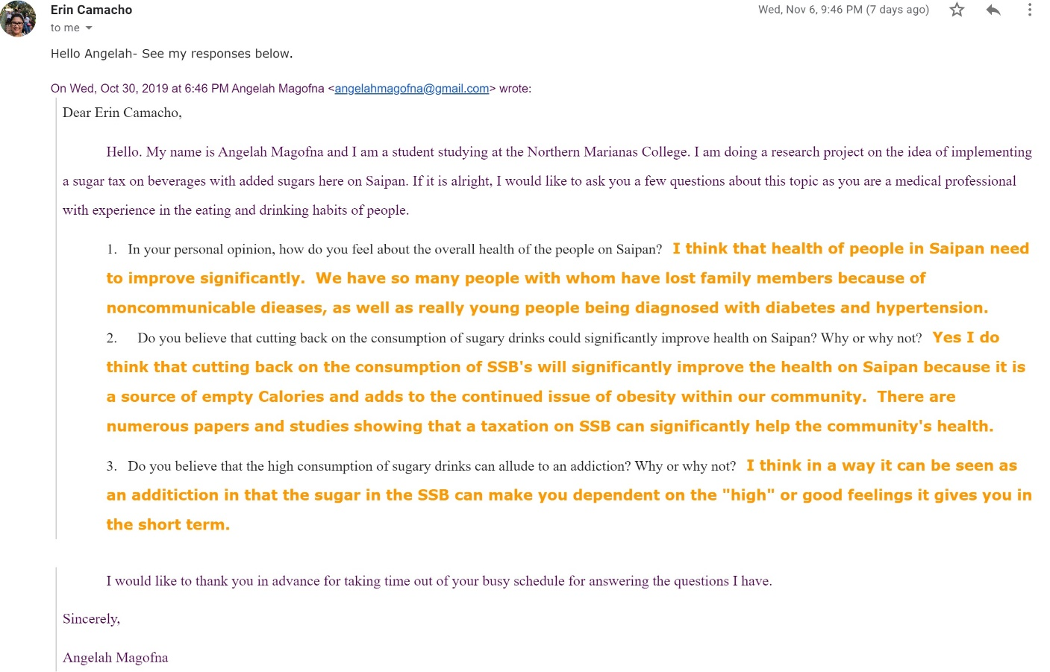
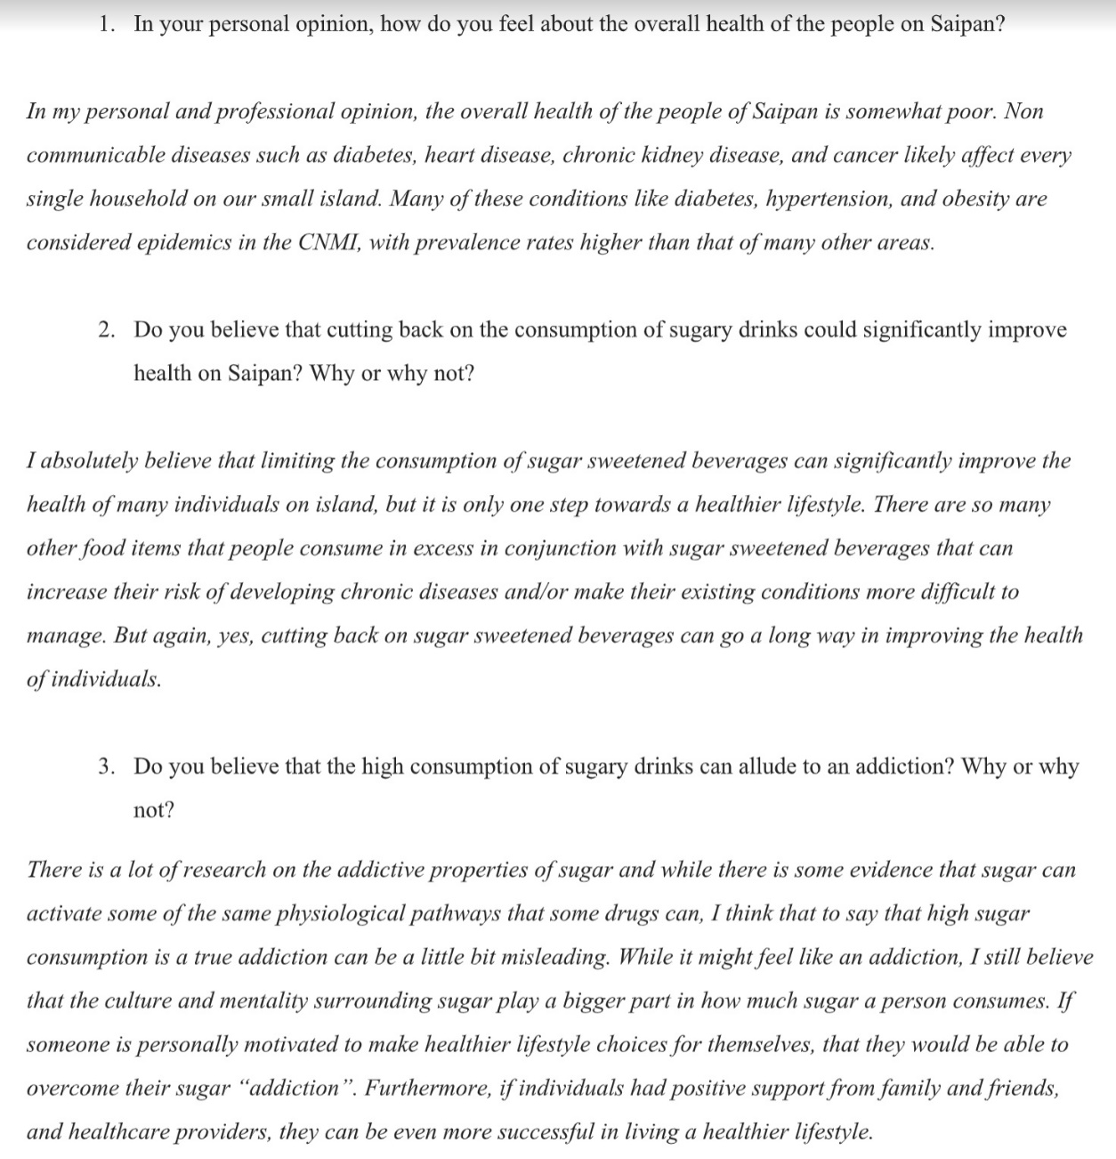

Appendix G
Letter to Representatives Angel Demapan and Felicidad Ogumoro
Dear (Insert Name),
Hello. My name is Angelah Magofna and I am a student studying at the Northern Marianas College. I am doing a research project on the idea of implementing a sugar tax on beverages with added sugars here on Saipan. If it is alright, I would like to ask you a few questions about this topic as I read in the newspaper that you had petitioned for this back in 2016, but it did not pull through.
- If the bill would have passed back in 2016, where would the money for the tax have gone?
- In your personal opinion, why do you believe the tax was unpopular and did not pass?
- What are some things you wish you did differently so that the tax would have been passed?
I would like to thank you in advance for taking time out of your busy schedule for answering the questions I have.
Sincerely,
Angelah Magofna

Appendix H
Letter to Hardt Eye Clinic and Diabetes Education Center and Response
Dear Dr. Hardt,
Hello. My name is Angelah Magofna and I am a student studying at the Northern Marianas College. I am doing a research project on the idea of implementing a sugar tax on beverages with added sugars here on Saipan. If it is alright, I would like to ask you a few questions about this topic as sugary drinks are one of the contributors to diabetes here in the CNMI.
- In your personal opinion, do you believe that implementing a sugar tax will in any way help reduce the increasing percentage of people with diabetes here?
- I have read several articles that claim that excess sugar intake can cause diabetes and other articles that claim that excess sugar consumption does not cause diabetes. Can you confirm for me which one is true?
- What is the number one method you recommend for preventing or lowering a person’s risk for diabetes?
I would like to thank you in advance for taking time out of your busy schedule for answering the questions I have.
Sincerely,
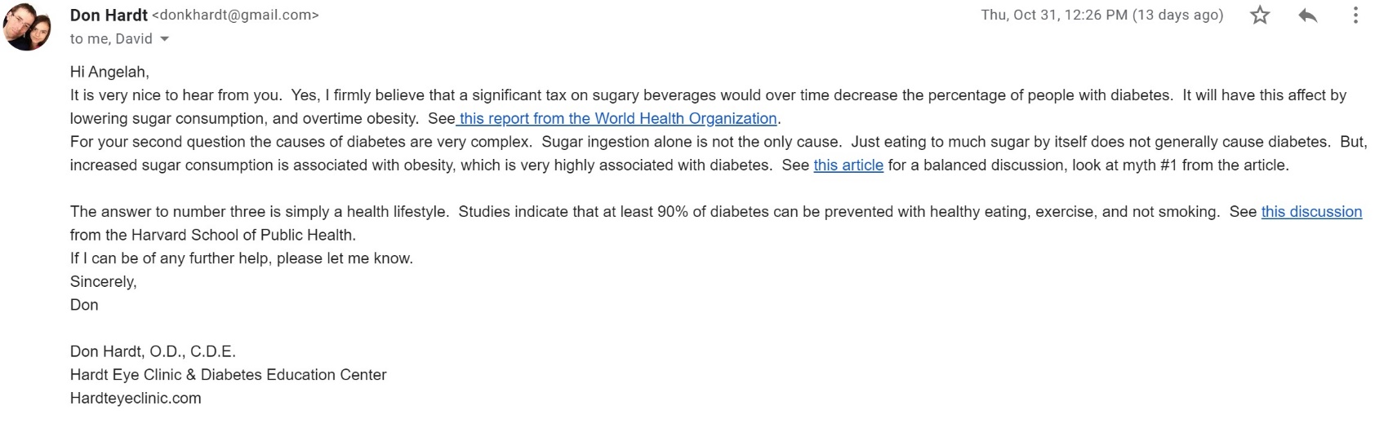
Angelah Magofna

Appendix I
Letter to Coauthor of Sugar Addiction: From Evolution to Revolution
Dear Dr. Nicole Avena,
Hello. My name is Angelah Magofna and I am a student studying at the Northern Marianas College in the Commonwealth of the Northern Mariana Islands. I am doing a research project on the idea of implementing a sugar tax on beverages with added sugars here on my island. While researching information for my project, I stumbled upon a paper that coauthored, “Sugar Addiction: From Evolution to Revolution,” and would like to ask you a few questions about it, if it is okay with you.
- Due to the addictive properties sugar can have, as you have highlighted in your paper, do you personally believe that a sugar beverage tax could potentially encourage people to consume less sugary drinks?
- How difficult would it be to break a person’s addiction to sugar?
- Can people with an addiction to sugar experience withdrawal symptoms in a similar way to those who are addicted to drugs, nicotine, et cetera?
I would like to thank you in advance for taking time out of your busy schedule for answering the questions I have.
Sincerely,
Angelah Magofna

Appendix J
Letter to Coauthor of Literature Source
Dear Melanie Bertram,
Hello. My name is Angelah Magofna and I am a student studying at the Northern Marianas College in the Commonwealth of the Northern Mariana Islands. I am doing a research project on the idea of implementing a sugar tax on beverages with added sugars here on my island. While researching information for my project, I stumbled upon a paper that coauthored, “Evidence that A Tax on Sugar Sweetened Beverages Reduced the Obesity Rate: A Meta-analysis,” and would like to ask you a few questions about it, if it is okay with you.
- In the conclusion of your paper, you said that the increase of price in sugar sweetened beverages may result in “modest” weight loss within the population. Due to this statement, do you personally believe that a sugar beverage tax is a viable way of preventing obesity?
- The people here on my island are strongly against the idea of a sugar tax. Do you believe that the findings in your paper would be enough to convince people that a sugar tax is a good idea?
- Of all the articles you analyzed in your paper, which one did you find had the strongest evidence that a sugar tax can reduce the obesity rate?
I would like to thank you in advance for taking time out of your busy schedule for answering the questions I have.
Sincerely,
Angelah Magofna
Appendix K
Letter to Medical Professionals in Places with Sugar Beverage Taxes
Dear (insert name),
Hello. My name is Angelah Magofna and I am a student studying at the Northern Marianas College in the Commonwealth of the Northern Marianas Islands. I am doing a research project on the idea of implementing a sugar tax on beverages with added sugars on my island. If it is alright, I would like to ask you a few questions about this topic as you are from an area where a sugar tax has been implemented.
- After the sugar beverage tax was implemented, did you see any changes in the overall health of the people in your area?
- Do you personally believe that the tax truly works or do you believe that it does not work at all?
- Due to your experience, would you recommend that the tax be implemented in other places?
I would like to thank you in advance for taking time out of your busy schedule for answering the questions I have.
Sincerely,
Angelah Magofna

Dela Cruz, R. & Cash, H. (2016). Commonwealth of the Northern Marianas Islands Non-communicable Diseases & Risk Factor Hybrid Survey Report. Retrieved from http://i2io42u7ucg3bwn5b3l0fquc.wpengine.netdna-cdn.com/wp-content/uploads/2017/04/CNMI-NCD-Survey-Report-FINAL-2017.pdf
Escobar, M. A. C., Veerman, J. L., Bertram, M. Y., Tollman, S. M., & Hofman, K. J. (2013). Evidence that a tax on sugar sweetened beverages reduces the obesity rate: a meta-analysis. BMC Public Health, 13(1), 1–20. https://doi.org/10.1186/1471-2458-13-1072
Powell, L. M., Wada, R., Persky, J. J., & Chaloupka, F. J. (2014). Employment Impact of Sugar-Sweetened Beverage Taxes. American Journal of Public Health, 104(4), 672–677. https://doi.org/10.2105/AJPH.2013.301630
Purtle, J., Langellier, B., & Lê-Scherban, F. (2018). A case study of the Philadelphia sugar-sweetened beverage tax policymaking process: implications for policy development and advocacy. Journal of Public Health Management and Practice, 24(1), 4-8.
Link: https://www.ncbi.nlm.nih.gov/pubmed/28257409
The Nutrition Source. (2019, May 22). Sugary Drinks. Retrieved from https://www.hsph.harvard.edu/nutritionsource/healthy-drinks/sugary-drinks/
Thomas-Meyer, M., Mytton, O., & Adams, J. (2017). Public responses to proposals for a tax on sugar-sweetened beverages: A thematic analysis of online reader comments posted on major UK news websites. PLoS ONE, 12(11), 1–18. https://doi.org/10.1371/journal.pone.0186750
UC Berkeley. (2019, February 21). Three years into soda tax, sugary drink consumption down more than 50 percent in Berkeley: Taxes may be a promising new tool in the fight again obesity, cardiovascular disease and diabetes. ScienceDaily. Retrieved October 26, 2019 from www.sciencedaily.com/releases/2019/02/190221172056.htm
Willet, W. [Harvard T.H. Chan School of Public Health]. (2009, May 19). Time to Focus on Healthier Beverages. Retrieved October 26, 2019, from https://www.youtube.com/watch?v=9S9wfbFIea4&feature=youtu.be
Villanueva-Dizon, F. (2016, April 21). Businesses, Chamber against sugar tax - Saipan News, Headlines, Events, Ads: Saipan Tribune. Retrieved from https://www.saipantribune.com/index.php/businesses-chamber-sugar-tax/
From Proposal Essay
Dela Cruz, R. & Cash, H. (2016). Commonwealth of the Northern Marianas Islands Non-communicable Diseases & Risk Factor Hybrid Survey Report. Retrieved from http://i2io42u7ucg3bwn5b3l0fquc.wpengine.netdna-cdn.com/wp-content/uploads/2017/04/CNMI-NCD-Survey-Report-FINAL-2017.pdf
Senthilingam, M. (2015, May 1). How paradise islands became the world's fattest place. Retrieved from https://edition.cnn.com/2015/05/01/health/pacific-islands-obesity/index.html
The Nutrition Source. (2019, May 22). Sugary Drinks. Retrieved from https://www.hsph.harvard.edu/nutritionsource/healthy-drinks/sugary-drinks/
University of California - Berkeley. (2019, February 21). Three years into soda tax, sugary drink consumption down more than 50 percent in Berkeley: Taxes may be a promising new tool in the fight again obesity, cardiovascular disease and diabetes. ScienceDaily. Retrieved September 19, 2019 from www.sciencedaily.com/releases/2019/02/190221172056.htm
University of Otago. (2019, June 25). Sugary drink taxes reduce consumption, major review shows. ScienceDaily. Retrieved September 20, 2019 from www.sciencedaily.com/releases/2019/06/190625093302.htm
Villanueva-Dizon, F. (2016, April 21). Businesses, Chamber against sugar tax - Saipan News, Headlines, Events, Ads: Saipan Tribune. Retrieved from https://www.saipantribune.com/index.php/businesses-chamber-sugar-tax/
Wiss, D. A., Avena, N., & Rada, P. (2018). Sugar Addiction: From Evolution to Revolution. Frontiers in psychiatry, 9, 545. doi:10.3389/fpsyt.2018.00545
Link: https://www.ncbi.nlm.nih.gov/pmc/articles/PMC6234835/

Note Taking Sheet: Reading # 1
1. Author’� s Name: Frauleine S. Villaneuva-Dizon
2. Author’� s Credentials: Degree in Journalism from University of Santo Tomas
3. Publisher [or title of organization]: Saipan Tribune
4. Heading of Section [title of reading]: Businesses, Chamber against sugar tax
5. Year of Publication: 2016
6. Pages: N/A
7. Website URL: https://www.saipantribune.com/index.php/businesses-chamber-sugar-tax/

Main Ideas/Points | Important Quotations | Supporting Details | Relevance to Your Assignment
- Are businesses and the people of Saipan in agreeance with a sugar tax?  - How does the government feel about the idea of a tax on sugar?  - What does the government feel is the best way to improve health on the island, if not in agreeance with a sugar tax? | - “Residents and businesses on island along with the Saipan Chamber of Commerce are against a pending legislation adding taxes on sugar-sweetened beverages and sugar-sweetened concentrates.”  - “Since the beginning, the Chamber has opposed the bill introduced by Reps. Felicidad Ogumoro (R-Saipan) and Angel Demapan (R-Saipan).”  - “We believe that the way to change consumer behavior is to educate, not to penalize. Our island has a significant low-income population and this effect of this bill will take more of their meager income for the cost of everyday needs. These beverages are not the only foods that are unhealthy for consumption. Will other food products also become subject to tax?” SCC said. | - Businesses claim that the bill will negatively impact their business. Glen Hunter, a citizen who served as a manager for the distributors of Pepsi and Coca-Cola on the island, also claim that the increased price on soda will be astronomical.  - The government was not in favor for this tax as they believe that it is not the best way to improve health on the island.  - They feel that the best way to improve health on the island is not through forcing people to change their habits, but to educate them on their bad habits and on ways to change their lifestyle for the better. | - This is relevant to my assignment as it will show how the businesses as it shows evidence on how the businesses and the citizens of Saipan would feel about the implementation of a sugar tax.  - This will help with my paper as it shows me what policymakers feel about the idea of a sugar tax.  - This will help with my paper as I plan to see both sides of the argument: if a sugar tax is helpful or if it is not.

In this article, is it possible that any of the authors might have a bias about the subject matter? Provide examples if needed. -No

Is the article timely or a bit outdated? -Timely

Was it published in a reputable source? -Yes

It is an academic source? -No

Other important information: Article was written in 2016, so it may be a little outdated as three years have already passed.

Note Taking Sheet: Reading # 2
1. Author’� s Name: Junhan B. Tobino
2. Author’� s Credentials: N/A
3. Publisher [or title of organization]: The Guam Daily Post
4. Heading of Section [title of reading]: Diabetes rates in the CNMI very alarming, Hardt says
5. Year of Publication: 2017
6. Pages: N/A
7. Website URL: https://www.postguam.com/news/cnmi/diabetes-rates-in-the-cnmi-very-alarming-hardt-says/article_162f5762-50d1-11e7-9574-0f5266ae0e9e.html#comments

Main Ideas/Points | Important Quotations | Supporting Details | Relevance to Your Assignment
- What is the rate of diabetes in the CNMI?  - What populations in the CNMI have the highest rates of diabetes?  - What is the main source of calories in people’s diets? | - “In the U.S. 12.5 percent of the adult population, or one in every eight people, have diabetes, while in the CNMI the rate is 18.7 percent.”  - “The survey shows that 25.3 percent of the CHamoru population and 21.9 percent of Carolinians have diabetes, he said.”  - “The main source of sugar and calories in the American diet is sugar-sweetened beverages, he said.” | - Hardt claims that one of the factors of getting diabetes is the overconsumption of sugary drinks.  - Hardt also asserts that pacific islanders have higher rates of being overweight and obese than any of the 50 states, aside from Native Indians living in Ohio. This could possibly be due to the fact that most locals in the CNMI consume processed foods, sugary drinks, and lead a sedentary lifestyle.  - Hardt additionally asserts that a huge difference would be made if everyone switched to water. | - This is relevant to my assignment as it will help me establish the argument that implementing a tax on sugary beverages could improve health in the CNMI.  - This is relevant to my research as it, like stated in the earlier bullet, helps to establish my argument for a sugar beverage tax.  - Like stated in earlier bullets, this will help establish my argument in favor of a sugar tax.

In this article, is it possible that any of the authors might have a bias about the subject matter? Provide examples if needed. -No

Is the article timely or a bit outdated? -Timely

Was it published in a reputable source? -Yes

It is an academic source? -No

Other important information: The article was made by a news outlet in Guam, but the accuracy of the information should remain the same as if it were made by a news outlet in the CNMI.

Note Taking Sheet: Reading # 3
1. Author’� s Name: D. Papandreou, E. Andreou, A. Heraclides, and I. Rousso
2. Author’� s Credentials:

Dr Dimitrios Papandreou, Ass. Professor of Nutrition, University of Nicosia, 46 Makedonittisas Ave., 1700, Nicosia, Cyprus. Senior Researcher of Nutrition, 2nd Dep. of Pediatrics, Aristotle University of Thessaloniki, St.kiriakidi
3. Publisher [or title of organization]: Hippokratia
4. Heading of Section [title of reading]: Is beverage intake related to overweight and obesity in school children?
5. Year of Publication: 2013
6. Pages: N/A
7. Website URL: https://www.ncbi.nlm.nih.gov/pmc/articles/PMC3738277/

Main Ideas/Points | Important Quotations | Supporting Details | Relevance to Your Assignment
- What are the correlations between beverage intake and obesity in children?  - Along with obesity, studies also show that sugar sweetened beverages have positive correlations with diabetes.  - However, despite what was said earlier, some studies have also shown that sweetened drinks do not have positive correlations with being overweight.  - What are the main findings of the paper?  - Does 100% fruit juice contribute to obesity in school children? | - “In the study by Dennison et al⁷, 100% of fruit juice and sweetened fruit drinks have been found to be positively correlated with obesity in children, who consumed ≥360 ml/d compared to those who consumed ≤360 ml/d (32% vs. 9%).”  - “More recently, in a meta-analysis review of 310,819 participants the authors concluded that in addition to weight gain, higher consumption of SSBs was associated with development of metabolic syndrome and type 2 diabetes⁸.”  - “On the other hand, Welsh et al⁹ examined the association of sweetened drink consumption, defined as 100% fruit juice, fruit drinks and sodas and found no statistically significant association between development of overweight and sweet-drink consumption.”  - “Children consuming sugar beverage drinks were 2.57 times more likely to become obese compared to normal peers.”  - “SSBs but not 100% fruit juices and milk are associated with obesity.” | - According to the paper, studies have shown that 100% fruit juice has no more nutritional value over whole fruits and asserts that children’s intake of 100% fruit juice should be limited as it is high in calories.  - Due to the high sugar content of sugar sweetened drinks, it is possible that they may contribute significantly to type 2 diabetes.  - Though sugar sweetened beverages may contribute to weight gain, it is not the largest contributor of weight gain.  - Because sugar contributes a modest amount to weight gain, it is not shocking to find that children who consume sugar beverage drinks were more likely to become obese than their other peers.  - In contradiction to other studies highlighted in the paper, the authors found that sugar sweetened beverages, but not pure fruit juice and milk contribute to obesity. This is because pure fruit juice and milk have more nutritional value than sugar sweetened drinks. | - This is relevant to my assignment as it helps prove a point that, yes, sugary drinks have a correlation with diabetes.  - One of my arguments for the reasons why a sugar tax should be implemented here is because it may help with our high obesity rate and this will help me establish this argument.  - Though my paper is mostly about the benefits of implementing a sugar tax in the CNMI, I am also looking into arguments against implementing a sugar tax and this statement will help me significantly.  - While the paper highlighted many counterarguments, it also highlighted many arguments, like this one, that I can use to establish the usefulness of a sugar beverage tax.  - This is relevant to my assignment as it shows that only sugar sweetened beverages contribute to obesity and that water, pure fruit juices, and milk, which are drinks with high nutritional value, do not contribute to obesity.

In this article, is it possible that any of the authors might have a bias about the subject matter? Provide examples if needed. -No, the paper event stated that none were declared.

Is the article timely or a bit outdated? -A bit outdated

Was it published in a reputable source? -Yes

It is an academic source? -Yes

Other important information: The article is about six years old but is still relevant and quite recent.

Note Taking Sheet: Reading # 4
1. Author’� s Name: Orly Tamir, Tamar Cohen-Yogev, Sharon Furman-Assaf, and Ronit Endevelt
2. Author’� s Credentials:

The Gertner Institute for Epidemiology and Health Policy Research, Sheba Medical Center, Ramat Gan, Israel. School of Public Health, Haifa University, Haifa, Israel

3. Publisher [or title of organization]: Isr J Health Policy Research
4. Heading of Section [title of reading]: Taxation of sugar sweetened beverages and unhealthy foods: a qualitative study on key opinion leaders’ views
5. Year of Publication: 2018
6. Pages: N/A
7. Website URL: https://www.ncbi.nlm.nih.gov/pmc/articles/PMC6069556/

Main Ideas/Points | Important Quotations | Supporting Details | Relevance to Your Assignment
- How do policy makers feel about taxes that essentially “regulate” how people live their lives?  - Do policy makers believe that a sugar beverage tax is the best way to improve health?  - What do policy makers believe should be done with the money gained from the tax? | - “Our in-depth interviews have revealed that leaders from all sectors acknowledge the societal responsibility for reducing the rates of obesity.”  - “A fiscal policy to tax SSBs and unhealthy snacks may help achieve that but it must be supplemented by other policy measures and norms.”  - “When asked which purposes the tax revenue should fund, three main purposes came up: health education, health promotion and healthy food subsidies.” | - The paper asserts that policy makers believe that there should be policies in place to help people make better food choices.  - Though taxing sugary drinks can help, sugary drinks are not the biggest contributor to obesity or diabetes, so it is best if policy makers tax other unhealthy food options on top of sugary drinks.  - Policy makers believe that if they take money from this tax, the purpose should be for fighting obesity. | - This is relevant to my assignment as it can help establish that sugar taxes can be useful and that other country’s leaders are willing to try it out.  - This is relevant to my assignment as it kind of counterargues one of my main points and strengthens one of the main points of the opposing argument.  - One of the biggest concerns of the sugar tax, I found, was where would the money go? This will help me establish arguments for where the money gained from the tax should go and why it will be beneficial for our island and not just a cash grab for the government.

In this article, is it possible that any of the authors might have a bias about the subject matter? Provide examples if needed. -No. “The authors declare that they have no competing interests in this research. To note, at the time the study was performed, Prof. Ronit Endevelt was not holding her current position as Manager of Nutrition Department at the Israeli Ministry of Health.”

Is the article timely or a bit outdated? -Timely

Was it published in a reputable source? -Yes

It is an academic source? -Yes

Other important information: The research was conducted within the middle east, however, the results of the research would probably mirror concerns with policy makers here on the island.

Note Taking Sheet: Reading # 5
1. Author’� s Name: Nicole Avena, Pedro Rada, and Bartley G. Hoebel
2. Author’� s Credentials: Department of Psychology, Princeton University, Princeton, NJ 08540 USA
3. Publisher [or title of organization]: Frontiers in Psychiatry
4. Heading of Section [title of reading]: Evidence for sugar addiction: Behavioral and neurochemical effects of intermittent, excessive sugar intake
5. Year Written: 2007
6. Pages: N/A
7. Website URL: https://www.ncbi.nlm.nih.gov/pmc/articles/PMC2235907/

Main Ideas/Points | Important Quotations | Supporting Details | Relevance to Your Assignment
- Are there links between obesity and consumption of sugar?  - Can sugar become an addiction?  - Sugar addiction is almost on-par with addiction to alcohol and drugs. | - “Sugar intake may lead to an increased number of and/or affinity for opioid receptors, which in turn leads to further ingestion of sugar and may contribute to obesity (Fullerton et al., 1985).”  - “The reviewed evidence supports the theory that, in some circumstances, intermittent access to sugar can lead to behavior and neurochemical changes that resemble the effects of a substance of abuse.”  - “What this review demonstrates is that rats with intermittent access to food and a sugar solution can show both a constellation of behaviors and parallel brain changes that are characteristic of rats that voluntarily self-administer addictive drugs.” | - Several studies have shown that a rise in obesity correlated with an increase in sugar consumption.  - According to the article, sugar intake may lead to an increased number of opioid receptors, which in turn cause more consumption of sugar.  - The experiments conducted on the rats show signs that rats can become dependent on sugar, just like how drug addicts and alcoholics become dependent on their poison of choice. | - This is relevant to my assignment as it shows that sugar and obesity are positively correlated and will help me establish my argument for a sugar tax.  - This is relevant to my assignment because it shows how sugar can be an addictive property and will help establish the benefits of implementing a sugar beverage tax.  - Again, like the previous two points, this helps establish my argument that a sugar tax is a good idea. However, it also highlights the dangers of sugar and brings up criticisms that maybe sugar taxes would not work because of the addiction.

In this article, is it possible that any of the authors might have a bias about the subject matter? Provide examples if needed. -No

Is the article timely or a bit outdated? -A bit outdated

Was it published in a reputable source? -Yes

It is an academic source? -Yes

Other important information: N/A

Note Taking Sheet: Reading # 6
1. Author’� s Name: Maria Escobar, J. Lennert Veerman, Stephen M. Tollman, Melanie Y. Bertram, and Karen J. Hofman
2. Author’� s Credentials: PRICELESS SA (Priority Cost Effective Lessons in System Strengthening South Africa), Johannesburg, South Africa; School of Population Health, The University of Queensland, Brisbane, Australia; Wits/Medical Research Council Rural Health and Health Transitions Unit, School of Public Health, Faculty of Health Sciences, University of Witwatersrand, Johannesburg, South Africa
3. Publisher [or title of organization]: BMC Public Health
4. Heading of Section [title of reading]: Evidence that a tax on sugar sweetened beverages reduced the obesity rate: a meta-analysis
5. Year of Publication: 2013
6. Pages: 21
7. Website URL: http://www.biomedcentral.com/1471-2458/13/1072

Main Ideas/Points | Important Quotations | Supporting Details | Relevance to Your Assignment
- Increase in prices in sugar-sweetened drinks results in decrease in purchase and consumption.  - Does the application of a sugar tax cause consumers to buy alternative, healthier options?  - Can a sugar beverage tax induce weight loss within the population? | - “This comprehensive literature review suggests that an increase in price of SSBs is associated with a decrease in consumption; and the higher the price increase, the greater the reduction in consumption (pg. 9).”  - “Also, as the price of SSBs rises, the consumption of fruit juices and whole milk tends to increase (although the evidence for the latter trend is not statistically significant), and the consumption of diet drinks decreases (pg. 10).”  - “The few available studies suggest that higher prices of SSBs may lead to modest reductions in weight in the population (pg. 12).” | - Higher prices are associated with lower demand. Thus, as the price continues to rise and demand continues to fall, it is sufficient to say that consumption would also fall.  - Because of the increase price in sodas, drinks that do not contain added sugars like whole milk, water, and pure fruit juices seem to be bought and consumed more often.  - Though sugary drinks are a part of the equation when it comes to obesity, it is not the biggest contributor to obesity, hence why it only results in “modest” weight reduction. | - This is relevant to my research because it shows that sugar-beverage taxes do result in decreased consumption.  - This is relevant to my assignment because it shows that the application of a sugar tax can induce healthier drinking habits within the population.  - This is relevant to my assignment as it helps me establish that, yes, a sugar beverage tax can reduce the weight of the population. However, it also supports the cons of the tax, in that sodas are such a small contributor to obesity that sugar taxes do not work.

In this article, is it possible that any of the authors might have a bias about the subject matter? Provide examples if needed. -No, the article even states, “The authors have declared that no competing interests exist.”

Is the article timely or a bit outdated? -Timely

Was it published in a reputable source? -Yes

It is an academic source? -Yes

Other important information: N/A

Note Taking Sheet: Reading # 7
1. Author’� s Name: Powell, Lisa M.; Wada, Roy; Persky, Joseph J.; Chaloupka, Frank J.
2. Author’� s Credentials: Institute for Health Research and Policy, University of Illinois, Chicago; Division of Health Policy and Administration, School of Public Health, University of Illinois, Chicago
Institute for Health Research and Policy, University of Illinois, Chicago
Department of Economics, University of Illinois, Chicago
Institute for Health Research and Policy, University of Illinois, Chicago; Department of Economics, University of Illinois, Chicago
3. Publisher [or title of organization]: American Journal of Public Health
4. Heading of Section [title of reading]: Employment Impact of Sugar-Sweetened Beverage Taxes.
5. Year of Publication: 2014
6. Pages: 7
7. Website URL: https://ajph.aphapublications.org/doi/10.2105/AJPH.2013.301630

Main Ideas/Points | Important Quotations | Supporting Details | Relevance to Your Assignment
- Sugar beverage taxes can cause loss of jobs, but it can also create more jobs and bring in more tax revenue. | - “We found that the imposition of a 20% tax on SSBs would result in a net employment increase of 4406 jobs in Illinois and 6654 jobs in California, which is close to a zero net change (0.06% and 0.03% of jobs in those respective states) (pg. 675).”  - “A recent study funded and widely distributed by the American Beverage Association, including on its sponsored Web site (http://www.nofoodtaxes.com), concluded that a federal 10-cent tax on a 12-ounce serving of SSBs would cause the loss of approximately 210 000 jobs in the beverage industry and another 150 000 jobs in related industries. However, this industry-funded study did not account for reallocation of consumer spending on nonbeverage goods and services (pg. 675).” | - The experiment conducted in the article shows that a sugar tax would result in an increase of jobs, as opposed to a decrease in jobs.  - Several studies have shown that sugar-beverage taxes will cause massive loss of jobs within the industry, however, as the article explains, it does not take into account how much jobs would be made because consumers usually reallocate their sugary beverage funds elsewhere. | - This is relevant to my assignment as it debunks one of the criticisms against the tax: that people would lose their jobs.  - This is relevant to my assignment as it shows the many points that businesses overlook when trying to argue against a sugar tax.

In this article, is it possible that any of the authors might have a bias about the subject matter? Provide examples if needed. -No

Is the article timely or a bit outdated? -Timely

Was it published in a reputable source? -Yes

It is an academic source? -Yes

Other important information: “There are a number of limitations in this study. First, we provided evidence for 2 states that may not be representative across the country. States with a greater presence of beverage manufacturing (i.e., where it contributes to jobs to a greater extent) may experience proportionately higher job losses (pg. 675).”

Note Taking Sheet: Reading # 8
1. Author’� s Name: Qibin Qi, Ph.D., Audrey Y. Chu, Ph.D., Jae H. Kang, Sc.D., Majken K. Jensen, Ph.D., Gary C. Curhan, Sc.D., Louis R. Pasquale, M.D., Paul M. Ridker, M.D., M.P.H., David J. Hunter, M.B., B.S., Sc.D., Walter C. Willett, M.D., Dr.P.H., Eric B. Rimm, Sc.D., Daniel I. Chasman, Ph.D., Frank B. Hu, M.D., Ph.D., et al.
2. Author’� s Credentials: From the Departments of Nutrition (Q.Q., M.K.J., D.J.H., W.C.W., E.B.R., F.B.H., L.Q.) and Epidemiology (G.C.C., D.J.H., W.C.W., E.B.R., F.B.H.), Harvard School of Public Health; and the Divisions of Preventive Medicine (A.Y.C., P.M.R., D.I.C.), Cardiovascular Disease (P.M.R.), and Genetics (D.I.C.), and the Channing Division of Network Medicine (J.H.K., G.C.C., L.R.P., D.J.H., W.C.W., E.B.R., F.B.H., L.Q.), Department of Medicine, Brigham and Women's Hospital and Harvard Medical School; and the Department of Ophthalmology (L.R.P.), Massachusetts Eye and Ear Infirmary, Harvard Medical School — all in Boston.
3. Publisher [or title of organization]: The New England Journal of Medicine
4. Heading of Section [title of reading]: Sugar-Sweetened Beverages and Genetic Risk of Obesity
5. Year of Publication: 2012
6. Pages: N/A
7. Website URL: https://www.nejm.org/doi/10.1056/NEJMoa1203039?url_ver=Z39.88-2003&rfr_id=ori%3Arid%3Acrossref.org&rfr_dat=cr_pub%3Dwww.ncbi.nlm.nih.gov

Main Ideas/Points | Important Quotations | Supporting Details | Relevance to Your Assignment
- Do those with a genetic disposition to obesity consume more sugary drinks than those who are not predisposed to obesity?  - How do sugary drinks contribute to obesity? | - “In two prospective cohorts of U.S. women and men, we found that greater consumption of sugar-sweetened beverages was associated with a more pronounced genetic predisposition to an elevated BMI and an increased risk of obesity.”  And  - “In the NHS and HPFS cohorts, the genetic association with BMI was stronger among participants with a higher intake of sugar-sweetened beverages than among those with a lower intake (Table 2).”  - “The intake of sugar-sweetened beverages contributes to obesity through several potential mechanisms, including a high caloric content with low satiety and incomplete compensation for these liquid calories, resulting in an increased total energy intake.” | - The article examined various people, those with a predisposition to obesity and those without, and asked them what their drinking habits were.  - Table two shows significant evidence that those with a predisposition for obesity drink more sugary drinks than those who do not have a predisposition.  - Because sugar-sweetened beverages have a lot of added sugars in it, and because sugar is one of the reasons for weight gain, it is understandable to see how and why sugar sweetened drinks contribute to the obesity epidemic. | - This is relevant to my assignment because so many people here are either overweight and obese and consume a large amount of sugary drinks and this article helped me figure out why.  - This is relevant to my research because it shows me that those who are predisposed to obesity may drink more sugary drinks. It will help me establish the argument that a sugar tax could be a potential way to improve health in the CNMI.  - This is relevant to my assignment because it helps me establish how much sugary drinks contributes to obesity and why implementing a sugar tax here would be beneficial to the island.

In this article, is it possible that any of the authors might have a bias about the subject matter? Provide examples if needed. -No

Is the article timely or a bit outdated? -A bit outdated maybe, it was written 7 years ago

Was it published in a reputable source? -Yes

It is an academic source? -Yes

Other important information: According to the article, “Several limitations need to be acknowledged. Measurement errors in the intake of sugar-sweetened beverages and other dietary factors are inevitable, but the food-frequency questionnaires have been extensively validated. In addition, the self-reported weight and height in our cohorts were found to be highly reliable. Although we adjusted for several major lifestyle and dietary factors in the analysis, the potential for confounding by unmeasured or unknown factors could not be fully eliminated. The proportion of the total energy intake derived from sugar-sweetened beverages was not evaluated. Our genetic-predisposition score captured the combined information from all the established BMI-associated loci that have been identified to date, but it accounts for only a small amount of variation in BMI. Our study cohorts were restricted to persons of European ancestry, and it is unknown whether our results can be generalized to other ethnic groups.”

Can We Convince Saipan to Give Up Sugary Beverages?
EN202-03
Dr. Kimberly Bunts-Anderson
Angelah Magofna, 000026190
20 September 2019

Can We Convince Saipan to Give Up Sugary Beverages?
Saipan has a problem with the consumption of sugar-sweetened beverages, and this is severely affecting the health of the citizens. The intake of sugary drinks can quickly pile on the calories, which is why most people forego these types of drinks in favor of water when going on a diet. However, though water is the healthiest drink option, that does not particularly mean it is the most popular. In a survey conducted in 2016, it was found that in the CNMI, about 74.2% of adults consume one or more sugar-infused drinks per day (Dela Cruz & Cash, 2016, p. 1). This behavior is startling and a major health risk for multiple problems like obesity and diabetes. By imposing a sugar tax, the expectation is that the percentage of consumption will significantly drop, thus improving health. This essay will emphasize the importance of a sugar tax and demonstrate that the student researcher is en route to starting the research project by discussing background information, reviewing literature found, explaining how the topic will be approached, laying out a researching and writing schedule, and highlighting the student researcher’s interest in the topic.
Obesity is a worldwide epidemic but is much more prevalent within the Pacific Islands, which hosts nine of the top ten countries with obesity (Senthilingam, 2015). Much of the reasons for this issue include the increased consumption of processed foods, sedentary lifestyles, and the sizeable intake of sugar-sweetened beverages. As stated earlier in the essay, a large percentage of people in the CNMI consume one or more sugary drinks a day. This risky behavior is alarming as sugar-infused drinks are said to be “major contributors to the obesity epidemic” (The Nutrition Source, 2019). Due to this, it is not hard to believe that the quality of health in the CNMI is quite poor, evidenced by the results of a 2016 survey which revealed that about two-thirds of the adult population in the CNMI were either overweight or obese (Dela Cruz and Cash, 2016, p. 11). In order to alleviate this problem, the student researcher hopes that the possible application of a tax on sugary beverages will encourage the people of Saipan to give up these drinks in favor of healthier options. Multiple studies have shown that sugar taxes can be quite successful in bringing down consumption rates and improving health.
To help establish an argument, multiple literature sources on sugar taxes, sugar addiction, and obesity in the CNMI had been gathered. One of the two local sources collected is a survey report by Rica Dela Cruz and Haley Cash that demonstrates the CNMI’s affinity towards sugary drinks (2016). This source will be extremely useful to the student researcher when trying to explain the need for a sugar tax on Saipan. The second local source is a newspaper article written by Frauleine Villanueva-Dizon showing that Saipan had tried to implement a sugar tax in the past, but it was unpopular and never passed (2016). The purpose of this source will help answer the question on whether or not a sugar tax on Saipan would be successful and opens up questions for interviews with legislature members on the topic. Along with two local sources, three academic articles were found, two of which talk about the successfulness of taxing sugar-sweetened beverages in their respective countries, (University of California – Berkeley, 2019; University of Otago, 2019). The third academic source is an article written by David Wiss, Nicole Avena, and Pedro Rada on the possible existence of an addiction to sugar and the impact it has on obesity (2018). This article will help answer one of the secondary research questions the student researcher has about the nature of sugar. In combination, utilizing the literature found and during the process of personal investigation, the student researcher hopes to answer this preliminary question:
- Could Implementing a Tax on Sugary Beverages Reduce Consumption and Improve Health in Saipan?
and these additional questions:
- What are the links between a sugar tax and obesity?
- If a sugar tax is to be implemented, how would the government collect money from the tax and how would the money be used?
- Who in the CNMI consumes the greatest number of sugary beverages?
- Does the high consumption of sugar allude to an addiction?
- How far are people willing to go to consume sugary drinks?
In addition to finding sources, the student researcher aims to answer the questions posed above through two different methods. One method is through a public survey that asks citizens several questions like if they drank sugary drinks, how much they consume per day, and would a sugar tax hinder them from buying? The purpose of the survey is to find out the beverage consumption habits of the citizens, what the public opinion of the possibility of a sugar tax is, and to discern whether or not a sugar tax would be successful. Another method is through interviews with experts, like a dietician. Questions about sugar, its addictive properties, the health of citizens in the CNMI, and the expert’s personal opinion on implementing a sugar tax will be asked to gain further knowledge on the subject. Additional interviews with Felicidad Ogumoro or Angel Demapan, who were presenters of the sugar tax bill in 2016, will be considered to see why the bill failed in the first place. If possible, an interview with a medical professional in areas where sugar taxes have been executed will be done to see if the quality of health had improved.
Because of the extensiveness of this research project, a writing and researching schedule was made by the student researcher so they will not fall behind. Each of the schedules were made with the personal schedule of the student researcher in mind and may be subject to change. The research project had been divided into weeks, with each week having a different task to be accomplished unless the task required more time. The researching schedule (see Table 1) and writing schedule (see Table 2) are quite similar and each corresponds to the other. For example, if surveys are to be finished in one week, the body paragraph discussing the results of the survey will attempt to be finished within the same week. Both schedules show that the student researcher will try to finish the research project before the first week of November and use the rest of the time to redraft the essay as needed. However, this, like everything else on the schedule, is also subject to change.
Table 1
Week | Research Plan
Sept. 22 to 28 | Fully reading all literature sources  Drafting questions for surveys and interviews  Deciding best candidates for interviews
Sept. 29 to Oct. 5
Oct. 6 to 12 | Start surveying the general public  Sending out emails for interviews
Oct. 13 to 19 | Following up with emails for interviews  Finish public survey by this point
Oct. 20 to 26 | Waiting on answers for interviews  Finish essay as well as all research by this point
Oct 27 to Nov. 2
Rest of November | Getting peer feedback on essay, fixing mistakes made

Table 2
Week | Writing Plan
Sept. 22 to 28 | Start working on the introduction paragraph, general thesis, and detailed thesis
Sept. 29 to Oct. 5 | Making topic sentences
Oct. 6 to 12 | Drafting the body paragraphs
Oct. 13 to 19 | Redrafting body paragraphs as answers for surveys and interviews come in  Start working on the reference list for the literature
Oct. 20 to 26
Oct 27 to Nov. 2 | Concluding the essay  Working on the abstract, appendix, and essay checklist
Rest of November | Getting peer feedback, redrafting research project as much as needed

In order for a research paper to truly stand out, the researcher as well as the audience must be, at the very least, mildly interested in the chosen topic. Fortunately, the subject of a sugar tax has always interested the student researcher, especially when they first found out about it during a trip to California. Be that as it may, the general public of Saipan is another story. Due to a newspaper article written in 2016 that stressed the vehement opposition of the implementation of a sugar tax in the CNMI, it might be sufficient to say that the topic may not be of interest to some citizens (Villanueva-Dizon, 2016). However, with the rising obesity rates and the multiple health risks many citizens face, perhaps this disinterest will soon change to interest. What the student researcher hopes the most for their research project is that it spreads awareness. And perhaps as the results of the research comes into light, it will generate public interest in the topic, and then maybe positive changes will start being made.
To conclude, this essay has emphasized the importance of a sugar tax and has proven that the student researcher is on the way to starting the research project. Being able to give background information on the topic helps to establish the credibility of the writer. Additionally, by reviewing the literature sources gathered and discussing the methods of investigating the topic, it shows the readiness of the student researcher to begin the project. Furthermore, the discussion of the researching and writing schedules demonstrates great time-management skills, showing the writer will be able to accomplish the task within the given time. Moreover, the student researcher’s analysis of the interest the topic may generate shows awareness and establishes that the project will not be a waste of time. This research assignment is an extensive, tedious assignment, but the student researcher is as ready as ever. Could a sugar tax improve health in the CNMI? Yes, definitely. However, would a sugar tax improve health in the CNMI? Now, that is the question, is it not?

References
Dela Cruz, R. & Cash, H. (2016). Commonwealth of the Northern Marianas Islands Non-communicable Diseases & Risk Factor Hybrid Survey Report. Retrieved from http://i2io42u7ucg3bwn5b3l0fquc.wpengine.netdna-cdn.com/wp-content/uploads/2017/04/CNMI-NCD-Survey-Report-FINAL-2017.pdf
Senthilingam, M. (2015, May 1). How paradise islands became the world's fattest place. Retrieved from https://edition.cnn.com/2015/05/01/health/pacific-islands-obesity/index.html
The Nutrition Source. (2019, May 22). Sugary Drinks. Retrieved from https://www.hsph.harvard.edu/nutritionsource/healthy-drinks/sugary-drinks/
University of California - Berkeley. (2019, February 21). Three years into soda tax, sugary drink consumption down more than 50 percent in Berkeley: Taxes may be a promising new tool in the fight again obesity, cardiovascular disease and diabetes. ScienceDaily. Retrieved September 19, 2019 from www.sciencedaily.com/releases/2019/02/190221172056.htm
University of Otago. (2019, June 25). Sugary drink taxes reduce consumption, major review shows. ScienceDaily. Retrieved September 20, 2019 from www.sciencedaily.com/releases/2019/06/190625093302.htm
Villanueva-Dizon, F. (2016, April 21). Businesses, Chamber against sugar tax - Saipan News, Headlines, Events, Ads: Saipan Tribune. Retrieved from https://www.saipantribune.com/index.php/businesses-chamber-sugar-tax/
Wiss, D. A., Avena, N., & Rada, P. (2018). Sugar Addiction: From Evolution to Revolution. Frontiers in psychiatry, 9, 545. doi:10.3389/fpsyt.2018.00545

