The Clichés of Horror:
The Effectiveness of Overused Themes in Horror Media
Leeza Dowez
Northern Marianas College

Author Note
Leeza Dowez, English Composition 202, Section 3, under the instruction of Dr. Kimberly Bunts-Anderson, Northern Marianas College.
Correspondence concerning this article should be addressed to Leeza Mae Grace Dowez. Contact: leeza.dowez@my.marianas.edu

Table of Contents
Abstract 3
Introduction 4
Background 4
Literature Review 5
Research Questions 7
Primary Research Question: 7
Secondary Research Questions: 7
Methodology 8
Table 1: Research Process (Revised Schedule) 9
Findings and Analyses 10
Self-Observation 10
1st Research Method 11
2nd Research Method 13
3rd Research Method 15
Conclusion 18
References 19
Appendices 21
Appendix A 22
Horror Movies and Games (2016) 22
Appendix B 23
1) Horror Movies and Games: Psychological Effects, (2016) 23
2) Horror Movies and Games: Psychological Effects, (2016) 23
Appendix B 24
3) Horror Movies and Games: Psychological Effects, (2016) 24
4) Horror Movies and Games: Psychological Effects, (2016) 24
Appendix C 25
Evil Dead (2013) Survey, (2016) 25
Evil Dead (2013) Survey, (2016) 25

Abstract
This research is a two-part study that involves the researcher’s peers (adolescents) and the researcher herself, in exploring how horror media continues to attract audiences despite the growing predictability in the horror genre. The studies will also determine if the amount of exposure to horror media actually affects how an individual responds to suspicious hypothetical situations. Psychological sources, as well as articles that analyzed fear, have been reviewed in order to understand secondary questions such as, “Do humans react commonly to certain threats,” “Are humans biologically the same in response to fear,” etc. Three methods were used to investigate among the researcher’s adolescent peers, which were mostly conducted through surveys. The first survey had 48 respondents; the second had 19 responses; and the third had 6 responses. The results overall proved inconclusive, yet some findings actually seem to contradict past studies. One finding showed that males did not enjoy gore as much as the females when watching a horror film, and that none of the participants of this research reported any aggressive behavior or thought after the slasher film. It is important to note that these results cannot be proven for all humans or demographics because the research was experimented upon a fairly small group of adolescents in Saipan, but these studies will at least help us understand more of how adolescents (and probably humans in general) react to horror media.

(Keywords: fear, threat, violence, horror, cliché, horror media, horror movies)

Introduction
Horror fiction is not for the fainthearted. Gore, violence, and all sorts of disturbing imagery are some of the defining elements in the horror genre. But as time goes on, the same concepts are used over and over, yet many viewers still cover their eyes despite having a good guess on what comes next. One famous example of a horror trope is the haunted house setting like in The Amityville Horror and Sinister (Wood, 2013, slide 10). Another example would be how children become a sort of bridge or target to paranormal entities, as showcased in Poltergeist or Insidious (Wood, 2013, slide 5). Some people continue to pay to see these sorts of movies or play these horror games in hopes for a good scare. Because of such observations, this research is a two-part study that involves the researcher’s peers and the researcher herself to explore how horror media continues to attract audiences despite the growing predictability in the horror genre. The studies will also determine if the amount of exposure to horror media actually affects how an individual responds to suspicious hypothetical situations.

Background
Markiplier, one of the fastest rising Let’s Play YouTubers, frequently plays horror games for the entertainment of others. The student researcher has recently become addicted to watching his videos. Although the researcher was actually sensitive to horror, she could not stop playing one video after another because of the thrill of jumpscares and suspense. However, she noticed that there were many similarities in scare tactics and concepts throughout the games Markiplier played. The genre created many questions in the student researcher, and when this research project was assigned by her EN202 instructor, the researcher had the chance to fully investigate and write a report of her findings.

Literature Review
The reviewed online literary sources to be used are based on how people react to horror films and games, why they react in certain ways, and sources that explain different horror tropes within the genre. These literary sources are to provide evidential support in answering the researcher’s question, “Do recurring themes/concepts in horror media reflect people’s psychological/biological fears despite various exposure levels to horror media?”
Dividing the literary sources into two categories, the first sort is centered on how people react to horror films and games. In the academic article Sex and Violence in the Slasher Horror Film: A Content Analysis of Gender Differences in the Depiction of Violence, Welsh provides many examples of research studies that focus on the connection between sexual content, gender roles, and violence in slasher horror films (2009). This article offers a great amount of opposing data to the researcher’s assumption of stereotypical gender roles in horror media. Another academic article under this category is Sign of a Threat: The Effects of Warning Systems in Survival Horror Games by Bernard Perron, which goes into a detailed examination of the different incorporations of eeriness between various horror games. Perron’s article offers many cases of effective strategies used for incorporating fear, which helps the researcher understand the value of suspense and jumpscares within horror games.
The second category of literary sources gives support towards why people react to horror media in a particular way. In Body of Fear: How Your Body Keeps You Playing Horror Games, this Web article explains the biological science behind people’s “fight or flight” reactions to horror games (and horror media in general), and how the resulting adrenaline rush can become addictive (Agnello, 2013). The reporter for this online article also interviewed a psychologist/addictions specialist, as well as provided a few YouTube videos displaying gamer reactions to the horror game Outlast. Another source about the biological reaction to horror is the academic article Monsters Evolve: A Biocultural Approach to Horror Stories by Mathias Clasen. The article contains interesting analyses by reviewing various demographics and human history to explain why humans react negatively to monsters (Clasen, 2012). Furthermore, in the academic journal article, Understanding the Popular Appeal of Horror Cinema: An Integrated-Interactive Model by Glenn D. Walters, a great analysis is offered about what are the certain factors in the horror genre that attract certain audiences and why (2004). The article also contains an in-depth analysis on why many adolescents find horror movies appealing. And so, these literary sources give excellent evidence for explaining why people respond to horror tropes unique to its genre.
An additional category was made to differentiate the source that explained horror tropes and themes often seen in the horror genre. This literary source is actually an online slideshow called The Horror Genre – Media Studies by Rachel Wood, in which certain stereotypical situations and characters are described with mentioned movie titles to illustrate these stereotypes.
Fear is biologically imprinted in humans so that we react similarly to the same concepts, which horror media makers know and exploit frequently, thus creating certain cliches. All of the reviewed literature mentioned agrees to this. Furthermore, these sources help determine the reason for their popularity and effectiveness for scaring people despite obvious cliches contained in the horror genre.

Research Questions

Primary Research Question:
Are the repetitive themes throughout the horror genre actually effective in creating a strong response in many people (whether it be fright or attraction) instead of creating boredom/desensitization?

Secondary Research Questions:
- How does fear make us react to horror?
- Do humans react commonly to certain threats?
- Can horror movies and games be addictive? Why?
- Why are there some people who watch horror movies or play horror games despite similar plots/scenarios/monsters/etc.?

Methodology
The study will consist of two parts: one in which the researcher will provide her own observations through personal experience, and three research methods using surveys in order to record the choices and reactions of the researcher’s adolescent peers towards horror media and to threatening situations resonant to the horror genre.
The first survey focused on the respondents’ levels of horror media exposure, as well as the cliches they noticed throughout the horror media they encountered. On the other hand, the second survey focused on the participants’ psychological responses to hypothetically threatening situations. Their choices were recorded, and the results were analyzed for a connection between these choices and the individual’s horror media exposure. These first two methods were distributed through Facebook among the researcher’s peers and EN202 course-mates. The third method was having participants view a horror film housing typical horror tropes, and later have them take a survey for their reactions to the characters, graphics, and plot. The film chosen was Evil Dead (2013), a remake of the 1989 original. For more details about the surveys, see Table 1: Research Process (Revised Schedule) below.
There were some alterations to the schedule that was created during the early stages of the researcher’s study. The initial plan was for the second method to be personal interviews conducted similarly to psychiatric sessions, in which certain visuals and situations will be presented to the participant. The participant would then make a choice on what they seem is the best action, which will be recorded down by the researcher for analysis. However, this method was altered due to the time inconvenience. Therefore, the researcher decided to input the images and questions in an online survey for the participants to answer in their free time. In addition, there was originally a fourth method which would be similar to the third method, except it would be on the horror app game called Project: Slender. This was the most common game played/viewed by the participants in the first survey, and so the researcher decided to make another survey specifically for this game. Yet again, due to time inconvenience and the outright refusal of people to participate, this method was abandoned, and any results about horror games in this study would be taken from the first survey. Another setback would be the demographics of the surveys’ participants. The researcher was unable to sufficiently reach out to the age groups below 14 and those above 21. Because of this, the researcher decided to focus on the adolescent age group between 14-21 years old. Despite the described setbacks, the research methods done had provided certain findings and results worth mentioning. Below is the revised schedule of the research process:
Research Process
First Method: Horror Movies and Games (Survey) | Distributed: February 24, 2016 (by Google Forms, via Facebook, 48 responses)
Second Method: Horror Movies and Games: Psychological Effects (Survey) | Distributed: March 23, 2016 (by Google Forms, via Facebook, 19 responses)
Third Method: Horror Movie Survey: Evil Dead (Survey) | Movie: March 19, 2016 (via Skype, 2 males)  March 22, 2016 (EN202 class, 10 females)  Survey Distribution: March 24, 2016 (by Google Forms, 6 respondents)
Reading Notes and Literature Review | Reviewed: April 4-25, 2016

Table 1: Research Process (Revised Schedule)

Findings and Analyses

Self-Observation
The student researcher has watched over an estimated 100 horror gameplays by Markiplier over the last few months and decided to give an analysis on the effects watching so many of these videos. Markiplier is a man who appears in a corner of these videos in order to show his reactions to the horror games he plays, sometimes recommended by his fans or other Let’s Play YouTubers. He provides much commentary and often cracks jokes as he plays through these games.
The first significant effect is how addicted the researcher has been when watching these videos. Dr. Benjamin Donner, PhD, explains that horror games have an effect of causing an adrenaline rush activated with dopamine and endorphins, which give a sort of electrifying feel as horror games play with our own senses with false threats and sharp jumpscares (Agnello, 2013). Yet as more and more of these horror gameplays are viewed, the same jumpscares and same plots and similar monsters are evident in many. Despite all these cliches, why is the researcher still addicted to watching even more? Donner, who is also an addictions specialist, describes that the adrenaline rush can be compared to using cocaine. When one keeps playing horror games for the thrills, a fear tolerance is developed, requiring more intense scares to keep up the level of adrenaline the player seeks (Agnello, 2013). Horror cliches aside, the researcher became addicted, and was apt to overlook the horror cliches in order to get a good jumpscare to get the adrenaline going.
Another effect in relation to the former effect mentioned is the researcher’s desensitization to horror media. This is evident during the third research method (which will later be mentioned). As the researcher showed the horror film Evil Dead to her EN202 classmates, the graphic and gory images did disturb the researcher, but it did not elicit a strong response of horror unlike the rest of the audience. In fact, the researcher was actually more amused of the others’ reactions. This actually leads to another observation.
Although the researcher seems quite desensitized to horror media, she concludes that this is because her experience is second-hand. When watching Markiplier play those horror games, it is him playing, not the researcher. Therefore, the horror game experience was not as personal. When she conducted the horror film experiment for others to watch Evil Dead, she had her classmates in the room with her as a kind of distraction. Their reactions provided additional entertainment. If the researcher watched alone in that dark room and big screen, it would most likely cause a much stronger reaction from her.
And so, with the help of online articles, the researcher has come to understand her own behavior towards horror media. The researcher, however, has more methods to investigate how her own peers react to the horror genre.

1st Research Method
The first method was a survey titled Horror Games and Movies, which was focused on the amount of horror games and movies the respondents encountered, as well as the tropes repeatedly used among the works the respondents mentioned. There were 48 responses total. More than half of the respondents were of Asian descent; and although some reported to have certain medical conditions that would affect their viewership of horror films, all reported watching a horror movie at one point in their lives (see Appendix A1).
75% of the respondents agreed that horror movies have become predictable, while 12.5% disagreed, and the rest were unsure. When the responses were filtered to those who rarely viewed horror videos or films either online, in television, or in theaters, it is interesting to note that these people were still able to list down several horror tropes for films and games in common with other respondents with more horror media exposure. Perhaps this is due to what other researchers believe in which fear is biologically passed down by evolution in order for future generations to survive in face of similar threats (Walters, 2004).
The most common horror movie between the respondents was The Grudge series, and the most common horror game was Slender. The Grudge is a classic paranormal film, based on the original Japanese film Ju-On, because of the horrifying white skinned-black haired female ghost, haunted house, and relentless hauntings in which the protagonists are left completely vulnerable to. Slender, a breakout indie game in 2012 based on an only creepypasta, not only has many rip-off versions but a fan-base as well. This game contains a lot of repetitive themes used in so many horror games such as a poor flashlight, finding objects, and wandering alone in a dark isolated location for some illogical reason to risk safety. Yet, the Slenderman is quite a fresh character not typically heard of before his debut to gamers. He is described as being an extremely tall man wearing a suit and having a white, faceless head, making sudden terrifying appearances and sometimes sporting large black tentacles sprouting from his back. Perhaps the novelty of this new type of horror antagonist is what engaged many people’s curiosities into playing Slender. Despite the repetitive objectives and jumpscares, the fact that people have refused to participate for the fourth research method in playing Slender shows how effectively scary the game is even when some have not played it before. Perron mentioned that terror was based on a dread based on anticipation and imagination. The “terror” aspect is certainly true. Although Slenderman does not do anything but suddenly appear (and encounter static if the player faces him for too long), the anticipation of his next appearance—along with the subtle yet ominous music, character vulnerability, and disturbing setting—are what fuels the player’s fears. Will H. Rockett also adds that the usual factor in eliciting terror is nighttime because it gives a person uncertainty when perceiving the threat, creating that anticipatory dread (Rockett, 1988). Slender certainly implements the night factor.

2nd Research Method
The second survey, Horror Games and Movies: Psychological Effects, gives certain situations which are a loose emulations of scenes found in horror movies, and the respondents will choose the outcome of these situations. This method was mainly to determine if certain fears were common despite varying demographics (such as gender or religion) or levels of horror media exposure among individuals.
One question asked how often the respondents viewed horror media. The researcher had an assumption that adolescents with young children in close proximity would limit watching graphic/disturbing content generally found in horror media, therefore resulting to lower horror media exposure. The results proved this assumption as either false or inconclusive. Results showed that although 11 out of 19 respondents had children under the age of 13 living with them, six of them had rated higher than 5/10 in horror media exposure, similar to the eight other participants, who did not have children under 13 living with them (see Appendix B).
In one situation, the respondents were asked whether or not they would allow certain hitchhikers into their car on a rainy day (see Appendix B). Only 2 out of 11 females would allow a man in a suit to ride with them, while the same number out of 8 male participants responded likewise. Interestingly enough, when it came to the hitchhiker scenario, 4 out of 5 of the respondents with a rating of 5 and below for horror media exposure answered “No” consistently to all the hitchhikers provided. The researcher concludes that these people are actually more perceptive of potential threats, making them much more anxious in suspicious situations; therefore this might explain why they limit their encounters with horror media.
In being asked the objects they preferred to be killed with, the answers were mostly consistent in choosing automatic weapons such as guns rather than melee-styled weapons such as knives or axes (see Appendix B). These results were true for both the respondents with higher and lower horror exposure, respectively. The researcher believes that this result’s cause is none other than human imagination and relevant violent media exposure nonetheless. Guns are automatic weapons that can be fired from a distance, and if one is a good shot, then it takes one quick bullet to kill a person. The resulting death is more immediate, in contrast with being killed with a knife. A knife requires getting close to the target (unless thrown), therefore the victim has more time to process the threat, shooting down more fear adrenaline and anxiety down a person’s veins. Most of the respondents would rather not watch a knife create bloody gash on their bodies nor have their limbs cut off.
In relation to the finding mentioned above, 31.6% of the respondents preferred to die in a plane crash, 10.5% would rather drown, 21.1% would rather drown, and another 21.1% would rather have their head cut off (see Appendix B). These results do not show much preference when considering if people would rather die a less gory death, due to the former finding of the respondents preferring to be killed with guns than knives. Yet, the researcher did note that none chose any sort of paranormal death. As Clasen puts it, ghosts are known to violate and defy physical reality, meaning it is almost impossible to avoid or even fight against, leaving a sense of vulnerability and helplessness (2012).
In another situation, respondents had to judge the best choice between stereotypical horror homes to move into. Only one person chose to live in the isolated house by the dark forest, while more than half of the respondents chose the large old mansion.
Another result worth mentioning is that 84.2% of the 19 respondents would feel most uncomfortable finding a classroom, although fully lit, with only one chair in the center.

3rd Research Method
This experiment involved participants from the researcher’s EN202 class and peers to watch a horror film called Evil Dead (2013). This film can be classified under the slasher (and paranormal) sub-genre, in which it contains the classic slasher tactics of a lone female survivor, extremely graphic content with explicit deaths, and a horrific past event that is the basis of the murders (Clover, 1992; Jones 2008, April 16; Molitor and Sapolsky, 1993, p. 235). However, this film rarely contains any sexually provocative content as is frequent in other slasher films such as Friday the 13th (1980). The researcher then provided them the link to an online survey two days after. The participants would then answer about their opinions and reactions to the movie. The main focus was to find if the horror tropes in the film were still effectively scary to the audience and to analyze their reactions to the film in general.
During the film in the EN202 class, the researcher’s most significant observation was how the audience became more reactive during scenes where distinctive horror tropes come into play, such as when Olivia looks into the bathroom mirror. This is perhaps because they already assume what will happen. Yet despite being able to predict the outcome, most of the audience still displayed strong emotions during these scenes. An assumption to why this is so could be that because the audience senses an oncoming threat, the body becomes alert and ready for action. This sort of reaction can be described as “fight or flight,” in which a person will get ready to elude the threat or go against it (Agnello, 2013). In the audience’s case, some persons will either close their eyes (flight) or comment directly at the movie characters to warn them (fight). This is as much they can do in response to the threat on screen, since the viewers are helpless to alter the sequence of events. As Clasen argues, “horror stories do not reflect empirical reality but rather the psychology of our species,” (2012). Only four females and two males responded to the survey, despite having an estimated 10 females who viewed the film in the EN202 class. Furthermore, four people have never watched the film until this experiment.
When rating the movie, five respondents rated it higher than 5 out of 10 according to its predictability (see Appendix C). Although the Evil Dead (2013) remake contained horror tropes (and even its own cliché-twists), four out of six respondents rated 4 out of 5 on the film’s scariness (see Appendix C).
In another result, only one respondent reported to being desensitized to gore/violence while the rest reported more commonly to either mental trauma or anxiety (see Appendix C). Contrary to past studies as provided by an academic article by Andrew Welsh, the respondents did not report any signs of aggressiveness after watching this graphic film (2009). However, in agreement with these past studies, the males did show less empathy with the female characters than what the female respondents viewed.
There were no significant differences between the males and females in regards to choosing the most frightening or disturbing scene. All chose either the scene where Mia became possessed or the gory/graphic parts of the movie in general. Unlike what other studies have shown (Welsh, 2009), this result shows that gore/graphic content is still as disturbing to males as to females.
With only six respondents to the survey, these results are not accurate enough to represent adolescents in general. Nevertheless, this study’s results do prove some aspects of previous studies into horror films as not completely precise either.

Conclusion
Through the three research methods conducted and several literary sources reviewed, the results are overall inconclusive. The results show that having children under 13 living in the household did not limit the adolescent participant from frequent horror media exposure. In the second study, when asked what object respondents preferred to be killed with, results heavily leaned towards automatic weapons (e.g. guns, machine guns, shotguns). However, when being asked what sort of death was preferred, results varied, showing no preference towards a less gory death. In another finding, it did seem to confirm (from past studies) that males are less empathetic towards female characters in a horror film. But this study showed that the males did not enjoy gore as much the females did. In addition, none of the participants reported any aggressive thoughts or behavior after watching the horror film, as past studies have found (Welsh, 2009). Therefore, the research methods actually contradict past studies and the researcher’s own assumptions, and so this research should be taken into consideration in juxtaposition to other studies.
The literary sources also helped the researcher understand the effects of watching so many horror gameplays. However, this does not account to all people, especially of the squeamish type. The researcher could be classified as a “thrill-seeker” because of the addiction towards the adrenaline rush provided by horror games.
The participants of this research should not be accounted for representing all adolescents, for this research is but a small study located in Saipan in order to analyze how the respondents react to typical horror concepts and why they react in such way. This study can at least provide more insight on how adolescents react to horror media.

References
Agnello, A. (2013) Body of Fear: How Your Body Keeps You Playing Horror Games. Retrieved 26 March 2016, from http://www.ign.com/articles/2013/09/09/body-of-fear-how-your-body-keeps-you-playing-horror-games
Clasen, M. (2012). Monsters Evolve: A Biocultural Approach to Horror Stories (1st ed.). none: Educational Publishing Foundation. Retrieved from http://www.academia.edu/463640/Monsters_Evolve_A_Biocultural_Approach_to_Horror_Stories
Clover, C.J. (1992). Men, women, and chainsaws: Gender in the modern horror film. Princeton, NJ: Princeton University Press.
Jones, S.G. (2008, April 16). State of the slasher address. Retrieved from http://www.popmatters.com/pm/features/article/57439/state-of-the-slasher-address/
Molitor, F., & Sapolsky, B.S. (1993). Sex, violence, and victimization in slasher films. Journal of Broadcasting and Electronic Media, 37, 233-242.
Perron, B. (2004). Sign of a Threat: The Effects of Warning Systems in Survival Horror Games (1st ed.). Croatia: COSIGN. Retrieved from http://ludicine.ca/sites/ludicine.ca/files/Perron_Cosign_2004.pdf
Rockett, Will H. (1988) Devouring Whirlwind. Terror and Transcendence in the Cinema of Cruelty. New York; Greenwood Press
Walters, G. (2004). Understanding the Popular Appeal of Horror Cinema: An Integrated-Interactive Model. Journal Of Media Psychology, 9(2). Retrieved from http://web.calstatela.edu/faculty/sfischo/horrormoviesRev2.htm
Welsh, A. (2009). Sex and Violence in the Slasher Horror Film: A Content Analysis of Gender Differences in the Depiction of Violence (1st ed.). Albany: Journal of Criminal Justice and Popular Culture. Retrieved from http://www.albany.edu/scj/jcjpc/vol16is1/Welsh.pdf
Wood, R. (2013). The Horror Genre – Media Studies [online slideshow]. Retrieved from http://www.slideshare.net/thewoodseyy/the-horror-genre-media-studies

Appendices

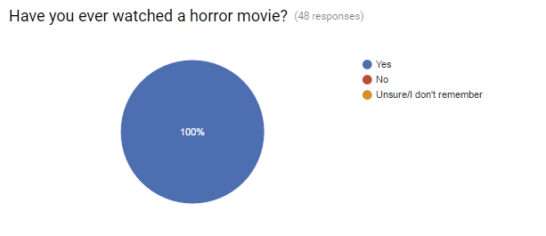
Appendix A

Horror Movies and Games (2016)

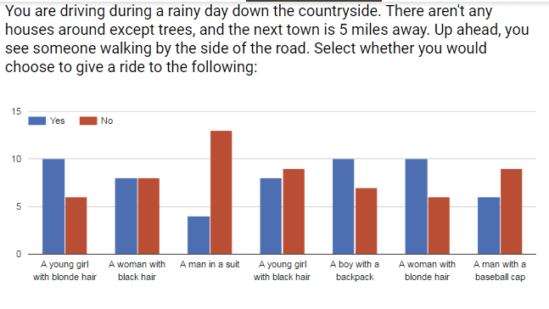
Appendix B

Horror Movies and Games: Psychological Effects, (2016)

Horror Movies and Games: Psychological Effects, (2016)
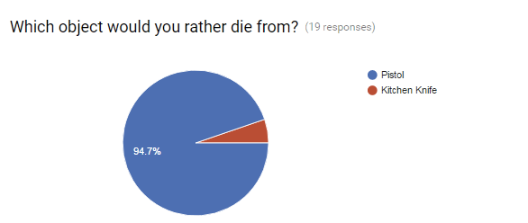

Appendix B

Horror Movies and Games: Psychological Effects, (2016)

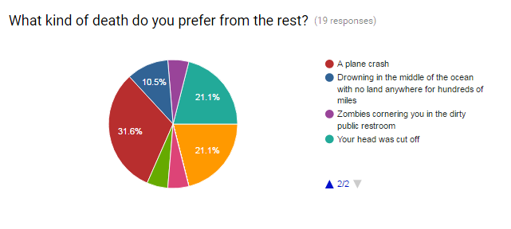
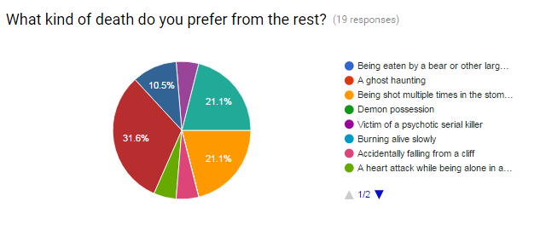
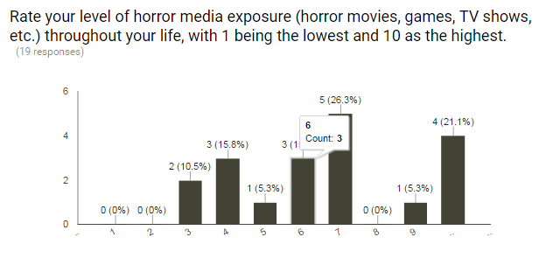
Horror Movies and Games: Psychological Effects, (2016)

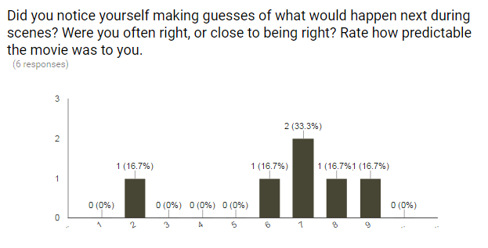
Appendix C

Evil Dead (2013) Survey, (2016)

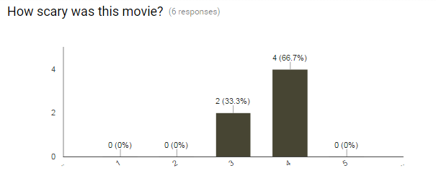
Evil Dead (2013) Survey, (2016)

