The Usage of Student Support Services in Northern Marianas College

Marijean Fernandez
Northern Marianas College
Dr. Kimberly Bunts-Anderson
EN202-002: English Composition II
Final Research Report
June 14, 2019

Table of Contents
Abstract 2
Introduction 3
Literature Review 3
Primary and Secondary Questions 5
Methodology 6
Results and Analysis 7
Conclusion 8
Reference 10
Appendices 12
Appendix A 13
Appendix B 14
Appendix C 15
Appendix D 16
Appendix E 17
Appendix F 18
Appendix G 19
Appendix H 20
Appendix I 21
Appendix J 22
Appendix K 23

Abstract
A college student at Northern Marianas College, CNMI, describes an original ten-week study highlighting the usage of student support services by NMC students. Fernandez wanted to inform the readership of the quantity of students utilizing services while emphasizing the number of teachers promoting the service and the subject areas being tutored in. Data collection was accumulated through surveys, observation, informal interviews, and letter to experts. The findings indicated that many students have a general knowledge of student support services that are provided, but rarely use it. It was also noted that students with a high GPA tend to not take advantage of the services and teachers rarely recommend their students to seek help. This study is important because it illustrates the relationship between NMC students and student support services.

Introduction
Northern Marianas College is an institute in the CNMI that provides a number of support services that aims to aid students to succeed in college and prepare them for their future career. Some support services provided are Career Service, Computer Lab, Disability Student Service, International Student Service, Learning Student Service, Library and Project PROA. All services aim to serve students in the best of their ability. Many students do not take advantage of these services due to the negative stigma. Student support service is seen as for people who are failures. If students are reluctant to seek help because of embarrassment and shame, then the possibility of failure may happen. Students tend to not see the value of it. Student support services in higher education is to help any type of students in any way, so that the graduating numbers increase. The purpose of this study was to identify the number of students using student support services to aid them in succeeding.

Literature Review
A general search on Google Scholar was conducted on May 23, 2019, using the key words “usage, student support services, and college” and came back with 685,000 results. A large percentage of the results were academic journals and case studies. The first significant section consisted of case studies pertaining to usage of support services in a specific community college (Diestsche, 2012; Laskey, 2011; Stemmer 2016; Tamuilene, 2013; Vance, 2016). The second section were journals on way to improve the numbers of students and factors that influenced the lack of usage (Copper, 2010; Gabriel-Millette, 2016; How College Tutoring Makes You 86% More Likely to graduate). Further searches were conducted on Google on May 24, 2019, to narrow the topic using the key words “usage, student support services, Northern Marianas College.” The outcome of this search was 146,000 hits and it was primarily non-academic sources on student support services provided in the Northern Marianas College page (marianas.edu). With the help of reading notes, the student researcher was able to gather important that were relevant and beneficial to the research topic.
The student researcher located five case studies which illustrated that many students do not utilize support services. The first case study was titled, “Use of Campus Support Services by Ontario College Students.” The case study was published in 2012 by CSSHE SCEES. According to the Diestsche, the usage level of services by Ontario students was low despite the fact that students need it (2012). It emphasized that the number of students who utilize it were mostly at-risk students and students graduating. The second case study was “Investigating the Relationship of Library Usage to Student Outcomes,” which was published in 2016 by American Library Association. It mainly focused on the positive and negative relationship between the usage of library and student learning outcomes. According to Stemmer, the value of library increases as students learning enhances and grade level advances (2016). On the other hand, negative relationship is shown between the lower classes and library usage. In an article written by Rasa Tamuliene titled Adjusting College Students’ Support Services to Students focused on the relationship between type of students and the demand of student support services. Tamuliene conducted a research on all state colleges in Lithuania by differentiating two types of students. These students were categorized into two groups which were non-conformist and collegiate students. According to Tamuliene, the essential support services for both non-conformist and collegiate students were orientation courses, language training and community activity. Moreover, career counseling services was found to be significant for non-conformist students. On the other hand, it was shown that collegiate students need psychological counseling and accommodation services. However, there were no data results concerning demands of services for academic and vocational students. In the end, the demands of services differ in all colleges and to accommodate these demands identify the types of students in the college. (Tamuliene, 2013)
Another academic source was a journal that provided background information on the impact and solutions to student support services. The journal was “Student Support Services at Community Colleges: A Strategy for Increasing Student Persistence and Attainment,” which was published by American Association Community College in 2010. It discussed strategies and efforts to improve services in community college (2010). According to Michelle Cooper, “Because so many community college students spend limited time on campus, they have fewer opportunities to make use of all of these services” (2010, pp. 18). The best solution Cooper provided was to categorize students and determine what services they need the most. This journal provided relevance and significance by giving a general insight of services in community colleges.
The final source was a non-academic catalog provided by Northern Marianas College. It consisted of detailed information on each student support service in Northern Marianas College provides. Due to the fact, it was an outdated source the student researcher reached out to other services to obtain background information. The student researcher noticed there were little non-academic sources that focused on the usage of support services in the CNMI. Therefore, the student researcher conducted interviews with directors to acquire information on the usage of services by Northern Marianas College students.

Primary and Secondary Questions
Primary Question: How often do Northern Marianas College students utilize students support services?
Secondary Question: Are Northern Marianas College teachers encouraging their students to take advantage of these services?

Methodology
The research was carried out from April 2019 to June 2019, which consisted of eleven weeks. Students from Northern Marianas College and experts participated in the research. With the help of surveys, formal letters to experts, and interviews, the student researcher was able to gather sufficient amount of data crucial for answering the primary research question.
The first form of data collection the student researcher used were two surveys, which were given to 30 Northern Marianas College students during Spring 2019. Both surveys were designed using a digital tool called SurveyMonkey. The first survey was a pilot survey that was used to test data collection with instructor and peers. It consisted of ten questions that were demographic, close ended, and open-ended questions in the forms of multiple choices, checkboxes, text, matrix, drop box and yes/no answer (Appendix A). Then the survey was posted on a Google Doc that was shared to receive feedbacks from the instructor and peers. The feedbacks were utilized for the student researcher to edit and modify questions for the final survey. The final survey was the second survey which was available on Google Docs for a three-week period for feedbacks. A total of 19 feedbacks were given to the student researcher that help create a well-improved survey. The surveys allowed the student research to see support services in a college student’s perspective. It was also able to accumulate information on the usage, effectiveness and promotion of support services in Northern Marianas College.
The second form of data collection was letters to experts which were sent to five on-island and five abroad. The experts were directors of support services in college, such as Northern Marianas College, University of Guam, and Honolulu Community College. The letters sent abroad consist of a short questionnaire that helped the researcher to gather information on support services from an expert’s perspective. In the email, there was a questionnaire provided to gather data (Appendix D) However, only three experts respond back. Moreover, the letters that were sent on-island consisted of short questionnaire and asking to schedule an appointment for an interview.
The last form was informal interview conducted to collect personal information from Northern Marianas College students (Appendices F-K). The interview questions consisted of demographic and open-ended questions that provided an insight of personal experience. The student researcher conducting informal interview that was written with Atalig and Camacho. Atalig was interviewed for 10 minutes on NMC campus at Y18. According to Atalig, "Project PROA is the only support service I am aware of. I avail to their service when I need help in understanding something in math." (informal interview, May 7, 2019, 9:20AM, NMC Campus) Another interview was conducted at Java Joes that lasted for 15 minutes with Camacho. Camacho said, "I did not use any support services during my first semester in college because I was busy taking care of my family." (Informal Interview, May 8, 2019, 9:21PM, Java Joes) From this the student researcher was able to gather information on usage, knowledge and experience of support services available at NMC.

Results and Analysis
The participants of this study were NMC students and directors of student support services from abroad and NMC. After following a planned schedule (Appendix E), the student researcher was able to gather sufficient amount of data. The results revealed that students were aware of support services, but sometimes use it (Appendices C). Most of the students who utilize it are students with low GPA compare to students with high GPA. On average, students spend most of their time off-campus due to employment, taking care of family, and entertainment. It was also noted that many teachers do not refer their students to services. Based on the survey, English and Math teachers are the only ones encouraging their students to seek help. Analyzing the responses, the student researcher noticed the reluctancy of students. One participant said, “I never tried going, but the navigators seem helpful and kind.” Another stated “I have never used any of these services.” However, there were a great number of students who shared positive experiences from Project PROA, Library, Disability Student Service, and Computer Lab. Another interesting response came from question number 10 (Appendix A). A participant shared, “A campus gym for who are trying to get fit and staying fit. More activities for students to participate in.” Participant #8 stated, “The services available are very helpful, but if I were to suggest a service, I would recommend English Sign Language for those students entering college and have a hearing disability.” Participant #6 shared, “I think having services online would be nice.” Lastly two participants stated that service on how things work around here and how to use moodle, email, and technology would be nice.
Apart from the survey, observations and interview took place took place. During the observations, the student researcher saw that students seek services when they need something to print, peer-edit, find literature source, or understand a word problem. On a daily base, about 5-15 students per day come in to seek tutoring at Project PROA. Because of Typhoon Yutu, the number of students who come in the library increased compare to last semster. According to an expert Hofschneider, there are about 50-60 students each semester who receive tutoring and/or mentoring services (Appendix F). Despite the fact, the number is low Hofschneider noted that the quantity is not as important as the quality.

Conclusion
Data from this study revealed that students sometimes avail to student support services. From the survey, it revealed a vast amount of positive responses from participants, but the numbers of students utilizing support services are still low. It is evident that students with high GPA, employed, and taking care of family do not utilize support services. There are also students who are reluctant to seek help because they are timid. The best solution is to have college teachers practice their students to avail to these services, so they will feel more encourage to use them. In addition, a college student suggested that more friendly promotion and advertisement is another solution. Moreover, students of NMC suggested a few services to implement, which were fitness, how to use technology, sign language, and an orientation on how things work around NMC. Overall, the result showed a negative relationship between the usage of students services and NMC college students.

Reference
Business Wire. (2018, April 13). Survey of American College Students, Use of &
Satisfaction with College Tutoring Services, 2018 - ResearchAndMarkets.com.
Retrieved from https://www.businesswire.com/news/home/20180413005463/en/Survey-American-College-Students-Satisfaction-College-Tutoring
Cooper, E. (2010). Tutoring Center Effectiveness: The Effect of Drop-In Tutoring. Retrieved
from https://files.eric.ed.gov/fulltext/EJ887303.pdf
Dietsche, P. (2012, November). Use of Campus Support Services by Ontario College
Students. Retrieved from file:///Users/marijeanf/Downloads/2098-Article Text-
186541-1-10-20130128 (1).pdf
Gabriel-Millette, C. (2016). The Effects of Tutoring on Academic Performance. Retrieved
from https://www.valleycollege.edu/about-sbvc/offices/office-research-
planning/reports/tutoring-performance-measures-final-revisions-review.pdf
How College Tutoring Makes You 86% More Likely to Graduate. (n.d.). Retrieved from
https://www.joinknack.com/college-tutoring
Laskey, M. L., & Hetzel, C. J. (2011). Investigating Factors Related to Retention of At-risk
College Students. Retrieved from https://files.eric.ed.gov/fulltext/EJ919577.pdf
Northern Marianas College Catalog. (2014). Retrieved from
http://www.marianas.edu/media/2013_nmc_catalog/nmc_catalog_22_OCT_2013.pdf
Stemmer, J. K., & Mahan, D. M. (2016). Investigating the Relationship of Library Usage to
Student Outcomes. Retrieved from
https://crl.acrl.org/index.php/crl/article/view/16514/17960
Tamuliene, R. (2014). Adjusting College Students’ Support Services to Students’ Type:
Lithuania’s Case. Retrieved from
https://www.sciencedirect.com/science /article/pii/S1877042814035010
Vance, L. (2016, January). Best Practices in Tutoring Services and the Impact of Required
Tutoring on High-Risk Students. Retrieved from
https://encompass.eku.edu/cgi/viewcontent.cgi?article=1439&context=etd

Appendices
Marijean Fernandez
Northern Marianas College

Appendix A
- Demographics

  - Age
  - Sex
  - Ethnicity
  - Major
  - College Level
  - Course Loads
  - GPA
  - Employment Status
  - Special Need(s)
  - Have you taken an online course?

- Which of the following NMC support services are you familiar with? (Check all that apply)

  - Career Services
  - Computer Lab
  - Disability Support Services (DSS)
  - Early Intervention Counselors
  - English Student Lab (ESL)
  - International Student Services (ISS)
  - Learning Support Services (LSS)
  - Library
  - Project PROA
  - Other (please specify)

- Do you avail of these services? Yes/No
- How often do you avail to these services? Always/ Usually/Sometimes/Rarely/Never
- How helpful are/were these services to you?
  - Career Services (Very Helpful/ Somewhat Helpful/ Not Helpful/ No Opinion)
  - Computer Lab (Very Helpful/ Somewhat Helpful/ Not Helpful/ No Opinion)
  - Disability Support Services (Very Helpful/ Somewhat Helpful/ Not Helpful/ No Opinion)
  - Early Intervention Counselors (Very Helpful/ Somewhat Helpful/ Not Helpful/ No Opinion)
  - English Student Lab (Very Helpful/ Somewhat Helpful/ Not Helpful/ No Opinion)
  - International Student Services (Very Helpful/ Somewhat Helpful/ Not Helpful/ No Opinion)
  - Learning Support Services (Very Helpful/ Somewhat Helpful/ Not Helpful/ No Opinion)
  - Library (Very Helpful/ Somewhat Helpful/ Not Helpful/ No Opinion)
  - Project PROA (Very Helpful/ Somewhat Helpful/ Not Helpful/ No Opinion)
  - Other (please specify) (Very Helpful/ Somewhat Helpful/ Not Helpful/ No Opinion)
- Has any of your teachers, friends, close relatives, or yourself referred you to any support services? If so, for which subject and service?
- After receiving services, do you feel encouraged to return? Yes/No/No Opinion
- Did the service(s) effectively aid you in succeeding your college course? Describe your experience.
- Were any support services provided by NMC available to you as an online student? If so, which services? No Opinion/No/Yes (please specify)
- What types of new services or improvements would you recommend for student support?

Appendix B
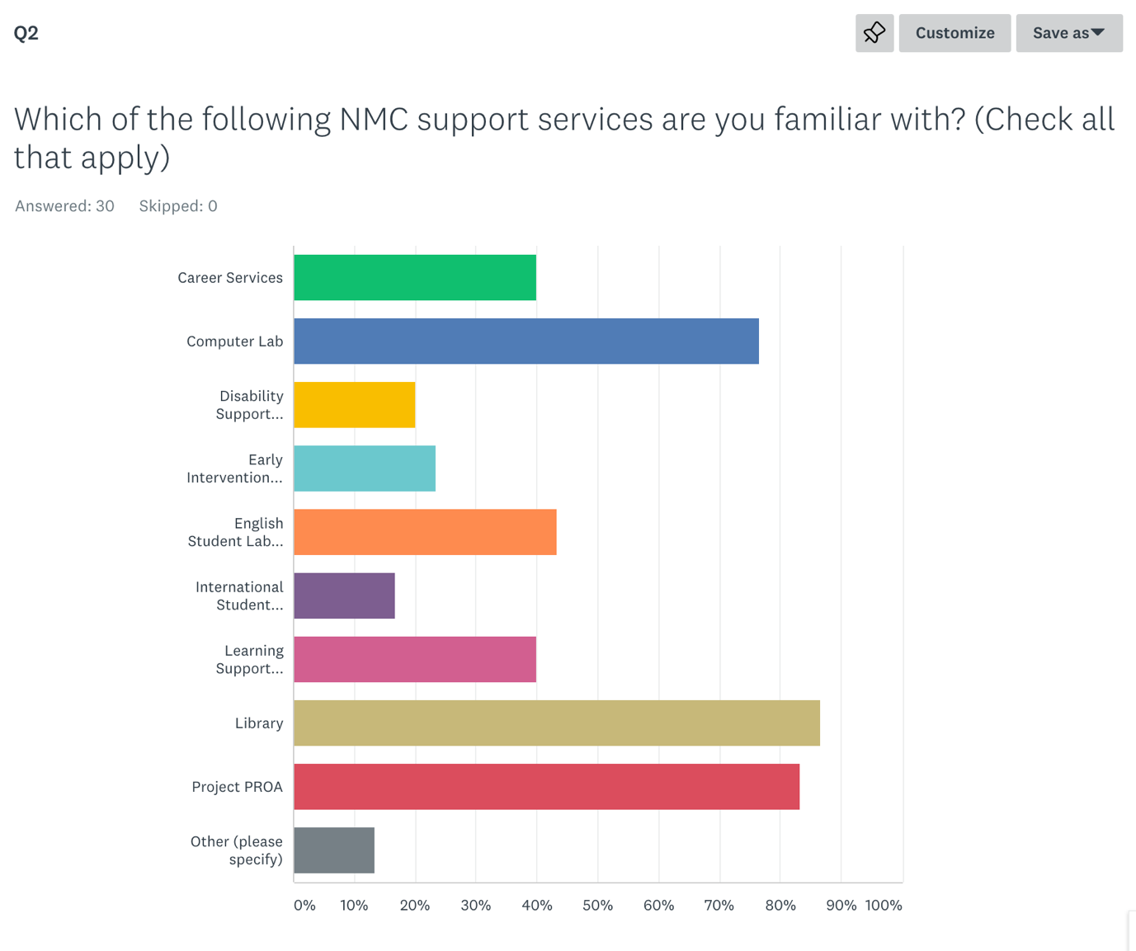

Appendix C
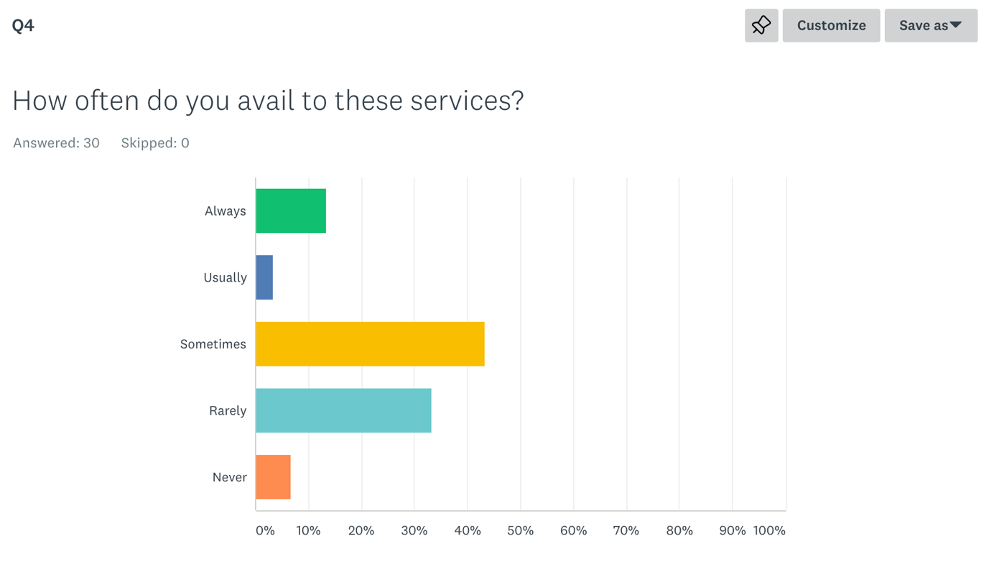

Appendix D

Experts off-island
Yoichi K. Rengiil yrengiil@gmail.com
Roland San Nicholas rolandsn@triton.uog.edu
Makanani Pili makananipili@gmail.com
Charles Miller chmilleere@hawaii.edu
Jonathan Morrel morell@dixie.eedu

Experts on-island
Christine Inos christine.inos@marianas.edu
Hedwig Hofschneider hedwig.hofschneider@marianas.edu
Isabel Matsunaga isabel.matsunaga@marianas.edu
Samuel Crawford Samuel.crawford@marianas.edu
Neda Deleon Guerrero neda.dlgueerrero@mariana.edu

Questionnaire
- On an average, how many students use your service each week?
- What courses do most students seek tutoring for?
- In your opinion, are teachers referring students to take advantage of the service?

Appendix E

Week 5  (4/29-5/3) | Week 6  (5/6-5/10) | Week 7  (5/13-5/17) | Week 8  (5/20-5/24) | Week 9  (5/27-5/31) | Week 10  (6/3-6/7) | Week 11  (6/10-6/14)
Create a survey for NMC students to answer  Find local sources | Survey 15 more NMC students  Schedule appointments for interviews | Interview directors of services provided in NMC | Collect all data and compile in an excel sheet (optional)  Begin writing the report (draft) | Find someone to proofread the report | Final Research Report due  Finalize report | Present report

Appendix F

The Usage of Project PROA
Interviewee: Hedwig Hofschneider
Date: 5/14/2019
Time: 8:25AM-8:28AM
Location: Archives

Questionnaire:
On an average, how many students use your service?
- 40-50 each semester
- Never want to sacrifice quality for quantity
What course do most students seek tutoring for?
- English and Math
What type of students do you think come in?
- All kinds of students. Target population is Chamorros and Carolinians, but we welcome everybody.
In your opinion, are teachers referring students to take advantage of Project PROA?
- I believe so, we had teachers who brought their class to the Project PROA center. We make sure they know our services and what we provide.

Appendix G

Informal Interview
Interviewee: Johnson Atalig
Date: 5/7/2019
Time: 9:20AM-9:26AM
Location: Y18, Northern Marianas College

Questionnaire:
- Demographic Questions
  - Ethnicity: Chamorro
  - Major: Liberal Arts Emphasis in Education
  - Course Loads: 5
  - College Level: Freshman
  - GPA: 3.77
  - Job: Unemployed
  - Special Need: None
- Name support services you are familiar with in NMC?
  - Project PROA
- How often do you avail of this service?
  - Once a week
- Was the service helpful to you?
  - Very helpful because they helped me understand something I did not know for math.
- Did any of your teachers or friend refer you to this service?
  - Yes, my EN101 teacher. She told us to seek peer review from tutors at Project PROA.
- Are you taking an online class?
  - Yes, HI122 (Did not recommend any student service)
- Where do you spend most of your time? Off or on campus?
  - On-campus

Appendix H

Informal Interview
Interviewee: Camacho
Date: 5/10/2019
Time: 9:21PM-9:24PM
Location: Java Joes

Questionnaire
- Demographic Questions
  - Ethnicity: Thai and Chamorro
  - Major: Liberal Arts with the Emphasis of Health and Physical Education
  - Course Loads: 5
  - College Level: Freshman
  - GPA: 3.78
  - Job: Unemployed
  - Special Needs: None
- Name support services you are familiar with?
  - Project PROA and ESL
- How often do you avail of this service?
  - Once
- Was the service helpful?
  - Very helpful. They helped me understand and complete my math homework. I used ESL when I was taking EN092.
- Did any of your teachers or friends refer you to this service?
  - No
- Are you taking an online class?
  - No
- Where do you spend most of your time? Off or on campus?
  - Off-Campus

Appendix I

Informal Interview
Interviewee: Pangelinan
Date: 5/7/2019
Time: 11:00AM-11:06AM
Location: Library

Questionnaire
- Demographic Questions
  - Ethnicity: Chamorro
  - Major: Liberal Arts Emphasis in Education
  - Course Loads: 4
  - College Level: Freshmen
  - GPA: 4.00
  - Job: Unemployed
  - Special Needs: None
- Name support services you are familiar with?
  - Project PROA, Library, and Computer Lab
- How often do you avail of this service?
  - Once a week
- Was the service helpful?
  - Very helpful. I was able to peer review my essay as well as understand math problems.
- Did any of your teachers or friends refer you to this service?
  - Yes. My EN101 and EN202 teacher.
- Are you taking an online class?
  - Yes, PY101 (Did not recommend to use any service)
- Where do you spend most of your time? Off or on campus?
  - Off-Campus

Appendix J

Informal Interview
Interviewee: Salas
Date: 5/14/2019
Time: 11:10AM-11:19AM
Location: Library

Questionnaire
- Demographic Questions
  - Ethnicity: Chamorro
  - Major: A.A. in liberal arts with emphasis in education
  - Course Loads: 4
  - College Level: freshman
  - GPA: 4.0
  - Job: None
  - Special Needs: None
- Name support services you are familiar with?
  - Project PROA, Library, and Computer Lab
- How often do you avail of this service?
  - Very often (Library)
- Was the service helpful?
  - Very helpful. I was able to print my assignment and use the computer in the Library.
- Did any of your teachers or friends refer you to this service?
  - Yes, my friends but I did not seek tutoring services.
- Are you taking an online class?
  - No.
- Where do you spend most of your time? Off or on campus?
  - On-Campus

Appendix K

Informal Interview
Interviewee: Alonzo
Date: 5/20/2019
Time: 1:00PM-1:05PM
Location: Library

Questionnaire
- Demographic Questions
  - Ethnicity: Filipino
  - Major: Computer App
  - Course Loads: 4 courses
  - College Level: Freshman
  - GPA:
  - Job: Unemployed
  - Special Needs: None
- Name support services you are familiar with?
  - Project PROA
- How often do you avail of this service?
  - When teacher refers us to get a feedback
- Was the service helpful?
  - Very helpful
- Did any of your teachers or friends refer you to this service?
  - Yes
- Are you taking an online class?
  - No
- Where do you spend most of your time? Off or on campus?
  - Mostly off campus, but when needed, I go to the library to do some homework assignments

