The First Steps that the Residents of Garapan took in Order to Survive from the Aftermath of Typhoon Soudelor
By
Joann Mae G. Villaluna
Northern Marianas College
Commonwealth of Northern Mrianas Island, Saipan, U.S.A

Author Note
Research paper for English 101-08
Instructor: Kimberly Bunts-Anderson
If you have questions please contact Joann at: joann.villaluna@my.marianas.edu

Table of Contents
Abstract……………………………………………………………………………………3
Introduction……………………………………………………………………………….4
Background………………………………………………………………………………..4
Literature Review……………………………………………………………………….…5
Primary Research Question…………………………………………………………….….6
Secondary Research Question……………………………………………………………..6
Methodology………………………………………………………………………………4
Findings and Analysis……………………………………………………………………..7
Discussion…………………………………………………………………………………8
Conclusion………………………………………………………………………………...8
References…………………………………………………………………………………9
Appendices……………………………………………………………………..……...…10
Appendix A………………………………………… 11
Appendix B……………………………………………12
Appendix C……………………………………………13
Appendix D……………………………………………14
Appendix E……………………...…………………….15
Appendix F…………………………………...………..16
Appendix G………………………………...………….17
Appendix H……………………………………………18
Appendix I…………………………...………………..19

Abstract

This research essay is a review on the first steps that the residents of Garapan took in order to survive from the aftermath of Typhoon Soudelor in terms of shelter, electricity, and water. The researcher conducted data through survey program SurveyMonkey, interviews of Garapan residents and literature reviews. This essay focused on the basic strategies Saipan residents used to have shelter, electricity and water. This research report illustrates the experiences of Typhoon victims living in one village and how the victims coped up with the situation. "Typhoon Soudelor impacted the island of Saipan ... with wind speeds of 91 mph," the Energy Department stated. "Severe damage to the electricity infrastructure on the island Saipan was observed with estimates of restoration ranging from three weeks to one month." ( Dumat-ol, 2015).

Introduction
This research paper addresses the first steps that the residents of Garapan did in order to survive from the aftermath of Typhoon Soudelor. The purpose of this research paper is to gain knowledge on how the Garapan residents handled the intense situation when typhoon Soudelor hit the island of Saipan. This research study focused on hardship that the Garapan residents did in order to survive from the aftermath of Typhoon Soudelor in terms of shelter, electricity, and water. The objective of this research paper was to determine the survival steps of the residents of Garapan after Typhoon Soudelor left the island. The importance of this essay was determined by the researcher in conducting surveys and academic literature. “The President declared a major disaster exists in the Commonwealth of Northern Mariana Islands and ordered federal aid to supplement commonwealth and local recovery efforts in the area affected by Typhoon Soudelor during the period of August 1-3, 2015”( Office of the Press Secretary, 2015).
Background
Garapan is the largest village and the center of the tourism industry on the island of Saipan, which is a part of the United States Commonwealth of the Northern Mariana Islands (CNMI). Garapan, as a census-designated place, has an area of 1.2 km² and a population of 3,588 (US Census Bureau, 2000). Garapan citizens had limited access on their basic needs due to the impact of Typhoon Soudelor. “It could take at least three weeks to a month to restore essential services in Saipan, and island residents are preparing for extended power and water outages” a local government assessment stated (Dumat-ol Daleno, 2015). According to Vernice Ronda, remittance agent of Western Union, they were unable to operate for two days and use generator for almost two months. Families were also affected by Typhoon Soudelor. Herminio Beronio, one of the interviewee, state that Typhoon Soudelor damages their home and suffer from water and electricity outages.

Literature Review
Typhoon Soudelor left a massive impact in Garapan residents. “While Saipan residents have struggled without power, their hardships are compounded by the lack of running water. Without electricity to pump water supply, residents have had to fill water bottles from truck deliveries positioned in certain areas, according to the CUC's report” (Dumat-ol Daleno, 2015). Herminio Beronio who lives in Garapan said in an interview with the researcher that they suffer from water outages for 2 months and electricity for almost 3 months.( Appendix) “The typhoon hit Saipan in the Commonwealth of the Northern Mariana Islands on Sunday, knocking out electricity on the 124-square-kilometre island. About 50,000 people live on the commonwealth's four populated islands, with most of them living on Saipan, which took the brunt of the storm” (Jones, 2015). The impact of Typhoon Soudelor affected the everyday lives of Garapan residents. Blu Haus owner Maria Cecilia Obaldo said that they use generator for two weeks to continue the operation of their business. White House release a statement “President Barack Obama declared a major disaster exists in the Commonwealth of Northern Mariana Islands and ordered federal aid to supplement commonwealth and local recovery efforts in the area affected by Typhoon Soudelor during the period of August 1-3, 2015” (The Office of Press Secretary, 2015) .

Primary Research Question
The first steps that the Garapan residents took in order to survive from the aftermath of typhoon Soudelor in terms of shelter, electricity, and water.
Secondary Research Questions
- What are the effects of Typhooon Soudelor in electricity and water?
- Are they able to still live on their houses?
- How long did it take to finally coped up with the situation?
- What are the strategies that they do to have electricity and water?
- Did they experience lining-up to have food and water. How often ?
- What did they do to get help from financial agencies?
7. How did they manage to live in their houses without electricity?

Methodology
This research paper study the survival steps that the residents of Garapan took in order to survive from the aftermath of typhoon Soudelor. Typhoon Soudelor is one of the strongest typhoons that ever occurred in Saipan. This research paper focused on the basic strategies that the survivors employed to have shelter, electricity, and water. This study also illustrated the experiences of Typhoon Soudelor victims and how they coped up with the situation. A lot of people had been affected by the typhoon and the readers will see the hardships of typhoon survivors through the actual victims’ stories. This research paper discussed how they managed to survive despite of many difficulties. The study was completed by the reviewing literature and conducted primary research.
First, an interview was collected from the residents of Garapan supported the main point of the essay. Businesses, families, and students were affected by the Typhoon Soudelor. Sharmaine Casquero, Job beautician of Shine Moist, Vernice Ronda,remittance agent of Western Union, and Maria Cecilia Obaldo’ Blu Haus owner was interviewed because there were effects that Typhoon Soudelor bring on their business. Business’ owner and employee was asked about the effects of Typhoon Soudelor in the profit of their business. Justine Mallari’s family, HerminioBeronio, and Mary Joy Laquian, residents of Garapan, was interviewed also because they experienced power outages. Families were asked on how they handled difficulties on living on an island after Typhoon Soudelor’s wrath. Anonymous students through online living in Garapan were asked on the effects of Typhoon Soudelor.
Next, a survey was also conducted from different people in Garapan to support the information that was given in the essay. Ten survey questions was conducted in Garapan, some of the questions were: What are the things that they do to get food and water, did they line-up and use bucket to different areas of Garapan to pail water; did they apply for any assistance through aid agencies and are they still able to live in their houses. The question will be given to anyone and all of Garapan residents can take the survey. The researcher also provid academic literature like White House, Office of the Press Secretary , American Red cross, and online newspaper; some of these newspapers will come from Pacific Daily News, CTV News and Stars and Stripes.
As a conclusion, these are the things that the researcher did to finish the whole research study and submitted to the the instructor. This research paper was completed after the interviews on the residents of Garapan were completed. We will also learn to be prepared for emergencies like this typhoon. The topic of the research study was supported by the details that were answered by the research questions. An effective research paper was given after the research questions details was conducted. All of these were done before the end of fall 2015 semester.

Findings and Analysis

The researcher conducted survey through the software program called surveymonkey. Out of 24 respondents that answered the survey 7 were males and 17 were females, ages 18-35 years old. According to some of the respondents Typhoon Soudelor damaged their house and personal things. One student response said that her books, laptop, and television did not function anymore, also her clothes are all wet and cannot be used when Typhoon Soudelor hit their home. (Appendix B). The roof of their house was also blown away due to the heavy wind the night Soudelor hit the island of Saipan. When asked if they experience lining up to get food and water, half of the respondents answered yes. Most of the respondents state that they line-up every day to get water and it take them 2 hours at the line. “We lined up for NAP to get food stamp. My family also received relief goods and personal hygiene from the American Red Cross” said one respondent ( Appendix D). In a closer look on the survey, most of the respondents said that they were still able to live on their houses despite of the impact of Typhoon Soudelor (Appendix H). Majority of the respondents state that they experience power outages for aalmost 2 to 3 months.
(Appendix I).
Discussion
The detailed thesis of the research paper was gathered through the help of internet and academic resources. To obtain the result of the research question, the researcher provides surveys through software program surveymonkey.com. It is clearly stated that Saipan was greatly damage by typhoon Soudelor through the academic literature that researcher provide. Typhoon Soudelor cause massive damage to Garapan residents by limiting water and electricity. In the beginning, the researcher made a schedule to garner all the data that was needed to complete the research paper. The researcher use electronic programs, surveys, and interviews in completing the study. The research paper was a helpful study to other students who wanted to know the effects of Typhoon Soudelor in Garapan. As the center of tourism, Garapan is one of the most important places in the Commonwealth of Northern Marianas Island. Though Garapan is recovering from the aftermath of typhoon Soudelor, the damage of Typhoon Soudelor affected the lives of the residents in this village. The researcher promotes conducting more surveys and interviews as a helpful device in doing research papers.

Conclusion
The affected residents of Garapan had difficulties facing the aftermath of Typhoon Soudelor. The research paper was a long process to finish. The short semester had a limited time for students to do research paper. The researcher had a hard time to complete all the details of her report; however, the research paper enhances her skills to do multiple tasks. The student researcher provides online surveys to finish her paper early. Academic literature helped the researcher to analyze data to provide an effective and accurate essay. Information must be gathered early to finish the research paper on given time.

References
Anonymous(2015). Red Cross Typhoon Soudelor Response. American Red Cross Retrieve from
http://www.redcross.org/news/article/hi/honolulu/Red-Cross-Typhoon-Soudelor-Response-Update

Dumat-ol Daleno, Gaynor. "Power, Water Restoration Could Take a Month." Pacific Daily News August 6, 2015. Accessed October 22, 2015. http://www.guampdn.com/story/news/2015/08/05/power-water-restoration-could-take-month- 0806/31148857/.

Kelleher, Jennifer Sinco. "Saipan Remains without Water, Electricity 4 Days after Typhoon Soudelor." CTVNews. August 5, 2015. Accessed October 22, 2015. http://www.ctvnews.ca/world/saipan-remains-without-water-electricity-4-days-after-typhoon-soudelor-1.2504320.

Office of the Press Secretary (2015). President Obama signs Commonwealth of Northern Mariana Islands Disaster Declaration, 1-1. White House. Retrieve from: https://www.whitehouse.gov/the-ress-office/2015/08/06/president-obama-signs-commonwealth-northern-mariana-islands-disaster.

Slavin, Erik. "Water, Electricity Still at Premium as Saipan Recovers from Typhoon Soudelor.
Stars and Stripes. August 12, 2015. Accessed October 22, 2015
http://www.stripes.com/news/water-electricity-still-at-premium-as-saipan-recover
fromtyphoon-soudelor-1.362510.

Appendices

Appendix A: Research Schedule
October 8-15, 2015 -Research essay topic
-Secondary questions
-Outline of persuasive essay
October 17-30, 2015 - Rough Draft of persuasive essay
- Final draft of persuasive essay
-Survey questions on the survey monkey website
-Shared pilot survey link on google docs page
November 2-13, 2015 - Answered other surveys and provided feedbacks
other peers
-Outline of process essay, Rough Draft of process
essay
November 17, 2015 -Final draft of process essay
-Outline of compare and contrast
November 27, 2015 - Rough draft of compare and contrast essay
December 2-9, 2015 - Info graph, Final draft of compare and contrast
December 14-17, 2015 - Rough draft of research report, Final draft of
research report, One page Reflection

Appendix B

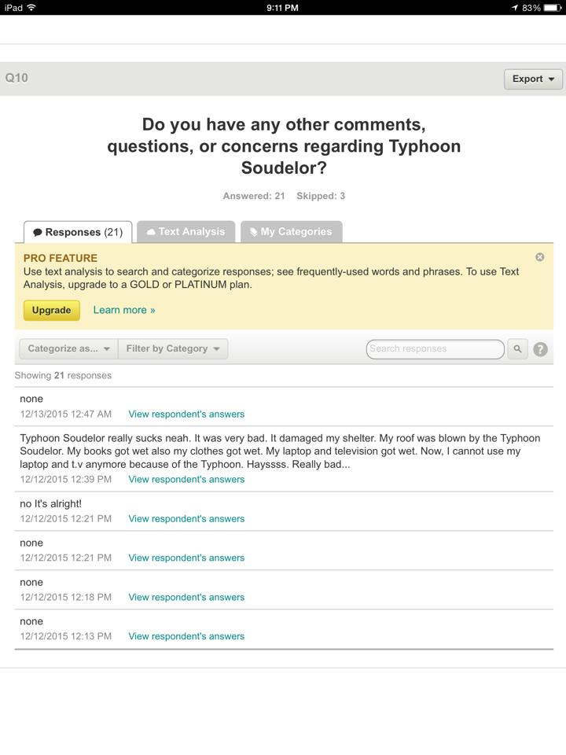

Appendix C

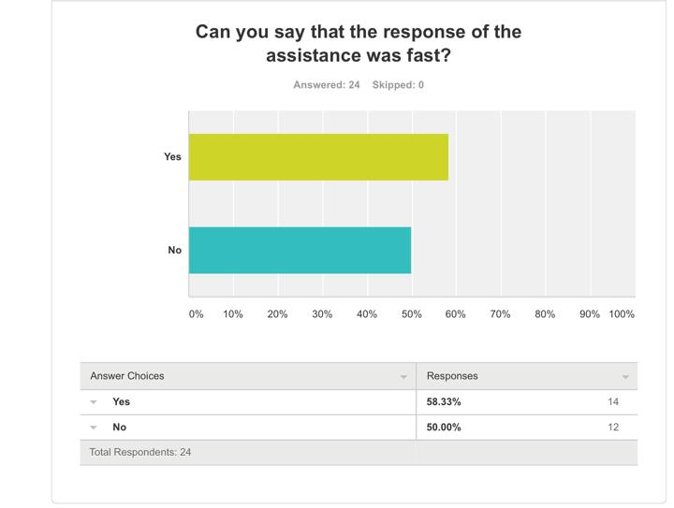

Appendix D

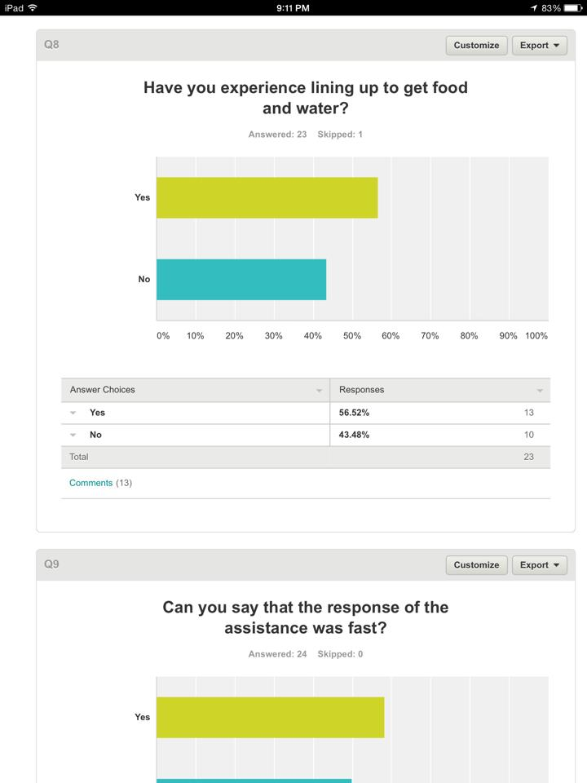

Appendix E

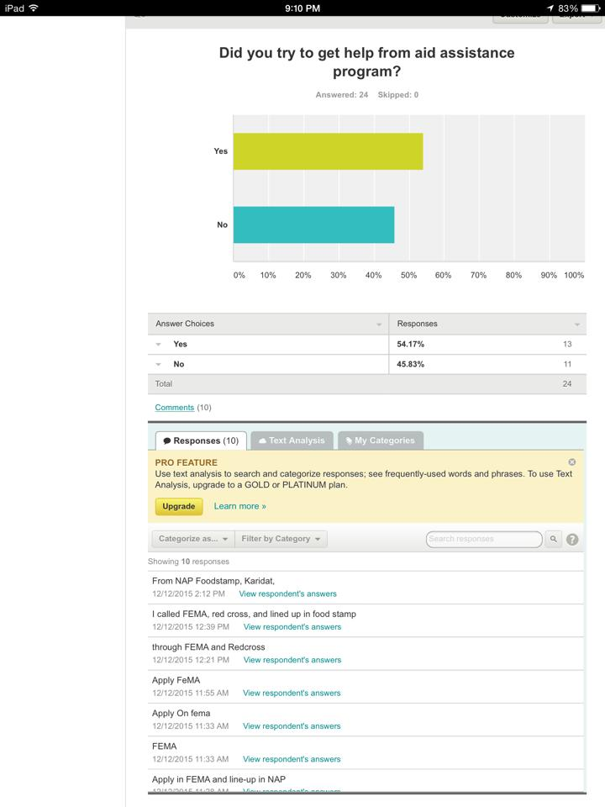

Appendix F

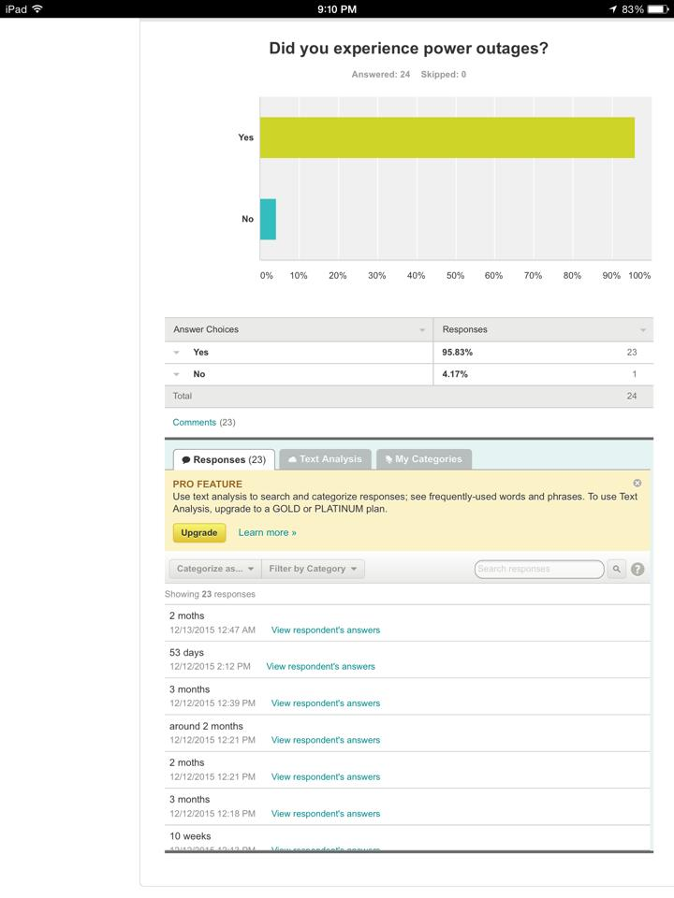

Appendix G

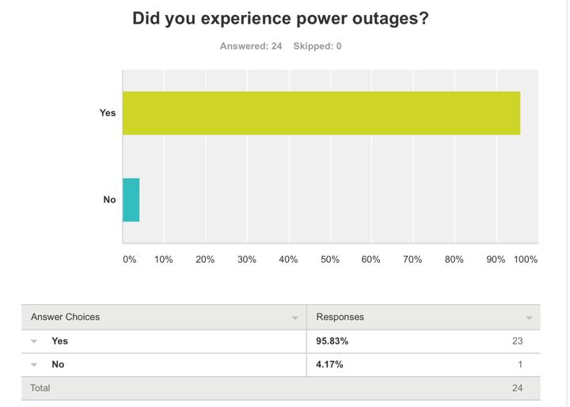

Appendix H

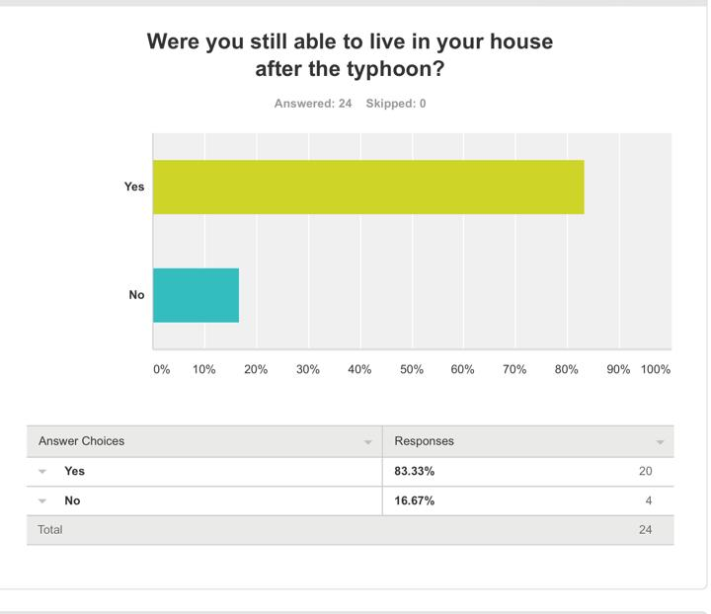

Appendix I





