E-Portfolio
Halia Taisacan
Northern Marianas College
EN202-ON01

Essay 1: Illustrative
Artificial Intelligence: Technology Aids the Visually Impaired
Technology has advanced so much since the 20th century. The year 1973 was when Motorola came out with the first ever hand held mobile device. That is roughly 46 years prior… not even half a century ago. Fast-forward to 2019 and we have an iPhone XR as well as a Samsung galaxy 10. We have many technological advances that help to ease the daily lives of individuals all over the world. Artificial Intelligence (AI) is more recently programmed in smart phones as well as everyday technologies such as televisions and cars. In my opinion, AI is a type of support that can be used to help individuals with disabilities like visual impairment. AI in technology can offer help to the visually impaired in ways such as, using technology as communication, enjoying a book, and finding directions.
Modern day companies like Apple have made it so that visually impaired people can use mobile phones daily with ease. Apple offers a wide range of applications that assist visually impaired people. One way in which Apple accommodates them is with their voiceover application. The main thing commonly associated with visually impaired individuals is their sense of touch. Using the voiceover application is as simple as using a couple gestures. One way to control the voiceover is to touch or drag the finger anywhere on the screen. The mobile device will then read out loud the words under the finger. It is useful in the sense that people who have poor vision will still be able to use technology. As the human population grows, it is good to see that all kinds of people are included in the experience. From there, the user can now navigate their way through the device. Aside from voiceovers, Apple devices also come equipped with the ability to describe audio. What this feature does is simply provide detailed audio description movies for people unable to physically watch movies. However, not all movies come with the option of audio descriptions. But it is still something that is beneficial to people that want the experience of a movie.
From poor vision to fully blind people, there are ways in which a book could be enjoyed. Despite the fact that it isn’t a physical copy of a book, electronic books come equipped with automated voice overs which enhances the use of e-books for the visually impaired. There are many downsides to not being able to physically read a book, but what more innovative way could there be than to have everyone enjoy a book. Aside from automated voiceovers, there is a feature which allows the users to adjust the size of the fonts. Depending on the vision situation, the text on the e-book can be enlarged or reduced. As previously mentioned, voiceovers can be a godsend when it comes to vision impairment. It can allow many individuals to broaden their knowledge and experience. Although there are braille books made specifically for visually impaired individuals, the selection is less. Having the option of automated voiceover broadens the number of books accessible to them.
Although looking at a map and finding directions may be second nature to most people, the visually impaired struggle with it. They can’t just open a map and find their desired location. People with optimum sight have the privileged of doing basic things that other people may struggle with. Nonetheless, there are ways in which technology has eased the burden of directions for visually impaired individuals. The main focus in which helps them navigate is Siri. Although that may be a bit strange, Apple does have the voiceover feature which makes Siri more tentative when being used. For example, when asking Siri for places to eat, a list pops up in a way that every Siri provides. However, when that feature is enabled, Siri will voice the options one by one and ask, “Is this what you want?” followed by the ratings and location. If the user decides on a place, Siri will then provide the option of calling for directions or have opened the digital map. On the map provided, is a button for walking, which will also be automated if the user so wishes to do so. There are many cool features in which aid visually impaired individuals.
All in all, the technological advancement providing artificial intelligence to be programmed into everyday devices is a big step to insuring distinctive experiences. Individuals with visual impairments are offered a chance to experience new things in a way they haven’t experienced before. The access of technology has provided voiceovers, as well as a way for people to watch a movie with detailed audio description. It is a way which allows visually impaired people to enjoy a movie, catch up on some reading, as well as find a good restaurant to dine. All types of people, impaired or not, should have the option to do things that the majority experience. Through technology, the human race is being brought together in ways that haven’t been seen before; yet, it is only the beginning.

Essay 2: Persuasive
Technological Advancement: The Social Impact of Technology
The timely development of technological advancement in the more recent years has caused education to become heavily reliant on technology. The implementation of the World Wide Web within classrooms has opened up many doors to opportunity. As the world continues to evolve, there are many ways in which the advancement of technology could benefit specific social groups. Just like the benefit of technology in classrooms; visually impaired individuals such as blind people can take advantage of the same opportunities. Throughout this essay, the reader will begin to understand the benefits of technological advancement towards society as a whole, as well as the disabled.
As sight is one of the main 5 senses of the human body, it is quite an important asset. Humans value sight in ways that are beneficial to daily life. However, some people are unlucky in the sense that they aren’t given “normal” eye sight. Being blind is something that many people have to endure whether it be from genetics, a disease, or old age. Of course, technology isn’t just beneficial to the blind, but also to the whole entire disabled community. There is a way such as artificial intelligence in which improves the lives of the disabled. From things like Siri to Alexa, these programs can ease the lives of many people around the world. The development of technology is a life changing innovation. Today, the people can experience artificial intelligence. Tomorrow, it may as well be the end of viruses. Technology has and is changing for the better of mankind.
In an article by Brilhault, Gutierrez, Jouffrais, Kammoun, & Truillet (2011) the authors begin to discuss a way in which to develop a device which sole purpose is to assist the blind with navigation. Their idea is that a system could be developed in a way that can assist the blind in ways such as situational awareness. In that light, it is important, and it is innovative. It is the future of the readers; todays leaders are paving the way for equality. By the invention of a GPS system for the disabled, they are able to have more access and mobility than they would have had 50 years prior. Many people who are disabled or of old age may feel a disconnect from everyone. Because of the restrictions that their situation has put them under, they may feel isolation. According to Bradley and Poppen (2003), the technological advancement that includes artificial intelligence like computers and the Internet help them to cope with problems of isolation. Because they have an outlet to reach out to others they may feel less alone. Although it is through technology, people can make lifelong friendships in the virtual world. This is an idea that shines on its own, the fact that technology can one day be tremendously beneficial in a simple way.
The process of gathering information is a long process. However, in order to gather the data needed to succeed there are a few things that have to be done. The first being, a survey that get the opinion of a select group of individuals. Second, are the opinions of experts in that field. The last thing is, observations. By surveying peers, it increases the chances of discovering the local environment and how things are affected. The opinion of experts can also help in the sense that they could give a more detailed overview of what to expect. They can provide insight to things that had not be made aware. Lastly, by doing a little bit of observation, the researcher can then formulate an opinion based off of first-hand experience. This all pulls together in relation to the research. It is the researchers main obligation and duty to find time in which to complete the required research. With work, family, and school, the best time to work on the required material would be on days off. It would be the ideal time for any student. By following the process and making time in ways such as planning, the researcher can without a doubt write a beautiful research paper.
In conclusion, technology helps more than it hurts. It is advancing in ways that is scary yet brilliant. The disabled people have a way to socialize as well as navigate the world around them. That would not at all have been possible 50 years prior. However, thanks to the advancement of technology, it is now possible. Today, many people are getting access to the technology they need to live with ease. By providing an outlet for disabled as well as elderly people, it ultimately provides hope in a sense of equality. It is not only beneficial to them, but to the human race as a whole. It is important to have technological advances, for the present and for the future.

Essay 3: Process
Disabled Individuals on Technology:
The Impact of Technology in the Various Lifestyle Communities
Technology has advanced at a rapid rate throughout the years. More so with the intent of providing accessibility in ways that haven’t been done in the past century. It has been beneficial to many people with different disabilities. According to the World Health Organization, individuals with disabilities make up about 15% of the world’s population (16 January 2018). With artificial intelligence and accessibility features at its peak who knows what may be instore for people within the next few years. More importantly, how has technology today improved the lives of disabled individuals. Throughout this essay the student researcher will indicate ways in which data would be collected in order to support technological advancement and the impact it has on the disabled community through surveys, letters to experts/professionals, as well as research of academic journals.
To start off, surveys had been sent out by the student researcher distributed to 38 students enrolled at NMC. This particular survey was created using Survey monkey in order to achieve the required data. The survey included 10 questions to further gather data from peers within the two college composition classes. Among questions dealing with technological advancement towards the help of disabled individuals were demographic questions. In the pilot survey the student researcher had composed the demographic questions into 4 questions. However, a student provided feedback to have the demographic portion made into one question. With that recommendation in mind, the demographic questions were revised on the final survey. These questions asked of the respondents’ gender, age, ethnicity, as well as their major. Furthermore, the researcher added questions in which required the respondents’ opinion and experiences of technology with disabled individuals. These questions will help to get an understanding of the rate in which Saipan in developing in response to disabled individuals. More specifically, this survey will help to analyze the ways Saipan can improve on its accessibility features in public dealing with transportation and everyday necessities.
Second, the student researcher will find and write letters to experts who specialize in technology and the disabled to further advance the essay. By doing this, the student researcher has the opportunity to collect data from a professional as well as their opinion on the topic. It is a great method in conducting a research. In terms of this particular topic, it would be in the researcher’s best interest to contact two special education teachers within the CNMI. By doing so it creates a relatable scenario for the readers. It would provide insight to how teachers would tackle the everyday obstacles of disabled student and how they think the CNMI can improve in helping gain better access for them. Another source that would be sufficient in collecting data would be to email Chieko Asakawa. Ms. Asakawa appeared on a TED talk to discuss how the new technology can help blind people explore the world. It would be a great addition to collecting substantial data when finalizing the research report. Among contacting Ms. Asakawa and special education instructors, there will be 8 more people who either specialize in technology with disabled individuals or have experience with them. These letters are beneficial to the data in ways that provide perspectives from different angles.
Lastly, through various amounts of research the student researcher will find academic journals in which provide supporting details on the topic. Aside from writing letters to professionals, the student researcher can collect more data by reading other people’s academic journals. By doing this, it is not only ensuring quality work, but quality information. Scholarly articles as well as academic journals are all peer reviewed which means that it is checked over and over again by other people who are also professionals in the field. The exact articles to be used in the research report is yet to be decided by the student researcher. However, using journals and articles can provide more of the hard facts that come with research. Because unlike the survey and letters, those are more of opinions. By doing the research, it can have the effect of giving a more generalized argument towards disabled individuals and technology. It can help to provide more statistics and literal evidence supporting the topic.
To conclude, there are many contributing factors when writing a research report. There are many ways to go about collecting data to support the claims being made. However, by sending out surveys to peers and getting feedback in return helps to localize the problems of accessibility features within the CNMI. By asking the public their opinion of the topic it is providing room for discussion and interpretation. Writing letters to professionals in the topic is a great way to understand more about the topic discussed. These professionals can provide more insight into the issue at hand, for they are the professionals. Furthermore, doing basic research on the topic has served many people well in writing reports. There is nothing greater that finding facts and statistics that support the topic of technological accessibility within the disabled community. All three of these methods are strong methods used to collect data. It will provide information from all different point of views which can make for a compelling report.

Essay 4: Descriptive
Technology and Disability:
The unique sides to the advancement of technology
Technology has come a long way throughout the years. One area technology could improve is within the disabled community. The Oxford dictionary defines disabled as a person who has a physical or mental condition that limits movements, senses, or activities. Disabled and impaired individuals struggle with many normal things on a day to day basis. Studies have shown technology to provide social inclusion, access of technology in low income countries, as well as interventions of children with autism.
The disabled and impaired community have been outcasted from technology. These devices were made to suit to the needs of the majority and not thinking about the minority. In a study conducted by Clarke, Dinsmore, Fitzgerald, Kayabu, Larkan, Maclachlan, Mcconkey, Owuor, & Sheaf (2018) they go into detail about the technological contribution to social inclusion. As we are in such a technologically advanced day in age technology plays a huge role in our everyday lives. As stated in the study, “The global push for greater social inclusion of people with disabilities is taking place at a time of great technological advances.” This idea contributes a unique perspective on the way technology had impacted the disabled community.
The impact of technology has been great. However, the impact of technology in low income communities are different than that of a middle to high income community. In an article by Harniss, Matter, & Raja (2015) they come together to talk about the limited resource of assistive technology in low- and middle-income countries. “The increasing productivity and longer work life of older workers and the need to provide elder care and independent living opportunities for senior citizens are becoming important concerns for governments of developing and developed economies.” The access to simple things such as elder care is much harder to come by in developing countries. People who have access to these are considered luxury simply for the fact that not everyone has them available. According to the article, by 2050 20% of the world’s population will be above the age of 60. Hopefully, by that year technology has evolved enough to accommodate the elderly and provide the comfort and luxury of having the option. Assistive technology as well as access to it will increase the advancement of policy and practice in these areas.
The youth are one of the main reasons to keep the fight for technological advancement going. Children with autism are one of many reasons to thrive in that department. There are many young kids diagnosed with a disability or impairment. It is those people, the youth, that have to live the full life only with what they have been given. Goldsmith & LeBlanc (2004) stated that “Tactile stimulation in the form of manual gestural and physical prompts has often been used successfully for children with autism.” This speaks volumes about how technological intervention should be rendered useful and accessible for children with autism and other disabilities. The youth are the future of the world, people must prepare them for whatever comes their way.
To conclude, technology has a long way to go. However, everyday there are people working to make the world a better place. It is finding a way to be equal, to have access, and be prepared through technology. There have been a few studies that showcase the things technology can do for the disabled and impaired communities. It is through these steps that the human race as a whole can look and discover new ways in which to accommodate everyone’s needs. From the disabled to the elderly, technology can assist in a variety of ways through research and experiments.

Final Research Report

Technology and Disabilities:
The Technological Revolution of Persons with Disability
Halia T. Taisacan
Northern Marianas College: EN202-ON01

TABLE OF CONTENTS

Abstract………………………………………………………………………………….. 3
Introduction……………………………………………………………………………… 4
Background……………………………………………………………………………… 4
Literature review………………………………………………………………………… 6
Methodology…………………………………………………………………………….. 7
Analysis………………………………………………………………………………….. 9
Findings………………………………………………………………………………….. 10
Discussion……………………………………………………………………………….. 12
Future plans……………………………………………………………………………… 13
Conclusion……………………………………………………………………………….. 14
Works cited………………………………………………………………………………. 15
Appendices………………………………………………………………………………. 16

Abstract
A student at the Northern Marianas College describes a two-month study centralized around the technological advancement within the disabled/impaired community in the Mariana Islands. Taisacan hoped to inform the readers of the impact technology can make by focusing on the inclusion of all diverse groups of people. Factual and personal experiences were recorded to further aid the research. Surveys were sent out to a group of 35 individuals over a two-month period. The data collected suggests that about 72.73 percent of respondent have or know someone that has been diagnosed with a disability. Of that survey, only 36.36 percent of respondents reported having experienced limited access for persons with disability. This suggests that the development in the CNMI isn’t as impactful as third world countries. This study is important because it focuses on the advancement of technology and its need to aid persons with disability to further revolutionize the inclusion and equality of humanity in regard to technological advancement.

Technology and Disabilities:
The Technological Revolution of Persons with Disability
The Oxford dictionary defines disabled as a person who has a physical or mental condition that limits movements, senses, or activities. This word is used to define various individuals. According to the World Health Organization, individuals with disabilities make up about 15% of the world’s population (16 January 2018). With artificial intelligence and accessibility features at its peak who knows what may be instore for people within the next few years. More importantly, how has technology today improved the lives of disabled individuals. The timely development of technological advancement in the more recent years has caused education to become heavily reliant on technology. The youth are one of the main reasons to keep the fight for technological advancement going. But it isn’t impossible to see that the disabled and impaired community have been outcasted from technology. These devices were made to suit to the needs of the majority and not thinking about the minority. All types of people, impaired or not, should have the option to do things that the majority experience.
Background
Artificial Intelligence (AI) is more recently programmed in smart phones as well as everyday technologies such as televisions and cars. Modern day companies like Apple have made it so that visually impaired people can use mobile phones daily with ease. People with optimum sight have the privileged of doing basic things that other people may struggle with.
As sight is one of the main 5 senses of the human body, it is quite an important asset. Humans value sight in ways that are beneficial to daily life. However, some people are unlucky in the sense that they aren’t given “normal” eye sight. Being blind is something that many people have to endure whether it be from genetics, a disease, or old age. Of course, technology isn’t just beneficial to the blind, but also to the whole entire disabled community. There is a way such as artificial intelligence in which improves the lives of the disabled. From things like Siri to Alexa, these programs can ease the lives of many people around the world. The development of technology is a life changing innovation. Today, the people can experience artificial intelligence. Tomorrow, it may as well be the end of viruses. Technology has and is changing for the better of mankind.
In an article by Brilhault, Gutierrez, Jouffrais, Kammoun, & Truillet (2011) the authors begin to discuss a way in which to develop a device which sole purpose is to assist the blind with navigation. Their idea is that a system could be developed in a way that can assist the blind in ways such as situational awareness. In that light, it is important, and it is innovative. It is the future of the readers; todays leaders are paving the way for equality. By the invention of a GPS system for the disabled, they are able to have more access and mobility than they would have had 50 years prior. Many people who are disabled or of old age may feel a disconnect from everyone. Because of the restrictions that their situation has put them under, they may feel isolation. According to Bradley and Poppen (2003), the technological advancement that includes artificial intelligence like computers and the Internet help them to cope with problems of isolation. Because they have an outlet to reach out to others they may feel less alone. Although it is through technology, people can make lifelong friendships in the virtual world. This is an idea that shines on its own, the fact that technology can one day be tremendously beneficial in a simple way.
The process of gathering information is a long process. However, in order to gather the data needed to succeed there are a few things that have to be done. The first being, a survey that gets the opinion of a select group of individuals. Second, are the opinions of experts in that field. The last thing is, observations. By surveying peers, it increases the chances of discovering the local environment and how things are affected. The opinion of experts can also help in the sense that they could give a more detailed overview of what to expect. They can provide insight to things that had not be made aware. Lastly, by doing a little bit of observation, the researcher can then formulate an opinion based off of first-hand experience. This all pulls together in relation to the research. It is the researcher’s main obligation and duty to find time in which to complete the required research. With work, family, and school, the best time to work on the required material would be on days off. It would be the ideal time for any student. By following the process and making time in ways such as planning, the researcher can without a doubt write a beautiful research paper.
Literature Review
In a study conducted by Clarke, Dinsmore, Fitzgerald, Kayabu, Larkan, Maclachlan, Mcconkey, Owuor, & Sheaf (2018) they go into detail about the technological contribution to social inclusion. As we are in such a technologically advanced day in age technology plays a huge role in our everyday lives. As stated in the study, “The global push for greater social inclusion of people with disabilities is taking place at a time of great technological advances.” This idea contributes a unique perspective on the way technology had impacted the disabled community.
The impact of technology has been great. However, the impact of technology in low income communities are different than that of a middle to high income communities. In an article by Harniss, Matter, & Raja (2015) they come together to talk about the limited resource of assistive technology in low- and middle-income countries. “The increasing productivity and longer work life of older workers and the need to provide elder care and independent living opportunities for senior citizens are becoming important concerns for governments of developing and developed economies.” This particular sentence in the article states that the prioritization of the health of the elderly is increasing. By focusing on this issue, possible technology could be made available to the elderly in low income communities. The access to simple things such as elder care is much harder to come by in developing countries. People who have access to these are considered luxury simply for the fact that not everyone has them available. According to the article, by 2050, 20% of the world’s population will be above the age of 60. Hopefully, by that year technology has evolved enough to accommodate the elderly and provide the comfort and luxury of having the option. Assistive technology as well as access to it will increase the advancement of policy and practice in these areas.
Children with autism are one of many reasons to thrive in that department. There are many young kids diagnosed with a disability or impairment. It is those people, the youth, that have to live the full life only with what they have been given. Goldsmith & LeBlanc (2004) stated that “Tactile stimulation in the form of manual gestural and physical prompts has often been used successfully for children with autism.” This speaks volumes about how technological intervention should be rendered useful and accessible for children with autism and other disabilities. The youth are the future of the world, people must prepare them for whatever comes their way.
Methodology
To start off, surveys had been sent out by the student researcher distributed to 38 students enrolled at NMC. This particular survey was created using Survey Monkey in order to achieve the required data. The survey included 10 questions to further gather data from peers within the two college composition classes. Among questions dealing with technological advancement towards the help of disabled individuals were demographic questions. In the pilot survey the student researcher had composed the demographic questions into 4 questions. However, a student provided feedback to have the demographic portion made into one question. With that recommendation in mind, the demographic questions were revised on the final survey. These questions asked of the respondents’ gender, age, ethnicity, as well as their major. Furthermore, the researcher added questions in which required the respondents’ opinion and experiences of technology with disabled individuals. These questions will help to get an understanding of the rate in which Saipan in developing in response to disabled individuals. More specifically, this survey will help to analyze the ways Saipan can improve on its accessibility features in public dealing with transportation and everyday necessities.
Second, the student researcher will find and write letters to experts who specialize in technology and the disabled to further advance the essay. By doing this, the student researcher has the opportunity to collect data from a professional as well as their opinion on the topic. It is a great method in conducting a research. In terms of this particular topic, it would be in the researcher’s best interest to contact two special education teachers within the CNMI. By doing so it creates a relatable scenario for the readers. It would provide insight to how teachers would tackle the everyday obstacles of disabled student and how they think the CNMI can improve in helping gain better access for them. Another source that would be sufficient in collecting data would be to email Chieko Asakawa. Ms. Asakawa appeared on a TED talk to discuss how the new technology can help blind people explore the world. It would be a great addition to collecting substantial data when finalizing the research report. Among contacting Ms. Asakawa and special education instructors, there will be 8 more people who either specialize in technology with disabled individuals or have experience with them. These letters are beneficial to the data in ways that provide perspectives from different angles.
Lastly, through various amounts of research the student researcher will find academic journals in which provide supporting details on the topic. Aside from writing letters to professionals, the student researcher can collect more data by reading other people’s academic journals. By doing this, it is not only ensuring quality work, but quality information. Scholarly articles as well as academic journals are all peer reviewed which means that it is checked over and over again by other people who are also professionals in the field. The exact articles to be used in the research report is yet to be decided by the student researcher. However, using journals and articles can provide more of the hard facts that come with research. Because unlike the survey and letters, those are more of opinions. By doing the research, it can have the effect of giving a more generalized argument towards disabled individuals and technology. It can help to provide more statistics and literal evidence supporting the topic.
Analysis
A survey consisting of 10 questions on Survey Monkey, was sent out to a group of 35 individuals on a google docs spread sheet. However, of the 35 participants, only 11 responded to the survey. The unexpected lack of respondents limited the variety of opinions. When analyzing the data collected from the survey, it was found that the respondents age raged from 18-23 years old. Most if not all are categorized into Native Hawaiian or another Pacific Islander. Among that information, it was found that 9 out of 11 respondents are studying Liberal Arts and three have an emphasis in social work. Right off the bat, judging from the age range the student researcher can expect the responses to have a youthful vibe. The most common reason behind having disabled people integrated more in cellular devices is to have instantaneous contact when help is needed. When looking at the logic of all the respondent’s answers, the student researcher can infer that the CNMI as a whole is technologically behind in the development and advancement. However, it is a major incline from 30 years ago.
Aside from the survey, a questionnaire was sent out to 10 experts. Of those ten experts, one responded to the email. Ms. Suzanna Lizama, a special education coordinator for the CNMI’s Public School System offered her opinion. She gave detailed answers and a genuine response. Three questions were provided for Ms. Lizama to answer and she did indeed answer them. As a special education coordinator, she deals with quite a lot of disability cases in the school system. She is what would be considered an expert in her field.
Findings
Of the total respondents about 70% have been or know someone who has been diagnosed with a disability. Seven of said respondents have to or know someone who has to use an assisted device (e.g. wheelchair, guide dog, hearing aid, cane, and crutches). The most common device listed by the respondents was a wheelchair and hearing aids. To avoid stereotyping the student researcher has refrained from assuming that these devices would automatically mean most of the disabled are senior citizens. The same number of people who use assisted devices don’t recall having accessibility issues when going out in public. However, when asked to rate the CNMI’s ability to accommodate people with disabilities, the respondents averaged at a 60%. Although this rate is at a higher percentage than average, the student researcher considered all variables and took into consideration the opinion of the respondents. From the answers acquired, Saipan is not very technological and could use a bit of improving. However, majority, 8 of 11, of the respondents would recommend Saipan’s Call-A-Ride program to a person with disability. This is a system in the CNMI enabled by the government to provide transportation to specific locations for those that don’t have it available. The exact number of people that would recommend Saipan’s Call-A-Ride thought the CNMI should implicate an audio tactile pedestrian detector (A safe indicating system for vision and hearing-impaired pedestrians to cross the road safely at traffic lights). Those same number of people think that motorized shopping carts should be available in the CNMI. When asked for their opinion on how technology in the CNMI can improve, many of the answers were that the disabled needed to be integrated in technology and mainstream devices such as cellphones and wireless devices.
Sifting through all the data collected, the student researcher had found Ms. Lizama’s response to be the most genuine. When asked her opinion on ways technology had improved the lives of the disabled and if there were any negative issues brought to her attention, she responded with: “In my opinion, technology has definitely improved the lives of individuals with disabilities in our community. Appropriate technology designed to meet the unique needs of an individual with a disability allows the individual a sense of freedom and independence that they might not otherwise have or enjoy. Technology provides the mobility to get around their environment, it provides a voice to be heard for non-verbal individuals, and it provides the means to navigate the world.” A well thought out response to a delicate question. Majority of the world is without disabilities or impairments. As a country and as a race, people sometimes forget the limitations that other people may have.
When asked if the lack of technology in her area/community affected the impaired/disabled, she responded with: “When an individual depends on a wheelchair to get around, or an iPad to bring the world closer so the student can work on and complete a science project, or the speech to text functions on an individual’s computer is no longer available, that individual’s life will be adversely affected beyond reason. For many individuals with disabilities, the technology is not simple items or equipment they want for convenience but are needed to live an independent life.” In agreement with Ms. Lizama, technology can pose as a necessity for the impaired/disabled. Many people don’t have access to such tools and in many parts of the world, it can be considered a luxury. However, it goes to show that technology is integrating the impaired/disabled with useful features such as, speech to text and artificial intelligence.
Lastly, when asked if artificial intelligence like Siri and Alexa can work to revolutionize elderly care, she once again responded with: “I’m not an expert on elderly care but I do believe programs like Siri and Alexa will make the life of an elderly person so much more exciting and allow the convenience of asking questing verbally rather than type it in. Often the elderly loose the flexibility and dexterity in their hands so tying or texting is a real challenge.” Apple was one of the first companies to provide such technology in a wide range scale. They have products available to anyone of any age or background. By using the technology at hand, especially in the impaired, disabled, and elderly communities, it can prove to have a positive effect.
Discussion
In an article written by Ferri, B. & Foley, A. (2012) they state that “Accessibility, by definition, is about ensuring access to online or digital information by making specific accommodations for particular disabilities or, more specifically, to the types of technologies that individuals with disabilities would presumably use.” This is a great key point for this report because accessibility and technology are the message the student researcher is trying to get through. With the advancement of technology and the integration of the disabled, more and more people are gaining access to life changing devices. The growth of the Internet and small devices have changed the way humans interact; however, it increases isolation for individuals who do not have access to that luxury. To be surrounded by the things you need to be able to live a little more comfortably, and not be able to get it, is a problem in most third world countries. The authors begin to state that “Although technology is typically associated with access and integration, technology can also isolate people, creating unique forms of social exclusion.” Everyone hopes for the best when looking for a solution in uncharted territory. The very thing this paper may be working towards can have the opposite effect. There is really no way of knowing for sure. However, the student researcher suggests that a cochlear implant is a favored or “necessary” piece of technological advancement over deafness. Many people feel the need to be “normal”. Sometimes sticking out in society is the worst thing that can be put on a person. This article in particular provides a perspective useful to this report because it talks about how technology should be opened to all diverse groups of people but, it sadly is not. The authors also discuss ways in which access would be given to the disabled population to keep them socially included. That alone is a huge part of social integration within diverse communities.
Padraig Belton (2016) said, “Technology can even help the 1.5 million people in the world who are deaf and blind.” That is a lot of people who are in need of objects that majority of the population take advantage of. Say that a couple high school students use Siri to ask, “why are fire trucks red?” wouldn’t that be misuse of technology. Then again, it is the 21st century and people have free will. The only hope is that people will find ways to accommodate other individuals without having to go out of their way. With that being said, throughout the article, the authors mentioned of a study. Researchers at John Hopkins have adapted an armband to control a prosthetic limb. “There are about 39 million blind people in the world, according to the World Health Organization. But 90% have at least some level of light perception.” Mr. Hicks at Oxford developed a pair of glasses that can accentuate the contrast between light and dark objects. With people like this in communities, that care for individuals, the fight for technological revolution is moving steadily. Everyday there is a new piece of equipment waiting to better the lives of individuals. The article mentioned above relates to my topic in a way that helps to see new technology can help the disabled. More so, including the disabled in the technological advances. As the 21st century is full of technological innovation, it is only fit that it should be inclusive to everyone.
Future Plans
The data collected by the student researcher will hopefully open the minds of the people in the CNMI. Although one respondent stated in the survey that technology isn’t really needed in the CNMI, it is a benefit to have access to it. The reasoning the respondent had was that the people of the CNMI are all friendly and will help if help can be given. Because of the small community, everyone is treated as family regardless of your background. The hope for the data collected is mainly awareness in the CNMI. Spreading the word out to family and friends can increase awareness tremendously. The student researcher hopes to open eyes as this is a topic with not much discussion, research, and studies. This may not be a first world problem, but it is a situation that many individuals have to face on a daily basis.
Conclusion
Technology can come in many different forms. Before the start of this research paper, the student researcher often thought of technology in a technical sense. However, throughout the months of research it is clear that technology has improved in countless ways. The development of wheelchairs and motorized shopping carts are two of the many technological advances. Without touching on the subject of technological devices, it is clear that any one of these options can severely impact a person with disabilities/impairments. It can help to bring the world closer and prove to be useful for simple daily activities. This report points out the times when and how technology can be of use. The technological revolution happening in todays society can provide voices for the non-verbal and acceptance in society.

Reading Notes 1&2
Note Taking Sheet: Reading #1
- Author’s Name: Brilhault, A. Kammoun, S. Gutierrez, O. Truillet, P. & Jouffrais, C.
- Authors Credentials: IRIT, Université de Toulouse, France. & Centre de Recherche Cerveau & cognition, CNRS.
- Publisher [or title of organization]: ResearchGate
- Heading of section [title of reading]: Fusion or Artificial Vision and GPS to Improve Blind Pedestrian Positioning
- Year Written: 2011
- Pages: 5
- Website URL: Fusion of Artificial Vision and GPS to Improve Blind Pedestrian Positioning
  - Main Ideas/ Points:
    - Assisted devices for the blind can help with navigation
    - Electronic Travel Aids/ Electronic Oriental Aids
    - NAVIG EOA
  - Important Quotations:
    - “Electronic Travel Aids (ETAs) are designed to improve mobility by detecting obstacles in the surrounding.”
    - “This precise localization method combined with a GIS adapted to Blind needs opens new perspectives for the visually impaired population in terms of mobility and space representation.”
    - “Though this approach was designed for assisted navigation for the visually impaired, we suggest that it is fully compatible with other situations requiring a precise positioning”
  - Supporting Details:
    - Mobility is the most problematic issue in the visually impaired population
    - Current EOAs for the blind use standard commercial GIS. These GIS are mainly based on road networks and are adapted to vehicle navigation only. It is obvious that they are not adapted to pedestrian navigation due to the lack of primary information corresponding to pedestrian mobility
    - Existing EOAs for the Blind, usually based on commercial GPS and SIG are not adapted to Blind mobility
  - Relevance to Your Assignment: This article is relevant to my assignment because of the aspects that artificial vision and GPS can help the blind community. My focus is on technological advancement improving disabled/impaired communities and this article discusses exactly that.

- In this article, is it possible that any of the authors might have a bias about the subject matter? No
- Is the article timely or a bit outdated? It is a bit out dated as it was published in 2011
- Was it published in a reputable source? Yes
- Is it an academic or non-academic source? It is an academic source

Note Taking Sheet: Reading #2
- Author’s Name: Bradley, N. Poppen, W.
- Authors Credentials: University of Tennessee, Department of Education, Psychology and Counseling.
- Publisher [or title of organization]: IOS Press
- Heading of section [title of reading]: Assistive technology, computers and Internet may decrease sense of isolation for homebound elderly and disabled persons
- Year Written: 2003
- Pages: 6
- Website URL: Assistive technology, computers and Internet may decrease sense of isolation for homebound elderly and disabled persons
  - Main Ideas/ Points:
    - Assistive technology with homebound and isolated individuals.
    - The unique experienced that these elderly individuals encountered.
    - The quality of life the elderly has experience by living alone or in residential care.
  - Important Quotations:
    - “The numbers of elderly and disabled individuals living alone are increasing on a global basis.”
    - “Elderly citizens, disabled individuals and caregivers found themselves with a new sense of camaraderie and friendship”
    - “As I was introduced into the world of computers and cyberspace my life has changed. I began a revelation.”

  - Supporting Details:
    - Eight of the participants were over age 60, and some of these individuals also had dis- abilities. Two of the participants were caregivers, and one of the caregivers was also elderly with a significant disability.
    - Hays and George state that “elders who live alone are more entrenched in poverty: report more depression, loneliness. . .”
    - Access to a computer and the Internet has also led to home-based employment opportunities, allowing the participants to supplement their incomes.
  - Relevance to Your Assignment: It is relevant to my assignment in a sense that the authors talk of how more recent technology can help elderly people feel less alone. They talk about how it can be a substitute for elderly homes as well as a substitute for human companionship.

- In this article, is it possible that any of the authors might have a bias about the subject matter? No
- Is the article timely or a bit outdated? It is extremely outdated
- Was it published in a reputable source? Yes
- Is it an academic or non-academic source? It is an academic source

Reading notes 3&4
Note Taking Sheet: Reading #3
- Author’s Name: Ferri, B. A. Foley, A.
- Authors Credentials: Syracuse University
- Publisher [or title of organization]: Journals of Research in Special Education Needs
- Heading of section [title of reading]: Technology for people, not disabilities: ensuring access and inclusion
- Year Written: 2012
- Pages: 8
- Website URL: Technology for people, not disabilities: ensuring access and inclusion
  - Main Ideas/ Points:
    - Having accessible technology through various communities
    - The social exclusion the new technology can bring upon disabled individuals
    - Inclusive and accessible technology vs. Assistive technology
  - Important Quotations:
    - “Although technology is typically associated with access and integration, technology can also isolate people, creating unique forms of social exclusion.”
    - “Accessibility, by definition, is about ensuring access to online or digital information by making specific accommodations for particular disabilities or, more specifically, to the types of technologies that individuals with disabilities would presumably use.”
    - “First, similar to universal design, accessible and inclusive technology would build in accessibility from the start rather than try to retrofit after the fact or make accommodations.”
  - Supporting Details:
    - A cochlear implant is a favored or “necessary” piece of technological advancement over deafness.
    - The neglect of some teachers who find students who need material to be transferred to braille or audio to be an inconvenience.
    - The growth of the Internet and small devices have changed the way humans interact; however, it increases isolation for individuals who do not have access to that luxury.
  - Relevance to Your Assignment: The article is relevant to my assignment because it talks about how although technology should be opened to all, it sadly is not. The authors discuss ways in which access would be given to the disabled population to keep them socially included.
- In this article, is it possible that any of the authors might have a bias about the subject matter? No
- Is the article timely or a bit outdated? It is a bit outdated; it was published in 2012.
- Was it published in a reputable source? Yes, I believe it was published in a reputable source.
- Is it an academic or non-academic source? It is an academic source.

Note Taking Sheet: Reading #4
- Author’s Name: Clarke, M. Dinsmore, J. Fitzgerald, G. Kayabu, B. Larkan, F. Maclachlan, M. Mcconkey, R. Owuor, J. O. A. & Sheaf, G.
- Author’s Credentials: Centre for Global Health (CGH), Trinity College Dublin (TCD), Dublin, Ireland. ALL Institute, Department of Psychology, National University of Ireland Maynooth, Maynooth, Co. Kildare, Ireland. The Library of Trinity College Dublin, Trinity College Dublin (TCD), Dublin, Ireland. Trinity Centre for Practice and Healthcare Innovation (TCPHI), School of Nursing and Midwifery, Trinity College Dublin (TCD), Dublin, Ireland. Institute of Nursing and Health Research, School of Nursing, University of Ulster, Newtownabbey, UK. Centre for Public Health, Queen’s University Belfast, Belfast, UK. Global Cooperation on Assistive Technology (GATE), The World Health Organization, Geneva, Switzerland.
- Publisher [or title of organization]: British Medical Journal
- Heading of section [title of reading]: Does assistive technology contribute to social inclusion for people with intellectual disability? A systematic review protocol
- Year Written: 2018
- Pages: 9
- Website URL: Does assistive technology contribute to social inclusion for people with intellectual disability? A systematic review protocol
  - Main Ideas/ Points:
    - Assistive Technology
    - Behavioral and social benefits of using assistive technology
    - The enhancement of social inclusion through technology
  - Important Quotations:
    - “The global push for greater social inclusion of people with disabilities is taking place at a time of great technological advances.”
    - “The use of digital AT may create risks such as confidentiality concerns or cyberbullying. The focus on AT should not compromise the overall quality of life of people with ID and their social inclusion goals.”
    - “Feelings or experiences of inclusion or exclusion are dependent on demographic characteristics, such as age, gender and environmental factors; older adults with mild ID, for instance.”
  - Supporting Details:
    - Having limited access to assistive technology creates disempowered community living.
    - Social inclusions vary from interpersonal relationships to community participation. More specifically, the category, structure, and function/ level on involvement.
    - Use of digital AT may open doors that create risks like cyberbullying.
  - Relevance to Your Assignment: This article is especially relevant to my assignment in a sense that it focuses not only on disabilities as a whole but more specifically intellectual disabilities. Unlike the article listed above, this one is more detailed. They go in-depth with the specifics of intellectual disabilities. My whole research is focused on the advancement of technology within the disabled/impaired community.
- In this article, is it possible that any of the authors might have a bias about the subject matter? No
- Is the article timely or a bit outdated? It is fairly timely, published in 2018.
- Was it published in a reputable source? Yes
- Is it an academic or non-academic source? It is as academic source
Reading Note 5&6
Note Taking Sheet: Reading #5
1.Author’s Name: Paul Carter
2. Author’s Credentials: Contributor at Pro Bono Australia
- Publisher [or title of organization]: Pro Bono Australia
- Heading of section [title of reading]: Impacts of Tech change on People with Disability
- Year Written: July 25, 2018
- Pages: 1
- Website URL: Impacts of Tech Change on People with Disability
  - Main Ideas/ Points:
    - The universal design
    - Technological innovation
    - Inclusion of people with disabilities in technology
  - Important Quotations:
    - “About one in five Australians have a disability, a significant proportion of the community needing access to technology.”
    - “Mobile phones were originally designed for hearing people; text messaging became widespread and popular because deaf people discovered the functionality in the 90s.”
    - “Innovation and technology could play a key role in challenging traditional ways of work, removing barriers to equality and participation for people with disability in the workplace.”
  - Supporting Details:
    - People with disability don’t need to be told what they want or need, they simply need to be provided with the environment and tools to grow and be independent.
    - Digital revolution is transforming the lives of people with disabilities.
    - The inclusion of disabled individuals is imperative rather than widening the gap where disability is forgotten and not a first thought.
  - Relevance to Your Assignment: This article relates to my assignment in a way that provide more of a news outlet perspective rather than a research perspective. It can offer a different view on the topic especially in a different region of the world.
- In this article, is it possible that any of the authors might have a bias about the subject matter? No
- Is the article timely or a bit outdated? It was published at a more recent time
- Was it published in a reputable source? No, it is not a reputable source
- Is it an academic or non-academic source? It is a non-academic Source

Note Taking Sheet: Reading #6
- Author’s Name: Padraig Belton
- Author’s Credentials: Business Reporter for BBC News
- Publisher [or title of organization]: British Broadcasting Corporation (BBC)
- Heading of section [title of reading]: The tech giving people power to deal with disability
- Year Written: January 29, 2016
- Pages: 1
- Website URL: The tech giving people power to deal with disability
  - Main Ideas/ Points:
    - Smart Glasses
    - dB GLOVE
    - 3D printers
  - Important Quotations:
    - “There are about 39 million blind people in the world, according to the World Health Organization. But 90% have at least some level of light perception.”
    - “Technology can even help the 1.5 million people in the world who are deaf and blind.”
    - “Advances in 3D printing and bio-electronics are also helping replace missing limbs with prosthetics and give disabled people extra functionality.”
  - Supporting Details:
    - Mr. Hicks at Oxford developed a pair of glasses that can accentuate the contrast between light and dark objects.
    - Mr. Capo Russo developed a glove that would enable blind/deaf people to operate computers and smartphones with ease.
    - Researchers at John Hopkins have adapted an armband to control a prosthetic limb.
  - Relevance to Your Assignment: This particular article relates to my topic with the thoughts that these new technologies can help the disabled. More so, including the disabled in the technological advances. As the 21st century is full of technological innovation, it is only fit that it should be inclusive to everyone.
- In this article, is it possible that any of the authors might have a bias about the subject matter? No
- Is the article timely or a bit outdated? This article is a bit out dated, as it was published in 2016
- Was it published in a reputable source? I am not too sure is the BBC is considered a reputable source.
- Is it an academic or non-academic source? This source is a non-academic source.

Reading Notes 7&8
Note Taking Sheet: Reading #7
- Author’s Name: Harniss, M. Matter, R. Raja, D. S.
- Author’s Credentials: Department of Rehabilitation Medicine, University of Washington, Seattle, WA, USA, Burton Blatt Institute, Syracuse University, Washington, DC, USA, Center for Technology and Disability Studies, University of Washington, Seattle, WA, USA, and School of Public Health and Family Medicine, University of Cape Town, Cape Town, South Africa.
- Publisher [or title of organization]: NCBI PubMed
- Heading of section [title of reading]: Assistive technology access and service delivery in resource-limited environments: Introduction to a special issue of Disability and Rehabilitation: Assistive Technology
- Year Written: 2015
- Pages: 3
- Website URL: Assistive technology access and service delivery in resource-limited environments: Introduction to a special issue of Disability and Rehabilitation: Assistive Technology
  - Main Ideas/ Points:
    - Assistive technology
    - Resource limited environments
    - Low and middle income countries
  - Important Quotations:
    - “There are few large, high-quality research projects being conducted. Rather, most research is observational with small sample sizes.”
    - “This study addresses the ways in which mobile technologies can reduce the social exclusion of people with disabilities and their caregivers, and thus relates to an important part of the AT ecosystem.”
    - “The increasing productivity and longer work life of older workers and the need to provide elder care and independent living opportunities for senior citizens are becoming important concerns for governments of developing and developed economies.”
  - Supporting Details:
    - “By 2050, it is estimated that over 20% of the world’s population will be above the age of 60 years.”
    - “They found that access to a mobile device resulted in increases in independence and in the size of a person’s social circle.”
    - “National strategies and programs to increase AT access should be guided by evidence, yet the paucity of research available poses a significant barrier to advancing policy and practice.”
  - Relevance to Your Assignment: This article talks about the issue of limited access in low- and middle-income counties. Saipan is one of those places on earth.
- In this article, is it possible that any of the authors might have a bias about the subject matter? No
- Is the article timely or a bit outdated? It is a bit outdated, it was published about 4 years ago
- Was it published in a reputable source? Yes, it was published in a reputable source
- Is it an academic or non-academic source? It is an academic source.

Note Taking Sheet: Reading #8
- Author’s Name: Goldsmith, T. R. LeBlanc, L. A.
- Author’s Credentials: Western Michigan University
- Publisher [or title of organization]: American Psychological Association (APA)
- Heading of section [title of reading]: Use of Technology in Interventions for Children with Autism
- Year Written: 2004
- Pages: 8
- Website URL: Use of Technology in Interventions for Children with Autism
  - Main Ideas/ Points:
    - Autism in children
    - Technological interventions
    - Robotics
  - Important Quotations:
    - “Tactile stimulation in the form of manual gestural and physical prompts has often been used successfully for children with autism.”
    - “Overall, video is an increasingly popular, economical, readily available, user-friendly technology that can prove beneficial for children with autism.”
    - “Technological advancements in the last decade have created cost-effective automated prompting devices with the ability to deliver the same level of prompting with less human interaction and obtrusiveness.”
  - Supporting Details:
    - “Individuals with autism often need external stimulus prompts to initiate, maintain, or terminate a behavior.”
    - “While technology may be perceived as sterile, foreign, or unnatural to some, technology is quickly melding into the societal mainstream with PDA’s, cell phones, laptops, and MP3 players becoming increasingly common and affordable.”
    - “Video technology is perhaps one of the most readily available technologies for parents, educators, and clinicians.”
  - Relevance to Your Assignment: This article speaks volumes about how technological intervention should be made useful and accessible for children with autism. It describes the way technology could be of help to these individuals with certain disabilities/impairments. Which, in truth is what my whole assignments rotates around: the development of technology in favor of the disabled/impaired.
- In this article, is it possible that any of the authors might have a bias about the subject matter? No
- Is the article timely or a bit outdated? Yes, it is a bit outdated
- Was it published in a reputable source? It was published in a reputable source
- Is it an academic or non-academic source? It is also an academic source

Works Cited
Asakawa, C. (2015, December 3). TED. Retrieved from www.ted.com: https://www.ted.com/talks/chieko_asakawa_how_new_technology_helps_blind_people_explore_the_world/up-next#t-3210
Belton, P. (2016, January 29). The tech giving people power to deal with disability. British Broadcasting Corporation, pp. 1-1.
Carter, P. (2018, July 25). Impacts of Tech change on People with Disability. Pro Bono Australia, pp. 1-1.
Clarke, M. D. (2018). Does assistive technology contribute to social inclusion for people with intellectual disability? A systematic review protocol. British Medical Journal, doi:10.1136/bmjopen-2017-017533.
Ferri, B. A., & Foley, A. (2018). Technology for people, not disabilities: ensuring access and inclusion. Journals of Research in Special Education Needs, 1-8.
Goldsmith, T. R., & Leblanc, L. A. (2004). Use of technology in interventions for children with autism. Journal of Early and Intensive Behavior Intervention, 1(2), 166-178.
Harniss, M., Matter, R., & Raja, D. S. (2015). Assistive technology access an service delivery in resource-limited environments: Introduction to a sepcial issue of Disability and Rehabilitation: Assistive Technology. Disability and Rehabilitiation, 10(4), 267-270.
Organization, W. H. (2018, January 16). World Health Organization. Retrieved from WHO: https://www.ted.com/talks/chieko_asakawa_how_new_technology_helps_blind_people_explore_the_world/up-next#t-3210

APPENDICES

Appendix A- Survey
Number of researchers: 1
Number of respondents: 11
Demographics: 11 individuals ranging from ages 18-26. 7 of the respondents being female, and 4 being male.
Type of Survey: Survey of Convenience
Survey Questions:

- Age, Ethnicity, Gender, Major
- Disability is defined as a physical or mental condition that limits a person's movements, senses, or activities. Have you or anyone you know been diagnosed with a disability?

Do you or anyone you know rely on any kind of assisted device on a daily basis? (e.g. A wheelchair, cane, guide dog, hearing aids). If so, what type of device?
- In your experience, have you or someone you know been limited in venue or activities for the lack of disabled access?

How would you rate the CNMI's ability to accommodate people with disabilities?
- The CNMI currently has a Call-A-Ride program set up which has a stop at the local hospital. Would you recommend this type of transportation for people with disabilities?
- In your opinion, should the CNMI implicate an audio tactile pedestrian detector? (A safe indicating system for vision and hearing-impaired pedestrians to cross the road safely at traffic lights)
- My grandmother often has to brace herself on carts when shopping. How useful do you think motorized shopping carts would be in the CNMI?
- Over the years, technology has come to be familiar with artificial intelligence within mobile devices (e.g. Siri, Alexa) are you aware of the accessibility features available to you?

In a few words, how can technology within the CNMI improve to better accommodate people with disability.

Appendix B: Survey Results

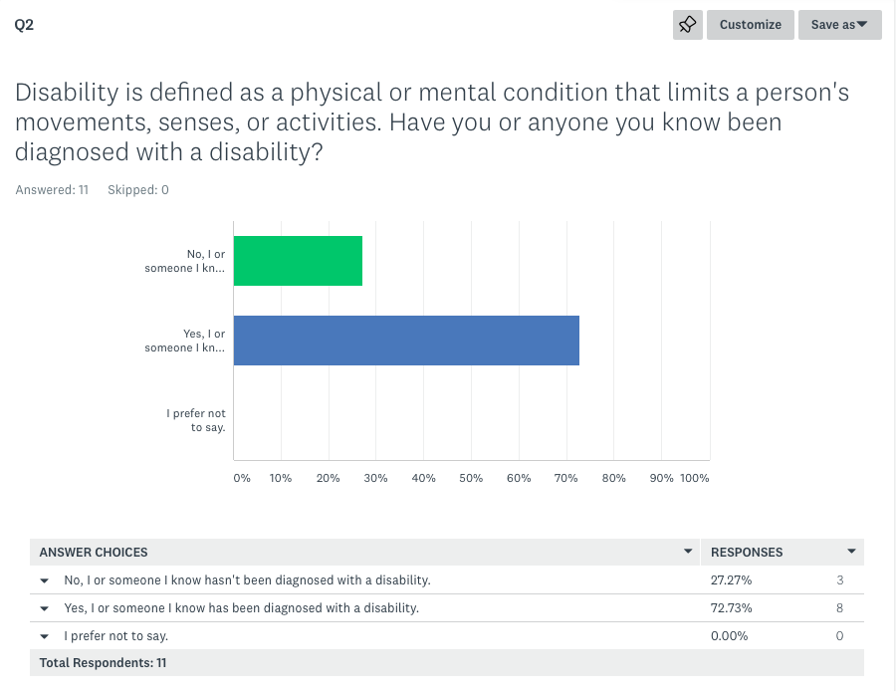
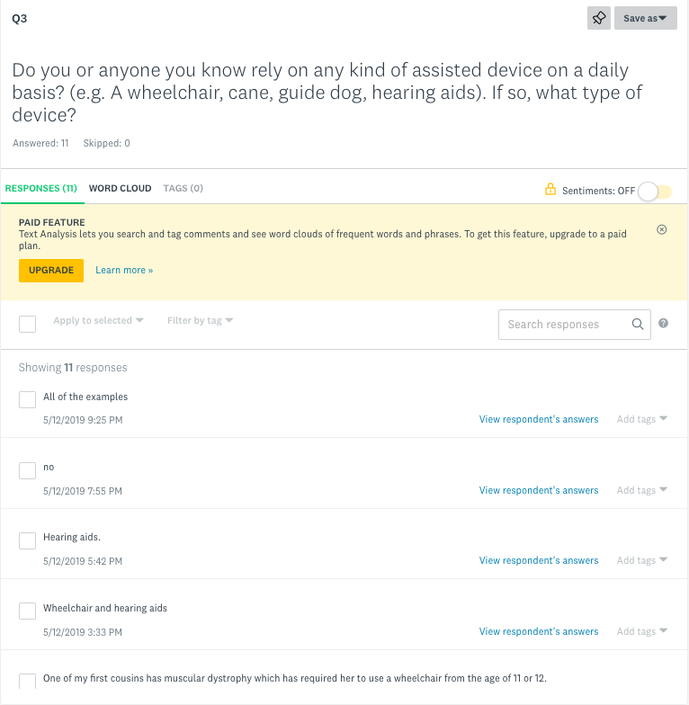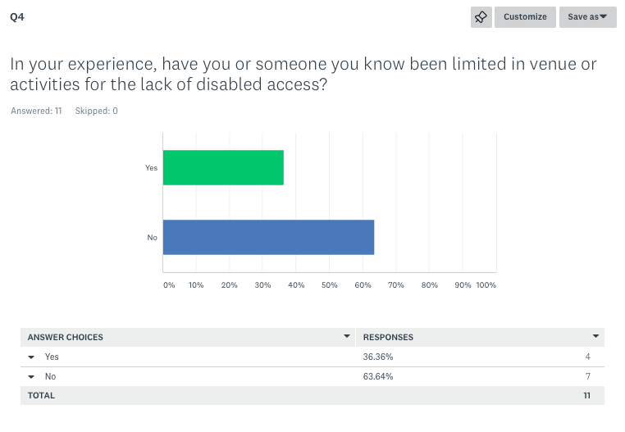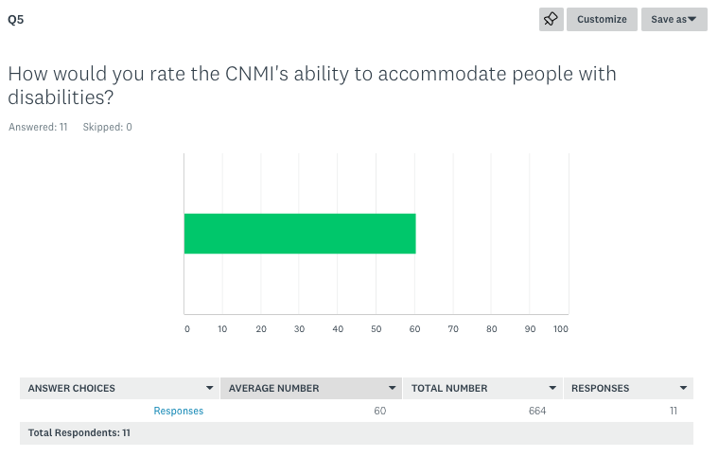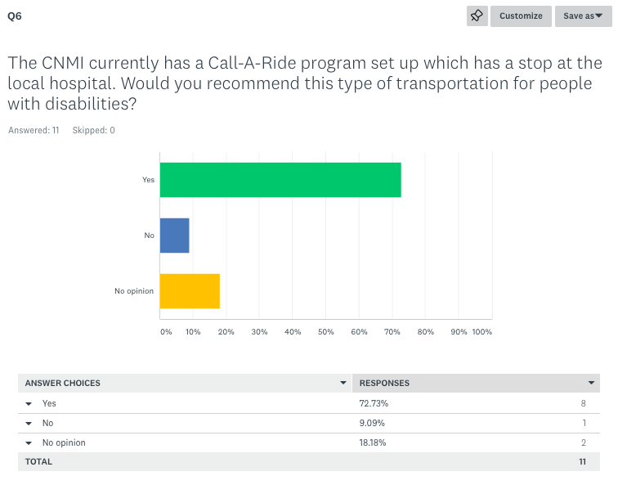

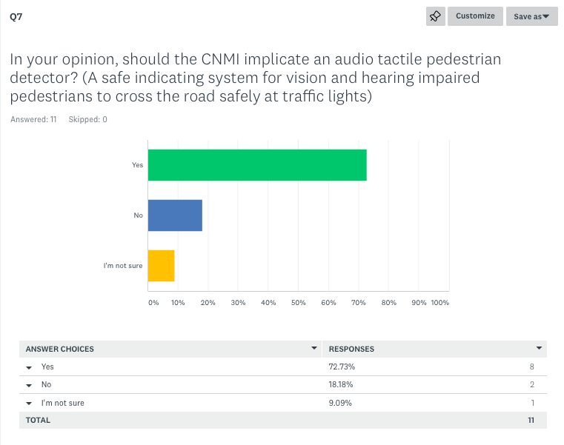
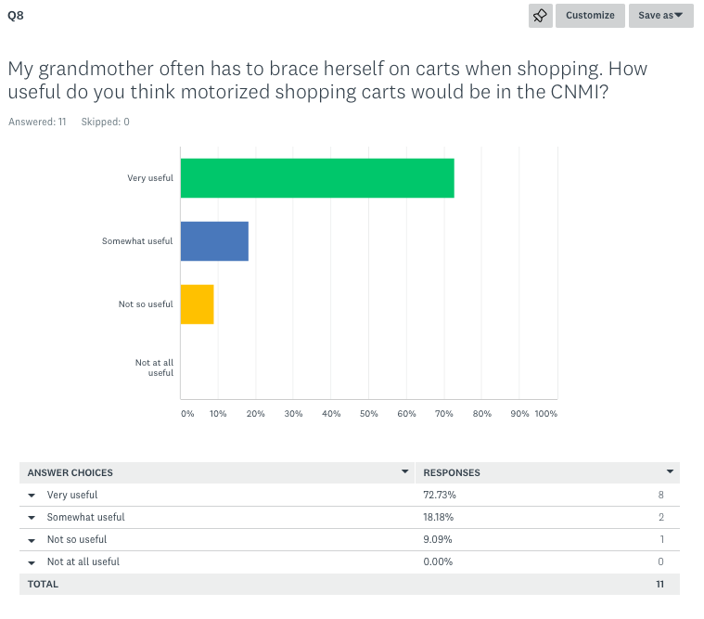
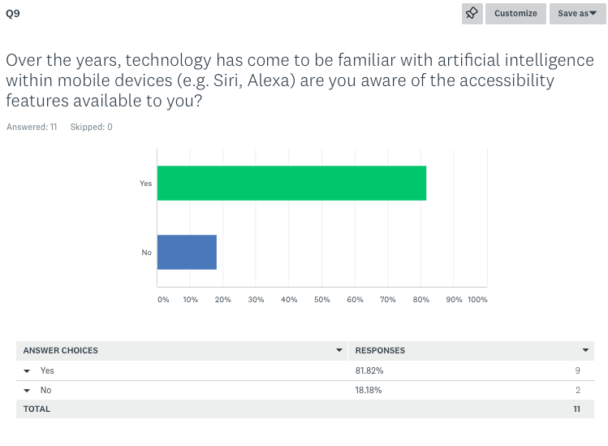

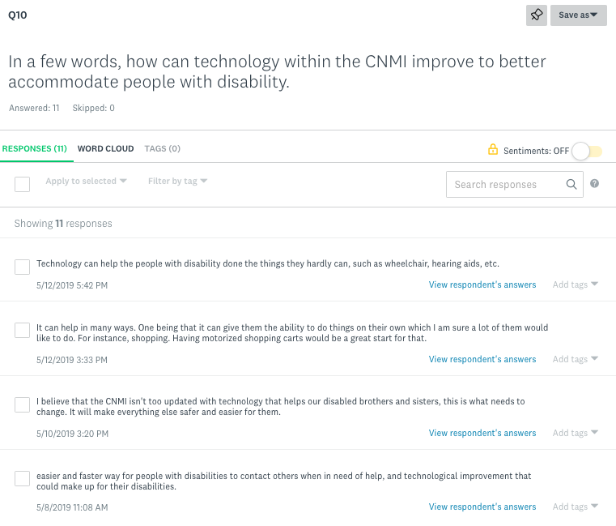

Appendix C: Interview

Number of Researchers: 1
Number of interviews: 1
Demographic: Female; Special Education Coordinator, PSS
Interview Questions:

1. In your opinion, what are some ways technology has helped to improve the lives of the impaired/disabled community? Have you noticed any harm or negative issues?
2. From your experience, has the lack of technology in your area affected an impaired/disabled individual? Please describe.
3. Do you believe that artificial intelligence (e.g. Siri, Alexa) can work to revolutionize elderly care? Please explain.

Appendix D: Interview Results

