Research Proposal
Mae Indalecio
Northern Marianas College
EN202-01
Dr. Kimberly Bunts-Anderson
Essay2_FinalDraft
October 6, 2018

Research Proposal
Why are pre-nursing students changing their minds? Perhaps the decrease of nursing students is due to the education or the job itself. When a person starts to think about their future career, there are many important things to consider. Someone may not be able to choose right away, but eventually they will find it. Going through college and getting a degree is the common way to help a person get a job, especially if it is a job that requires someone to have a license or a certification. One of the few degrees that Northern Marianas College (NMC) offers is an Associates in Science in Nursing (ADN). This degree prepares students to take a licensure exam, called National Council Examination – Registered Nurse (NCLEX-RN), which when they pass will allow them to work in the nursing profession. When attaining an ADN in Nursing, it usually takes about four years to complete due to various obstacles. When a student first decides to major in nursing they start off as a “pre-nursing” student. They spend about two years taking pre-requisite classes before being formally accepted into the nursing program. It is during this pre-nursing stage where students most often decide to change their major. Which brings about the question why are NMC students changing their major particularly, as the job outlooks are positive if they complete the program. The student researcher is proposing a study to uncover the reason behind these pre-nursing students change in majors. This proposal will exhibit literature that pertains to information about the lack of individuals in this major, the methodology that has been planned, and a schedule that has been organized to achieve the study within a six-week time.

Literature
There are both academic and non-academic sources of different literatures that are collected including academic journals and studies, newspapers, blogs, etc. The references listed below are a few sources that will be used to help with this research project.
Cassidy, V. R., & Oddi, L. F. (1991). Professional autonomy and ethical decision-making among graduate and undergraduate nursing majors: a replication. The Journal Of Nursing Education, 30(4), 149–151. Retrieved from http://search.ebscohost.com/login.aspx?direct=true&db=cmedm&AN=1646305&site=ehost-live
CNMI BILL TO ADDRESS NURSING SHORTAGE. (2006, November 20). Retrieved from http://www.pireport.org/articles/2006/11/20/cnmi-bill-address-nursing-shortage
Encinares, E. (2018, June 26). Proposed nursing scholarship extended from 5 to 6 years. Retrieved from https://www.saipantribune.com/index.php/proposed-nursing-scholarship-extended-from-5-to-6-years/
Fulcher, R., Mullin, C. M., & American Association of Community Colleges. (2011). A Data-Driven Examination of the Impact of Associate and Bachelor’s Degree Programs on the Nation’s Nursing Workforce. AACC Policy Brief 2011-02PBL. American Association of Community Colleges. American Association of Community Colleges. Retrieved from http://search.ebscohost.com/login.aspx?direct=true&db=eric&AN=ED522919&site=ehost-live
Kaminski, K. (2017, February 26). Munson, NMC address nursing shortages. Retrieved from http://www.record-eagle.com/news/local_news/munson-nmc-address-nursing-shortages/article_61984f3c-6943-5184-b0d1-585a9692507f.html
Maneval, R. E., & Teeter, M. M. (2010). THE STUDENT PERSPECTIVE on RN-Plus-10 Legislation: A Survey of Associate Degree and Diploma Nursing Program Students... with discussion. Nursing Education Perspectives (National League for Nursing), 31(6), 358–361. https://doi.org/10.1043/1536-5026-31.6.358
Merrifield, N. (2018, March 29). 'Historic decision' by NMC brings in raft of nurse education changes. Retrieved from https://www.nursingtimes.net/news/education/historic-decision-by-nmc-brings-in-raft-of-nurse-education-changes/7023913.article
Parlett, D. K. (2012, January 1). A Comparison of Associate and Bachelor Degree Nursing Students’ Motivation. ProQuest LLC. ProQuest LLC. Retrieved from http://search.ebscohost.com/login.aspx?direct=true&db=eric&AN=ED538067&site=ehost-live

Methodology
With literature giving the background to the research topic, surveys and interviews will be done for the foundation of why there is a switch of students in nursing to a non-nursing major. By conducting a survey to both nursing and non-nursing majors, it will help identify difficulties to why a student might keep or switch majors. The survey will be given to a total of 40 NMC students, 20 pre-nursing and 20 non-nursing majors. It will ask why these students chose this major, what they find difficult, and what is their motivation to overcome their difficulties. By interviewing, this will give absolute reasons to why individual made the switch to a non-nursing major. At least three students who were previously nursing majors will be interviewed on their stance. Getting the opinions of the NMC nursing advisors on why a student might switch will also be helpful.

Schedule
Gathering data from many sources through different means require an ample amount of time. By scheduling what needs to be done every week for six weeks will assure that the research project can be executed smoothly. Week one consists of collecting and analyzing literature to help draft survey and interview questions. On week two, the surveys will be distributed, and interview requests will be sent to NMC Nursing advisors and three students who have previously majored in nursing. Week three will be the desired week for the interview to take place, but it all depends on whether the interviewee will be available. Week four to six will consist of finalizing information and proofreading the project.

Schedule | Task
Week 1 | - Create Outline  - Collect all literature information  - Draft survey questions
Week 2 | - Finalize survey questions  - Draft interview questions  - Schedule interviews with NMC Nursing advisors and 3 previous nursing majors
Week 3 | Interview Week
Week 4 | Finalize all collected data
Week 5 | Have 2 people proofread the draft
Week 6 | Make any changes and finalize for submission

Conclusion
The purpose of this study is to uncover the reason behind on why pre-nursing students change their majors. This proposal has listed the literature that was collected, the methodology that has been planned, and a schedule that has been organized to achieve the study within a six-week time. This proposal should be approved because with this study we will be able to find the answer to why pre-nursing student change their minds about the nursing majors. With this answer NMC could create a new approach to increase the number of nursing students at NMC and maybe even increase the number of nurses in the Commonwealth of the Northern Marianas Islands (CNMI).

A Study on the Decrease of Nursing Students
Mae Indalecio
Northern Marianas College
EN202-01
Dr. Kimberly Bunts-Anderson
Process Essay
March 18, 2019

Abstract
Mae Indalecio, a student researcher conducted a six-week study aimed at finding the reason behind the decrease of nursing students at Northern Marianas College (NMC). This qualitative study illustrates the reason why there is a decrease in nursing students each year.The researcher found factors by reading through literature, distributing a survey, and conducting an interview. The student researcher wanted to explore the reasons by researching and inquiring previous and past students on their experiences. This study is important because it was discovered that the effect of the decrease in nursing students causes the need of registered nurses to increase too.

A Study on the Decrease of Nursing Students
Introduction
In the Fall semester of 2018, the student researcher, Mae Indalecio was tasked with creating a study of her interest. The student researcher decided to research on the question: Why are pre-nursing students changing their majors before entering the nursing program? The purpose of this study was to find out why pre-students would change their mind about enter the nursing program when it is right at their fingertips at NMC. This question poses important on the fact that there is a declining number of registered nurses on the island of Saipan as the years start to pass. Perhaps the decrease of nursing students is due to the education or the job itself.
Background
When a person starts to think about their future career there are many important things to consider. Someone may not be able to choose right away but eventually they will find it. Going through college and getting a degree is the common way to help a person get a job. Especially if it is a job that requires someone to have a license or a certification. One of the few degrees that Northern Marianas College (NMC) offers is an Associates in Science in Nursing (ADN).
This degree prepares students to take an exam, the NCLEX, which when they pass will allow them to get a job. When majoring in Nursing to get an ADN at NMC it usually takes a minimum of four years to complete but, due to various obstacles. When a student first decides to major in nursing they start off as a “pre-nursing” student. They spend about two years as a pre-nursing student taking pre-requisite classes before being formally accepted into the nursing program. It is during this pre-nursing stage that students most often decide to change their major. Which brings about the question why are NMC students changing their major particularly, as the job outlooks are positive if they complete the program.
Literature Review Essay
Process
At the beginning of this study the first thing that was done was to gain information through written literature about this topic. The student researcher had searched for literature on topics about nursing programs in the United States (US), degrees in nursing, and college students changing majors. After reading on these topics, the student researcher was able to make survey questions based on the missing information she did not get from the literature (See Appendix A). The survey was then put on a forum where composition students of Dr. Bunts-Anderson were able to access and answer the survey. On the week of waiting for respondents, the student researcher had set up an appointment with one of the nursing advisor’s at NMC named Mrs. Rosa Tudela. The student researcher had also emailed the Commonwealth Healthcare Corporation (CHCC) HR office and requested to set up a interview meeting with the person in charged. As the survey was posted and the scheduling of interviews were half way through the student researcher, had started to make draft questions to ask the NMC Nursing advisor (See Appendix B). While waiting for a response from the CHCC HR office the student researcher also started to try and find three experts she could ask questions to. This was the last step to collecting data that was needed for the research. Unfortunately, some steps had gone undone due to Typhoon Yutu hitting Saipan and taking a toll on the student researcher’s researching.
Analysis and Findings
Ths qualitative study took place in the fall semester from August 2018 to March 2019, looking at the issue of why pre-nursing student’s change their majors. Data was triangulated and was supposed to be collected in three ways: surveying, letters to experts, and interviewing. Initially data was to be collected through a pilot survey distributed to 35 NMC students through the ages 17 and up. The distribution was random, all students participating were in composition classes or other classes taught by Dr. Bunts-Anderson and participation was required in all composition classes. The pilot survey consisted of 17 questions: 8 questions on demographics, 6 close ended questions, and 3 open ended questions (See Appendix A). As a result of Typhoon Yutu the survey was only able to get a total of 8 respondents.
Analysis
The demographics for the survey are an important part because it tells us what type of people answered the survey. There was a total of 8 responses to all the questions. When asked about their ethnicity 50% of the respondents had chosen Filipino while there also was a 25% of Chamorros and 25% Korean. The age range of these respondents were from the years 18-27 and about 63% of them are working toward an Associate’s degree at NMC. The respondents also consisted of 63% sophomores and 37% freshmen. More than half of the respondents are receiving financial aid. A question about whether the respondent was working or not was asked 57% of the students were working either full or part-time jobs while 43% of students were unemployed. Of these students 86% of them were full time student while 14% was part time. And overall 71% of the students are US citizen.
Findings
With the information gather from the demographics of the 8 respondents we can conclude that majority of the respondents were in their young adult years of US citizenship. Also majority of them were employed while working full time. Since NMC does offers many associate degree programs it makes sense that most of the respondents were working towards their associate’s degree.
Analysis
Among the 18 questions on the survey that was distributed questions 2-10 were able to acquire some information regarding the research question. Question 2 of the survey asks the respondent if their current major was their first choice. 87.50% claimed yes while 12.50% said no and unsure. Question 7 asked if the person ever thought about changing their major. There was a solid 50% split between yes and no. Question 9 asks what the respondent thinks what is difficult about the nursing degree 57% says it’s time consuming while 14% thinks it’s the cost of getting the degree and 28% thought that the classes were what’s difficult. Question 10 asks the respondent whether the nursing program at NMC benefits the CNMI, no one answered no 25% were unsure and 75% answered yes it does.
Findings
With this information (See Appendix B) we could say that though none of the respondents are majoring in nursing they all respond that they think their current major is less difficult than the nursing major (See Appendix B). We can also say that choosing a major is highly based on interest, if the person does not enjoy or like their current major there is a high chance of switching out. Which proves that a factor of pre-nursing students switching out of nursing deals with loosing interest in the subject. We can also say that even though people think that the NMC nursing program will benefit the CNMI some may find it unimportant. According to question 10 although majority find benefits with in it, in question 9 they seem to contradict by choosing that it takes up too much time (See Appendix B). Also taking a look at survey questions 6 and 8 the respondents have noted that difficulty level is to high compared to their own majors nursing seems to have a high difficulty in their eyes (See Appendix B). From this survey we can concluded that difficulty is definitely a factor to why pre-nursing student may change their majors.
Analysis
The student researcher was able to conduct one informal interview with a few graduated nurses, only 5 questions were asked (See Appendix C). The graduated nursing students, who all wish to stay anonymous, had a lot of insight on what it’s like once a student enters the program. The graduates all agreed that they chose this major based on their interest but their drive to finish it was the financial cost.
Finding
The informal interview with the nursing graduates was able to scrape up good amount of information for this research (See Appendix C). According to the graduate nurses, they all unanimously agreed that though the nursing subject is very difficult, it was already too late to back out. They said “If I leave now, I would have wasted thousands of dollars on tuition and book fees, and nursing text books aren’t cheap.” The factor that they have invested a lot of time and money into pursuing this major was the biggest factor to go through with it. When asked to give advice to the pre-nursing students they all agreed to the quote, “Study hard during your prerequisite classes, you’ll regret it if you don’t.” What the student researcher could concluded from this information the reason a person would stay or leave all leads up to the cost and time invested into the major. There is a chance that most pre-nursing students have heard about the high difficulty level in the nursing program and chose to switch majors before experiencing it. To save them from investing too much of their time and money into pursuing the nursing major.
Discussion
The topic of why this study is important is because it led to a great factor of the diminishing number of nurses on the island of Saipan. With the Contract Worker (CW) issue more and more nurses at CHCC are starting to leave. Less number of nursing students increases the need of more nurses at CHCC. A hospital with out nurses won’t be able to function, the nurses play a big part in helping it function. It is also important because our future health system depends on it.
Conclusion
Due to the devastation of Typhoon Yutu this study had to be cut short. Though the information that the student researcher was able to gather gave two answers, many questions were still left unanswered. This study was start through the curiosity of a student wondering why there is a decreasing number of pre-nursing students at NMC. The student researcher was able to gather factors to why a pre-nursing student may switch out. But nothing is confirmed because the study was not finished. The student researcher does not plan on continuing this study seeing that the information gather can lead to a prediction that the answer may vary from person to person because the decision to change majors depends on their situation and personality.

Appendix
Appendix A
Survey Questions:
- Demographics: ethnicity, age, degree, class level, financial aid status, employment status, student status, and citizenship
- Is your current major your first choice?
- What made you choose your major?
- What are some challenges about your major?
- Why do you think students change their majors?
- On a scale from 1-10 how difficult is your major?
- Have you ever thought about changing you major?
- On a scale from 1-10 ho difficult do you think the nursing major is?
- What do you think is most difficult about majoring in nursing?
- Does the nursing program at NMC benefit the CNMI?
Appendix B
Interview questions Draft
- How long have you been working here at NMC in the nursing department?
- What was the number of students at the start of the nursing program?
- What is the current number of nursing students in the program this year?
- Why do you think the CHCC is in great need of nurses?
- Why do you think a pre-nursing student would discontinue the nursing major?
- How do you plan to get more people to apply to the nursing major/program?
- Do you think in the future the need of nurses would start to decrease or increase more?
Appendix C
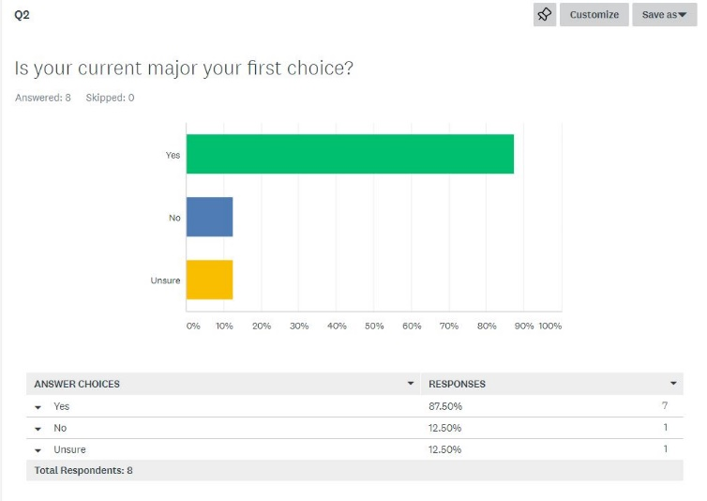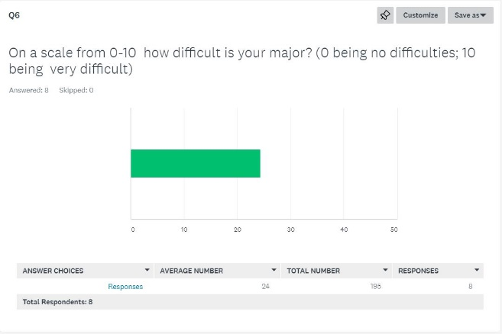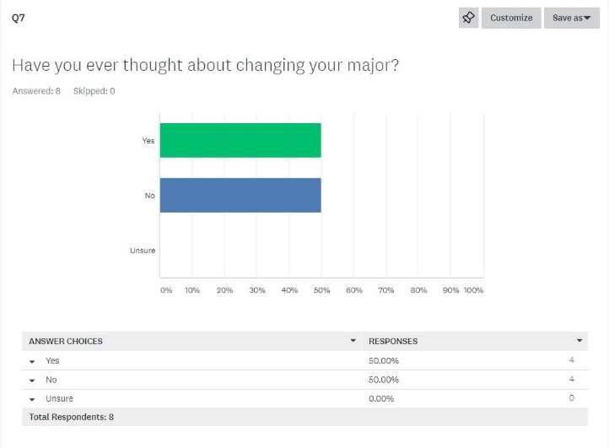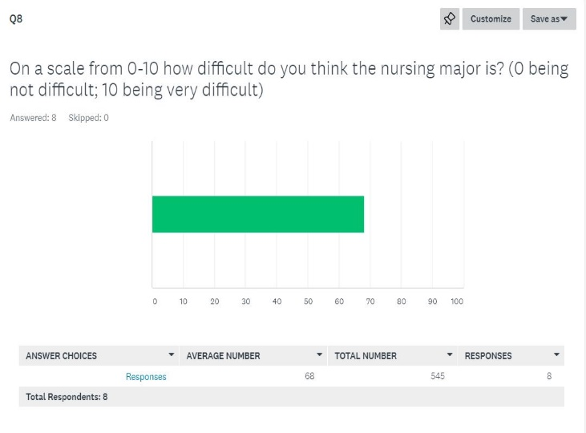
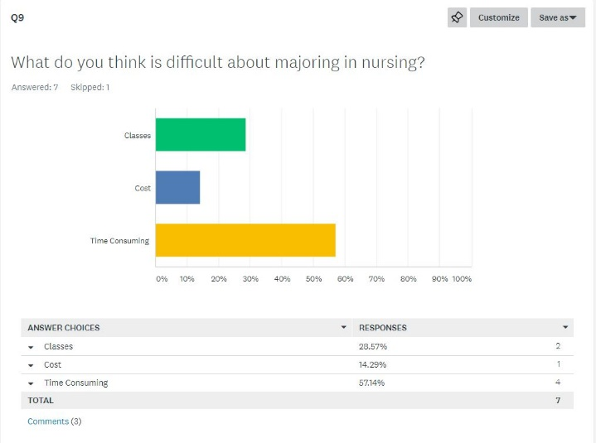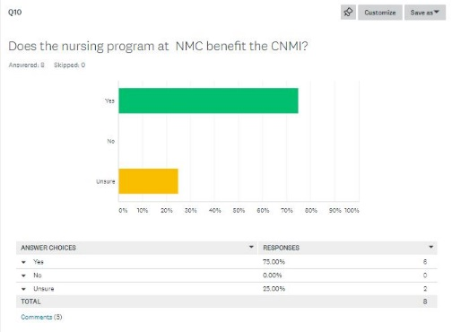
Appendix D
Informal Interview Questions w/ graduated nursing students:
- What is most difficult about the nursing program once you have entered?
- How much money did you spend during the first year of the program?
- Did you ever have thought of leaving the nursing program?
- Do you plan on getting a higher nursing education level?
- Any advice for the pre-nursing students?

Works Cited
Cassidy, V. R., & Oddi, L. F. (1991). Professional autonomy and ethical decision-making among graduate and undergraduate nursing majors: a replication. The Journal Of Nursing Education, 30(4), 149–151. Retrieved from http://search.ebscohost.com/login.aspx?direct=true&db=cmedm&AN=1646305&site=ehost-live
CNMI BILL TO ADDRESS NURSING SHORTAGE. (2006, November 20). Retrieved from http://www.pireport.org/articles/2006/11/20/cnmi-bill-address-nursing-shortage
Encinares, E. (2018, June 26). Proposed nursing scholarship extended from 5 to 6 years. Retrieved from https://www.saipantribune.com/index.php/proposed-nursing-scholarship-extended-from-5-to-6-years/
Fulcher, R., Mullin, C. M., & American Association of Community Colleges. (2011). A Data-Driven Examination of the Impact of Associate and Bachelor’s Degree Programs on the Nation’s Nursing Workforce. AACC Policy Brief 2011-02PBL. American Association of Community Colleges. American Association of Community Colleges. Retrieved from http://search.ebscohost.com/login.aspx?direct=true&db=eric&AN=ED522919&site=ehost-live
Kaminski, K. (2017, February 26). Munson, NMC address nursing shortages. Retrieved from http://www.record-eagle.com/news/local_news/munson-nmc-address-nursing-shortages/article_61984f3c-6943-5184-b0d1-585a9692507f.html
Maneval, R. E., & Teeter, M. M. (2010). THE STUDENT PERSPECTIVE on RN-Plus-10 Legislation: A Survey of Associate Degree and Diploma Nursing Program Students... with discussion. Nursing Education Perspectives (National League for Nursing), 31(6), 358–361. https://doi.org/10.1043/1536-5026-31.6.358
Merrifield, N. (2018, March 29). 'Historic decision' by NMC brings in raft of nurse education changes. Retrieved from https://www.nursingtimes.net/news/education/historic-decision-by-nmc-brings-in-raft-of-nurse-education-changes/7023913.article
Parlett, D. K. (2012, January 1). A Comparison of Associate and Bachelor Degree Nursing Students’ Motivation. ProQuest LLC. ProQuest LLC. Retrieved from http://search.ebscohost.com/login.aspx?direct=true&db=eric&AN=ED538067&site=ehost-live

Reading Notes to fill out when reading course and outside reading materials for assignment

Note Taking Sheet: Reading # 01

Course EN COURSE NAME EN202 Section 01

With many sources to read and evaluate, you need a way to keep track of the material you may use in your research paper. You need to record where you have looked, what you have found, and how to find each piece of information again (this is for your bibliography).

Directions: Fill in the information below, and keep with all of your resources. This will help you when it is time to write both your outline, paper, and annotated bibliography.

1. Author’� s Name: Press Release Bruce Ballenger
2. Author’� s Credentials (Press Release): Emeritus Professor of English and former department Chair at Boise State University, specializing in composition theory, inquiry-based learning, and creative nonfiction, author of seven books, and published more than thirty articles and essays.
3. Publisher [or title of organization]: Pearson Education Inc.
4. Heading of Section [title of reading]: The Second Week 5. Year Written: 2015 6. Pages: 57-58, 61, & 83-84
7. Website URL: [textbook]

Main Ideas/Points | Important Quotations | Supporting Details | Relevance to Your Assignment
- (pg 82) “Ask your friends and instructors”  - (pg 83) “Checking the Internet” | - No quotations used. | - (pg 82) “One of your instructors may know other faculty working in your subject area who would do an interview.”  - (pg 83)” You can use the Internet to find the e-mail addresses and phone numbers of many scholars and researchers, including those affiliated with your own university and ones nearby.” | - This relates to my topic because it helps me figure out ways to find and contact experts I need for my research topic.
Main Ideas/Points | Important Quotations | Supporting Details | Relevance to Your Assignment
- (pg 57) Find Varied Sources | - (pg 58) “Are they primary or secondary sources? Are the objective or subjective? Are they stable or unstable?” | - (pg 57) “In part, the kinds of sources you rely on in preparing your paper depend on your topic.”  - (pg 58) “There are several ways to think about how sources can be distinguished from each other…” | - This relates to my topic because it gave me tips on what sources to use, like what sources to use, etc.
- (pg 61) Look for Often-Cited Authors | - No quotations used. | - “…pay attention to the names of authors whose works you often encounter or who are frequently mentioned in bibliographies. These individuals are often the best scholars in the field…” | - This related to my assignment because it helped me identify experts for my topic through reading my literature.

In this article, is it possible that any of the authors might have a bias about the subject matter? No, it’s a textbook so it’s usually not bias. provide examples if needed.

Is the article timely or a bit outdated? Timely.

Was it published in a reputable source? Yes.

It is not an academic source. No.

Other important information:

Reading Notes to fill out when reading course and outside reading materials for assignment

Note Taking Sheet: Reading # 02

Course EN COURSE NAME EN202 Section 01

With many sources to read and evaluate, you need a way to keep track of the material you may use in your research paper. You need to record where you have looked, what you have found, and how to find each piece of information again (this is for your bibliography).

Directions: Fill in the information below, and keep with all of your resources. This will help you when it is time to write both your outline, paper, and annotated bibliography.

1. Author’� s Name (Press Release): Kyle Kaminski
2. Author’� s Credentials (Press Release): Crime Reporter, Central Michigan University alumnus.
3. Publisher [or title of organization]: Record Eagle
4. Heading of Section [title of reading]: Munson, NMC address nursing shortages 5. Year Written: 2017 6. Pages: 1
7. Website URL: http://www.record-eagle.com/news/local_news/munson-nmc-address-nursing-shortages/article_61984f3c-6943-5184-b0d1-585a9692507f.html

Main Ideas/Points | Important Quotations | Supporting Details | Relevance to Your Assignment
- Shortages of Nurses | - “The American Nurses Association predicts about 1.13 million registered nurses will be needed nationwide through 2022.” | - “We’re always working in a shortage situation.” | - This is related to my topic because it explains that the shortages of nurses aren’t only on Saipan but worldwide.
Main Ideas/Points | Important Quotations | Supporting Details | Relevance to Your Assignment
- Difficulties of the Nursing | - “The U.S. Bureau of Labor Statistics deemed a baccalaureate degree in nursing as the “typical entry-level qualification” into the field.” | - “But a 51-year-old Michigan law grants only four-year universities the legal ability to offer the program.”  - “A baccalaureate degree is becoming the entry-level credential in many fields.” | - This relates to my topic because it talks about the difficulties of obtaining a nursing degree.
- The Education System | - ““There is no documented, critical need to change the conditions here,” Cotto said.”  - Other NMC leaders advocate for the ability to confer the BSN degree | - “Lawmakers effectively killed state Sen. Mike Shirkey’s Senate Bill 0098 to expand community college offerings shortly after it was introduced in 2015. And many still think the Republican-led state Senate is unlikely to produce a change.” | - With most nursing jobs requiring people to obtain a BA in nursing it’s getting more difficult for others. This relates to my topic because it talks about how not all people are for the idea of helping the nursing education system.

In this article, is it possible that any of the authors might have a bias about the subject matter? provide examples if needed. No, because this article is mostly quoting the people that were interviewed. None of the authors opinions are in the article.

Is the article timely or a bit outdated? Probably a bit outdated.

Was it published in a reputable source? Yes.

It is not an academic source. Yes.

Other important information:

Writing Schedule
Original:
Schedule | Task
WEEK 1 | - Create Outline  - Collect all literature information  - Create survey questions  - Work on Draft 1  - Schedule interview with CHCC HR, Saipan Health Clinic, Marianas Medical Clinic & NMC Nursing Advisor
WEEK 2 | - Distribute the survey to at least 20 pre-nursing students  - Create interview questions  - Schedule interview with CHCC HR, Saipan Health Clinic, Marianas Medical Clinic & NMC Nursing Advisors
WEEK 3 | - Interview week  - Work on Draft 2
WEEK 4 | - Finalize all the information from the literatures, survey, and interviews (make sure all its all included in Draft 2)  - Proofread the Draft
WEEK 5 | Have at least two people proofread the Essay
WEEK 6  December | Finalize all the changes for the final draft.
Adjusted Version:
Schedule | Task
WEEK 1 | - Create Outline  - Collect all literature information  - Create survey questions  - Work on Draft 1  - Schedule interview with CHCC HR, Saipan Health Clinic, Marianas Medical Clinic & NMC Nursing Advisor
WEEK 2 | - Distribute the survey to at least 20 pre-nursing students  - Create interview questions  - Schedule interview with CHCC HR, Saipan Health Clinic, Marianas Medical Clinic & NMC Nursing Advisors
WEEK 3  October | - Interview week (canceled)  - Work on Draft 2
WEEK 4  Feburary | - Finalize all the information from the literatures, survey, and interviews (make sure all its all included in Draft 2)  - Proofread the Draft
WEEK 5  March | Have at least two people proofread the Essay
WEEK 6  March | Finalize all the changes for the final draft.

Original Brainstorm:
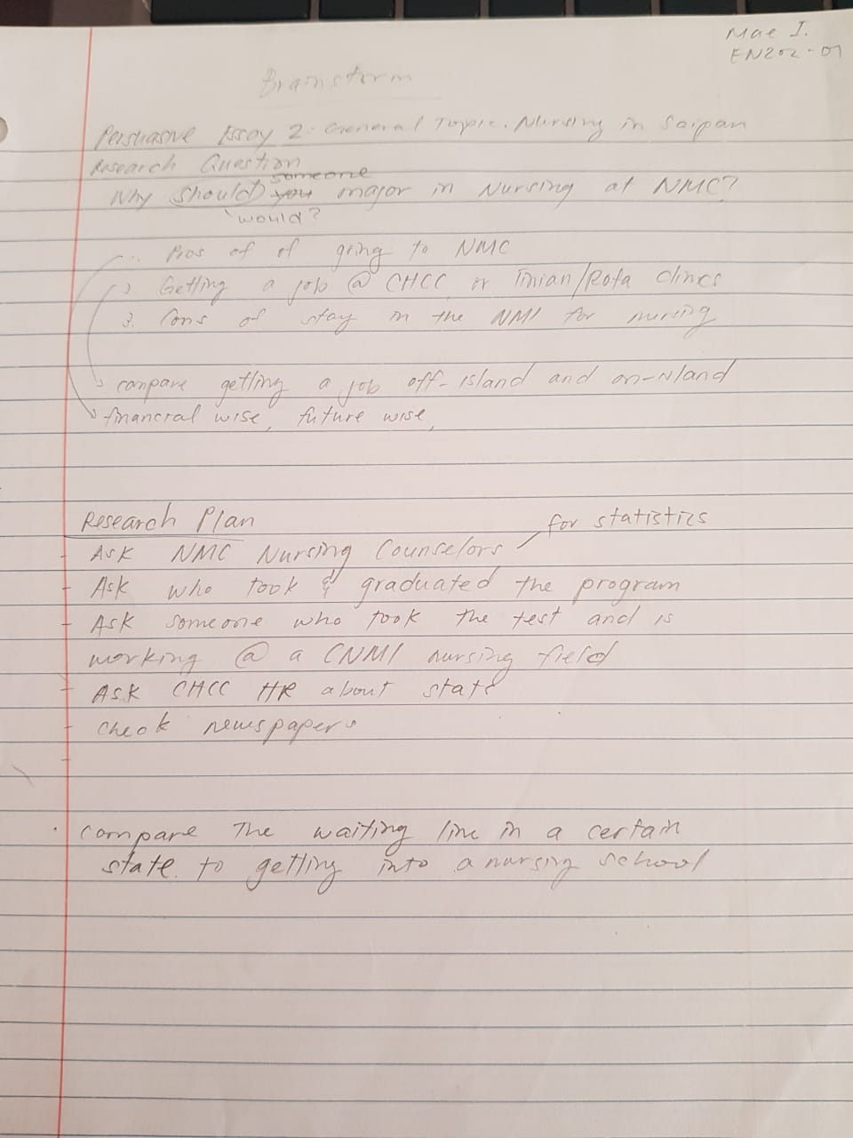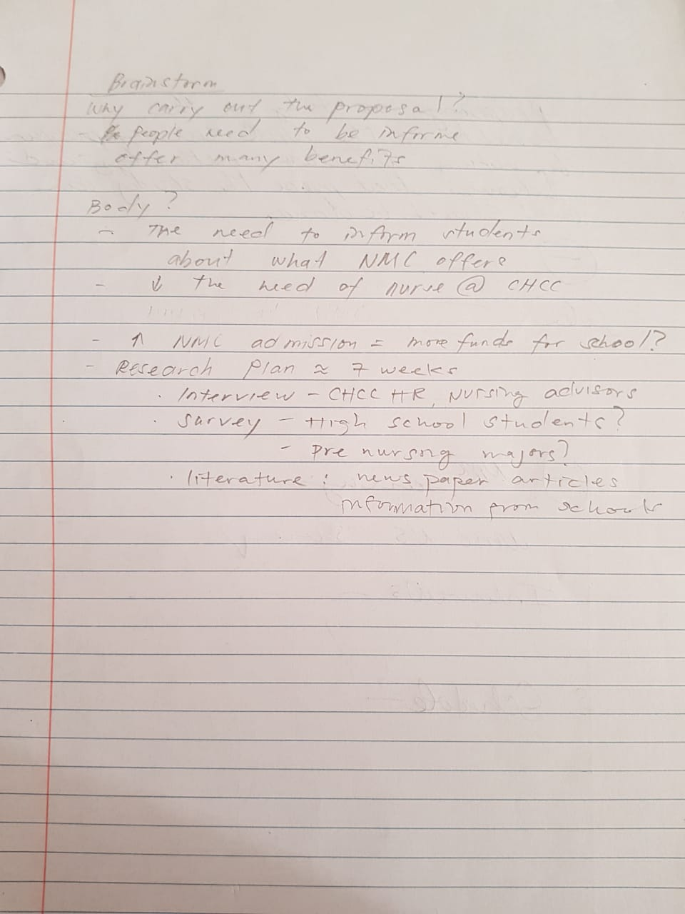

Online Sources:
Cassidy, V. R., & Oddi, L. F. (1991). Professional autonomy and ethical decision-making among graduate and undergraduate nursing majors: a replication. The Journal Of Nursing Education, 30(4), 149–151. Retrieved from http://search.ebscohost.com/login.aspx?direct=true&db=cmedm&AN=1646305&site=ehost-live
CNMI BILL TO ADDRESS NURSING SHORTAGE. (2006, November 20). Retrieved from http://www.pireport.org/articles/2006/11/20/cnmi-bill-address-nursing-shortage
Encinares, E. (2018, June 26). Proposed nursing scholarship extended from 5 to 6 years. Retrieved from https://www.saipantribune.com/index.php/proposed-nursing-scholarship-extended-from-5-to-6-years/
Fulcher, R., Mullin, C. M., & American Association of Community Colleges. (2011). A Data-Driven Examination of the Impact of Associate and Bachelor’s Degree Programs on the Nation’s Nursing Workforce. AACC Policy Brief 2011-02PBL. American Association of Community Colleges. American Association of Community Colleges. Retrieved from http://search.ebscohost.com/login.aspx?direct=true&db=eric&AN=ED522919&site=ehost-live
Kaminski, K. (2017, February 26). Munson, NMC address nursing shortages. Retrieved from http://www.record-eagle.com/news/local_news/munson-nmc-address-nursing-shortages/article_61984f3c-6943-5184-b0d1-585a9692507f.html
Maneval, R. E., & Teeter, M. M. (2010). THE STUDENT PERSPECTIVE on RN-Plus-10 Legislation: A Survey of Associate Degree and Diploma Nursing Program Students... with discussion. Nursing Education Perspectives (National League for Nursing), 31(6), 358–361. https://doi.org/10.1043/1536-5026-31.6.358
Merrifield, N. (2018, March 29). 'Historic decision' by NMC brings in raft of nurse education changes. Retrieved from https://www.nursingtimes.net/news/education/historic-decision-by-nmc-brings-in-raft-of-nurse-education-changes/7023913.article
Parlett, D. K. (2012, January 1). A Comparison of Associate and Bachelor Degree Nursing Students’ Motivation. ProQuest LLC. ProQuest LLC. Retrieved from http://search.ebscohost.com/login.aspx?direct=true&db=eric&AN=ED538067&site=ehost-live
Survey Analysis Link: https://www.surveymonkey.com/results/SM-SZB72R3MV/

