Voting in the CNMI
The Importance of Voting in the CNMI
Erica Leon Guerrero
Northern Marianas College

Author’s Note:
This paper was prepared for English 101, Online-01, taught by Dr. Kimberly Bunts-Anderson

Table of Contents
Abstract 3
Introduction 4
Literature Review 4
Methodology 6
Analysis 8
Conclusion 9
References 10
Appendices 11
Appendix A: 11
Appendix B: 11
Appendix C: 12
Appendix D: 12
Appendix E: 13
Appendix F: 14

Abstract

For centuries, local elections have shaped the way we live here in the Commonwealth of the Northern Marianas Islands (CNMI). The CNMI being a small island run by a municipal council; these local elections are significant to our islands. Many citizens may feel like their voices have not been heard, or feel no need to vote because they do not know their candidates. In this research paper, the importance of voting in the CNMI will be addressed. The data presented had been collected through numerous surveys, online and academic research, as well as interviews with people of many different age groups ranging from 17-55. I am writing this essay not only to share the importance of voting, but the opinions of others in the topic of voting in the CNMI.

Introduction

Municipal elections are nothing new to the citizens of the CNMI. Local elections bring out meetings, family gatherings, and invigorating rallies. Although our elections may not seem as thrilling as the United States, we are indeed seeking for the same outcome. We are looking for strong leaders to administer and guide us. We rely on these officials to manage our hospitals, our school system, and our villages. Citizens often forget the importance of voting and all the unauthorized authority we give out to candidates when we do not.

Literature Review

One very important academic source to the student researcher’s topic that supports her research project is a handout, “We Are All West Virginia” by the Secretary of State in West Virginia, Natalie Tennant. This source supports the student researcher’s topic in many ways, but mostly in the sense that if a person does not vote, they allow others to make decisions for them. “It's your money. The county commissioners, governor, state treasurer, legislators, President and members of Congress you vote for will decide how to spend your money, vote for those that agree with your point of view” (Tennant, N/A). The citizens of the CNMI rely on a council to provide good education, healthcare, and safety to their villages. When a citizen of the CNMI does not vote, he/she is often left with a municipal council who has a different point of view from its citizens.
Another very important academic source to the student researcher’s topic that refutes her research project is a website article, “Voter Turnout at 20-Year Low in 2016”, provided by CNN Politics. In this academic source, it refutes the student researcher’s topic with the importance of voting because although citizens of the United States have continuously showed their disagreements towards the idea of Donald Trump being their president, he had won anyways. “That measure of turnout is the lowest in a presidential election since 1996, when 53.5% of voting-age citizens turned out” (Wallace & Yoon, 2016). The following source connects to a non-academic source, “Turn out Kind of Low”, provided by a local newspaper company in the CNMI, The Saipan Tribune. The source explains the low turnout of voters in the CNMI for the year of 2016 as well. Citizens of the CNMI have constantly voiced their concerns towards the works of their municipal council, but still many citizens have not progressed to changing their government officials. “Out of 17,930 registered voters, only 10,993 voted, which comes out at 61.31 percent participation” (Encinares, 2016).
Another source that supports the student researcher’s topic is a blog, “Voting: What is the Point?” by Lorraine Wilke. This source explains the facts of what major decisions a president can make that shapes our everyday lives but most especially the laws we are to abide. “Because to not vote is to have no hand in who gets those aforementioned powers, no influence in choosing who might be the better choice, even if, in your mind, they’d be “the lesser of two evils” (Wilke, 2012). Just like in the CNMI, the buildup of the Best Sunshine casinos has been a back and forth issues with the citizens of the CNMI and the elected municipal council. Although people have voted “No” to the casino, candidates who are for the casino are being elected. This source supports the importance of voting in the CNMI because the citizens of the CNMI have a say of who they give power to.

Methodology

First, with a well thought outline and a clear overview of her topic, the student researcher proceeded on to creating a survey as one method of collecting data. Using the online survey generator, www.surveymonkey.com, she was able to incorporate the questions she created in her outline. For example, “How do you think your vote will help towards the betterment of the CNMI?” The student researcher then shared her survey with her classmates and instructor on their designated google forum for peer feedback. This is her test-run survey, or her ‘pilot survey’. After reviewing the helpful comments/suggestions left by her peers, she had taken the initiative of following their advice and applying it on to her final survey. One of the many comments that stood out to her was by one of her peers, Yijia Zhao, who commented, “I think your survey questions are really good, all relevant to your topic which is local elections. I like your question #5, the thumb scale is really cool. It’s actually the first time I’ve ever seen it in that format. It is good that you have some comments box for people. And the example really helps people to understand your question.” In addition, the student researcher was able to edit her survey removing all grammar issues and leading questions as well as questions that may stand as leading or offensive.
Second, the student researcher then created a list of ‘experts’ to share her survey with as this is her second method of collecting data. Local voting being her research topic, she had chosen to interview both Congressmen Edwin K. Propst and Angel Demapan. After selecting these two out of a list of many government officials shared by the CNMI Legislature website, www.cnmileg.gov.mp, she was also able to get hold of their contact information and addresses. Another expert she had chosen was the Director of the CNMI Election Commission, Ms. Julita Villagomez. The student researcher was able to retrieve information about Ms. Villagomez by paying an office visit to the Election Commission office. After creating a list of experts and retrieveing as much information on them, the student then started working on her “Letter to Experts”. This “Letter to Experts” is a short letter written formally to the specific expert requesting their permission to be interviewed by the student researcher. The student researcher then distributed her survey via office visits and email. (Unfortunately, due to the hectic schedule of the government officials because of the upcoming election, she has yet to hear back.)
Lastly, the student researcher moved on to her third method of collecting data, by interviewing voters and concerned citizens of the CNMI. She interviewed these voters not only by the survey she had created, but by questions she observed concerned voters asked repeatedly. One question she used to interview Brabu Pharmacy and Wellness Center’s Pharmacist, Theodore Parker, was, “Why do you think it is important to vote in the 2016 CNMI election?” Mr. Parker’s answer was, “The whole purpose of being in a democracy is to participate in it, and the way to participate in a democracy is to vote”. Note that the people she had chosen were very active, and unconcerned voters at random. Another question asked and answered by CNMI citizen, Ms. Kina Sablan was, “What characteristics do you look for in a candidate?” Ms. Sablan replied, “I look for candidates who can serve the community well without being selfish and biased”. Lastly, she interviewed a DPS employee, who wanted to remain anonymous, the question, “From one to ten, rate the level of nepotism and scandal in the CNMI”. The DPS employee answered, “Nine, because people only vote for the people they know personally but when it comes to getting the job done, you are related to no one”. With the data she was able to collect and will be collecting, the student researcher continuously updates her excel spreadsheet for further analyzation.

Analysis

As time has gone on and numerous surveys and interviews had passed, data had been collected and analyzed thoroughly. The student researcher had come upon many people who had answered no to her question, “Are you at the legal age of 18, a U.S. citizen, and had registered to vote?” in the survey that she distributed. She then asked in the next question to further explain why, and had come upon answers that explained that they were either not old enough, or not eligible to vote in the CNMI (Appendix A). Although there are many people here on island, some people are not able to cast a vote because of citizenship. It makes voting even more important here on CNMI because we are voting for others as well.
In her survey, the student then asked, “What is one word that you could use to describe the changes that the village congressmen have made to your village?”, it was surprising to find out that many people have answered “little to none” (Appendix B). This makes voting important because we want to vote for people who will get the job done!
Although all her survey takers had voted yes to her question “Do you think citizens should be more involved in elections?” (Appendix C), the average vote on a 1-5 scale of the question “How important is voting to you?” was 3 (Appendix D). This has resulted in the analyzation that although may people feel that citizens should participate more in local elections it is of little importance to them which is indeed a contradiction.
In a personal interview with citizens from the CNMI, many great answers had come up when asked “Why do you think voting is important?” (Appendix E). A great amount of participation in the student researchers survey that had been noted was from college students whose ages ranged from 17-24 (Appendix F).

Conclusion

In conclusion, although many people feel that voting here in the CNMI is important, many still do not know the significance of it. Voting is one great way to express your thoughts on issues that you feel need to be fixed, or simply to have your voice be heard. Coming from a small community run by a municipal council, it is just as important to vote because people are more affected by what is going on as a whole. The CNMI is a melting pot of cultures and different citizenships, and as a U.S. citizen with the rights to vote, many are counted on to make the right decisions for others as well. Personally, voting is important to me because it is what controls our islands and what our daily activities are based on. When we don’t vote, we allow people to make decisions that we don’t agree with. Your single vote will not only save yourself and the people around you, but preserve the indigenous culture of the CNMI.

References

Encinares, E. (2016, November 11). Turn Out Kind of Low. Saipan, MP, United States: Saipan Tribune.
Tennant, N. (N/A). We Are All West Virginia. A Civics Education Program. Retrieved from www.wvsos.com
Wallace, G., & Yoon, R. (2016, November 12). CNN Politics. Retrieved from edition.cnn.com: http://edition.cnn.com/2016/11/11/politics/popular-vote-turnout-2016/
Wilke, L. D. (2012, December 07). Voting: What is the Point. The Huffington Post. United States. Retrieved from http://www.huffingtonpost.com/lorraine-devon-wilke/importance-of-voting_b_1944496.html

Appendices

Appendix A:
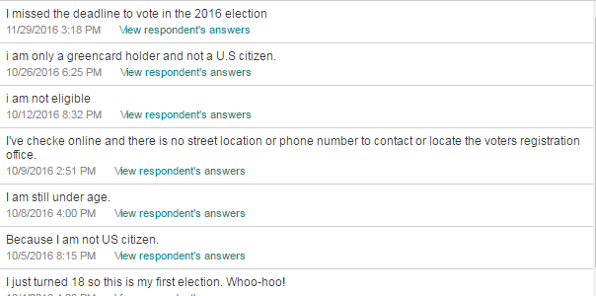

Appendix B:

Appendix C:
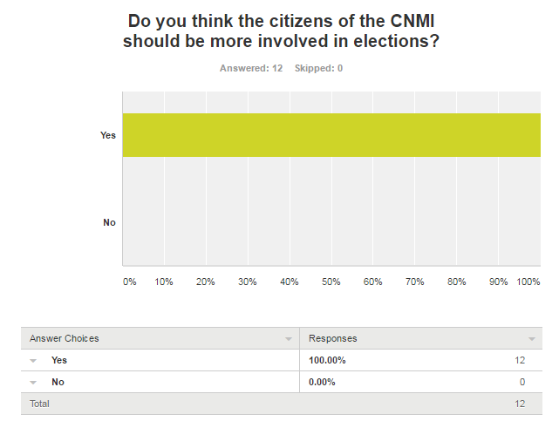
Appendix D: 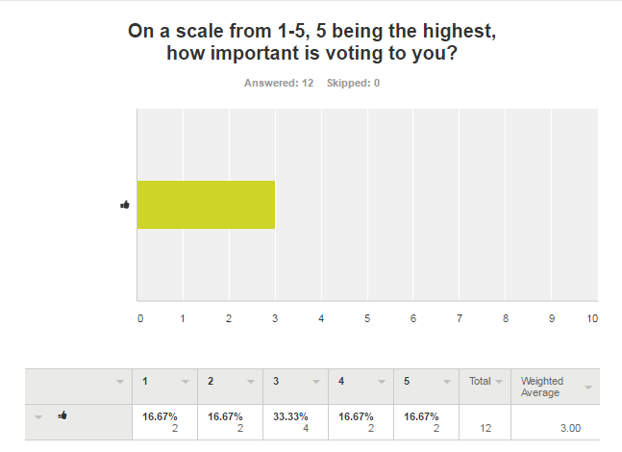

Appendix E:
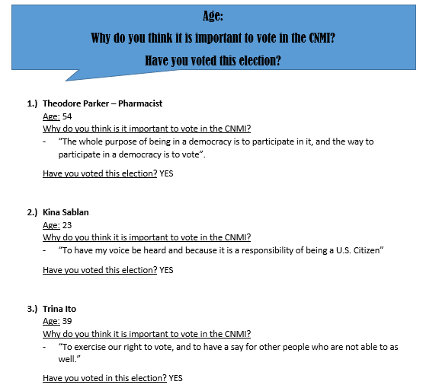

Appendix F:
