Final Draft of Research Paper:
CNMI-Only Transitional Worker Visa
Su A Kim
Dr. Kimberly Bunts-Anderson
EN 202 – 02
March 04, 2018
Northern Marianas College
Table of Contents
Abstract 3
Introduction 4
Literature Review 4
Research Questions 5
Methodology 6
Findings / Analysis 7
Discussion 7
Conclusion 8
References 9
Appendices 11
Appendix A 12
Appendix B 13
Appendix C 14
Appendix D 15
Appendix E 17

Abstract
This research explores whether the CW visa affects companies like I Love Saipan, how people feel about the CW visas, and to know whether they think the decreasing of CW visa is good or bad to our economy. Kim wanted to research whether it would have a big influence to CNMI. In addition, Kim also wanted to know what would happen to CW visa holders after the program end on Dec. 31, 2019. The information was gathered by conducting a survey, interviews, and from the literatures that was searched. This study is important because it provides the information about the CW visa and how people feels about it.

CNMI – Only Transitional Worker Visa
Anyone who lives in Saipan would have heard about the CNMI-Only Transitional Worker (CW) visa, the CNMI-only transitional worker visa, which “allows employers in the Commonwealth of the Northern Marianas Island to apply for the permission to employ foreign (nonimmigrant) workers who are otherwise ineligible to work under other nonimmigrant worker categories” (USCIS, August 28, 2017). Especially for those people that are CW visa holders. The CW visa has been an issue for the CNMI because of the cap of the visa. The cap of the visa has been decreasing and it will decrease in the future, which will cause the decrease in the labor.
Literature Review
The CW visa program is scheduled to end on December 31, 2019. This had lead Governor Torres expressed the need for the CW program to continue, adding that an adequate workforce is critical to the economic success of the CNMI” (Villahermosa, April, 2017). But in the other side, people think that the CW visa should not extend. The reason for this is because there were lots of people, especially Chinese, are committing a visa fraud. “Bruce Mailman, an attorney at Mailman & Kara in Saipan, who has worked with companies employing workers on the CW-1 visa” (The Associated Press, 2018) said, “Seen from the distance of Washington, D.C., this looks like a program that doesn't deserve to be continued — it's not being properly monitored for abuse” (The Associated Press, 2018).
Researches showed that the CW visa program is also an important part of personnel recruitment for many businesses. For example, I Love Saipan, Alex Youn, the president of I Love Saipan, said, “It’s going to be hard to find language skilled workers immediately to try to do sales. We rely on them to provide personal service to our customers and that is one of the things that our customers like about the stores—that there is someone here who can talk to them and help them pick out items they need” (Cabrera, 2017). He expressed the difficulties that the company is facing after the decrease of CW visa holders. According to U.S. Congressman Gregorio Kilili Camacho Sablan, “those U.S. workers are now at risk of losing their jobs, because by cutting the CW workforce in half — from the FY2018 cap of 9,999 to 4,999 in FY2019 — the Trump administration will cause the Marianas economy to shrink” (Villahermosa, March, 2018). He also added, “Right now I know that it’s a big concern for businesses and their employees, but we just need to understand that this is part of the process. Until the NMI U.S. Workforce Act becomes law, USCIS has to operate based on the existing law” (Villahermosa, March, 2018).
According to USCIS, the cap of CW visa is also decreasing due to the closing of the program. They added, “USCIS may only reduce the CW-1 cap every fiscal year; we cannot raise it. In addition, we are required by statute to reduce the number of CW-1 nonimmigrant workers to zero by the end of the transition period, Dec. 31, 2019” (USCIS, November 22, 2017). CW visa’s cap is now “4,999, five thousand less than the FY 2018 cap of 9,998” (King, 2018). During the research, the USCIS announced that “U.S. Citizenship and Immigration Services announced yesterday it is going to weigh using a lottery system for the issuance of CW permits for fiscal year 2019” (Encinares, 2018).
Research Questions
- What is CNMI-Only Transitional Worker Visa?
- How does it affect companies like I Love Saipan?
- How does the people feel about the CW visa?
- Is it bad/good to our economy?

Methodology
Survey
The student has created a pilot survey and received about ten people’s feedback on the questions posed (see Appendix A). The feedback student researcher had received was that student should add a few more questions to this survey, question #1 can be little confusing for many people, and it would be better if student change some questions to multiple choice so that people could choose the answers. The reason for this was that the first question is vague. The respondents were confused whether to answer it as yes or no question or to explain it further (see Appendix B).
Next, the student researcher made changes to pilot survey with the feedback the student researcher received to create the final survey questions that are qualitative. Student researcher had conducted a poll with this survey. The sample size was 15. Student researcher received eight feedbacks about the questions and fifteen respondents took the survey. Student received a feedback suggesting to create another survey for those people who does not know about the CW visa. The student researcher analyzed the data trying not to be bias.
Interview
Student conducted an interview with the manager of I Love Saipan to gather more data about the CW visa holders. The student conducted an in-depth interview and held semi-structured interview. The data quality of these responses is high because the interviewee is the current manager of the I Love Saipan.
Experts
The student sent out emails to the experts with CW visa program. The email was sent out to Kamana Mathur and Ms. Christine, the Community Relations Officer of USCIS, and Gregorio Kilili Camacho Sablan, the U.S. House of Representatives from the Northern Mariana Islands. The student researcher did not receive any responses from the experts yet but is still waiting for the responses about the three questions that was written in the emails.
Findings / Analysis
Based on the student researcher data collected on her survey, it showed that lot of people thought that they think 60~75% people on Saipan were CW visa holders (see Appendix D). For question 1, 14 out of 15 people said yes (93 percent) (see Appendix D), they are aware of CW visa program. Only one person said no to this question. Majority of people said that they think are about 20 people they know are CW visa holders. Some respondents said that they know about 50 to 60 people who are CW1 visa holders. For the question 4, respondents said that they felt that it is helps the people but it is also devastating because it would ruin lots of people’s life if the CW visa got canceled (see Appendix D).
In the interview, the interviewee, the manager of I Love Saipan, said that there was about 26 percent of employees were under CNMI-Only Transitional Worker program. She also mentioned that it is difficult for them to provide services to the tourists that visits the store because people who were providing the language services were holding CW 1 permit and they are gone now.
Discussion
In this research, the student researcher had combined the information collected from surveys, interviews, and literatures. According to the data, it showed that it companies like I Love Saipan were affected by the CW visa program due to the decreasing of the cap, which had led to the decrease of employees who were able to speak different languages that would help the company provide the personal services to their customers. It also showed that people felt that CW visa is good and helpful, but also bad for the people who wasn’t able to renew the CW visa and nine of the total respondent believed that the decreasing of CW visa holders in CNMI is bad to our economy (see Appendix D).
Conclusion
In conclusion, CNMI-Only Transitional Worker Visa has been so issued and still an issue on CNMI because it is related to people’s lives. The research method that student researcher had used are creating a pilot survey and final survey, conducting an interview, and organized the information that was collected from the academic articles. All of the information was analyzed to get the results to student researcher’s questions, whether the CW visa affects companies like I Love Saipan, how people feel about the CW visas, and to know whether they think the decreasing of CW visa is good or bad to our economy. The research was conducted to inform people who needed the information of CW visa.

References
Cabrera, B. (2017, December 06). “I Love Saipan Frets About Future.” Saipan Tribune, https://www.saipantribune.com/index.php/love-saipan-frets-future/
Encinares, E. (2018, March 22). “USCIS eyes lottery for CW permits.” Saipan Tribune, https://www.saipantribune.com/index.php/uscis-eyes-lottery-cw-permits/
King, J. (2018, February 05). “CW1 visa procedures to remain the same for fiscal year 2019: first date to file is April 2, 2018.” Marianas Variety, http://www.mvariety.com/cnmi/
cnmi-news/local/102009-cw1-visa-procedures-to-remain-the-same-for-fiscal-year-2019-first-date-to-file-is-april-2-2018
The Associated Press. (2018, April 03). “Labor Abuses Muddy Future of Saipan Work Visa Program.” The New York Times, https://mobile.nytimes.com/aponline/2018/04/03/us/
ap-us-saipan-visa-changes.html
USCIS. (2017, August 28). “CW-1: CNMI-Only Transitional Worker.” USCIS,
www.uscis.gov/working-united-states/temporary-workers/cw-1-cnmi-only-transitional-worker
USCIS. (2017, November 22). “The CNMI-Only Transitional Worker (CW-1) Cap.” USCIS,
www.uscis.gov/working-united-states/temporary-workers/cw-1-cnmi-only-transitional-worker/cnmi-only-transitional-worker-cw-1-cap
Villahermosa, C. (2017, April 06). “Governor meets with Trump” Marianas Variety, http://www.mvariety.com/cnmi/cnmi-news/local/94261-breaking-news-governor-meets-with-president-trump

Villahermosa, C. (2018, March 22). “CW cap for FY 2019: 4,999” Marianas Variety,
http://www.mvariety.com/cnmi/cnmi-news/local/103094-cw-cap-for-fy-2019-4-999

Appendices
Su A Kim
Dr. Kimberly Bunts-Anderson
EN 202 – 02
April 26, 2018
Northern Marianas College

Appendix A
Pilot Survey Questions
- Do you know anything about CNMI-Only Transitional Worker Visa (CW visa)?
- About how many percent of employees do you think was CW visa holders?
- About how many CW visa holders did you know?
- Do you think/believe the decreasing of CW visa holders in CNMI is good/bad to our economy?
- Please write down why you think that way in Question #5.
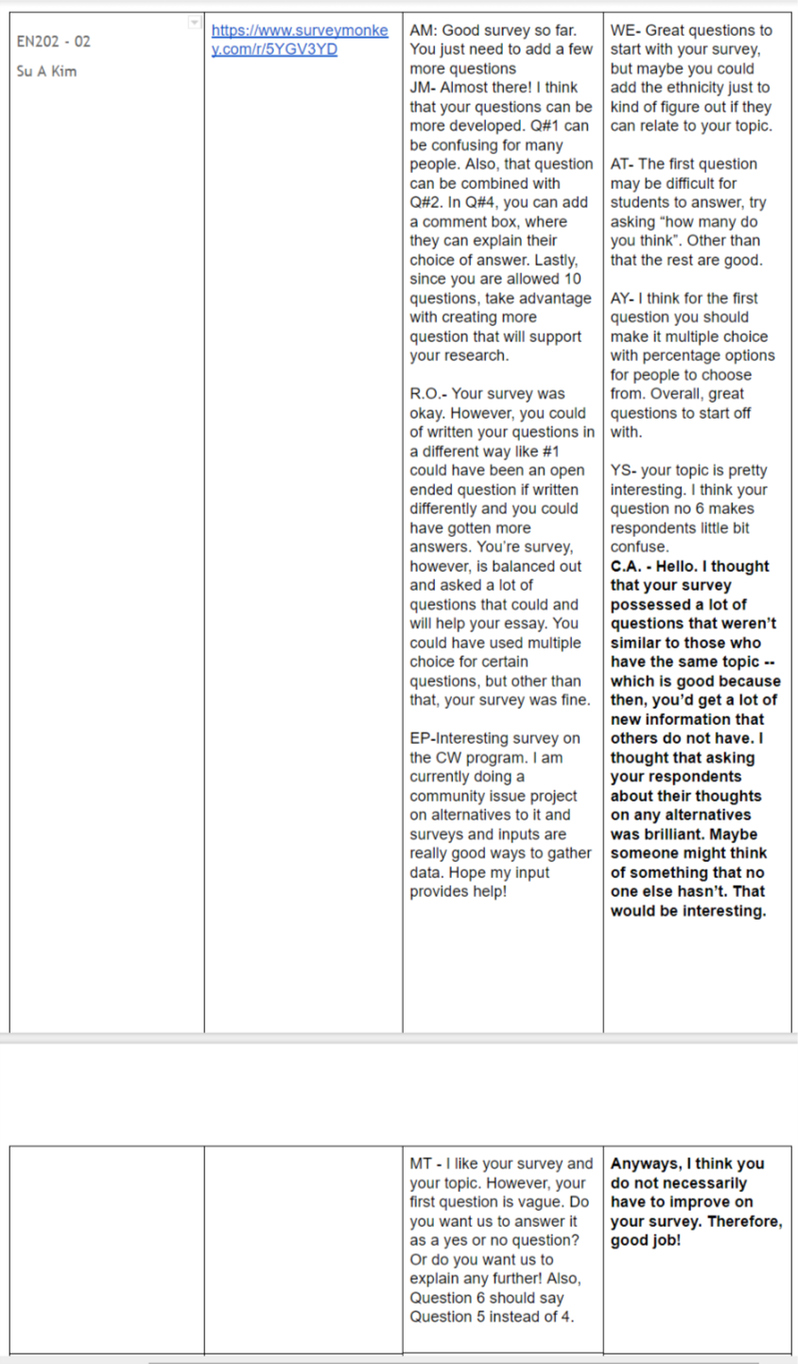
Appendix B

Appendix C
Final Survey Questions
- Do you know anything about CNMI-Only Transitional Worker Visa (CW visa)?
- About how many percent of employees do you think was CW visa holders?
- About how many CW visa holders did you know?
- What/How do you feel about CW visa?
- Do you think/believe the decreasing of CW visa holders in CNMI is good/bad to our economy?
- Please write down why you think that way in Question #5.
- Do you think that there’s any alternatives for CW visa?
- Please write down why you think that way in Question #7.

Appendix D

Question Four
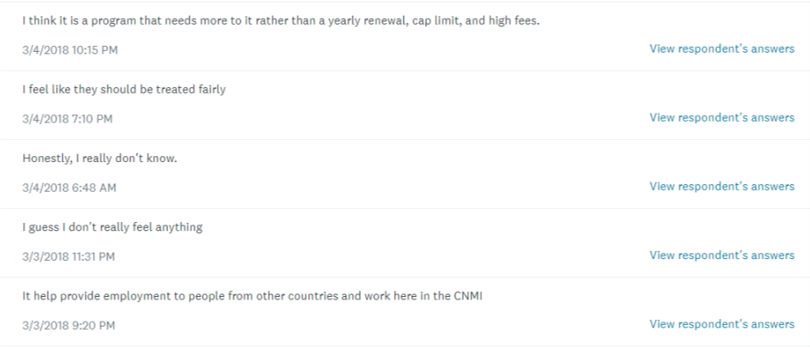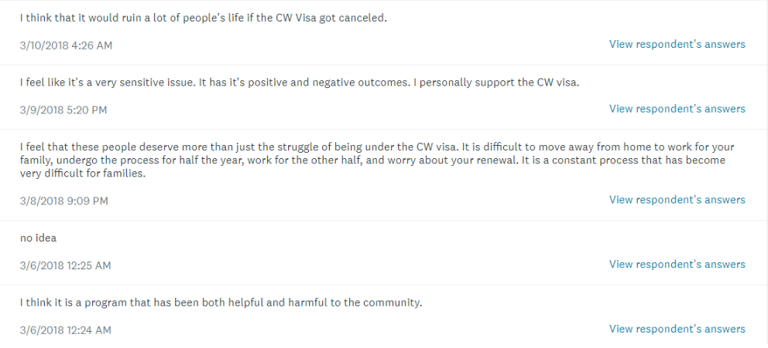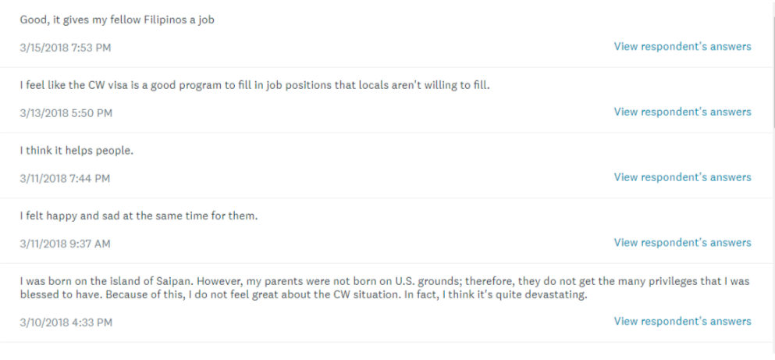

Appendix E
Interview Questions
- About how many percent of employees in this company were CW visa holders?
- Is there’s any CW visa holders working in this company now?
- What/How do you feel about CW visa?
- Is there’s any problem happening to company after the cap of CW visa has decreased?
- Do you think/believe the decreasing of CW visa holders in CNMI is good/bad to our economy?

