Running head: Technology In Education

Kathleen L. Beri

Dr. Kimberly Bunts

EN 101 ON1
Spring 2016

Table of Contents

- Abstract……………………………………………………………………………….pg. 3
- Introduction…………………………………………………………………………pg.4
- Research Questions…………………………………………………………….pg.5
- Literature Review……………………………………………………………….pg.6
- Discussion……………………………………………………………………………pg.7
- Methodology……………………………………………………………………….pg.8
- Finding and Analysis………………………………………………………….…pg.9
- Conclusion…………………………………………………………………………..pg.10
- Appendix………………………………………………………………………..…..pg.11
- Reference……………………………………..…………………………………….pg.15

Abstract
Technology gave a huge impact in school. Mostly every class you enter is
provided with projector screen since instructors uses laptop to teach students.
Technology has given every student and teachers an opportunity to work
productively and more unique when it comes to presentations, power points, and
project. We intend to learn more when we explore the internet. It expands our
learning skills and we can develop new ways to unique our work.

INTRODUCTION
Most college students are really busy with their lives. They either have a full time, double job or have kids to take care of. If the instructors are available at a certain time and the students are not, it will be tough to have a communication with one another. In Northern Mariana College, a student had been trying to get a hold of their instructor but he was hard to find. Of course, she goes there when it was her free time, but he was not available as he was teaching other classes. That’s why instructors recommend student emails to reach them because they are rarely around. Technology also gives benefits to students to do an instant research.

RESEARCH QUESTION
- PRIMARY QUESTION
- How technology efficient to students and teachers?

- SECONDARY QUESTION
- How does it benefit NMC students?
- Does it improve student’s grades?

LITERATURE REVIEW
In 2015, Saipan Tribune titled “PSS aims to be technology proficient” has
indicated that PSS finalized wide goals to improve their technological skills.
Board of Education Chair, Herman Guerrero said by 2018, students will be
equipped with knowledge and skills to achieve success in the of 21st century
through technology and tools. The website they provided in the article,
Learning.com, stated that digital helps instructors and students to learn in
advance. PSS believes technology has been efficient with their daily works and it
is better for students to learn it as soon as possible because in the future,
technology will probably enhanced their system and students need to catch up.

DISCUSSION
I’ve interviewed students and teachers to give me reasons how it helps learning
easier and better. The research that I have collected has proven that technology is
efficient to students and teachers work. Instead of buying chalks and markers all
the time, Northern Mariana College can save more. 6 out of 6 in the pilot survey
agrees that using laptop in school helps them put their work in one.

METHODOLOGY
The data’s that I used to collect are from observations, surveys and interviews.
I would sit in the NMC library and Joeten Kiyu library and about 75% of them are
using laptops, phones and ipad to do their work. Rarely any of them have a book
beside them. But if they do, it seems like they are typing notes from what they are
reading. Also, I would see students take a picture of the book. The survey I gave
out, (see Appendix C), determines how many students uses technology while
learning. Another data that I also collected, see Appendix B, were questions that I
ask from students and teachers.

FINDING AND ANALYSIS

The survey that was distributed online gave the feedbacks and opinions

from students. Students did the survey and all of them use technology

when they are doing their work. The responds from them specified that

results are compatible from survey. (See Appendix A).

I’ve walked around the campus and asking 3 random students and

teachers to answer the questions. (See Appendix B)

The observations that I was collecting through the libraries were very

slightly different. (See Appendix D)

CONCLUSION

The data’s that I have collected over all, 100% agrees that it is a very

useful part of our education and work life. Because in the future,

technology will upgrade and there will be new discoveries that may be

created and it will definitely apply to us when for we apply for a job.

Cashiers are not using manual machines anymore. They are now using a

Point of Sales (POS) program to accurately calculate their sales.

Since most jobs require computer it is best to start at school. But

hopefully in the far future even if technology has taken over the world,

it will not affect the presents of our family and friends.

Appendix A
Pilot Survey
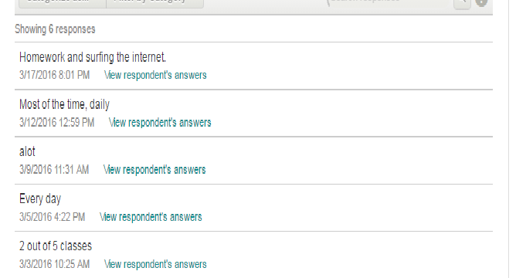

Appendix B
Interview Questions
Students
- How does it make it easier for you to do your classwork/homework?
- Why did you replace notebooks with laptops?
- Do you get better grades when you use technology?

Teachers
- Do you think in the future students will not use any books when coming to school?
- What are your thoughts on students bringing technology in class?
- In high school, technology weren’t allowed in class, what makes college approve of it?

APPENDIX C
Pilot survey questions

- How often do you use your technologies at school?

- Does Northern Mariana College require you to use technology?

- Do you find it helpful for students to use technology in class?

- What device helps you does work efficiently?

- How do you describe the benefit it gives you?

- Do you consider the use of technology cheating in knowledge?

- Do you think it is a distraction when you use it in the classroom?

- Do you think it makes tutors discourage their job?

- What are the disadvantages of technology use in the classroom?

10.Do you think students will still be using technology in the later future?

APPENDIX D
Observations

Northern Mariana College library – I sat in the library for 1 hour and 30

minutes and I have observe students who are entering in are bringing

their laptops.

Joeten-Kiyu Library – 30 minutes of sitting, about 10/ 23 have brought

in their laptops and I observe 10 people went to the computer section.

References
Herold, B. (2015) Technology in Education : an overview
http://www.edweek.org/ew/issues/technology-in-education/
Cox, J. (2009) Benefits of Technology in the classroom
http://www.teachhub.com/benefits-technology-classroom
Wainwright, A. (2016) Reason students needs technology in classroom
http://www.securedgenetworks.com/blog/10-Reasons-Today-s-Students-NEED-Technology-in-the-Classroom
Kessler, S. (2010) 8 ways technology is improving education
http://mashable.com/2010/11/22/technology-in-education/#6kC5CHHLKqq3
Chan, D. (2015) PSS aims to be technology proficient
http://www.saipantribune.com/index.php/pss-aims-to-be-technology-proficient/

