RUNNING HEAD: TEENAGE PREGNANCY

Teenage Pregnancy
Can being a young parent be a good thing? An investigation of CNMI teenage parents
HaJin Oh
Northern Marianas College

TEENAGE PREGNANCY 2
Table of Contents
Abstract …………………………………………………………………………………3
Introduction …………………………………………………………………………….4
Background ……………………………………………………………………………..4
Literature Review ………………………………………………………………………5
Research Question ……………………………………………………………………...6
Primary Question …………………………………………………………...6
Secondary Question ………………………………………………………...6
Methodology …………………………………………………………………………....6
Findings …………………………………………………………………………………7
Discussion ………………………………………………………………………………9
Future Plans and Conclusion …………………………………………………………..10
Reference ………………………………………………………………………………11
Appendix A …………………………………………………………………………… 13
Appendix B …………………………………………………………………………… 14
Appendix C …………………………………………………………………………….19

TEENAGE PREGNANCY 3
Abstract
An NMC college student describes an original six month study highlighting if there is possibility that a young parents be a good thing in the CNMI. The researcher wants to persuade the reader that being teenage parents is not a bad thing and there are some positive things. Interview with the teenage parents concluded that one of the positive things about being a teenage parent was having a closer relationship with their children than the normal parents. Even in the interview, there was some sign of a close relationship as it seems like they are best friends. The study is important because it persuades the readers that being a teenage parent is not that bad.

TEENAGE PREGNANCY 4
Introduction
If the researcher did a quick survey and ask people their opinions about teen pregnancy, he will assume that a vast majority of people will talk negatively about teen pregnancy. Teen pregnancy is under remained as pregnancy among the young people of 18 years and underneath. Teen pregnancy ought to be disheartened since it put a strain on them. Also, the guardians of the eager teen need to bring about costs viewing hospital bills and in addition including themselves in high schooler parenthood other than making a decent living for the entire family. Along these lines, teen pregnancy should be destroyed through the making of mindfulness on the negatively effects on teen pregnancies, education to teen parents, and also lessening destitution in the public
Background
In today’s world, the rate of the teen pregnancy has been increased in the past several years. More often than not, the teen pregnancy is unpredictable. It turns into an extraordinary stun to realize that the teenage girls have turned out to be pregnant in their young age. This is regularly achieved by some concealed elements and the teenage girls because of the absence of a right decision to the scourge of bearing the babies even in the youthful age. However, teenage pregnancy is not always bad. The Health Research Funding, for examples, says that teenage parents would able to relate to their children in sorts of financial and emotional problems to make them better kids. (June 3, 2014)
Teenage pregnancy is a pregnancy in female individuals who are underneath the age of twenty years. Teenage pregnancy ought to be exceedingly disheartened has it has impact on the teenage mother and the child conceived. Teenage pregnancy has been a major issue in
TEENAGE PREGNANCY 5
today society. Not only in CNMI, but in worldwide population, teen pregnancy has been increased in the past several years. Whether it was planned or unplanned, teenage parents can most likely lead you to a difficult life. This essay is about the cause of teenage pregnancy, effect of teenage pregnancy, and people thoughts about teenage parents.
Literature Review
A general browser search on April 9th 2018 on the topic of “teenage parents” resulted in about 1,720,000 hits with the majority of publications of being talked about how we should avoid this situation. With a cultural relationship, this research that has been held at Clark University tended to be two formative speculations that teenagers need more self-sufficiency and less parental standards than guardians think about fitting. (Jensen, 2015 In addition, inconsistency amongst teenagers and guardians on perspectives of authority resulted in conflicts. During the research indicated culturally diverse shared characteristics, for example, independence looking for among young people, they likewise featured the significance of culture to various implications of authority. In an examination with African American and European American families, high inconsistency amongst teenagers was emphatically identified with reports of contention and contrarily identified with young people's reports of attachment.
The survey done at Boston University recognizes cutoff points of the present arrangement reaction to teenage parents getting welfare.(Collins, 1999) The minimum effective results were those that mirror these inconveniences. Attempt to improve the probability of ideal results should all the while go for instructive and preparing frameworks, protected and reasonable lodging, and esteem introductions that are steady of teenage parents
TEENAGE PREGNANCY 6
and teenage families. In particular, regarding instructive and preparing frameworks, more significance ought to be set on preparing for nontraditional employments that compensation higher wages, adaptability in school situations that oblige teenage parents, expanded importance on school instruction, school instructive help as far as financial problems, and the payment of high school and preparing to tally toward the work necessity
Research Questions
Primary Research Question: Since I assume that people talk negatively about teen pregnancy, is teen pregnancy really always bad?
Secondary Question
What are some benefits of being a teenage parent?
Methodology
Through literature and discussion with NMC students, most people talked negatively about teenage parents and he wondered if teenage pregnancy really always bad? To know more about teenage parents, a researcher in Northern Marianas College collected data based on how teenage parents live in our society. In this section, it shows a step by step process on a survey, final survey, interview, and letter to expert and will be analyze about the data that was collected.
The pilot survey was made up of 10 questions and most of the question provided with open ended questions (see Appendix A). The question was about how teenage parents live in our society and positive or negative effects of being teenage parents. The survey can be completed to anyone and doesn’t have an age limit. The survey has been shared in
TEENAGE PREGNANCY 7
Northern Marinas College and the researcher used a program called survey monkey to make a survey. The people that have been participated have taken this survey of an average of 6 minutes. The researcher didn’t like the response due to the fact that most questions were broad. The researcher fixed the questions and some grammatical mistake and made a final survey.
The final survey was collected between March 3, 2018 to March 11, 2018 (see Appendix B). The survey was distributed through online and only 7 people responded to my survey. Since little people participated in this survey, the researcher wants to extend the period of time until he gets enough people to analyze the survey. According to survey monkey, people took an average of 5 minutes to finish the survey and didn’t miss any of the questions that were provided. The researcher will analyze the data by how people positively or negatively think about the teenage parents and the advantage the disadvantage of teenage parent is. The researcher will update his information after all of the data and statistics is fully collected into the research paper. The researcher also interview teenage parents in high school with an open minded question asking the positivity of being a teenage parents and how they are being treated by the society. The responses that the researcher received were amazing and unique it was beyond the researcher expectations.
Findings
A range of variables may influence teenagers and their decisions about sexual relationships, such as how openly discussed sexual relations are discussed in the teenager’s life both at home and in the broader community through to the use of social media. It could be assumed that easier access to social media and technology in modern societies may impact
TEENAGE PREGNANCY 8
decisions of teenagers as there is easier access to a larger group of individuals who may promote sexual relationships. There has been a range of studies on this exact topic and these may be useful to your research paper such as Social Media and Sexual Behavior Among Adolescents. Social media is now considered one of the most influential modes in developing ‘relationships’. Teens are greatly influenced by what they see others are doing (whether it is true or false, they still believe what they are exposed too). There is a rise in sexting, which never existed 15-20 years ago. The level of intimate relationships moves forward much faster than in the past, as teens feel they know the person because of all of the time they got to spend with them via social media, even if they never saw them in person, until the first hook up. Our teens are being greatly affected by social media, as they do not get the opportunity to develop truly meaningful relationships – through true face-to-face interaction, and this is affecting their understanding of how to make better decisions when it comes to sexual relationships.
Another identical trend that the researcher found was that teenage parents are often very capable young parents and individuals who still want to achieve their goals and dreams that had for themselves before they became an expecting or parenting teen. Often the negatives are focused on when a teen becomes pregnant or is parenting and these can be challenges such as finding it difficult to return to education through to being forced out of the home with a lack of support, but each situation will be different. One of the most significant positives of being a teenage parent would be becoming a parent as watching a child develop and learn is beautiful. Other positives of becoming a teenage parent are that it can often focus some teenagers on their priorities such as getting a driver’s license to make transport easier through to general skills that individuals don’t learn until they are in their early thirties.
TEENAGE PREGNANCY 9
Discussion
There are a wide range of circumstances that teenager gets themselves associated with that can prompt teenage pregnancy. Numerous young people don't comprehend the dangers that are included with engaging in sexual relations. Teenagers who are uneducated about sex will probably have an unintended pregnancy. A few teenagers don't completely comprehend the organic and passionate viewpoints related with having intercourse. Ordinarily, teenagers don't have the learning expected to settle on educated and dependable choices about regardless of whether to take part in sexual action that can change their life.
In the society, people seek teenage pregnancy as a negative component according to Healthy Futures (2016). The general public is influenced by teenage pregnancy in that a pregnant young person should be upheld beginning from the guardians to the neighbors who will take a gander at the teenage pregnancy when there is nobody around to deal with them. It turns out to be difficult for the parent to help the teenage parents. Since the majority of the teenage parents wind up dropping out from school, this makes a general public that is uneducated. This demonstrates if teenage pregnancy rates increment the general public turns out to be very uneducated.
The number of teenage parents in Australia has been in decline for many years. A report from Australian Bureau of Statistics demonstrated this as in 1971 56 per cent of babies were born to teenagers in every 1,000 women and in 2015 this was at just 13 babies per 1,000 births. It would be difficult to demonstrate that any one organization has been responsible for this decline however; it is likely that this is due to the easier access to long-term birth control. Brave foundation is the only national organization in Australia that supports expecting and
TEENAGE PREGNANCY 10
parenting teens by building a village of support around them. According to Brave Foundation’s their vision is to support teenage parents in furthering their education, reducing the stigma and meeting the needs of these young people.
Future Plans and Conclusion
To any teenage parent that is expecting or parenting, the researcher would be to tell them that it will all be okay and to try and surround themselves with as much support as possible, as it really does take a village to raise a baby. Each parent will face their individual challenges and I would always encourage to do what is best for them and their new baby for example, whether that means returning to education within six months or within two years, only they know what is best.
Teens learn quickly the importance of their own healthcare and as they prepare to become parents the importance of understanding the healthcare needed for their child. Many adults do not grasp the importance of healthcare according to Teen Outreach Pregnancy Services (2018). Teen parents, with the right kind of social and emotional support are very open to learning the best way to be a better parent than how they were parented. They are motivated to do well. Many of teenage parents, rather than drop out of school, are determined to not only finish high school, but go on to college so they can make their child proud of them some day. Some of our teen parents are very happy about having a child young, so they can be more interactive with their child, as they feel they have more energy to parent than an older parent.

TEENAGE PREGNANCY 11
References
B. Causes And Effects Of Teenage Pregnancies. Retrieved March 04, 2018, from https://www.beingtheparent.com/causes-and-effects-of-teenage-pregnancies/

IPROJECT. THE CAUSES AND EFFECT OF TEENAGE PREGNANCY AMONG SECODNARY SCHOOLS Edu... Retrieved March 04, 2018, from https://iproject.com.ng/education/project-topics/the-causes-and-effect-of-teenage pregnancy-among-secondary-schools-7352

Wiki.ubc.ca. (2018). Causes and Effects of Teen Pregnancy - UBC Wiki.
http://wiki.ubc.ca/Causes_and_Effects_of_Teen_Pregnancy

RUNNING HEAD: TEENAGE PREGNANCY 12

Appendices
HaJin Oh
Northern Marianas College

TEENAGE PREGNANCY 13
Appendix A
Pilot Survey
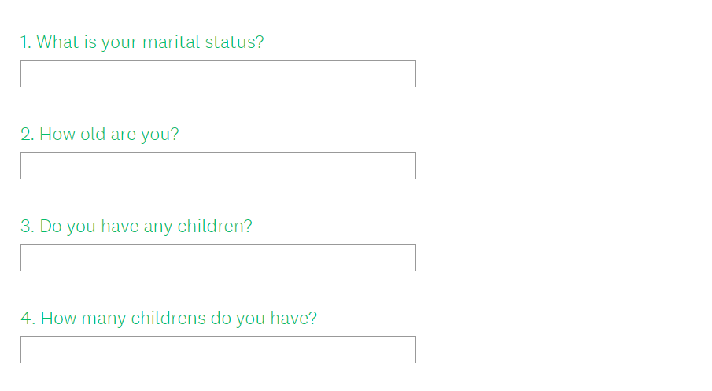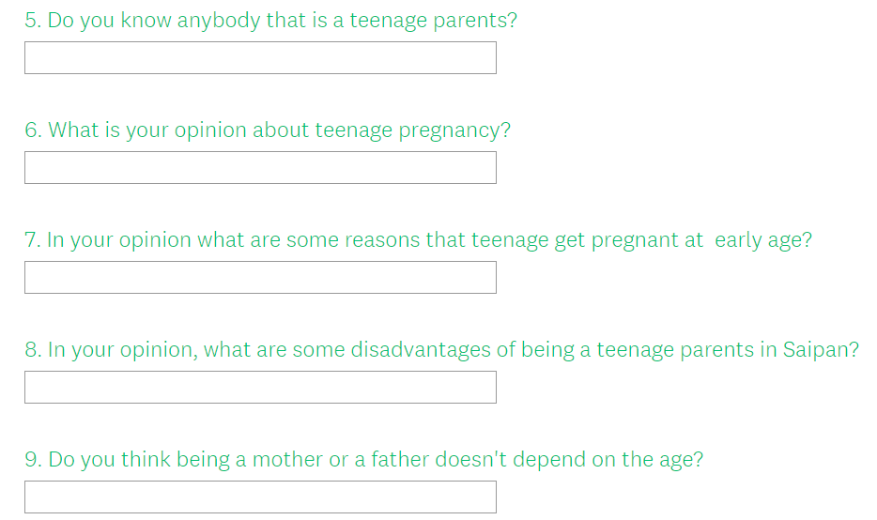

TEENAGE PREGNANCY 14
Appendix B
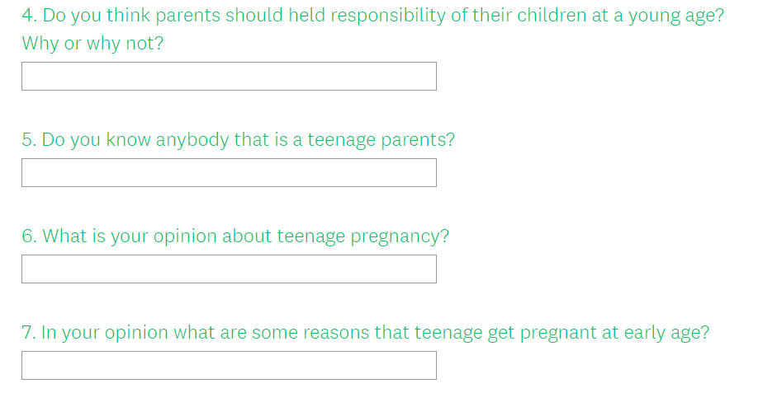
TEENAGE PREGNANCY 15
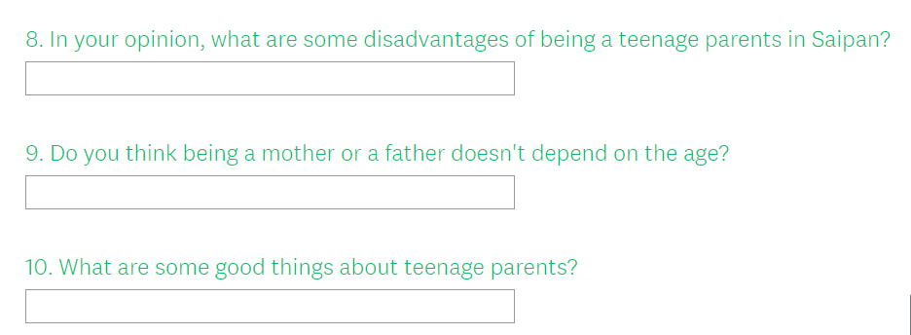

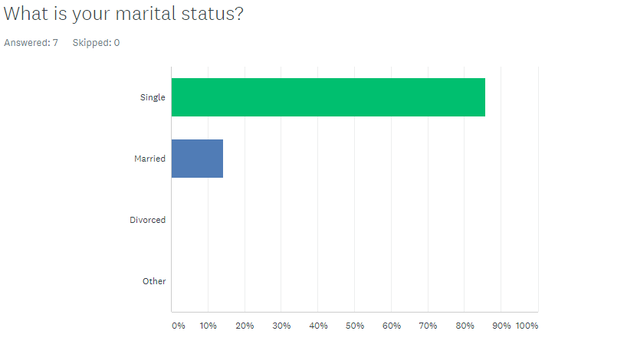

TEENAGE PREGNANCY 16
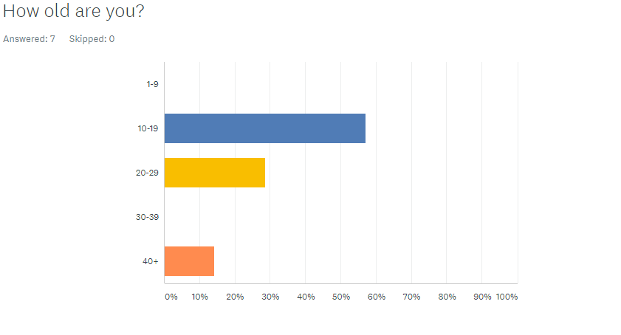

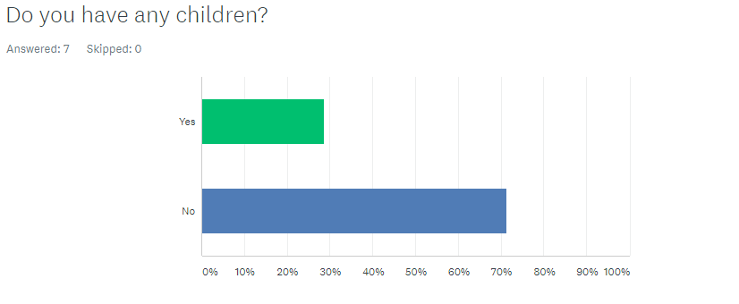

TEENAGE PREGNANCY 17
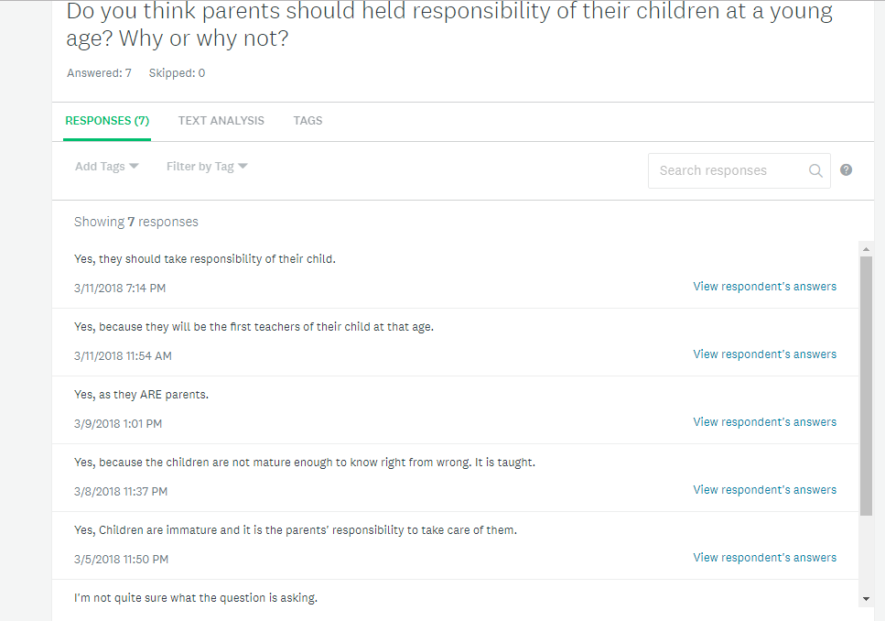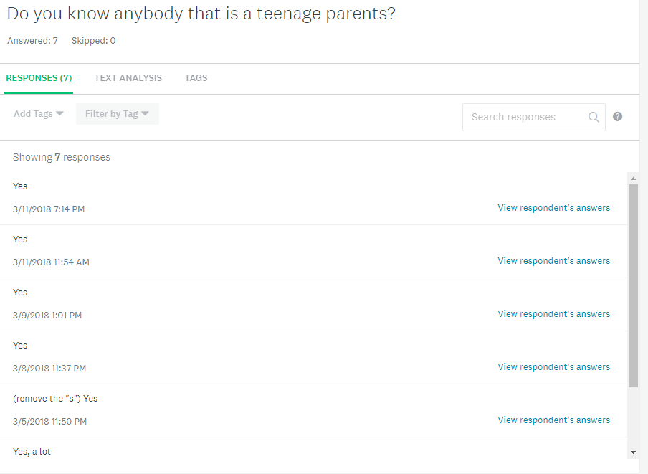
TEENAGE PREGNANCY 18
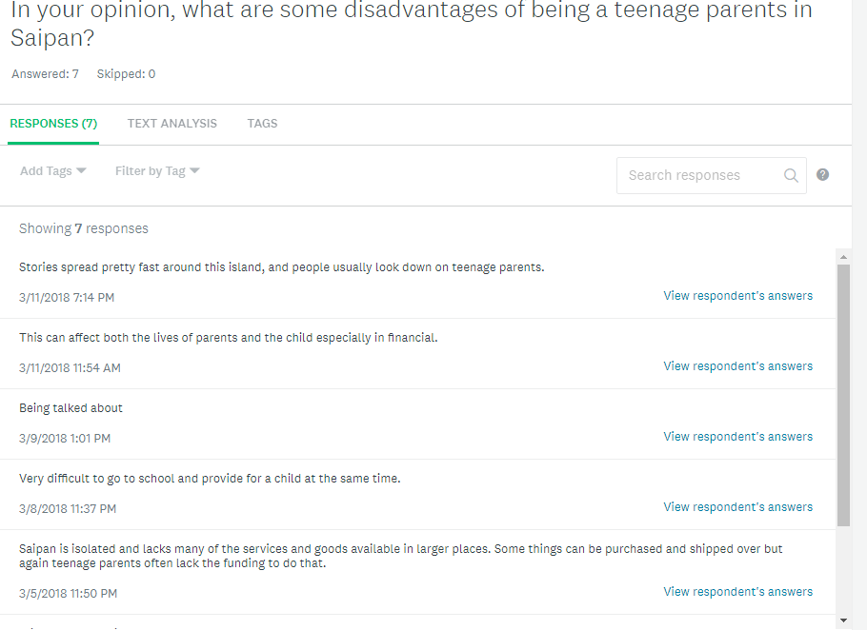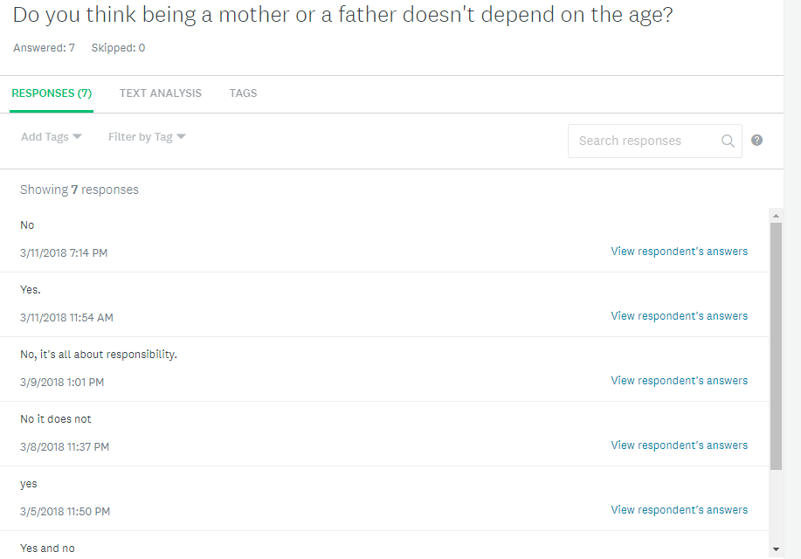
TEENAGE PREGNANCY 19
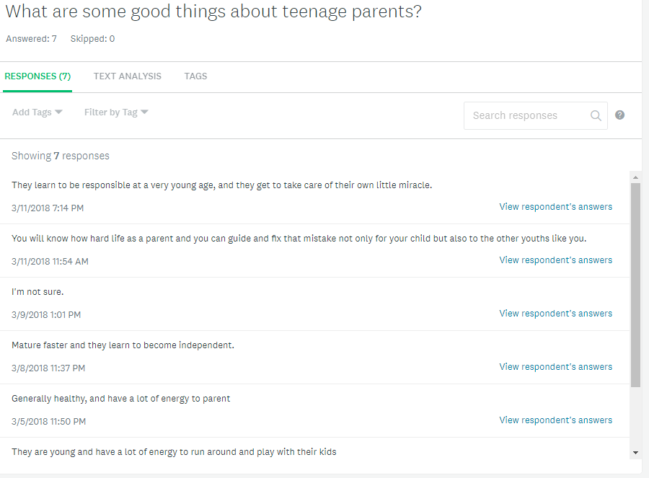
Appendix C
Interview Questions
What do you want to say as a teenage parents?
Is there any disadvantages in the society?
As a teenage parents, is there any benefits?
What are some positive things about teenage parents?
What are some negative things about teenage parents?

