Chinese Tourists in the CNMI
Christian De Jose

11/22/2016
Kimberly Bunts Anderson
EN 202 – 01
Research Essay
Table of Contents
- Title Page
- Table of Contents
- Abstract
- Title
- Intro
- Background
- Literature review
- Research question
- Methodology
- Findings/Analysis
- Discussion
- References
- Appendices

Abstract
In this research project, the student researcher has found an interest in the local tourist count rates on the CNMI, specifically the Chinese tourists. The research paper will be about why Chinese tourists are the largest number of tourists that come to the CNMI. The student researcher had gathered data and literature that relates to the topic and will be explained in this paper. The research paper will include summaries of articles and facts relating to the topic of Chinese tourists in the CNMI that could be the answer to why Chinese tourists come. The student researcher had planned ways to gain data by sending three letters to experts, finding six online articles and creating a survey. The paper will include the responses and answers obtained from the methods used to gain data.

Chinese Tourists in the CNMI
The CNMI has many ways to improve economy, whether by selling island merchandise, food transportation services, or from contingent workforce labor. One major source of money that the CNMI gets income from is the tourism industry. Tourism is a very important service for our economy in the CNMI: it opens the CNMI to many diverse tourists and people. But to which ethnicity is the CNMI getting the most money from? The research’s plan is to look at the largest group of tourists that the CNMI gets. The researcher would like to understand and research on why they come here, how they found this place, and what attracted them to come here.
Literature Review
In a research paper, the literature review is used to demonstrate understanding of a literature on a specific topic. Researchers use literature review to show their understanding by synthesizing and analyzing the information to prove something. The student researcher however, will be writing a literature review from 4 to 5 academic sources and 2 non-academic sources on the topic of large Chinese tourists in the CNMI. The topic is based on local facts and information that may interest people because our economy is reliant on tourism.

Academic Sources
The first academic source found is an abstract by Hailin Qu expert from San Francisco State University, and Sophia Lam expert from The Hong Kong Polytechnic University. The student researcher found this abstract from a website called ScienceDirect. The abstract was titled “A travel demand model for Mainland Chinese tourists to Hong Kong”. The main idea of this abstract was about the travel demands for Mainland Chinese tourists to Hong Kong. The article explained that Mainland Chinses tourists go to Hong Kong because of the disposable income per capita. An important quote in the article that the student researcher may use is “The results showed that travel demand for Mainland Chinese tourists to Hong Kong could be explained by ‘disposable income per capita’ and ‘relaxation of visa requirements” (Qu H., Lam S. 1998, p.1, para. 1). The student researcher may use this as a relevance to his topic which is on Chinese tourists coming to the CNMI. The travel demand for the Chinese tourists to the CNMI may be because of disposable income per capita.
The second academic source was a PDF document prepared by Cesar Environmental Economics Consulting under awards CRI-3, 4 and 5 from the US Department of Interior and National Oceanographic and Atmospheric Administration. The PDF titled “The Economic Value of the Coral Reefs of Saipan, Commonwealth of the Northern Mariana Islands”, published on March 2006. The document was mainly about the Northern Marianas Islands status on economic value of the coral reefs. The reason why the student researcher thought this might be of relevance is because in the document, the writers talked about the coral reef attracting tourists. Some important information that was said that China had higher share in a tourist exit survey then the actual number of Chinese that came in 2002. This is because of the rapid increase of Chinese tourists coming to CNMI (Cesar Environmental Economics Consulting 2006, p.29). This summary is proof that Chinese tourist numbers are growing in the CNMI. Another important quote that was said in the document was that the Chinese tourism market is also growing, and the number of Chinese visitors going to the CNMI increased nearly five-fold to 10,471 in 2002 (Cesar Environmental Economics Consulting 2006, p. 30). This may be out dated but still applies to current and present Chinese tourism growth in the CNMI.
The third academic source found was an article in EBSCO by Mcphetres and Samuel F. titled “Commonwealth of the Northern Mariana Islands” and written on January 05, 2005. The student researcher found information that may be of use to his research paper on page 2 of the article titled “Immigration plan ready”. The page was about the government being ready to thwart illegal Chinese immigrants now that the “Approved Destination Status” (ADS) has been signed. This could be proof that most of the population here in the CNMI is not just from Chinese tourists but also from some illegal Chinese migrants. An important finding was “The Government says a special immigration system is already in place to thwart illegal Chinese migrants posing as tourists from entering the Northern Marianas now that the ADS has been officially signed” (Mcphetres, S. F. 2011). This is a very important topic because the agreement has lasting importance for the tourism in the CNMI, it is the core of the CNMI’s economy. The student researcher found this interesting and may use this in his research paper as a cause to the multiple Chinese tourists coming to the CNMI. The student research has found out that not only are Chinese tourist numbers growing in the CNMI but also illegal migrants.
The final academic source found is by Samuel Seongseop Kim, Yingzhi Guo, and Jerome Argrusa. The abstract was found by Google Scholar titled “Preference and Positioning Analyses of Overseas Destinations by Mainland Chinese Outbound Pleasure Tourists”. The 3-author’s main objective was to study the competitiveness of the Mainland Chinese overseas travels and what attributes make them want to go there. In their abstract, it said “Mainland Chinese respondents considered “safety” and “beautiful scenery” to be the most important attributes” (Samuel Seongseop K., Yingzhi G., Jerome A. 2005, November). So, taking this information by the student researcher, he could relate this to the tourists in the CNMI. The CNMI is known for its beautiful sceneries and traditional cultures. This could be a reason to why Chinese tourists love to come to the CNMI.

Non-Academic Sources
A news report found on USA TODAY titled “Birth tourism in Saipan causing headaches for USA” was about pregnant Chinese woman visiting the Northern Mariana Islands to give birth. The news report briefly explained the problems they faced because of the Chinese tourists trafficking, documentation problems, and bills left unpaid at the Commonwealth Health Center. The Chinese tourists may be traveling to the CNMI for citizenship because the 15 islands between the Philippines and Hawaii are close to China and cheap to travel to which are eligible for U.S citizenship. In the passage, it said “and in the past two years, the number of women delivering babies here has jumped dramatically” (Coleman Z., 2013, September 9, p.1, para.3) This may be one of the many reasons why Chinese tourists are growing in the CNMI as well as immigrants.
Lastly, another news report but found at Marianas Variety titled “Saipan poised to benefit from surge in Chinese tourists”. The writer Alexie Villegas Zotomayor talked about how Chinese tourists are very beneficial to the islands of the Commonwealth. An important quote that may help the student researcher is “Tao said owing to Saipan’s proximity to mainland China, the island will be at the top of the list of Chinese tourists’ destinations” (Villegas Zotomayor A. 2015, Jun 10, p.1, para.3). The writer not only informed us that the islands are the top of the list of Chinese destinations but explained because of Best Sunshine, beautiful beaches and pristine environment, it is a great place and opportunity for the island and the growth of Chinese tourism.
In this literature review, it could be agreed on that Chinese tourists have many reasons for coming to the CNMI, the student researcher’s academic and non-academic sources prove so. The sources both give opinions and facts from experts in the study. The Chinese tourists that the CNMI attracts bring benefits such as growth in economy and downfalls such as illegal migrants and over population. Chinese tourist numbers are not only growing at an increasing pace but because of that, the CNMI’s economy too. Hopefully, Chinese tourism will continue to grow beneficially and be controlled to a certain extent.
Research Question
The researcher’s primary research question is “why are Chinese the largest group of tourists that come to the CNMI?” The research was heavily based on the types of tourists and their reason to come to the CNMI. The student researcher primarily looked for tourists and hotel workers to collect data. The researcher had asked some questions on how the types of tourists benefit the hotels, and what the hotels do to gain different types of ethnic groups, some other secondary research questions were:
- Why what are the reasons for most of them to come here?
- Is it for work related things?
- For family?
- Because it is cheap to travel here?
- Just for vacation?
- What has attracted them or how did they find our islands?
- Did they discover this place from relatives who live here?
- They discovered a good place to settle in and work?
- From a website? Or just for personal favors
- Who or what type of Chinese come here? Travelers? Business workers? Etc.
Methodology
This section would be about how the student researcher will find his data. This will focus on how the data, where the data, and why the data has been collected. In this paper, the student researcher is writing about why Chinese are the largest group of tourists that come to Saipan. This student researcher is majoring in Liberal Arts and wishes to someday transfer to Hospitality, therefore the student researcher found an interest on the topic of large Chinese tourists visiting Saipan. This essay will be showing what methodology the student has used and how the student researcher gathered some data on his research paper.
What the Researcher Did
The student researcher’s topic is asking “why are Chinese the largest group of tourists on Saipan?”. His research requires finding out and searching for information, the method that the student researcher found best is to create a questionnaire. The student thought that using questionnaires was the best way to approach his topic because it will get the student answers that only experts know. What the student researcher did was carefully looked in to his topic and tried to find things that might relate and help on his research paper. The student researcher looked at hotels and searched for people who were experts in the tourism field. There he may find some sources for his research paper.
How the Researcher Is Going to Do It?
The student researcher has found a way to obtain some data which is a methodology that most researches use, it is by creating a survey and or questionnaire. The student plans on creating questions that may help him solve his research question. Questions such as asking experts the facts from official documents. The student researcher walked around local hotels looking for Chinese tourists and asking them why they came to Saipan. The student researcher could get some good information from the Chinese tourists themselves. However, the student researcher found that asking the Chinese tourists themselves is not enough, the student plans on looking for higher positioned experts in the field. The student researcher may create a letter with questions that may help him get some data for his research paper. The student has chosen 2 general managers from Hyatt Regency and LeoPalace from Guam, and one letter to the Marianas Visitors Authority. The student chosen the general managers of those hotels because the student thought that they are knowledgeable of what the student’s topic is about and because they have a high position in the hotel industry. The more knowledgeable people the student asks, the better data he may collect.
Researching is very difficult but at the same time fun especially when the students do research on topics that interests them. Researching also has many different processes and methods to gaining has done sending out the questionnaires and will hopefully obtain some data along the way. The process that the student had to go through was from brainstorming on questions that may help him, then to finding where he may get some data from.
Data Analysis
Student Survey
In this research study, the student researcher has used many methods in order to collect data. Somewhere in the middle of the study, the student researcher had created two student surveys including the draft and the finalized version of the survey, the reason of creating two surveys was so that other fellow students may analyze my first survey and correct any errors it may have so that the finalized version would bring more impact. The surveys both had 10 questions and were answered by fellow students at Northern Marianas College (NMC) regarding the topic which was about Chinese tourists in the CNMI. The draft survey had a total of 19 responses and the finalized survey had 12 total responses. In the draft survey question number 3: “what kind of tourists do you mostly see on island?”, both surveys got the same results which was “Chinese”. The draft got a total of 70% votes on Chinese and in the finalized survey, it got about 85% votes. This information brings to attention that most students in NMC mostly notice Chinese tourists in the CNMI than other ethnic groups. This may be proof that Chinese tourists are increasing on the islands of the CNMI. On the 5th question of the surveys which was “what is your impression of Chinese tourists?” there seems to be of change in opinion on the surveys. On the draft survey, the majority responses were encouraging and explaining that they are kind and friendly. Now on the finalized survey, the student responses got much more critical and majority became that Chinese tourists are very loud and rude people. It seems to be that about 30% of the students may have had experienced rude behaviors from the Chinese tourists. Other responses that stood out for the student researcher was in question number 6. The question was “what do you think attracts Chinese tourists to the CNMI?”. Both majority responses were about the visas. A response by a unanimous student stood out due to well-said and specificity. The student said that the CNMI is part of the U.S territory and that Chinese tourists do not need to apply for a specific visa to come. This could be a hard reason to why Chinese love to come to the CNMI.
Online Research
While doing online research, the student researcher had found some academic articles and two non-academic that related to his topic of Chinese tourists. During the research, the student researcher used the student responses in the survey questions to create keywords to find some data. Some keywords produced from the survey responses were Chinese tourists, Chinese visa, CNMI tourists, and CNMI beauty. The student researcher had found some articles that relates to some of the responses in his survey. The academic data found was an article about travel demand, a PDF document about the Coral Reefs and how it attracts tourists, another article about government rules on illegal Chinese migrants, and another article on a study of travel destinations of Chinese. A lot of information in these sources were also mentioned in the student surveys. The survey questions were also answered through the findings of these academic sources. Some interesting findings were the non-academic sources. One source was about pregnant Chinese woman coming to the CNMI just to give birth. Because of how easy it is to become U.S citizen for these visitors, it may offend other people who are deserving to become U.S citizens. Some deserving to become U.S citizen are people who have traveled to the CNMI and have stayed and worked for a large amount of years. It wouldn’t be fair because Chinese tourists get to come to the CNMI for free and to become a U.S citizen would be simple as just giving birth to a child, and that child get many benefits from the government in the CNMI.
Letters
The student researcher had sent out 3 emails to experts that may help answer and better explain some questions that may be useful to the researcher. The first expert to send a letter to was for Mr. Nick Nishikawa general manager of the Hyatt Regency Saipan. The student researcher looked online for Mr. Nishikawa’s personal email address but could not find anything but the telephone number and fax of the Hyatt Regency. The student researcher then called Hyatt and asked for his personal email and had thankfully obtained it. Having the email address, the student sent the email on November 2, 2016. Sadly, the student researcher had never obtained any replies on the email. The second expert to send a letter next was for Mr. Toshiro Doi. The student researcher had searched online looking for hotels in Guam. One hotel that was found was The Westin Resort Guam. The student found that the general manager was Mr. Doi, so the researcher emailed the hotel on November 8, 2016 asking for Mr. Doi’s personal email for assistance on this research paper. After the email was sent, the student received a reply the following day November 9, 2016 giving another email address saying that the student researcher may contact Mr. Doi through his Executive Assistant. With Mr. Doi’s executive assistant’s email address, the student researcher sent another email with the same letter for Mr. Doi on the same day. In reply, Mr. Doi’s executive assistance said that Mr. Toshiro Doi is general manager of LeoPalace now and that they have no longer have any affiliation with The Westin Resort. The student apologized and said that the information he got about Mr. Doi was probably outdated, so the student researcher sent another email to LeoPalace Guam with Mr. Toshiro Doi as current general manager. Again, the student researcher did not get any response. The final letter was sent to Marianas Visitors Authority on November 17, 2016. The student contacted them using their website, it said that they will answer them within a week, however, the student had never gotten any replies until now.
Discussion/Conclusion
In this research, the student was primarily looking into why Chinese are the largest number of tourists that come to the CNMI. The student researcher created sub-questions or secondary questions that would help get closer to finding the answer such as why they come, how they found this place, and what attracted them to come? The student used a survey to students at NMC to help find opinions on Chinese tourists, online research for general information, and created letters for experts to obtain much more hard facts. Major findings were mostly from the online research because the student didn’t get any replies on the letters to experts. A major found was that Chinese are coming to the CNMI because of the visa. The CNMI is a U.S territory and China did not need visas to come. China to the CNMI had a short travel distance, is cheaper, and has tropical beautiful islands. Another major finding was because of the income per capita. Currency from China to the CNMI meant an increase. China also had much more expensive items than CNMI does. These are significant findings because they are the major reasons to why Chinese tourists are coming here, and considering that China does not need visa to come here is easier and benefits more than other tourists. The student researcher could have harden the facts if the experts that was sent letters to answered, by sending much more than 3 letters and trying to send them apart from the islands of the CNMI, the student could have gotten much more diverse answers.
Appendices
Appendix I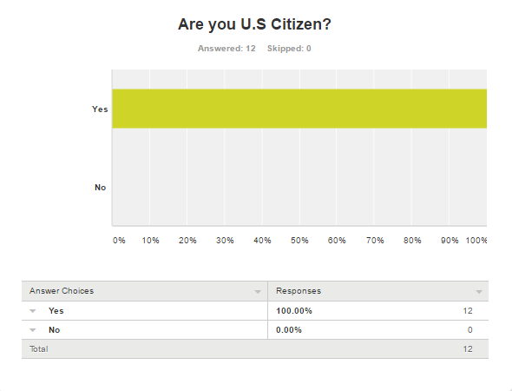
Student survey with 12 respondents were all U.S citizens

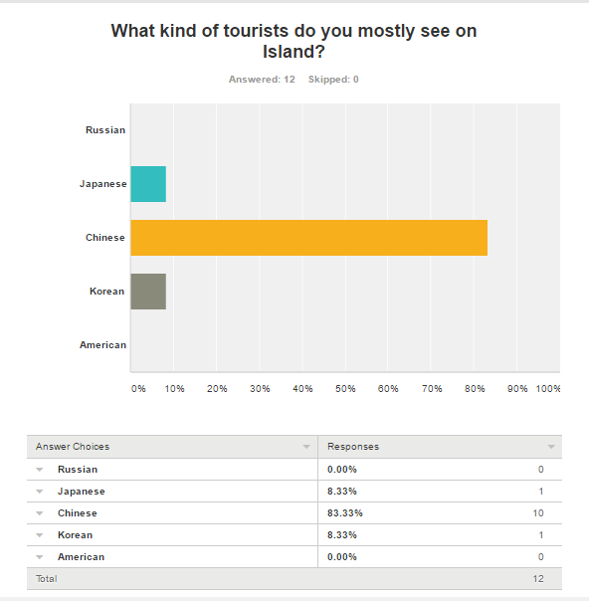
10 out of 12 respondents voted for Chinese to be the mostly seen on Island. 1 for Japanese and 1 for Korean.
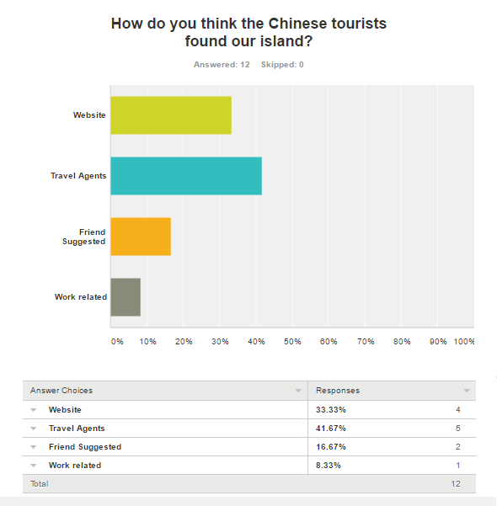
Student respondents mostly chosen Travel Agents as the reason to why Chinese tourists finds our islands.
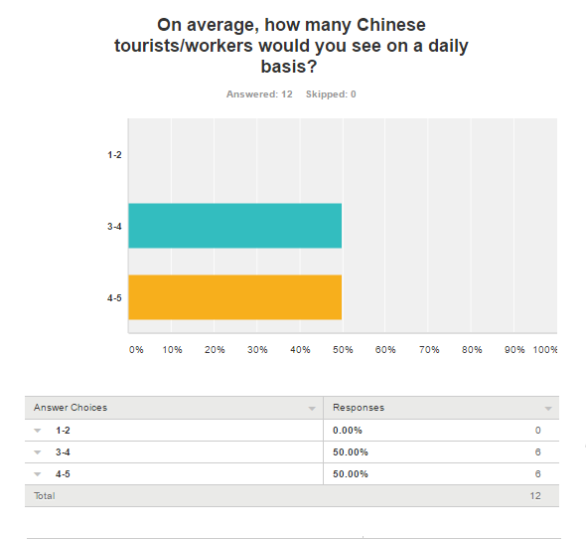
Half of the 12 student respondents both chosen 3-4 and 4-5 to as how many Chinese tourists they see on a daily basis.
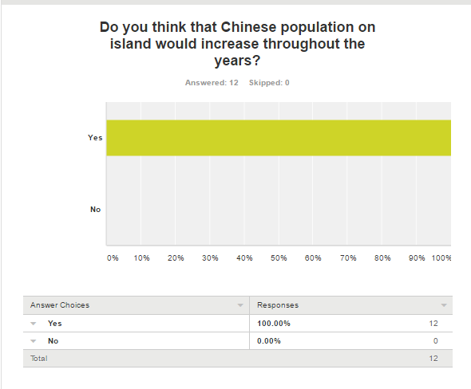
12 out of 12 student respondents answered yes to the Chinese population increase on island.
Appendix II
Letter to Toshiro Doi
Email: joanne.camacho@leopalaceguam.com
105 Gun Beach Road
Tumon, Guam 96913
United States

Dear Mr. Toshiro Doi,

My name is Christian De Jose. I am a student studying at Northern Marianas College (NMC) in Saipan majoring in Liberal Arts and Hospitality. I am writing a research paper for my EN 202 class which is about Chinese being the largest group of tourists on CNMI. As a successful general manager, at LeoPalace Resort Guam, with expertise in the field of hotel management, tourism, revenue analysis and more, I would like request your assistance with answering a few of my questions below. I know you are a busy person. I understand your limited availability, but I thank you in advance for this opportunity and assistance for my research paper.

Can you please explain the factors that contribute in bringing Chinese tourists to LeoPalace Resort?

Do you have any opinions on why a lot of Chinese tourists go to LeoPalace Resort?

Best Regards,
Christian De Jose

Letter to Nick Nishikawa
Email: nick.nishikawa@hyatt.com

Nick Nishikawa, General Manager
Hyatt Regency General Manager
Chinese Tourists on Saipan

Dear Mr. Nishikawa,

My name is Christian De Jose. I am a student studying at Northern Marianas College (NMC) in Saipan majoring in Liberal Arts and Hospitality. I am writing a research paper for my EN 202 class which is about Chinese being the largest group of tourists on Saipan. As a successful general manager, in our community, with expertise in hotel management, tourism, revenue analysis and more, I would like request your assistance with answering a few of my questions below. I know you are a busy person. I understand your limited availability, but I thank you in advance for this opportunity and assistance for my research paper.

Can you please explain the factors that contribute in bringing Chinese tourists to Saipan?

Do you have any opinions on why most Chinese come to Saipan?

Do you think that the continuation increase of Chinese tourists is good? Why?

Best Regards,
Christian De Jose

Letter to Marianas Visitors Authority

Email: (Contacted from Website) http://www.mymarianas.com/contact.asp?secID=21
Hello Marianas Visitors Authority,

My name is Christian De Jose. I am a student studying at Northern Marianas College (NMC) in Saipan majoring in Liberal Arts and Hospitality. I am writing a research paper for my EN 202 class which is about Chinese being the largest group of tourists on Saipan. I would like request your assistance with answering a few of my questions below. I know you guys are always busy. I understand the limited availability you guys have, but I thank you in advance for this opportunity and assistance for my research paper.

Can you please explain the factors that contribute in bringing Chinese tourists to the CNMI?

Do you have any opinions on why most Chinese come to the CNMI?

Do you think that the continuation increase of Chinese tourists is good? Why?

Best Regards,
Christian De Jose

References
Coleman Z. (2013, September 9). Birth Tourism in Saipan causing headaches for USA. USA TODAY. p.1. Retrieved from
http://www.usatoday.com/story/news/world/2013/09/09/chinese-tourist-births-cnmi/2784797/
Mcphetres, S. F. (2011). COMMONWEALTH OF THE NORTHERN MARIANA ISLANDS. Contemporary Pacific, 23(1), 190-198. Retrieved from
http://web.a.ebscohost.com/ehost/detail/detail?sid=913c9fe1-5a95-4e8b-bf8a-bff83bfd07b0%40sessionmgr4010&vid=6&hid=4109&bdata=JnNpdGU9ZWhvc3QtbGl2ZQ%3d%3d#AN=57521152&db=aph
Qu H., Lam S. (1998, June 9). A travel demand model for Mainland Chinese tourists to Hong Kong. Retrieved from http://www.sciencedirect.com/science/article/pii/S0261517797000848
Samuel Seongseop K., Yingzhi G., Jerome A. (2005, November). Preference and Positioning Analyses of Overseas Destinations by Mainland Chinese Outbound Pleasure Tourists. Retrieved from
http://jtr.sagepub.com/content/44/2/212.short
Van Beukering P., Haider W., Wolfs E., Liu Y., Van der Leeuw K., Longland M., Sablan J., Beardmore B., di Prima S., Massey E., Cesar H., Hausfather Z., (2006 March) The Economic Value of the Coral Reefs of Saipan, Commonwealth of the Northern Marianas Islands. Retrieved from http://citeseerx.ist.psu.edu/viewdoc/download?doi=10.1.1.410.37&rep=rep1&type=pdf
Zotomayer, A. (2015, June 10). Saipan poised to benefit from surge in Chinese tourists. Retrieved November 26, 2016, from
http://www.mvariety.com/cnmi/cnmi-news/local/77767-saipan-poised-to-benefit-from-surge-in-chinese-tourists

