Final Research Paper
Genetic Diabetes and Healthy Lifestyle
EN202- ON01
Dr. Kimberly Bunts- Anderson
Catherine Diaz 000024146
2019 November

Table of Contents
- Cover page
- Table of contents
- Abstract
- Literature Review- research questions
- Methodology
- Analysis
- Findings
- Discussion
- Conclusion
- References
- Appendix

Abstract
A Northern Marianas College student from Saipan constructed a research report on the effects of healthy lifestyle habits with genetic diabetes. The purpose of this research was to inform the readers of the importance of a healthy lifestyle, especially within an area with a high diabetes rate. The student researched the benefits of exercising and diet in relation to diabetes, and gathered data from surveys that were taken by college students on Saipan. Evidence was found that many relatives were diabetic and most causes of diabetes is poor lifestyle habits, which can be changed. Therefore, incorporating exercise and a healthy diet daily can help stop the genetic cycle of type 2 diabetes in a person or family.

Literature Review
Diabetes has been a worldwide health concern for many years and continues to multiply due to the many environmental risk factors including one’s genetics. As of October 2019, on an EBSCOhost website, this disease already has a total of 2,326 search results that are all academic literature sources. After the world “genetics” have been included in the field search, the academic search was narrowed to a total of 145 results. Due to better sources, the student researcher limited the search to include sources that have the full PDF text and are scholarly peer review journals. The student researcher also included non-academic literature sources for this research such as news articles. Non-academic sources will be used from the CNMI local news. Saipan Tribune’s online website provides all the recent and old local news. There are 204 total pages of news articles regarding health and diabetes that starts from 1999 to October 21, 2019. In this essay, the student researcher will give a broad explanation about all the academic and non-academic literature sources used and how it will be applied to the research.
According to a newspaper article on Saipan Tribune, “An estimated 12 percent to 18 percent of adults in the CNMI have diabetes, while about two-thirds of them are either overweight or obese, according to the Commonwealth Healthcare Corp.’s 2016 Non- Communicable Disease and Risk Factor Report,” (Encinares, 2019). Also according to CHCC, two of the leading causes of death within the CNMI are from cardiovascular disease (heart disease) and cancer. Obesity and being overweight increases the development of diabetes and/or hypertension (high blood pressure) (Encinares, 2019). From the information provided in the non-academic source, the student researcher will distinguish a relationship to what was reported by the exports and the data found from the student researcher’s survey, observations, and interviews.
Another non-academic source from Saipan Tribune is about diabetes sufferers in the CNMI. Dr. John L. Doyle, physician at the Marianas Medical Center wrote a newspaper article for Saipan Tribune. He discussed about diabetes in Saipan and stated that diabetes is known and very common in the island. People usually know relatives, friends, or neighbors who suffer from diabetes. He mentions that it mostly occurs because of one’s genetics. It was mentioned that being overweight and obese is the main cause of diabetes. An interesting fact that came from Dr. Doyle is how diabetic parents die. “Diabetics die from kidney failure. Diabetics die from losing limbs and losing their mobility... Diabetics go blind,” (2018). This article mentions that losing weight, exercise, and low carb diets are the best for preventing and dealing with this illness (Doyle, 2018). The student researcher will apply this information for the research by including a question in the survey that talks about how many people are diabetic in their family. The student researcher also will include a question that asks what the people are currently struggling with in regards to symptoms of having diabetes. Lastly, in the survey, it asks, “In our community, is diabetes more of a genetic or lifestyle issue?” This will allow the student researcher to include the participant’s comments and beliefs about diabetes.
Linda S. Birnbaum wrote an article talking about diabetes. She stated that, “Diabetes and obesity are two of the most significant public health issues of our day, and both are major epidemics in the United States and abroad,” (Birnbaum, 2012). Being overweight or obese has been estimated to account for approximately 70% of the cases of type 2 diabetes. Based on data collected, from (Center for Disease Control and Prevention 2011), 25.6 million of all people in the U.S. over 20 years old are diagnosed with diabetes (Birnbaum, 2012). The student researcher will use this article to collect data to support the research project. By using the case study provided in this essay, the researcher determine if it’s the same with the CNMI.
In conclusion, the student researcher has created a pilot survey of 10 total questions. It was then posted on a class Google document for feedback from peers. From all the advice and feedback given, an updated survey was made. The student research has been collecting the responses from the survey to gather statistic and compare it with the other literature sources. Another perspective comes alongside the research which is about dietary and physical habits overcoming the genetic genes of diabetes. Letters were sent to 10 total experts on and off-island asking for personal experiences and more information about diabetes that the student research could use in the research. Observations have been scheduled 2 times a week for more facts and solid evidence to this topic. These literature resources has helped the student researcher answer the primary question which is will a healthy lifestyle consisting of diet and exercise help avoid hereditary type 2 diabetes? Also, the secondary question which is does a healthy lifestyle help change the perspective of life?
Methodology
Is it possible to end a chain of diabetic genes in a person? According to an article called “Diabetes and Exercise,” “Recent studies have improved our understanding of the acute and long term physiological benefits of physical activity, although the precise duration, intensity, and type of exercise have yet to be fully elucidated,” (Pierce, 1999). It also stats that, “exercise can also help to prevent the onset of type 2 diabetes, in particular in those at higher risk, and has an important role in reducing the significant worldwide burden of this type of diabetes,” (Pierce, 1999). In order to find information on the important issue, the student researcher will properly conduct the steps to answer this essay question by collecting data from surveys, opinions from replied letters, and comments from interviews.
To begin this research, the student researcher first collected data through surveys that were shared to 38 Northern Marianas College students through Google Docs. The researcher included demographic questions such as age, gender, and race. Further into the survey, the student researcher inputted short answer questions such as, what are their eating habits and exercise routines, what is the history with diabetes in their family and how many family members they have who are currently diabetic. The researcher expects to gather statistics that will help provide information on the people of a specific region. The student researcher allowed surveyors to give feedback and suggest ideas to improve the survey. After a few days of revision, the student researcher uploaded a new survey including the feedback and suggestions.
The next step following the survey was to send letters to specific individuals. Five letters were sent locally, and the other five will be sent internationally. The student researcher briefly introduced the research question and included the information gathered from the surveys. The student researcher asked the recipient what unique information could contribute to this research based on their profession. Then, the student researcher included all findings from all recipients into the research. The letters aided the researcher understand what is not clear about the research
The last step of this process was to interview a few people who can represent information for this research. The student researcher asked for four volunteers to participate in a ten minute interview, but these interviewees won’t all be random civilians. The student researcher kindly asked for a volunteer who is currently diabetic, someone who is not diabetic, someone who has an immediate diabetic family member, and someone who usually partakes in a healthy lifestyle. The student researcher’s focus was to gather a short introduction of these individuals, and ask questions about their lifestyle regarding healthy or unhealthy habits. The student researcher hoped to find correlation to whether a person who comes from a history of diabetes, can avoid the development of diabetes with healthy habits such as exercise and diet. The student researcher then analyzed the information collected from these interviews with a report.
In conclusion, the student researcher followed these steps to properly conduct this part of the research. This research required a lot of observation, surveys, interviews, and opinions to support the argument that diet and exercise can end diabetic genetic history in a person. The information gathered did aid the student researcher in subjects that are unclear. The student researcher suggested these specific methods will aid in any type of research.
Analysis
The information from the online surveys were analyze by the results from Survey Monkey and interviews. Based on the survey, the student researcher was able to collect nineteen responses, which most were at the age of 18-24 and mostly females. The analysis was able to determine the average number of diabetic relatives that the person has, the amount of information that is known about diabetes, what factors might cause such a high rate in our area, and what type of solutions might help this problem. In regards to interviews, the student researcher interviewed two people. The first interviewer has a high number of relatives who had and are currently living with diabetes. The second interviewer also has a few relatives who are diabetic. It comes to show that diabetes is greatly hereditary in genetic history. The interviewee number 2 has taken measures and took control of their health and her body. The student researcher asked questions about family history, eating habits, physical activity habits and her whole lifestyle in general. The student researcher noticed that both interviewees had very different lifestyles. These information helped the student researcher support the thesis of this research paper.
Findings
According to the results from the surveys, 57.89 percent answered that they have three or more diabetic relatives. It comes to show that diabetes is common and exposed to in one’s genetic history. Another question was asked, “Is diabetes more of a genetic or lifestyle issue?” The results were 89.47 percent for lifestyle choices and 10.53 percent for both genetics and poor lifestyle. This information is important because it supports the reason that most of type 2 diabetes is caused by poor lifestyle choices. 57.89 percent were pacific Islanders and the rest were Asian. This information describes the area of which it pertains to. The survey showed that 57.89 percent answered that they have 3 or more diabetic relatives in their family. The student researcher found in the interviews that one person decided to take actions into their hands. The interviewee has quite a few family members with diabetes and that makes them prone to the illness. The interviewee maintains a healthy diet with moderation for unhealthy foods and keeps up with daily exercises whether it be intense or mild. The other interviewee simply accepts the fact that diabetes is common in the culture and lifestyle and does not do anything about it. This interviewee is on the verge of becoming diabetic. During the interviewee with the person who is taking action, said that “Life is better and much happier. I’ve developed a new perspective and it has been such a journey. My health is great, just like my life.” The other interviewee had a gloomy perspective.
Discussion
The purpose of literature sources was to support and indicate the importance of the findings gathered in the research conducted. The researcher noticed that a person who has a healthy lifestyle has a higher chance of the avoidance of hereditary diabetes, especially coming from an area with a high diabetes rate. It is crucial that people take control instead of just ignoring the possibility. The student researcher plans to help change the minds of these individuals and help them develop a new perspective of their health. The student research would like to help individuals by offering free sessions about healthy choice and also provide ways to incorporate daily exercise without having to pay a fee for a gym membership. For those who can afford, the student researcher would help promote the gyms in the area. By doing this, the student researcher is slowly helps a small part of the world at a time, live a healthy and happy life.
Conclusion
In conclusion, the student researcher presented the literature, methodology, analysis, and findings that was conducted through this research and has emphasized the importance of information found. The reason of this essay was to collect as much information the student researcher could to answer their questions based on this research topic. Multiple surveys and interviews provided information that helped the student researcher answer their questions. The findings of this research was important because it provided support for the thesis of this research. The literature resources were valuable in conducting the research and provided credible information. The student researcher gained much more knowledge about this non-communicable disease and how it highly affects many parts of the world, especially their own home. The student researcher hopes that this research has made or will make a difference to society today.

References
Birnbaum, L. S. (2012). Is Supersize More than Just Too Much Food? Environmental Health
Perspectives, 120(6). doi: 10.1289/ehp.1205200
Doyle, J. L. (2018, October 17). Diabetes in the CNMI - Saipan News, Headlines, Events, Ads:
Saipan Tribune. Retrieved October 18, 2019,
from https://www.saipantribune.com/index.php/diabetes-in-the-cnmi/.
Encinares, E. (2019, April 23). About 12-18 percent of adults in the CNMI had diabetes in 2016
- Saipan News, Headlines, Events, Ads: Saipan Tribune. Retrieved October 18, 2019, from https://www.saipantribune.com/index.php/about-12-18-percent-of-adults-in-the-cnmi-had-diabetes-in-2016/.
Pierce. (1999, June 1). Diabetes and exercise. Retrieved from https://bjsm.bmj.com/content/33/3/161.info.

Appendix
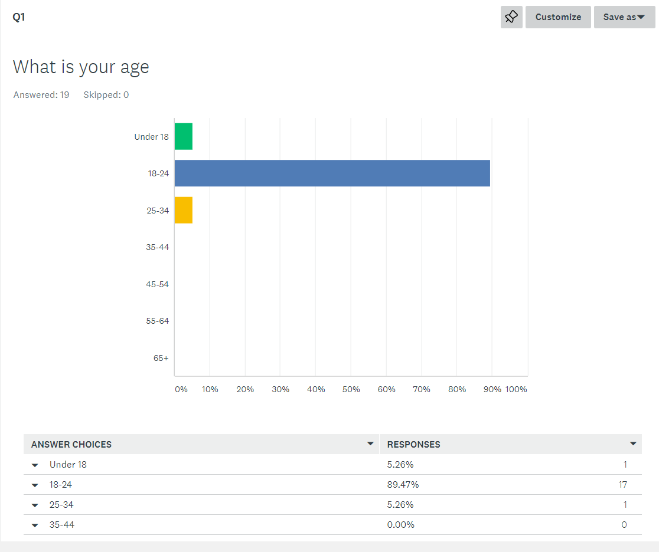
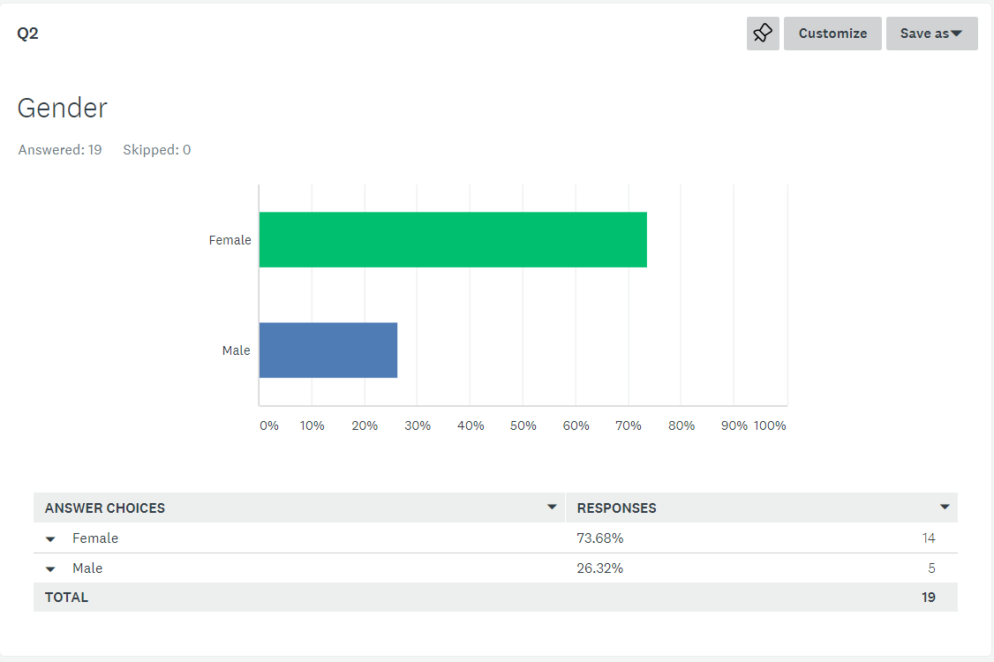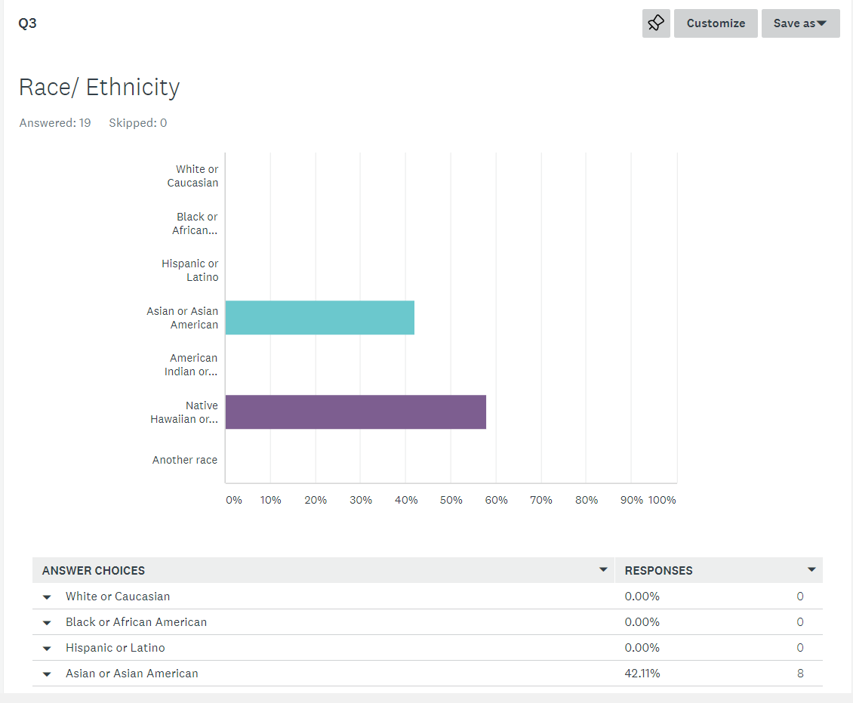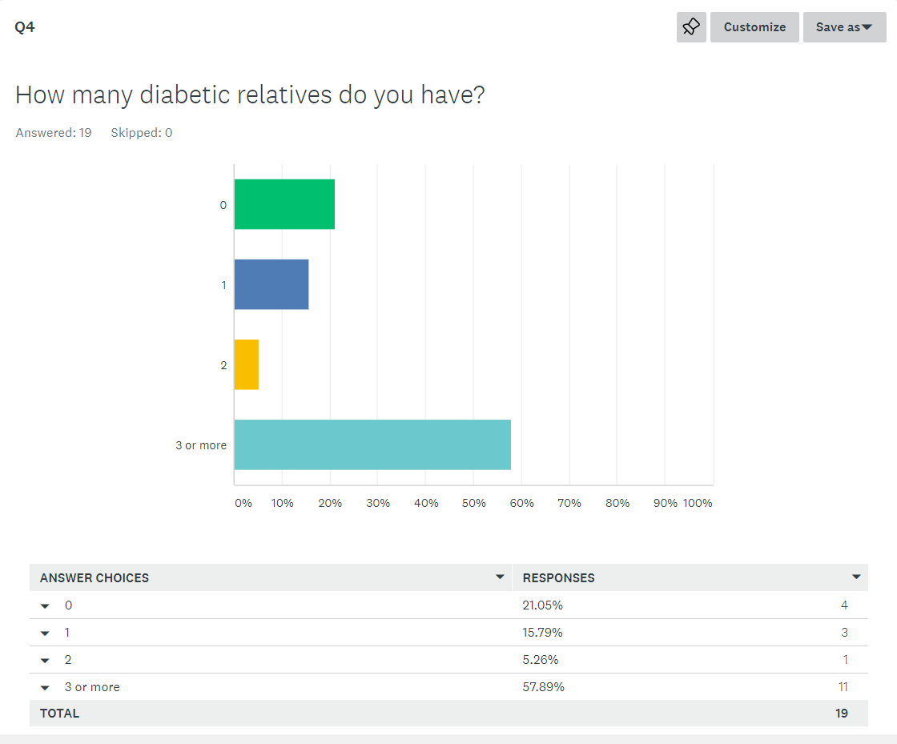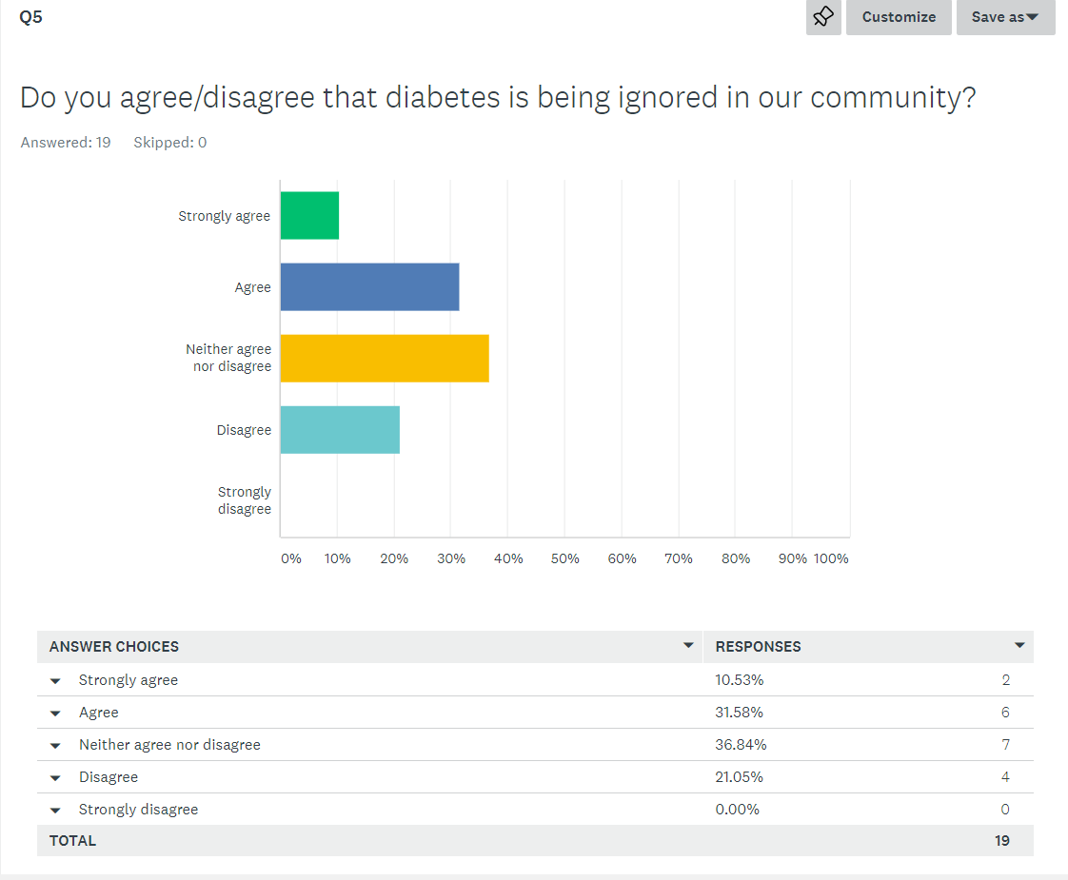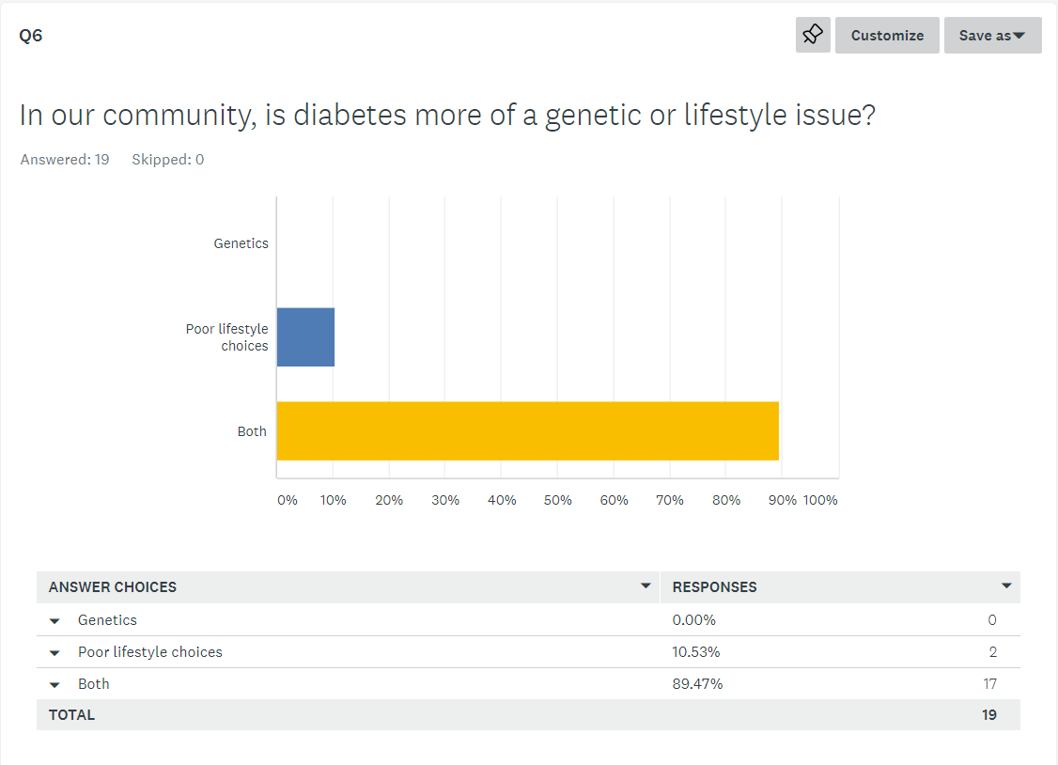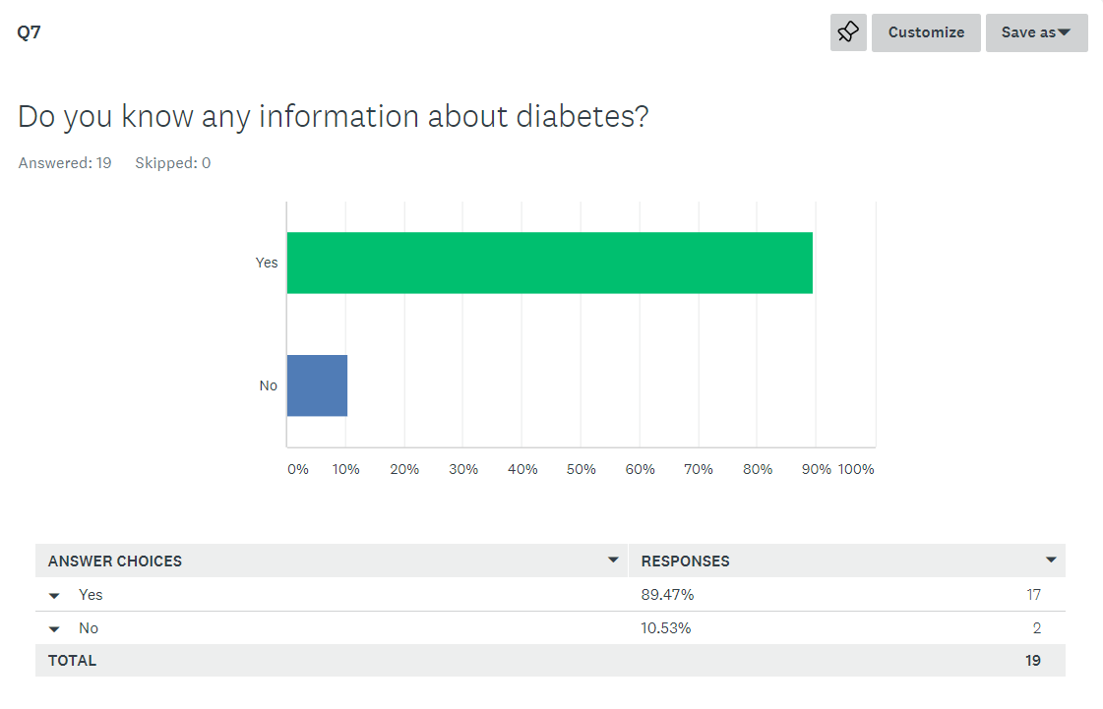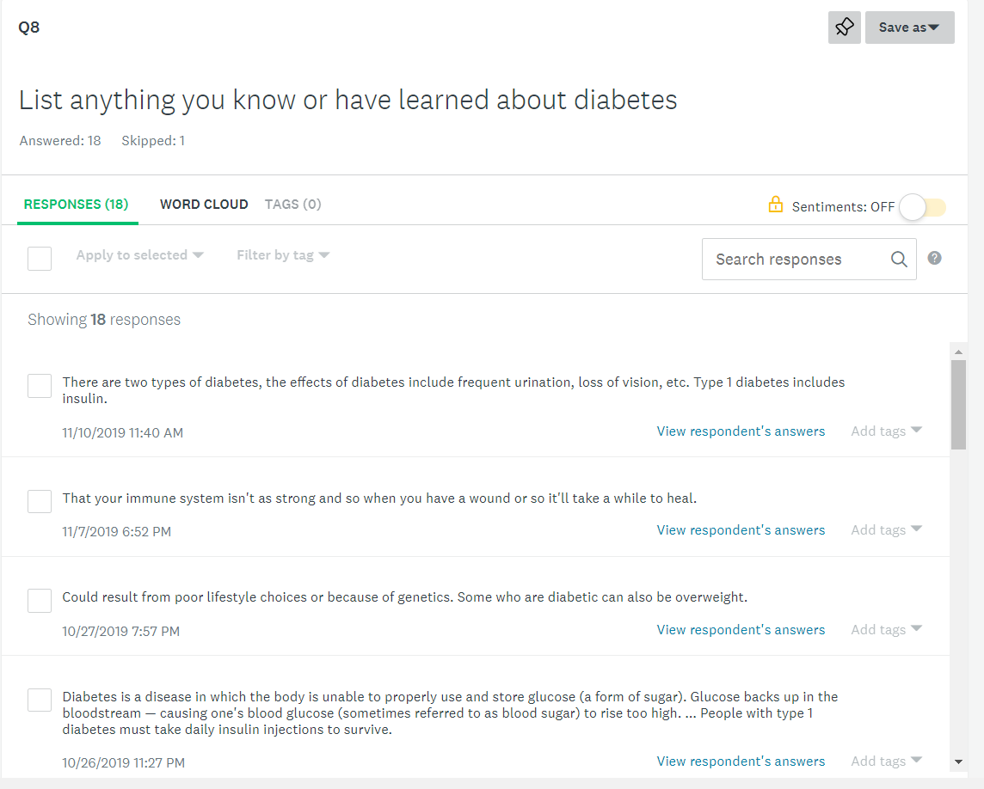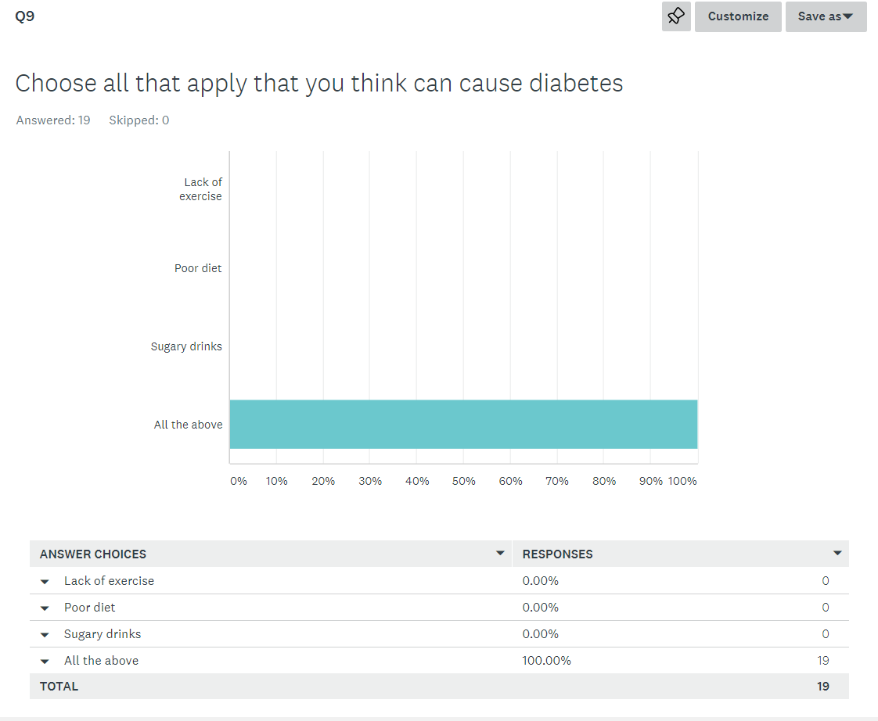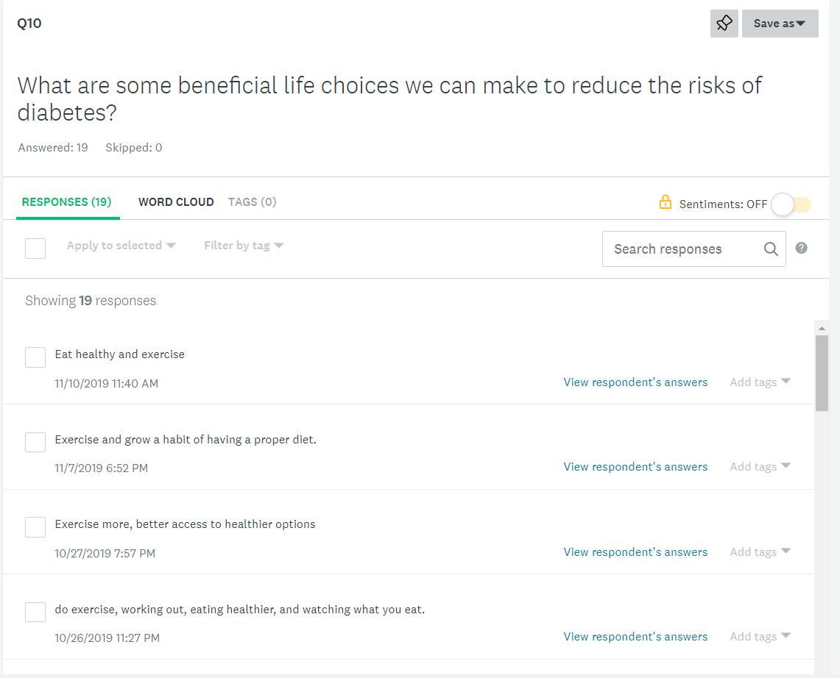

PROJECT SCHEDULE
Writing Schedule
Monday  Essay writing | Tuesday | Wednesday  Essay writing | Thursday  Essay writing | Friday  Essay writing | Saturday  Essay writing | Sunday

Literature and Primary Data Schedule
Monday  Observation and survey | Tuesday | Wednesday  Literature review  Data collection | Thursday | Friday  Observations and data collection | Saturday  Letters to experts  More observations | Sunday  Surveys

Catherine Diaz
EN101- ON01
Dr. Kimberly Bunts-Anderson
10/18/19
Brainstorm and Outline for Essay #4

Brainstorm
Literature #1: Non Academic
Encinares, E. (2019, April 23). About 12-18 percent of adults in the CNMI had diabetes in 2016 - Saipan News, Headlines, Events, Ads: Saipan Tribune. Retrieved October 18, 2019, from https://www.saipantribune.com/index.php/about-12-18-percent-of-adults-in-the-cnmi-had-diabetes-in-2016/.
(Encinares, 2019) In text
In a newspaper article posted on Saipan Tribune, “An estimated 12 percent to 18 percent of adults in the CNMI have diabetes, while about two-thirds of them are either overweight or obese, according to the Commonwealth Healthcare Corp.’s 2016 Non-Communicable Disease and Risk Factor Report,” (Encinares, 2019). Also, according to CHCC, two of the leading causes of death in the CNMI are cardiovascular disease, which is heart disease, and cancer (Encinares, 2019). Obesity and overweight high increases the risks of developing diabetes and/ or hypertension, which is high blood pressure.
How will it be applied to the project:
Using this information for comparison, I will conduct a new survey to show the updated percentage of adults who are diabetic in the CNMI with the help from CHCC.

Literature #2: Non Academic
Doyle, J. L. (2018, October 17). Diabetes in the CNMI - Saipan News, Headlines, Events, Ads: Saipan Tribune. Retrieved October 18, 2019, from https://www.saipantribune.com/index.php/diabetes-in-the-cnmi/.
(Doyle, 2018) In text
Dr. John L. Doyle is a physician at the Marianas Medical Center. He wrote a newspaper article for the Saipan Tribune discussing diabetes in Saipan. He stated that diabetes is known in our island and that nearly everyone knows someone who’s diabetic. It was mentioned that being overweight and obese is the main cause of diabetes. An interesting fact from Dr. Doyle was how diabetic patients die. “Diabetics die of heart disease. Diabetics die from kidney failure. Diabetics die from losing limbs and losing their mobility. Diabetics go blind,” (Doyle, 2018). This article is important because it gives information about dietary habits.
How will it be applied to this project:
I will use this information to help gather data. I also will like to interview Dr. Doyle to share his opinions on exercise and healthy eating habits.

Literature #3: Academic
Birnbaum, L. S. (2012). Is Supersize More than Just Too Much Food? Environmental Health Perspectives, 120(6). doi: 10.1289/ehp.1205200
Linda S. Birnbaum wrote an article talking about diabetes. She stated that, “Diabetes and obesity are two of the most significant public health issues of our day, and both are major epidemics in the United States and abroad,” (Birnbaum, 2012). Being overweight or obese has been estimated to account for approximately 70% of the cases of type 2 diabetes. Based on data collected, from (Center for Disease Control and Prevention 2011), 25.6 million of all people in the U.S. over 20 years old diagnosed diabetes.
How will it be applied to this project:
I will use this article to data collected to support the research project

Outline:

- Introduction
  - General Statement:
  - Narrow Focus:
  - Main Idea:
- Body Paragraph #1: Literature Source #1 – Non academic
  - Summary
  - How it will be applied
- Body Paragraph #2: Literature Source #2 – Non academic
  - Summary
  - How it will be applied
- Body Paragraph #3: Literature Source #3 – Academic
  - Summary
  - How it will be applied
- Body Paragraph #5: Pertinent study #1
  - Study
  - Reflection
- Body Paragraph #6: Pertinent study #2
  - Study
  - Reflection
- Conclusion
  - What was done
  - How the project fits in with the literature source

Catherine Diaz
11/29/19
EN 101-ON01
Outline Research Report

- Cover page
- Table of contents
- Abstract
- Literature Review- research questions
  - Non- academic
  - Non-academic
  - Academic
  - Academic
- Methodology
  - Process essay
- Analysis
- Findings
- Discussion
- Conclusion
- References
- Appendix
  - Graphs of survey

LETTERS TO EXPERTS

Paresh Dandona, Univeristy at Buffalo
Chief of the Division of Endocrinology
716-645-4605
dandona.diabetes@gmail.com
October 17, 2019

Dear, Mr. Dandona,

My name is Catherine Diaz. I am a student at Northern Marianas College of the Commonwealth of the Northern Marianas Islands, USA. I am currently working towards an Associate’s degree in Liberal Arts. I am writing this letter for my research project in my English composition class, requesting an interview with you about the diabetes epidemic. I would like to gather information about the relationship of diabetes with healthy habits such as exercise and good food habits. This should only take a few minutes out of your day. I understand that this may be a challenge due to your busy schedule. I’d be more than happy to attach a brief questionnaire in supplement for the interview for your convenience. I would like to thank you in advance for any time you put in efforts to help my research project. I look forward to hearing from you and for the valuable information that you could provide.

Warm Regards,
Catherine Diaz
catherine.diaz@my.marianas.edu

Questionnaire
1. Could my diabetes be reversed?
2. Why is weight loss so important? What's the best way for a person with type 2 to lose weight?
3. What are the best foods to eat before and after exercising?
4. Does exercise and healthy eating habits help reduce risk of diabetes?
5. What are some facts that people misinterpret about diabetes?
6. Is there a cure for diabetes? If not, is it possible to create?
7. What are the types of treatments?
8. Does genetics play a greater role in the manifestation of diabetes?
9. What is the best dietary plan for diabetes?
10. What is the best physical activity plan?

READING NOTES
Note Taking Sheet: Reading # 1& 2

Catherine Diaz
EN202-ON01

1. Author’� s Name: Erwin Ecinares
2. Author’� s Credentials (Press Release)
3. Publisher [or title of organization]: Saipan Tribune
4. Heading of Section [title of reading]: About 12-18 percent of adults in the CNMI had diabetes in 2016
5. Year Written: 2019
6. Pages: Website
7. Website URL: https://www.saipantribune.com/index.php/about-12-18-percent-of-adults-in-the-cnmi-had-diabetes-in-2016/.

Main Ideas/Points | Important Quotations | Supporting Details | Relevance to Your Assignment
- Being either overweight or obese increases the chances of developing either hypertension or diabetes. | - “Additionally, cardiovascular disease and cancer are two of the leading causes of death in the CNMI,” | - 12 percent to 18 percent of adults in the CNMI have diabetes, while about two-thirds of them are either overweight or obese, according to the Commonwealth Healthcare Corp.’s 2016 Non-Communicable Disease and Risk Factor Report. | - This information is relevant to my research paper by providing statistics in a specific region
Main Ideas/Points | Important Quotations | Supporting Details | Relevance to Your Assignment
- overweight and obese is the main cause of diabetes  - Keeping blood sugar levels controlled actually extends life. | - All of the complications of diabetes can be prevented for most people by losing weight and getting to a healthy size.  - When sugar is too high the sugar tends to “leak” through the blood vessel walls, damaging the blood vessels as it does. | - If you have more body than you have insulin then you will become diabetic.  - The small vessels in the eye, the kidney and the heart are most affected but the vessels in the legs and feet are also subject to damage. | - It shows the relationship between exercise and body weight to diabetes  - Displays consequences when neglected or not taking care of sugar levels and body care
- Treatment strategies for diabetes have emerged | - Initially the diabetic is started on a diet. Carbohydrate restriction and healthy eating can sometimes help control diabetes and medication might not be required. | - Ideally one starts with an oral medicine such as metformin. Metformin causes less glucose to be released from the liver and also helps boost sensitivity to existing insulin and to decrease absorption of glucose in the diet | - This information will provide knowledge on how to maintain a healthy with and or without diet and exercise

In this article, is it possible that any of the authors might have a bias about the subject matter? No

Is the article timely or a bit outdated ? Timely
Was it published in a reputable source? Yes
It is not an academic source. Yes, it not an academic source
Other important information: none

Note Taking Sheet: Reading #3 & 4

Catherine Diaz
EN202-ON01

1. Author’� s Name: Primary: P. Hemachandra Reddy
2. Author’� s Credentials (Press Release)
3. Publisher [or title of organization: https://www.ncbi.nlm.nih.gov
4. Heading of Section [title of reading] Can Diabetes Be Controlled by Lifestyle Activities?
5. Year Written: 2017
6. Website URL: https://www.ncbi.nlm.nih.gov/pmc/articles/PMC5792082/

Main Ideas/Points | Important Quotations | Supporting Details | Relevance to Your Assignment
- Diabetes is a complex disease that affects millions of people worldwide | - “Diabetes is a metabolic disease, in which increased blood glucose levels ultimately lead to heart disease, stroke, kidney failure, foot ulcers, and damage to the eyes.” | - Diabetes is mostly polygenic condition, accounts for about 95% of total diabetes cases and it is mostly late-onset. | - This article also discusses how lifestyle factors delay and/or prevent diabetes.
Main Ideas/Points | Important Quotations | Supporting Details | Relevance to Your Assignment
- The total number of persons with diabetes worldwide is estimated to increase from 171 million in 2000 to 366 million in 2030 | - “The worldwide prevalence of diabetes was 2.8% in 2000, and it is expected to increase to 4.4% by 2030.” | - According to the Center for Disease Control and Prevention, in the United States the number of persons with diabetes older than 65 years of age rose nearly 300% between 1980 and 2014, from 5.5 million in 1980 to 22 million in 2014. | - These statistics I will analyze in my findings of the research paper.

In this article, is it possible that any of the authors might have a bias about the subject matter? No
Is the article timely or a bit outdated? Timely
Was it published in a reputable source? Yes
It is not an academic source. No, it is an academic source
Other important information: none
Note Taking Sheet: Reading #5 & 6

Catherine Diaz
EN202-ON01

1. Author’� s Name: Linda Hepler, RN
2. Author’� s Credentials (Press Release)
3. Publisher [or title of organization: Healthline
4. Heading of Section [title of reading] Junk Food and Diabetes
5. Year Written: 2016
6. Website URL: https://www.healthline.com/health/type-2-diabetes/junk-food

Main Ideas/Points | Important Quotations | Supporting Details | Relevance to Your Assignment
- One of the top risk factors for developing type 2 diabetes is being overweight. | - “Insulin is a hormone that moves sugar out of your blood and into your cells.” | - When your cells are unable to use insulin properly, your pancreas mistakes this as a need for more insulin, so it pumps out more. | - This is relevant to my research report because it provides a brief introduction on the development of diabetes
Main Ideas/Points | Important Quotations | Supporting Details | Relevance to Your Assignment
- Junk foods are highly processed and high in calories. | - “This can cause them to digest more quickly, which can spike blood sugar levels and increase bad cholesterol levels.” | - They tend to have few vitamins and minerals, and are usually low in fiber. Junk foods also often contain large amounts of added sugar and are high in saturated fats and trans- fats. | - This shows the correlation between junk food, diabetes, and healthy diet. I will use this to persuade readers to agree with my argument.

In this article, is it possible that any of the authors might have a bias about the subject matter? No
Is the article timely or a bit outdated? Timely
Was it published in a reputable source? Yes
It is not an academic source. Yes, it is not an academic source
Other important information: none

Note Taking Sheet: Reading #7 & 8

Catherine Diaz
EN202-ON01

1. Author’� s Name: P. Hemachandra Reddy
2. Author’� s Credentials (Press Release)
3. Publisher [or title of organization: HHS Public Access
4. Heading of Section [title of reading] : Cost of Diabetes
5. Year Written: 2017
6. Website URL: https://www.ncbi.nlm.nih.gov/pmc/articles/PMC5792082/

Main Ideas/Points | Important Quotations | Supporting Details | Relevance to Your Assignment
- Rates of cardiovascular disease has drastically risen within diabetic people | - Based on statistics from 2003 to 2006, cardiovascular disease death rates were about 1.7 times higher among adults with diagnosed diabetes who were aged 18 years or older compared to adults who did not receive a diabetes diagnosis, after adjusting for age differences in these population groups. | - According to the American Diabetes Association, from 2009 to 2012, of the adults aged 18 years or older who were with diagnosed diabetes, 71% had increased blood pressure and 65% had LDL cholesterol levels greater than normal | - This information will support the thesis of my research report
Main Ideas/Points | Important Quotations | Supporting Details | Relevance to Your Assignment
- The cost of diabetes treatment is constantly rising | - After adjusting for age and sex differences in persons diagnosed with diabetes, their average medical expenditures were found to be 2.3 times higher than for persons without diabetes | - In 2012, the costs of treating illnesses associated with diabetes, such as blindness, heart attack, and stroke, rose to $245 billion in the United States, with direct medical costs of about $176 billion | - This information will support the reason why having daily exercise and a healthy diet is better than paying these costs.

In this article, is it possible that any of the authors might have a bias about the subject matter? No
Is the article timely or a bit outdated? Timely
Was it published in a reputable source? Yes
It is not an academic source. Yes, it is not an academic source
Other important information: none

