The Negative Effects of Teenage Beauty Pageants

Jefferson Mateo
EN101-ON01
Dr. Kimberly Bunts – Anderson
December 7, 2017
Northern Marianas College

Table of Contents
Abstract -- 2
Introduction – 3
Research Questions
Literature Review
Discussion -- 4
Limitations
Spotlight
Pageantry Today -- 5
Methodology
Conclusion -- 6
References -- 7
Appendix A -- 8
Appendix B – 9
Appendix C – 11
Appendix D -- 12

Abstract
This study explores the awareness that the community has about beauty pageants. Beauty pageants display a positive message to society, but contestants are unnoticed for their sacrifice and struggles. The articles used in the research reveals the many aspects of beauty pageants. Moreover, interviews with past pageant contestants were conducted to support the ideas from the research results. This paper is supported by five articles, but for the most part, information was emphasized and examined from materials reviewed by Cartwright and Deninno.

The Negative Effects of Teenage Beauty Pageants
Beauty pageants is defined as an event of glamor and beauty, but a vast amount of people do not consider what the contestants may undergo to show off their intellect and allure. Although beauty pageants reflect self-confidence, one may encounter trials that resort to self-inflicted damages. These trials include drug and alcohol abuse, starvation, or in extreme cases, forced weight gain, which can result to obesity. Ph.D. Martina M. Cartwright agrees that most girls who grow obsessing in body perfection may develop a condition which is referred to as a fairy tale, “The Princess Syndrome.” As a young women continue to believe that beauty has standards, her vision and conception of society differs from other girls.
Research Questions
- Do teenage beauty pageants have a negative effect on young women?
- Do beauty pageants sexually objectify young women?
Literature Review
In Martina M. Cartwright’s article revealing the effects of beauty expectations, it was agreed that many experts have studied that children who are exposed to activities that focuses on physical appearance at an early age can influence teen and/or adult self-esteem. Struggles with eating disorders and body image can be detrimental in their adulthood. In addition, a small research was published in 2005, elucidating the increased rates of children who are dissatisfied with the outcome of dieting (Cartwright 2011).
Furthermore, beauty pageants are extremely costly. Kim Gravel, 1991 Miss Georgia America hypothesized that contestants sum up a huge amount of money to win a beauty contest. In most cases, pageants contestants spend more then what they win. One factor most constants take into consideration are dresses that they wear. Gravel stresses that a dress can run from $700 to $1000. This totals up the cost of attempting to win a pageant (Deninno, 2014).

Discussion
Both Cartwright and Deninno’s studies are true about the unconstructiveness of beauty pageants. Although the information was used as a support in the overall research, the information conflicted and disagreed upon other perceptions about the impact in joining beauty pageants.
Limitations
The number of disagreements are identified from the materials reviewed by Deninno. These differences consist of the spotlight of the experience winning the pageant, and the modern world of pageantry.
Spotlight
According to the materials examined by Deninno, Kim Gravel states that young women believe that winning will help them grow into the spotlight (Deninno, 2014). Young women believe that attention from their appearance will make them well-known and soon become famous. In comparison to music artist, Britney Spears and actress, Ali Landry, pageants are worthwhile and rewarding. Yes, many girls may be unfortunate not winning a pageant, but with such passion, it can lead one to many opportunities.

Pageantry Today
In addition, pageants can be pricey, but the world of pageantry has changed over the years. Kim Gravel stresses that one thing that is costly when joining a pageant is buying a dress. Surprisingly, pageants back in the days were much more expensive. Reason is, unlike today, dresses used in pageants were custom-made. This was considered to be expensive. Today, we have dress shops that display an array of colorful, poufy dresses. This sets back the high cost of beauty pageants.
Methodology
Throughout the research, interviews were conducted with two past teenage pageant contestants. The first interview was with a teen pageant contestant from 2008. On the other hand, an interview was conducted with a teen pageant contestant from 2014. Both contestants were asked with questions that share similar ideas (Appendix A & B). 2008 contestant shared intriguing information, and her responses link to an article by Deninno. 2014 contestant shared responses that were related to the present day.
Also, a survey was created and given to 20 people, specifically teenagers. Proposed amount of survey takers is 20, but only 19 people responded (Appendix C & D). Solution to this issue was to combine pilot survey questions and responses with general survey as they share similar questions. This was done to support the research.

Conclusion
Beauty pageants will always exude positivity, from building social relationships, and allowing pageant contestants to achieve a life-long experience. Although the experience is worthwhile, many people overlook the negative impacts of competing in a beauty contest. To comprehend this topic, one must conduct meticulous research and explore the many avenues of pageantry. To avoid the shaming of young women, we can begin to appreciate their confidence and talents, rather than focusing on their flawless face and body.

References
Cartwright, M. M. (2011, August 12). Child Beauty Pageants: What Are We Teaching Our Girls? Retrieved December 06, 2017, from https://www.psychologytoday.com/blog/food-thought/201108/child-beauty- pageants-what-are-we-teaching-our-girls
D. (2014, August 4). The Negative Effects of Beauty Pageants. Retrieved December 06, 2017, from https://www.ultius.com/ultius-blog/entry/the-negative-effects- of-beauty- pageants.html
DeNinno, N. (2014, June 10). The High Cost of Beauty Pageants. Retrieved December 06, 2017, from http://www.ibtimes.com/high-cost-beauty-pageants-1595724
Fleishman, T. A. (2002, August 08). The Cost of Winning a Beauty Pageant. Retrieved December 06, 2017, from http://www.bankrate.com/finance/smart- spending/cost-of- winning-beauty-pageant.aspx
Gabrielle, O. (2014, December 19). Miss World Pageant Eliminates Swimsuit Competition Round. Retrieved December 06, 2017, from http://people.com/bodies/miss-world-pageant-eliminates-swimsuit- competition-r ound/

APPENDIX A
Interview Questions and Responses 1
- If you can recall, what were some emotional, physical, social, and/or financial challenges that you’ve encountered joining a pageant?
Definitely! I was so stressed out from practicing and trying to focus on my school work. I was dependent on drugs to help my cope with the stress. For financial trials, I was sponsored during the time so, I didn’t spend a lot. My aunty did my hair and makeup.
- How did joining a pageant impact your life? How did it affect you after?
When I joined the pageant, I didn’t win, but I was called for several photoshoot taking at DFS. My aunty would always bug me to go and focus on doing the photoshoots. Sure, I was making money from it, but it did hold me back from my friends and I. I didn’t spend a lot of time with them. In the end, I decided to be fat and overweight so that companies would stop calling me.
- Do you think beauty pageants have a negative impact on young woman?
Yes. During my time, when girls didn’t win, they make it such a big deal. They take it so negatively. One time, one girl fell to the ground crying about it. It also changed the way most of us looked at ourselves. We wanted to be skinny.

APPENDIX B
Interview Questions and Responses 2
1. Do you think that pageants have a negative impact to contestants? If so, please provide a brief explanation to your answer.
Because pageants are usually associated with beauty and society's perceptions of beauty it can go two very different ways. The girls can feel empowered by one another, or feel the need to compare themselves to one another. It has its negative impact of highlighting the physical aspects of a young girl who is still developing their sense of self-love and self-worth. Under pageant pressure, young contestants can agonize over not meeting certain expectations in regards to body image, personality, etc.
2. What have you encountered during the process of a beauty pageant (emotional issues, social interaction, financial crisis)?
It was definitely costly. I was only introduced to the idea of sponsorship and even that was challenging because I didn't have too many family members on island. Also, the means to get around and collect resources was a bit difficult. It was all worth it, the confidence I gained after the pageant allowed me to practice my social skills towards girls of my age. Also, I sought a lot of great mentorship from the pageant community.
3. Do you think participating in beauty pageants put young women at risk for sexual objectification?
Absolutely. Beauty pageants highlight the physical features of these young women. I think in turn, there just needs to be more diverse pageants on the island; pageants that highlight more on talents and the women's social values. I think moving the spotlight from the conventional "grace" and "beauty" will allow younger women who watch these pageants understand that there is more to life than showcasing your body and having a perfect photo-ready face.
4. What do you think you can do to raise awareness on the effects of teenage beauty pageants?
A short film documentary would help girls relate to the pressures of society. School campaigns that promote new ideas of beauty to deconstruct the "perfect girl image" that pageants tend to create.

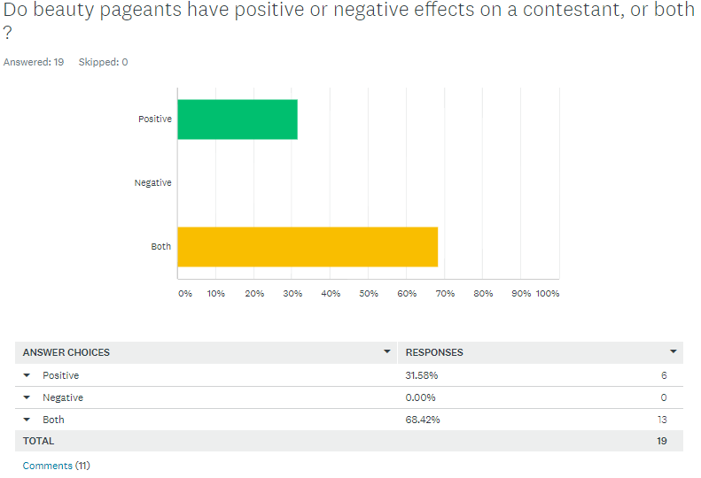
APPENDIX C

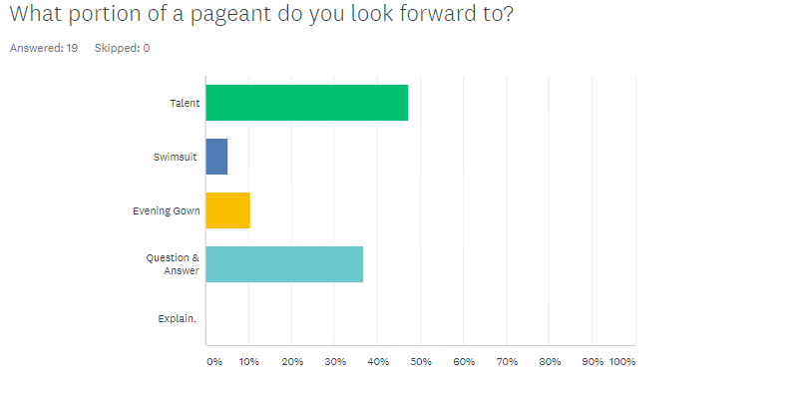
APPENDIX D

