Shell gas stations after Typhoon Soudelor
Carla Mae Carees Quinto
Northern Marianas College

Author Note
This research was a requirement for English Composition 101 Section 08 instructed by Dr. Kimberly Bunts- Anderson of Northern Marianas College

Table of Contents
Cover Page………………………………………………………………………………………...1
Table of Contents…………………………………………………………………………….……2
Abstract……………………………………………………………………………………………3
Introduction……………………………………………………………………………………......4
Background……………………………………………….….………………………………........5
Primary & Secondary Question(s)……….……………………………………………………….6
Literature Review...…………………………………………….………………………….......7&8
Methodology……………………………………………….…………………...………….…9&10
Analysis…………………………………………………………………………………………11
Discussion………………………………………………………………………………………12
References………………………………………………………………………………………13
Appendices………………………………………………………………………………..……14
Appendix A………….…………………...………………………………………………14
Appendix B………………………………………………………………………………15
Appendix C…………………..…………………………………………………………..16
Appendix D………………………………………………………………………………17
Appendix E………………………………………………………………………………18
Appendix F……………………………………………………………………………….19
Appendix G………………………………………………………………………………20
Appendix H………………………………………………………………………………21

Abstract
On the month of October, a primary question had was developed for a research project. A 10 question survey and interview questions was created by a student researcher. Responses from different peers were gathered but the information wasn’t efficient. Since the questions was highly recommended for revision, it later on had to be distributed by the English instructor to her college English classes which made the survey highly recommended.

Introduction
Lines, lines, lines. What many had to go through after Typhoon Soudelor struck the island of Saipan on August 2, 2015. One of those many lines people had to go through, which some might have thought to be the longest on island were at gas stations. Like many establishments and homes in Saipan, gas station particularly Shell stations were affected by Typhoon Soudelor. Typhoon Soudelor affected gas station businesses internally and externally.
Before Typhoon Soudelor, Shell already had its faults and was already in need of renovations and repairs. According to an employee, they have sent many MROs, maintenance request orders to their head, IP&E, but have yet to have fundings for such repairs. Aside from needed repairs, another hindrances were the customers themselves. Most were already complaining about slow pumps and services. On the day before Typhoon Soudelor struck, Shell establishments did not experience a change in the pace of customers coming in. This, according to many of their employees, was the calm before the storm.
During Typhoon Soudelor, many of Shell gas stations were forced to close early for the safety of their employees and their stations which was authorized by IP&E Guam. Even though Shell gas stations were forced to close early, according to a Shell employee they were able to distribute gas during Typhoon Soudelor. Despite the precautions into securing the establishments two of Shell stations, Shell DanDan and Shell San Roque were massively damaged and forced to close down the next.
After Typhoon Soudelor, the worse is yet to come. According to supervisor Ephrem Gaagin employees had to be brought in instead of one or two which extended to four pumps two cashiers and one pump attendant controlling traffic. Typhoon Soudelor affected the gas stations of Saipan through the establishments themselves, to the employees, and the customers.
Background

The researcher will be providing information from newspaper articles from Marianas Variety and Saipan Tribune. The student researcher will also provide a survey provided by surveymonkey.com which are answered by anonymous people. One sources from an academic source which was found by the student which is the affect of long lines and shortages of fuel. In this case Typhoon Soudelor had everyone expecting the unexpected with the lines with gas and handling the situation by panicking. This meant the CNMI wasn’t prepared for this kind of matter.

Primary Question:
How did Typhoon Soudelor affect Shell gas stations?

Secondary Research Question(s):
- After Typhoon Soudelor did you line up for gas?
- How long did you wait in line for gas?
- Were you frustrated about the gas dilemma?
- Were you misinformed about the gas stations hours?
- Did you prioritize putting gas before fixing or cleaning your home?
- Do you think limiting gas stations after Typhoon Soudelor was a smart idea?
- Do you think the government prioritizing themselves for gas was a good idea?
- What lesson(s) did you learn after the gas dilemma?
- Were you in any way mistreated by the gas attendant(s)/ cashier(s)?
- Do you think the gas stations could have handled the situation in a different way? How?

Literature Review
Wonder what benefits planning ahead versus not so plan events? Lining up for gas on time will benefit the person from the lines and less hassle with the time. As for lining up for gas in a later time, limits the person from getting things done on time. Between both of this situations has its good and its bad, which actually gives tips why it’s best to plan ahead while people wait and struggle in the end without planning on time. (Khetagurov, V. A., & Sokolov, K. K. 2009).
The right time and day to gas a car is to plan ahead before a typhoon is about to come. For example, plan a certain day before a typhoon hit, start filling up the car(s). Actually save the person time and waiting in line to deal with. The good part about fueling before a typhoon is chances that gas won’t run out and there’s no limit needed for any transaction on how much a person wants gas. (Winnie, H., & Krauss, C. 2012, November 15). There is no hassle in getting gas or even no hassle in waiting in line for hours and hours. Lining up for gas beforehand will benefit the person, to plan ahead in other things important than gassing for example getting dinner ready, chores, and homework done. It’s better to plan ahead, because, it will be useful in the near future.
Not planning ahead before a typhoon will cause the person hours and hours, and long lines. Erediano, E. (2015, August 11) While waiting in line for gas on the day of a typhoon the staff of the station/management may only accept cash and not credit card etc. or limit on how much people should gas or even close the station due to the strong winds. No person would like to deal with that kind of situation especially a typhoon is coming up. Consequences for not planning ahead will have the person needing to gas again and again if he or she doesn’t get the chance to line up. (Agpoon-Cabang, R. 2015, August 18).

Similarities between lining up for gas in an earlier time versus fueling in a later time. There are possibilities the person on both sides can still manage to get gas. Depending on the person if he/she lines up for gas in an earlier time he/she can still get gas. As for gassing in a later the time the person can still get the gas if the person has patients to wait in line or he/she doesn’t mind wasting time in line. It really depends on the person whether he/she wants to get gas early or not the person will eventually get gas. (Ozguven, E. E., & Ozbay, K. 2015).
In conclusion, planning ahead is always a good way to start a good day, start the day right and less hassle to go through. For example, less things to worry about the person can actually move to another agenda before a typhoon comes. As for not able to plan ahead it will cause the person to rush things as in getting ready to go to shelters, in need to grocery shopping, in need to go to relatives house to get them etc. either way a person who doesn’t plan ahead before a typhoon hits won’t make the person’s life easier. (Winnie, H., & Krauss, C. 2012, November 15).

Methodology
On the month of October, a primary question had was developed for a research project. A 10 question survey and interview questions was created by a student researcher. Responses from different peers were gathered but the information wasn’t efficient. Since the questions was highly recommended for revision, it later on had to be distributed by the English instructor to her college English classes which made the survey highly recommended.
While getting sources on the internet, it was time for the student to start on creating survey/survey questions and interview questions for the research question. This survey conducted interview question are developed both had minimum of 10 questions. These survey questions and interview questions had to go through the instructor, it had to be reviewed and approved. As the questions were approved by the instructor the student had to get people to interview and survey. The student had already chosen few people to interview from a certain management (Shell Gas Stations) and for the survey questions the Shell customers. These questions were done on the fourth week of October.
Interview questions had been written down on paper with only one participant who is a manager from Delta Management Corp. five questions will be asked, two interview questions from the five “were there any damages to any of the stations?” and “we’re there any disruption in the business?”. The student had finished interviewing a manager who manages four Shell stations which are Shell Susupe, Puerto Rico, Highway Express and San Roque. The student had to do an interview with the manager who is managing these four stations to let the audience/customers know if there were damages to any of the Shell stations or has there been any complications did the stations have. These questions will help the student understand why some stations needed to be closed and opened in a later time.
As for the survey questions on SurveyMonkey.com the student will be needing 50 customers to answer the survey which is still ongoing. The student researcher has only three participants from the survey. Students were tested on to answer other peers survey to get information as a student researcher. Responses from the students were expressed, limited information but it still helped the student gather details.
Data was collected using an online free survey tool SurveyMonkey.com, were done on Northern Marianas College campus with the peers of the student researcher. Getting feedbacks from the students and customers was helping the research question pull through. As for the interview questions, the student researcher interviewed a supervisor from Shell (Delta Management Corp) who is handling four stations which are Susupe, Highway Express, Puerto Rico and San Roque. This interview took place in an office which happened on October 26, 2015 at around 3:00PM, it about 3 ½ hours. Question typed was formal/informal, answers were written down and recorded.
In conclusion there are fifty participants who will be answering the student researchers survey questions. As from now the survey questions is still ongoing, there were only three who answered the survey. The outcome of it the student researcher still has to at least survey forty more customers to complete the task. As for the interview questions the student researcher interviewed a supervisor from Shell (Delta Management Corp) who is handling four stations which are Susupe, Highway Express, Puerto Rico and San Roque. This interview took place in an office which happened on October 26, 2015 at around 3:00PM, it about 3 ½ hours. Question typed was formal/informal, answers were written down and recorded. The outcome the student had gathered enough information.

Analysis
The gathered data from a data base called SurveyMonkey contains feedbacks from people who are completely anonymous. Gender and age were only given for the public to fill out, nothing more. Here are examples of answers given to the survey “Well can feel the frustration of people”, “Yes, due to the possibility that gas may run out”, “I'll say 50/50. It was good that the government had their own place to gas up their vehicles ex (police cars, ambulances, FEMA and other sources that was helping out with those in need), so that they won't be standing in the long line for gas.” the student researcher found these three collected data helpful for the research project. There are more feedbacks from people who have taken the survey these three are only examples of collected data.

Discussion
The student researcher has gathered data from a data base called SurveyMonkey, below are survey feedbacks graph from different people ranges up to 18 and above of age and gender. All recorded data are completely anonymous. The student researcher has the survey graph on how many people have taken the survey from October 26, 2015- December 9, 2015. The one ranging the most would be December 9, 2015 as for the lowest survey taken was November 2, 9 and 16 2015.

References

Agpoon-Cabang, R. (2015, August 18). Motorists line up at gas stations, again. Retrieved October 22, 2015, fromhttp://www.mvariety.com/cnmi/cnmi-news/local/79338-motorists-line-up-at-gas-stations-again

Erediano, E. (2015, August 11). 8 ½ hours in line. RetrievedOctober 22, 2015, from http://www.mvariety.com/cnmi/cnmi-news/local/79105-8-hours-in-line

Khetagurov, V. A., & Sokolov, K. K. (2009). Creation of axial expanders on magnetic supports for natural gas. Chemical & Petroleum Engineering, 45(9/10), 641-642. doi:10.1007/s10556-010-9252-6

Ozguven, E. E., & Ozbay, K. (2015). An RFID-based inventory management framework for emergency relief operations. Transportation Research: Part C, 57166-187. doi:10.1016/j.t

Winnie, H., & Krauss, C. (2012, November 15). Gas Crisis Abates, With Rations, Special Deliveries and Refinery's Return. New York Times. p. 26.

Appendices

Appendix A: Schedule
- Research Topic: (October 8, 2015) How did Typhoon Soudelor affect the gas stations?
- Research Questions: (October 10, 2015) Newspaper articles and Academic Resources
- (October 11, 2015): Interview Questions
- (October 12, 2015): Interview Questions (Approved)
- (October 13, 2015): Outline
- (October 15, 2015): Revising Process Essay
- (October 19-22 2015): Designing Survey Questions and Interview/ Survey Questions & Survey Questions- Approved
- (October 20- 25): Starts interviewing and surveying- Getting information
- (October 26-29) Methodology Outline/ Methodology First Draft Essay/ Process Essay
- (November 2-5) Process Essay First Draft
- (November 9-12) Process Essay Final Draft
- (November 16-19) Compare and Contrast Academic
- (November 23-26) Compare and Contrast Rough Draft
- (December 3) Compare and Contrast Final Draft and Graph
- (December 4-10) Literature Review Final Draft

Appendix B: After Typhoon Soudelor did you line up for gas? If you did how long did you had to wait in line?

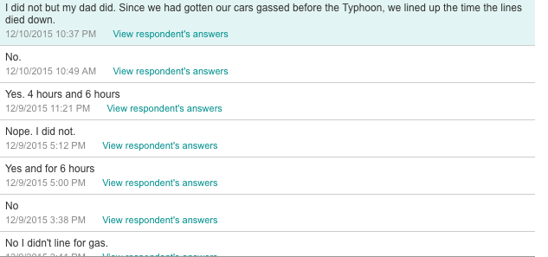
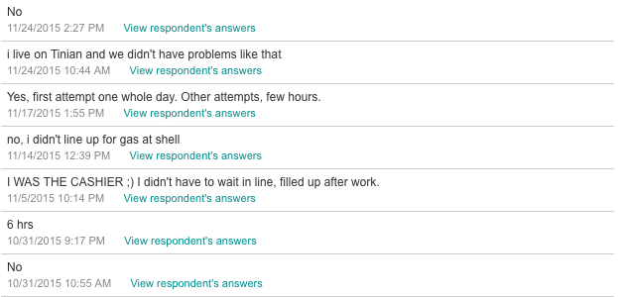
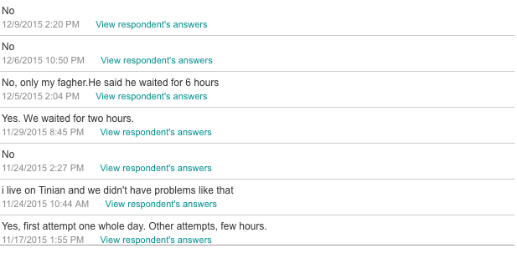
Appendix C: Were you frustrated about the gas dilemma?

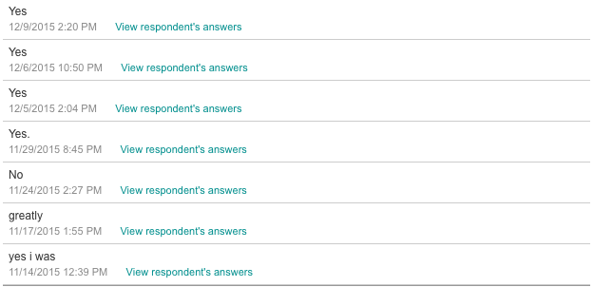
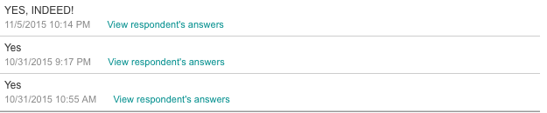
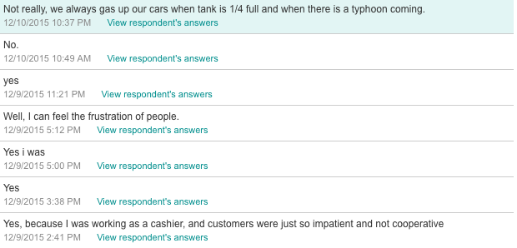
Appendix D: Do you think the government prioritizing themselves for gas was a good idea?
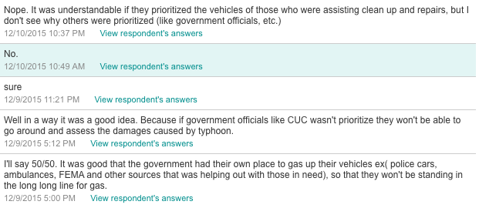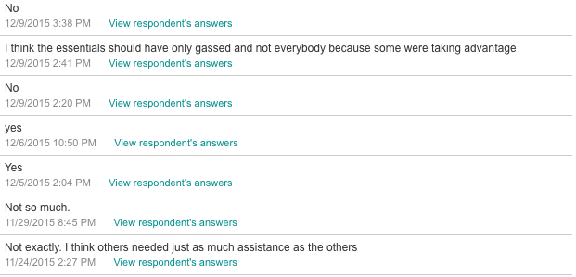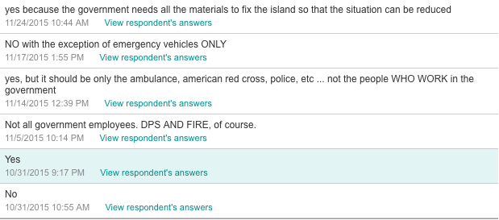
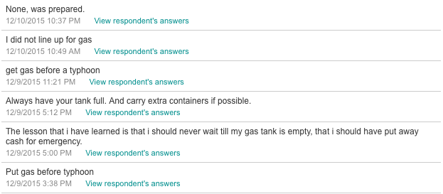
Appendix E: What lesson(s) did you learn after the gas dilemma?

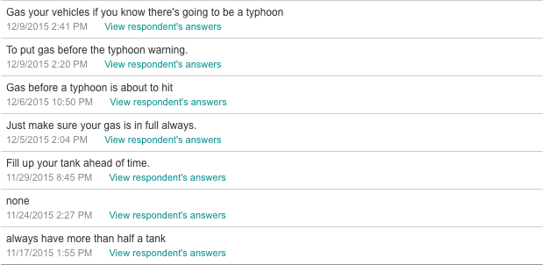
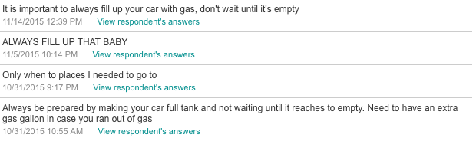
Appendix F: Do you think Shell gas stations could have handled the situation in a different way? How?
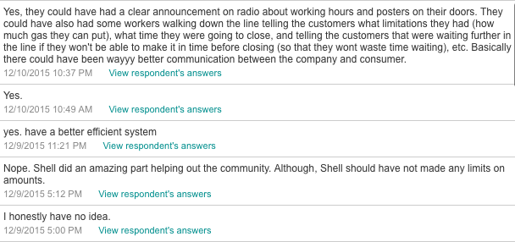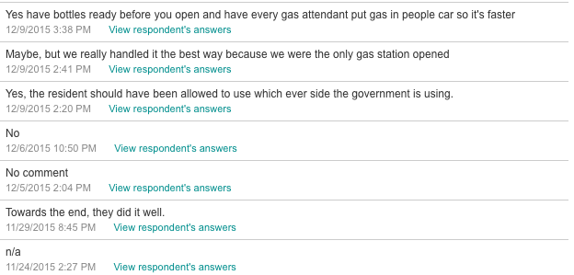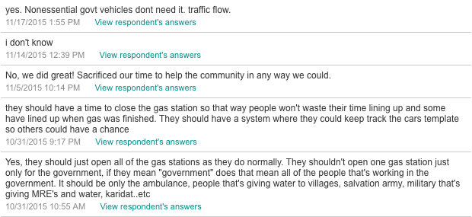
Appendix G: Do you think limiting Shell gas stations after Typhoon Soudelor was a smart idea?
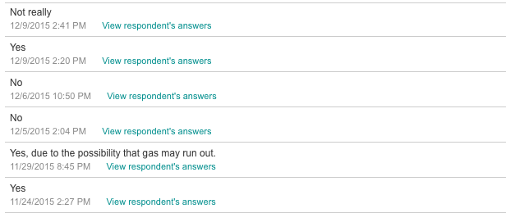
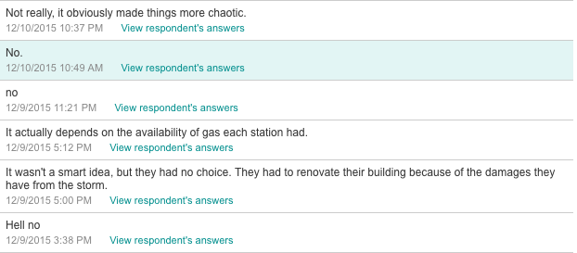

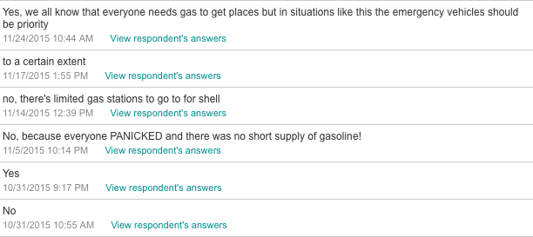

Appendix H: Graph

