Saipan-Korean Residents’ Typhoon Preparedness:
How Well Did the Korean Residents of Saipan Prepare for the Typhoon Soudelor?
Yeji Lee
Northern Marianas College

Author Note
This final research report is being submitted on December 21, 2015 for instructor Kimberly Bunts-Anderson’s ED 202 English Composition II, Section 1 course.

Table of Contents
Abstract......................................................................................................................................3
Saipan-Korean Residents’ Disaster Preparedness before Typhoon Soudelor.............................4
Background................................................................................................................................4
Literature Review.......................................................................................................................6
Importance of Disaster Preparedness...........................................................................6
Knowledge in Disaster Preparedness and Reduction...................................................7
Research Questions....................................................................................................................7
Primary Research Question..........................................................................................7
Secondary Research Question......................................................................................7
Method.......................................................................................................................................8
Research Proposal........................................................................................................8
Data Collection............................................................................................................8
Participants.....................................................................................................8
Sources & Questions......................................................................................8
Results.......................................................................................................................................9
Awareness vs. Needfulness..........................................................................................9
Individual’s Disaster Preparedness.............................................................................10
Discussion...............................................................................................................................10
Primary Research vs. FEMA’s National Survey........................................................10
Primary Research vs. Recommendations...................................................................11
Conclusion................................................................................................................................13
References...............................................................................................................................14
Appendix A: Research Schedule.............................................................................................15
Appendix B: Reading Notes....................................................................................................17
Appendix C: Survey Questions................................................................................................22
Appendix C: Survey Results................................................................................................26
Abstract
This paper reports on an examination of data on how local Korean residents in Saipan, a part of the Commonwealth of Northern Marianas islands, prepared for a disaster before Super Typhoon Soudelor struck the island on August 3, 2015. Due to significance of individual pre-disaster preparedness, a survey was conducted among 34 Saipan-Korean adult residents including 17 males and 17 females. In age variations, the study investigated that participants in younger aged group were likely to better prepare for the disaster, but all participants in different age groups were neither sufficiently prepared for the typhoon nor fully aware of disaster preparation procedures. The data also showed that a great number of participants are highly interested in the government’s provision of disaster preparedness guideline in Korean which is not available currently. In conclusion, by increasing awareness of disaster preparedness procedures through providing Korean disaster preparedness guidelines, Saipan-Korean residents’ disaster preparedness will be promoted.

Saipan-Korean Residents’ Disaster Preparedness before Typhoon Soudelor
Introduction
On August 3, 2015, the super typhoon Soudelor struck the Commonwealth of Northern Marianas islands (CNMI). Indeed, the storm was extremely destructive affecting the entire populations of Saipan. In response to such a large-scale natural disaster and its damage, significance of disaster preparedness among individuals has increasingly drawn public concern in Saipan. The purpose of this paper is to examine Saipan residents’ awareness and actual level of disaster preparedness prior to Typhoon Soudelor. Specifically, this paper focuses on understanding pre-disaster preparedness by Korean citizens of Saipan in certain areas which are based on disaster preparedness recommendations by several disaster management departments and agencies. The paper then discusses whether the distribution of disaster preparation information was sufficient and appropriate enough or not for individuals before the typhoon. Yet, it should be noted that although a primary survey research was conducted on the topic, the survey does not address the level of participants’ proficiency in English which can greatly help explaining the impact of lack of Korean disaster preparedness guidelines. In addition, the participants solely represent a small portion of Korean population in Saipan. Furthermore, the paper anticipates the need of continuous efforts and interests of the citizens to improve the level of citizens’ pre-disaster readiness as well as of the local government and other responsible agencies to promote their provision of personal disaster preparedness guidelines in Korean.
Background
To begin with, it is useful to know how scholars and government agencies define disaster preparedness prior to examine how well the individual prepared for a disaster. The International Federation of Red Cross and Red Crescent Societies (as cited in Kim, 2009), for example, defines disaster preparedness as any measure “to predict and—where possible—prevent them, mitigate their impact on vulnerable populations, and respond to and effectively cope with their consequences.” Faupel, Kelley and Petee (as cited in Kim, 2009) “conceptualize household preparedness as planning and engaging in activities based on general knowledge and information that enable individual households to implement appropriate disaster responses.” In the guidebook Are You Ready?, the Federal Emergency Management Agency (FEMA) illustrates that disaster preparedness is all about protecting people and property from all types of hazards before, during, and after an event with association of a deep cooperation between “citizens, local, state, and federal government” (FEMA, 2004, 8-9).
In addition, many official disaster management departments and agencies have provided useful disaster preparation guidelines for individual. One of the biggest providers of disaster relief to citizens in United States, for example, the FEMA provides a disaster preparedness guidebook entitled Are You Ready?(FEMA, 2004). In this guidebook , FEMA emphasizes the importance of pre-disaster preparedness by suggesting several preparation procedures prior to a disaster, especially in areas of knowing the disaster risk, planning for communication and evacuation, acquiring first aid skills, ensuring supplies, and protecting properties (FEMA, 2004). While FEMA provides general preparedness procedures for all types of hazards for people in different areas, the CNMI Homeland Security & Emergency Management (OHS & EM) offers the most suitable typhoon preparedness information for the CNMI locals in its webpage. OHS & EM provides individual’s typhoon preparedness by different typhoon condition levels from 1 to 4 along with additional descriptions of each level. Despite of usefulness of guidelines provided by FEMA and OHS & EM, FEMA does not obtain a full length of preparedness information in languages other than English, such as Korean, as well as OHS & EM which also obtain the information but in English only. In fact, FEMA notes that prepare for disasters through using its guide as well as information from local emergency management offices can make preparation practical (FEMA, 2004). Thus, this lack of Korean preparedness guidelines provided for Korean citizens of Saipan might potentially affect the Korean citizens’ performance on preparing for typhoon Soudelor.
Literature Review
Importance of Disaster Preparedness
Disaster preparation is important and necessary for all from individual to the entire world due to a rapid increase of typhoon occurrences. According to the Centre for Research on the Epidemiology of Disasters (CRED), > 2331 storms have occurred; > 754 million people have been affected; and > 211,000 people were killed at an economic cost of > US$ 1 trillion in the past 25 years (CRED, 2009). Storms continuously occur and the frequency of this type of disaster occurrences has been gradually increasing (CRED, 2009). This statistic amplifies the need of public attention toward disaster preparation and mitigation efforts. In fact, it may be impossible to control the increase of natural disaster occurrences in the world. Yet, “planning, preparation, and community development” can possibly “defeat, or at least minimize, the damage caused to the community” (Arbon, 2009, 334).
As frequent typhoons continue to impact our Nation, the significance of personal disaster preparedness in reducing the risk of disaster damage has become steadily evident. In FEMA’s guidebook, people cannot only reduce or even completely prevent the impact of disaster by preparing before an event but also minimize fear, anxiety, and losses that arouse concurrently with disasters (FEMA, 2004, 7). FEMA also note that pre-disaster preparedness can be the very first disaster relief that individual is guaranteed before local government and other organizations’ help arrive (FEMA, 2004, 7-9). Because disaster preparedness operates efficiently with building up shared responsibilities and participation at each level from citizen to federal government of a pyramid-like structure, individuals are actually responsible for disaster preparedness, forming the base of the structure at the beginning (FEMA, 2004, 8-9). Similarly, Arbon in his article points out people often misunderstand that “the surgical and emergency care response” has the greatest impact on the health and recovery of affected communities (Arbon, 2009, 333). Arbon mentions that community members with health practitioners play the most important role “in developing the capacity and resilience of communities” where as surgical team generally arrive a little too late to save lives and has less impact on survival or longer recovery (Arbon, 2009, 333).
Research Questions
Primary Research Question: How well did the Korean residents of Saipan prepare for Typhoon Soudelor?
- Socio-demographic differences in preparedness: gender and age
- Level of overall disaster preparedness by Korean residents of Saipan
- Level of familiarity with disaster preparedness procedures provided by local government and other agencies
- Rate of necessity of local government and other agencies’ Korean disaster preparedness procedures provision
Secondary Research Questions: What is the potential correlation between the level of residents’ awareness of disaster preparedness procedures before Typhoon Soudelor and the level of individuals’ disaster preparedness in reality?
Methods
Research Proposal
The primary research topic was “How Did the Korean Residents of Saipan Prepare for the Typhoon Soudelor,” and the chosen method for collecting data was survey. The survey questions ask five areas including the demographic information, level of disaster preparedness in specific areas, level of overall disaster preparedness, level of familiarity of disaster preparedness procedures, and rate of necessity for Korean disaster preparedness procedures. The process of the primary research was structured along with weekly schedule starting from October 19 to December 21, 2015. Prior to collecting data, the primary questions, survey questions, research schedule, and research proposal were approved by Instructor Kimberly Bunts-Anderson and piloted with some of the Northern Marianas College students.
Data Collection
Participants. The survey participants were limited to minimum of 20 people of randomly chosen, over 18-years-old Saipan Korean residents who have lived in Saipan for at least a year and directly experienced Typhoon Soudelor. The participants were able to use electronic devices along with internet connection in order to participate in the survey. All participants were provided with two same surveys in English and Korean with URLs. According to their demographic information, the participants were further organized into different gender groups and age groups.
Sources & Questions. The survey was generated, distributed, collected, and analyzed through Survey Monkey. FEMA’s disaster preparedness guidebook entitled Are you ready? was used to examine the level of individual’s disaster preparedness in areas of six including knowledge of disaster risk, communication plan, evacuation plan, first aid skills or emergency repose, supply protection, and house property protection were measured by rating scales ranged from “extremely familiar/likely” to “not at all.” Also, a short essay question was asked collecting thoughts of the participants regarding provision of disaster preparedness guidelines in Korean by the public organizations as well as the local government.
Findings
Individual’s Disaster Preparedness
From October 19 to November 17, 2015, the participants (n=34) including males (n=17) and females (n=17) of Saipan-Korean residents took part in the electronically distributed survey. The participants were further organized into three age groups: young adults (18-29 years old; 41.12%; n=14), middle-aged adults (30-49 years old; 32.4%; n=11), and older adults (50 + years old; 26.5%; n=9). In Table 1 from the appendix C, graph A and B illustrate different areas of disaster preparedness measured by different age groups. By understanding Table 1, it is clear that Korean residents of Saipan in younger age group were likely to better prepare in most of areas of disaster preparedness for Typhoon Soudelor. Yet, the overall level of disaster preparedness by all age groups was extremely low as it is addressed in Table 2. According to participants’ comments, this insufficient disaster preparedness level could be resulted by either the failure in predicting the risk of the typhoon; ignorance of disaster preparedness procedures; indifference to pre-disaster preparedness; lack of resources or supplies; or lack of disaster experiences. In Table 1, communication planning was the best prepared areas of disaster preparedness where as evacuation planning was the lowest prepared area by Korean residents of Saipan. Interestingly, preparedness for first aid skills and emergency response was shown the widest variations in age differences. One participant from the young adults group mentions that his current major in the nursing department at northern Marianas College benefited him to better prepare for the area of first aid skill and emergency response. Overall, individual’s age difference can impact the individual’s disaster preparedness which in this case was shown to be very un prepared due to several reasons. See Appendix C for detailed information on the finding at page .
Awareness vs. Needfulness
As the level of Saipan-Korean residents’ disaster preparedness was reported to be very insufficient enough regardless of the participants’ age differences to protect oneself and others, Table 2 addresses the very low level of awareness of disaster preparation procedures among all age groups. This probably affected individual’s disaster preparation performance before typhoon Soudelor. Despite of the similar rage of awareness level between young, middle, and older adults, the mid-aged adults group was slightly better known for how to and what to prepare before the event occurs compared to two other groups. Acknowledging the lack of Korean preparedness guidelines provided, approximately 91. 2% of the participants have agreed that the local government and disaster relief organizations should provide disaster preparedness procedures in Korean. Specifically, the older age group found the most need of provision of hazard preparation procedures in Korean. The common reasons why the majority of survey participants have agreed over this matter include mainly low level of proficiency in English; value of Koreans in Saipan community; responsibility of such organizations and the local government; better understanding and possible effect on improvement of disaster preparedness. Considering a large population of Korean older adults and some who are more comfortable communicating with Korean in Saipan, many young adults similarly agreed that some people may need the provision of Korean version of disaster guidelines even the young adults themselves did not necessarily need it. Two participants noted that there is no negative side of the provision but the benefits and therefore no reason to oppose the provision. Additionally, one participant realized the need of many other languages version of guidelines including Korean due to a massive number of Saipan residents whose first language is not English (ESL) Nevertheless, from the groups of young adults and middle aged adults, three participants opposed the provision of Korean disaster preparation guidelines. The all three disagreed participants criticized the possible low level of individual disaster preparedness mainly depends on individual’s indifference attitude and lack of efforts on disaster preparedness whereas many suggested guidelines in English are easy enough to understand even if one is ESL or not.
Discussion
Primary Research vs. FEMA’s National Survey
In Preparedness in America, FEMA illustrates several results of its national survey preparedness data by social-demographic traits including age differences and many others (FEMA, 2014, 40). Through reviewing the two surveys, the researcher finds several similarities between the primary research done by the researcher and FEMA’s sociodemographic study. According to the basic demographic information, the three aged groups of participants from both surveys share some similar characteristics. While FEMA’s group young adult respondonts as well as the researcher’s young adult participants were likely to be a student and unemployed, both surveys’ older adult group were more likely to be retired (FEMA, 2014, 40). Also the retired-aged groups of both surveys are shown to have low level of disaster preparedness in areas of planning for emergencies especially for communication and evacuation (FEMA, 2014, 40). Interestingly, FEMA and the researcher ended up getting overall results illustrating the lack of individual’s disaster preparedness.
Primary Research vs. Recommendations
The majority of Saipan-Korean residents’ typhoon preparedness was reported as very low and insufficient in the surveys unlike many conscious and well-organized disaster preparedness guidelines have suggested. For example, FEMA has recommended individuals to create and review minutely structured family emergency plans before a disaster whereas the Saipan residents had performed poorly on planning for emergencies (FEMA, 2014). With planning suitable evacuation plans, individuals will be highly guaranteed a safe evacuation during typhoons Yet, the survey results illustrate that about 52.9% of Saipan-Korean residents were slightly likely to prepare for a family evacuation plan prior to the event; and, 29.4% of the residents have answered that they did not prepare for evacuation at all before the event.. Corresponding to evacuation, having a plan to communicate with family and community members is also highly recommended by the FEMA (FEMA, 2004, p.25). Nevertheless, about 44.1% of the Korean participants did not prepare for communication plan at all before the event. Based on the result of surveys, it is clear that individual’s preparedness for emergency planning was insufficient compared to the FEMA’s recommendations. For another example, In the guidebook Are You Ready?(2014), FEMA encourages individuals to learn and practice “first aid and CPR” through taking training classes prior to any disasters so that individuals can be able to provide the first assistance before professional help arrives in case of emergency (30). Interestingly, however, approximately 79.4% of the survey participants were answered that they lacked awareness of first aid skills and emergency response actions before Soudelor. This extreme result may conclude that many residents were not following recommendations suggested on disaster preparedness guidelines.
Limitations of the Study
Although all 34 participants are valuable in the research, the number of survey participants cannot represent the entire Saipan’s Korean population. Therefore, the result of this research is restricted to only the participated Saipan Korean residents. Also there were a bit of more participants in young adults compared to participants in other two groups which may impact greatly on the result. Lastly, the survey does not address the level of participants’ proficiency in English which can effectively help explaining the impact of lack of Korean disaster preparedness guidelines on individual’s preparation performance.
Conclusion and Future Study
In this study the researcher provide evidence that awareness, measured by different age and gender, has a significant relationship with disaster preparedness. The paper distinguishes the level of individual’s disaster preparedness and awareness of disaster preparedness guidelines provided by local government or responsible agencies. Then, the researcher find that both disaster preparedness and awareness of disaster preparedness procedures were vey insufficient and possibly affected one another. In detail, research reports that failure in predicting the risk of the typhoon, ignorance of disaster preparedness procedures, indifference to pre-disaster preparedness, lack of resources or supplies, and lack of disaster experiences resulted in individuals’ unpreparedness for Typhoon Soudelor. Also a massive number of the participants think it is necessary to be provided disaster preparedness guidelines in Korean to increase the level of disaster preparedness. Furthermore, through understanding primary research, the low level of personal disaster preparedness potentially correlates with the lack of distributing Korean disaster preparedness procedures among Korean residents of Saipan. Therefore, the correlation between disaster preparedness and proper procedure distribution should be studied in the future.

References
Arbon, P. (2009). Guest Editorial: Understanding and preparing for disasters and catastrophic emergencies. Nursing & Health Sciences, 333-335.
Centre for Research on the Epidemiology of disasters (2009). Disaster Trends. Em-dats Emergency Data Base. [Cited 8 December 2015.] Retrieved from URL: http://www.emdat.be/disaster_trends/index.html
CNMI Homeland Security & Emergency Management (2015). Typhoon Preparedness. Retrieved from URL: http://www.cnmihsem.gov.mp/typhoon-preparedness.php
Federal Emergency Management Agency (2004) Are you ready? An In-depth Guide to Citizen Preparedness. Retrieved from URL: http://www.fema.gov/pdf/areyouready/areyouready_full.pdf.
Federal Emergency Management Agency (2014). Prepareness in America: Research Insights to Increase Individual, Organizational, and Community Action. Retrieved from URL: http://www.fema.gov/media-library-data/1409000888026-1e8abc820153a6c8cde24ce42c16e857/20140825_Preparedness%20in%20America_August%202014%20Update_508.pdf
Kim, Y., & Kang, J. (2010). Communication, neighbourhood belonging and household hurricane preparedness. Disasters, 470-488.
Weichselgartner, J., & Pigeon, P. (n.d.). The Role of Knowledge in Disaster Risk Reduction. International Journal of Disaster Risk Science Int J Disaster Risk Sci, 107-116.

Appendix A
Research Schedule
Dates | What to do | Result
Sept 28 | First day of classes
Week 1  Sept 28-Oct 1 | Deciding and developing a research topic and question about typhoon soudelor | Research q: “How did the Korean residents of Saia prepare for the typhoon?”
Week 2  Oct 5-8 | Proposal Prompt distributed  Finding academic sources for the question  Peer review through Google Doc
October 12 | HOLIDAY – | Commonwealth Cultural Day
Week 3  Oct 12-15 | Working on developing the question.  Making research schedule  Peer review in class  Writing a research proposal | Finalize the question.  Ready to get approval
Week 4  Oct 19-22 | Writing a research proposal and turning it in  Designing a Survey Questions and survey schedule | Final draft of Research Proposal (Persuasive Essay)  Finishing Surveys and Questionnaires
Week 5  Oct 26-29 | Survey proposal approved  Start conducting a survey | Essay with updated schedule
November 4 | HOLIDAY – | Citizenship Day
Week 6  Nov 2-5 | Process Essay hard copies and electronic copy Due.  Finishing the survey at the end of this week  Analyzing the survey result  Collecting more of literature sources | Finishing and analyzing the survey
November 11 | HOLIDAY – | Veterans Day
Week 7  Nov 16-19 | Revising, In-class revision  Start making an outline for a rough draft  Finishing analyzing the survey result | Research paper outline
November 26 | HOLIDAY – | Thanksgiving Day
Week 8  Nov 9-12 | Peer & Instructor Review  Writing a rough draft
Week 9  Nov 23-26 | Writing a rough draft  Consultations on Projects | Consultations on project
November 26 | HOLIDAY – | Thanksgiving Day
Week 10  Nov 30-Dec 3  Through end of week | Consultations on Projects  Peer Review and Instructor Review over Break  Finishing the first draft of final research report | First Draft Completed Final Research Report Submitted Turnitin
Week 11  Dec 7-10 | Peer review/ workshop  Writing and finishing a research report  Reflection on Process Assigned | Research Report Upload, Plagiarism Check
Week 12  Dec 14-19 | Online workshop- building presentation page  Preparing presentation  Revising the paper
Week 13 Final Exam Week  Dec 21-24 | final week! | Research Report Upload,  Revisions on Final Essay (if requested) must be done as a consultation with Teacher on or before Finals times for course .

Appendix B
Reading Notes
Reading Notes #1
1. Author’s Name: Kim, Y., & Kang, J
2. Publisher [or title of organization]: Disasters
3. Heading of Section [title of reading]: Communication, Neighborhood Belonging and Household Hurricane Preparedness
4. Year Written: 2010
5. Pages: 470-488
6. Website URL: None
Main Ideas/Points | Important Quotations | Relevance to Your Assignment
Scholars have defined the meaning of disaster preparedness in several ways. | 1. The International Federation of Red Cross and Red Crescent Societies (as cited in Kim, 2009), for example, defines disaster preparedness as any measure “to predict and—where possible—prevent them, mitigate their impact on vulnerable populations, and respond to and effectively cope with their consequences.”  2. Faupel, Kelley and Petee (as cited in Kim, 2009) “conceptualize household preparedness as planning and engaging in activities based on general knowledge and information that enable individual households to implement appropriate disaster responses.” | it is useful to know how scholars and government agencies define disaster preparedness prior to examine how well the individual prepared for a disaster.

In this article, is it possible that any of the authors might have a bias about the subject matter?
Yes ___ X ___ No ___ ___ provide examples if needed.
—Because those works have already been cited from different references which I have not got a chance to look through each of the references. Thus, I might have to look through each of the works to clarify whether it has a bias or not.
Is the article timely or a bit outdated?
—No, it is not outdated.
Was it published in a reputable source?
—Yes.
If it is an academic article or study were the results peer reviewed? How often has it been cited?
—Yes/Unknown.
Important information summarized and paraphrased. Include pg. numbers.
—1. The International Federation of Red Cross and Red Crescent Societies (as cited in Kim, 2009), for example, defines disaster preparedness as any measure “to predict and—where possible—prevent them, mitigate their impact on vulnerable populations, and respond to and effectively cope with their consequences.”
—2. Faupel, Kelley and Petee (as cited in Kim, 2009) “conceptualize household preparedness as planning and engaging in activities based on general knowledge and information that enable individual households to implement appropriate disaster responses.”

Confusing words or terms? List and look up using Easy Define.
—No.
Other important information : New topic specific terms to use in your paper. List and look up using Easy Define.
—No.
Reading Notes #2
1. Author’s Name: Federal Emergency Management Agency (FEMA)
2. Publisher [or title of organization]: Federal Emergency Management Agency (FEMA)
3. Heading of Section [title of reading]: Are you ready? An In-depth Guide to Citizen Preparedness
4. Year Written: 2004
5. Pages: None
6. Website URL: http://www.fema.gov/pdf/areyouready/areyouready_full.pdf
Main Ideas/Points | Important Quotations | Relevance to Your Assignment
Government agency has defined disaster preparedness in its guidebook. | 1. In the guidebook Are You Ready?, the Federal Emergency Management Agency (FEMA) illustrates that disaster preparedness is all about protecting people and property from all types of hazards before, during, and after an event with association of a deep cooperation between “citizens, local, state, and federal government” (FEMA, 2004, 8-9). | It is useful to know how government agencies define disaster preparedness prior to examine how well the individual prepared for a disaster.
Main Ideas/Points | Important Quotations | Relevance to Your Assignment
Disaster preparedness guidelines are provided by the government agencies. | 1. In this guidebook , FEMA emphasizes the importance of pre-disaster preparedness by suggesting several preparation procedures prior to a disaster, especially in areas of knowing the disaster risk, planning for communication and evacuation, acquiring first aid skills, ensuring supplies, and protecting properties (FEMA, 2004).  2. FEMA notes that prepare for disasters through using its guide as well as information from local emergency management offices can make preparation practical (FEMA, 2004). | FEMA is one of the biggest providers of disaster relief to citizens in USA. In other words, FEMA is responsible for providing information on how to prepare for disasters to individual. Yet, it lacks sufficiently providing info in many other languages than English.
Disaster preparedness is important and necessary. | 1. In FEMA’s guidebook, people cannot only reduce or even completely prevent the impact of disaster by preparing before an event but also minimize fear, anxiety, and losses that arouse concurrently with disasters (FEMA, 2004, 7).  2. FEMA also note that pre-disaster preparedness can be the very first disaster relief that individual is guaranteed before local government and other organizations’ help arrive (FEMA, 2004, 7-9).  3. Because disaster preparedness operates efficiently with building up shared responsibilities and participation at each level from citizen to federal government of a pyramid-like structure, individuals are actually responsible for disaster preparedness, forming the base of the structure at the beginning (FEMA, 2004, 8-9). | As frequent typhoons continue to impact our Nation, the significance of personal disaster preparedness in reducing the risk of disaster damage has become steadily evident.

In this article, is it possible that any of the authors might have a bias about the subject matter?
Yes _______ No ___X___ provide examples if needed.

Is the article timely or a bit outdated?
—Possibly, but still relevant and useful.
Was it published in a reputable source?
—Yes, it was published from official agency, FEMA.
If it is an academic article or study were the results peer reviewed? How often has it been cited?
—it is not an academic article.
Important information summarized and paraphrased. Include pg. numbers.
—1. In FEMA’s guidebook, people cannot only reduce or even completely prevent the impact of disaster by preparing before an event but also minimize fear, anxiety, and losses that arouse concurrently with disasters (FEMA, 2004, 7).
2. FEMA also note that pre-disaster preparedness can be the very first disaster relief that individual is guaranteed before local government and other organizations’ help arrive (FEMA, 2004, 7-9).
3. Because disaster preparedness operates efficiently with building up shared responsibilities and participation at each level from citizen to federal government of a pyramid-like structure, individuals are actually responsible for disaster preparedness, forming the base of the structure at the beginning (FEMA, 2004, 8-9).
Confusing words or terms? List and look up using Easy Define.
—No
Reading Notes #1
1. Author’s Name: Arbon, P
2. Publisher [or title of organization]: Nursing & Health Sciences
3. Heading of Section [title of reading]: Guest Editorial: Understanding and preparing for disasters and catastrophic emergencies.
4. Year Written: 2009
5. Pages: 333-335
6. Website URL: None
Main Ideas/Points | Important Quotations | Relevance to Your Assignment
Impact of disaster preparedness | 1. “planning, preparation, and community development” can possibly “defeat, or at least minimize, the damage caused to the community” (Arbon, 2009, 334). | It describes why it is required for individual to prepare for disasters and how important it is to be prepared before a disaster.
Main Ideas/Points | Important Quotations | Relevance to Your Assignment
Disaster preparedness is important and necessary. | 1. Arbon in his article points out people often misunderstand that “the surgical and emergency care response” has the greatest impact on the health and recovery of affected communities (Arbon, 2009, 333).  2. Arbon mentions that community members with health practitioners play the most important role “in developing the capacity and resilience of communities” where as surgical team generally arrive a little too late to save lives and has less impact on survival or longer recovery (Arbon, 2009, 333). | 1. As frequent typhoons continue to impact our Nation, the significance of personal disaster preparedness in reducing the risk of disaster damage has become steadily evident.  2. It supports the similar concepts illustrated in FEMA’s guidebook.

In this article, is it possible that any of the authors might have a bias about the subject matter?
Yes _______ No ___X___ provide examples if needed.

Is the article timely or a bit outdated?
—Possibly, but still relevant and useful.
Was it published in a reputable source?
—Yes
If it is an academic article or study were the results peer reviewed? How often has it been cited?
—Yes/unknown
Important information summarized and paraphrased. Include pg. numbers.
—1. Arbon in his article points out people often misunderstand that “the surgical and emergency care response” has the greatest impact on the health and recovery of affected communities (Arbon, 2009, 333).
2. Arbon mentions that community members with health practitioners play the most important role “in developing the capacity and resilience of communities” where as surgical team generally arrive a little too late to save lives and has less impact on survival or longer recovery (Arbon, 2009, 333).
Confusing words or terms? List and look up using Easy Define.
—No

Appendix C
Survey Questions
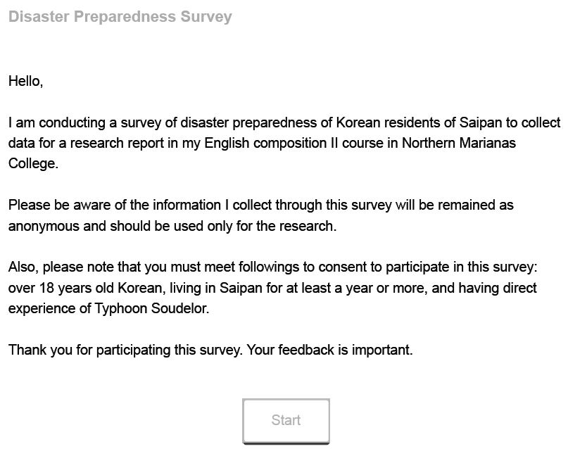
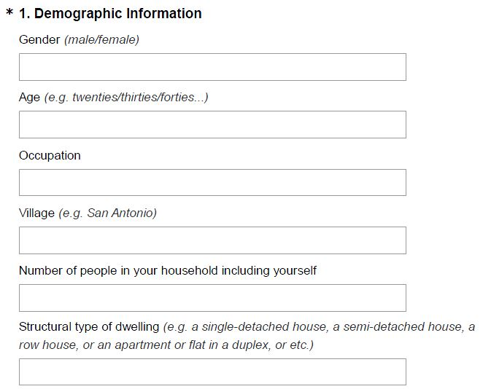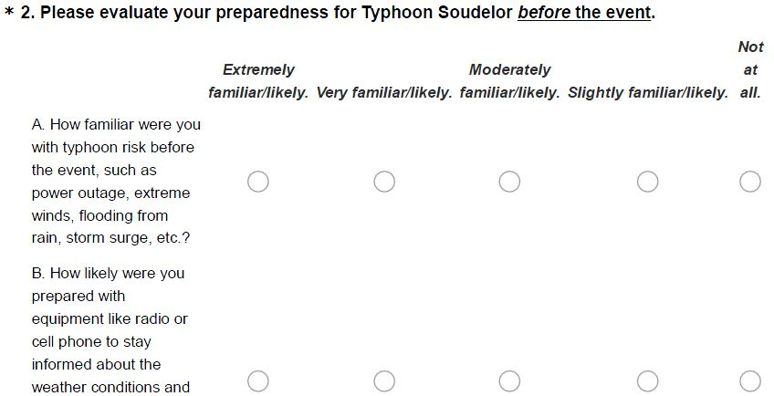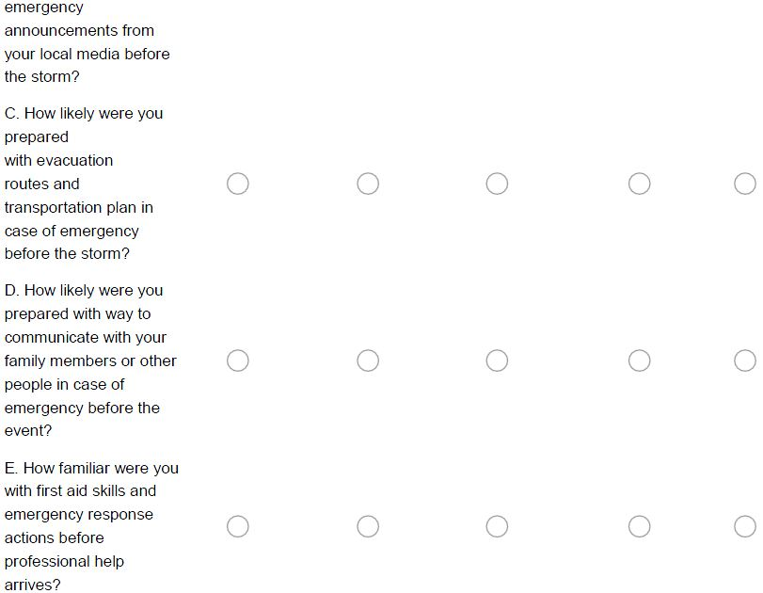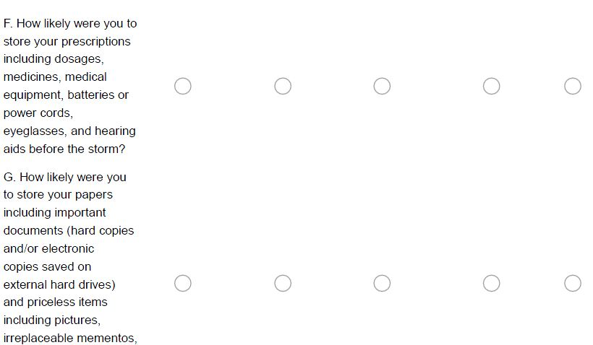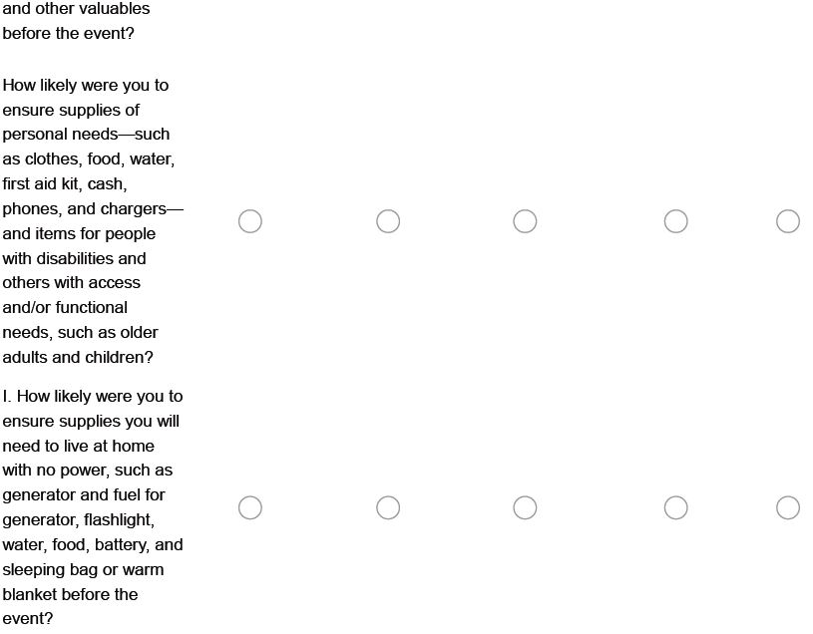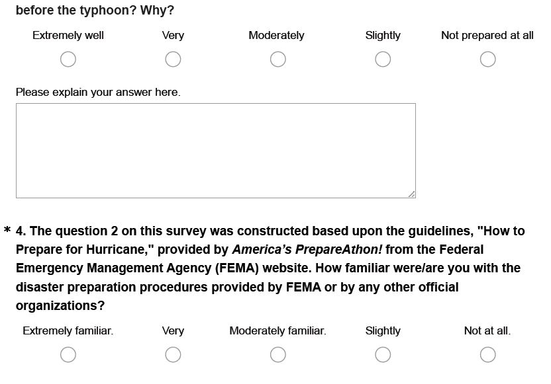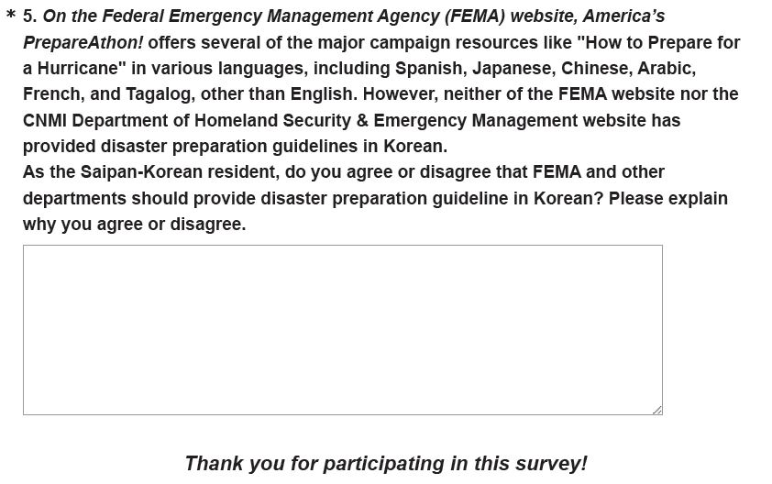
Appendix D
Survey Results
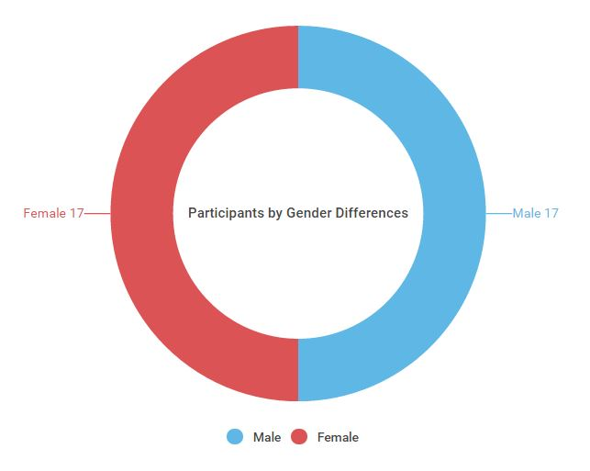
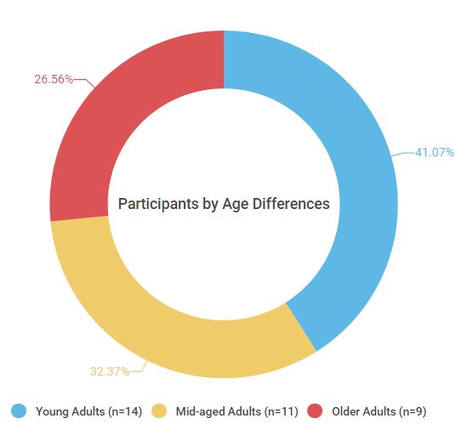
The survey participants are total 34 individuals of 17 males and 17 females and organized into different aged groups: young adults (18-29 years old; 41.12%; n=14), middle-aged adults (30-49 years old; 32.4%; n=11), and older adults (50 + years old; 26.5%; n=9).

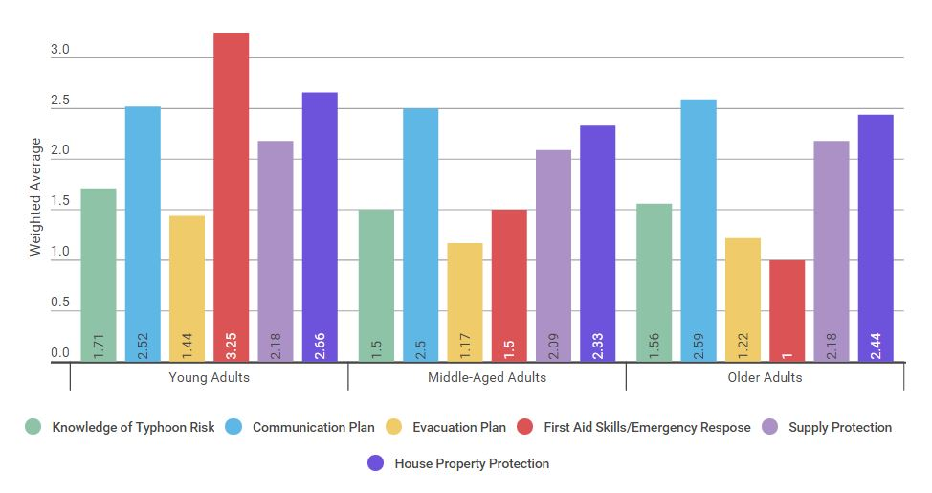
Table 1—Graph A
Table 1, Graph A. The weighted averages of disaster preparedness in specific areas by different age groups.
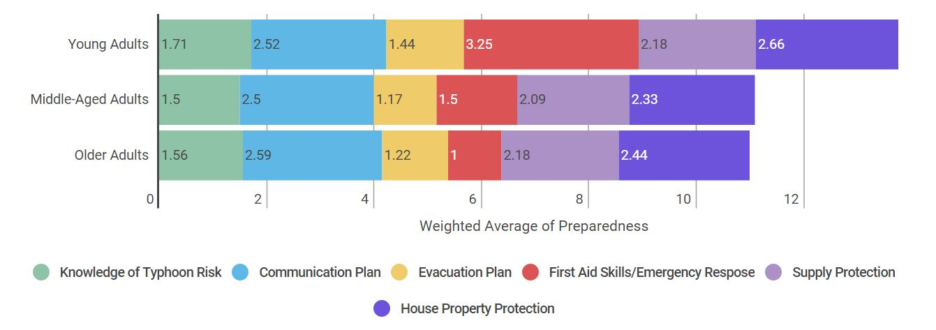
Table 1—Graph B.

Table 2
Table 1, Graph B. The weighted averages of disaster preparedness in specific areas by different age groups.
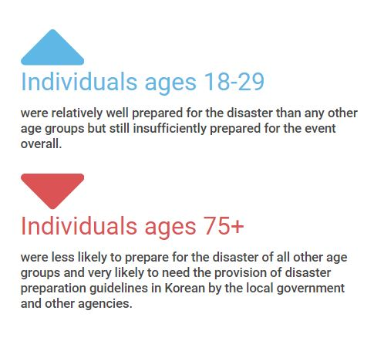
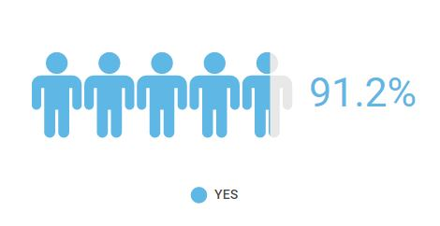
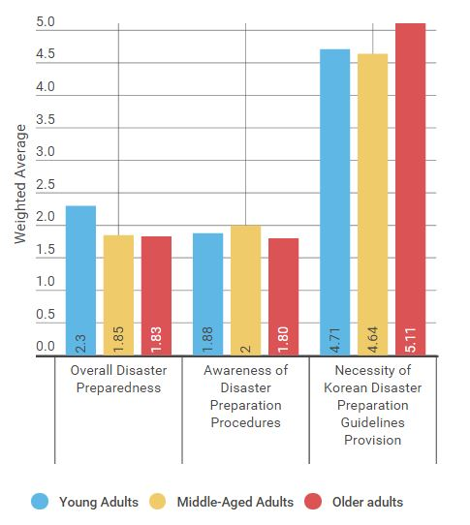
Key Findings
Should the local government and responsible agencies provide disaster guidelines in Korean?
Table 2. The weighted averages of overall disaster preparedness, awareness of disaster preparation procedures, and necessity of Korean disaster preparation guidelines provision in specific areas by different age groups.

