Pregnancy Risk Occurrences in the CNMI

Krizel V. Manuzon
English 101, Online Section 1
Dr. Kimberly Bunts-Anderson
April 27, 2018
Northern Marianas College

Table of Contents
Introduction – 3
Abstract – 3
Literature Review – 4
Methodology – 5
Analysis – 5
Research Questions – 6
Discussion – 6
Conclusion – 6
Appendix I – 7
Appendix II – 8
Appendix III – 9
Appendix IV – 10
References – 11

Introduction
The purpose of this study was to observe receive feedback from peers who may have experienced difficulties during their labor. This study includes an individual’s awareness of the risks and amount of resources that the CNMI is able to provide for women who visit from off island and teens during their pregnancy.

Abstract
This study explores the community’s awareness on pregnancy risk occurrences in the CNMI. In the recent years, rises in pregnancy from both teenage residents and foreigners have emerged and more often than not, people are not alert about potential dangers or situations a mother may face. The articles used in this research contain information obtained from online sources and responses from a distributed survey. Moreover, the responses received included comments on experiences an individual, or someone they know, may have encountered when in regards to delivering in the CNMI. This report also includes the Commonwealth Healthcare Corporation’s ability to perform its duties to its fullest and the obstacles it is facing with its day to day operation.

Literature Review
In an article posted by the Medical Daily, Lizette Borreli had stated that international flights are often restricted for pregnant women who are at a minimum of 32 weeks due to the access of medical care that may be received depending on the country being visited (Borreli, 2013). The CNMI’s lone public hospital provides services to those who need it without requiring immediate payment. Although despite this, it lacks adequate resources to support specialized fields especially in the women and childcare department. This poses potential risks since medical referral isn’t an option for urgent aid. For example, if a woman were to experience ectopic pregnancy (the fetus developing outside of the uterus) and the hospital experiences a shortage in required medicine or professionals the woman may experience her fallopian tube rupturing causing an urgent need to find an immediate solution.
Furthermore, teenage pregnancy has also become a concern for many residents due to how common it has become. A few survey respondents stated that the lack of sexual education at a young age might be a contribution to the matter. “Based on what the CDC had gathered that 24.2 percent of every 1,000 live births in 2014 are from mothers 15 to 19 years old. In total, the CNMI has 41.3 percent.” (Barrineau, 2016). With these means, the community needs to become more aware of potential health risks these young mothers may experience if not provided proper healthcare. All of this leads back to the resources that can be provided by the Commonwealth Healthcare Center.

Methodology
Due to the researchers unavailability to go out and administer face-to-face interviews, the entire research was focused on receiving responses from respondents on a survey or through conducted research online. In total the survey was distributed to about 30 people, but only received 18 responses back. Regardless of this, these respondents provided experiences they encountered while being hospitalized or being a teenage mother. Respondent number 18 shared responses that they’ve seen through observation from others.
Analysis
To give birth to another human being has always been one of the most spectacular events to occur for women. However, the absence of awareness on this topic should be a concern due to the correlation of the Commonwealth Healthcare Corporation’s medical ability to assist women who may experience a difficult pregnancy. Whether it is internal (health issues) or environmental factors (, risk awareness is the key to delivering a healthy baby. With the responses received from residents on a conducted survey, many had agreed that the CNMI lacked healthcare professionals who specialize in childcare. This is a concerning manner because the CNMI is basically isolated and is in the middle of the Pacific Ocean. Flying out to seek immediate medical assistance is difficult and costly for both the patient and their family.

Research Questions
1. In your opinion, do you think that teenage pregnancy puts the young mother’s health at high risk?
2. Do you think that women who board flights close to their due date risk their health than those who do not?

Discussion
In discussion, a few resident respondents had raised some concerns regarding the growing birth tourism in the CNMI. Although that is not the focus of the article, a large majority of tourists that deliver on Saipan are foreigners who risk their pregnancy flying close to their due date. As discussed, access to healthcare is not similar in all countries. It is also unsafe if the woman has health issues prior to her pregnancy and boarding a plane.

Conclusion
In conclusion, increased awareness on these important issues will aid in reducing these dangers for pregnant women. A contributing factor to this solution would also be if the Commonwealth Healthcare Corporation were able to obtain professionals in these specialized fields to avoid sending patients off island. Medical referral requires more expenses for the hospital to provide approval and send off a patient with one companion. In addition, it would raise revenue and reduce costs because residents from Tinian and Rota are also very reliant on this public hospital. The hospital would then regain the trust of its people and provide quality healthcare.

Appendix I
(Please note that some responses may have been altered due to grammatical errors.)

Question 1: From your observance, has the Commonwealth Healthcare Corporation (CHCC) gained more professionals in different fields or is it lacking adequate staff?
§ Response 1: “Yes, it is lacking an adequate amount of staff for specific fields. I feel that if they could acquire these staff, or at least a more decent amount of professionals, then we wouldn’t always have to send people off island.”
§ Response 2: “They’ve gained more professionals over the years, but due to rapid population growth in the CNMI I would say they’re still lacking adequate staff.”
§ Response 3: “From my experience working there, they lack equipment, supplies, and healthcare professionals such as surgeons.”
§ Response 4: “I believe they’re lacking staff. At the time I was in labor and delivery, they had me hold my baby from being born due to the doctor was not in at the moment. He was on call and it took him time to arrive.”

Appendix II
(Please note that some responses may have been altered due to grammatical errors.)

Question 2: Please use this section to add any additional comments in regards to population growth and pregnancy risks in the CNMI.
§ Comment 1: “Pregnancy risks and population growth in the CNMI are not so bad as other countries, but that doesn’t mean we should ignore it until it becomes worse. Our selected leaders and the community should be educated about these topics and there should be some preventative methods/options available to be taken.”
§ Comment 2: “Definitely need to upgrade the equipment such as ultra sound machine, to detect complications or defects early on.”
§ Comment 3: “Extend sex education to as low as 6th graders. As years go by, teenage pregnancy has grown substantially from as young as 13 years old.”
§ Comment 4: “Hard to say. Population is growing due to unplanned pregnancy, but majority of this growth seems to be from tourists coming in working illegally. In addition to tourists coming in, most of them are pregnant Chinese women who stay much longer than they should just to give birth here.”

Appendix III 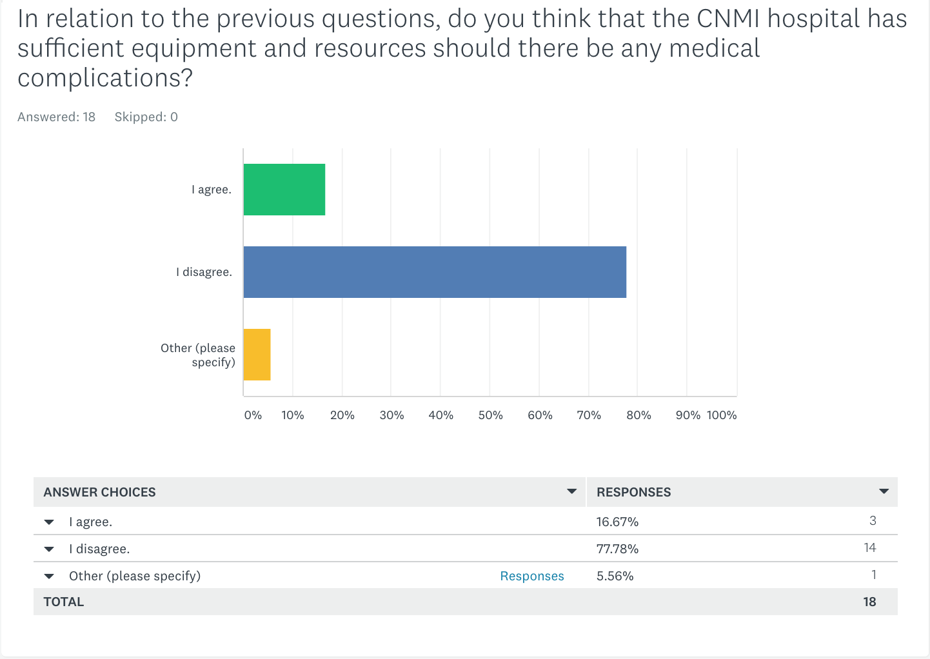

Appendix IV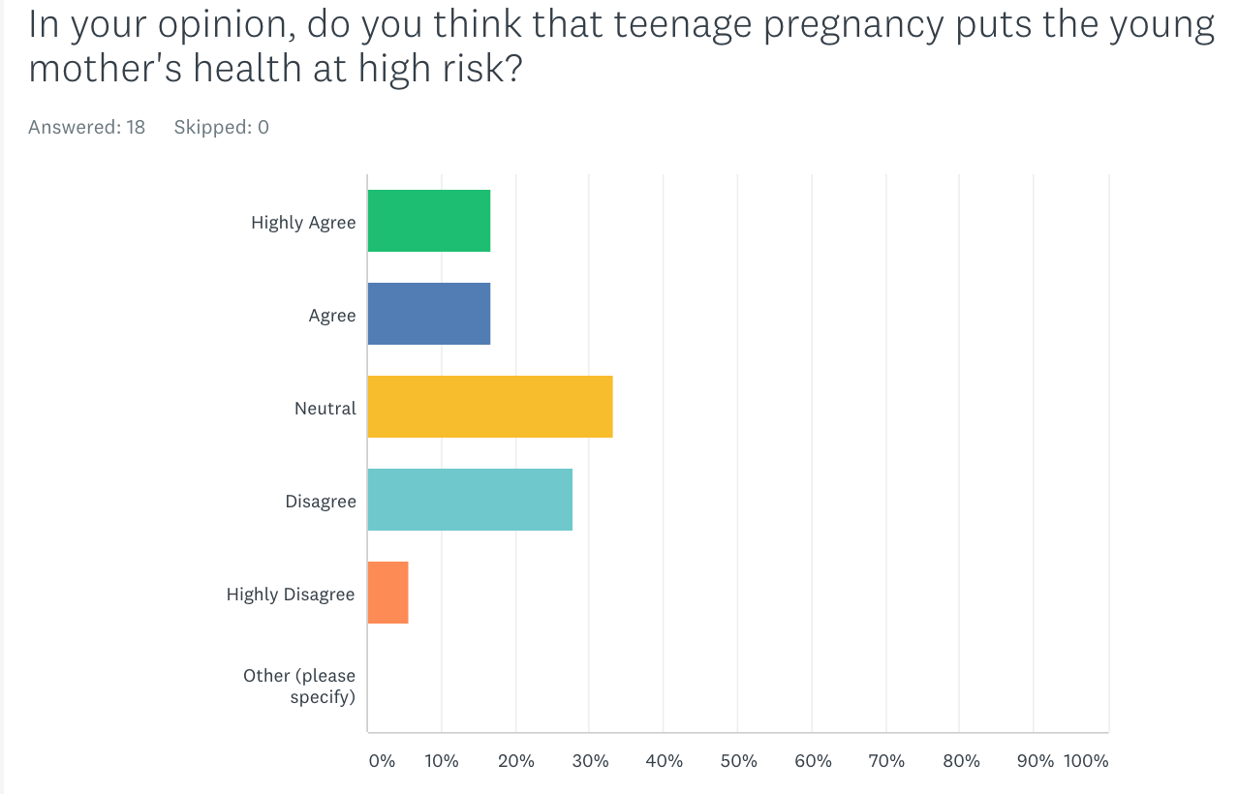

References
Borreli, L. (2013, July 9). Pregnancy And Flying: Risks Of Air Travel For Pregnant Women. Retrieved from http://www.medicaldaily.com/pregnancy-and-flying-risks-air-travel-pregnant-women-247514

Mack, L. (2017, November 9). http://webcache.googleusercontent.com/search'q=cache://www.cheapflights.com/news/air-travel-and-pregnancy. Retrieved from https://www.cheapflights.com/news/air-travel-and-pregnancy

Perez, J. (2016, May 29). Programs set to curb NMI teen pregnancy. Retrieved March 14, 2018,from https://www.saipantribune.com/index.php/programs-set-curb-nmi-teen-pregnancy/

Swierzewski III, S. (2000, October 31). Teen Pregnancy & Health Risks to the Baby - Teen Pregnancy - HealthCommunities.com. Retrieved from http://www.healthcommunities.com/teen-pregnancy/children/risks-to-baby-in-teen-pregnancy.shtml

