Research Report: Obesity in the CNMI
Vaeotootoo N. Failauga, Jr.
Northern Marianas College

Author Note:
Vaeotootoo Namona Failauga, Jr., Undergraduate, Northern Marianas College
This research report was finalized on May 05, 2016 and was prepared in fulfillment of the subject course EN202 – 03 English Composition II under Mrs. Kimberly Anderson’s class.
Correspondence concerning this paper should be addressed to Vaeotootoo Namona Failauga, Jr., Undergraduate, Northern Marianas College, Saipan, MP, 96950

Table of Contents
Abstract …………………………………………………………………………………………...3
Introduction ……………………………………………………………………………………….4
Method ...………………………………………………………………………………………….9
Participants ………………………………………………………………………………..9
Measures ………………………………………………………………………………….9
Procedure ………………………………………………………………………………..10
Results …………………………………………………………………………………………..11
Discussion ……………………………………………………………………………………….15
References ……………………………………………………………………………………….17
Appendices ………………………………………………………………………………………18
Appendix A ……………………………………………………………………………...19
Table 1.1 ………………………………………………………………………...19
Appendix B ……………………………………………………………………………...20
Section 1.1 ………………………………………………………………………20
Appendix C ……………………………………………………………………………...37
Section 1.2 …………………………………………………………………….....37
Appendix D ……………………………………………………………………………...37
Section 1.3 ……………………………………………………………………….37
Appendix E ……………………………………………………………………………...38
Section 1.4 ………………………………………………………………….……38
Appendix F ………………………………………………………………………………38
Section 1.5 ……………………………………………………………………….38
Appendix G ……………………………………………………………………………...39
Section 1.6 ……………………………………………………………………….39

Abstract
It is an alarming fact that the Commonwealth of the Northern Mariana Islands (CNMI) has ranked to be one of the top ten countries with high rates of obesity. Obesity is one of the most prominent factors of chronic diseases in the CNMI, in which has become one of the leading causes of death. Due to poor lifestyle choices, obesity poses a variation of severe life threats and consequences to many residents. While many findings have been conducted on the factors of obesity worldwide, only a few studies have been lead and completed in the CNMI. The local population is the most significant asset for the hope of the CNMI. Assuring the health and longevity of the community should be of supreme significance. The intent of this research is to describe and explain the existing state of obesity in the CNMI, investigate and point out the prime factors, dictate its need to be addressed and suggest healthy ideas or alternatives to prevent obesity from escalating. The research has been structured into a fundamental process of production, planning, informational consolidation and data analysis along with its results. This paper will further discuss the process of the research and methods of interventions as well as its outcomes in portraying the significance of comprehending and resolving the ongoing calamity around the islands. The study will also provide a better and healthier alternative of living in the CNMI in order to deal with and prioritize the obesity pandemic.

Introduction
According to the Merriam-Webster online dictionary, obesity is defined as, “a condition characterized by the excessive accumulation and storage of fat in the body” (2015). It is linked to an array of chronic diseases that many people in the Commonwealth of the Northern Mariana Islands (CNMI) are now acquiring. Consequently, the local population has continued to decline. Underneath the surface of fresh and steamy dreamlands, the CNMI is considered to be home to some of the largest rates of obesity amongst the nation (Calindas, 2007). The CNMI community is enduring an enormous burden of prolonged illnesses. More and more people in the CNMI are becoming obese nowadays – and worse, many of them are children and teenagers. This excruciating news has been prevailing and is now receiving notice through the media in hopes to promote an in-depth understanding of the influences and effects of this issue. According to the CNMI Department of Public Health (DPH), hefty elements have been inflicted onto them through outside influences and acculturation, in which are of extreme convenience for living a “fast-paced” life and is continuously constant to be prevented. Like many small island territories, the native populations of the CNMI die young due to their current lifestyle choices because of the influences they are currently undergoing. DPH also points out that, “Levels of obesity… are at historical highs” adjacent to the variety of unanimous diseases that come with it (p13). The consequences of being obese as a child are way past being tantalized or tormented at school (Dalton, 2004). The urgency to tackle obesity in the CNMI should highly be considered for the overall health and quality lives of our children.
However, it seems like obesity is not much of an issue in the CNMI. Many residents continue to make poor choices when it comes to their overall health and longevity without considering the consequences. Not many people in he CNMI are taking action to prevent obesity. They become ignorant of the facts of obesity not realizing that it is one of the most prominent factors of chronic diseases in the CNMI. Thus, leading to the many reasons of mortality. Obesity has continued to be on the rise and numbers has rapidly increased throughout the years. In an article by Henry Ichiho, he points out that out of 190 participants from a study conducted in the CNMI, 40.5% were obese and 6.3% were perversely obese. His article further reveals the need for awareness and response within the CNMI. An assessment conducted by the National Institutes of Health in 2011, a 22.7% decrease in the CNMI population was illustrated between the years of 2000 and 2010. Conclusions of conditional statistics disclose that the alarming influences of lifestyle choices are a prime factor for obesity and consequently non-communicable diseases (NCDs) (2013). Throughout many studies, there are primarily four major categories of influences and lifestyle choices that cause obesity in the CNMI, which consist of poor eating habits, the lack of parental guidance and support, the lack of awareness that ties into cultural influences and beliefs as well as the lack of physical activity in one’s everyday routine.
Poor eating habits and food choice are mentioned frequently as prime factors when it comes to obesity (CNMI DPH, 2008; Senthilingam, 2015; Curtis, p37). In the constant life that we currently live, people in the CNMI go day by day not taking the time to indulge in their meals and tend to speed eat instead. The CNMI DPH elaborated that many are too busy doing other things and choose to eat fast food while others like to skip breakfast, which leads to overeating later during the day or late at night. Canned goods and other unhealthy foods are easily accessible and are way more affordable than purchasing natural or organic ingredients. “A visit to any store” in the CNMI will disclose isles of unhealthy canned goods, such as “Spam, corned beef, Vienna sausages… cake mix,” ice cream, candy bars and potato chips. All of which are foods that are not only high in calories, but also high in carbs and fat as well.
The document also pointed out that poor diet is essentially associated with obesity, which leads to many other chronic illnesses–(2008). In addition, an article written by Micheal Curtis, entitled, “The Obesity Epidemic in the Pacific Islands,” mentions that, the main reasons of obesity originate from large ingestions of greasy or oily foods as well as foods that are high in sugar and carbohydrates. Curtis states, that the influences of such an endemic is the reliance on the so called “Western Diet,” which substitutes the customary foods of the islands from “fresh fish, meat and local fruits and vegetables” to “rice, sugar, flour, canned fruits and vegetables, soft drinks and beer” (Journal of Development & Social Transformation, p37). Breaking News on CNN elaborated that the “Pacific Islands are home to nine of the top ten countries for obesity globally” (Senthilingam, 2015). The news supplemented that despite the elegance and reservation of the islands, the territories face an additional certainty within their residency, an existence centered on processed food.
Another leading factor that influences obesity amongst others would include the lack of parental guidance and support. According to a study that took place in the CNMI by the Primary Prevention in Childhood Obesity, the author pointed out that in order to counteract obesity, it must initially originate within the residence. A book entitled, “Super Sized Kids: How to Rescue Your Child from The Obesity Threat,” affirmed that the decisions and choices parents make when it comes to dieting and nutrition can make an overall impact on the health and welfare of their children. The book further explains that increased family involvements with daily health-promoting activities as well as the implementation of good nutrition have everything to do with their children’s weight. It pointed out the essence of “raising children” to become knowledgeable in order to grasp the “power to avoid becoming or remaining Super-sized” (Flynt, Halliday, Larimore, 2005 p4). Likewise, an article entitled, “The Parent’s Role in Childhood Obesity,” indicates that, “There is abundant evidence supporting the idea that a child’s attitudes towards healthy living habits are significantly related to those of their parents” (Wintrup, 2010). The article further explains that, children first pick up behavioral patterns such as eating habits or making healthy choices by observing their primary caregivers whom are, in most cases, usually their parents. It also points out the importance and benefits of promoting and fostering healthful lifestyles with their kids at a young age in order for them to make better choices as they grow.
It has also been revealed in many findings that the lack of awareness is a principal influence of obesity as well, in which is highly linked to cultural beliefs and influences within the CNMI. Brittany Goodison stated that according to a study, “the CNMI culture is a care giving one, a trait that has been thought to influence the way children are fed and their subsequent weight.” To be exact, the study portrayed confusion between “traditional dietary practices and beliefs, knowledge of disease as it relates to food, expectations of the family, and the values of society at large.” Goodison also points out that customarily, when it comes to the people of the CNMI, there is a correlation between the caring, love and generosity of food–(2015). The American Diabetes Association indicated in an article that, “Culture is believed to contribute to disparities in childhood obesity in numerous ways” (Kirkman, 2016). It also indicated that, “Culture influences child-feeding practices in terms of beliefs, values, and behaviors related to different foods,” in which ultimately influences the insight of threats correlated with obesity.
However, in addition to Curtis’s statement about the primary causes of obesity, physical inactivity plays a big part. According to an article by a personal trainer, Nicole Glanville, “government guidelines recommend that the average healthy individual” should exercise about “3 to 5 times per week” (2000). In the fast-paced world that we live in, many people have no time to put in exercise in their daily routine these days. The lack of movement and exercise is what makes overweight people obese. Curtis affirms, that the accumulative practice of contemporary machinery and the move from “agricultural-based” employments to domestic professions has tremendously altered the physical routine of everyday life in society (p. 37). Likewise, DPH also stated that there was a low rate of physical activity among the children in the CNMI. The document also indicated that obesity influenced by “physical inactivity is significantly associated with an increased risk of diabetes…and poor health status” (2008, p19). In Dalton’s book entitled, Our Overweight Children, she implied that adolescents are more prone to become heavier than usual when there is an absence of continuous physical activity in which they can engage or be promoted in (p54). Sequentially, obese children are more than likely to grow into obese adults.
Obesity has not only become one of the most prevalent reasons of long-term illnesses in the CNMI, but also the leading cause of death. There are many other influences and other leading factors that may contribute to obesity in general. Although, many of which were mentioned are the primary aspects of obesity in the CNMI today. It has become a serious issue in the CNMI and has yet to be properly addressed and resolved. These many factors include that of an individual’s lifestyle choices. The numbers of obese adults and children have increased dramatically around the world. Obesity is the leading factor of mortality in the CNMI and if this pandemic is not prevented and ultimately put to a stop, the CNMI population will cease to exist in the years to come. It is essential to come up with a resolution to tackle such influences in order to preserve the CNMI population and maintain an active and healthy lifestyle for future generations to come. If not, the shores of tiny islands in the CNMI will continue to become one of the highest ranked places of obesity in the world and eventually the local population and beauty of the islands will cease to exist.
Method
Participants
The participants in this research consisted of various ethnic backgrounds of individuals around the islands. A group size of 70 participants of different age ranges was surveyed concerning the topic of obesity. 56% of participants were females and 44% were males. 43% of participant’s age ranged from 16 to 24 years old. 20% of participant’s age ranged from 25 to 32 years old and only 9% of participant’s age ranged from 32 to 40 years old, while 29% were 40 years old or older. The mean age of the entire group of participants ranged between 16 years up to 24 years of age. The survey was anonymously administered to participants on a volunteer basis (For full survey questionairres please refer to Table 1.1 in Appendix A).
Measures
The goal of this research was not only to determine the number of cases of obesity in the CNMI and the influences of such, but also to collect suggestions and ideas on how to address the pandemic. To retrieve and collect such data, participants were presented with a variety of questionnaires in which some questions were required to be answered and a few were optional. Furthermore, the survey included a series of multiple-choice options, check-all that apply types, a linear scale as well as open and closed answer responses. Participants were required to indicate their gender as well as age group. A Body Mass Index (BMI) Chart was also provided for participants to assess the amount of body fat they had and indicate their measurement on the list provided (See Section 1.2 in Appendix C). Some examples of the questions within the survey provided are as follows: (For full survey questionairres please refer to Table 1.1 in Appendix A)
1. How often do you exercise?
2. Do you think obesity is a serious issue in the CNMI?
3. Rate your daily schedule or prioritization of work/family and other outside influences on a scale of 1 to 5 on how it affects your lifestyle (in the way you eat, sleep, exercise) from 1 being not at all to 5 being extremely.
Such questions were included in the survey to determine the actual reasons and causes that leads to obesity and why it continues to increase in the CNMI. Majority of the responses specified that many local residents eat big portions and do not consider a healthy diet. Others indicated that poor eating habits as well as the lack of exercise were the number one culprits for being obese. Survey questions required both open and closed answers as to not limit responses and rather to get ideas or suggestions on how to go about in addressing obesity in the CNMI. Many participants responded by suggesting a recreational center that was free to the public for all types of physical activities and events. The survey also required participants to state their preferences as well as their challenges in lifestyle choices and ways of living. Most responses implied that the prioritization of work, family or other outer influences prohibited their time for exercise or consider healthier alternatives for living. (For full survey responses please refer to Section 1.1 in Appendix B)
Procedure
Survey participants were chosen randomly around the community as to indicate the overall health of different population groups in the CNMI. Survey responses range from a variety of different ethnic backgrounds, age groups, as well as family class types that were included into the research. Data was requested from one essential group on obesity in the CNMI. This group consisted of the students within the CNMI Public School System of William S. Reyes Elementary School (WSR). A general consolidation of 733 students BMI data was collected from that of WSR for school year 2015 through 2016 from 1st grade through 6th grade. All data and statistics from the survey conducted as well as WSR were consolidated and analyzed for review and justification of the need to address obesity in the CNMI. The methods indicated and utilized throughout the research were purposefully chosen to collect results on why and how obesity continues to be a common problem around the islands today and has unfortunately become the norm. Surveys were conducted from a variety of participants to compare lifestyles as well as eating habits and cultural beliefs. Data analyses portrayed numbers and percentages of studies that involve obese people in the CNMI and indicated suggestions on how to live healthier and active lifestyles.
Results
Obesity in the CNMI continues to be an appalling issue. It has become one of the main causes of mortality in the CNMI because of the many chronic illnesses that residents from the islands develop overtime. According to the survey results conducted for this research, the majority of participants defined obesity as being fat, too fat, overweight or unhealthy. Amongst the participants, 19% were indicated to be overweight and are subsequently at risk of being obese. 21% of participants fell under the category of being obese while 19% of participants placed on being morbidly obese. When asked if obesity was a serious issue in the CNMI, 96% of participants agreed. The majority explained that many local residents including infants, children and teenagers are developing chronic illnesses such as diabetes and heart disease, are overweight or obese or are living inactively due to lifestyle choices.
Studies indicated that poor eating habits such as choosing to eat fast food or junk food or eating big portions of food containing fatty, oily or starchy substances and staying inactive were some of the main factors for obesity’s alarming rate in the CNMI. Accordingly, 86% of participants indicated that they either had friends or family members who are currently obese. A whopping 91% of survey participants implied that they consumed junk food and unhealthy snacks. Out of the 70 participants, 47 people indicated the consumption of cookies, 51 of them eats chips, 47 of them eats ice cream, 40 of them eats cake and drinks soda, 48 participants indicated the consumption of cheeseburgers, 49 of them eats deep fried foods, and 54 participants eats pizza (See Section 1.3 in Appendix D).

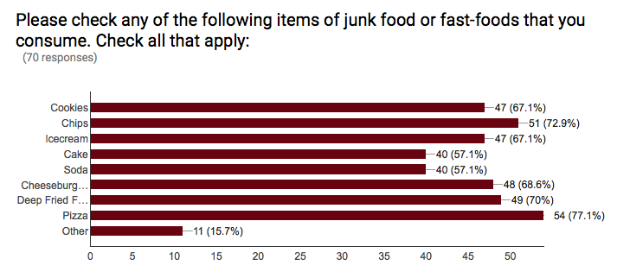

94% also suggested that poor eating habits, such as overeating, skipping breakfast and having late night snacks, or being inconsistent with meal schedules is another factor. Whereas, 73% of participants thought that the lack of awareness had something to do with obesity and 76% perceived that the lack of parental support and encouragement were factors as well. 67% viewed cultural beliefs and influences to also be a principal cause, while 76% agreed that disease was linked to obesity (See Section 1.4 in Appendix E).
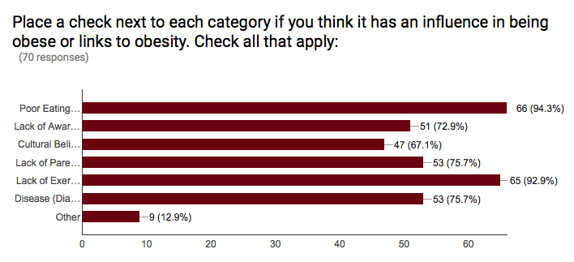
Additionally, when asked to indicate how often did each participant exercise, 39% of participants signified that they do not exercise at all and only 11% takes the time to exercise about 1 to 2 times a week while 19% exercised 3 times a week. 93% of participants denoted that the lack of exercise or inactivity influences obesity and is linked towards it. Respectively, when asked to rate their daily schedule and prioritization of work and family or other outside influences considering their eating, sleeping and exercise habits on a scale of 0 being not at all to 5 being extreme, 43% indicated that employment or domestic responsibilities as well as other outer elements affected their lifestyle choice. 21% of them rated on a scale of 4, while 23% rated on a scale of 3 (See Section 1.5 in Appendix F).

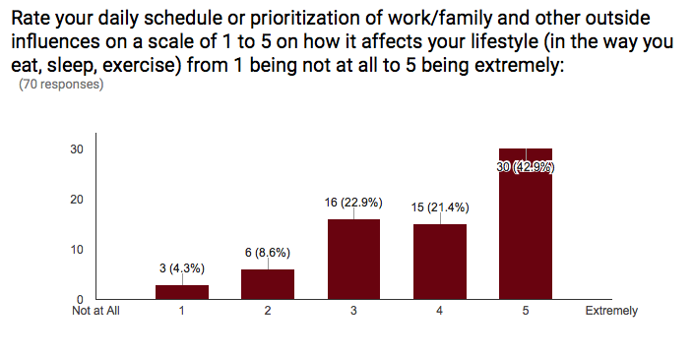
In addition to this, many indicated only a couple places that were identified as groups or agencies that was known to assist people who were struggling with obesity such as, the hospital or the gym. Majority of the participants also listed down the same responses and suggestions to provide free or public recreations to be built in order to further prevent obesity in the CNMI.
Conversely, from the CNMI Public School System of WSR for school year 2015 through 2016 illustrated that out of 733 students from grades kinder through sixth, 116 students were at risk of being obese, while 93 students were currently obese. The largest group of kids that were at risk was illustrated in grade 4 with a number of 24 students, followed by grades 1 and 5 with a total amount of 21 students each. The largest group of students that were currently obese during this school year was that of the 5th graders amounting at a total of 23 students in all, which is equivalent to one class size followed by the 1st grade group of 18 students (WSR, 2015) (See Section 1.6 in Appendix G).
Discussion
Many studies have concluded that obesity in the Commonwealth of the Northern Marianas Islands (CNMI) is not only a common problem, but has also become a serious issue today. Unfortunately, for the people of the islands, it has also become the norm. Obesity is one of the leading factors of mortality in the islands nowadays and will continue to be so if not properly addresses. Linked to an array of chronic diseases, which many are now acquiring because of such pandemic, the local population has continued to decrease. Due to life-threatening magnitudes, it is essential that obesity is properly managed and dealt with in the CNMI. The results indicated highly justify that it is of precarious significance to completely scrutinize such dynamics of obesity to further understand its influences to prevent it from persisting and ultimately cease it from existing.
Once obesity is finally recognized and understood, projections of attention and intermediations as well as accommodations will take place for further inquiry in routes that would be constructive in tackling such concern. There are sizeable amounts of confirmation and evidence to justify that obesity is exceedingly influenced by one’s lifestyle choices. Some of which would include poor eating habits, the lack of parental guidance and support, the lack of awareness due to many conflicts between cultural influences and beliefs as well as the lack of physical activity. Residents become vested in an unhealthy lifestyle leading them to shorten their lifespan and suffer as they continue to age.
However, through systematic planning, the future and hope for the CNMI population to further cultivate throughout the years ahead will be established. Providing methodical intervention and resources for the community will ensure the promotion and participation of healthy and active lifestyle choices. Organizing public events for awareness and institutional courses that teach children and adults about food, physical activity and nutritious selections would definitely be a virtuous lead. Building on capital improvements and other infrastructures would also motivate the CNMI community to get out of their homes more often and maintain activeness.
In addition to promotional and awareness activities, the support and encouragement the community receives will eventually create a domino effect in battling obesity island-wide from one individual to another and from one generation to the next. People should be aware of the many consequences that they would have to endure from being obese. They do not have to be agonized in silence or make up excuses on not having time or resources to utilize. They should be given the opportunity to combat such issue and fight for their longevity with everyone in general for the sake of future generations to come. Otherwise, life expectancy will further decline on the beautiful islands of the CNMI.

References
Calindas, Marconi. (2007). Study: 70 Percent of CNMI Adults Overweight. Saipan, MP: Saipan Tribune. Pacific Islands Development Program. http://pidp.eastwestcenter.org/pireport/2007/May/05-15-07.htm
Dalton, Sharron. (2004). Our Overweight Children: What Parents, Schools, and Communities Can Do to Control The Fatness Epidemic. London, England: University of California Press, Ltd.
Glandville, Nicole. (2000). How Often Should I Exercise. Weight Loss Resources, Ltd. http://www.weightlossresources.co.uk/exercise/questions-answers/how-often-should-i-exercise.htm
Ichiho, Henry M. (2013). An Assessment of Non-Communicable Diseases, Diabetes, and Related Risk Factors in the Commonwealth of the Northern Mariana Islands: A Systems Perspective. Rockville Pike, Bethasda, MD: Hawaii Journal of Medicine & Public Health. http://www.ncbi.nlm.nih.gov/pmc/articles/PMC3689462/
Larimore, W., Flynt, S. and Halliday, S. (2005). Super Sized Kids: How to Rescue Your Child From The Obesity Threat. (1st ed). New York, NY: Center Street – Time Warner Book Group
Merriam-Webster Online Dictionary. (2015.) Merriam-Webster, Incorporated.
http://www.merriam-webster.com/dictionary/obesity

William S. Reyes Elementary School. (2015) School Year 2015-2016 BMI Data. Saipan, MP: CNMI Public School System

APA Format: Appendices
Vaeotootoo N. Failauga, Jr.
Northern Marianas College

Author Note:
Vaeotootoo Namona Failauga, Jr., Undergraduate, Northern Marianas College
This research report was finalized on May 05, 2016 and was prepared in fulfillment of the subject course EN202 – 03 English Composition II under Mrs. Kimberly Anderson’s class.
Correspondence concerning this paper should be addressed to Vaeotootoo Namona Failauga, Jr., Undergraduate, Northern Marianas College, Saipan, MP, 96950

Appendix A
Table 1.1
Research Report Survey Questions on Obesity in the CNMI
- Please describe or define obesity in your own words.
- Do you think obesity is a serious issue in the CNMI?
- Please explain why you think obesity is a serious issue in the CNMI, or why not?
- Do you have family members or friends who are obese?
- How often do you eat fast-food or eat out at restaurants? (Optional)
- Do you eat any type of junk food or unhealthy snacks?
- Please check any of the following items of junk food or fast-foods that you consume. Check all that apply:
  - Cookies
  - Chips
  - Ice cream
  - Cake
  - Soda
  - Cheeseburger/Hamburger
  - Deep Fried Foods
  - Pizza
  - Other
- How often do you exercise?
  - 0 times/week
  - 1-2 times/week
  - 3 times/week
  - 4 or more times/week
- Place a check next to each category if you think it has an influence in being obese or links to obesity. Check all that apply:
  - Poor Eating Habits (Overeating, Skipping Breakfast, Meal Schedules, Late Night Snacks…etc.)
  - Lack of Awareness
  - Cultural Beliefs and Influences
  - Lack of Parental Support/Encouragement
  - Lack of Exercise
  - Disease (Diabetes, Cardiovascular Disease such as Heart Attacks, …etc.)
  - Other: Please indicate
- Rate your daily schedule or prioritization of work/family and other outside influences on a scale of 1 to 5 on how it affects your lifestyle (in the way you eat, sleep, exercise) from 1 being not at all to 5 being extremely.
- What are some places that you know that may help people who are struggling with obesity?
- Please list down types of recreations that can be created or built that you think will help or prevent obesity in the CNMI.

Appendix B
Section 1.1
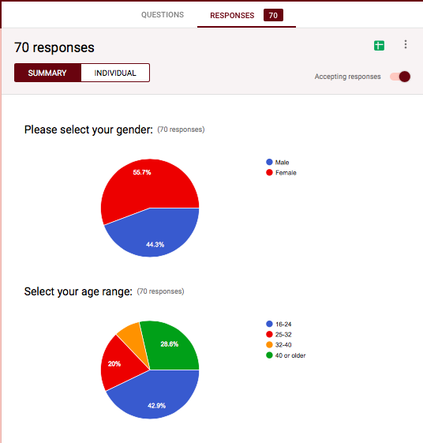
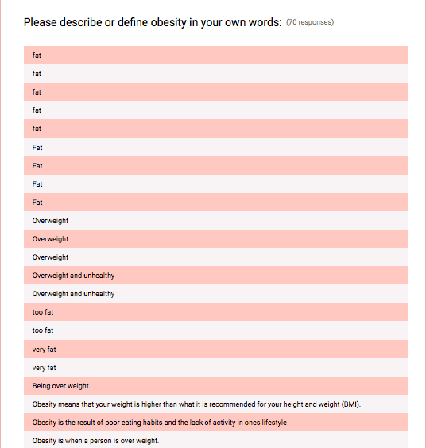
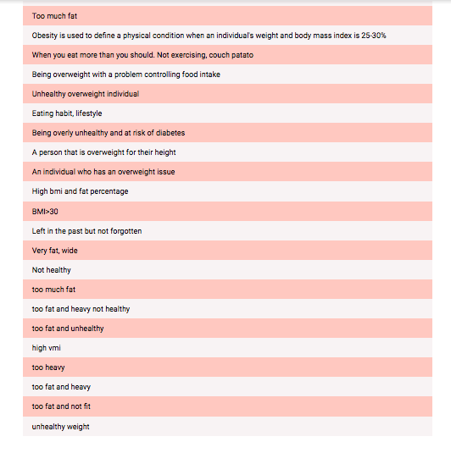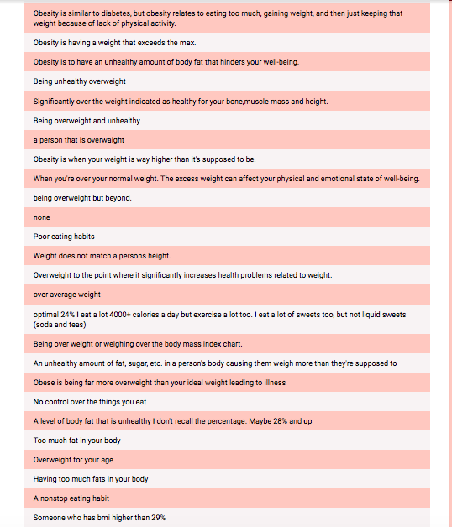

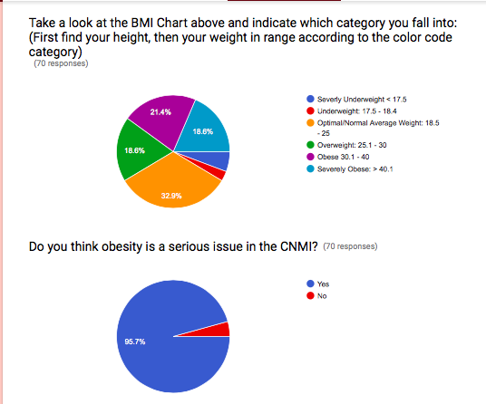
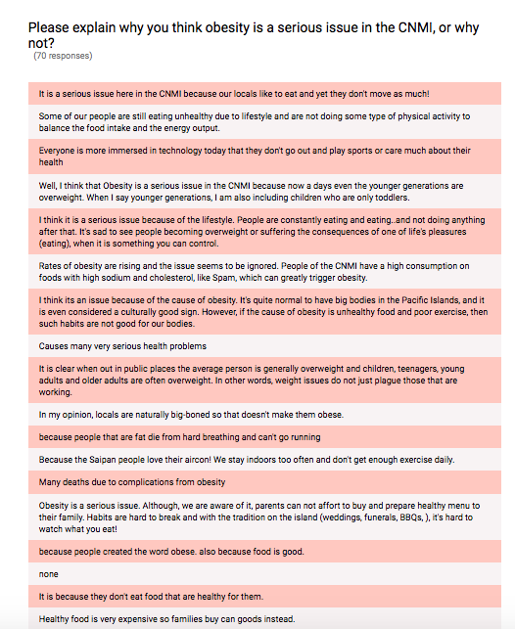

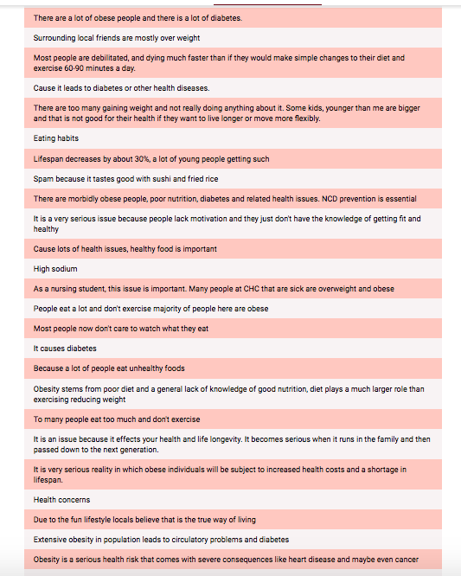

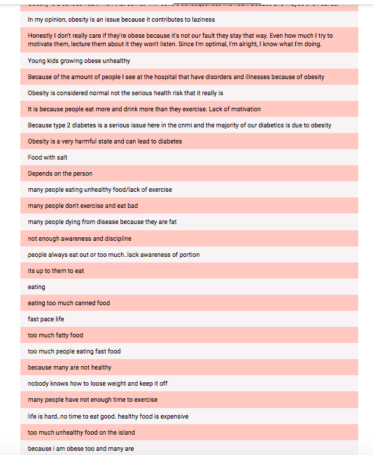

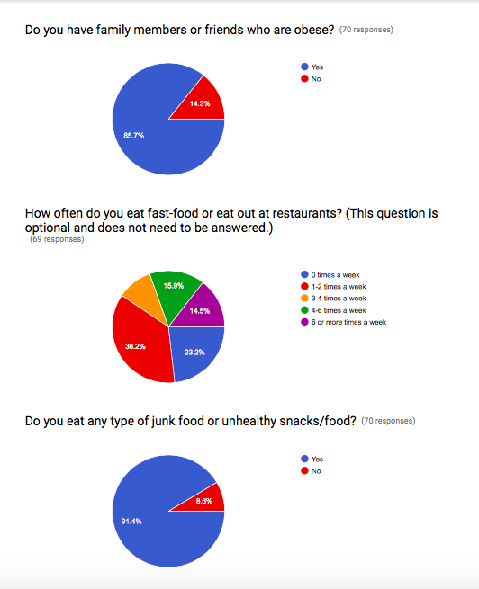

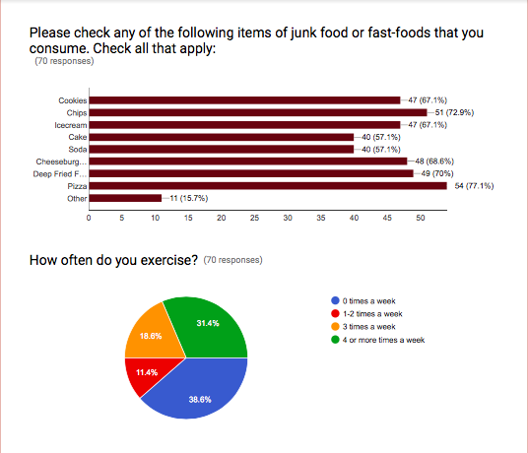
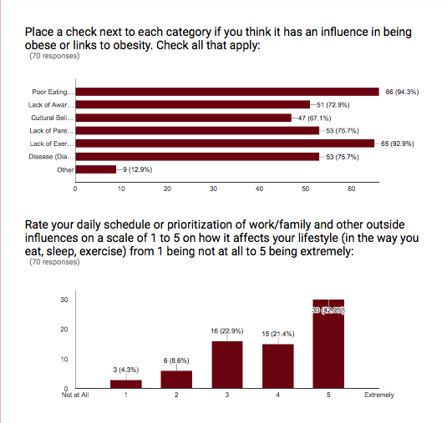

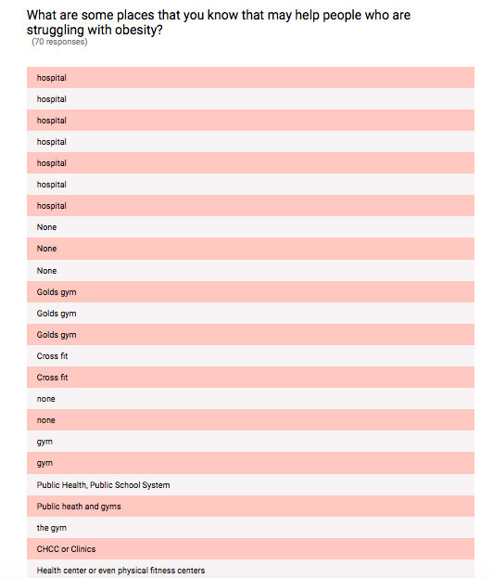

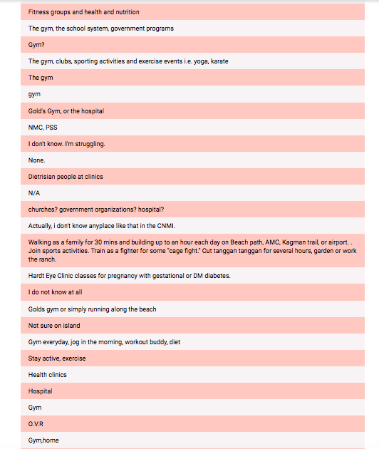
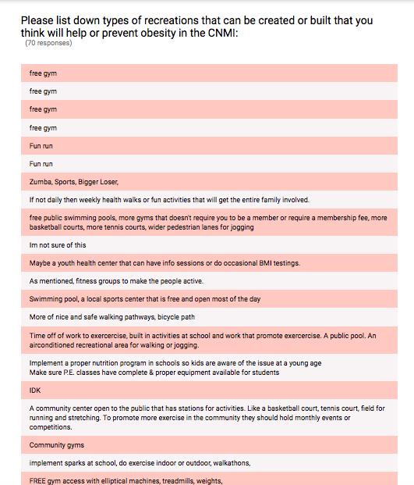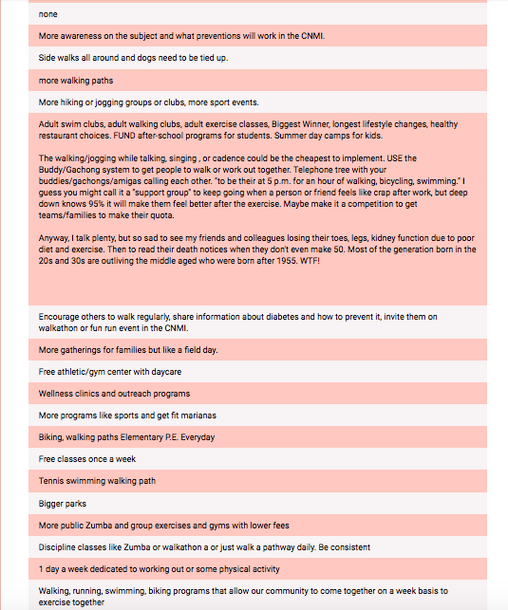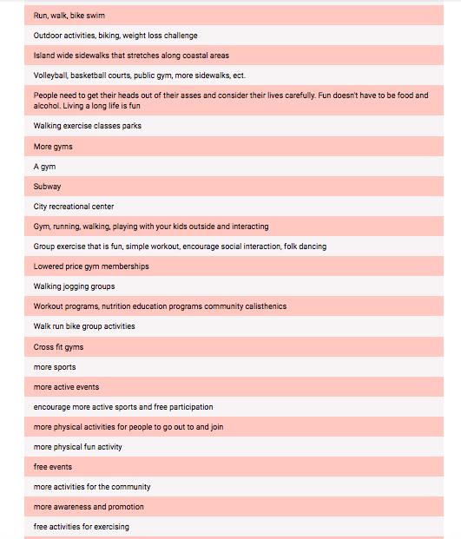

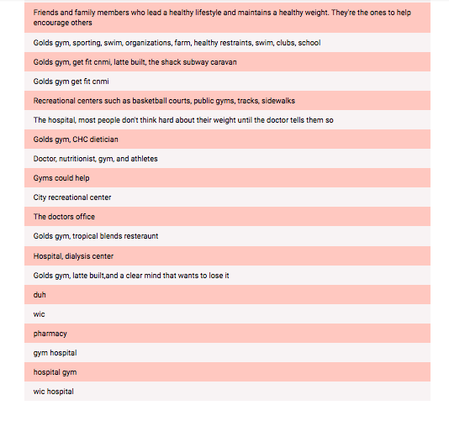
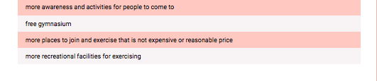

Appendix C
Section 1.2
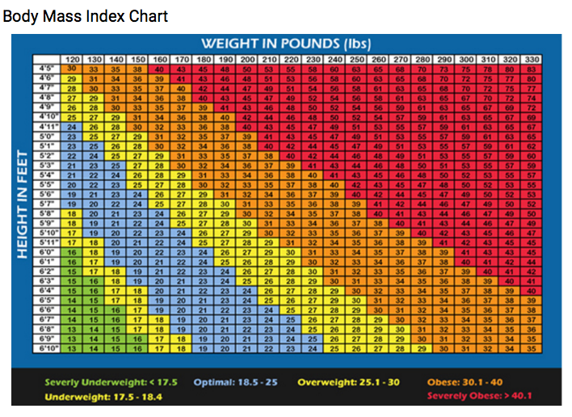
Appendix D
Section 1.3

Appendix E
Section 1.4
Appendix F
Section 1.5

Appendix G
Section 1.6
William S. Reyes Elementary School Pre & Post Grade Level BMI Screening & Surveillance Report (1st, 2nd and 3rd Grade)
Grade Level Teacher: | Under Weight | Healthy | At Risk | Over Weight | Total Students
Divine | 3 | 18 | 4 | 3
Martha | 1 | 16 | 7 | 4
Nelly | 3 | 13 | 4 | 6
Paulette | 2 | 16 | 6 | 5
Dana
Total | 9 | 63 | 21 | 18

Grade Level Teacher: | Under Weight | Healthy | At Risk | Over Weight | Total Students
Kathy | 3 | 18 | 2 | 3
Ton | 2 | 13 | 5 | 5
Jessie | 1 | 17 | 5 | 3
Winni | 2 | 15 | 4 | 3
Junie
Total | 8 | 63 | 16 | 14

Grade Level Teacher: | Under Weight | Healthy | At Risk | Over Weight | Total Students
Dorothy | 0 | 17 | 4 | 4
Darlene | 0 | 20 | 3 | 3
Reanna | 0 | 16 | 5 | 5
Tammy | 0 | 15 | 6 | 4
Total | 0 | 68 | 18 | 16

William S. Reyes Elementary School
Pre & Post Grade Level BMI Screening & Surveillance Report (4th, 5th and 6th Grade)
Grade Level Teacher: | Under Weight | Healthy | At Risk | Over Weight | Total Students
Mel | 1 | 14 | 6 | 6
Jay | 0 | 18 | 11 | 1
Claire | 0 | 19 | 5 | 2
Calla | 2 | 21 | 2 | 4
Total | 3 | 72 | 24 | 13

Grade Level Teacher: | Under Weight | Healthy | At Risk | Over Weight | Total Students
Maria ana | 0 | 15 | 5 | 7
Skilang | 0 | 15 | 4 | 5
Monica | 1 | 14 | 6 | 5
Gilles | 0 | 16 | 6 | 6
Total | 1 | 60 | 21 | 23

Grade Level Teacher: | Under Weight | Healthy | At Risk | Over Weight | Total Students
Hannah | 1 | 11 | 8 | 4
Jenny | 0 | 17 | 5 | 3
Maria | 0 | 15 | 2 | 7
Lourdes | 0 | 9 | 4 | 9
Lori | 1 | 52 | 19 | 23
Total | 0 | 76 | 16 | 9 | 101

