Benefits and Side Effects of Chewing Betel Nut
Joy Celis
Northern Marianas College

Authors Note:
This paper was prepared for English 202, Section 03, instructed by Dr. Kimberly Bunts-Anderson.
Table of Contents

Abstract ………………………………..3
Introduction……………………….. ….4
Literature Review………………..…….4
Methodology……………………..……6
Conclusion………………………….…8
Findings ………………………………8
Reference………………………….…10
Appendix A…………………………..11
Appendix B…………………….…….12
Appendix C………………..…….…..13
Appendix D…………………….……15
Appendix E…………………………..15
Appendix F…………………….…….19

Abstract

Joy Celis a sophomore at the Northern Marianas College informs readers on the topic

Benefits and Side Effects of Chewing Betel Nut. Surveys of 2 classes of nine students indicted

that it does not matter if you’re Chamorro or chewing is part of your culture, it is your decision

to make. Also, there is a great similarity in how chewing betel nut is perceived. Doing a research

of chewing betel nut is important because the chewing of betel nut is very popular in the CNMI

and it increases their risk of having oral cancer.

THE BENEFITS AND SIDE EFFECTS OF CHEWING BETEL NUT
Introduction
The stimulating effects of betel nut is used in a manner similar to the western use of tobacco or caffeine In the island of Saipan, the chewing of betel nut has become part of the Chamorro culture and a habit developed by younger generations. It is used by almost a tenth of the world’s population (Sui & Lacey, 2015). If you didn't already know, the name betel nut comes from the association of chewing the nut along with the mint-tasting leaf commonly known as betel leaf (Artero & Santos). Another name they use is areca nut because it is grown in the Areca palm tree. However on Saipan they call it pugua, which comes from their native language. Because of the positive ways betel nut has affected the chewers for a short time, they ignore the harmful side effects that could last a lifetime.
Literature Review
The student researcher began searching for articles and studies on March 16th that would help with her research question: Causes and effects of continued betel nut chewing. The key words “effects of chewing betel nut” were entered in Google Scholar resulting 16,600 hits. Out of the 16,600 results, only one article was chosen which was written by Nai Shin Chu. Although it is a bit outdated, the article provided some positive effects of chewing betel nut. According to Nai Shin Chu’s study he stated that “it has been claimed that the chewing of betel nut produces a sense well-being, euphoria, heightened alertness, sweating, salivation, a hot sensation in the body and an increased capacity to work” (Shin, 2000).
The student researcher then went on to the Northern Marianas College website and clicked on library services. And from there, the student clicked on EBSCO, to find academic and peer reviewed journals. The student researcher typed down the key words, “betel nut”, “chewing”, and “effects”, and up came 6 journals the student chose the journal entitled, “The Oral Health Consequences of Chewing Betel nut”, by C. R. Trivedy, G. Craig and S. Warnakulasuriya. As it is known betel nut is no longer chewed on its own, but with other substances. However, the journal states that even without consuming the other substances, the potential harmful effect on the oral cavity will still occur. Chewing the betel nut alone mainly affects the teeth. The habitual chewing of betel nut may result in severe wear of incisal and occlusal tooth surfaces, particularly the enamel covering. “The exposure of dentine may also result in dentinal sensitivity. The degree of attrition is dependent upon several factors, which include the hardness of the betel nut, the frequency of chewing and the duration of the habit” (Trivedy, Craig, & S. Warnakakulsuriya , 2002). Also, the staining of the teeth can happen, with poor dental care. In addition, they had found from several population studies, that suggest that areca on its own may play an etiological role in the causation of oral cancer (Trivedy, Craig, & S. Warnakakulsuriya , 2002).
Using the same source which is EBSCO, the student researcher typed the key words, “chewing betel nut” and found 68 academic journals. With this search I was able to find a study done here on the CNMI (Commonwealth of the Northern Mariana Islands) entitled, “Areca (betel) nut chewing habit among high school children in the Commonwealth of the Northern Mariana Islands (Micronesia)” by Eric Oakley, L. Demaine and Saman Warnakulasuriya. In 2005, a study was done on Saipan's three high schools which consisted of 2415 students of whom 1186 were female and 1229 are male. The questions were demographic characteristics, areca nut use, daily frequency of use, reasons for use, social influence factors, risk perceptions and reasons for disliking the habit. Also, an oral examination was done by a specialist; when a lesion was found on a student, their parents were informed (Oakley, Demaine, & Warnakulsuriya, 2005). A lesion is a region in an organ or tissue that has suffered damage (Google ). Data was collected on the 309 students who participated; 41 percent Chamorro, 16 percent Carolinian, 14 percent Filipino and 9 percent Palauan. Some information’s that they had found out was that, 60 students started to chew at age 10, tobacco was used widely among the children, that most got their chew on their own and 12.9 percent had oral leukoplakia (Oakley, Demaine, & Warnakulsuriya, 2005), which is a white or gray patch that develops on the tongue, the inside of the cheek, or on the floor of the mouth that can’t be rubbed off, can’t be characterized clinically or histologically as any other condition, and is not associated with any physical or chemical causative agent except tobacco.
After finding information from the internet, the student researcher looked for books in the library and found a book related to her topic. The book is entitle, “Ancient Chamorro Society”, written by Lawrence J. Cunningham in 1992. According to the book, chewing betel nut is a custom that spread from India to Southeast Asia and from there it reached here in the Marianas (Cunningham, p. 138) and chewers consider it a courtesy to offer another person betel nut (Cunningham, p. 7). Also, the ancient Chamorros chewed their betel nut with substances such as, quicklime; which they say makes the betel nut much stronger. Betel pepper leaf; gives a person’s breath a fragrant smell and eliminates bad breath. In addition, chewing betel nut back then helped them kill stomach worms and intestinal parasites, also the staining of the teeth were considered beautiful (Cunningham, p. 7).
Methodology
Researching about betel nut and its effects was quite easy, because the student sees it everywhere and every day. The student researcher used many methods such as, sending out surveys to college students and questionnaires and letters to experts. It is important to understand the methods used to collect data so that similar studies can be conducted in the future. To gather a complete view, the student researcher designed tools and collected data from as many individuals as possible. This process essay describes the methods used to design measurements and tools to collect data to inform the research question: Continuous effects of chewing betel nut.
The first method used to collect data was through the form of a survey that was distributed online with the assistance of the instructor. The survey was taken by the student researcher’s class and another class of the instructors. The student researcher had a total of fifteen answered surveys, ten from betel nut chewers and five from non-betel nut chewers (see appendix A). The purpose of the survey was to gather data about the research and provide some feedback on its quality. However, before sending out the final survey, the student researcher’s classmates gave some positive and helpful feedback to improve the survey (see appendix B). The questions were then changed, edited or removed. For example, the first survey that was done only had questions for betel nut chewers, making non betel nut chewers unable to answer the survey. So the student made two surveys with different questions for non-betel nut chewers and betel nut chewers. And after it was edited and complete, the instructor sent it to other students to collect data.
Not only did the student researcher do surveys but wrote letters to experts to ask questions that she can’t ask students. However, out of three experts one replied which is a dentist from Hawaii, she says that she did have one patient relating to betel nut a long time ago and she does not know much about betel nut and that she is sorry she cannot help (see appendix D). Although, the student did not get any much information from the experts, the student understands because of their busy schedules.
Conclusion
In conclusion, the methods the student researcher used to collect information and data were sending out surveys to students within the Northern Marianas College via e-mail. Also, the student researcher wrote letters and questionnaires to experts, however only one replied. Overall, all information and data that was collected were really helpful, not only to the student researcher but also to the future researcher. Overall, all information and data that was collected were really helpful, not only to the student researcher but also to the future researcher.
Findings
The student researcher made two surveys; non-betel nut chewers and betel nut chewers. With the help of the instructor the student was able to get a total of 15 responses, 10 from non-betel nut chewers and 5 from betel nut chewers.
Non-Betel Nut Chewers
In this survey there were 8 females and 2 males(see Appendix E). Ages 18-21 and 45(see Appendix E). The nationalities were 4 Filipinos, 4 Chamorro’s and 2 Australians(see Appendix E). When asked do you have friends who chew betel nut, 7 said yes and 3 said no(see Appendix E). The reasons these individuals do chew betel nut is because it’s disgusting, unattractive and also because of the side effects it causes(see Appendix E). Also, when asked if they were aware of the side effects, 8 said yes while 2 said no(see Appendix E). In addition, when the student asked if they knew anyone who had been diagnosed with mouth cancer, 4 people said yes and 2 of those individuals said the outcome was death(see Appendix E). Lastly, when asked if there was an age imposed too chewing betel nut what should it be and the popular answer was 21 years old andabove(see Appendix E).
Betel Nut Chewing
This survey has 3 males and 2 females. Ages 19, 20 and 40(see Appendix F). Their nationalities are 1 Chamorro, 1 Filipino, 2 Palauans and 1 Australian(see Appendix F). The first question asked, what do you chew your betel nut with and the answer was betel leaf, lime and tobacco(see Appendix F). Also, the popular answer to why they chose to chew betel nut is because it helps them relieve stress(see Appendix F). And when asked if they knew that betel nut is harmful to your health, the answer were yes(see Appendix F). And the answer were all yeses as well, when asked if they knew the side effects of chewing betel nut(see Appendix F).

Reference
Artero, Victor, & Santos Vincent. Betel Nut Palm Care. University of Hawaii. http://www.hawaii.edu/hivandaids/Betel-Nut%20Palm%20Care.pdf
Chu, Nai-Shin. (2001). Effects of betel chewing on the central and autonomic nervous systems. Journal of Biomedical Science. Volume 8, Issue 3, pp 229-236 http://link.springer.com/article/10.1007/BF02256596
Cunningham, Lawrence.(1992). Ancient Chamorro Society. P. 7 & 138
Oakley Eric, Demaine L., & Warnakulsuriya Saman. (2005). Areca (betel) nut chewing habit among high school children in the Commonwealth of the Northern Mariana Islands (Micronesia). EBSCO. http://www.who.int/bulletin/volumes/83/9/656.pdf?q=the-oral-health-consequences-of-chewing-areca-nut
Siu, Cindy, & Lacey Anna. (2015). Asias deadly secret: The scourge of the betel nut. BBC News. http://www.bbc.com/news/health-31921207
TRIVEDY C. R., & CRAIG G. & WARNAKULASURIYA S.. (2002). The oral health consequences of chewing areca nut. EBSCO http://www.hawaii.edu/hivandaids/The_Oral_Health_Consequences_of_Chewing_Areca_Nut.pdf

Appendix A

Appendix B

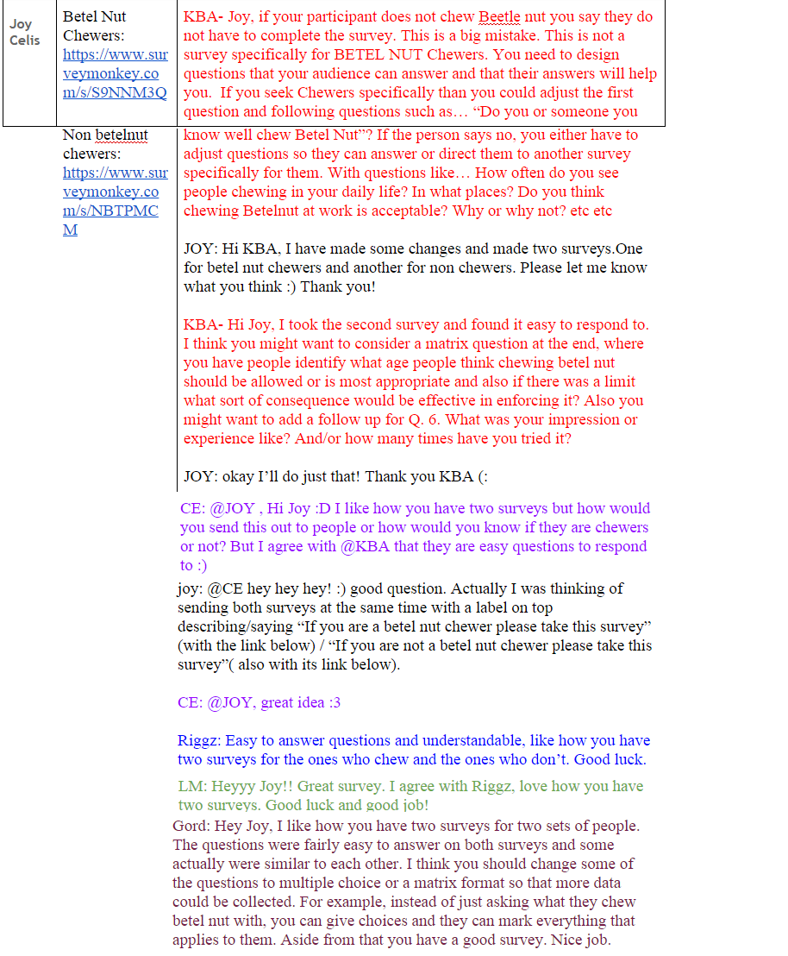
Appendix C
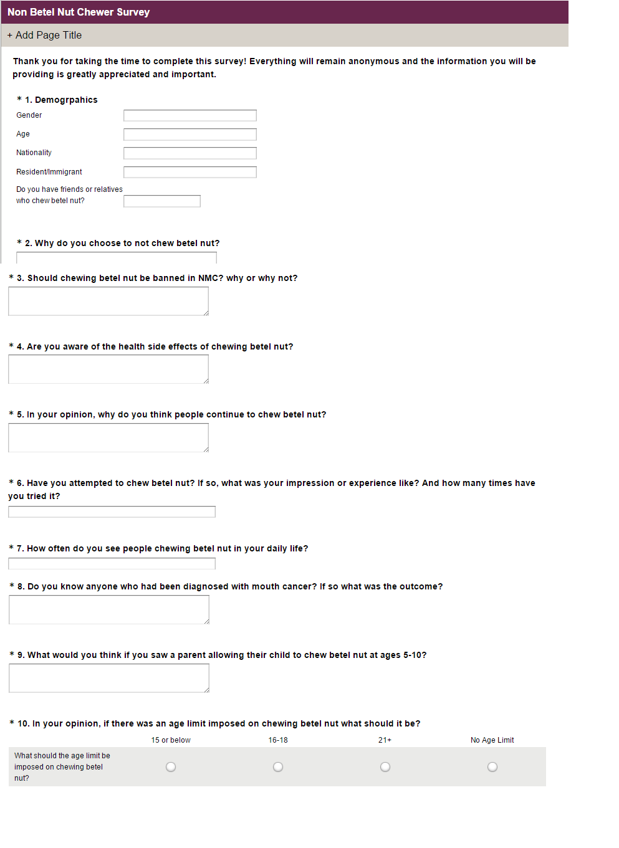

Appendix D

Appendix E
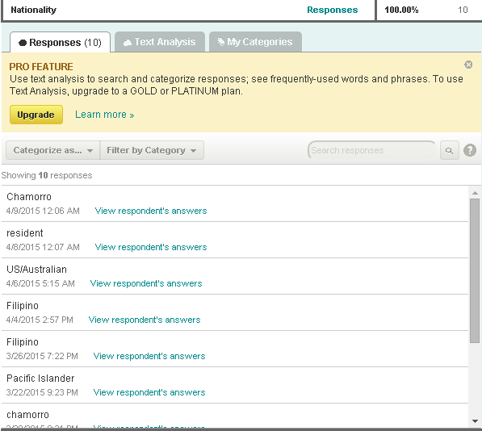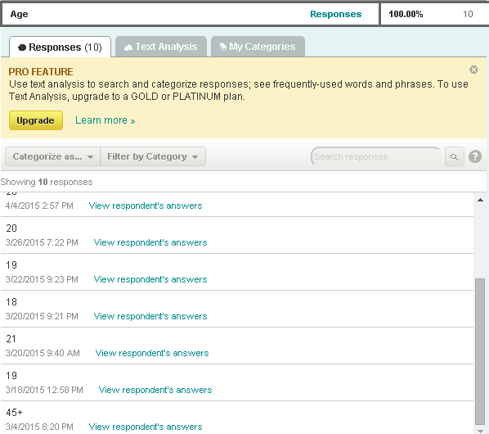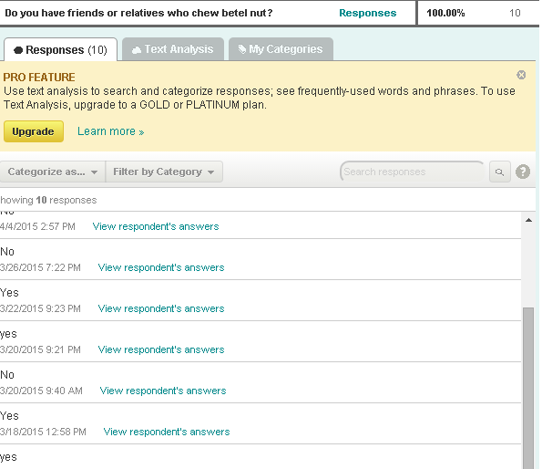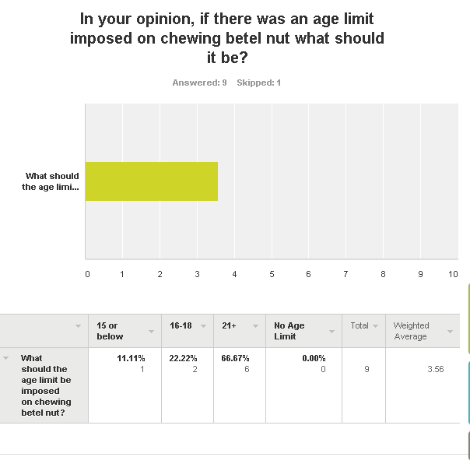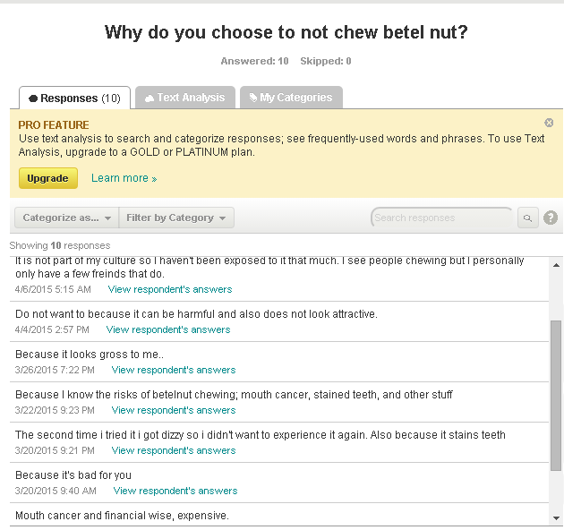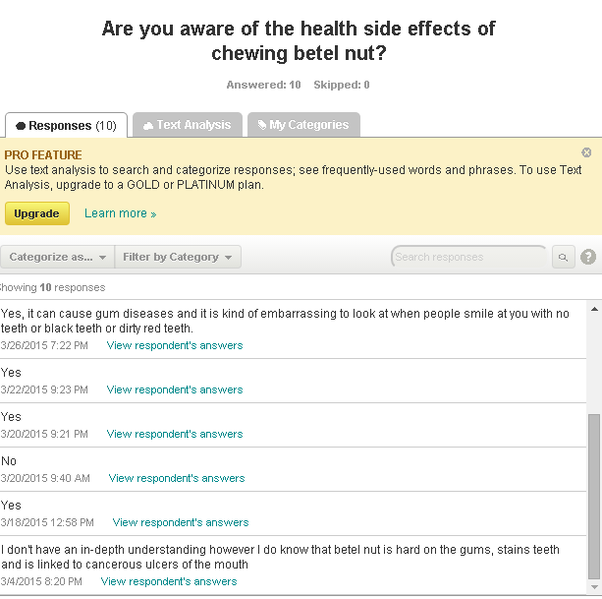
Appendix F
