Gerald Flores
CO210-VR03
Dr. Kimberly Bunts- Anderson
Fall 2020
Community Issue Speech Outline
Introduction of Speech
I. Attention Grabber: “Elected official” and “Corruption” are two terms that never fail to be put in the same sentence when speaking of our CNMI Government.
II. Central Idea: Bring light into past and current issues involving the corruption of government in the CNMI, primarily the misuse of funds and misappropriation of official power.
III. Specific purpose: To inform listeners how Corruption and the misuse of government funds are not only illegal but have detrimental effects in our economy and community. It causes essential programs to be underfunded, creates stress on taxpayers and diminishes the people's trust in our government.

Body of speech
I. First Main Point: My first point expresses my concerns toward my issue and provides examples on how corruption of government and the misuse of funds has and could cause essential programs to be underfunded.
Transition Statement: “There is not enough funding to keep staff within these programs resulting in the furloughing of many essential employees.”

II. Second Main Point: My second point highlights how misuse of funds creates stress on tax payers and provides examples of past accusations of government officials that support my thesis. I also give my opinion on how these issues could have probably been resolved.
Transition Statement: “The resources that were spent carelessly could have been used to fund the shortage in PSS salary budget and in return the island would not have to bear the burden of releasing educators in charge of our future generations.”
III. Third Main Point: My third point is about how government corruption and the misuse of funds diminish the peoples trust in our government. I then provide results gathered from community surveys I conducted which support my thesis.
Transition Statement: Majority of participants also felt that they had no confidence in our government.
Conclusion of Speech
I. Review of Main Points: The shortfall in government funds will directly impact the economy while putting more burdens on tax payers in the long run. As government officials continue to misappropriate funds into their personal lifestyles, the CNMI’s economy will continue to collapse. We will continue to see essential programs and workers being cut due to a lack of funding and the number of job opportunities available will continue to decrease.
II. Final Thought: “. Now the most important question to be asked is, “where’s the money?” As long as corruption remains in government, we will never see the CNMI thrive. Gone will be the days of a booming economy and happy constituents.”

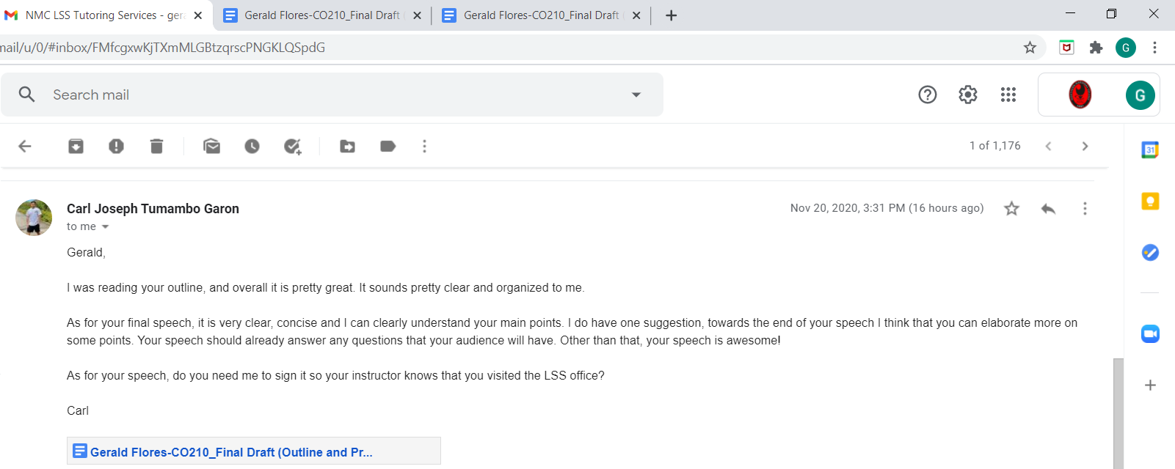
TUTOR FEEDBACK:

