Community Issue: Big Problems for Big People
Donna Mae Laguardia Delos Reyes
Northern Marianas College (NMC)
Fundamentals of Speech and Communication - CO210-05
Northern Marianas College
K. Bunts Anderson
December 2, 2019

Table of content:
Abstract……………………………………….. 3
Big Problems for Big People………………….. 4
References/sources…………………………… 6
Appendix/Surveys ……………………………. 9

Abstract:
This speech will cover the community health problem: obesity in the CNMI. Using statistics from [the World Health Organization (WHO) and Saipan Tribune, combining general information from the National Heart, Lung, and Blood Institute (NHLBI), National Institutes of Health (NIH), PMC, and Encyclopedia on Early Childhood Development.] Also making references to articles [from, Saipan Tribune, Marianas Variety, Investopedia, Hindawi, The News Lens, The New York Times, and Civil Eats] as inspiration for solutions to the problems presented. Problems being, the food environment specifically in stores, the sedentary lifestyle of workers and students alike, and what is lacking in early development curriculum. Followed by solutions like rearranging food items, annual checkups and clinical evaluation of workers and families based on weight and fat, and courses like agriculture and health sciences that could be introduced earlier or improved to have greater impact on the community.

Big Problems for Big People
People across the globe are now facing problems with a non-communicable yet preventable disease. According to the World Health Organization, worldwide obesity has tripled since 1975 and in 2016 over 1.9 billion people were overweight and 650 million were obese. (WHO, 2018) Here is the thing, if obesity is preventable, why do we struggle so much with it? In the Marianas Region alone two-thirds of our population is overweight or obese (E. Encinares, 2019). Fortunately or unfortunately, because obesity is now a global problem we can examine further reasons for why it’s bad, possible factors for why more people are obese now, and measure we can take to improve the situation.
Let’s start with why obesity is a big problem in the Marianas Region; first of all we know that being obese increases a person’s risk of developing diabetes, cardio-vascular diseases, or cancer. These effects do not exclude anyone, not only will they be exposed to the risks of these diseases, but they would also have a life expectancy 8 years shorter than the average person. Not to mention the impact obesity has on our economy, due to the major costs of healthcare for the people who already have these diseases. Obviously there is no easy fix to this problem, but let us go over some factors that have been worsening it.
So, what causes obesity? Unfortunately, there is no one definite answer for it may vary from person to person, but we can list three visible factors that could improve the situation if changed. For example, in a majority of our major grocery stores it is noticeable that our fresh produce is usually located in the back while chips and candies are in the front. Another example is the sedentary lifestyle of workers and families nowadays not only living for convenience, but also failing to visit public health facilities or ignoring free health screenings in events, or how schools need to teach children how to take better care of themselves, especially in early development, because of their influential nature they will easily form bad habits leading to obesity. These are some of the visible problems that we can see in our islands, so what do we do about them?
What are the changes that could be made to fix these issues? For starters, it will not be too hard for grocery stores to rearrange stock, by rearranging their utilities to preserve their fresh produce in the front, that would encourage people to put that in their basket as the first thing they see. Meanwhile for sedentary people, government offices and schools should require its staff or students to have an annual checkup to determine whether they need to seek medical attention to problems they had put aside, and if they are found to have excessive amounts of fat they could be provided assistance to lose weight. As for school curriculum, they should incorporate agriculture and better health sciences for kids, when kids learn interesting and new ideas they tend to share the information to their parents, and if their parents listen they themselves could seek improvement to their family’s diet or lifestyle. These methods probably won’t take too much taxpayer money and could also be treated as community projects with donations and fundraisers even allowing adults and college students to learn how to prepare their own meals. For example a soup-kitchen that voluntarily teaches children basic food preparation, budgeting, and nutrition has found that it has proven effective in making kids eat more healthy food (Can Teaching Kids, 2018).
The Mariana islands is a peaceful region with strong willed people, it is just that as individuals ignorance is bliss and we sometimes turn a blind eye to what may be harmful to ourselves and to those we love. Overcoming the obesity crisis will be tough and weight loss in general is not a simple task since food is a necessity to our survival, the solutions I give are not the only ones out there, but these are merely ideas of ways we can gradually incorporate change into our lives. We must educate ourselves and find ways to unconsciously restrict our bad habits; whether it be from our grocery stores, our jobs, or from our schools. With the help of our government and our community we will see change for the better and hopefully, we will see that soon.

References/Sources:
About 12-18 percent of adults in the CNMI had diabetes in 2016 - Saipan News, Headlines,
Events, Ads: Saipan Tribune. (2019, April 22). Retrieved from:
https://www.saipantribune.com/index.php/about-12-18-percent-of-adults-in-the-cnmi-had-diabetes-in-2016/
Cutting talks about islands' obesity problem at Rotary - Saipan News, Headlines, Events, Ads:
Saipan Tribune. (2016, September 14). Retrieved from:
https://www.saipantribune.com/index.php/cutting-talks-islands-obesity-problem-rotary/
Can Teaching Kids to Cook Make Them Healthier Later in Life? (2018, August 6). Retrieved
from:
https://civileats.com/2018/07/30/can-teaching-kids-to-cook-make-them-healthier-later-in-life/
Obesity and overweight. (n.d.). Retrieved from:
https://www.who.int/news-room/fact-sheets/detail/obesity-and-overweight
Variety, M. (n.d.). Marianas Variety. Retrieved from:
http://www.mvariety.com/special-features/health-matters/69267-health-in-the-cnmi-obesity-and-cancer
The Secrets Behind Your Grocery Store's Layout. (n.d.). Retrieved from:
https://www.realsimple.com/food-recipes/shopping-storing/more-shopping-storing/grocery-store-layout
Obesity Health Problem, Healthy Weight Basics. (n.d.). Retrieved from:
https://www.nhlbi.nih.gov/health/educational/wecan/healthy-weight-basics/obesity.htm
Nath, T. I. (2019, November 18). The Economic Cost Of An Obese Society. Retrieved from:
https://www.investopedia.com/articles/personal-finance/041715/economic-cost-obese-society.asp
Magazine, T. B. T. O. P. I. C. S. (2018, December 7). How Taiwan's Experimental Schools Help
Students Think for Themselves. Retrieved from:
https://international.thenewslens.com/article/109713
Gonchar, M. (2015, September 22). Should Schools Teach Children How to Cook? Retrieved
from:
https://learning.blogs.nytimes.com/2015/09/22/should-schools-teach-kids-how-to-cook/

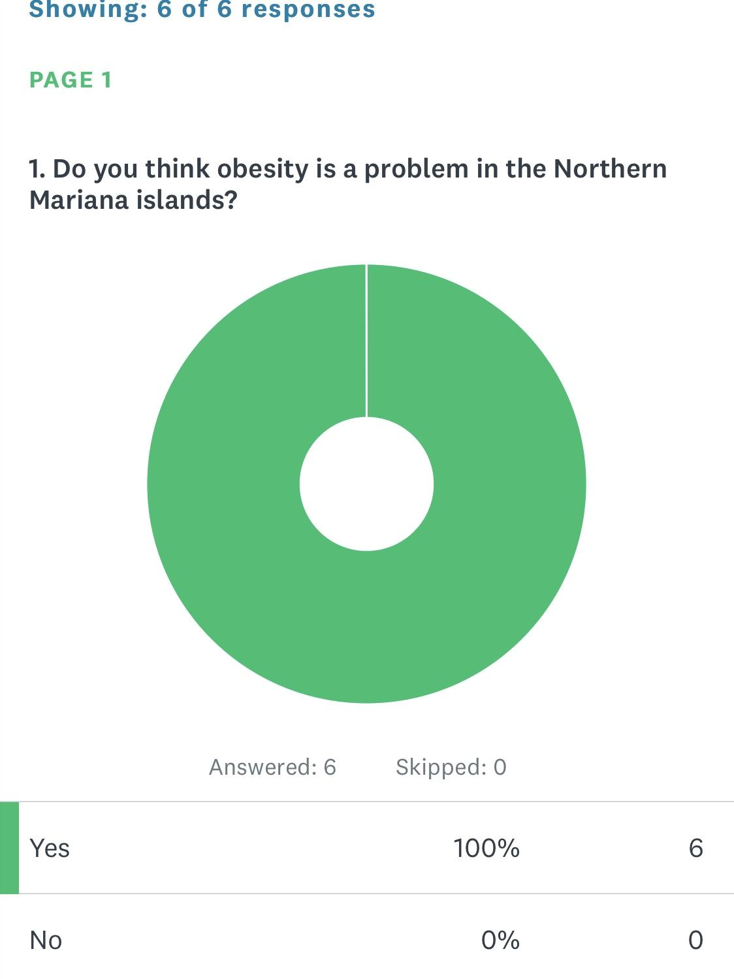
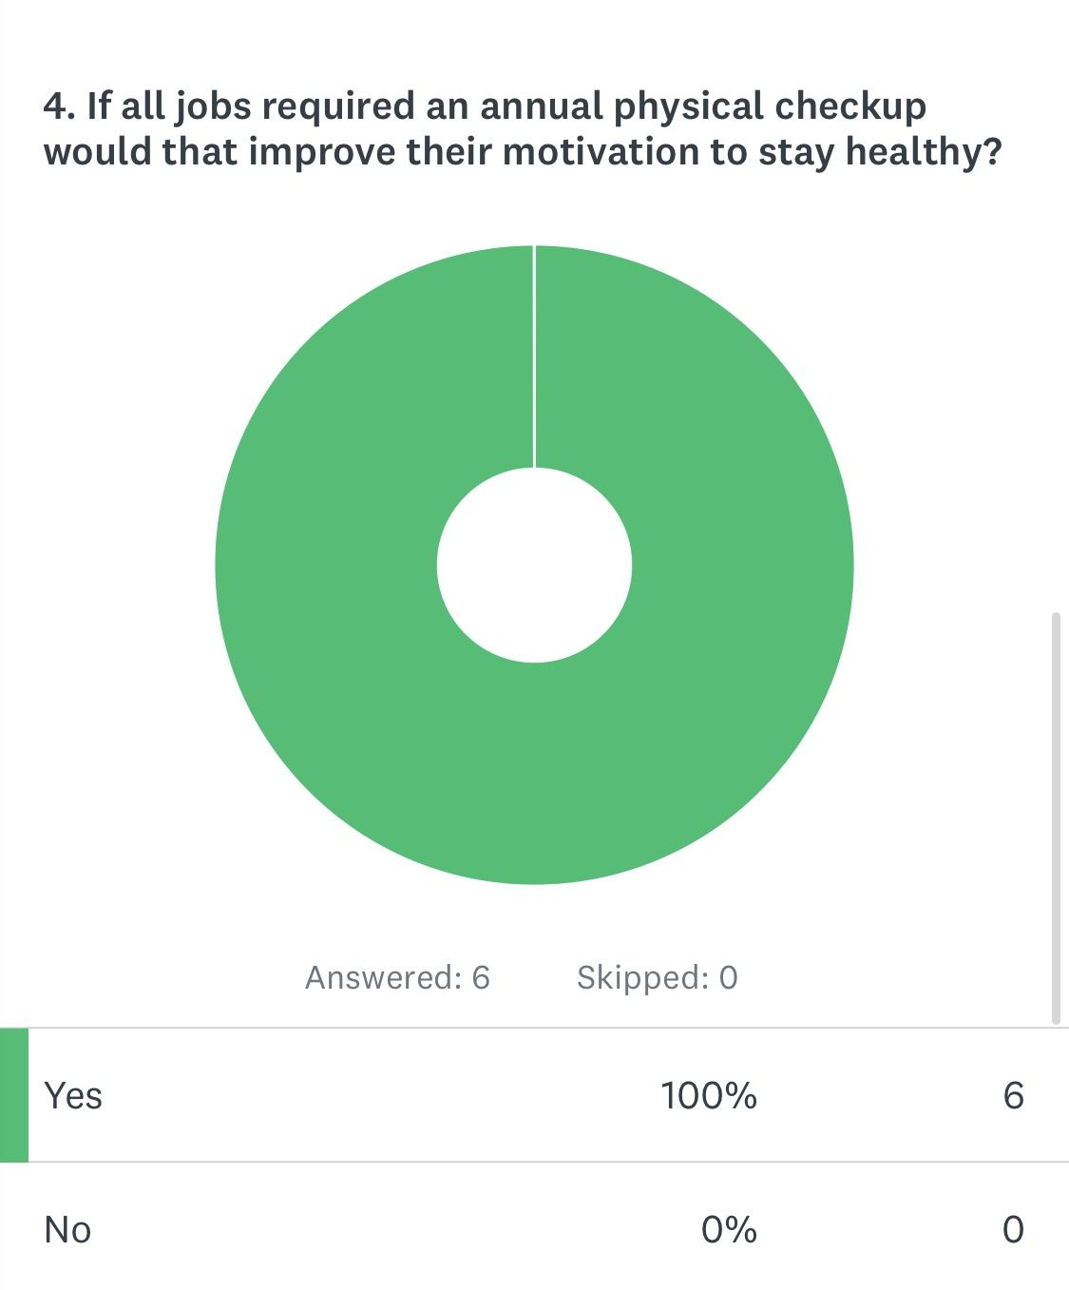
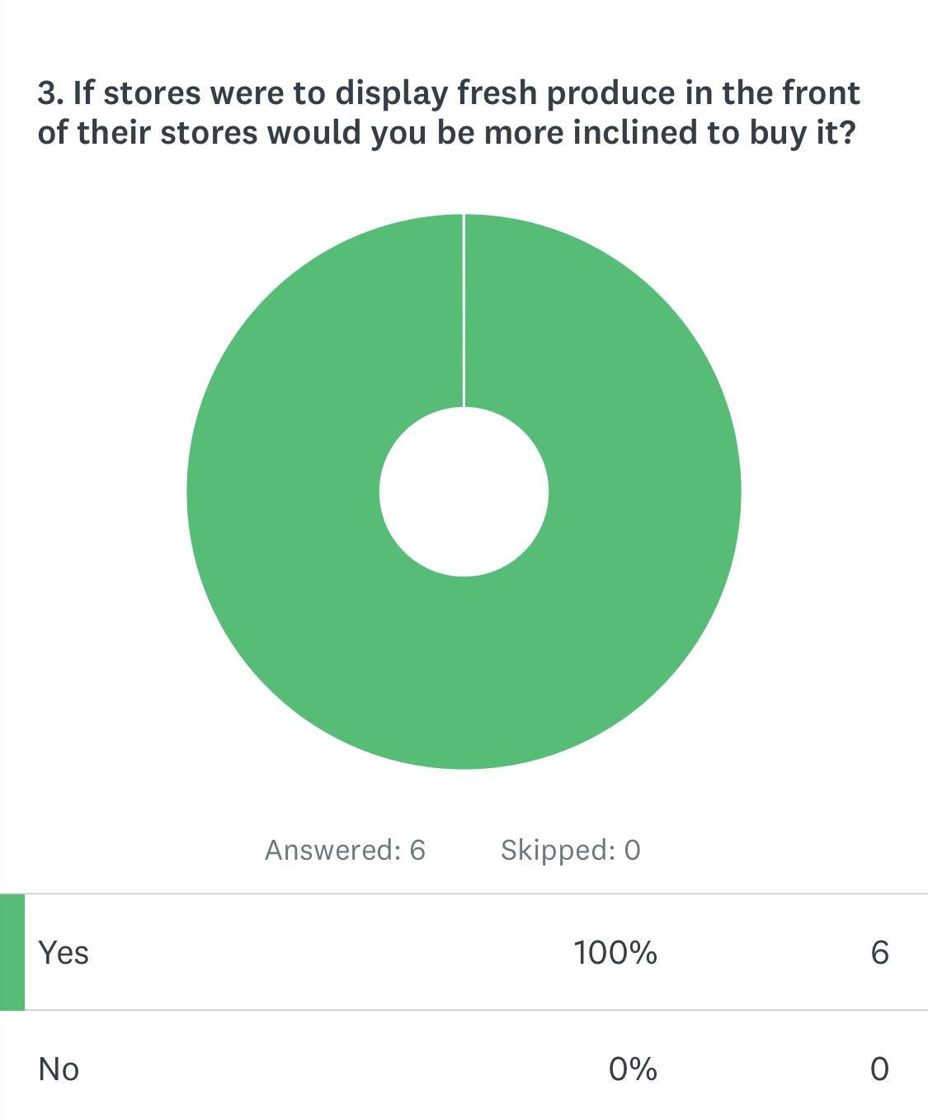
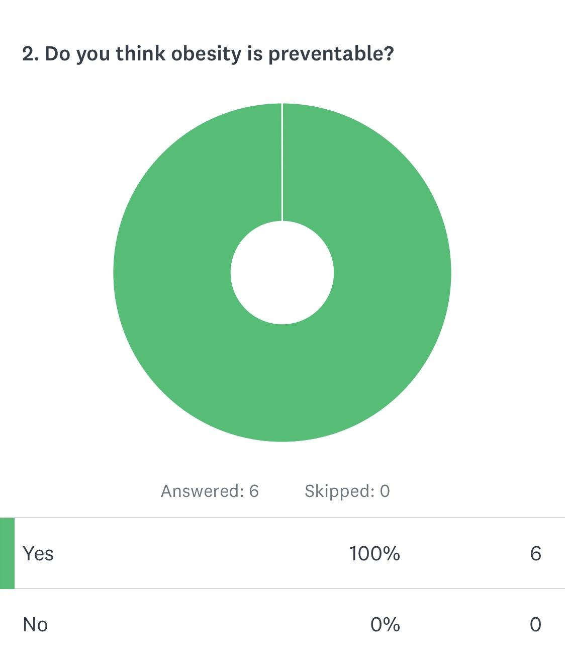
Appendix/Surveys:
: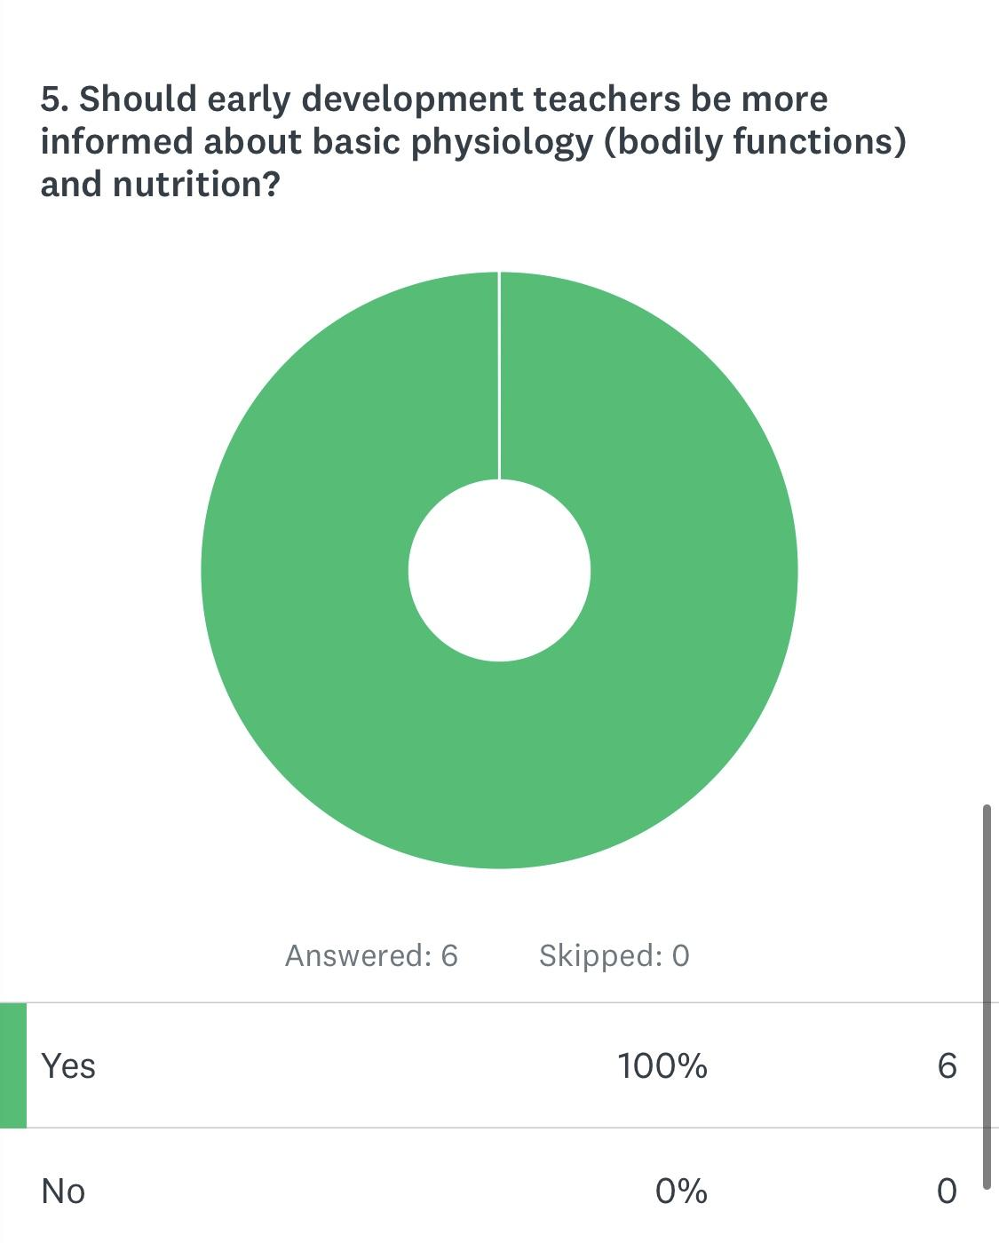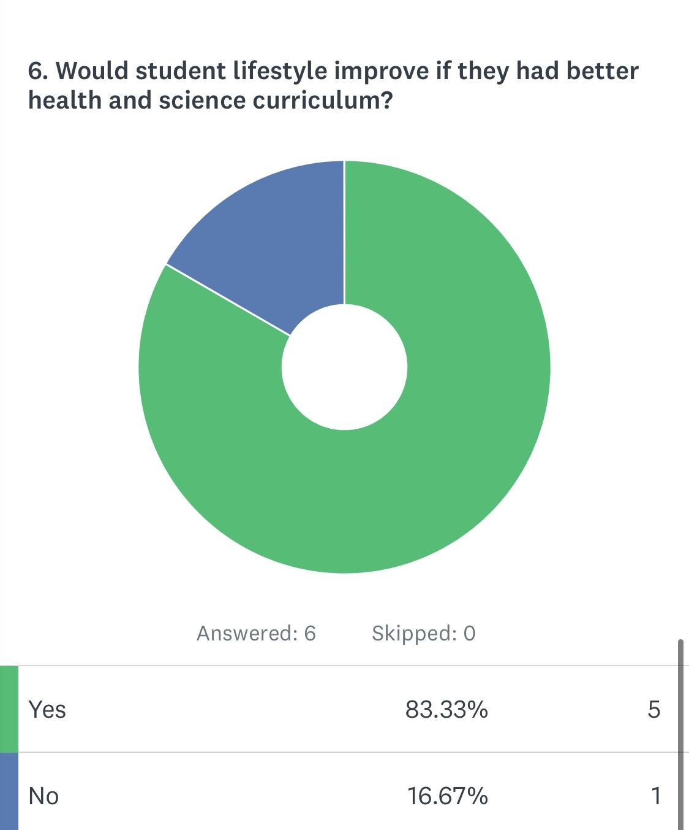
7. Why do you think people struggle so much with obesity?
