My 30 Day Challenge
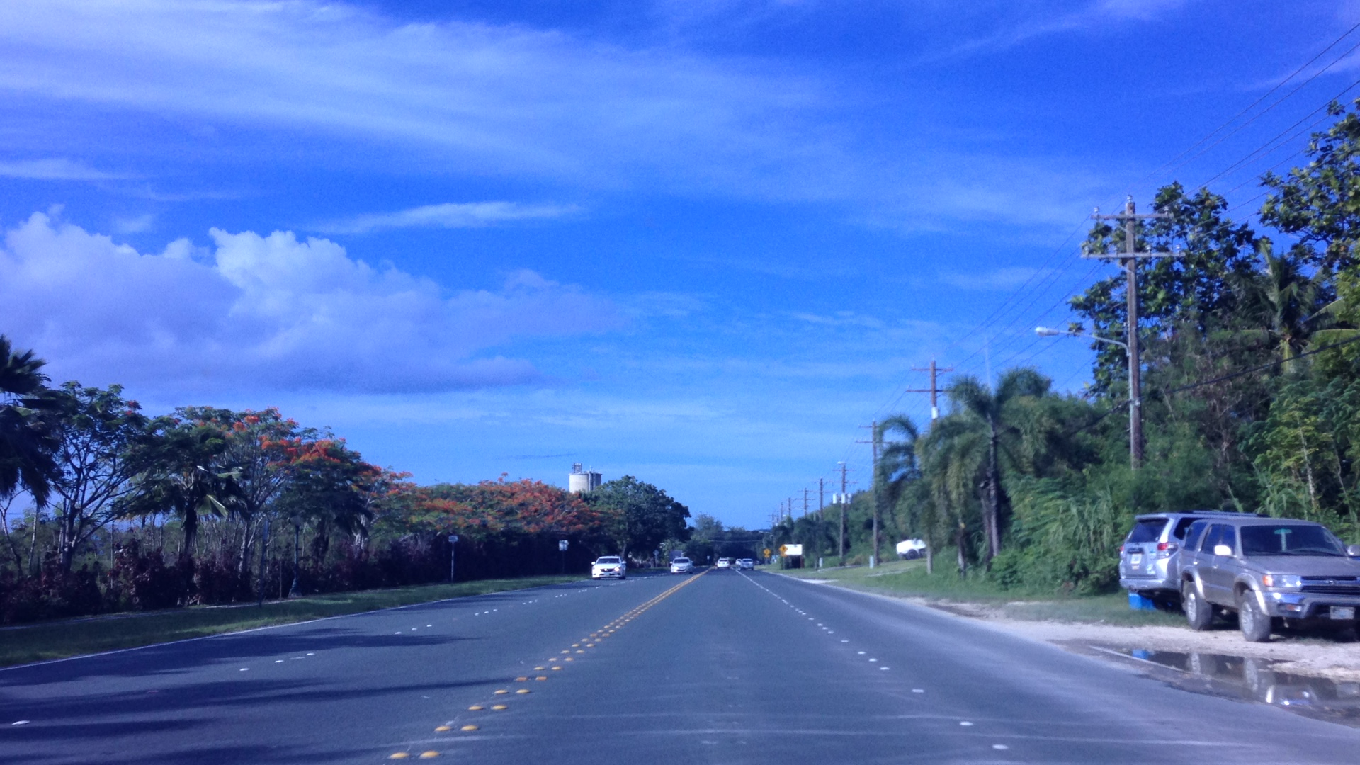

July 4 - 10, 2015
Before my family and I could start on anything that was planned for the 4th of July, my brother, Brandon, had taught me the parts or basics of the car. He told me how much force the wheel could be turned, how hard I could step on the brakes, and the basic speed I may go around Saipan. After, he had me drove from my house to the nearest store, Cheng Cheng. As I headed back home, he told me my problems in driving, which was turning the wheels when exiting the store and how much force I had put on the gas. This was just the beginning in my 30 day challenge. On the second day in driving, my brother told me to drive to the store further from the last one, Lucky De. He said it was to see if there were more problems in my driving because the nearest store was pretty close. As I headed back, he noticed another problem in my driving. He said that my signaling was a little fast. He also said that I was driving a little fast for a beginner. Although, he said that I was good for a beginner and the second day. The following day, after my classes in NMC, my mother decided for me to pick up the laundry with my brother. My brother gave me the keys to further up my driving abilities, although I didn’t ask to drive. As I was driving on the road, he noticed how I was using both my feet. It was unusual for him and maybe for others. He said that if I were to only use my right foot, driving would be much easier because I would only focus on one thing. He was right. Only using my right foot was easier. On the fourth day of driving, my brother wasn’t really in the mood for driving. After my classes in NMC, he gave me the keys to drive home. He was a little tired so I didn’t really practice that much on the third day. After class the next day, my brother told me that my order arrived. I told him to get out of the car so I could drive to the post office. I was really waiting for a long time for my order that I sort of drove fast, enough to make my brother scared because I’m still in the process of learning. My signaling and my control of the wheel has improved after the drive.
The next day, when my brother picked me up from class, he told me to dive to Seven Day Adventist because we had an appointment. When I made a right turn, I almost failed to do so. My brother said that if I were to continue doing what I did, I would’ve crashed.

July 11 – 17, 2015

To start my weekend of, I drove my mom to CUC in Dan Dan to pay off the power bills. My brother didn’t want to follow because he had important stuff to attend to. To be honest, driving for a week had really improved my driving skills. I had my hand coordination in place, my handling of the foot is intact and my signaling became better. At first, I thought that I was partially ready to take the driving test, although my mom noticed that I tend to go to the right side of the road. I did not know if I was too short. Although, I remember that my brother told me on the first day that I needed to visualize the car when parking. That I had to improve. On the second way of week two, my mom had to go to work and do some errands, since she has the control of opening the door. Nothing much changed during this day so I didn’t see any improvements. The third day hit me. I was back to basics. From that day, my sister in law had to teach me since my brother wasn’t available this day. So my sister in law, Nish, had me drove around airport road, seeing how I managing with the car. She saw the same problem with my visualization. During the whole day, she made me parked in an abandoned building to practice my parking. Then on, I tried to perfect it. I did not visualize myself with the car, although I did improved. On the fourth day after classes, I had to go to Southern High School to pick up my packet for online. Since I do not attend Southern High School, I wasn’t really sure on where to go. My instructor for the day is yet again my sister in law, Nish. What she said, surprisingly, is that I was well aware on the road signs. I told her that I had to memorize the signs in order to receive my permit. On the next day after class, my family and I did not had any errands to attend to. I decided to head to the pharmacy with my brother to look for a medicine that I really needed. On the sixth day of the week, I basically drove to the gas station when classes were over. After driving for how many days, we weren’t really focused on the gas mileage. It took me an hour later, going to my mom’s work and back home. Finally, at the end of the week, my mom decided that I should go to Dan Dan Bakery with my brother for our breakfast the next day. From this week, I can say that my driving had improved.

July 19 – 26, 2015

On Saturday, my brother had to go to NAPA to fix his car because something was wrong with the brakes. I decided to follow him, trying not to panic that the brakes were unstable. So with the problem being known, I know that my time braking wasn’t a problem. The following day, I had to go to Southern High School to get the missing documents I needed for online classes. I didn’t had the time to go to another area because my family and I had a busy schedule. The next day after class, I told my brother that I needed to go to Borderline to check out some stuff for school. Unfortunately, I didn’t buy anything. When I made that turn however, I sensed that my turning coordination was mediocre. I was in week two for my thirty day challenge and I needed to improve. For a while at home, I had really forgot about my thirty day challenge. So then, I followed my mom to Joeten Dan Dan to do some groceries unfortunately. I noticed, however, that my parking had improved. The next day, I drove from NMC to the house. I felt that driving at a close distance was useless so I asked my brother if we could go to McDonald’s. For the following past days, I had the same improvements that I needed to work on. Although, nothing much changed during the week.

July 27 – August 2, 2015 – anticipated to take test on Saturday

On the final week for my thirty day challenge, I basically drove around to various places, such as MIHA, the laundry, super store, and troungs. This week, I was expecting myself to improve. Although, I wasn’t expecting myself to improve myself, rather to just get used to the road. Unfortunately, I was unable to take my driving test. I found out on August two, the day the typhoon came, that people are unable to take the driving test. So generally, I did not complete my thirty day challenge to obtain my driver’s license, although I did improved in my driving skills. From my experience, I learned how to manage my flexible time and that practice makes perfect.

