Letters to Dieticians and Responses
Dear (Maribeth Manibusan/ Erin Camacho),
Hello. My name is Angelah Magofna and I am a student studying at the Northern Marianas College. I am doing a research project on the idea of implementing a sugar tax on beverages with added sugars here on Saipan. If it is alright, I would like to ask you a few questions about this topic as you are a medical professional with experience in the eating and drinking habits of people.
- In your personal opinion, how do you feel about the overall health of the people on Saipan?
- Do you believe that cutting back on the consumption of sugary drinks could significantly improve health on Saipan? Why or why not?
- Do you believe that the high consumption of sugary drinks can allude to an addiction? Why or why not?
I would like to thank you in advance for taking time out of your busy schedule for answering the questions I have.
Sincerely,
Angelah Magofna

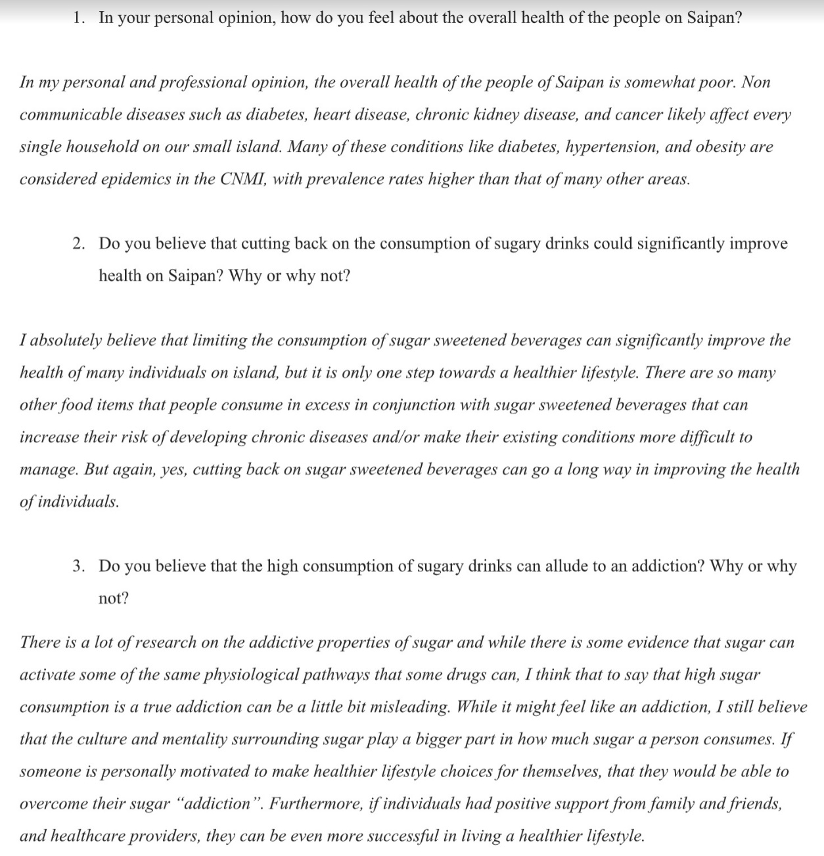

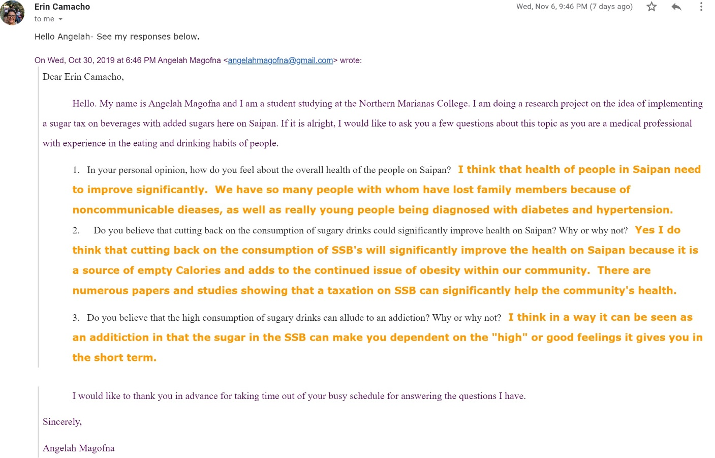

Letter to Hardt Eye Clinic and Diabetes Education Center and Response
Dear Dr. Hardt,
Hello. My name is Angelah Magofna and I am a student studying at the Northern Marianas College. I am doing a research project on the idea of implementing a sugar tax on beverages with added sugars here on Saipan. If it is alright, I would like to ask you a few questions about this topic as sugary drinks are one of the contributors to diabetes here in the CNMI.
- In your personal opinion, do you believe that implementing a sugar tax will in any way help reduce the increasing percentage of people with diabetes here?
- I have read several articles that claim that excess sugar intake can cause diabetes and other articles that claim that excess sugar consumption does not cause diabetes. Can you confirm for me which one is true?
- What is the number one method you recommend for preventing or lowering a person’s risk for diabetes?
I would like to thank you in advance for taking time out of your busy schedule for answering the questions I have.
Sincerely,
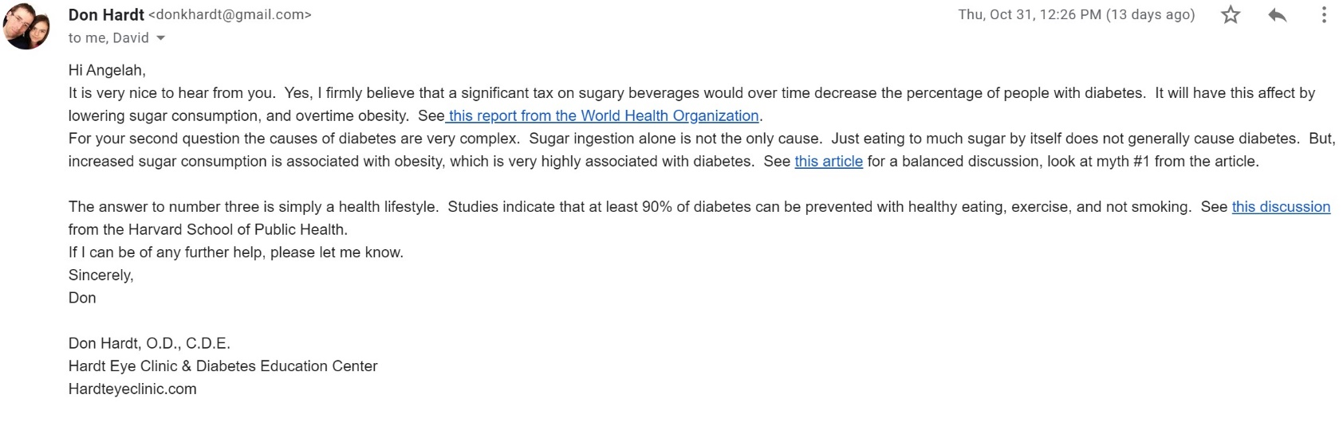
Angelah Magofna

