Final Research Paper
Childhood Obesity in the Hands of Parents
EN202 – ON01
Dr. Kimberly Bunts-Anderson
Guadalupe Diaz 000024119
2019 November

Table of Content
- Abstract ……………………………………………………………………………….3
- Introduction……………………………………………………………………………4
- Background……………………………………………………………………………4
- Literature Review……………………………………………………………………...4
- Research questions…………………………………………………………………….7
- Methodology ………………………………………………………………………….7
- Analysis/ Findings………………………………………………………………..….10
- Discussion………………………................................................................................11
- Conclusion…………………………………………………………………………...10
- References……………………………………………………………………………13
- Appendices
  - Appendix A – Pilot Survey………………………………………………………14
  - Appendix B – Results of Pilot Survey…………………………………………...15

Abstract
An NMC student researcher describes an original three month study highlighting childhood obesity based in the CNMI. Diaz determines whether or not parents contribute to childhood obesity. In the CNMI, parents rely heavily on processed foods, fast foods, and are influenced by many environmental factors that contribute to this worldwide epidemic which happen to let children continue the unhealthy habit along the way. Observations of fitness gyms and restaurants over a 5 week period supports that children are influenced by their parent’s actions and decisions. Interviews and surveys of NMC students reveal the participants’ beliefs and experiences relating to childhood obesity. This study is significant because it thoroughly illustrates the continuous chain of environmental factors leading to childhood obesity.

Introduction
Like everyone says, “you only live once, so why not do what you wish and just enjoy life”. Eat whatever, even if it means exceeding five times the amount of calories, fat, or sodium than is needed. Eat out in restaurants or fast food places because cooking is too much work. Being on a diet is hard and vegetables are gross! While that is one’s thought and mindset, does that person realize the harm it can do to their children because of their unhealthy habits, poor diet, and choices? The answer would most likely be no. Children are at high risk of obesity because of their societal, economic, and constructed environments.
Background
Obesity has been in effect for not only the people in the CNMI, but everyone else around the world. The most influential factor is from one’s genetics and unhealthy habits. There’s a leading cause of obesity which involves the parents unhealthy decision and lack of responsibility. It has been known that children are highly influenced by what their parents do daily. This includes the food they prepare to eat. In addition, most of the CNMI people rely on federal benefits like food stamp. Free money equals free opportunity to get what is craved and wanted by their children which is mostly snacks and candies.
Literature Review
Obesity is a global epidemic that during this period of time already has 1,755 total search results of academic literature sources regarding the disease on EBSCOhost online. Specifically, childhood obesity is limited to 198 total search results that are provided on the website. The majority of the results are based on academic journals while the remaining are reviews. However, there are also non-academic sources that are useful such as news articles and blogs. The news articles will be based on the CNMI’s local news. Also, Saipan Tribune’s website online provides all records of past and present news to where there are a variety of search results that can be used. The most updated news on childhood obesity provided on Saipan Tribune is from October 05, 2016. This descriptive literature review essay will explain thoroughly about the epidemic of obesity from both academic and non-academic literature sources and will explain how the studies included will be helpful to the student researcher.
In a Saipan Tribune news article online, a press release released an article “Rates of childhood obesity in the CNMI on the rise” (2016). Also, the Center for Disease Control recorded that there are about 1 out of every 5 young children who reside within the U.S. that suffer from obesity. It has been noted that there are specific groups of children who are often affected than the rest. During 10 years of research, CNMI high school students were participants for a conducted Youth Risk Behavior Survey. From that survey, it was concluded that the rates of obesity in children weren’t that high. However, over the years the rates began to rise. Obesity, especially in young children, could lead to other future life-threatening illnesses including mental health issues. Poor dietary and lack of exercise are the top factors of childhood obesity. It has been addressed to parents that childhood obesity could be situated at home and with the help of the support and programs provided by the community (Press, 2016). The student researcher decided to see what nationality is most affected by this illness within the CNMI. In the survey, the participants were asked about their nationality which then will determine the group of people. Statistics from the surveys gave solid facts that go along with the research.
According to Encinares (2016), on September 13, 2016, Derek Cutting who is a local gym owner, nutritionist, and fitness trainer mentioned that obesity is the CNMI’s top health concern. Cutting explained that because of the parents’ lack of nutritional knowledge, the children are affected. He also stated that “It also comes down to the food they give their children and the options they let their children choose” (Encinares, 2016). After World War II, people in Saipan relied heavily on canned goods and continued that habit over the years. It eventually made children do the same. It’s both the portion and the frequency of meals that contribute to this illness. It’s been noted that a great way to let the community be aware and gain knowledge of the obesity issue and to help the community reach their goal in becoming healthier in regards to their weight is by competitions such as the public relations body fat challenge that was hosted by Tanholdings Company (Encinares, 2016). The student researcher noticed that canned goods are known to be a huge factor in the CNMI that caused obesity, therefore in the survey, it is asked how frequent do the participants eat canned goods.
Leonardo Trasande (2009) examined an approach made by the National Children’s study (NCS) to view the different environmental factors that influence obesity. NCS did a prospective study of 100,000 children in the U.S.A. for 21 years. The study focused on factors such as genetic inheritance and children’s surrounding, constructed, and natural environments. The peer-review article provided in EBSCOhost is constructed to engage the readers to perceive the issue of obesity by understanding the causes of this illness. It has been studied that children are more capable of becoming obese before they begin their school years. The student researcher included a question about how frequent the participant and the participants’ family work out. This will allow the researcher to connect the relationship between the parent’s habits with their children. In the student researcher’s survey, it asks what challenges are brought upon the participant in striving for a healthy weight and lifestyle so the factors that were mentioned in the literature sources could be compared. Using the case study that was provided in the academic literature sources would be useful in gathering more information to compare its similarity to the researcher’s data.
Schmidt, C. W. (2003) wrote an article on one of the most worldwide epidemic issues, obesity. He explained the effects that obesity brought to individuals who suffer from the illness. It as well demonstrated how children have a continuous chain of unhealthy activities that they do daily which increases the risk of obesity. From a forum posted by the Federal Interagency in July 2003, it’s been recorded that childhood obesity has more than doubled within the last two decades. In this article, it explained how the environment plays a huge factor in the development of obesity. Schmidt also provided a list of the effects of having too much fat. “It leads to low self-esteem and depression” (Schmidt, 2003). The student researcher decided to ask how confident does the participant feel about their weight in the survey because then it’ll determine whether they are capable of having low self-esteem. In the survey, it is also asked for the participants’ opinions about how the health of the children is in the hands of parents. From the survey and interviews provided to the participants, the student researcher will be able to include the participant’s ideas and beliefs about their knowledge and experiences with childhood obesity.
Listed below are a primary question and two secondary questions that the student researcher will conduct further along the research. In addition, the data collected will connect with the literature sources reviewed above.
- Do parents contribute to childhood obesity?
- What nationality is most affect with obesity?
- Do food stamps increase the rate of obesity?
Methodology
For the first step in this research, the student researcher started by constructing questions for a survey to be shared with 38 NMC students. The researcher created a 10 question pilot survey on a website called Survey Monkey. It was shared on Google Docs for peer review and feedback. With that, errors were corrected and got peers’ opinions on how to make it better. After it’s been revised, the student researcher then copied the updated survey as the final survey. The survey consisted of multiple-choice questions relating to the topic. The first few questions asked about the participant’s age, nationality, and gender, monthly income, and benefits received. With that, the student researcher gathered statistics for the secondary question which is what nationality suffers most from obesity. The other questions that the researcher included are how often the participant and their family work out and eat out. That allowed the researcher to investigate the participants’ actions in maintaining their wellbeing. Other questions such as are you confident about your weight and what are some challenges in maintaining your weight were asked in the survey for the researcher to determine what factors influence obesity. Lastly, it asks opinions about parents contributing to obesity.
The next step the student researcher’s did to gather data was to send out letters via email to experts about the research topic. The student researcher constructed a total of ten letters which five was sent to off-island professionals and the remaining five letters to local professionals. To do so, the researcher searched for emailed provided in the scholarly peer-reviewed literature sources. In the letters, the researcher briefly explained the information found in literature sources and the survey. The letters also helped the researcher connect their finding with the knowledge and information from the recipients. The student researcher too, had the opportunity to add more information that could be useful for the research. Lastly, the researcher had the chance to ask any questions that the student researcher may have for the exports since they have more knowledge in that specific field of study.
In the third step, what the student researcher did was conduct observations and interviews that will go alongside the research. The first observation was at the gym that had a separate section for the children to play. Parents who go to the gym regularly have a good habit which enhances their well-being. Those people would most likely want the same for their children so they bring them along to stay active in the gym. The other observations are in restaurants. The parents who eat out often and who order more unhealthy meals have poorer habits for their well-being. With those observations, the student researcher recorded the well-being and connection between the parents and their children. The researcher also observed how the parents’ actions and decisions affect their children as the result of becoming obese. Interviews were also conducted with certain people who receive food stamps. This allowed the student researcher to get results like experiences and habits of the interviewee.
The student research conducted a survey that was given to NMC students to collect the CNMI’s statistics about obesity. It collected data about the beliefs of participants regarding childhood obesity, what nationality is most affected by this illness, and a new perspective that goes along with this research which is about food stamps being a factor of obesity. The student research constructed letters to experts which asked for more information, personal experience, and feedback for the research. Observations were weekly scheduled that took place in restaurant and fitness gyms. The student researcher observed the relationship between the parents, community, and children’s lifestyle. Lastly, the student researcher scheduled interviews for personal experiences, knowledge, and thoughts about obesity and how parents are contributing to obesity.

Analysis/Findings
From the survey responses, it’s been shown that 70% of participants are not confident with their weight. With the data, participants stated that 50% of their family members are overweight including them. Most of them are Pacific Islanders and Asians. However, Pacific Islanders showed the most results in obesity. According to the literature source that was reviewed, it indicated that Native Hispanics were known to be the top sufferers with obesity. The Pacific Islanders are very much identical with the Hispanics, therefore it was concluded from prediction and actual evidence that the Pacific islanders too, suffer more than the other race groups. The survey indicated that on average, the participants spend twenty dollars on snacks per week. It also shows that the cause of obesity is by the food they eat and lack of exercise. 64% of their parents never work out or less than once a month which resulted in 41 % of participants who do not work out or work out less than once a month. In the survey it asks about what one thinks about when stated that the health of children is in the hands of parents. One responded, “Children are young and make most decisions based on how much they like or enjoy something (such as eating habits). It's up to parents to find what works for the child in terms of both health and enjoyment. Lacking to do so means that the parent either is unknowledgeable in that area, or cannot act like a true parent.” Another participant stated that, “Yes, because parents are responsible for influencing their child's healthy lifestyle.”
The student research sent out a total of 10 letters to experts on-island and experts off-island to ask for advice, new information, and experiences regarding the research topic. There were several question asked that were attached to the letter. Not much responded to the letter, however the student researcher was lucky enough to receive two responses back.
Observations were done in the Latte Built Fitness Gym and the rest were done in restaurants such as McDonalds, Shirley’s, and Great Harvest. The student researcher saw that when the members go to the gym on a daily basis, they would bring their children along with them. There is a kid’s play area in the fitness gym which the kids would play in as their parents are doing their workouts. It showed the relationship between the parents and children’s physical activity. The parents seemed to influence their children in staying active. In result, the children were averaged weight. It’s been observed several times that a kid would follow the parents as they were being trained by a personal trainer. The student researcher saw that the children would tend to follow and copy the parents’ daily routines and activities. As mentioned the rest of the observations were from restaurants. More children were seen to be obese in restaurants than in the fitness gym. This accounts for the parents’ decision in eating out rather than cooking a nutritional home-cooked meal. However, Great Harvest Bread Co. that serves high quality healthy food is much different from the rest of the of food places on island. That is the only company that showed better results in weight. Multiple observations were shown that the parents’ meal choices would influence the children’s eating habit. The children were seen to be eating more vegetables than the children in McDonalds and Shirley’s.
Discussion
The student researcher noticed the relation between the parents’ habits in diet and exercise with their children’s own. The data provided from the literature sources and the data from the literature sources indicated that the children would continue and follow everything they do in their childhood onto their adulthood. The more parents exercise and follow a nutritional meal the more the kids will too.

Conclusion
In conclusion, the following steps helped the student researcher conduct this research. The researcher used a survey; letters to exports, interviews and observations to fully conduct whether or not parents contributes to childhood obesity, what nationality is most affected by the illness, and does food stamps contribute to childhood obesity. The researcher will have the opportunity to use these methods to aid him/her in collecting the best data from the community. The rate of obesity in children has been drastically multiplying. Parents need to be aware of their actions for their children’s sake. The student research has conducted a survey that will be given to NMC students to collect the CNMI’s statistics about obesity. It will determine what nationality is most affected by this illness and the common factors that the CNMI struggles with today. There is a new perspective that goes along with this research which is about food stamps being a factor of obesity. The student research has constructed letters to experts which asks for more information, personal experience, and feedback for the research. Observations were weekly scheduled that took place in restaurant and fitness gyms. The student researcher is observing the relationship between the parents, community, and children’s lifestyle. Lastly, the student researcher is scheduling interviews for personal experiences, knowledge, and thoughts about obesity and how parents are contributing to obesity.

References
Encinares, E. (2016, September 14). Cutting talks about islands' obesity problem at Rotary –
Saipan News, Headlines, Events, Ads: Saipan Tribune. Retrieved from https://www.saipantribune.com/index.php/cutting-talks-islands-obesity-problem-rotary/.
Press Release. NMPASI: Rates of childhood obesity in CNMI on the rise - Saipan News,
Headlines, Events, Ads: Saipan Tribune. (2016, August 30). Retrieved from https://www.saipantribune.com/index.php/nmpasi-rates-childhood-obesity-cnmi-rise/.
Schmidt, C. W. (2003). OBESITY: A Weighty Issue for Children. Environmental Health
Perspectives, 111(13), A700. https://doi.org/10.1289/ehp.111-a700
Trasande, L., Cronk, C., Durkin, M., Weiss, M., Schoeller, D. A., Gall, E. A., … Gillman, M. W.
(2009). Environment and Obesity in the National Children’s Study. Environmental Health Perspectives, 117(2), 159–166. https://doi.org/10.1289/ehp.11839

Appendices
Appendix A – Pilot Study
Number of researchers: 1
Number of survey responses: 32
Demographics: Students between the ages 11-34

Survey questions:
- Demographics:
  - Age?
  - Nationality?
  - Gender?
  - Are you receiving food stamp?
  - How much do you make in a month?
- How many children do you have?
- How do you consider you weight?
- How much do you spend on average on snacks per week?
- How often do you eat canned goods?
- How often do you and your family work out?
- How many of your family members (including you) are overweight?
- What do you think is the main cause of childhood obesity?
- What are some challenges in trying to maintain a healthy lifestyle?
- Explain your opinion to the following statement: “The health of children are in the hands of parents.”
Appendix B – Results of Pilot Study
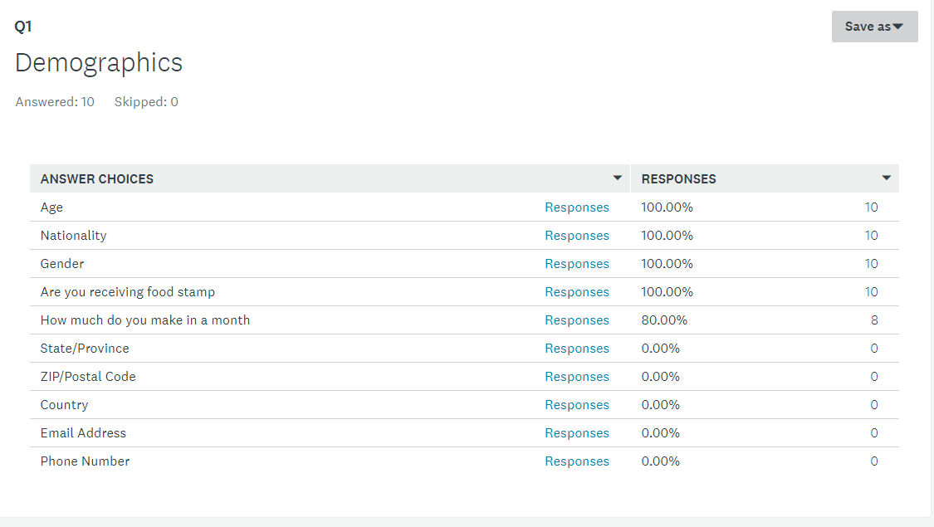
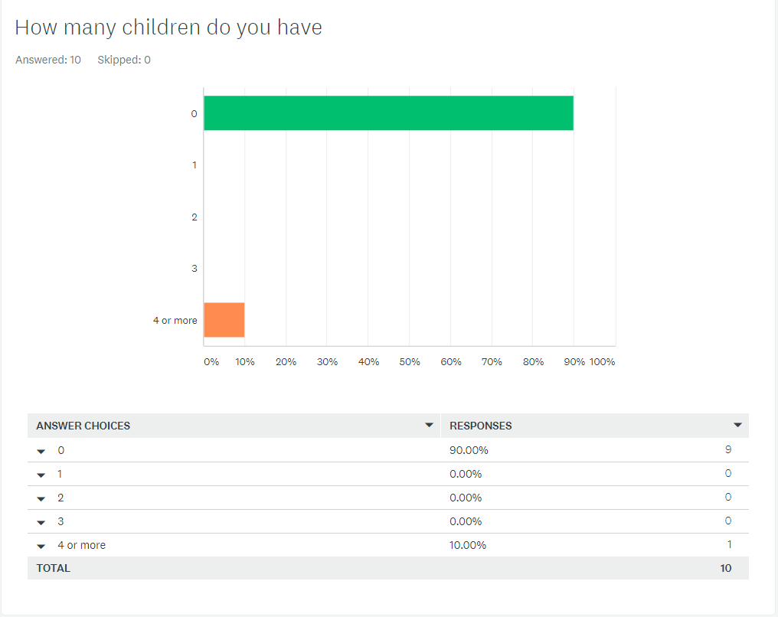
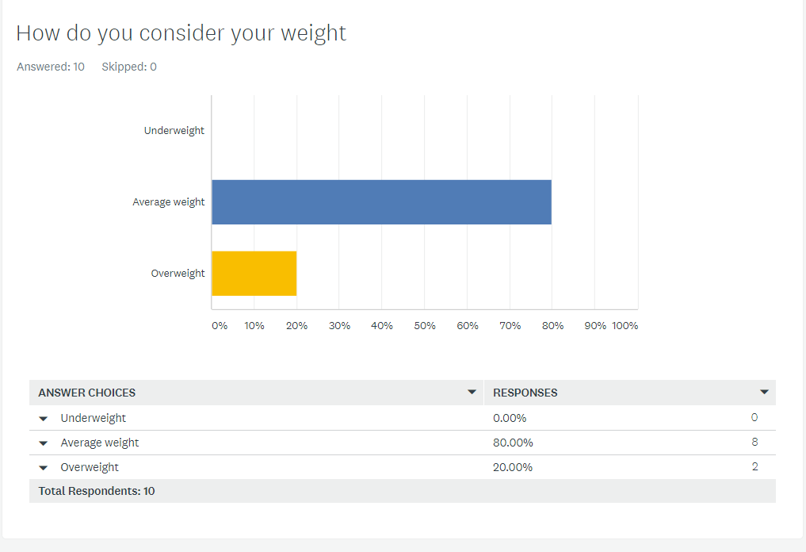
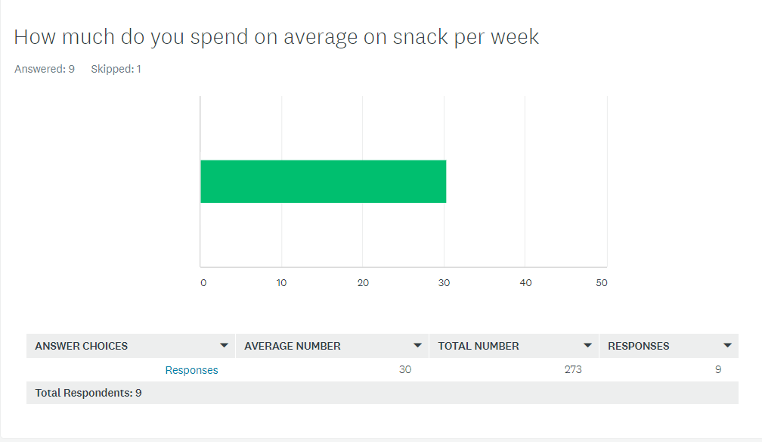

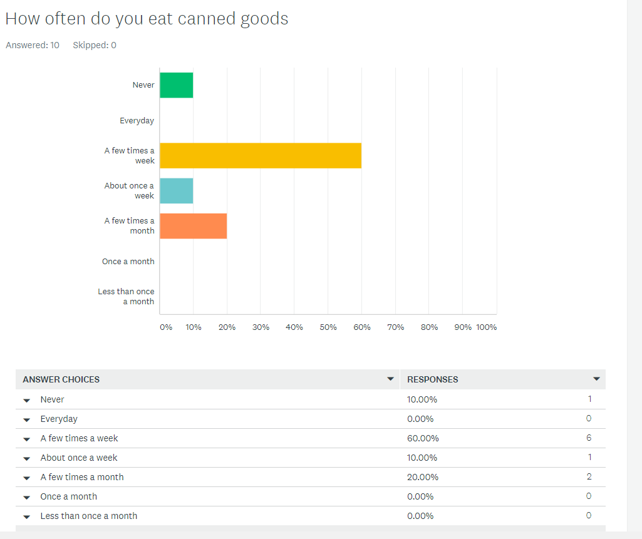
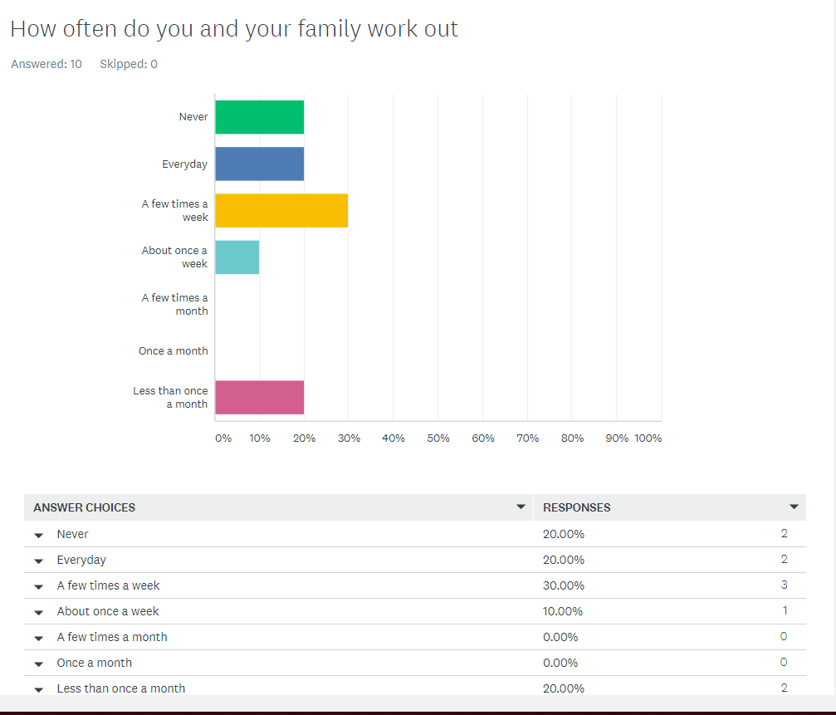
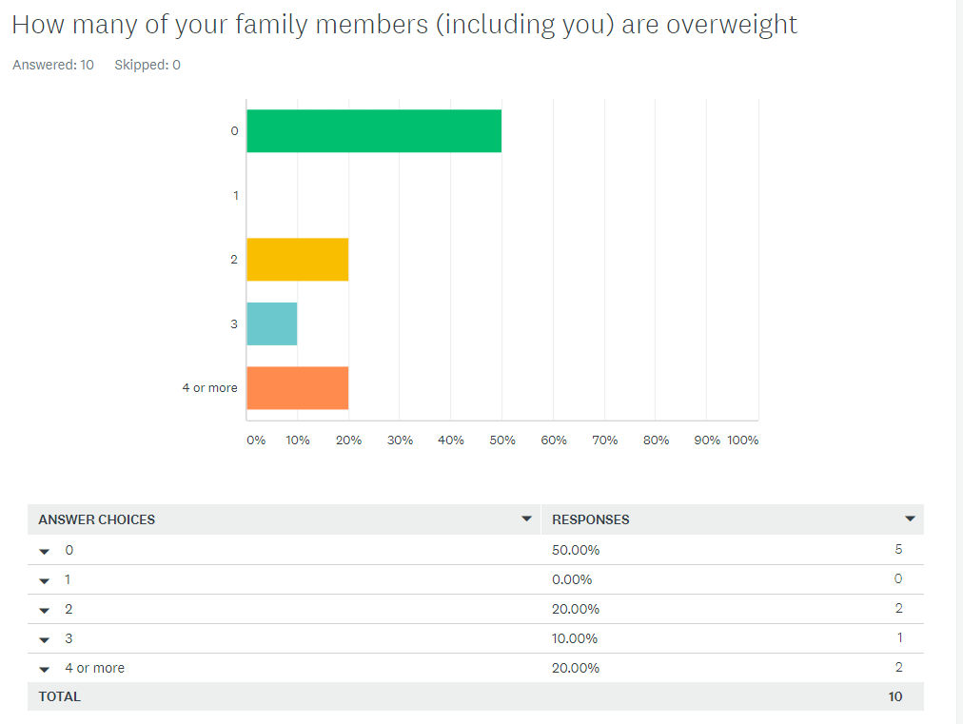
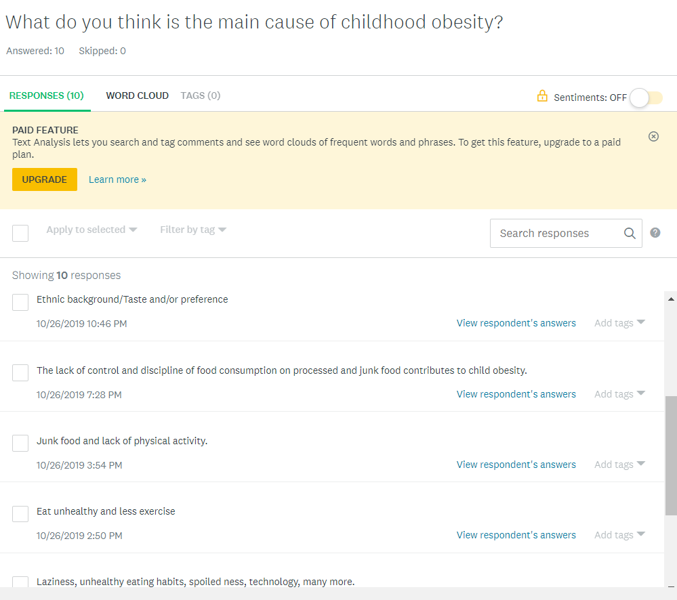
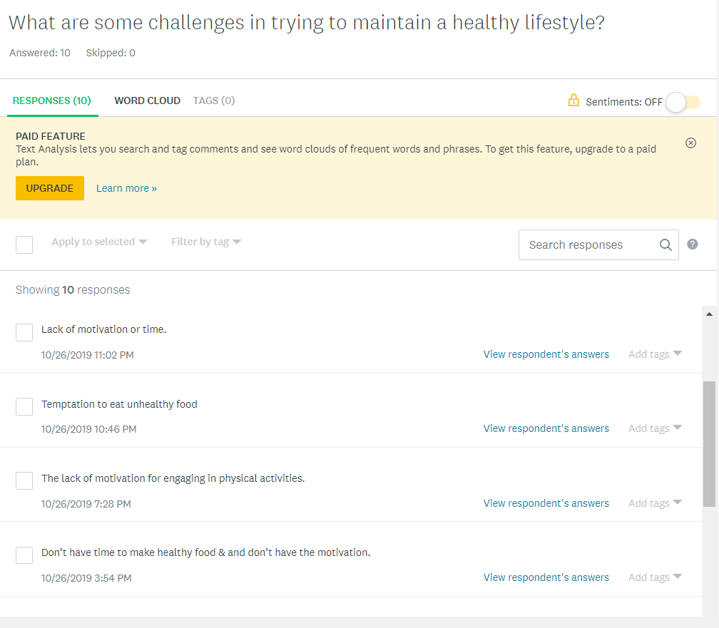
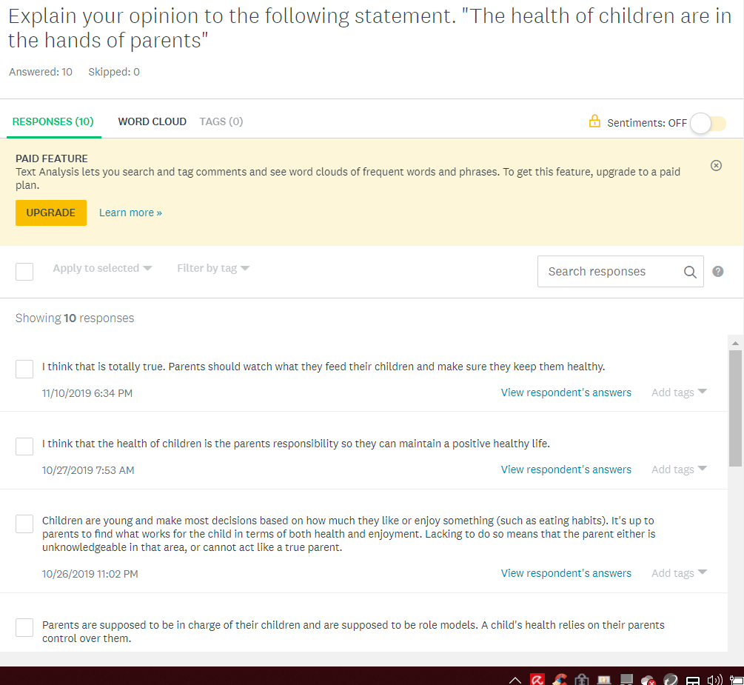

Note Taking Sheet: Reading #1
Lupe Diaz
EN202 – ON01

1. Author’� s Name: Press Release
2. Author’� s Credentials (Press Release)
3. Publisher [or title of organization]: Saipan Tribune
4. Heading of Section [title of reading]: Rates of Childhood Obesity in the CNMI on the rise
5. Year Written: 2016
6. Pages: Web
7. Website URL: https://www.saipantribune.com/index.php/nmpasi-rates-childhood-obesity-cnmi-rise/

Main Ideas/Points | Important Quotations | Supporting Details | Relevance to Your Assignment
- Certain groups are more affected than the rest  - 1 out of 5 young children residing within the U.S. suffers from obesity  - Obesity leads to many other future life threatening illnesses  - It can be situated at home  - It would help if there is support and programs from the community  - Rates of obese children have been drastically increasing year by year  - Poor dietary and lack of physical exercise are the top leading cause of obesity in children.  . | - To help ensure that children have a healthy weight, energy balance is important. To achieve this balance, parents can make sure children get adequate sleep, follow recommendations on daily screen time, take part in regular physical activity, and eat the right amount of calories.  - Parents can ensure access to water as a no-calorie alternative to sugar-sweetened beverages.  - Parents can help children get the recommended amount of physical activity each day by encouraging them to participate in activities that are age-appropriate and enjoyable | - During a 10 year period research, CNMI high school student were participant for a Youth Risk Behavior Survey | - It gave me the idea to conduct what nationality suffers most of obesity.

In this article, is it possible that any of the authors might have a bias about the subject matter? No. Provide examples if needed.

Is the article timely or a bit outdated? A bit outdated

Was it published in a reputable source? Yes

It is not an academic source. No

Other important information:

Note Taking Sheet: Reading #2
Lupe Diaz
EN202 – ON01

1. Author’� s Name: Erwin Encinares
2. Author’� s Credentials: Press release
3. Publisher [or title of organization]: Saipan Tribune
4. Heading of Section [title of reading]: Cutting talks about islands obesity problem at Rotary
5. Year Written: 2016
6. Pages: Web
7. Website URL: https://www.saipantribune.com/index.php/nmpasi-rates-childhood-obesity-cnmi-rise/

Main Ideas/Points | Important Quotations | Supporting Details | Relevance to Your Assignment
- Children become affected from this illness because most times parents like the nutritional knowledge  - After world war II, people in Saipan rely heavily on canned goods  - Children developed the habit of cooking canned food on a daily basis  - Both the portion and frequency contributes to becoming obese  - A way to let people be aware of the obesity issue and the help the community reach their goal in becoming healthier in regards to weight is by competitions | - “Coming from post World War II, when the U.S. came in, a lot of the stuff was left here. Like the SPAM, Portuguese sausage, Vienna sausage, and all that stuff, and that was all they were able to eat for a few years because of the war,” said Cutting. “There was no such thing as farmer’s market or being able to go to Joeten for fresh ground beef. It was all canned food. That generation got used to that because it was easy and they liked it, and they even created local dishes out of a lot of it. And what happened is that it became part of a family’s meal. Now, the children are learning the same thing. “  - “An issue that I really see here on the island is the lack of knowledge [of nutrition]. Kids learn from what the parent puts in their plate, they don’t really know anything different. It’s not the child’s fault, but the parents don’t have the knowledge either to understand that they’re the ones causing it,” explained Cutting.  - “ “But a challenge, a chance to actually win something and some fun involved, then they have a reason to be there, at the same time they’re learning. So that is a good way for me to speak to a hundred plus people at one time.” | - Tanholdings company in Saipan hosted a public relations body fat challenge which made the community excited to join because they could win a price. Many people joined and were able to be informed of the issue. | - I added the question to my survey that asks about canned foods, diet, and exercise.  - I want to conduct what factor most leads to obesity here in the CNMI.

In this article, is it possible that any of the authors might have a bias about the subject matter? No. Provide examples if needed.

Is the article timely or a bit outdated? A bit outdated

Was it published in a reputable source? Yes

It is not an academic source. No

Note Taking Sheet: Reading #3
Lupe Diaz
EN202 – ON01

1. Author’� s Name: Leonardo Trasande, Chris Cronk, Maureen Durkin, Marianne Weiss, Dale A. Schoeller, Elizabeth A. Gall,
Jeanne B. Hewitt, Aaron L. Carrel, Philip J. Landrigan, and Matthew W. Gillman
2. Author’� s Credentials
3. Publisher [or title of organization]: EBSCOhost
4. Heading of Section [title of reading]: Environment and Obesity in the National Children’s Study
5. Year Written: 2019
6. Pages: Web
7. Website URL: https://doi.org/10.1289/ehp.11839

Main Ideas/Points | Important Quotations | Supporting Details | Relevance to Your Assignment
- .There are many environmental factors that influences childhood obesity  - The study focuses on factors such as genetic inheritance and people’s surrounding, constructed, and natural environment  - The recent explosive  Increase in prevalence of obesity reflects a complex interplay among thing like changes in individual behaviors, changes in community structure, lifestyle, and the built environment, and possibly exposures to certain synthetic chemicals, such as endocrine disruptors (EDs), that may have the capacity to disrupt energy balance.  - Recent studies also suggest that obesity develops as a chronic condition much earlier than the school-age years | - “Obesity is the consequence of a chronic net positive energy balance”  - “Access to safe play spaces may also influence activity patterns and thus reduce risk of obesity”  - Unique windows of vulnerability have been  identified for many of the environmental exposures linked to obesity | - NCS conducted a perspective study of 100,000 children in the U.S for 21 years focusing on factors of obesity | - This gave me the idea to input the question such as “what do you think are some challenges in maintaining a healthy weight” into my survey  - It also made me put the question of how many children do the participants have and how many are overweight

In this article, is it possible that any of the authors might have a bias about the subject matter? No. Provide examples if needed.

Is the article timely or a bit outdated? A bit outdated

Was it published in a reputable source? Yes

It is not an academic source. No, it’s academic

Other important information:

Note Taking Sheet: Reading #4
Lupe Diaz
EN202 – ON01

1. Author’� s Name: Scmidt W. C.
2. Author’� s Credentials:
3. Publisher [or title of organization]: EBSCOhost
4. Heading of Section [title of reading]: OBESITY: A Weighty Issue for Children
5. Year Written: 2003
6. Pages: Web
7. Website URL: https://doi.org/10.1289/ehp.111-a700

Main Ideas/Points | Important Quotations | Supporting Details | Relevance to Your Assignment
- Obesity is a worldwide epidemic issue  - Children have unhealthy routines that they do on the daily which increases the development of obesity  - There are a lot of environment factors that influences children on becoming obese  - The modern world today has so many effects such as illnesses than the past. | - “Obesity can be a dangerous health hazard”  - “It leads to low self-esteem and depression”  - “Energy-dense processes foods and declining physical activity”  - “Our ancestors had to expand a lot of energy just to get through the day. So our genes say” “Eat when food is available and rest when you don’t have to be active” | - From a forum posted by the Federal Interagency in July 2003, it’s been recorded that childhood obesity had more than doubled within the last two decades | - I included the question how do you feel about your weight into my survey  - I asked if the participant and/or their parents exercise often in my survey  - I decided to make an observation of the relationship between the parents’ and children’s wellbeing habits.

In this article, is it possible that any of the authors might have a bias about the subject matter? No. Provide examples if needed.

Is the article timely or a bit outdated? A bit outdated

Was it published in a reputable source? Yes

It is not an academic source. No, it’s an academic source

Note Taking Sheet: Reading #5
Lupe Diaz
EN202 – ON01

1. Author’� s Name: Susan Okie
2. Author’� s Credentials Book Review
3. Publisher [or title of organization]: EBSCOhost
4. Heading of Section [title of reading]: Fed Up! Winning the War against Childhood Obesity
5. Year Written: 2006
6. Pages: A318
7. Website URL: http://search.ebscohost.com/login.aspx?direct=true&db=8gh&AN=20814595&site=ehost-live

Main Ideas/Points | Important Quotations | Supporting Details | Relevance to Your Assignment
- Shows the relationship between parents and the poisonous environment  - Soda, juice, portions, fast foods, and television are all strong factors that lead to obesity.  - Provides the effects obesity brings upon to children and puts the disease into action.  - Pregnancy information are provided and gives advice on parenthood responsibilities by approaching the disease  - Obesity is a family issue  - Insight to how parents could observe the environments for adjustments needed to better the children’s wellbeing. | - “Preventing unhealthy weight gain in American children will require adults to make profound changes in many of their own choices about diet, activity, and lifestyle”  - “Teaching children to make choices that add up to a healthier lifestyle requires a degree of sophistication that simply was not necessary for parents in the past” | - Interviews from several other obesity researchers which talks about the struggles and solutions of obesity from their own experience  - Observations of the schools snacks, menu of meals, drink machines, and other environments. | - I decided to do an observation in schools and gyms to see the factors that leads to obesity  - I provided questions in a survey that talks about their own struggles and solutions from the participant’s experience.

In this article, is it possible that any of the authors might have a bias about the subject matter? No. Provide examples if needed.

Is the article timely or a bit outdated? A bit outdated

Was it published in a reputable source? Yes

It is not an academic source. No, it is an academic source.

Other important information:

Note Taking Sheet: Reading #6
Lupe Diaz
EN202 – ON01

1. Author’� s Name:Galvez, M. P.
2. Author’� s Credentials: Editorial Perspective
3. Publisher [or title of organization]: EBSCOhost
4. Heading of Section [title of reading]: Obesity in the 21st century
5. Year Written: 2003
6. Pages: Web
7. Website URL: http://search.ebscohost.com/login.aspx?direct=true&db=8gh&AN=11449710&site=ehost-live

Main Ideas/Points | Important Quotations | Supporting Details | Relevance to Your Assignment
- Obesity is determined by the by the Body Mass Index  - This illness continues to grow ever year  - 15 percent of children are overweight as of 2003  - A survey was constructed to lower the rate of obesity  - Obesity occurs at an early age  - It can remain in adulthood  - 23% non-Hispanic blacks are overweight  - 23.4% Mexican Americans are overweight  - 12.7% non-Hispanic whites are overweight. | - “Americans today are overwhelmingly influenced by environmental exposures that promote poor dietary habits and less-active lifestyles”  - “Advertising, pricing, and availability all encourages Americans to eat more food, not less” | - A national survey was made  - National Health and Nutrition Examination Survey concluded that specific groups are affected the most which are the African Americans and Mexican Americans | - I decided to research was nationality within the CNMI are mostly affected by this disease  - I included a question in the survey that asks about canned foods and exercising.

In this article, is it possible that any of the authors might have a bias about the subject matter? No. Provide examples if needed.

Is the article timely or a bit outdated? A bit outdated

Was it published in a reputable source? Yes

It is not an academic source. No, it’s an academic source

Note Taking Sheet: Reading #7
Lupe Diaz
EN202 – ON01

1. Author’� s Name: Sahoo, K.
2. Author’� s Credentials:
3. Publisher [or title of organization]:
4. Heading of Section [title of reading]: Childhood Obesity: causes and consequences
5. Year Written: 2015
6. Pages: A318
7. Website URL: https://www.ncbi.nlm.nih.gov/pmc/articles/PMC4408699/.

Citation: Sahoo, K., Sahoo, B., Choudhury, A. K., Sofi, N. Y., Kumar, R., & Bhadoria, A. S. (2015). Childhood obesity: causes and consequences. Retrieved from https://www.ncbi.nlm.nih.gov/pmc/articles/PMC4408699/.
Main Ideas/Points | Important Quotations | Supporting Details | Relevance to Your Assignment
- Obesity can affect one’s physical and psychological well-being  - Cultural environments is a factor that leads to obesity  - Obesity is defined as excess body fat  - Children who are constantly living on unhealthy habits will continue the habits through adulthood if no changes are made  - Depression can be both a cause and consequence of this illness  - Some suffers will have low self-esteem while others won’t  - Nowadays, most packaging of food have a big portion size which influences people to overeat  - Over consumptions of snacks are a big factor of obesity | - “The growing issue of childhood obesity can be slowed, if society focuses on the causes”  - “If parents enforce a healthier lifestyle at home, many obesity problems could be avoided” | - Basal metabolic rate is accountable for 60% of total energy expenditure in sedentary adults.  - Some studies have found that BMI is 25–40% heritable | - In my survey, I included how confident are they about their weight. This allows me to determine whether or not they suffer from psychological depression or whatnot.  - I also included questions to ask during interviews about what cultural traditions may influence obesity  - In the survey, I asked how much money is spent on snacks.

In this article, is it possible that any of the authors might have a bias about the subject matter? No. Provide examples if needed.

Is the article timely or a bit outdated? Timely

Was it published in a reputable source? Yes

It is not an academic source. No, it is an academic source.

Other important information:

Note Taking Sheet: Reading #9
Lupe Diaz
EN202 – ON01

1. Author’� s Name: Gray, L. A.
2. Author’� s Credentials:
3. Publisher [or title of organization]:
4. Heading of Section [title of reading]: Family lifestyle dynamics and childhood obesity: evidence from the millennium cohort study
5. Year Written: 2018
6. Pages: Web
7. Website URL: http://search.ebscohost.com/login.aspx?direct=true&db=8gh&AN=11449710&site=ehost-live
Citation: Gray, L. A., Hernandez Alava, M., Kelly, M. P., & Campbell, M. J. (2018, April 16). Family lifestyle dynamics and childhood obesity: evidence from the millennium cohort study. Retrieved from https://www.ncbi.nlm.nih.gov/pmc/articles/PMC5971431/.

Main Ideas/Points | Important Quotations | Supporting Details | Relevance to Your Assignment
- The causes of obesity are not fully determined  - 11.3% of the variations in child weight by age 7 years old because of family lifestyles  - Interventions should be made to parents with younger children like infants for a better result in awareness  - Studies were able to conclude about the lifestyle of families, it’s evolution of the child, and the risk factors that influence obesity within the child. | - “children from advantaged backgrounds are more likely to be exposed to healthier lifestyles and that this leads to inequalities in the prevalence of obesity”  - “Family lifestyle has a significant influence on all outcomes in the study, including diet, exercise and parental weight status” | - A Longitudinal Millennium Cohort Study was made to observe the connection between family lifestyle and childhood obesity with infants  - The researcher interviewed parents right after birthing their child and interviewed a follow up to the same interviewee when the same child was 3 to 7 years old | - I decided to interview parents who recently gave birth and also parents that have 3 to 7 year old children.  - I included how many children the participants have in the survey and how many of them are obese.  - I included questions that asks about the participants lifestyle such as eating habits, exercising habits, and struggles in maintaining a healthy weight

In this article, is it possible that any of the authors might have a bias about the subject matter? No. Provide examples if needed.

Is the article timely or a bit outdated? Timely

Was it published in a reputable source? Yes

It is not an academic source. No, it’s an academic source

Research & Writing Schedule

Literature and Primary Data Schedule
Sunday | Monday | Tuesday | Wednesday | Thursday | Friday | Saturday
Observation, & survey |  | Finding literature &  Collecting data |  | Observations, literature & collecting data | Email experts & observations | Observations & survey

Writing Schedule
Sunday | Monday | Tuesday | Wednesday | Thursday | Friday | Saturday
Essay writing |  | Essay writing |  | Essay writing |  | Essay writing

Original Brainstorm for Project

- Identify what type of research question you are asking for your project.
  - The type of research question I am asking for my research question is based on its relationship. Do parents will unhealthy habits and diet, contribute to childhood obesity?
- Brainstorm for process essay.
  - Choice of research design
    - Obesity has been a continuous chain that passes from generation to generation affecting many young children.
  - Construction of data
    - Ebsco Host – This is where I got some peer reviewed academic literature sources to use as backups for my research.
    - Online article – I decided to use an online article to include in my research which explained how parents do contribute to childhood obesity.
    - Online News – I found local literature sources that fit perfectly with my research. It gives real life observations.
    - Observations – I’ve decided to do observations because it gives eye to eye justification.
    - Online Survey – I created an online survey that would help me get peoples data that supports my research.
  - Sample
    - I would need to get data from people such as from books, online emails, and surveys

  - Procedure
    - 2 academic sources – Using Ebsco Host
    - 2 non-academic literature source – News articles
    - 1 online article
    - Survey – collect data for my research
    - Observations – I could experiment to justify my research
    - Interviews – This allows me to get real-life comments about my topic
    - Letters to experts – I would get up-to-date research from excerpts for my topic.
  - Analysis
    - Observation
      - Go to Latte Built Gym to see the relationship with the parents and children
      - Go to multiple restaurants and collect data on the relationship between the parents and children
    - Survey
      - Get responses from people anonymously to see whether they are influenced by the topic
    - Literature sources
      - Gather statistics that were conducted by researchers
    - Letters to experts
      - Connect information from the researcher and export

Outline
- Introduction:
  - Thesis statement: This process essay will detail specifically how the primary question of “Do parents contribute to childhood obesity,” will be conducted.
- Surveys:
  - Create a 10 question pilot survey
  - Upload on Google docs
  - Get feedback
  - Create final draft
  - Share to 38 NMC students
- Letters to Exports
  - Find emails of exports from literature sources
  - Email 5 on-island
  - Email 5 off-island
  - Connect information and include in research
- Observation:
  - Observation 1: In gym
    - See the relationship between parents and children
  - Observation 2: Restaurants
    - See the relationship between parents and children
- Conclusion:

List of Hyperlinks

https://www.saipantribune.com/index.php/nmpasi-rates-childhood-obesity-cnmi-rise/

https://www.saipantribune.com/index.php/nmpasi-rates-childhood-obesity-cnmi-rise/
https://doi.org/10.1289/ehp.11839
https://doi.org/10.1289/ehp.111-a700
http://search.ebscohost.com/login.aspx?direct=true&db=8gh&AN=20814595&site=ehost-live
http://search.ebscohost.com/login.aspx?direct=true&db=8gh&AN=11449710&site=ehost-live

https://www.ncbi.nlm.nih.gov/pmc/articles/PMC4408699/.

http://search.ebscohost.com/login.aspx?direct=true&db=8gh&AN=1144971
&site=ehost-live

