Name: Neling Arriola
BE111 ONO3

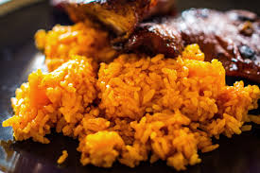
Local Red Rice

Achiote' (Soak in water)
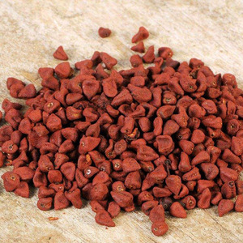

- I suggest you soak the achiote’ for several of hours to really get the color and taste. It taste so much better when it is really soak.

Black Pepper
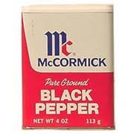

- People mostly do measurements on how much to put black pepper in their rice, although I do not measure. I only stop when I feel like I have known it has been enough.

Salt
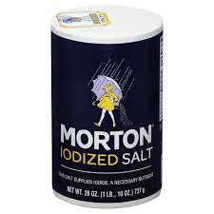

- Same thing with salt. I know when to stop and when to keep pouring. But it taste much better when it is a bit salty.

Salad Oil
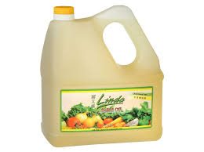

- Salad oil should be measured because you do not want to over oil your rice.

