Raymond C. Villagomez
EN202-02

Presentation for “CNMI’s Ocean Awareness”
For my presentation, I chose to use posters, magazines, and articles instead of a Powerpoint-type presentation.

“Food Fishes of the Mariana Islands”
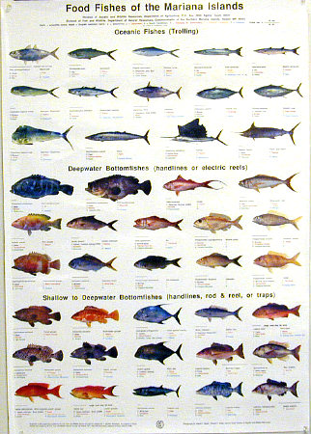
(http://www.fishposters.com/igs/mariana-dw.jpg)
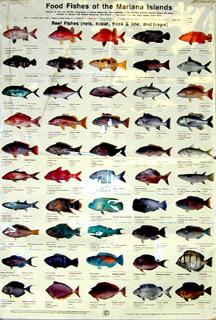
(http://www.fishposters.com/igs/mariana-dw.jpg)

I showed several local/regional magazines, articles, pamphlets, etc… all relating to our oceans.
“Marianas Fishing” Guam & CNMI Publications
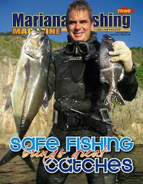
“Beach Road Magazine”
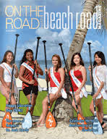
“Journal of Micronesian Fishing”
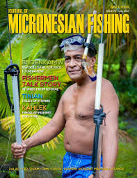

“Erosion Control Best Management Practices” BECQ-CRM

-No picture-
“The Deepest Ocean on Earth: A Scientific Case for the Mariana Trench Marine National Monument” Global Ocean Legacy
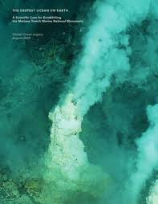
There were many other articles I used to present. I did not include them in my research paper for a number of reasons. My research paper included the more vital information, while I used these extra sources to show the audience the importance and events going on in the CNMI and that they can acquire or should acquire these types of resources. I did not have time to make a power point or other type of presentation for the paper. It was ok, because I felt it was presentable enough itself.

