Process Research Essay
By: Arni L. Salinas
Northern Marianas College
Dr. Kimberly Bunts-Anderson
EN101 – ON01

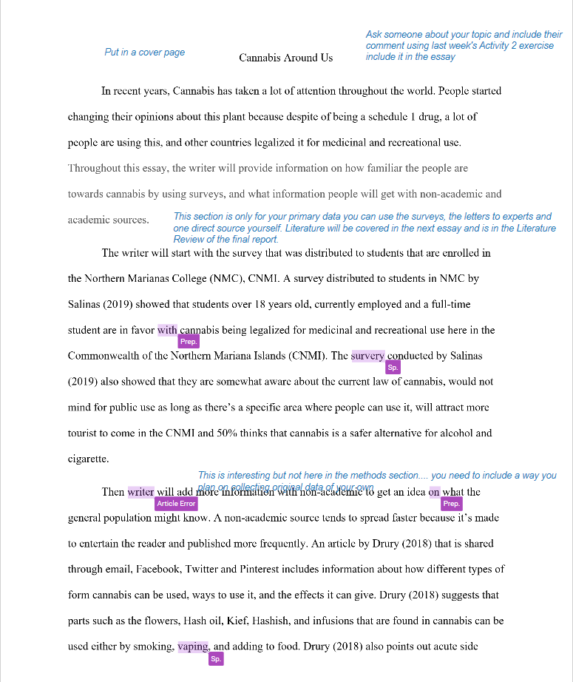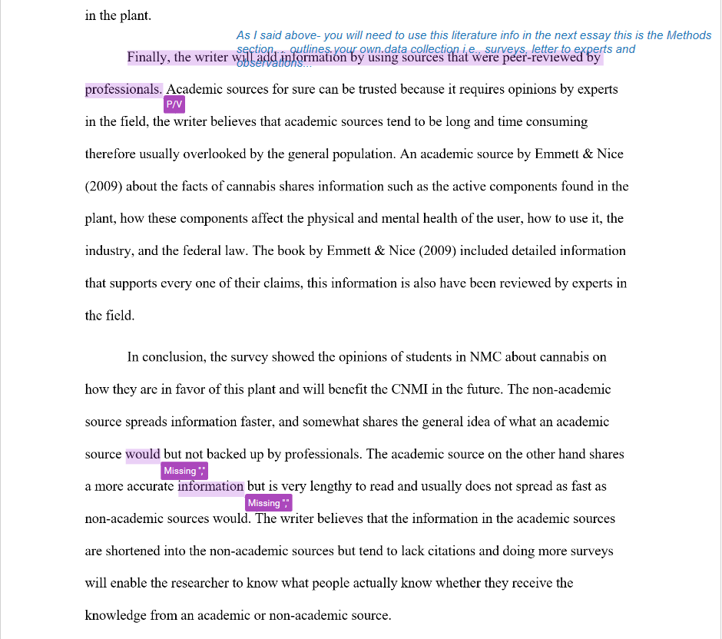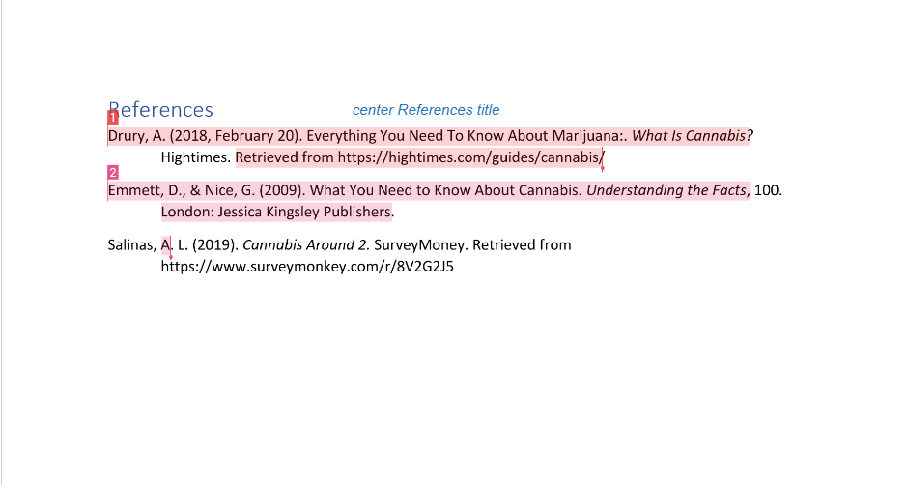

Cannabis Industry
A student researcher studying at the Northern Marianas College Arni L. Salinas is writing a research paper on cannabis that concentrates on the awareness, concerns, and predictions of the people and experts or professionals related in the field. Since the cannabis industry is somewhat new or still in the process, it will be a challenge for the student researcher to gather information locally. In recent years, Cannabis has taken a lot of attention throughout the world. People started changing their opinions about this plant because despite of being a schedule 1 drug, a lot of people are still using this, and other countries even legalized it for medicinal and recreational use. The writer will focus on “how familiar the people are towards cannabis,” “Does the people and experts have any concern towards medicinal and recreational use of cannabis,” and “The prediction they have towards the cannabis industry.”
The student researcher plans to expand or answer the questions by using information from an online survey, writing a letter that requests for the assistance of experts on and off the island for the questionnaires that the student researcher made, and using non-academic sources from the web and academic sources from either EBSCOhost or Google Scholar.
The student researcher created a survey draft on “surveymonkey.com” and given out to his peers in English Composition 2 Online class under Dr. Kimberly Bunts-Anderson in the Northern Marianas College. The survey was submitted in Google Docs that the instructor created, the first draft, Cannabis Around was used as a trial and error for the final version of the survey. After receiving comments and suggestion from the student researcher’s peers, the student researcher then created Cannabis Around 2 that includes a demography and focuses towards the familiarity, opinions, and predictions. Cannabis Around 2 currently have a response from 8 of the student researcher’s peers and hoping to receive more in the future.
Other than the student researcher’s survey, 10 letters to experts were also made and submitted 1 to the instructor to be approved before sending out the others. The student researcher’s letter to experts each includes a questionnaire about cannabis that is related to the expert’s profession to gather accurate information. The student researcher could not find any experts that has a profession in cannabis locally because the industry is still on the process.
Then writer will add more information with non-academic to get an idea on what the general population might know. The student researcher believes that a non-academic source tends to spread faster because it’s made to entertain the reader and published more frequently. The student researcher found an article by Drury (2018) that is shared through email, Facebook, Twitter and Pinterest includes information about how different types of form cannabis can be used, ways to use it, and the effects it can give. The article by Drury (2018) suggests that parts such as the flowers, Hash oil, Kief, Hashish, and infusions that are found in cannabis can be used either by smoking, vaping, and adding to food. In the article by Drury (2018) also points out acute side effects, the anatomy of the plant, different strains, and the active components that can be found in the plant. The student research thinks that a non-academic source gives a general information from an academic source, knowing what’s usually wirtten in non-academic sources will give the student researcher a general idea of what the general population might know about cannabis.
Finally, the writer will add information by using sources that were reviewed by professionals. Academic sources for sure can be trusted because it requires opinions by experts in the field, the writer believes that academic sources tend to be long and time consuming therefore usually overlooked by the general population. An academic source that the student researcher found by Emmett & Nice (2009) about the facts of cannabis shares information such as the active components found in the plant, how these components affect the physical and mental health of the user, how to use it, the industry, and the federal law. The book by Emmett & Nice (2009) included detailed information that supports their claims, the student researcher thinks that information that he gathered from the academic sources will be vital for comparing the response of the people and the letter for experts
In conclusion, the student researcher will gather information through a survey, letter to experts related in the field of cannabis on and off CNMI, non-academic sources from the web, and academic sources from either EBSCOhost or Google Scholar. The student researcher believes that the information being gathered is vital to give out examples and supporting details for his research paper on the Cannabis Industry. The student researcher also believes that the more information he gathers from the survey, letter to experts, non-academic and academic sources will help him point out the opinions, concerns and prediction of the people and experts related in the field of cannabis.

Reference

Drury, A. (2018, February 20). Everything You Need To Know About Marijuana:. What Is Cannabis? Hightimes. Retrieved from https://hightimes.com/guides/cannabis/
Emmett, D., & Nice, G. (2009). What You Need to Know About Cannabis. Understanding the Facts, 100. London: Jessica Kingsley Publishers.
Salinas, A. L. (2019). Cannabis Around 2. SurveyMoney. Retrieved from https://www.surveymonkey.com/r/8V2G2J5

