Typhoon Soudelor
Positive Experiences that Typhoon Soudelor Brought
Anna Canico

Northern Marianas College

Author Note

This paper was prepared for English 101, Online-01, taught by Dr. Kimberly-Bunts Anderson

Table of Contents

Abstract 3
Introduction 4
Literature Review 5
Methodology 6
Analysis 7
Conclusion 8
References: 9
Appendices 10
Appendix A: 10
Appendix B: 11
Appendix C: 12
Appendix D: 13
Appendix E: 14
Appendix F: 15
Appendix G: 16
APPENDIX H: 17

Abstract
On August 2, 2015, one of the strongest typhoons has made history on Saipan. Typhoon Soudelor winds were unexpected leaving the island with fallen trees, flipped cars, damaged homes, telephone poles and power lines laying everywhere causing an island wide blackout (no power or water) for months. The community was left devastated because they weren’t prepared for what Typhoon Soudelor brought. Soudelor changed our lives and has scarred us forever. During this disaster, the community has struggled to bring their lives back to normal. In this time of need, the community appreciated all the positive experiences that have happened and all the help that were given to the victims of Soudelor. This paper reviews the positive experiences of the residents of Saipan after and during Typhoon Soudelor. Data was collected through numerous surveys and interviews with college age students and people of mixed genders. As per survey and interview, people shared their positive experiences that they encountered.

Introduction
Typhoons are nothing new to Saipan, but Typhoon Soudelor took the community by surprise. The typhoon further deepened and reached its peak intensity with winds of 215 km/h (130 mph). Soudelor is one of the strongest typhoons to strike Saipan in nearly 30 years, after Super Typhoon Kim. Hundreds of home damaged or destroyed. Island was left devastated with no power or water and it would take months to restore. The islands main power supply was shut down due to fallen power poles and damaged transformers. Families sought for shelter, while others prayed for the storm to pass and a safe recovery. Acting Governor Ralph DLG Torres declared "a state of disaster and significant emergency". During this time of disaster, everyone has been thinking about the bad things that have been happening; in which people should also view the bright side of every situation. The only way to stay alive is to think positive and be thankful and blessed that they survived a destructive storm.

Literature Review
There is something in human nature that drives us to think "hope" even as we feel despair tugging at us from behind. As Typhoon Soudelor left its mark on our territory 5 months ago, the community continues to struggle to understand its devastating consequences. Typhoon Soudelor didn't just destroy our home, but our hearts and soul. But, even at this difficult time, people have come together to make a terrible situation into a positive experience. In several newspaper articles (See references), the community came out to help another and how that storm was an eye-opener for everyone. We are blessed that there wasn't any casualties and everyone is still together as we prepare for the holidays.

Methodology
This research essay is focused on the positive experiences/things that Typhoon Soudelor brought. Information was collected through a survey, interviews with college age students, and an informal recorded interview with 3 people who are 20 years and under, and 3 people who are 21 years and over of mixed gender.
In October, a 10 question survey was created using surveymonkey.com relating to the research topic. It was tested on students within the same class section and other students from the instructor’s English classes. Instructor advised to tweak the questions for more suitable data. Within a week, a tweaked survey was completed and shared again for responses. Researcher was able to gather 7 responses from people who took the survey.
Next, interviews with college age students were conducted. Prior to this, researcher prepared 3 questions to ask during the interview. Researcher had 5 successful interviews. Students shared their good experiences/things that they encountered.
Lastly, an informal recorded interview targeting mixed genders of people who are 20 years and under and 21 years and over was conducted. Researcher utilizes the same set of questions asked to the college age students. Researcher is targeting to find similarities and differences between age groups and gender. After interviews were conducted, researcher found more similarities than differences despite the age group and gender. People that were interviewed shared the same perspective.
In conclusion, these were several ways the researcher collected data to find out what positive experiences/things Typhoon Soudelor brought. During this time of struggle, being optimistic is great way to keep moving forward towards overcoming the obstacles we have encountered.

Analysis
As data was conducted through surveys and interviews, many people that liked the positive viewpoint on Typhoon Soudelor. There was a majority of people ages 17-21 that took the survey (Appendix A). When asked "What organizations were you able to receive assistance from?” majority receive NAP also known Food stamp, followed by American Red Cross, then FEMA (Appendix B). Imagine all the long lines at these organizations, yet people remained in line to get their share. NAP was the most helpful assistance received because it helped with saving money for other needs like to repair damages and broken appliances (Appendix C).
People gave back to the community in certain ways even if it was just a clean-up around the village. People volunteered in organizations in where they distributed water, food, and supplies (Appendix D). During these times, people met other new people in where it developed into friendships (Appendix E). People also shared how the storm brought the community together. A respondent shared "...after the disaster people were brought to the same level. Everyone understands each other".
Lastly, the storm was a lesson learned for the community. They are now prepared, never underestimating another storm, and gathering all their necessities. Respondents also shared a piece of advice for the higher authorities: "...a more accurate forecast, announce in advance on radio, newspaper, media, and etc." (Appendix F) The community is now attentive to the weather forecasts. (Appendix G)
Interviews with college age students and people of mixed genders were successful. Each individual shared their stories related to work, friends, and family relationships that got stronger, and how they benefited from them. Even through bad times, they had the chance to appreciate the good things in life. (Appendix H)

Conclusion
In conclusion, you have to weigh out the bad with the good. In order to move on with life, you would have to forget about the negativity and focus on positivity. The health benefit of positive thinking leads to better coping skills during hardships and times of stress. During and after, everyone was scared and hopeless, but with positivity, they get through the day with a smile. Anyone within and outside the community was willing to give out to the community, even if they have their own problems at home, they managed to go out of their way to help those who really needed it. Everyone has their own sad story to tell, but when asked to think about the positive things, you automatically see a smile on their face. Personally, I think that's when they know that they are blessed to still be alive and no one in their family got hurt. A positive person believes they can overcome any obstacle and difficulty, and that’s where we are right now. We have overcome all the obstacles with no power or water, and endured this tragedy together as a community and came out stronger and smarter.

References:
- http://www.saipantribune.com/index.php/better-safe-than-sorry/
- http://www.saipantribune.com/index.php/damage-assessment-relief-efforts-begin/
- http://www.saipantribune.com/index.php/saving-saipan-united-4-saipan-steps-up-to-the-plate/

Appendices

Appendix A:

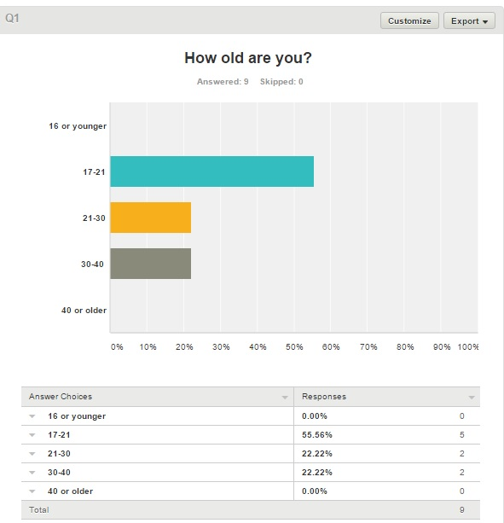

Appendix B:

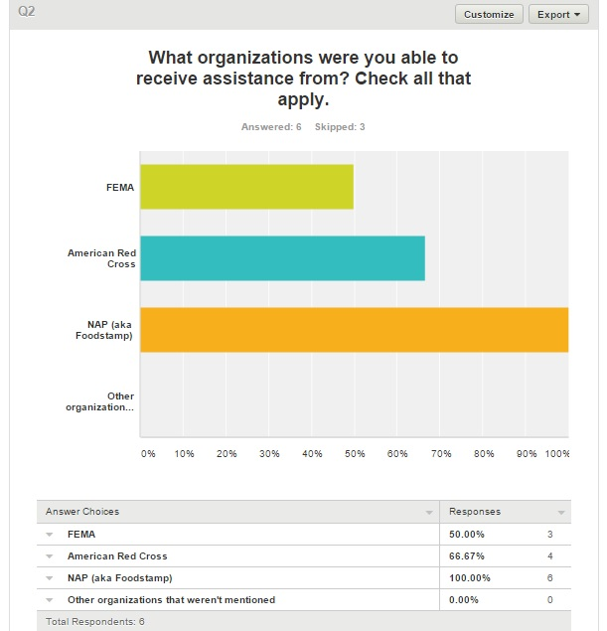

Appendix C:

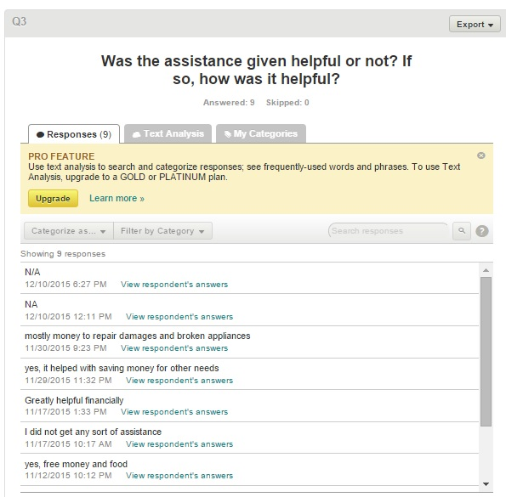

Appendix D:

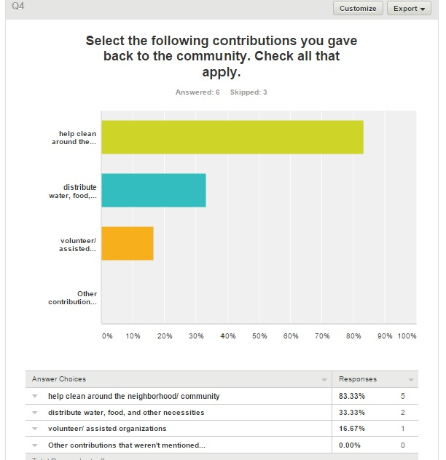

Appendix E:

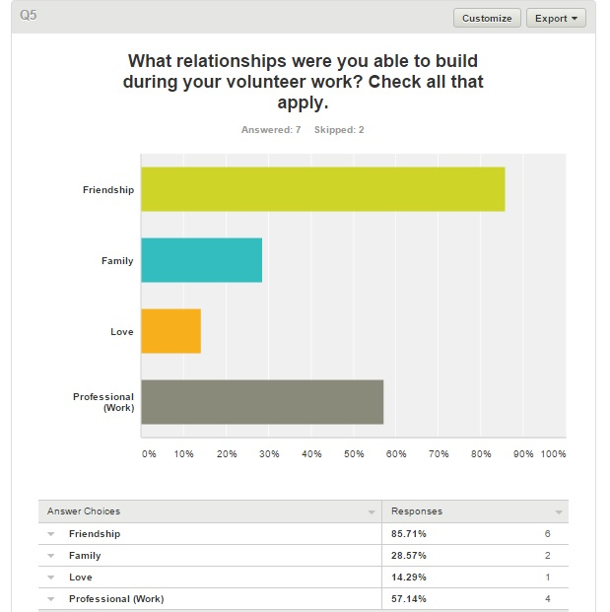

Appendix F:

Appendix G:

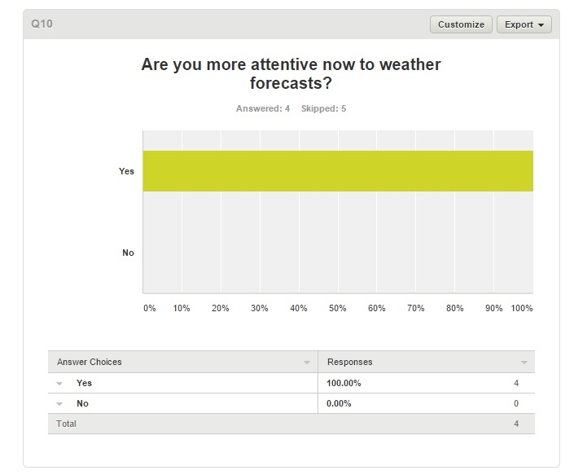

APPENDIX H:
Questions:
- Age?
- What relationships were built during or after the storm?
- Share one positive experience during or after the storm?

Person A:
- 19 years old
- I built a long-lasting relationship with my co-workers because after the storm we spent so much time together doing long hours of work and finding ways to make things easier for everyone. We had to come up with solutions that could make the day go by smoothly and we set aside our differences so we could work together as a team.
- Some positive things that Typhoon Soudelor brought were an open mind for every citizen of the CNMI. It made so many people realize how grateful they should be and it taught so many people, including myself, how to get back on our feet as a community.

Person B:
- 20 years old
- Love relationship with mosquito coils
- We learn the true meaning of CUC (Customers Use Candles)

Person C:
- 18 years old
- My work and friendship with people not just in my circle but within the community became stronger after the storm.
- People in higher positions than me saw potential and quality I didn’t see in myself.

Person D:
- 19 years old
- Professional/Work and Friendship
- I believe the best experience I had during Typhoon Soudelor is when everyone got together and clean up all the mess that the typhoon had caused.

Person E:
- 23 years old
- I didn’t realize I could get closer to my dad’s relatives. After the storm, during days without power, we would always go to my aunt’s house and eat dinner together. But before the storm, we seldom see them.
- The positive thing that Soudelor taught me was to be patient. I’m a person who gets an assignment or task and would work on it ASAP, but after the storm, it taught me how to breathe and take it one step at a time rather than work on it and stress.

(SEE STUDENT PAGE ON WEEBLY FOR VIDEO INTERVIEWS WITH PEOPLE OF MIXED GENDER)

