Should the CNMI Legislature Amend Article 12: Section 4?
Chelsea Borja
Northern Marianas College

Author’s Note
This paper was prepared for English Composition II, taught by Kimberly Bunts-Anderson.
Table of Contents
Abstract…………………………………………………………………………………………....3
Introduction………………………………………………………………………………………..4
Background………………………………………………………………………………………..4
Literature Review………………………………………………………………………………….4
Primary and Secondary Questions………………………………………………………………...6
Methodology………………………………………………………………………………………6
Analysis and Findings……………………………………………………………………………..6
Discussion…………………………………………………………………………………………7
Conclusion………………………………………………………………………………………...9
Reference List……………………………………………………………………………………10
Appendix…………………………………………………………………………………………11

Abstract
Article 12, Section 4 of the CNMI Constitution states that a person of Northern Marianas descent is a person who is of at least one-quarter Northern Marianas Chamorro or Northern Marianas Carolinian blood. This research report describes a project on an amendment of Article 12 entitling land not only to the indigenous people of the CNMI but also to those with some degree of ancestry. Should the CNMI Legislature amend Article 12: Section 4 so that any persons with some degree of Chamorro blood or Carolinian blood would be considered a Northern Marianas descent? Surveys were distributed to a wide range of individuals including land owners, non-land owners, lease owners, and a diversity of age groups to collect multiple perspectives. The initial findings suggest that majority of the results are against Article 12, the most informed on Article 12 was the age group twenty-thirty, and the remaining participants remained neutral to the subject.

INTRODUCTION
Only individuals that are at least twenty-five percent CNMI descents are eligible to own land within the Marianas Islands. Tourists, who come for a visit or vacation, will return in hopes of never leaving again. The gorgeous scenery, sandy beaches, tropical climate, and laid back way of life is what makes the Northern Marianas Islands an attractive place and to no surprise would it be if some would consider permanently settling in the island of paradise. Many people are unaware of this law stated in the Commonwealth Constitution, which makes moving permanently to the Marianas, difficult. The essay proposes that the amendment of Article 12: Section 4 of the Commonwealth Constitution could be interesting and could affect individuals with at least some degree of CNMI descent or no ancestry at all.
BACKGROUND INFORMATION
The criterion of eligibility of land ownership was ratified on March 6, 1977, and became effective January 9, 1978. As stated in the Commonwealth Constitution, a person of Northern Marianas descent is a United States citizen who is at least one-fourth Northern Marianas Chamorro or Northern Marianas Carolinian blood or both. Another exception to a Northern Marianas descent would be a child adopted before the age of eighteen by a person of Northern Marianas descent. To determine a Northern Marianas descent, a person shall be considered full Northern Marianas Chamorro or Northern Marianas Carolinian blooded if that person was born by 1950, in the Marianas, and was a citizen of the Trust Territory of the Pacific Islands.
LITERATURE REVIEW
On July 10, the student writer did a broad search on the Google search engine and found about 19,000 hits on the keywords "Article 12”, “CNMI Constitution”, “land alienation". To narrow the field to more specific information, the student writer found two online newspaper articles published within the month of June in 2014. One article is connected to the initiative of Article 12 and the other one article gives facts on Article 12. Jesus Taisague stated in his article The facts about Article 12 that the amendment of Article 12 will protect Northern Marianas descents from economic exploitation and eliminates the risk of stereotypes between Northern Marianas descents and non-Northern Marianas descents. Similarly in the article Judge: Non-NMD voters can vote on Article 12 initiative, Ferdie De la Torre implied that Northern Marianas descent is not a racial classification, but a political one.
Additional search of Article 12 was made by going to the Archives located in the NMC building. In there, the student writer came upon a book that gave information on measuring blood percentages of CNMI descents. In the book, McPhetres (1997) gave examples of situations that qualifies as Northern Marianas descent and what does not. For instance, Juan Sablan was born in Guam in 1945. Although he is a U.S citizen born into a Chamorro family, he is not qualified to own land in the CNMI because he did not become a Trust Territory citizen. It is essential to understand that being a member of the Chamorro or Carolinian ethnic group is not exactly a qualifying status (pg 151).
Further studies were found on EBSCO database as to why the debate of land alienation in the CNMI has been such a heated topic. One study explains the cultural conflicts in Hawaii due to land ownership and the other study emphasizes the motivation of security and heritage for future generations in Australia.
- Should the CNMI Legislature amend Article 12: Section 4 so that any persons with some degree of Chamorro blood or Carolinian blood would be considered a Northern Marianas descent?
  - What are people’s perspectives about Article 12: Section 4?
  - Who will be affected most by the amendment of Article 12?
METHODOLOGY
Having already established the basis and background of Article 12, Section 4, it is essential to reflect upon how evidence will be collected to support the research project. There were different approaches to go about this research such as surveys, interviews, observations, experiments, action research, and field study, but the student researcher chose to distribute questionnaires to land owners, non-land owners, lease owners, and through different age groups. Questionnaires seemed like the best way to collect data because Article 12 is a very private topic. Many of the individuals who willingly participated in the research project either had no opinion or biased opinions. Questions were based on whether the amending of Article 12, Section 4 will affect the economy and culture in the CNMI (See Appendix A). Questionnaires reported by land owners, non-land owners, and lease owners were chosen specifically to differentiate perspectives of property owners as opposed to those who cannot own land. The disparity of age groups were chosen for the reason that Article 12, Section 4 affects many individuals and not just property owners.
ANALYSIS AND FINDINGS
In a summer semester course, the investigator explores three land owners, three non-land owners, three lease owners, one government official, and individuals between the ages twenty to thirty, thirty to fifty, and over fifty in regards to the amendment of Article 12, Section 4. Perspectives on the subject were made with the analysis of the data classified by these specific categories. The initial results were as expected. Land owners were very well informed on the subject of Article 12 and although the answers revealed that land owners remained neutral on the subject: the amendment of Article 12 is to be expected. On the contrary, non-land owners were not much informed about Article 12, but are against it and suppose that Article 12 should be amended. Lease owners in Saipan are somewhat informed on the subject and anticipates the amendment of Article 12. Between the ages twenty and thirty, individuals were well informed on the subject, were against Article 12, and look forward to the amendment of such law. Between the ages thirty to fifty, individuals were fairly informed on the matters of Article 12, but deemed that Article should be amended and lands be open to all. For ages fifty and over, individuals were very informed on such matter, were in favor for Article 12, and believe that it should not be amended.
DISCUSSION
As already mentioned, the initial results were as to be expected. The results confirmed that more than half of the individuals who answered the questionnaire were for the amendment of Article 12 and the remaining were against Article 12. On a survey comment of a land owner, the individual noted that they are 'very well informed' on matters of Article 12 (See Appendix B). Lease owners, however, are not familiar with the subject which leads to the reason of not being particular to Article 12 (See Appendix C). Note that the younger age groups were entirely for the amendment, but the older individuals were against the amendment. It is clear that the amendment of Article 12 does not affect the older age groups, those with possibly higher Northern Marianas Chamorro or Northern Marianas Carolinian blood, which is mainly the reason for opposing the amendment. However, the younger age groups, land owners, and non-land owners, probably consists of non-Northern Marianas descents or individuals with low blood percentages, and therefore desire the changes to the law.
One discovery that I found interesting is that the older age groups, specifically the ages fifty and over, feel that Article 12, Section 4 should only be amended for the purpose of conflicting Northern Marianas descent and adoption (See Appendix D). In the book Self-Government and Citizenship in the Commonwealth of the Northern Mariana Islands U.S.A, McPhetres stated in the case that a foreigner under the age of 18, who is adopted by persons of Northern Marianas descent is to be considered of Northern Marianas descent, contradicts the law itself. The foreign minor does not twenty-five-percent Chamorro or Carolinian blood; therefore, should not be eligible to own land in the Mariana Islands (pg 164).
Another point that the investigator found interesting by the younger age group was a statement made about the influence on economic growth. Business is risky because it can help provide jobs for local residents, but can backfire with contracted workers. Stated in the answers of a survey done by a twenty-year old, "if certain people cannot own land, then they cannot invest in the property to start a business. If certain people can own land, then the rich will purchase majority of it and monopolize the economic industry (See Appendix E). Additionally, the investigator found that the CNMI's culture and traditions is steadily fading and consequently you will notice there are scarcely any full blooded Northern Marianas Chamorro or Northern Marianas Carolinian. An individual answered on a survey explained that the amendment of Article 12 will have a negative impact on culture. The CNMI is already a dying culture on its own. There are no pure NMD’s that exist anymore (See Appendix F). According to a study by Patrick D. Shelley, Hawaii, A Case to Study, the Hawaiians came from a cultural background in which there was no ownership of land until foreigners arrived with the persuasion of moving towards a democracy state for personal gain and fortune. Property ownership has become internationalized to a great extent depriving the Hawaiian people of their heritage and thus Hawaiians became second-class citizens in their own nation (pg 9-10).
CONCLUSION
As a result, this research project will be very successful because of thorough planning and analytical process. As to whether Article 12, Section 4 will be amended, that will remain unknown. Initial findings suggest that the issue will remain in debate for some time. The research project helped with informing my question but did not necessarily give an exact answer to the question. This information will be published on a website open to those who would like to continue on the same path. A research project within a month time frame is just not enough time to gather enough quality information. Overall, gathered in this process, the investigator concludes that according to nineteen individuals who participated in the study, the opinions to make changes on Article 12 outweighs the opinions that are in favor for the law. However, land is extremely limited in the Northern Mariana Islands, culture and history is embedded in the land and must not be all about economic interests.

References
De la Torre, F. (2014, May 21). Judge: Non-NMD voters can vote on Article 12 initiative. Saipan Tribune. Retrieved from http://www.saipantribune.com/index.php/judge-non-nmd-voters-can-vote-article-12-initiative/
McPhetres, S.F (1997). Self-Government and Citizenship in the Commonwealth of the Northern Mariana Islands U.S.A. Queensland, Australia: The Imprint Group.
Moran, M. (2008). DREAMING THE GREAT AUSTRALIAN DREAM. Architecture Australia, 97(5), 77-78.
Shelley, P. D. (2002). Hawaii, A Case to Study. International Congregational Journal, 2(2), 213.
Taisague, F. (2014, June 13). The Facts about Article 12. Saipan Tribune. Retrieved from http://www. saipantribune.com /index.php/facts-article-12/

Appendices
Chelsea Borja
Northern Marianas College

Author’s Note
This paper was prepared for English Composition II, taught by Kimberly Bunts-Anderson.
Appendix A: Empty survey
- Are you a U.S citizen?................................................................................... Yes or No
- Were you born in the CNMI?.................................................................. Yes or No
- Are you employed in the CNMI?............................................................ Yes or No
- Do you have a permanent residence in the CNMI?................................. Yes or No
- Are you at least 25% CNMI descent?...................................................... Yes or No
- Are you eligible to own land in the CNMI?.............................................Yes or No
- Would you say the CNMI is an attractive place to make a living?..........Yes or No
- How long have you been residing in the CNMI?
1-5 years, 5-10 years, 10-20 years, 20+ years

- How well informed are you about Article 12: Section 4?
(See attached page for brief information on Article 12: Section 4)
- Are you for, against, or neutral towards Article 12 in the Commonwealth Constitution?
- Do you think Article 12: Section 4 should be amended? Why or why not? Please explain.
- Do you think Article 12: Section 4 affects the economy in the CNMI? How? Provide an example.
- How can one quantify the eligibility of an individual to be qualified as a CNMI descent?
- Do you think that the amendment of Article 12: Section 4 will have a positive or negative impact on the culture in the CNMI? Please explain.
- As you know there are many orphaned properties on the island of Saipan. Do you think that the amendment of Article 12: Section 4 will prevent the orphanage of such properties? Please explain.
- For those that are not of CNMI descent, should property tax be imposed on them? Why? Please explain.
- Do registered voters who are non-CNMI descent entitled to vote on the determination of land ownership? Please explain.

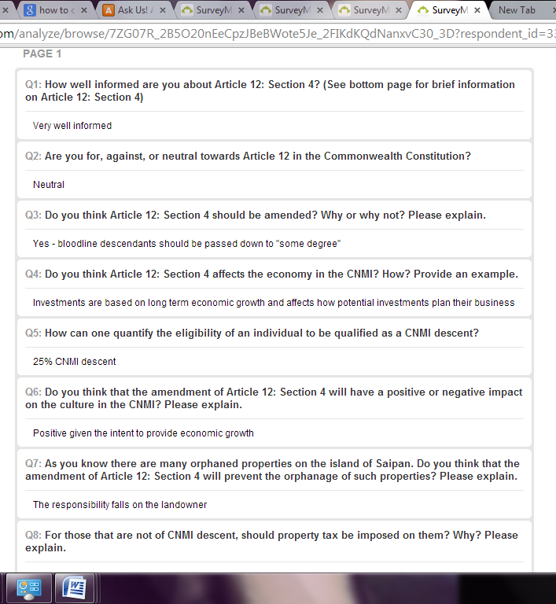
Appendix B:

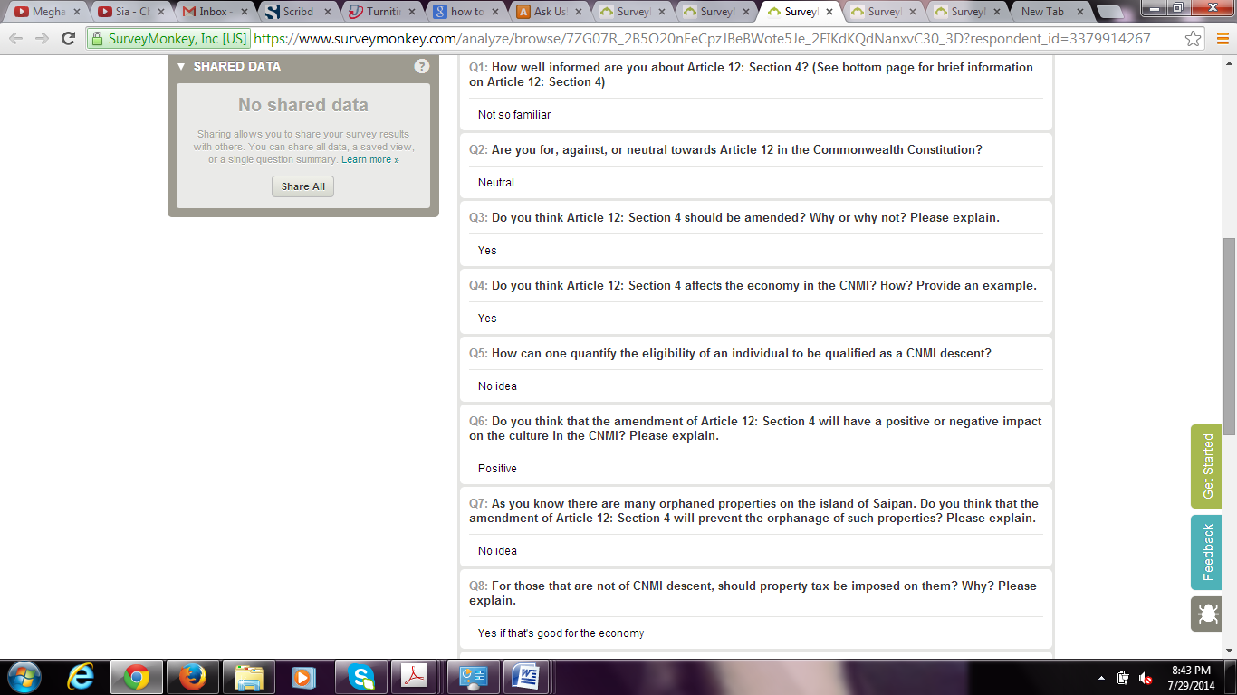
Appendix C:

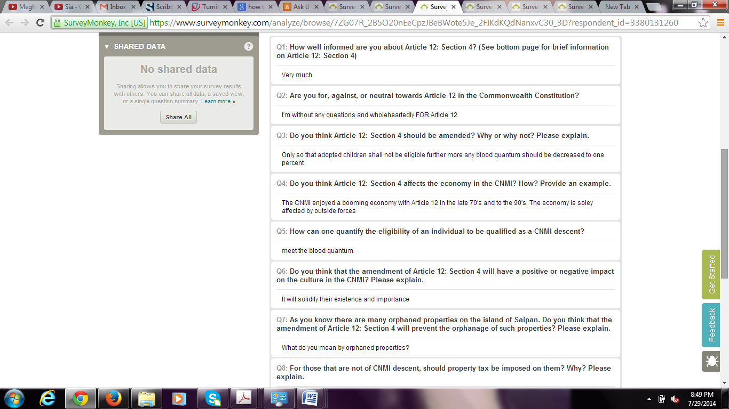
Appendix D:

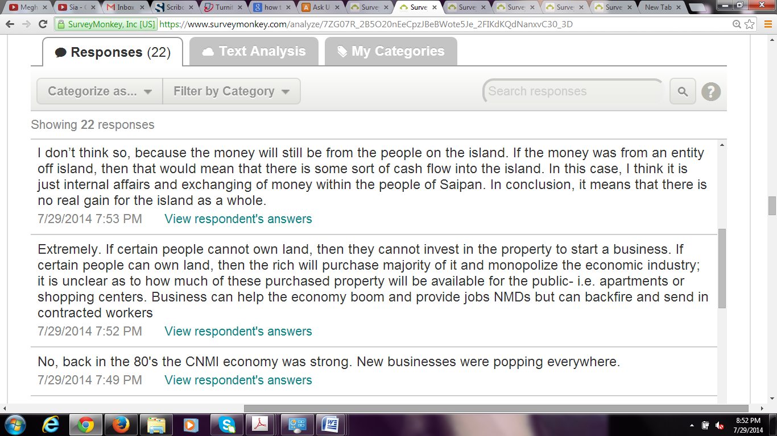

Appendix E:

Appendix F: 