Wilhelmina Cing
College Students and Cell Phones
Research Paper
Northern Marianas College
EN202-02
Dr. Kimberly Bunts-Anderson

Abstract
The NMC student researcher describes an eight-ten weeks worth of researching and highlighting the number of hours an NMC student can spend on their cell phone throughout the day. The student researcher wanted to inform her readers of the number of hours a college student at her community college campus can spend on their cell phones throughout the day while highlighting the reasons for their excessive usage. Actual surveys and results were recorded. Survey results of about twenty college students indicated that the average number of hours an NMC student spends on their cell phone was at least eight to ten hours per day. The main reason for the excessive usage of cell phones were because of mobile applications. A review of other college students in the mainland indicated that the average amount of hours a student spent on their cell phone, was about ten hours, as well. The study is important because it quantitatively illustrates the number of hours a college student spends on their cell phone throughout the day.

Introduction
In today’s world, technology seems to be taking over and the most commonly used device is probably the cell phone. From toddlers, to children, to teenagers, to adults; even us, college students depend on our cell phones for about everything. Whether the cell phone is being used for phone calls, text messages, mobile applications, or even used for some circumstances for work and education, we always have them in handy. However, a cellular device can either be beneficial to us, or it could be a distraction for us, as college students. The student researcher is a college student herself, and she can spend hours and she means, hours on her phone, even though she has more important things to take care of, and she is pretty sure she is not the only one.
Background
With that being said, the student researcher has conducted a research project and she has compared the usage of cell phones between NMC students and other college students abroad and how it affects their daily lives. Effects of their daily lives include educational and health responsibilities. Studying habits and homework may fall under a college student’s educational responsibilities. Being physically and mentally healthy may fall under a college student’s health responsibilities.
Even though college students may not treat this situation as a big deal, it actually is and it is important for us to know that being on our cell phones for a certain amount of hours during a day is not healthy and is not really beneficial to us, as students. For example, being on our devices could keep us from going outside and being active, it could distract us from studying or doing our homework, and many other reasons as I will find out more with my literature sources I have found.
This topic is an interesting one as well because about everyone on campus has a cell phone and it would be exciting to know how many hours a day a certain NMC student spends on their device and what they do on it, whether it be texting or any mobile device applications. And it would also be interesting to know how it affects them or not, as college students.
To collect her data, the student researcher has read different literature reviews that she has found; some of them include studies that have already been done and some may include articles. From this, the student researcher has gotten information and data on the college students from abroad. To collect data from NMC students, she has conducted her own survey and asked them such questions as: “How many hours a day do you spend on your cell phone?”, “Do you use it mostly for social media or for texting?”, “Does using your cell phone distract you from doing homework?” and more questions related to that.
The researcher believed that this research project has taken about 8-10 weeks. For the first three weeks, she has been collecting as much information as she could through the literature reviews that she has have found and had put them all together. For the next two weeks, the student researcher has conducted her survey and collected all the results she has received and put them all together, as well. And to prepare her research paper, which included writing drafts and getting peer reviews, and finalizing it, she has probably taken two, then if not, three weeks for that.
Literature Review
To many adolescents, specifically college students, the excessive use of cell phones does not seem to be a major issue in their busy lives. It is often a part of their everyday schedule as young adults and as students, too; they do not even notice that being on their cell phones for hours a day can actually be a distraction. However, to every con there is a pro and it all depends on what those reasons are. The student researcher has searched through her school library’s database and has found a number of academic literatures on the specific topic. Most of the literature that were found are academic journals based on studies that have been conducted by other individuals. Out of all the literature that are found, the one that answers the research question most relevantly is entitled, “Cellular Telephone Use: A Survey of College Business Students.”
Researchers suggest that the most common technology addiction is from the use of cellular phones. This problem has emerged drastically as the years have gone by, especially with adolescents and it is impacting them in negative ways, says Anujah and Savita Desphande. Excessive use of cell phones could impact a young individual’s behavior, causing them to check their cell phones again and again in an uncontrollable way, (Desphande, 2017). Research also suggests that since cell phones have been introduced, they have become well known on college campuses and have been marked as distractions to students, (Elder, n.d.). In the classroom most especially is where cell phone usage seems to be the most distracting and college instructors are beginning to wonder whether distractions like this could harm a student’s academic standing, (Elder, n.d.).
There may be negative impacts caused by the excessive usage of cell phones, but there could also be positive factors, as well. Some researchers suggest that using cellular devices in the classroom, could actually help a student out. With the device in hand, a student could easily access any needed information, interact with other students, and interact with the instructor as well, (Barkley, Karpinski, Lepp, 2015). Some researchers also suggest that since the cell phone has so many amazing capabilities, it might soon be in the replacement of textbooks in the classroom, (Prensky, 2006). However, there aren’t any literature that I have found that is based on the Pacific or the CNMI alone, and I believe it is that way because students here don’t really see the excessive usage of cell phones as a problem, because they see it as a part of their daily lives already.
This literature review explains the types of literature that are found by the student researcher and what they are about. According to the literature reviews, there are a numerous amount of negative and positive impacts from the usage of cell phones among college students. The studies were mainly about how the excessive usage of cell phones could affect a college student behavior wise, educational, wise, and results could even depend on whether the student is a male or a female. The student researcher’s study fits in with what she has read because the literature reviews talk about the negative and positive effects of the excessive usage of cellphones among college students.
Methodology
Writing a research paper does not require any skill, however, it requires a lot of hands on work, dedication, time, and research methods. With so many steps to follow, the student researcher is going to tell you about all the methodologies of triangulation she used to help her with her case study and answer her research question, “How many hours a day does a college student spend on their cell phone?”
The first method the student researcher used was creating, finalizing, and giving out surveys to NMC students. She decided to ask NMC students only because she was going to compare their results to other college students in the U.S. The student researcher first thought of some questions that could be related to her topic. The types of questions that she came up with included: the participant’s gender, how many hours do they spend on their cell phones, what applications do they mostly use it for, etc. She asked these kinds of questions on her sample survey because she thought it would be easier to compare, with the results on the literature reviews that she has found and collected.
The student researcher’s pilot survey was then looked at by her peers. She then revised her survey and created the final one, on a website called surveymonkey.com. She used this website to create her survey poll because it seemed to be the easiest way for her to create the survey, send the links to her participants, and have the data calculated at the end. Her final survey ended up having nine questions total. Out of fifty participants, only twenty have responded. Not satisfied with the amount of responses and the data quality she got back, the student researcher personally asked more students to participate in her survey. She believes that with the type of questions she asked, this type of research is a quantitative research.
The next method the student researcher did was writing letters to experts with good credibility. The student researcher took the authors from the literature reviews that she found, and picked them as the experts she would write to. She picked five experts in psychology, communications, humanities, and public relations, and they were all located in the United States. The student researcher asked them questions that were related to her topic, and that were based on their expertise. Some questions included: “How might the excessive usage of cell phones affect a college student’s education?”, “Do they think that it is a psychological matter or just a personal habit?”, and “Do they think that cell phone use in the classroom is helpful to a college student or could it be a distraction to them?” etc., (See Appendix C).
The last method the student researcher used was reading a bunch of literature and writing her own literature review. The student researcher went on her online campus library and searched through the databases and found the most interesting ones to her. All of the literature reviews were about studies that were conducted on college students and their cell phones, which was just what the student researcher was looking for. She read them all and took notes using note cards which was required for her homework but turned out actually being a big help to her. She then wrote her literature review.
A research project is not an easy one; in fact, it takes a lot of time, dedication, hands on work, and most especially a lot of methods. These are the methodologies that were used by the student researcher to answer her research question, “How many hours a day does a college student spend on their cell phone?”
Analysis and Findings
The student researcher conducted her own survey poll and asked about fifty NMC students to participate, however only about twenty have responded. The types of questions that the student researcher asked were based upon the participant. For example the first question asked whether the participant was a male or a female and whether they were a full time or part time college student, (See Appendix A). According to the survey results, 78.95% of all the participants happened to be females and 87.50% of the participants happened to be full time college students, (See Appendix B). Another question that the student researcher felt most important to ask was the number of hours a college student could spend on their cell phone. According to the results, the time range that an average college student spent was about 5-10 hours at the most, per day, (See Appendix B).
The findings of the first literature that the student researcher had found had conducted a survey on one hundred students whether or not their behavior would be impacted by the cell phone usage. According to the results of that study, males had a higher dependency rate on their cell phones than females. Anuja and Savita Deshpande had conducted this survey in 2016 and from their results, males used their cell phones more for shopping while the females used their cell phones more for educational purposes, (Deshpande, 2017). Unlike the survey that was conducted by the student researcher, about most of the NMC students who participated in the survey used their cell phones mostly for social media and majority of the users were female, (See Appendix B).
Another set of findings that the student researcher had found had conducted an observation for about eighty-eight college students, although only thirty-four participated. Those thirty-four students who participated were to take a quiz, and half of the students were allowed to use their cell phones during that time, while the other half were not allowed to use their devices. The purpose of the experiment was to see if those cell phone users were going to fail their quizzes. However, the experiment failed itself because everyone had passed the quiz, but it did record that those using their cell phones got lower grades than those who did not. That was just a part of Anastasia D. Elder’s project, though. She also created a questionnaire for what purpose do these students use their cell phones the most for.
Another set of findings fit very well with the student researcher’s own survey; James A. Roberts, Luc Honore Petnji Yaya, and Chris Manolis had conducted an online survey to see which cell phone activity is mostly used between male and female college students. The survey results revealed that the most well known cell phone activities were: web surfing, mobile games, and mobile applications. The authors also state, “A second objective of this study was to discern whether the relationship between cell-phone activities and cell- phone addiction differed across sexes. Before examining if there was any relationship between the constructs, it was necessary to examine if the proposed scale to assess cell-phone addiction was valid and invariant across the over- all sample and the two subgroups,” (2014).

Discussion
With that being said, from the student researcher’s online survey and some literature reviews, an average NMC student will spend about ten hours on their cell phone device throughout their day and their purpose for it will be for mobile applications such as Instagram, Snapchat, Twitter, Pinterest, etc. and texting as well, (See Appendix B). Majority of the students who participated in the researcher’s online survey (65.00%) also feel that their cell phone is a form of distraction to them when they are doing their school assignments, (See Appendix B). Cell phone usage also distracts these college students from being physically active on a daily basis, for some it is not a distraction. For the most part, an NMC student’s reasons of the excessive usage of cell phones is mainly for personal reasons.
Due to the unsatisfactory number of participants on her online survey, the student researcher feels as if she could have done better on this experiment. She thinks that if more of her peers at her college campus participated, the results would have been easier to compare to other college students that have been discussed about in the literature reviews. She also feels as if this topic should be paid attention to more in her community because it really is a problem that young people like herself are facing today. The student researcher also believes that someone with expertise should focus on this topic more especially here in the Marianas, and probably conduct a study (that is not part of an EN202 assignment) in the near future.
Conclusion
The present study finds that the number of hours a student at Northern Marianas College can spend on their cell phone is approximately ten hours a day. The reason for that is because of texting and cell phone applications. These results from the students at NMC are similar to those of other colleges outside the Northern Mariana Islands. The student researcher has conducted her own questionnaire to compare her results with the results of other studies. All findings and data seemed similar to each other’s.

Reference List
Aoki, K., & Downes, E. J. (2003, February 26). An analysis of young people's use and attitudes toward cell phones. p. 16.
Desphande, A., & Desphande, S. (2017). A study of cell phone dependency among college students. p. 6.
Elder, A. D. (n.d. , n.d. n.d.). College Students' Cell Phone Use, Beliefs, and Effects on their Learning. p. 9.
Hanson, T. L., Drumheller, K., Mallard, J., McKee, C., & Schlegel , P. (n.d., n.d. n.d.). Cell Phones, Text Messaging, and Facebook: Competing Time Demands of Today's College Students. p. 10.
Roberts, J. A., Petnji, L. H., & Manolis, C. (2014, June 7 ). The invisibile addiction: Cell phone activities and addiction among male and female college students. p. 12.

Appendices
Wilhelmina Cing
College Students and their Cell Phones
Research Paper
Northern Marianas College
EN202-02
Dr. Kimberly Bunts-Anderson

Appendix A
Survey Questions:
1. Male or female
2. Are you a part time or full-time college student?
3. How many hours a day do you spend on your cell phone?
4. What do you use your cell phone the most for?
5. What mobile application do you spend the most time on?
6. Does being on your cell phone throughout the day distract you from your education?
7. Does it interfere with your studying and/or homework time?
8. Does being on your cell phone keep you from going outside and being active?
9. In a typical weekday, do you use your mobile or cell phone most often for work, for personal reasons, or about an equal amount on both?

Appendix B
Survey Results:
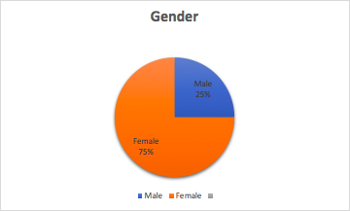
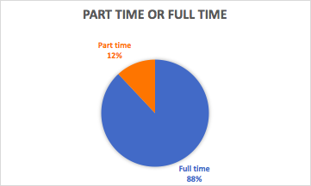
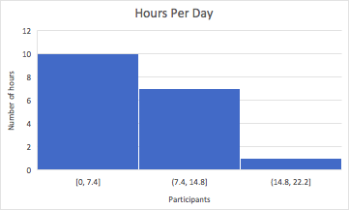
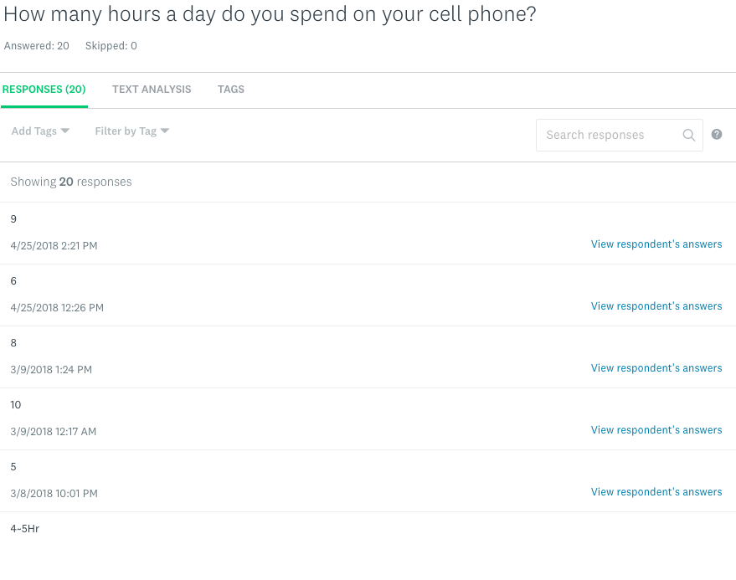
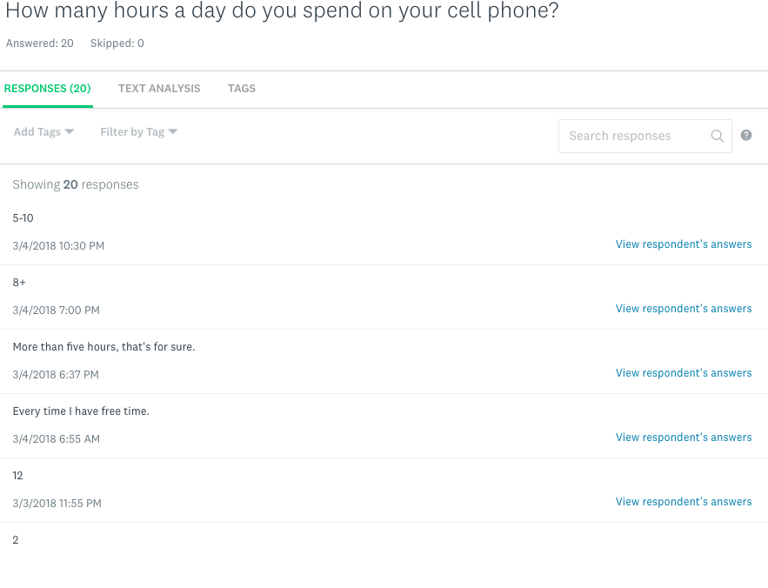
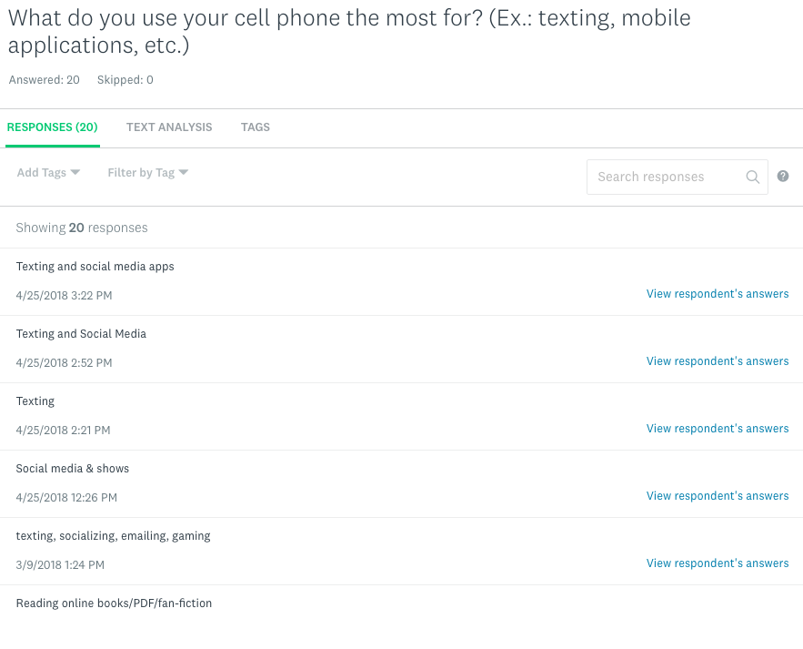
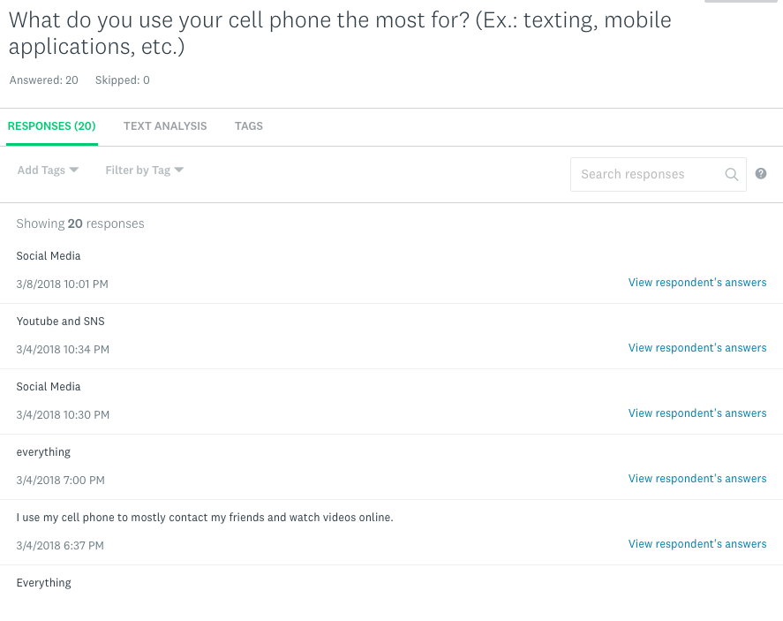
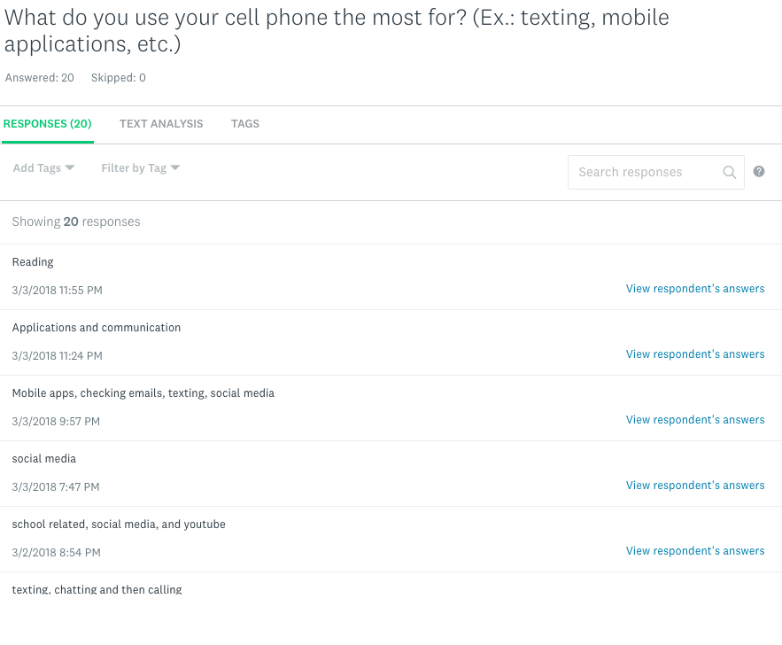
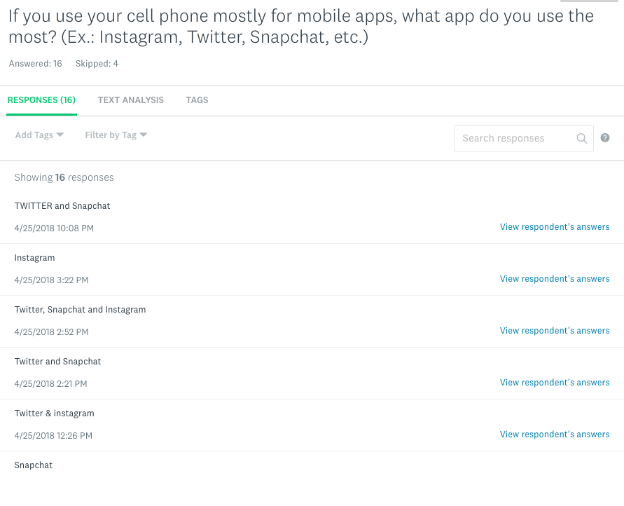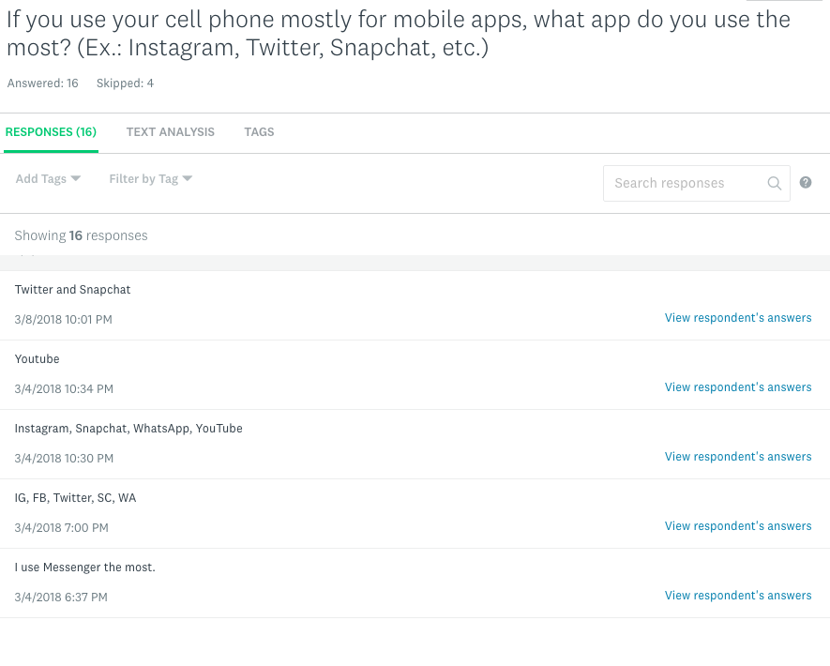
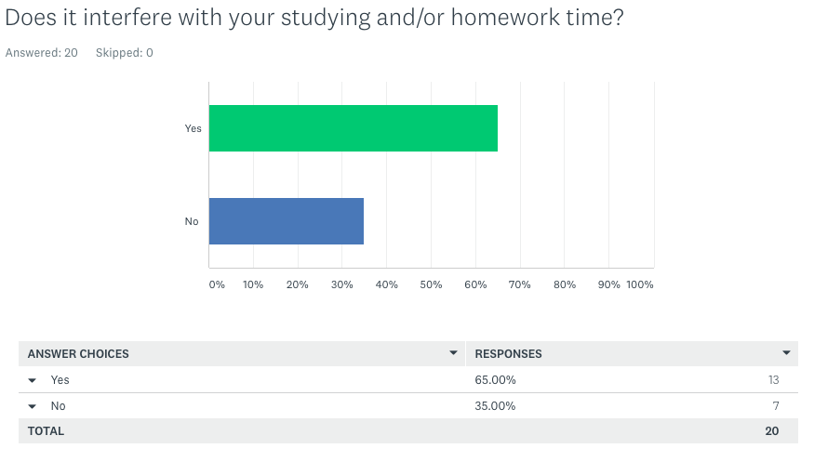
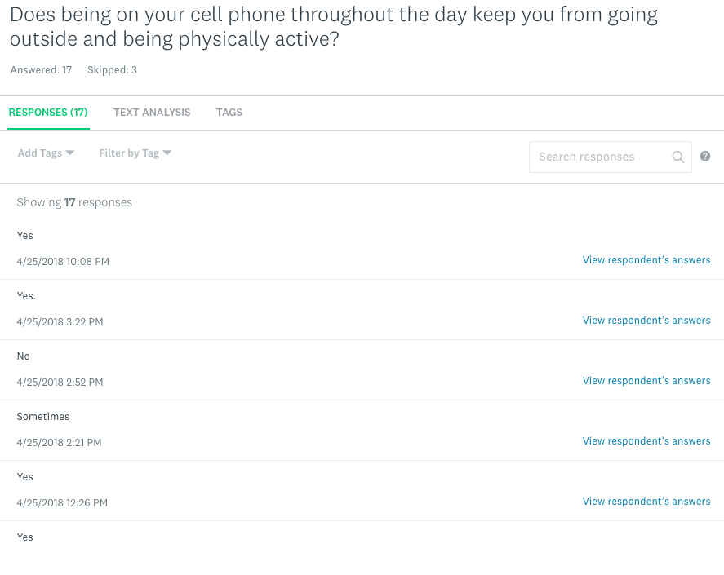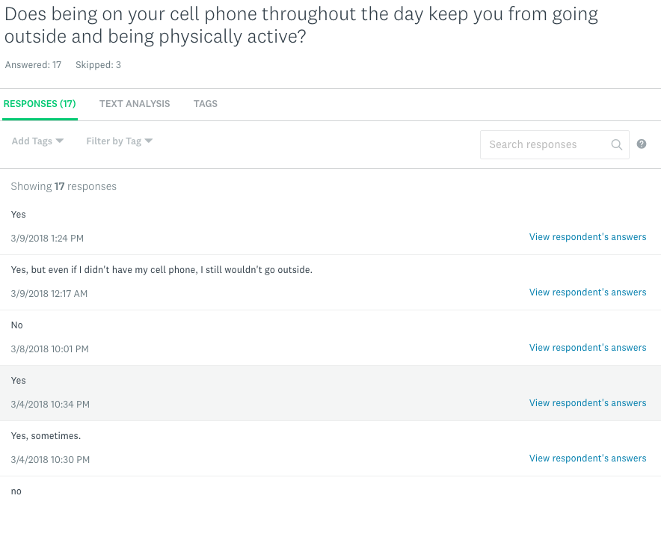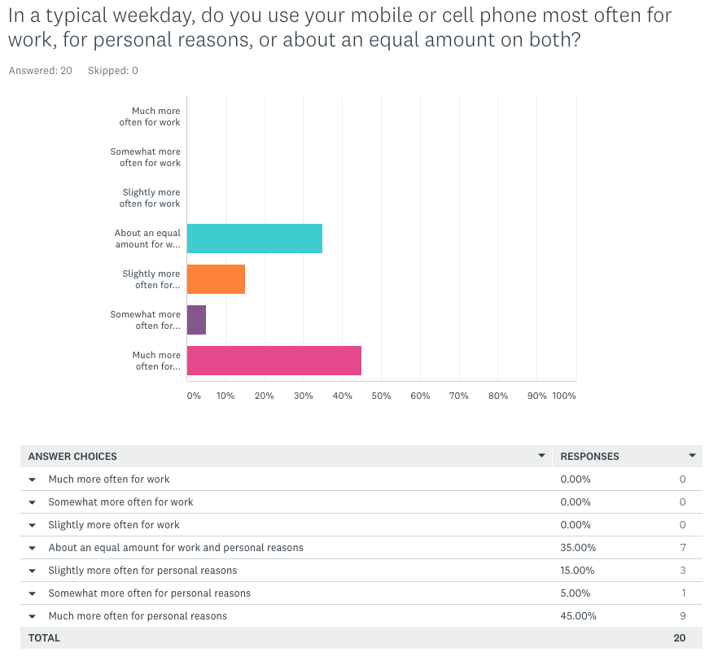

Letters to Experts:
Wilhelmina Cing
Student, Northern Marianas College
wilhelmina.cing@my.marianas.edu

Kristina Drumheller, Ph.D
Associate Professor
Interim Department Head, History

Dear Dr. Drumheller,

As a second-year college student, I am taking an English Composition II class and one of our main projects is a research paper.

I am writing this letter to you, in hopes of seeking more knowledgeable information based on your expertise. I believe that with your responses, I will be able to strengthen the quality of my research paper. Listed below are a few questions:

· How do you think the excessive usage of cell phones throughout a day, might impact a college student’s education?
· How do you think the excessive usage of cell phones throughout a day, might impact a college student’s communication skills?
· Do you think it is a psychological matter or a personal habit, as to why they are so needy of their cell phones?
· Do you think the attachment with their cell phones could last even after their college years?
· Do you think that cell phone use in the classroom is helpful to a college student or could it be a distraction to them?

I would be glad to get a response back.
Thank you for your consideration and valuable time!

