WHICH IS HEALTHIER BETWEEN FROZEN AND CANNED FOOD?
Lea Mendiola
Northern Marianas College

Author’s Note:
This paper was prepared for English 202, Section 01, instructed by Dr. Kimberly Bunts Anderson

Table of Contents

Abstract…………………………………………………………………….3
Introduction………………………………………………………………..4
Background ………………………………………………………….……4-5
Literature Review…………………………………………………………5
Methodology……………………………………………………………….5-6
Analysis……………………………………………………………………6-7
Pilot Survey
Findings……………………………………………………………………7-8
Conclusion…………………………………………………………………8
Reference List……………………………………………………………..9
Appendix…………………………………………………………………..10-13

Abstract
The student researcher informs to the readers the findings and results on the topic of “Health benefits of frozen and canned foods.” Results of surveys and interviews via email provided enough data and opinions about the topic. The people who took the survey appears to base their shopping mostly by price then followed by the taste and the ingredients. A study of the health benefits of frozen and canned foods is important for us to learn about because not many have been purchasing fresh goods anymore and prefer frozen and canned foods instead. In addition, it’s important because frozen and canned food contains bad chemicals that can affect our body.

Introduction
Majority of the people who consume canned and frozen foods almost every day aren't fully aware of the health benefits of canned and frozen foods. To find related articles about my topic, the student researcher used Google Scholar. The researcher have used "health benefits of frozen foods" for the key words and found about 87,400 articles all about frozen foods. The articles that the student researcher has found were the advantages of frozen foods, food irradiation, and factor that influence people to consume more frozen foods. In addition to the given topic, the student researcher has also found articles about the health benefits of canned foods. There were about 87,400 results about canned foods. There were helpful information about the safety and irradiation of canned foods, food processing, and different alternatives instead of consuming canned foods. This introduction is a summary of the health benefits of frozen and canned foods, the health risks of both, and will include opinions from students. During the research, the student have also used Ebsco and the books from the library to look for articles and found slight or little information about the ingredients contained in canned foods and how they process frozen and canned foods. The research proposed paper will investigate which are healthier, frozen or canned foods.
Background
According to the 2005 Dietary Guidelines, they require the population “to increase their fruit and vegetable intake regardless of type (canned, frozen, fresh and dried)” (Canned Food Alliance). Frozen foods are when you freeze a certain food or produce to keep it fresh until when it is time to be eaten. Freezing meat and vegetables slows down decomposition or rotting by turning moisture into ice and making the bacteria unable to grow. Frozen products are considered more nutritious in certain cases if stored only for short period and under a managed temperature (Canned Food Alliance). Canned foods, on the other hand, is when you preserve a certain food or produce by sealing in an airtight container or can. Canning provides a shelf life of over one to five years; however, it depends on the type of food being preserved. “The canning process locks in nutrients at their peak of freshness and due to the lack of oxygen during the storage period” (Canned Food Alliance).
Literature Review
The information gathered from the survey, emails, and online research, have given the student researcher ideas about the health risks and benefits of frozen and canned foods. This research had also informed the researcher that frozen foods are actually healthy for the population because it stores many nutrients as fresh foods have. Frozen foods are almost similar as having fresh food serve than having canned food that contains many chemicals and other preservatives. But according to the University of Minnesota, the negative thing about canned food is that “once canned veggies go through the necessary heating process to be packaged, about one-third to one-half of vitamins A, C, thiamin and riboflavin are lost” (Nelson, Consumer Affairs).
The student researcher’s literature review will consist of internet browsing, library searching, and gathering information using secondary sources informs the researcher that there are at least a few health benefits of frozen and canned foods. Frozen and canned foods are safe to eat but not all the time, because also keep in mind the health risks it may harm the human body.

Methodology
According to Jolliffe, “fresh fruits and vegetables serve as a nutritional powerhouse for most healthy diets” (Jolliffe, Spark People). It is because it is loaded with lots of vitamins, minerals and fiber which help our body against diseases (Jolliffe, Spark). However, frozen and canned food was introduced and the population only takes one-third of fresh produce (Gorman, Eating Well). This process essay will provide a list of steps and procedures used to find and gather general information about the topic.
The first step the student researcher did to collect data and information is to create survey questions and questionnaires to distribute to the community and fellow colleagues. The student researcher also created interview questions to distribute to experts gather specific information relating to the topic. The student researcher conducted various steps and procedures, where undertaken to collect general information and knowledge relating to the topic. With the help of Google Doc, the researcher was able to share the survey that the researcher prepared and the student researcher also emailed interview questions to experts to get specific information. An Ebsco and online research was also done and was helpful enough. Although Ebsco didn’t provide much information about the topic other online services like Google was able to help the researcher find data about the topic. For the interview questions that the researcher sent out through email, the student researcher did get a few responses from the experts. The student researcher sent an email to at least 4 experts and got only 2 replies.
Analysis
The student researcher had gathered information about health benefits of frozen and canned foods by conducting surveys, writing interview letters and questionnaires to experts and the community. The surveys and questionnaires provided general knowledge about the topic, while the interview letters to the experts provided specific and precise information regarding the topic. This topic is important to understand and learn a lot from it because it will educate the community about the health risks and health benefits of frozen and canned foods. This process essay contains the procedure that the researcher had used to gather and collect information about the topic.
Pilot Survey
A pilot study was done to collect as many general knowledge and information relating to the topic as possible. With the help of an electronic survey service called “Survey Monkey.” The researcher’s original survey contains only ten questions (see appendix A). Most of the survey was distributed to students, 5 NMC students and 5 high school students (See appendix F). The survey was distributed to the students through Google Doc and by using email. About 10 responded to the survey and 9 gave feedbacks and suggestions in how the student researcher can improve the survey.
Findings
The survey and online research has provided many findings and results connected to the given topic. The student researcher found out that majority of the consumers based their shopping preference by looking basing it through price, ingredients, popularity, and by taste, but the second highest responses is by looking at the price of the product (See Appendix C).
The other findings that the student have found is the percentage of how often the population consume fresh or local produce and imported frozen and canned goods. Local produce and imported frozen goods had a similar and highest percentage with 3.67% out of 9 (See Appendix D).
The student researcher also sent out emails to food manufacturers but got only few results. The student emailed corporations in Saipan as well. The researcher got only one response from the 3 that the student had emailed. The student researcher asked questions like what are the popular products bought by consumers, shipping costs, shelf lives, and their opinions on expired produce (See Appendix E).
The student provided informative references. It states the negative and positive results of frozen and canned foods. Consumer Affairs states that’s its really best that we grow our own veggies and we should rather stick to fresh produce (Nelson, Consumer Affairs). In addition to this, Jolliffe, a blogger, states that frozen goods “are the closest thing to fresh and sometimes even better” because it is processed quickly right after it is harvested or picked, (Jolliffe, Spark People).
Conclusion
In conclusion, both frozen and canned food goes through the similar packaging process and both have health risks and benefits. Frozen food is isn’t as unhealthy as canned food though. Frozen food has higher percentage of nutrients still stored on the food after it is processed. On the other hand, other chemicals had been added to canned food so it can still be stored for long. Although there are many health risks on frozen and canned food, people will continue to purchase it because it’s convenient and has an appetizing taste.

References:

American Heart Association (AHA), “Fresh, Frozen or Canned Fruits and Vegetables: All Can Be Healthy Choices!” (Feb. 5, 2015) http://www.heart.org/HEARTORG/GettingHealthy/NutritionCenter/SimpleCookingwithHeart/Fresh-Frozen-or-Canned-Fruits-and-Vegetables-All-Can-Be-Healthy-Choices_UCM_459350_Article.jsp

Canned Food Alliance, “Nutritional comparison of fresh, frozen and canned fruits and vegetables” (2014)

http://www.mealtime.org/professionals-and-government/research-and-resources/research-studies/canned-food-and-nutrition/documents/nutritional-comparison.aspx?siteLocation=823a8375-678e-42ee-8068-37999fdc562f

Gorman, Rachael Moeller, Eating Well, “Fresh vs. Frozen Vegetables: Are we giving up nutrition for convenience?”(November/December 2007) http://www.eatingwell.com/nutrition_health/nutrition_news_information/fresh_vs_frozen_vegetables_are_we_giving_up_nutrition_fo

Jolliffe, Tanya, Spark People, “Which is better: canned or Frozen Vegetables?” (8/26/2010) http://www.sparkpeople.com/blog/blog.asp?post=which_is_better_canned_or_frozen_vegetables

Nelson, Daryl. Consumer Affairs, “Fresh, Frozen and Canned Vegetables: Is there really a difference in nutrients levels?” (09/27/2012) http://www.consumeraffairs.com/news04/2012/09/fresh-frozen-and-canned-vegetables-is-there-really-a-difference-in-nutrient-levels.html

Appendix
Appendix A

Health Benefits of Frozen and Canned Foods
Thank you for taking this time out for completing up my survey. This survey will be used for my English 202 research project.
1. Information
Gender
Age
Nationality
Current number of households
Student/Parent
School/Occupation
How often do you do grocery shopping?
Which do you most likely shop for, frozen or canned foods?
2. When shopping for frozen or canned food, on which do you base it on?
By ingredients
By popularity
By taste
All of the above
3. In your opinion, do you think frozen foods have the same nutrients as fresh foods? Explain.
4. During the past 2 months, how often did you eat the following?
 | Never | Less than 1 time per week | 1-6 times a week | 1-3 times a day | 4 or more times a day
Local Produce (Beef, Pork, Vegetables, Fruits, etc.)
Imported Frozen Goods (Fish, Vegetables, Pork, Beef, Fruits, etc.)
Imported Canned Goods (Spam, Tuna, Sausage, Corn beef, etc.)
5. Where do you see expired or out dated goods for sale? How often do you purchase out dated goods?
6. On which do you spend more on, frozen, canned, or fresh foods? Explain why.
7. What is your opinion is canned food as nutritious as fresh and frozen food? Why or why not?
8. List down some frozen or canned goods you purchase at all times.
1.
2.
3.
4.
5.
9. Describe your good or bad experiences with purchasing expired foods.
10. List any suggestion(s) on what store owners should do with expired goods and explain why.
Appendix B
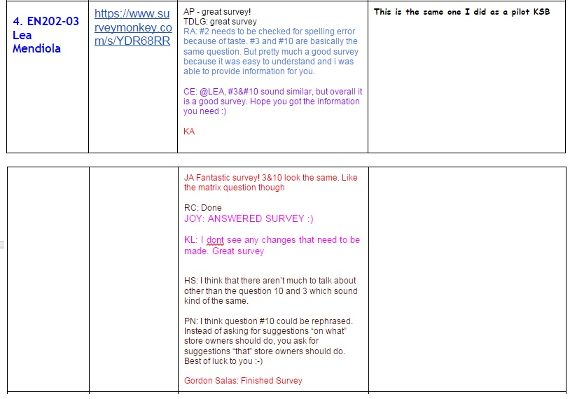
Appendix C
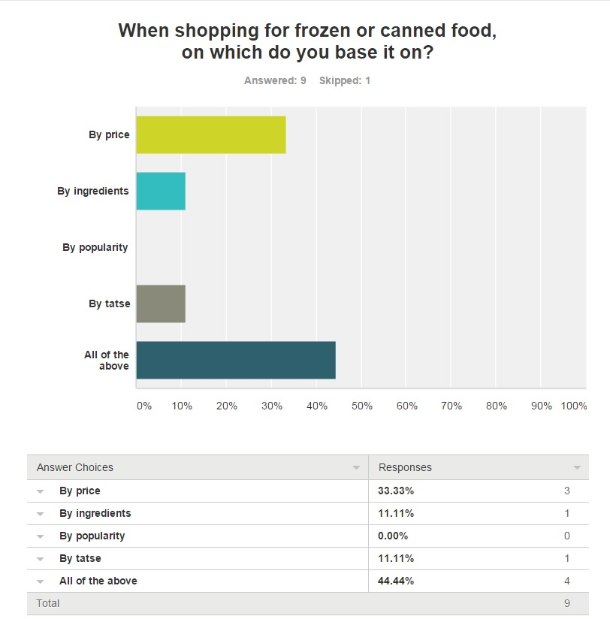
Appendix D
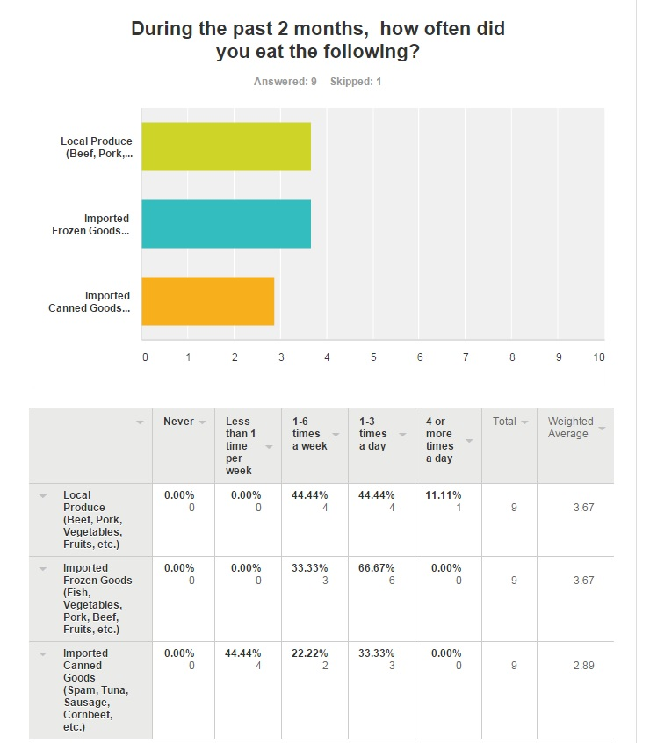
Appendix E
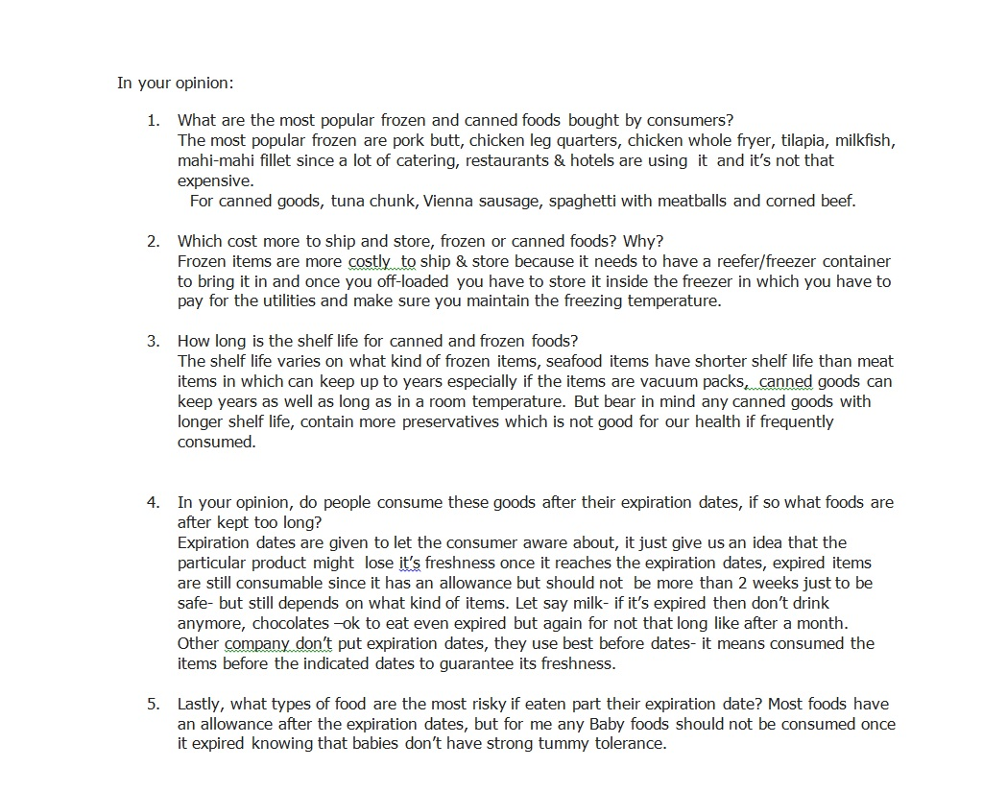
Appendix F
