Effects of Typhoon Soudelor in College

Lady Camille S. Espinoza

Northern Marianas Collge

Author Note
This research paper was prepared for EN-101, Section 8, taught by Dr. Kimberly Bunts Anderson.

Table of Contents
Abstract…………………………………………………………………………….……...3
Introduction…......................................................................................................................4
Literature Review……………………………………………………………………….....6
Research Questions…………………………………………………………………..........7
Methodology……………………………………………………………………………....8
Findings and Analysis……………………………………………………………………..9
Discussion………………………………………………………………………………..11
Conclusion……………………………………………………………………………….11
References…………………………………………………………………………….....13
Appendices……………………………………………………………………………....14
Appendix A………………………………………............15
Appendix B………………………………………………16
Appendix C………………………………………………17
Appendix D……………………………………………....18
Appendix E………………………………………………19
Appendix F……………………………………………....20
Appendix G……………………………………………...21
Appendix H……………………………………………...22

Abstract
“The Effects of Typhoon Soudelor in College” is a research report by Lady Camille Espinoza, a Northern Marianas College student in EN101-08. The purpose of this study is to figure out the effects of Typhoon Soudelor in Northern Marianas College’s administrators, faculties, students, and maintenances. A survey that consisted of 3 college administrators, 3 faculty members, 100 students, and 3 maintenances indicate that Typhoon Soudelor brought massive damage in NMC. The college administrators’ responses were regarding the changes in the curriculum of the college. The questionnaire was asked individually to faculty members and the responders stated that the major effect of typhoon is on the real surface of the campus and game plan. The survey for students was posted in a document sent by the instructor; it was about the impacts of Typhoon Soudelor in students’ learning outcomes. The question for maintenances was asked in person the responders claimed that some of the buildings was severely damaged by typhoon. The study shown that Typhoon Soudelor was a strong typhoon that leaves visible effects in college.

Effects of Typhoon Soudelor in College
Introductionto Typhoon Soudelor. Soudelor is the “worst storm” that ever hit the Northern Mariana Islands (NMI) in “nearly thirty years,” (Typhoon Soudelor, 2015, pp. 2). The aim of this persuasive essay is to persuade the students to utilize the Student Services Program. The aftermath of Typhoon Soudelor devastated the Northern Marianas College. This essay illustrates the physical damages of the college, the effects of Typhoon Soudelor in the curriculum, and to the students learning outcomes. In addition, this essay proposed a project that will describe the viewpoints of the people who make up educational environment of Northern Marianas College.
Background on the impacts. Due to Typhoon Soudelor, “eighteen out of twenty-five buildings of NMC were damaged,” (Logue, 2015, pp. 8). Buildings such as Building F and G that once belonged to Cooperative Research Extension and Education Services (CREES) were damaged and rendered unusable by Soudelor. According to President Sharon Hart, the budget of the recovery for NMC is still unknown. However, “Governor Eloy S. Inos has signed into law an appropriations bill moving $1 million to be used for repair and renovations of the college,” (Chan, 2015, pp. 1). Eventually, the repair for the college is still ongoing. In addition, maintenance personnel like Mr. Ding Evangelista, Raffy Monteflor, and Jovit Galvez are the precise workers to be asked about the physical damage of the college. Lastly, custodians agreed to be interviewed regarding the effects of Typhoon Soudelor; they will also be asked about their extra responsibilities at the college.
The effects on the curriculum. Due to the physical damages of the college, the curriculum has also been affected. According to Jun Dayao, the Northern Marianas College had to postpone the Summer 2015 final exam because of Typhoon Soudelor. Fall 2015 was also postponed and moved to September 28, 2015. The suspension of the semester has caused changes in all the schedule of classes and results to re-registration of students. Other changes include implementing a thirteen weeks semester instead of a regular sixteen weeks semester and maximize the use of limited number of classroom. In addition, college administrators like President Sharon Hart of NMC, Dean Leo Pangelinan of Student Services, and Dean Timothy Kock of NMC-CREES will be interviewed regarding the effects of the Typhoon Soudelor in the curriculum of the college. Also, faculty members like Mr. Barry Wononberg, Mr. John Joyner, and Mrs. Liban had agreed to be interviewed regarding the effects of Typhoon Soudelor on their teaching.
The students learning outcomes.The changes in the curriculum of the college may have been affected the Students Learning Outcomes (SLO). Some of the students are a having hard time in their classes. Students deal with the longer hours of classes, but still find the lecture very difficult. Due to the shortened semester, some of NMC’s students have moved to other college or university. However, other students have been decided not to register on Fall 2015 semester. In addition, some of the students experienced a change of the instructors. Students are also experiencing late night classes. Also, other students are complaining because they registered early to get the classes and instructor they wanted; yet they still did not get the classes they want. Lastly,NMC-CREES work study students like Chelsea Yangirelfil and Robert Suzuki Jr. will be interview regarding the effects of the Typhoon Soudelor in their learning.

Literature review
Introduction. On the month of August to December, the research of the effects of Typhoon Soudelor in the college was conducted. The term “Effects of Typhoon Soudelor in Northern Marianas College” was searched in Google. Initially, there were 7,840 results found and time was spent looking through the most popular and most related. Majority of the results that have been found were news article. Only a handful of news article were written by their respective author. The news article was either focused specifically on physical property of the college or the suspension of classes. The item that was scanned fall into three categories. One category was the physical damage that was brought by the Typhoon Soudelor. The second category was the suspension of classes and semester and the third category consisted of the updates for the repair and renovation of the Northern Marianas College.
Physical property. Some of the items that found through researching includes the physical impact of the Northern Marianas College. In the article Off the Radar, Complete Devastation, it states that Sharon Hart, the president of the college said “No one was prepared,” (Typhoon Soudelor, pp. 1). The article further explores the concept of the physical damages of the Northern Marianas College. Several studies were conducted regarding the Typhoon Soudelor. According to the same article, the facilities for Cooperative Research and Extension and Education Services (CREES) were all washed away. The president also stated that she doesn’t know how many dollars it would cost for the damages.
Suspension of classes. The second category focused on final exams suspension and delayed of Fall semester. There was an article about NMC postponed the Summer final exams due to the “destructive impact of Soudelor,” (Saipan Tribune, pp. 1). The news article announced that the Summer Final Exams was postposend until further notice. According to news updates of NMC posted in Saipan Tribune, the registration for upcoming Fall semester have been postponed as well. It seems that the Fall 2015 semester would be late. Also, the article Off the Radar, Complete Devastation stated that the Fall start date would be pushed from mid-August to September 28, 2015. In addition, the Fall semester became a thirteen weeks semester rather than sixteen weeks semester. So there seems to be crammed on Fall semester for the students.
Bill approval. Lastly, the third category consists of the repairs for Northern Marianas College. According to the news article of Saipan Tribune, Governor Eloy S. Inos has signed into law an appropriations bill moving $1 million to NMC for repairs and renovations due to Typhoon Soudelor. This bill appropriates from the Saipan Higher Education Financial Assistance. The article also stated that the expenditure authority of this bill was the President Hart. The president had to report on a quarterly basis to the chairman of Saipan and Northern Islands Legislative Delegation. Basically, the third category placed emphasis on the approval of funds for the repairs and renovations of the campus.
Primary Question:
What are the visible effects of Typhoon Soudelor in the College?
Secondary Questions:
- What were the effects of Typhoon Soudelor on the College?
- What are some of the difficulties that college experienced after typhoon?
- How has college recovered?
- What additional recovery plans are there?
- In your own opinion as (administrator, instructor, student, or maintenance) how did you handle it?
- In your own opinion as (administrator, instructor, student, or maintenance, how long will it take for college to fully recover from typhoon Soudelor?
- Has the college received assistance from government agencies or aid programs?
- What other efforts has the college made to build recovery?
- What has been the outcome of college getting assistance from funding the local and national governments?

Methodology
The first step that was done in trying to prepare this study was creating surveys with the help of peers and my instructor. A ten questions survey on survey monkey was created and posted in a document sent by the instructor. After getting responses from peers, there were some confusions that was made. Based on responses that was gathered, the revised questions became specific so that the respondents will not be confused. The revised questions were newly posted and sent to the students of Northern Marianas College.
While waiting for students’ responses, the research information was done on internet and some literature were found. One of the interesting information was about the physical damages of the Typhoon Soudelor at Northern Marianas College. The student found that there were 18 out of 25 buildings that were damaged by the typhoon. The student researcher also found the news about the bill moving a $1 million to be used for repair and renovations of NMC. It seemed that the Northern Marianas College was severely devastated by Soudelor.
After doing a research on internet, interview to administrators, faculty members, students, and maintenances was held to understand their point of view regarding on Typhoon Soudelor. The President of Northern Marianas College was interviewed as well as the Dean of Student Services and Interim Director of Cooperative Research Extension and Education Services (CREES). The Dean of Student Services helped the researcher in distribution of questionnaire to students by sending the survey link to student emails. Also, an art instructor, chemistry teacher, and speech professor were interviewed regarding the effects of typhoon in their teaching. In addition, the two work-studies of CREES sent an email to give their opinion regarding Typhoon Soudelor. The survey consisted of ten questions. After receiving data from the ones who completed it, the results were analyzed. The effects of Typhoon Soudelor in the college was prioritized by the researcher. Lastly, comparison between the motivation of students on a condensed semester and standard semester was made. After collecting and analyzing of data, the writing of a research paper was continued.
Analysis
The data that the student researcher collected consisted of 100 respondents that was sent from the beginning. From 100 respondents of the researcher, 27 of them were males and 73 of them were females (Appendix A). What was found out from the survey was more than half of the students indicated that the shortened semester was not working for them and was hard for them. However, there were 48 students who thought that the 13 weeks’ semester worked for them (Appendix B). Based on that information, there seems to be a correlation between the students’ learning on a standard semester and condensed semester. Majority of the students stated that the shortened semester caused too much stress and a little cramming for them. Furthermore, after looking at the answers of the students regarding their opinion on a shortened semester, there were some repetition on a students’ response that the classes were rushed. Some of them responded with “Not convenient for the students to learn the course.”, “…... it’s pretty challenging…”, “…… everything is overwhelming for me. I’m already falling behind” (Appendix C). Analyzing their responses, it seems that shortened semester had impacts on students learning outcomes. Thus, students having hard time on a shortened semester maybe because they were being pressured to learn the lessons and submit their projects before the end of Fall 2015 semester.
In addition, one of the respondents said that NMC bookstore should have reduce the price of the books and supplies because they have to spend more on damages in their home (Appendix D). Surprisingly, one of the students who answered the survey understand that a shortened semester was the only way to keep NMC on track on a proper schedule of semesters (Appendix E). The student stated that a better schedule would be better, but still understands that the college needs to keep the semester to be on time. In comparison to that, one student responded that NMC should not lessen the semester and must extend the Fall semester till January. The student also asked “What is really important to NMC, is it the money or the students?” (Appendix F). Thus, students are having difficulty on condensed semester because they lack time to understand the lessons in their classes.
Lastly, one interesting response came out was when a student stated that NMC should not started the Fall semester until the island was completely restored with power (Appendix G). The student also explained that she had no access with the internet and going to Mangosix and Java Joes for internet is expensive. In addition, there is an interesting suggestion from a student; the student suggested that NMC should start considering the 24/7 facility where students can do work (Appendix H). The student also stated that NMC should increase the security for NMC, because there are only one or two guards who are monitoring the premises. The concept that she introduced might help the students in their study and motivate them to attend their classes regularly.

Discussion
Introduction. The various studies that found from the literature was shown in my research as well; such as the physical damages of Typhoon Soudelor, the delayed of Fall 2015 semester, and recovery plans of NMC. Similarly, through analyzing the data it showed that NMC was severely damaged by the Typhoon Soudelor. The study of figuring out the effects of Typhoon Soudelor in the college had various barriers. The research was a challenge for the researcher. It is hard to find time to do the research because the interviewee were busy on their work. It was also hard gather answers from the respondents. Some of the respondents replied not applicable on some questions. A lesson to be learned is that collection of data should be done earlier on to increase the number of respondents.
Future aspects. Also, in order to continue on this research project, it is suggested to make more questions to get much data as possible. Explaining the questions helped the respondents to answer the questions. Giving them examples also helped them to understand the questions. In the future, this research paper might help the students understand the effects of Typhoon Soudelor in the college. Also, this study might help the administrators to come up with other possible solution if another typhoon will hit Saipan again. Lastly, this research paper might help the college to be always prepared for the typhoon.
Conclusion. In conclusion, the study was done by the help of the respondents, peers, and instructor. The data received helped the researcher to understand the severe impacts of Typhoon Soudelor on Northern Marianas College. Thus, Typhoon Soudelor would surely affect the students learning. Also, instructors were also affected due to the longer hours that they worked. The study was successful; it explained and described the effects of the typhoon in the college. As a suggestion, the collection of data should be done early to give time to the respondents and to receive different opinions from them.

References
Chan, D. (2015, October 14). Inos OKs $1M for NMC repairs - Saipan News, Headlines, Events, Ads | Saipan Tribune. Retrieved November 6, 2015, from http://www.saipantribune.com/index.php/inos-oks-1m-for-nmc-repairs-2/
Last Name, F. M. (Year). Book Title. City Name: Publisher Name
Dayao, J. (2015, August 5). NMC postpones summer final exams - Saipan News, Headlines, Events, Ads | Saipan Tribune. Retrieved November 6, 2015, from http://www.saipantribune.com/index.php/nmc-postpones-summer-final-exams/
Dayao, J. (2015, August 6). NMC updates - Saipan News, Headlines, Events, Ads | Saipan
Tribune. Retrieved December 16, 2015, from http://www.saipantribune.com/index.php/nmc-updates/
Logue, J. (2015, September 14). Typhoon Soudelor devastates Northern Mariana Islands community college | Inside Higher Ed. Retrieved November 6, 2015, from https://www.insidehighered.com/news/2015/09/14/typhoon-soudelor-devastates northern-mariana-islands-community-college
NMC postpones summer final exams - Saipan News, Headlines, Events, Ads | Saipan Tribune.
(2015, August 5). Retrieved December 16, 2015, from http://www.saipantribune.com/index.php/nmc-postpones-summer-final-exams/
Typhoon Soudelor. (2015, October 23). Retrieved November 6, 2015, from https://en.wikipedia.org/wiki/Typhoon_Soudelor_(2015)

Appendices

Appendix A
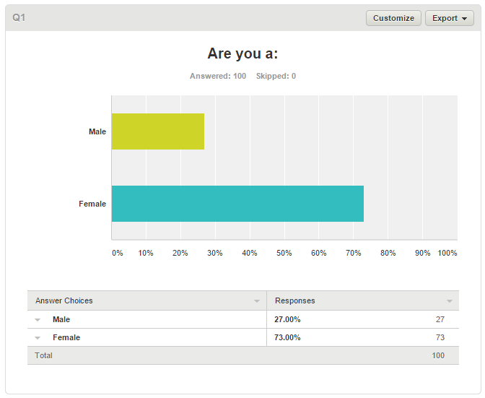

Appendix B
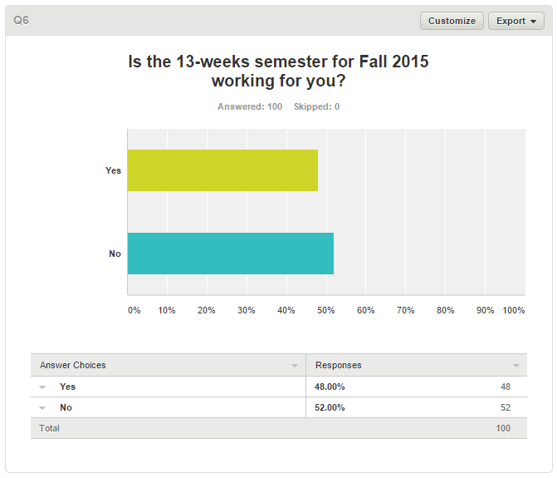

Appendix C
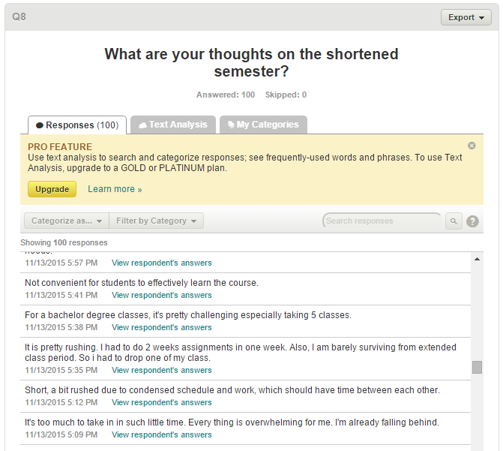

Appendix D

Appendix D

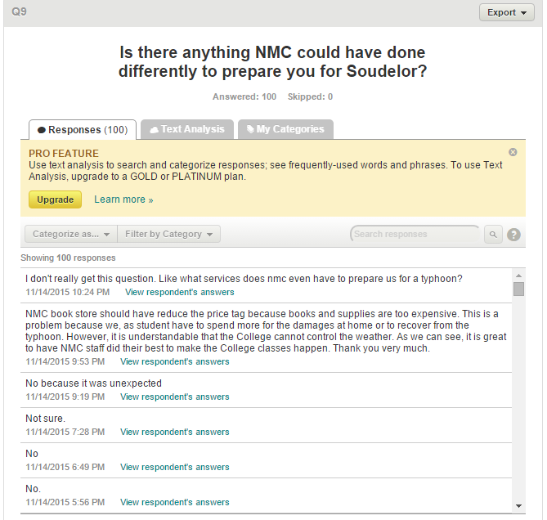

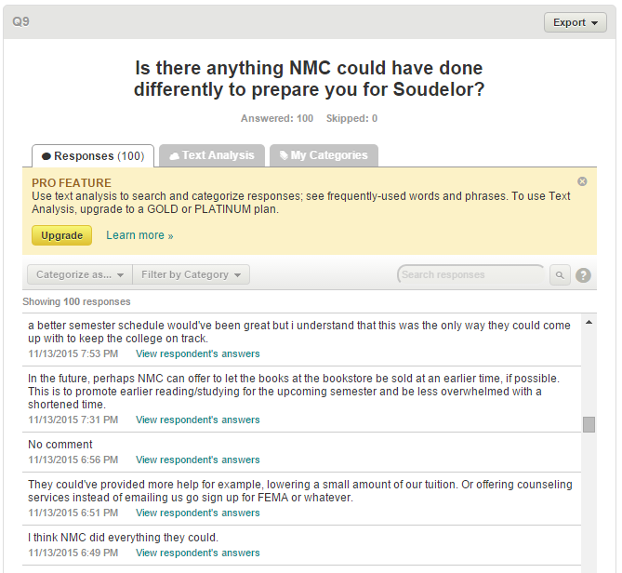
Appendix E

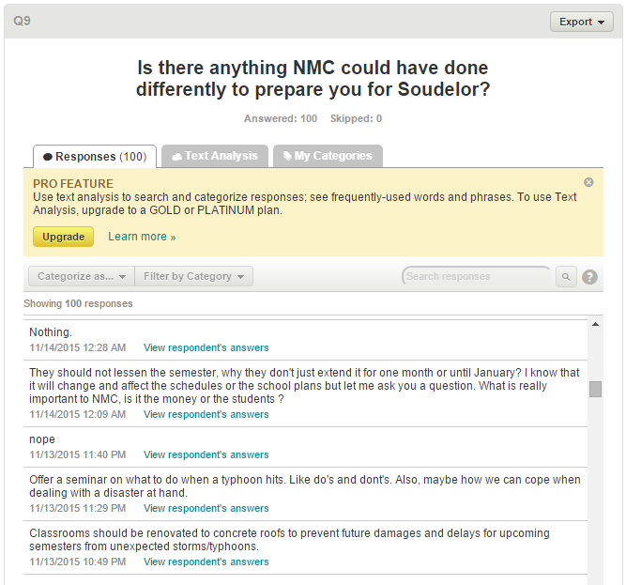
Appendix F

Appendix G
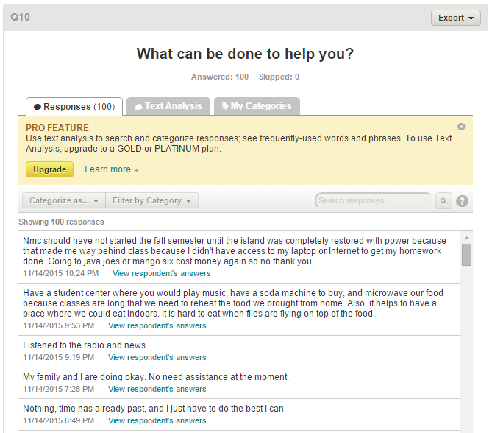

Appendix H
