Research Project:

The Qualities of Local Entrepreneurs

EN 202 English Composition II

Wei Wei

Author’s Note

This paper was written for EN 202 Section 2 at Northern Marianas College instructed by Kimberly Bunts-Anderson

Content

**Abstract** **3**

**Introduction 3**

**Background 4**

**Literature Review** **4**

**Research Questions­ 6**

**Methodology 6**

**Findings and Analysis 8**

**Conclusion 12**

**Reference 1****3**

**Appendices 15**

**Appendix A 16**

**Appendix B 18**

**Abstract**

Most people desire to achieve success and while some succeed some fail. Therefore there are various reasons why people succeed. Because of a person’s success must be the effect of their characters, a person’s character decides his or her destiny. The reason why the research student is interested in this topic is that to gathering the valuable secrets from successful people may helps others to avoid detours on the road of business. Therefore this is a research that taught the researcher a tremendously valuable lesson; it definitely will affect people to achieve success in their future career. However the entire results show that passionate person who is the master of self-discipline, and have the courage to taking risk is a perfect model of a successful entrepreneur; yet a hard working people who have a excellent social skill and advanced vision is described from the majority of local researches.

**Introduction**

The research student decides to compose a research paper to study the great qualities from those successful entrepreneurs in the Northern Mariana Islands. First the researcher collected abundant journals and articles from the Internet and library, also designed a pilot survey to the business related people in the CNMI and then interviewed numerous local entrepreneurs to investigate further about what are the common important qualities for being successful. In addition this research project is collecting, categorizing, and analyzing the great qualities and traits from those successful entrepreneurs, and how the successes are related to their characteristics. Consequently, the holistic results showed that passion, self-discipline, and risk taking are the top three vital qualities for being a successful entrepreneur; but from the local surveys and interviews, hard working, sociability, and vision are the common answers for being successful.

**Background**

Obviously success can be defined as a person whom achieves his or her desired aims. Success is something that almost every one desires, but not every one can achieve it. However people succeed or fail with reasons, people’s success can be related to their characters or traits. For example, a clever person may create neoteric products, or a sociable person may receive help from many capable friends. The reason of composing this research project is to deliver ideas that may influence people’s future career success. Yet the Northern Mariana Islands are the developing islands where many different ethnic backgrounds unite, so doing this research project in the CNMI also breaks the cultural limitation, and the results are more international.

**Literature Review**

During the period of a month collecting data, the researcher finally selected one business related book, which named Live for Success written by John T. Molloy in 1981. The book was written about success, the author stressed that it is not based on personal opinion, but on scientific researches. The author interviewed 300 people, and distributed a questionnaire to 995 executives; consequently summarized similar results from those successful business people. And they started every interview with the general question, “What do you think makes a person successful?” Therefore most successful people invariably stressed hard work and intelligence as dominant factors in their achievement.

In addition, there are several periodical articles that found in magazines Forbes, Inc., and Entrepreneurs. However, these three articles are very similar, they all listed many traits and qualities that the successful entrepreneurs got. For example, an official article from the influential magazine Forbes the topic is “5 Personality Traits of an Entrepreneur” which was composed by John Rampton who is an American entrepreneur, author and contributing writer for Forbes. This article listed 5 common personalities that the most entrepreneurs had, and those traits can be quote to answer the research questions “what does it take to be a successful entrepreneur?” and “Is it being born a prodigy?” Nevertheless, other two similar articles can be analyzed and to answer the research questions as well. One article is “15 Personality Traits of the Most Successful People” which was written by Thomas Koulopoulos from Inc. magazine; another article is named “The 7 Traits of Successful Entrepreneurs” which was written by Joe Robinson from Entrepreneurs magazine.

Furthermore, there are three more additional online articles can be use to finding answers for this research project. One article tittle is “8 traits of successful entrepreneurs.” from the website of the U.S. Department of Commerce (<http://www.mbda.gov>), one named “ Seven Characteristics of Highly Effective Entrepreneurial Employees” which was written by Joe Hadzima from the Boston Business Journal; and the last one is from Acton Foundation, the journal named “From Grizled Veterans of the Entrepreneurial Wars: Are successful entrepreneurs born or made?” which was composed by Jeff Sandefer. This article could be use to discuss the secondary research question which is “Are successful entrepreneurs in born?”

**Research Questions**

The research question is, “what are the important qualities that made the entrepreneurs succeed among those local outstanding entrepreneurs?” the research question is design to research the common factors that caused people to succeed, and analyze the relationship between their success and their characters. In addition, the secondary questions are how did they develop those characters? Are the qualities related to the entrepreneurs’ educations or experiences? These secondary questions can be assist to analyze the thesis specifically and deeply.

**Methodology**

To research and study the local entrepreneurs’ characters, which cause them to achieve success, and to study what the key qualities for a person to be successful in business is. Therefor a great research must contain sufficient data and information, because the research report is built by the data and information. However, the methods of collecting data for this research project are essential; so the researcher decides to seek the information by three different methods, which is send surveys to students, deliver questionnaires to business related experts, and make interviews with local entrepreneurs.

First of all, following the directions by the instructor, a feasible survey was created, which was named “The Qualities of Entrepreneurs”,designed and given to the students in the Northern Marianas College. Considering a long survey may cause people to get bored therefor affect the quality of the survey, so the survey was minimized to only 8 of the most essential questions. The questions mostly surrounded the topic of the research project, which all related to the qualities of the successful entrepreneurs. Although the survey was given to the student body, yet the amount of surveys completed was smaller than the researcher’s expectation. So the researcher will send more surveys to his classmates and college students for collecting more data in the next week.

Furthermore, twenty possible questionnaires were delivered to experts in the field of business. The questionnaire is designed base on the survey, which was mentioned on the previous paragraph. The questionnaires were delivered to over twenty expert participants, which included: hotel managers, luxury managers, casino supervisors, and gas station supervisors. The reason why the researcher chooses these people to deliver the questionnaire is that these supervisors and managers have a lot of experience of association with those successful entrepreneurs.

Lastly, the researcher set up several interviews with local entrepreneurs, which included the owners of supermarkets, gift shops, restaurants, hair salon, gift manufactories, and clothing manufactories. At the beginning, the researcher wanted to make interviews with those bigger size enterprises’ owners, such as Joten supermarket, or Herman’s bakery. But those bigger size enterprises’ owners are busier and it was hard to set up schedule for interviews. So the researcher decides to go for small and middle size companies’ owners. Also, the researcher discuss deeper with the interviewees to discover the relationship between their characters and their achievements.

**Findings and Analysis**

After a long period of collecting data, the answers for this research project are emerging. From literature sources, local business experts’ surveys and the interviews, passion or drive comes up the first quality, which have been mentioned by 13% of the literature researches, local surveys and interviews; the second trait is self-discipline which mentioned by 12% of the research. However, if researcher pulls out the non-local researches, the top three qualities may different. So the researcher categorizes the results by using two charts, one is the result from all researches, including literature, surveys, and interviews; another is the result merely from the CNMI local entrepreneurs’ surveys and interviews.

Drive defines as an innate determined urge to attain a goal or satisfy a need, and passion defines as a strong feeling of enthusiasm about doing something. （Merriam-Webster）Although drive and passion are not one but same, so the researcher classifies these two terms into one. Most articles listed that passion as a key trait for being a successful entrepreneur. Even a local entrepreneur named Ella Kim, who currently operate a local specialty factory and a gift shop, said that her passion was help her enter into the market immediately when she was just started her business.

The following No. 2 quality is self-discipline, the reason why this term occupied nearly 12 % of the entire research is that the researcher categorizes self-motivate, self improve, and self-evaluate into one category. Therefore a successful entrepreneur might be a very intrapersonal person. In another words, people who want to succeed must know how to control, motivate, and improve themselves.

The third successful trait that occupied 10% of the research is risk taking. This trait is frequently appeared on the online articles and business magazines, not only risks taking, but also the willing to fail. A successful entrepreneur must have the courage to take a risk, she must be not afraid to fail. Actually, most of the interviewees admitted that they had made wrong decisions in the past, and they are never giving up to taking risks in the future. Moreover, most interviewees mentioned that risk taking is a required quality for all the business people whether she or he is successful or not.

Nevertheless, the results from the researches of the CNMI local entrepreneurs are different to the entire researches’ results. Most of the local entrepreneurs from the CNMI voted that hard working, social skill, and vision as the top three qualities, which made them to succeed.

The local specialty factory owner Ella explained that when you start your own business you have to give all of your time, your mind, and your energy into the work. She told a illustrate about her own experience, when she was start her factory she slept only 2 or 3 hours a day, because she had to join the team to producing products and deliver to the stores. Hard work not only mentioned by local entrepreneurs but also introduced on the book *Molly’s Live For Success.* The writer also set interviews with 300 business people, and started every interview with a general question, “What do you think makes a person successful?” and majority successful women and men invariably stressed hard work and intelligence as dominant factors in their achievement. (Molloy, P3)

Another quality that also often mentioned by the local entrepreneurs is social skills. A president of a local travel agency and a president of a wholesale company both explained that the social skill is extremely important to a successful business people. They both stressed that having a great social skill can build your strong social net which helps you sweep a lot trouble away. Also a online article introduced too,

However, research indicates that entrepreneurs are often social people, according to Stanford University. Starting a business requires contacting people to generate funds, purchasing materials from suppliers, hiring employees and developing social networks in which to promote the business. (K. Page, & D. Media, Chron.com)

A great social skill is not only please your business partners or clients, but also steady your employees, all in all the great social skill is to make all the people to like you, and want to help you to achieve success.

There are two traits that also often mentioned both in non-local researches and local researches, which are vision and flexibility. A president of a local wholesale company claimed that an entrepreneurs’ vision is essential for a company’s success, from choose products, hire stuffs, and set directions; all the decisions he made shows whether a vision he had. Furthermore, flexibility is an essential quality as well. According to the article from the business magazine *Forbes,* Being able to changes and challenges is crucial for any business. In fact the successful entrepreneurs must flexible enough to adjust their deflected decisions.

**Conclusion**

Even though the research results from local researches and literature researches are a little bit diverse, but the entire research results cover wide and very accurate. Plus during this research, the researcher has learned a very significant lesson that may benefit the researcher’s future life. Therefore the answers for the question “what are the important qualities that made the entrepreneurs succeed among those local outstanding entrepreneurs?” are coming out; for this entire research project the top three qualities are passion, self-discipline, and risk taking. However, there are three answers that brainwashed the researcher’s mind; which are hard working, social skill, and vision as they repeatedly show up. Finally, absorbing such numerous valued secrets and experience from those successful entrepreneurs, does it feel like success is still unreachable?

**Reference**

John T. Molloy, (1981). Molloy’s Live for Success. Jason Bowser, Featured Startup Business Expert. 8 Traits Of Successful Entrepreneurs--Do You Have What It Takes? Retrieved from

<http://www.mbda.gov/blogger/starting-business/8-traits-successful-entrepreneurs-do-you-have-what-it-takes>

John Rampton,(April 14, 2014). 5 Personality Traits of an Entrepreneur. Retrieved from

[**http://www.forbes.com/sites/johnrampton/2014/04/14/5-personality-traits-of-an-entrepreneur/#15372a7b22f6**](http://www.forbes.com/sites/johnrampton/2014/04/14/5-personality-traits-of-an-entrepreneur/#15372a7b22f6)

John Rampton, n.d. *In* Wikipedia. Retrieved April 22, 2016

From <https://en.wikipedia.org/wiki/John_Rampton>

Passsion, n.d. *In Merrian-Webster.* Retrieved May 4, 2016 **<http://www.merriam-webster.com/dictionary/passion>**

Drive n.d. *In Oxford Dictionaries,* Retrieved May 3,2016

<http://www.oxforddictionaries.com/definition/english/drive>

Kara Page, Demand Media. What Are the Typical Traits & Characteristics of Entrepreneurs? Retrieved from

<http://smallbusiness.chron.com/typical-traits-characteristics-entrepreneurs-18325.html>

Jeff Sandefer. From Grizzled Veterans of the Entrepreneurial Wars: Are successful entrepreneurs born or made? (Action Foundation for Entrepreneurial Excellence).

Armin Laidre. Top 5 Characteristics of a Successful Entrepreneur. Retrieved from http://www.iplanner.net/business-financial/online/how-to-articles.aspx?article_id=entrepreneur-characteristics

Thomas Koulopoulos. Funder, Delphi Group. 15 Personality Traits of the Most Successful People. *Inc.* Retrieved from http://www.inc.com/thomas-koulopoulos/15-personality-traits-of-the-most-successful-people.html

# Joe Robinson. (January 2014) Entreprenuer. The 7 Traits of Successful Entrepreneurs. Retrieved from https://www.entrepreneur.com/article/230350

Appendices

**Appendix A**

Macintosh HD:Users:weiwei:Desktop:[SURVEY PREVIEW MODE] The qualities of entrepreneurs Survey.pdf

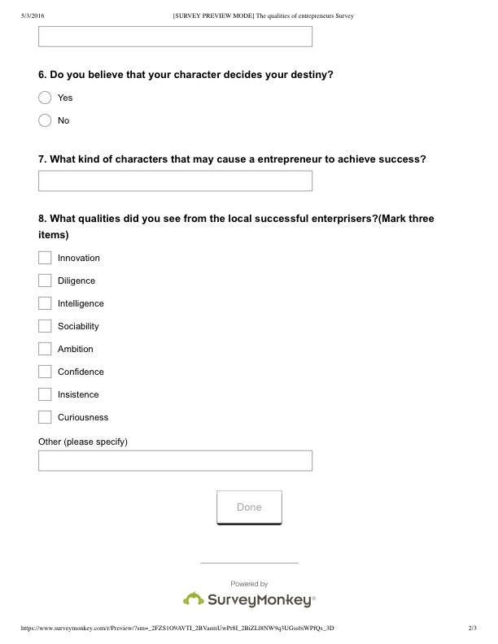

**Appendix B**