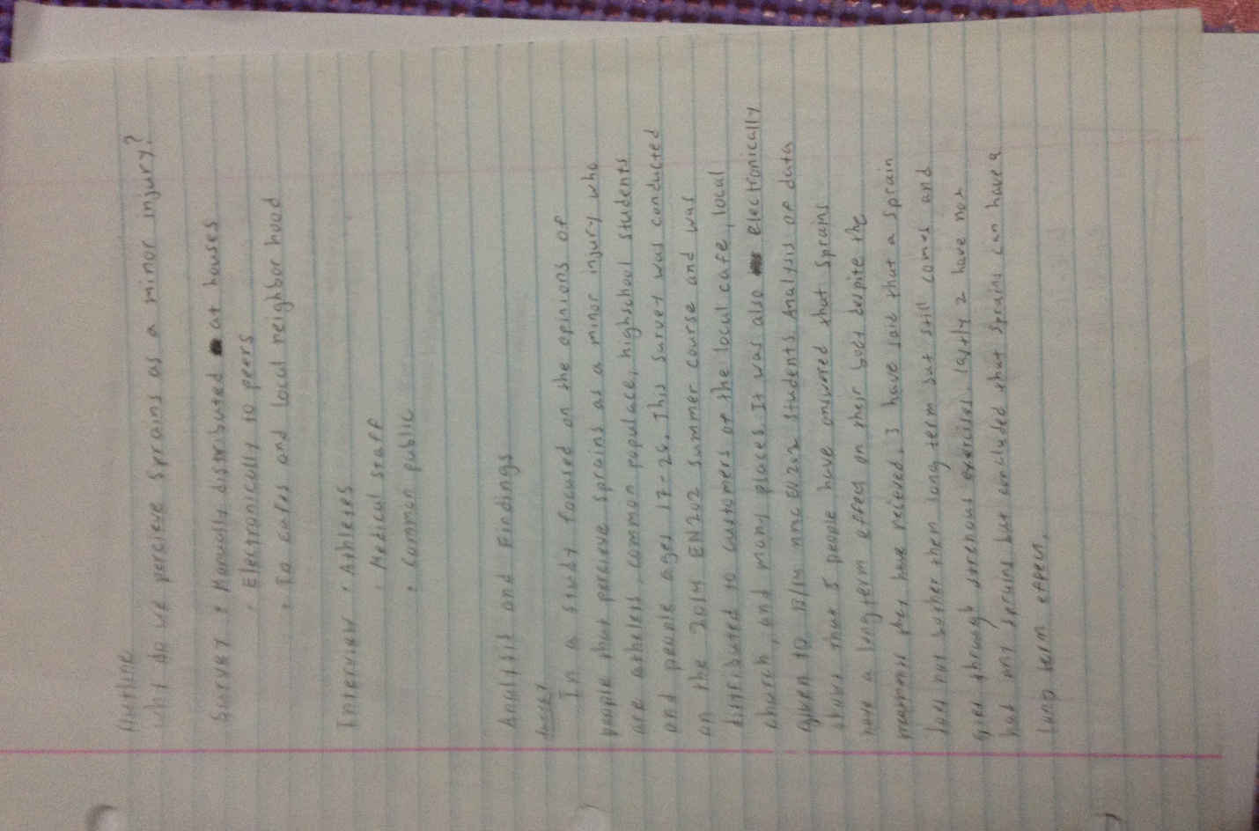

OUTLINE

READING NOTES
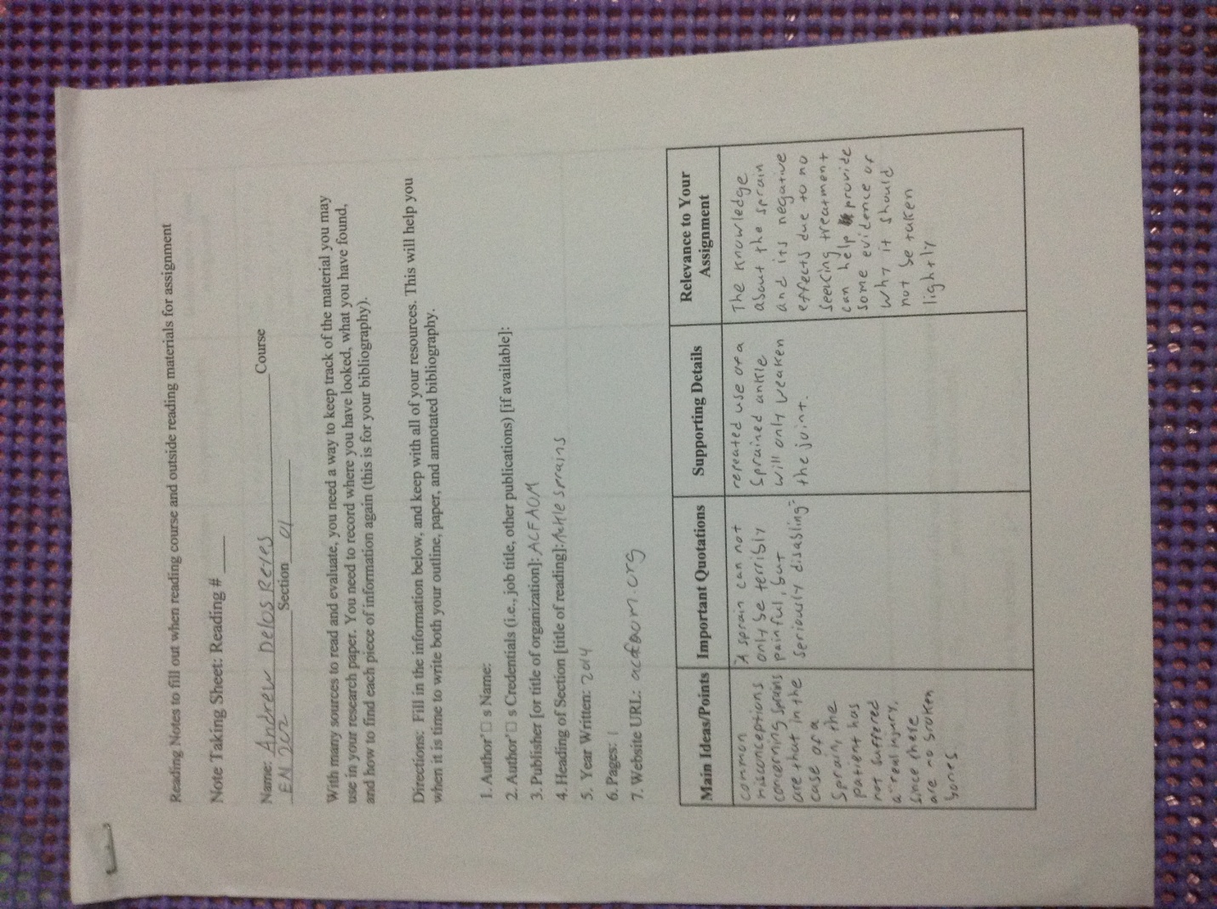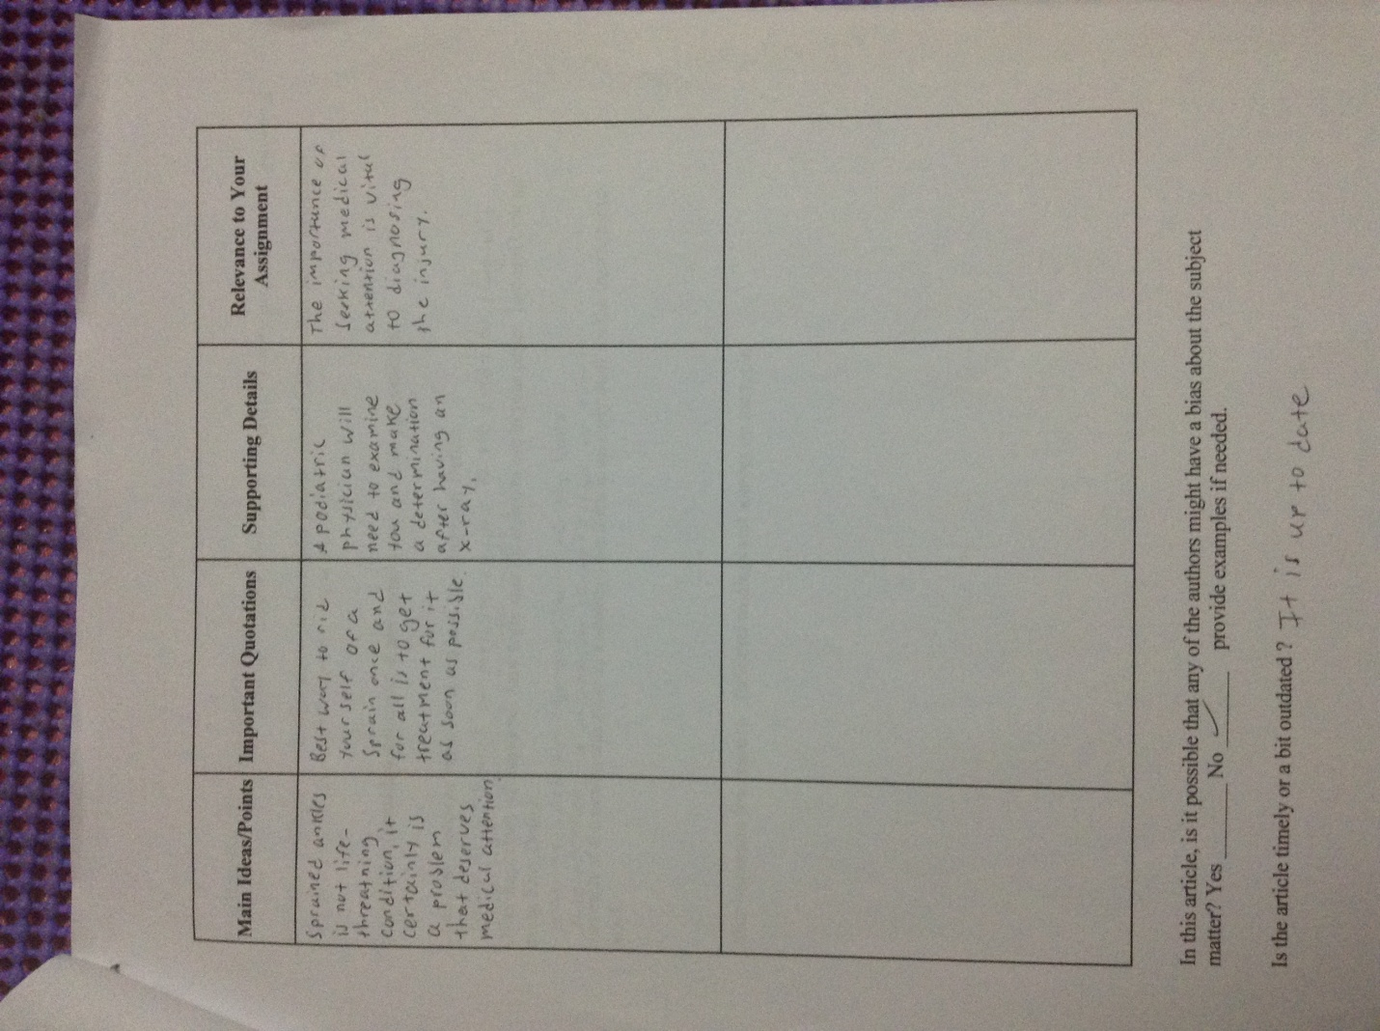

Running Head: Why Do People Perceive Sprains As A Minor Injury?

Why Do People Perceive Sprains As A Minor Injury?
Andrew E. Delos Reyes
Northern Marianas College
English 202 01 Summer 2014
Dr. Kimberly Bunts-Anderson
July 22 2014

Authors Note
This paper was prepared for English Composition 202 section 01 instructed by Dr. Kimberly Bunts-Anderson.

Table of Contents

Abstract 3
Introduction 4
Background 4
Literature Review 5
Research Question 6
Methodology 6
Pilot Study 7
General Survey 7
Experts Interview 7
Findings 8
Conclusion 9
References 10
Appendix 11

Abstract
The following report took place at Saipan’s Northern Marianas College EN 202-01 summer course. The report focuses on sports healthcare, and the primary research question which was “Why Do People Perceive Sprains as a Minor Injury?’ an investigation was conducted at Northern Marianas College and throughout the island of Saipan. The investigation started with surveys and then followed by expert’s interview. Initial findings suggest that people often disregard minor injuries but not knowing whether it could lead into bigger problems. However they had a good knowledge about Medical professionals have always traced major injuries/illnesses from minor complications that occurred early in their life.

Introduction

Throughout the years, our views of sprains have become unimportant as a serious grievance since then. It has always been thought to be a minor injury, as we all had seen of the swelling showed us that a simple home remedy would heal it. These injuries such as the ankle sprain, which is common to almost everyone, may brew a disaster waiting to happen. If left untreated it can weaken the joint making it unstable (ACFAOM). Getting the right diagnosis and treatment can help prevent further injuries to occur.

Background
A sprain is damage to one or more ligaments in a joint, it is often caused by a joint being taken beyond it limits. Physical exercise or strenuous labor that requires a lot of joint movement can cause sprains (Anklesprains). Leaving it untreated and forcing more stress can ultimately rupture ligaments or break bones. Doctors usually break down the severity of the injury into degrees. First degree is very minor with no tear in the ligaments, and is accompanied by slight swelling (Strainsandsprains). Second degree, about more than half of the muscle fiber is torn and healing time will take about 2-3 weeks (StrainsanSprains). The last is third degree, the tissue is completely ruptured and surgery may need to take place. Treating the sprain can be important, depending on the degree the patient may need to undergo surgery or simply have it get some rest.

Literature Review

Based on the research about sprains, many people have very little knowledge on the long-term effects on sprains. The few chosen people that were interviewed gave the interviewer a more accurate understanding on what do athletic people do to treat or heal their sprain or injury. As the interviewer asked the athletes about the activities they usually do such as prep games & training before the season starts. When they do injure themselves during these times, they would usually put an icepack to lower the swelling in the muscles and then go to a masseuse to fix the dislocated bone.

Looking for solid copy of books on sprains in our local library wasn't much help to the student due to the out-dated and very limited books on sprains itself. With this being said, many people really don't have much access to attain information but the web only. "The sprain is the most common injury a person is likely to have several times in their life." (allaboutsprains.com) gives us a hint that without the proper treatment for the injury could have a huge affect on your physically activity if the sprains continue occurring. Also proving that this injury or sprain may have a minor effect in the first few times, after more reoccurring sprain injuries it could lead to something far worse than just "the tearing of the muscles." (allaboutsprains.com)

Having a very limited time for the student and the summer semester as well, the information and data attains isn't what the student original goal for the essay. If the student were given more time to work on it, it would have more accuracy and better writing in it.

Research Question
Why do people Perceive Sprains as a minor injury?

Methodology
Pilot Study

This was the first method used to collect data through the form of a survey that have been distributed online with the assistance of the instructor. The survey was taken by the researchers class, however only 9 out of 12 students only completed the survey. The purpose of the survey was to gather data about the research and provide some feedback on its quality. However some of the class brought up some problems within the survey for example “Question 6 is a bit confusing. Please elaborate” it was then elaborated “Has the pain ever come and gone after the sprain has occurred?” (See Appendix A). And “Survey is short, add more questions” so more questions were added to the survey to better collect more data.

General Public Survey
Another survey was conducted and distributed to the community to better get more perception on people’s opinion towards a sprain and if it should be taken seriously or not. Unlike the pilot survey, it had a lot more questions added regarding if it should be funded and if it should be better addressed to the public (See Appendix B).The survey was handed out to the people down at a local restaurant, the neighborhood and through survey monkey.

Interviews
Finally experts were asked various questions in regards to the research question and their opinions towards the data collected from both the surveys. In the field of medicine a certified medical expert was interviewed, for the athletic field a tri-athlete was asked to share some of their personal experiences with the injury. All their responses were recorded by paper and through the interviewers Apple Ipad voice recorder.

Findings
In a study focused on the opinions of people that perceive sprains as minor injuries who are athletes, students, and people ages 17-26. This survey was conducted on the 2014 EN 202 summer course and was distributed to customers of the local café, local church, and at the local neighborhood. It was also electronically given to the researcher’s class through the help of the instructor. About 80 % of the participants who took the survey were between the ages of 17-26, and 40% were Asian or Pacific Islander (See Appendix B). Further Analysis of data shows that about almost have of the responders said that sprains could lead to other injuries/illness. Almost all seeked treatment in the form of either a massage or over the counter medication.
In a formal interview conducted on an athlete and a medical professional. The investigator explores the data recorded during the interviews. During the interview with the athlete, she stated that” That younger people with a sprain can lead to arthritis or other potential injuries at a older age if left untreated” (See Appendix B). The athlete also stated that having a poor diet could also make the injury worse. According to the interview with a nurse she said that” sprains are a minor injury, may lead to broken bones depends on the severity of the sprain” (See Appendix B).

Conclusion
In conclusion the findings were valuable to the research through surveys and formal interviews. The results have shown that most of the people who had a sprain did not seek professional help but depended on either just a massage or painkillers. Almost all say that sprains are just minor while some say it can become a serious injury. Professionals that were interviewed believe that any minor injury should not be left alone and have it checked out. But with more time in the summer session, more data could be collected. Overall all the participants were helpful especially the ones that were interviewed. The local community was helpful and was always happy to help.

References
Ankle Sprains. (2010, April 7). . Retrieved July 28, 2014, from http://www.acfaom.org/information-for-patients/common-conditions/ankle-sprains
Mitchell, M., Siegel, M., & Jacobs, N. (1996). Health Taking Care Of Ourselves. Wylie,Texas: Information Plus.
Peddie, S., & Rosenberg, C. (1997). The Repetitive Strain Injury Sourcebook. Los Angeles: Lowell House.
Sprains and strains need attention. (n.d.). . Retrieved July 7, 2014, from http://www.backsense.com/Sprain-Strains-require-attention.html
Strains and Sprains. (n.d.). . Retrieved July 28, 2014, from http://www.humanillnesses.com/original/Se-Sy/Strains-and-Sprains.html

Appendix

Appendix A
Pilot Survey
https://www.surveymonkey.com/s/3P87QTY
Survey
https://www.surveymonkey.com/s/QJJJQXM
https://www.surveymonkey.com/s/QJW2LJ2

Appendix B
Survey Responses
https://www.surveymonkey.com/results/SM-YLPSRJF8/
Expert Interviews
Interviews

Date July 25 2014
Time 4:00pm
Occupation Tri- Athlete
Location Winchell’s, Susupe

Question:
Have you ever experienced a sprain?
-yes I did, in my hamstring it was minor.
What kind of treatment did you get for it?
-I just got it massaged and stretched it out
Do you think sprains can lead to other injuries?
-yes it can lead to other injuries
What are the factors to making a sprain worse?
-Having a poor diet could make the injury worse and possibly lead to other injuries at an older age
Should the people be more aware of sprains and its potential danger?
-People regardless of background should be well aware and educated about sprains.

Date: July 23 2014
Location Kannat Tabla
Occupation: Nurse
Time 6:00 pm

Questions
Do you think sprains are a minor injury?
-of course its minor, may lead to broken bones depending on the severity
What kind of treatment should it go through?
-its best to get a diagnosis from a professional because you would never know it may be worse than it looks.
Should surgery be performed?
-It really depends on the severity, for example if there are any broken bones or any torn ligaments

