Sleep Deprivation in College Students
Phoebe Nekaifes
EN 101 – 01
Professor Kimberly Bunts-Anderson
April 2015

Author Note
This paper was prepared for English 101, Section 1, taught by Professor Kimberly Bunts-Anderson.
Table of Contents
Abstract . . . . . . . . . . pg. 3

Introduction . . . . . . . . . . pg. 4

Literature Review. . . . . . . . . .pg. 4

Research Question. . . . . . . . . .pg. 5

Methodology. . . . . . . . . .pg. 5

Analysis Critique. . . . . . . . . .pg. 7

Appendices. . . . . . . . . .pg. 8

Discussion. . . . . . . . .pg.12

Conclusion. . . . . . . . . .pg. 12

References. . . . . . . . . . pg. 13

Abstract
Sleep deprivation is common amongst people all over the world. This paper explores the finding of a student researcher from the Northern Marianas College. The main topic of this research paper is the pressing matter of sleep deprived college students. Interviews, surveys, and a questionnaire were conducted to gather data. The results from the data were taken and compared to statistics the student researcher found within literature. The student researcher collected a small portion of the CNMI college students to see where they stand in the growing issue. Sources came from academic literature found through an online database called EBSCO.

Sleep Deprived College Students
There have been recent studies on sleep deprived college students. However, none focused on the students of the Northern Marianas College. A student researcher sought out to conduct an observation of her own. She wanted to see whether or not her peers knew the health risks of being sleep deprived, and if they were experiencing what statistics say about the normality of college students lacking sleep. College students should be aware that there are hazards to not getting the suggested amount of sleep. Interestingly enough, college students all across the nation do go through the same trouble. It is important to go deeper into this to attempt to solve such a dilemma.
Literature Review
The student researcher used an academic search engine, EBSCO, to get information. She used the keywords: sleep deprivation and college students. Approximately 25 journals, all of which were relevant to the topic appeared. According to literature, college students who constantly stay up late make themselves vulnerable to getting colds (“Sleep Rocks”, 2015), stress (“Sleep Rocks”, 2015), lowered grade point average (Hershner, 2014), and a weakened strength (Arhberg, 2012). A local newspaper writer from The Saipan Tribune (Stephens, 2014) claims that some really nasty infections, such as; cancer, and cardiovascular diseases are said to be linked to a lack of sleep. In the Encyclopedia Britannica, it is written that the normal periods of sleep range from six to nine hours each night, with seven and a half hours being the average (p. 323). The student researcher can conclude that all these findings are similar and coherent to the fact that sleep deprivation is a serious issue. It is unhealthy.

Research Question
The student researcher found that the literature she had collected coincided with her research question for her peers at the Northern Marianas College. The question asks: How many hours of sleep do you usually get each night? The pressing issue on sleep deprived college students is not something new. There are articles and books written by experts who know how bad it is to not get enough rest. And college students, in general, are at a point in their lives where meeting deadlines for assignments is crucial. The student researcher’s work covers a small aspect of the global case. The question fits well with the students asking her peers where they stood on the topic of sleep deprivation. Whether they were or were not part of the norm.
Methodology
Sleep deprivation is among the most common issues with college students across the nation. It is important to find out how much of the students are sleep deprived so we can have a sense of awareness to the unhealthiness of it. The data of sleep deprived college students attending the Northern Marianas College was gathered through surveys, interviews, and questionnaires. The student researcher created a survey and shared its link to another class. It was meant to gather knowledge on the topic. Interviews were given by the researcher to experts and students to see where they stood on the issue of sleep deprivation of college students. To gain a broader view, the student researcher designed tools to gather as much information as possible. This process essay will show that the researcher has put in legitimate time and effort into the work.
The first step was done by creating a survey using an online survey maker called the Survey Monkey. The student researcher came up with ten questions from the topic of sleep deprived college students. The student then continued the process by uploading the survey and posting its link onto a shared Google Docs. Responses came from students attending the Northern Marianas College. Hence, making it easier to gain general knowledge to see where college students stood on the sleep deprivation issue.
Furthermore, the researcher also interviewed a nurse from the Commonwealth Health Clinic. The researcher asked for statistics on college students experiencing sickness from sleep deprivation. The nurse did not have much to say on the issue but did express her knowledge of the health risks with being sleep deprived. The student researcher connected her data from the nurse and sought out for more answers.
The last step in collecting data was done by asking random individuals on the Northern Marianas College campus a different question from the online survey. The researcher noticed a difference between the numbers of people who chose to do the online survey versus the personal interaction by asking the students up front. Fifteen students were randomly selected to give their thoughts from the questions on the survey. All of them had something to say about their experiences of being sleep deprived. The student researcher had decided that she had enough data collected.
In conclusion, the researcher had collected data by conducting an online survey which started off the project. The student researcher had gathered her data by creating an online survey in which she posted a link for her peers to see. This collected a subtle amount of responses but the researcher was not content. The student researcher furthered her work by interviewing a nurse at a local clinic. She was helpful enough to talk about what she knew of being sleep deprived. And lastly, the student researcher got personal insights from students at the Northern Marianas College by asking them questions from the online survey. The researcher now shed some new light for the research and hopes to build up on it.
Analysis Critique
The student researcher has done the literature findings and saw that there are people who do studies on sleep deprivation. Sleep deprivation is also very common amongst college students. The student researcher compared her results from the survey and saw many distinct similarities (See Appendix A for survey questions). Question number three in the survey asked “How many hours of sleep do you usually get each night?” Two out of the ten students answered five hours or less, one student answered eight hours or more, and seven students answered between six and seven hours each night. Statistics were proven right. The average person sleeps between six and seven hours every night. Question number four asks “Do assignments and deadlines take a toll on the number of hours you sleep at night?” Nine out of ten students answered yes. This comes to show that college students do have reason to being sleep deprived and a lot of it comes from the workload given by instructors (See Appendix B for results on questions three and four). Question number six asks, “Do you know any health risks from being sleep deprived?” Two out of ten students had no awareness whatsoever about the health risks of sleep deprivation. The other 8 students, however, did write short answers stating that they have headaches or mood swings when they do not have enough sleep (See Appendix C for results on question number six).

Appendices

Appendix A
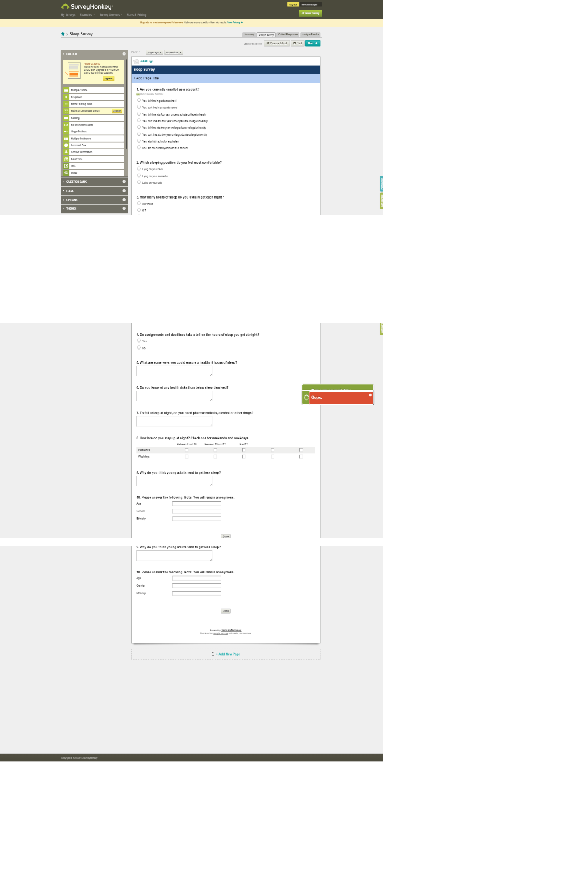

Appendix B
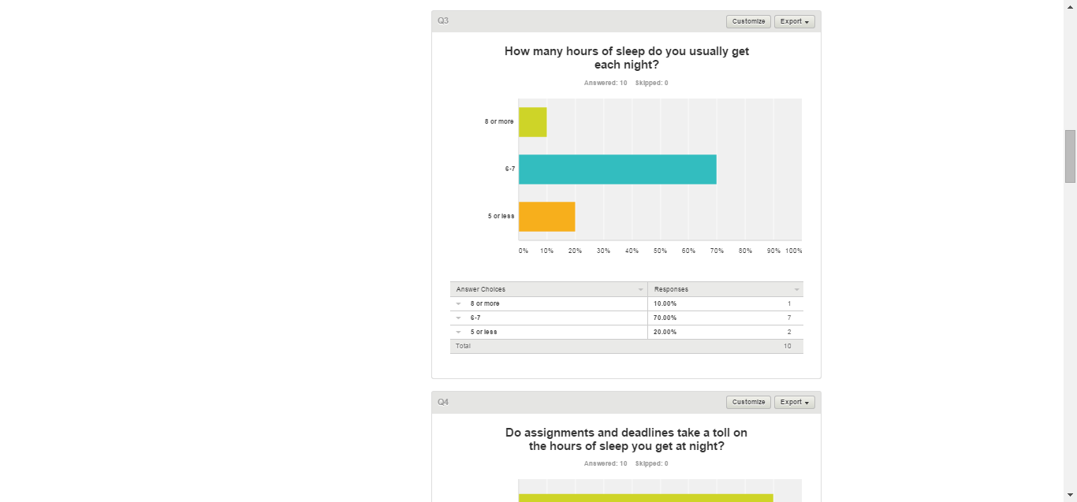
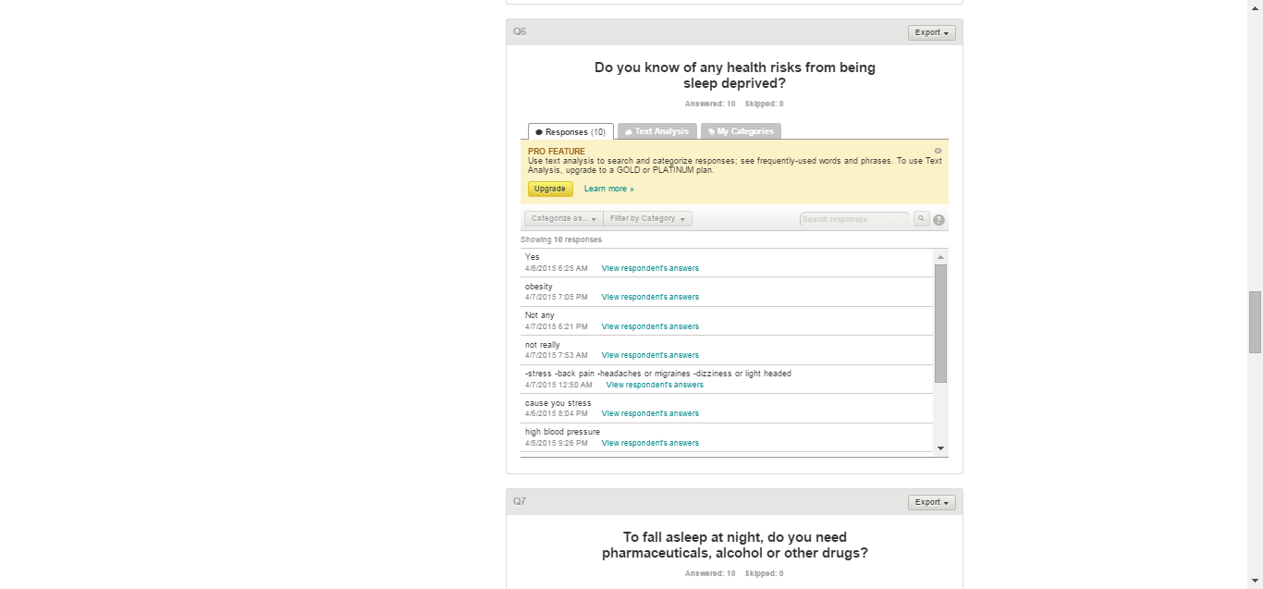

Appendix C
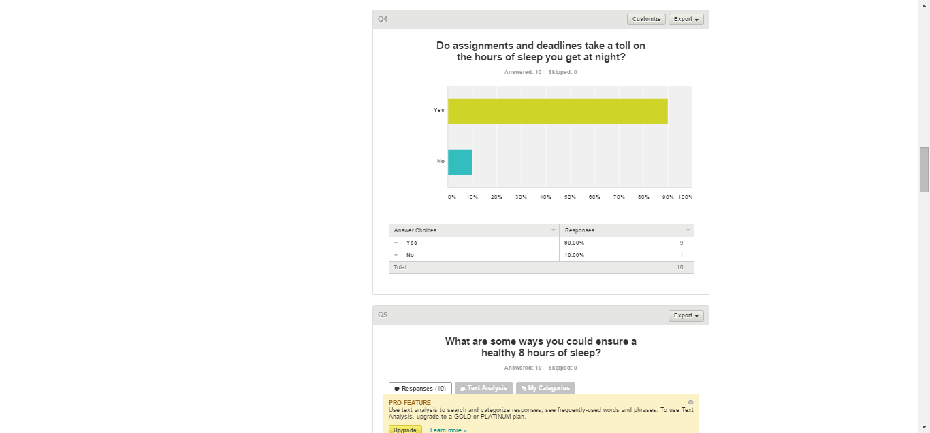

Discussion
The student researcher found that most of the data she collected were correspondent to statistics made by experts on sleep deprivation and its health risks. The survey that was created on Survey Monkey was a big help in analyzing data because the results page was convenient. The student researcher found the observations she conducted to be significant for herself and her peers. The students at the Northern Marianas College are not completely aware of how unhealthy it is to keep up the habit of sleep late. And one sort of solace to prevent having to stay up late is by time management. The body and mind gets worn out, too.
Conclusion
Sleep deprivation is a growing dilemma all across the country. This research paper focused mainly on sleep deprivation within college students attending the Northern Marianas College. A student researcher sought out to collect data by creating an online survey using Survey Monkey. She shared the link amongst her peers and received feedback. The student researcher also interviewed a nurse and got insight on the health risks of being sleep deprived. The student researcher then asked students on the Northern Marianas College campus some questions found on the survey. Literature on sleep deprivation in college students was also looked at. Online articles and journals on an academic search engine called EBSCO was used in this process.

References
Ahrberg, K., Dresler, M., Niedermaier, S., Steiger, A., & Genzel, L. (2012). The interaction between sleep quality and academic performance. Journal of Psychiatric Research, 1618-1622.
Compton’s Learning Company (1989). Sleep. (Volume 21, pp. 323-324. Chicago, IL: Encyclopedia Britannica.
Hershner, S. D., & Chervin, R. D. (2014). Causes and consequences of sleepiness among college students. Nature & Science Of Sleep.
Sleep Rocks (2015). Univerisity of Georgia.
Stephens, E.J (2014). Sleep Tight. The Saipan Tribune.

