Some Possible Long-Term Effects of Casinos on Saipan
Jacky Lou Pestillos

EN 101, ON 01
Dr. Kimberly Bunts-Anderson
November 23, 2016

Abstract
This research paper presents a plan to share a compiled research in 12 weeks on the topic of possible long-term effects of casinos here on the island of Saipan. This paper will cover a number of concerning issues that could drastically affect the island of Saipan. Some of the main points that will be covered in this paper will include environmental, economic, and social impact of casinos on the island. The method approach to aid to complete this essay will compromise of analyzing research material from online, academic sources as well as local newspapers, observations of activities of local businesses and the casinos being built on the island, and correlative studies of casino businesses in similar areas that could mirror probable effects here on the island. The reason for choosing this topic is because it is a pressing and a trending issue that is currently happening here on the island, but seems to be overlooked because the positive aspects are the only one being considered. At the completion of this essay, it is wished that to persuade its audience that casinos have their negative impacts, and give them a better idea of what these casinos will bring to the island and its people.

Some Possible Long-Term Effects of Casinos on Saipan
Bright, colorful lights, the bustling of people being tendered by card dealers, the tapping sounds emitted by slot machines, and cigarette smog settling over the horizon of the game floor; these are a few things that could people expect to experience in a casino. One of the leading businesses in the world, Imperial Pacific, recently opened Best Sunshine Live on the island of Saipan, CNMI in November 2015, and was rumored to mirror the gaming industry that was initially started in Macau. In fact, there are gossips that the island of Saipan would be the next Macau. Incoming revenue for the island is one of the things that many local residents, as well as its corporate officials are hoping for. Bringing in truckloads of income would surely boost the economy on this island, but with the good also comes with the bad. This research paper will discuss some of the cons of the possible long-term effects of casinos on society, the economy, and the environment here on Saipan.
The reason for choosing this topic is because it is a pressing and a trending issue that is currently happening here on the island. It is rather hard to ignore the conversations of the local residents that Best Sunshine had purchased a number of properties on the island for their corporate usage. It is difficult to overlook the tiers of construction that have been erected over the Garapan area where the biggest hotel and casino will be located at. Furthermore, the generous donation that Best Sunshine had given the locals towards their utility usage though the Commonwealth Utilities Corporation was possibly a way for them to sway the locals to agree for the big plans that they have for this island. Sure enough that there will be individuals that do not approve of these arrangements that the casino industry have on the island, and there are some points that need to be addressed and shed some light into. Many local residents of this island own a property here that this casino industry could be possibly be interested in taking possession. Majority of the residents of this island have children and families who want to make sure that their future will not be in jeopardy if they take over everything.
Method
The first method that was used to collect data to answer the question for this research paper regarding casino establishment here on island was through using a survey. The survey was created through Survey Monkey. When creating the survey, be sure to focus on the purpose of your survey to guarantee that the questions that will be generated will help the argument or reason for the research paper being written. Take in mind to consider the audience target group, simplicity of questions, and word choice when generating the questions. Provide a general approach, but have specific answers. For example, the research at hand is about some possible effects of casinos on the island of Saipan. For the audience, it will be good to think about young adults and elderly citizens of the island for they would be among, if not the most, affected group of people of the casino establishments. The questions should be as simple as possible, and with that word choice comes in to play. Just as one of the tips suggested by Survey Monkey, “speak their language.” The questions should be easy enough to understand, and should be easy enough to answer with a yes or no answer, but does not have to be limited to it. According to a blog written by Smith in 2012, using scales whenever possible can “extend the power of analysis from basic percentages to high-level analyses based on means and variant estimates (like t-test, ANOVA, regression, and the like)” (Smith, 2012). Some sample questions that this writer have used on their survey include questions like, “Are you in favor of Best Sunshine Casino on island?” and “Do you think property value will increase with the casino on island?”
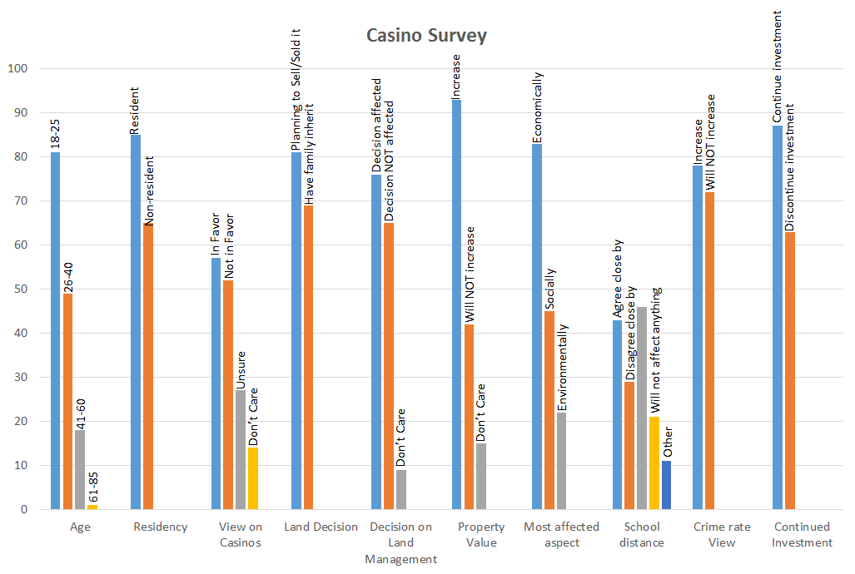
*based on 150 survey takers on 100 percentage calculation. Survey created on Survey Monkey.
The second method that was used to collect data to answer the question for this research paper regarding casino establishment here on island was through using the created survey above and released it online through social media; Facebook to be exact. Convenience is the key. According to research done by Szolnoki and Hoffman in 2013, “face-to-face interviews can be very discomforting for someone taking the survey, rather than it being done over the phone” (p. 2). So for the survey that aided the research paper at hand, an online survey had been reflected to be done. As suggested by the instructor for this class, the website Survey Monkey will be used to create the online survey for this research paper. The created survey was then posted on Facebook through the writer’s personal profile. This writer currently has about over 500 friends, and out of that, 150 had taken the survey. Based on data received from the survey released on Facebook alone, about 73% of people are in favor of having the casinos be established here on island.
Lastly, the method that was used to collect data to answer the question for this research paper regarding casino establishment here on island was through purposeful sampling. Earlier in the semester, the instructor for this course had asked the writer and rest of the class to create a letter to an expert regarding the research topic at hand. This writer had decided to write a letter to the CEO of Best Sunshine International, Mr. Mark Brown, a politician, Mr. Ed Propst, and an educator of the local college, Ms. Jacqueline Che. Their responses are still yet being followed up, but these experts’ feedbacks would be an important method that would be included on to the final report of the research paper.
Overview
Economically, this casino industry definitely brought in profit for the island. Tourism is obviously booming, and that can be seen with the new flights that have been coming in and out with tourists visiting the island. The increase of our tourists visits have also brought in new businesses; to name a few: new hotels, and new fast food restaurants such as iHop and Ajisen-Ramen. Employment has surely increased as well; giving even newly high school graduates a chance to start their occupational careers. Though these aspects of casinos appear to be positive, the reverse is high roller companies such as these casinos in fact, will hurt businesses here on island; especially the smaller, local companies. In a study done by Dr. Williams, Rehm, and Stevens, casinos such as Best Sunshine Live, offer other types of businesses, aside from their traditional gambling, that will bring them more internal revenue. Among of those amenities include hotels, varieties of internal vendors, and restaurants. Though that may sound pleasing to the ears of its consumers for transport or travel convenience, “these associated amenities could potentially compete with similar businesses in the local area (Rehm & Stevens, 2011, p. 38). The pros and cons of the economic impact of casinos on the island on several factors, but it do not change the fact that it could progressively hurt or even diminish local businesses here on the island.
Environmentally, these new constructions are starting to obstruct our beautiful exotic view of the beach side just so future hotel visitors will have a scenic sight from their room balcony. However, how will that affect the general outlook on the outskirts of the island from within the island itself? Will it be like the mainland where extreme traffic will be experienced and it will take 30 minutes to 1 hour just to drive to the closest beach? Will the island continue to lose our local plants like flame trees to make more room for these new buildings, when there are numerous-abandoned constructions that could have been revived and rescued?
According to research done by Shou-Tsung Wu and Yeong Shyang Chen, one of their sources indicated that generally, casinos are supposed to have a very positive feedback in a community. Aside from improving public awareness of the community’s environment, casinos also helped the protection of natural surroundings (Wu & Chen, 2015, p. 288)). In contrast, however, reported on the Pacific Islands Report, this last April 2016, a concerned citizen informed the Coastal Resource Management of evidence of wastewater discharge at the construction site of the Grand Mariana in Garapan. For this, the CNMI Bureau of Environmental and Coastal Quality fined Imperial Pacific/Best Sunshine International a charge of $40K for this repeated, destructive behavior (Erediano, 2016). One of the many things that the island is known for are its exotic sea wild life and coral reef preservation. With continuous constructions of these casinos and their possible, incessant violations of their permits, this island may lose one of its beautiful assets.
Socially, these booming businesses have brought Saipan new colleagues and friends overseas. Nonetheless, will they eventually come to try and adapt our island culture, or later completely takeover and change our local philosophies? Studies have shown social disturbances have actually occurred after casinos have been established for a certain period of time. On a journal written by Dr. Reith and the Scottish Centre for Social Research in 2006 mentions that,
“Research has found that proximity to casinos increases rates of problem gambling in the local population. Some studies have found that the location of a casino within 50 miles of an individual’s home can double the prevalence of problem gambling,” (Reith, 2006, p. 7).
There has already been reported news of families falling apart because of a family member who has become an addict gambler, causing domestic violence and extreme financial problems. One of the many cons of having a casino embarked on this island.
Economic, social and environmental impacts of casinos here on Saipan are just a few things that have been discussed in this essay. It would seem that revenue is the biggest upside for establishing these casinos here on Saipan, but the island people know, especially the elderly, that money is not everything. One of the many treasures that the island life can offer is its simplicity. The complexity that these casino businesses can generate may be the main thing that can destroy that simple life. Change happens, and that is a sign of progress, but unnecessary drastic changes, such as these casinos taking over may not be the best thing for Saipan.
Analysis
Every booming industry has its benefits. The casinos being established here on the island has its obvious subsidies for the island itself and its people, but this writer believes, otherwise, that in the long run, having the casino become the biggest part of the economy here on island will have its negative effects on the island and its residents. The following methods used to collect data for this research paper; the online survey and purposeful sampling are majority in favor of having the casinos be established on island, but a few have counter arguments that needed to be addressed and be heard.
As suggested by the instructor for this class, the website Survey Monkey will be used to create the online survey for this research paper. The created survey was then posted on Facebook through the writer’s personal profile. This writer currently has about over 500 friends, and out of that, 150 had taken the survey. Based on the data received from the survey released on Facebook alone, about 73% of people are in favor of having the casinos be established here on island. One of the many questions that seem to have taken quite an interest with the survey takers were the questions, “Do you think land property will increase with the casino on island?” and “Do you own land or property on this island…If yes, choose one of the following: planning to sell/lease it? Have children/family inherit the property?” Based on the results that have been collected just on these two questions alone, about 85% of the survey takers are in high favor of the casino establishments.
It would seem that the results received from the two main questions presented on the previous paragraph reflect what most of the residents of the island feel about having the casino industry. At least for those who have taken the survey, are implying that the revenue that they will receive from their properties, should they choose to sell, would be a very rewarding decision for them and their families. It also goes to show that monetary inheritances to be given to families are far more useful than land property inheritance.
The second method that was used to collect data to answer the question for this research paper regarding casino establishment here on island was through purposeful sampling. Earlier in the semester, the instructor for this course had asked the writer and rest of the class to create a letter to an expert regarding the research topic at hand. This writer had decided to write a letter to the CEO of Best Sunshine International, Mr. Mark Brown, a politician, Mr. Ed Propst, and an educator of the local college, Ms. Jacqueline Che. Out of the three letters that were sent out, only Mr. Brown and Ms. Che have successfully responded. Although it was just the two of them that came back to respond to this writer, their answers gave a lot to contribute for the data needed for this research paper. To summarize Mr. Brown’s response, he was very much in favor of having the casino industry be established here on island. Mr. Brown stated on his email interview, that though he would not know what the future holds for Best Sunshine and how it would affect the island in the long run, he does have some high hopes that would bring both the industry and its island community symbiotic success. Ms. Che, on the other hand, in summation, stated that she is not completely against the casino industry, but did want to share that change has both its positive and negative effects. Ms. Che indicated that with the changes that are about to take place, it is up to the residents of the island to embrace the good things, and either ignore the bad or deal with it head on to make it better.
Such results are worth sharing with the island community. With the help of the internet, this information will be shared through the writer’s social media. This writer had also considered creating a small pamphlet highlighting important information from this research project and possibly distributing it to convenient stores, the local schools and college, and may be even small business companies.
Conclusion
Concluding on the results for both the online survey and the responses from the purposeful sampling, this writer had actually come to consider Ms. Che’s feedback from her email interview. Though this writer was still not completely in favor of the casino industry being established here on island, this writer felt that the casino should be given a chance to show what they can improve to make this island more successful.

References
Erediano, Emmanuel T. (2016). Saipan Casino Fined for Environmental Violations at Site. Pacific Islands Report. 29 Apr 2016. http://www.pireport.org/articles/2016/04/29/saipan-casino-fined-environmental-violations-site. 15 Sept 2016.
Reith, Dr. Gerda. (2006). Research on the Social Impacts of Gambling. Final report prepared with the Scottish Centre for Social Research. p. 7.
Smith, Scott, Ph.D. (2012). 4 Common Sense Tips for Creating Surveys that Work. 31 Dec 2012. https://www.qualtrics.com/blog/creating-surveys/. 25 Oct 2016.
Survey Monkey. https://www.surveymonkey.com/r/JBTYPXY 18 Oct 2016.
Szolnoki, Gergely & Hoffman, Dieter. (2013). Online, Face-to-Face and Telephone Surveys – Comparing Different Sampling Methods in Wine Consumer Research. p.2.
Williams, R.J., Rehm, J., & Stevens, R.M.G. (2011). The Social and Economic Impacts of Gambling. Final Report prepared for the Canadian Consortium for Gambling Research. March 11, 2011. p. 38.
Writing Good Survey Questions. Survey Monkey. https://www.surveymonkey.com/mp/writing-survey-questions/. 25 Oct 2016.
Wu, Shou-Tsung, & Chen, Yeong-Shyang. (2015). The Social, Economic, and Environmental Impacts of Casino Gambling on the Residents of Macau and Singapore. Tourism Management. p. 288.

Note Taking Sheet: Reading Notes 2
Name: Jacky Lou B. Pestillos
EN101 Section ON01
With many sources to read and evaluate, you need a way to keep track of the material you may use in your research paper. You need to record where you have looked, what you have found, and how to find each piece of information again (this is for your bibliography).
Directions: Fill in the information below, and keep with all of your resources. This will help you when it is time to write your outline, paper, and annotated bibliography.

- Author’s Name: Szolnoki, Gergely & Hoffman, Dieter
- Author’s Credentials: Both are professors at Geisenheim University, Germany
- Publisher: Academy of Wine Business
- Heading of Section [title of reading]: How to Create a Survey and Collect Data
- Year written: 2013
- Pages: 2
- Website URL: http://academyofwinebusiness.com/wp-content/uploads/2013/04/Szolnoki-Hoffmann.pdf

- Author’s Name: Smith, Scott, Ph.D.
- Author’s Credentials: doctor of Philosophy
- Publisher: Qualtrics Blog
- Heading of Section [title of reading]: How to Create a Survey and Collect Data
- Year written: 2012
- Pages: [website]
- Website URL: https://www.qualtrics.com/blog/creating-surveys/

- Author’s Name: admin
- Author’s Credentials: not applicable
- Publisher: Survey Monkey
- Heading of Section [title of reading]: How to Create a Survey and Collect Data
- Year written: --
- Pages: [website]
- Website URL: https://www.surveymonkey.com/mp/writing-survey-questions/

Main Ideas/Points | Important Quotations | Supporting Details | Relevance to Your Assignment
- Disadvantages of face-to-face surveys | “face-to-face interviews can be very discomforting for someone taking the survey, rather than it being done over the phone” | - There are more convenient ways to send out surveys to help support studies. | - Convenience of collecting data to support the effects of casinos on the island
Main Ideas/Points | Important Quotations | Supporting Details | Relevance to Your Assignment
- Common sense tips for creating surveys | - “extend the power of analysis from basic percentages to high-level analyses based on means and variant estimates (like t-test, ANOVA, regression, and the like).” | - Using scales can give more information about a question on a survey | - An aspect that can be used in creating the surveys for the research paper
Main Ideas/Points | Important Quotations | Supporting Details | Relevance to Your Assignment
- One useful source to create surveys | - “speak their language.” | - Using language to relate with majority of the survey takers | - An aspect that can be used in creating the surveys for the research paper
- In this article, is it possible that any of the authors might have a bias about the subject matter? NO __ provide examples if needed.

Is the article timely or a bit outdated? Timely. Dated about 3 years ago.
Was it published in a reputable source? Yes
It is an academic source.
Other important information: Referred readings and sources on the topic.
- In this article, is it possible that any of the authors might have a bias about the subject matter? Yes, just because a blog can be based on a the author’s opinions.
Is the article timely or a bit outdated? Timely. Dated about 4 years ago.
Was it published in a reputable source? Yes
It is not an academic source.
Other important information: Referred readings and sources on the topic.
- In this article, is it possible that any of the authors might have a bias about the subject matter? Yes, just because this is a site composed by a number of makers that may have their own point-of-view of what a good survey is all about.
Is the article timely or a bit outdated? Yes. Dated about 4 years ago.
Was it published in a reputable source? Unsure, but copyright states up to date to 2016.
It is an online software used as a source to gather data.
Other important information: Referred readings and sources on the topic.

Process Essay Outline
Title: How to Create a Survey and Collect Data
Introduction
Thesis: The process of creating survey and collecting data can have significant help in a research paper.
Method Overview
Process 1: Brainstorm and outlining questions for the survey
- Consider audience, simplicity of questions, and word choice
Process 2: Creating the survey
- Mention different types of surveys (face-to-face interview, telephone interview, and written/digital (online) questionnaire)
- Mention what type survey has been chosen to aid this research paper (online survey)
Process 3: Collecting Data
- Describe how data was retrieved to draw a report to support the research paper
Conclusion

Brainstorm
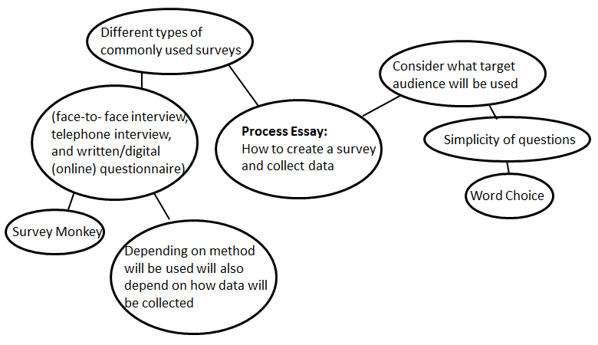

Reflection
A couple of years have gone by since I graduated high school, and it sure has been great to be back to pursue a higher level of education. One of the courses that I took this semester was English 101, and this class had given us a project to work on the whole semester regarding the pressing concerns that our island is experiencing or will be affected by. The research topic I had chosen to write was about how the casino would be affecting the CNMI in the long run. The reason why I chose this topic was because I felt so opinionated about it in the beginning of the semester. It was also one of the interesting topics that people of the island and visitors’ of the island have been talking about for the past couple of years. I felt that it was a really good topic, but as I worked on the four different types of essays to complete the research throughout the semester, I sensed that I should have chosen another topic.
To complete the research paper we were tasked by our instructor to write four different types of essays to collaborate at the end of the semester that will compose our research paper. We had to write a research essay, a cause and effect essay, a process essay, and an expository essay. I have learned that the process essay actually explained the method as to how the data was collected and presented to be used as a source to answer my research topic. At first I struggled writing it because I did not fully understand what was asked of me to do to write this process essay, but after being given a chance to revise it, I realized that it was like writing a recipe that can be used by future researchers to follow the methods I used to collect data for my research paper.
I was actually rather disappointed about my methodology outcomes. I felt that I did not collect more data to fully support my research question. I thought that maybe my research question was too superficial that I should have dug deeper into it. Despite that circumstance, however, I do feel that the sources and data that I have collected were good information to share with the public just so the island people and its visitors are more aware of what the casino has done for the CNMI so far since it has been established.
Sources wise, we had our in-class text book to help guide us in writing this research paper, but I found the internet far more useful. I guess it is because it is so much easier to look for anything on the internet. I had learned a lot about APA writing style that helped improved my writing skills, but I have gotten so used to writing in MLA format that I think in the future, I will continue to use Purdue Owl to help guide me in writing papers APA style. Regarding my sources for my research paper, I did find it rather difficult to find academic sources to support my research paper, which is why I guess I wished I had chosen a different topic.
I would say that I have learned so much in this course. I am confident to say that this class had helped me analyze literature in a more critical way. It helped me dissect information that I can use to write any given topic. Practice makes perfect, and I know that the more I am exposed to writing academic papers the more that I would get better at it. To be honest, writing papers in general is not my thing. Up to this point I feel that writing papers are one of the most difficult things a student can do, in exemption of course, to those students who love writing. I honestly feel that grammar can be so difficult that I find it rather frustrating to look at grammatical errors when essays are proofread though sound right when you listen to it, but it is what it is. It is a bunch of guidelines that we need to follow in order for us to achieve to deliver whatever our messages are to our audiences. Regardless of the some of the achievable struggles I had in this course, I am proud to say that I have learned so much that I will definitely use in future college courses.

