The Effects of Anchor Babies Research Project

Peter John Anore
EN01/ON01 Fall 2017
NMC
Dr. Kimberly Bunts- Anderson

Running Head: Immigration Page 1

U.S. Born Immigrants (Final Research Proposal)
Peter John D. Anore
EN 101
Northern Marianas College

Immigration Page 2
Introduction:
Children born as undocumented or illegal immigrants, gain no more rights to U.S. citizenship than their parents. Despite all the different proposals offered by our legislative, the immigration laws built in the U.S. contain no special rights regardless of what age a person arrived in the United States. However, a child born on U.S. soil (Ex: CNMI) is granted U.S. citizenship automatically, regardless of their parental status, obtaining all of the rights that every other citizen is entitled to. Referring to the 14th Amendment of the U.S. Constitution that states:
“No state shall make or enforce any law which shall abridge the privileges or immunities of citizens of the United States; nor shall any state deprive any person of life, liberty, or property, without due process of law; nor deny to any person within its jurisdiction the equal protection of the laws.”-14th Amendment
With that being said, the CNMI immigrant population stood at about 62.7% of the total CNMI population (53,467) as of July 2016. And in the U.S., the immigrant population stood at more than 43.3 million or 13.5% of the total U.S. population (321.4 million) as of 2015. An estimated 5.3 million children live with unauthorized/illegal immigrant parents. However, only 85% of those young men and women are born a U.S. Citizen.
Dissection:
Through the next twelve weeks, a research will be conducted to shine light on to the pros and cons of new born immigrants in the United States. Within the first two weeks, a personal research will be carried out to a minimum of 30 people on the island of Tinian. This personal
Immigration Page 3
research will have the participants complete a survey/questioner about the number of immigrants on island. This survey/questioner will consist of questions like; did any members of your family migrate to the country you live in? What are the reasons for migrating? And do you have more friends with migration back ground or more with natives from the island? Next, the survey will be analyzed/ reviewed within the third week of my research as well as prewrite my first draft.
Then the fourth to fifth week will be used to gain primary as well as secondary research from literature found with in text books, blog post, news articles, and scholarly journals. This research paper will also include statistical data found in Facebook, Twitter, and Instagram. In the sixth week, analyzation of the extensive research will take place to better organize the findings as well as compile the personal research, primary research, and secondary research. By then most of research/findings will be completed and during the seventh week, compilation will take place and first draft will take shape. During this week the additional research will be added if needed more information.
Next, the eighth to ninth week will be used to correct as well as edit the first draft, adding on any necessary data or corrections if needed. Finally, the tenth to twelfth week will be final corrections and completions. Within these three weeks, peer review will take place to better review the findings that were obtained and confirm if all the information is relevant. The research will include background information of immigrant children born United States as well as the benefits and drawbacks of their right to freedom.

Immigration Page 4
Conclusion:
Immigration is a big part of the CNMI. In fact 50 percent of the population in the CNMI are immigrants and make up a big part of our economy, and citizenship among immigrants is often seen as one of the highest status available under the U.S. immigration policy. As a born U.S. citizen, the child who is granted all of the rights and opportunities many other citizens are offered, such as the rights to vote, and be immune from deportation. However, with amazing opportunities come with consequences. Children with parents or guardians who are considered undocumented create the risk of hardships for their child who is granted the freedom. Though this research light will be shined onto why it is important to know the benefits and drawbacks of immigrants giving birth in the United States soil.
SCHEDULE:
September 18th - September 30th | Survey
October 1st - October 8th | Analyzation of Survey
October 9th - October 21th | Primary/ Secondary Source Research
October 22th - October 31st | Analyzation of Research
November 1st - November 8th | Compilation/First Draft
November 9th - November 21th | Editing/Correcting
November 22th – December 11th | Final Draft

Immigration Page 5
Reference Page:
• Should the Undocumented Parents of US Citizen Children Be Allowed to Remain in the United States? - Illegal Immigration - ProCon.org. (2015, August 2). Retrieved September 05, 2017, from https://immigration.procon.org/view.answers.php?questionID=000775
• Should the Children of Illegal Aliens Be U.S. Citizens? (2010, August 27). Retrieved September 05, 2017, from https://www.usnews.com/opinion/articles/2010/08/27/should-the-children-of-illegal-aliens-be-us-citizens
• Spalding, M. (2010, August 30). Should the Children of Illegal Aliens Be U.S. Citizens? Retrieved September 05, 2017, from http://www.heritage.org/immigration/commentary/should-the-children-illegal-aliens-be-us-citizens
• Northern Marianas Island People 2017, CIA world fact book (2017, January 12). Retrieved September 05, 2017, from https://theodora.com/wfbcurrent/northern_mariana_islands/northern_mariana_islands_people.html

What is the Difference between a research question and a research topic?
- Topic:
• Global warming and climate change in the CNMI.
Research Topic:
- Cause for global warming and climate change in the CNMI
- The effect of global warming and climate change towards the CNMI
- Solutions to climate change
Research Questions:
- What are the cause and effect of global warming and climate change?
- What are the different solutions to this problem?
- Are we able to reverse the effects?
- Who are we affecting the most?

- Topic:
- Anchor Babies
Research Topic:
- Children born in the U.S. from immigrant parents.
- Cause and effects of anchor babies
- Solutions to the problem.
Research Questions:
- What are the reasons for the rise in anchor babies?
- How does this problem affect us?
- Who are we going to affect the most?

Running Head: Immigration Page 1

U.S. Born Immigrants
(Process Essay Data Collecting Outline)
Peter John D. Anore
EN 101
Northern Marianas College

Immigration Page 2
Introduction:
Within my introduction paragraph I would start by introducing the data and statistic of the immigration in the United States. One source I would use is from Wikipedia, the free encyclopedia (Immigration to the United States), with the information “The United States has a larger immigrant population than any other country, with 47 million immigrants as of 2015.[1] This represents 19.1% of the 244 million international migrants worldwide, and 14.4% of the U.S. population.” Secondly, I would apply the 14th amendment form kids.laws.com which states that and individual born on United States soil will be granted the same rights and protections. Ultimately granting citizenship to any and all individual born in the United States.
Body 1:
Within body one I would be gathering information from online sights or articles. One sight that will help me with my research comes from Naturalization Advantages and Disadvantages (By: Tao Zhang). That states some of the positive effects of children immigrants born in the U.S. At the same time gathering information about the negative effects that come from immigrants being granted the right of a U.S. Citizen. This will help with my research because it brings up the opportunities and setbacks of Children born in the U.S. and compares them. The next source of information would come from Pros and Cons to Getting US Citizenship (By: britishexpats.com). This gathers more information on the benefits and setbacks.

Immigration Page 3
Body 2:
For my second body, information would be gathered from literary sources such as books or technology. Research will be conducted at the Tinian Public Library to discover book, newspapers, and technology (PC) sources. Gathering information about the positive/negative benefits and effects of children of immigrant parents born in the U.S. Recommended sources come from www.equalvoiceforfamilies.org. Here I will be able to find some real life pros and cons.
Body 3:
Within body three I’ll be show casing my own personal data which comes from a survey. The survey will consist of 10-13 questions that ask about personal experiences and general knowledge of children from immigrant parents born in the United States. The survey will be given to about 25 individuals from my community and from English 101-Online (classmates).
Conclusion:
In my conclusion paragraph I will restate my three main sources such as article data, literary sources, and personal data as well as restate my findings. I’ll include a resource or sight that show cases the benefits of these children like from www.newamerica.org. Finally, I’ll bring up my finally thoughts and views of the matter.

Process Essay Data Collecting Outline
- Data Collecting
  - Introduction:
    - Statistical Data from online sources
      - Population update (By Steven A. Camarota and Karen Zeigler on April 21, 2015)
  - Body:
    - Data will be collected though articles online
      - Naturalization Advantages and Disadvantages (By: Tao Zhang)
      - Pros and Cons to Getting US Citizenship (By: britishexpats.com)
    - Literary Sources
      - Research will be conducted at the Tinian Public Library to discover book, and technology (PC) sources. Gathering information about the positive/negative benefits and effects of children of immigrant parents born in the U.S.
    - Personal Research Survey
      - 20-30 random individuals from areas like Tinian JC Café, Tinian Library, or Tinian High School from 10/25-10/30. There will be approximately 10 questions.
      - Personal survey data will be collected and analyzed from EN101 course students from a previous week.
  - Conclusion:
    - Data from online sources: How many immigrants are naturalized U.S. citizens? (By: Jie Zong and Jeanne Batalova)

Peter John D. Anore
EN101-ON01
Anderson
FA, 2017
11/03/17
Children of Immigrant Parents Born in the U.S.
(Conducting Primary Research)
When it comes to the birth rates in the United States it is estimated that one out of 12 newborns in the U.S. can be classified as the so-called “anchor baby.” Anchor baby is a pejorative term used to classify a child or infant born in the United States to foreign national parents (mainly from mothers) who is classified as not a lawfully admitted permanent resident. The term is a reference to the role of the child, who automatically gains the right of an American citizen guaranteed by the 14th amendment. For example, a study from Pew Research says that the births to unauthorized-immigrant parents rose sharply from 1980 to the mid-2000s, but dipped since then, echoing overall population trends for unauthorized immigrants (Passel & Cohn, 2015). This goes to show that the so-called anchor baby situation have been a part of our society for a long time.
In a study, it is estimated that about 295,000 babies were born to unauthorized-immigrant parents in 2013, making up 8% of the 3.9 million U.S. births (Passel & Cohn, 2015) In 2007, an estimated 9% of all U.S. babies were born to unauthorized-immigrant parents, meaning that at least one parent was an unauthorized immigrant. The main source for the rise of anchor babies is tourism. The reason for this action is simple, to gain the rights and benefits of a U.S. citizen. While the number of pregnant 'birth tourists' who come here legally to take advantage of the fact that all persons born in the United States are citizens of the United States was recently estimated at 36,000 a year (Semotiuk, 2016). Anchor babies act as a sponsor for other family members upon reaching the age of adult hood (18). The ultimately offers the same rights and opportunities to immigrant parents. An incidence has occurred where there has been a growing trend, especially amongst Asian and African visitors from Hong Kong, China, South Korea, Taiwan and Nigeria to the United States, to make use of "Birth Hotels" to secure US citizenship for their child and leave open the possibility of future immigration by the parents to the United States (Los Angeles Times, All Africa, Audie Cornish, & Alyssa Newcomb “Wikipedia”). In the U.S., as I pointed out previously, “birth tourism” is a flourishing business, offering benefits to the economy. Pregnant women fly here, stay at special hotels and pay sometimes extraordinarily high costs for “concierge services” designed to facilitate the birth of their children (Semotiuk, 2016).
Anchor babies have many benefits to the economy, parents, and the children themselves. With the 14th amendment in affect it creates diversity in society and brings income to the community or state. With tourist paying high costs for “concierge services” to gain the rights of a U.S. citizen it brings the income needed to sustain the economy. That same survey found that most Americans (87%) said they were aware of the constitutional guarantee of birthright citizenship (Passel & Cohn, 2015). I believe that anchor babies bring opportunities. What will our economy/society in the U.S. be like without the births of children from immigrant parents? The reason why I have choose these sites and individuals to help with my research is because they offer data information and research about anchor babies (children from immigrant parents born in the Unites States)
Resource:
• Anchor baby. (2017, October 07). Retrieved November 04, 2017, from https://en.wikipedia.org/wiki/Anchor_baby
• Semotiuk, A. J. (2016, October 10). The Citizenship And Immigration Problems Of Anchor Babies And Surrogacy. Retrieved November 04, 2017, from https://www.forbes.com/sites/andyjsemotiuk/2016/10/05/the-citizenship-and-immigration-problems-of-anchor-babies-and-surrogacy/#5a0baa9155b3
• Passel, J. S., & Cohn, D. (2015, September 10). Number of babies born in U.S. to unauthorized immigrants declines. Retrieved November 04, 2017, from http://www.pewresearch.org/fact-tank/2015/09/11/number-of-babies-born-in-u-s-to-unauthorized-immigrants-declines/

Running Head: Anchor Babies 1

U.S. Born Immigrants
(Process Essay Data Collecting Outline)
Peter John D. Anore
EN 101
Northern Marianas College

Header: Anchor Babies 2
U.S. Born Immigrants
About every 12 newborns in the United States one can be classified as an “Anchor Baby.” The term, anchor babies is used to identify children born by noncitizen mothers in a country which has birthright citizenship, especially when viewed as providing an advantage to family members seeking to secure citizenship or legal residency. In Pew Research Center, roughly 295,000 children are born to undocumented immigrants in 2013, and while the number of pregnant “birth tourists” who come to the United States legally to take advantage of the opportunities was estimated to be at 36,00 every year. The rights of citizenship if offered be the 14th Amendment. This is just a few of many important findings that I have gathered over the duration of my research on children born by immigrant parents in the United States. So the question now is what are the outcomes?
During the course of my research I was able to discover important events, facts, and information on the so called anchor babies. My findings began with important events such as the creation of our constitution and the agreement of the 14th amendment. This states, “No state shall make or enforce any law which shall abridge the privileges or immunities of citizens of the United States; nor shall any state deprive any person of life, liberty, or property, without due process of law; nor deny to any person within its jurisdiction the equal protection of the laws.”- (14th Amendment). This important discovery led me to the understanding of what immigrants are looking for or hoping to gain. After understanding the law that was created to protect the citizens of the state I turned to another source/experts that helped me discover important facts

Header: Anchor Babies 3
and effects. By looking for and discovering individuals that are experts on the topic I was able to include data that was gathered over the years like statistics and population data.
Before analyzing my data I gathered my information by brainstorming important dates, facts, and events that has a great effect on my discovery of anchor babies. By using a scratch outline I was able to organize my findings/thoughts. My information/data was gathered from online research, literature and personal survey. I created questions that ask personal thoughts, and knowledge of the event. My survey was conducted by 15 random individuals from my community and my online course. After gathering some rather interesting data I was able to conduct the next step of analyzing my data. To analyze my information I referred back to my brainstorm strategy which is the scratch outline.
The outcome is discovering brand new information that help me identify reasons/purposes of the activities and determine the cause and effect of the rise in anchor baby’s birth rates. ---- In a study, it is estimated that about 295,000 babies were born to unauthorized-immigrant parents in 2013, making up 8% of the 3.9 million U.S. births (Passel & Cohn, 2015) In 2007, an estimated 9% of all U.S. babies were born to unauthorized-immigrant parents, meaning that at least one parent was an unauthorized immigrant. The main source for the rise of anchor babies is tourism. The reason for this action is simple, to gain the rights and benefits of a U.S. citizen. While the number of pregnant 'birth tourists' who come here legally to take advantage of the fact that all persons born in the United States are citizens of the United States was recently estimated at 36,000 a year (Semotiuk, 2016). Anchor babies act as a sponsor for other family members upon reaching the age of adult hood (18). The ultimately offers the same
Header: Anchor Babies 4
rights and opportunities to immigrant parents. An incidence has occurred where there has been a growing trend, especially amongst Asian and African visitors from Hong Kong, China, South Korea, Taiwan and Nigeria to the United States, to make use of "Birth Hotels" to secure US citizenship for their child and leave open the possibility of future immigration by the parents to the United States (Los Angeles Times, All Africa, Audie Cornish, & Alyssa Newcomb “Wikipedia”). In the U.S., as I pointed out previously, “birth tourism” is a flourishing business, offering benefits to the economy. Pregnant women fly here, stay at special hotels and pay sometimes extraordinarily high costs for “concierge services” designed to facilitate the birth of their children (Semotiuk, 2016).
Anchor babies have many benefits to the economy, parents, and the children themselves. With the 14th amendment in affect it creates diversity in society and brings income to the community or state. With tourist paying high costs for “concierge services” to gain the rights of a U.S. citizen it brings the income needed to sustain the economy. That same survey found that most Americans (87%) said they were aware of the constitutional guarantee of birthright citizenship (Passel & Cohn, 2015). I believe that anchor babies bring opportunities. What will our economy/society in the U.S. be like without the births of children from immigrant parents? The reason why I have choose these sites and individuals to help with my research is because they offer data information and research about anchor babies (children from immigrant parents born in the Unites States). Citizenship is viewed as the highest status available under the U.S. immigration laws. As a native-born U.S. citizen, the child in question will be granted all of the rights that every other citizen is entitled to, such as the rights to vote, assume public office, and be immune from deportation (removal).
Header: Anchor Babies 5
Resources:
• Anchor baby. (2017, October 07). Retrieved November 04, 2017, from https://en.wikipedia.org/wiki/Anchor_baby
• Semotiuk, A. J. (2016, October 10). The Citizenship And Immigration Problems Of Anchor Babies And Surrogacy. Retrieved November 04, 2017, from https://www.forbes.com/sites/andyjsemotiuk/2016/10/05/the-citizenship-and-immigration-problems-of-anchor-babies-and-surrogacy/#5a0baa9155b3
• Passel, J. S., & Cohn, D. (2015, September 10). Number of babies born in U.S. to unauthorized immigrants declines. Retrieved November 04, 2017, from http://www.pewresearch.org/fact-tank/2015/09/11/number-of-babies-born-in-u-s-to-unauthorized-immigrants-declines/

Name: Peter John Anore
Reading Notes to fill out when reading course and outside reading materials for assignment

Note Taking Sheet: Reading # __1__

EN 101 – ON01 English Composition I (Online) Fall 2017 Course
EN COURSE NAME English Composition Section ON01_

With many sources to read and evaluate, you need a way to keep track of the material you may use in your research paper. You need to record where you have looked, what you have found, and how to find each piece of information again (this is for your bibliography).

Directions: Fill in the information below, and keep with all of your resources. This will help you when it is time to write your outline, paper, and annotated bibliography.
Resource 1:
1. Author’s Name: Landale, Thomas, and Hook
2. Author’s Credentials: (Landale, Thomas, and Hook)
3. Publisher [or title of organization]: Future Children
4. Heading of Section [title of reading]: The Living Arrangements of Children of Immigrants
5. Year Written: 2011
6. Paragraph:
7. Website URL: https://www.ncbi.nlm.nih.gov/pmc/articles/PMC3241619/
Resource 2:
1. Author’s Name: Ana Campoy
2. Author’s Credentials: (Ana Campoy)
3. Publisher [or title of organization]: Quartz Media
4. Heading of Section [title of reading]: A quarter of all children in the US have an immigrant parent
5. Year Written: March 09, 2017
6. Pages/paragraph: 3
7. Website URL: https://qz.com/928098/a-quarter-of-all-children-in-the-us-have-an-immigrant-parent/
Resource 3:
1. Author’s Name: Penn Wharton Team
2. Author’s Credentials: (Penn Wharton Team)
3. Publisher [or title of organization]: Penn Wharton University
4. Heading of Section [title of reading]: THE EFFECTS OF IMMIGRATION ON THE UNITED STATES’ ECONOMY
5. Year Written: June 27, 2016
6. Pages/paragraph: 8
7. Website URL: http://www.budgetmodel.wharton.upenn.edu/issues/2016/1/27/the-effects-of-immigration-on-the-united-states-economy

Main Ideas/Points | Important Quotations | Supporting Details | Relevance to Your Assignment
- Lost of electricity and water from faucets | - “The island currently remains without power, water and wastewater services as broken power poles and downed wires lay scattered across roads and buildings.” | - Lack of electricity and water caused people to find other ways in order to catch water such as fetching rain water. | - Power was out which affected the people of Saipan.
Main Ideas/Points | Important Quotations | Supporting Details | Relevance to Your Assignment
Resource 1:  Children of Immigrant(s)’ living conditions. | “Parental social and economic attributes, for example, differ for children in refugee and non-refugee families, with other Asian immigrants tending to be more highly skilled and better educated than Southeast Asian refugees.” | In the CNMI with the Tinian Dynasty incident it created problems not only for the parents but for the children who are U.S. citizens. | The decrease in CW workers created an economic problem for the people of Tinian.
Resource 2:  The benefits of children of immigrant parents staying together. | “Immigrants’ kids are bound to have a big impact on US politics and policies in coming years. The vast majority of them, 15.8 million, or 88%, were born in the US.” | With CNMI comprise of different ethic back grounds. The future of the CNMI fall in the hands of the new. | Children have a bigger impact towards the future of the CNMI.
Resource 3:  Negative impacts of illegal immigrants. | “The largest impact has been on the supply of workers without a high school degree and of workers at the high end of the education spectrum – those with a college or postgraduate degree.” | Without the need of paper work, hiring illegal immigrants are easier to obtain and cost less. | For children with illegal immigrant parents. It creates some negative impact towards native workers.

Resource 1:
In this article, is it possible that any of the authors might have a bias about the subject matter?
- No
Is the article timely or a bit outdated?
- Outdated, 6 years back.

Was it published in a reputable source?
- Yes.
- A study of immigration living conditions.

Other important information:
- Referred readings and sources on the topic.

Resource 2:
In this article, is it possible that any of the authors might have a bias about the subject matter?
- No
Is the article timely or a bit outdated?
- Timely, 7 months back.

Was it published in a reputable source?
- Yes

Other important information:
- Referred readings and sources on the topic.

Resource 3:
In this article, is it possible that any of the authors might have a bias about the subject matter?
- No, in this article they were able to state both positive and negative impacts of immigration.
Is the article timely or a bit outdated?
- Bit outdated, 1year back.
Was it published in a reputable source?
- Yes.
- It is an academic source.
Other important information:
- Referred readings and sources on the topic.

Peter John Anore
11/08/17
EN 101 - ON01
Dr. Kimberly Anderson
Anchor Babies
“Anchor babies,” is a term used to identify children born by noncitizen mothers in a country which has birthright citizenship, especially when viewed as providing an advantage to family members seeking to secure citizenship or legal residency. This is just one of many important findings that I have gathered over the duration of my research on children born by immigrant parents in the United States.
During the course of my research I was able to discover important events, facts, and information on the so called anchor babies. My findings began with important events such as the creation of our constitution and the agreement of the 14th amendment. Which states, “No state shall make or enforce any law which shall abridge the privileges or immunities of citizens of the United States; nor shall any state deprive any person of life, liberty, or property, without due process of law; nor deny to any person within its jurisdiction the equal protection of the laws.”-(14th Amendment). This important discovery led me to the understanding of what immigrants are looking for or hoping to gain. After understanding the law that was created to protect the citizens of the state I turned to another source/experts that helped me discover important facts and effects. By looking for and discovering individuals that are experts on the topic I was able to include data that was gathered over the years like statistics and population data.
Before analyzing my data I gathered my information by brainstorming important dates, facts, and events that has a great effect on my discovery of anchor babies. By using a scratch outline I was able to organize my findings/thoughts. My information/data was gathered from online research, literature and personal survey. I created questions that ask personal thoughts, and knowledge of the event. My survey was conducted by 15 random individuals from my community and my online course. After gathering some rather interesting data I was able to conduct the next step of analyzing my data. To analyze my information I referred back to my brainstorm strategy which is the scratch outline.
I was able to discover much important information over the duration of my research. This essay will be able to fit in the discovery part of my research. By showcasing my proses it gives the readers a first person view of my discovery.

Survey:
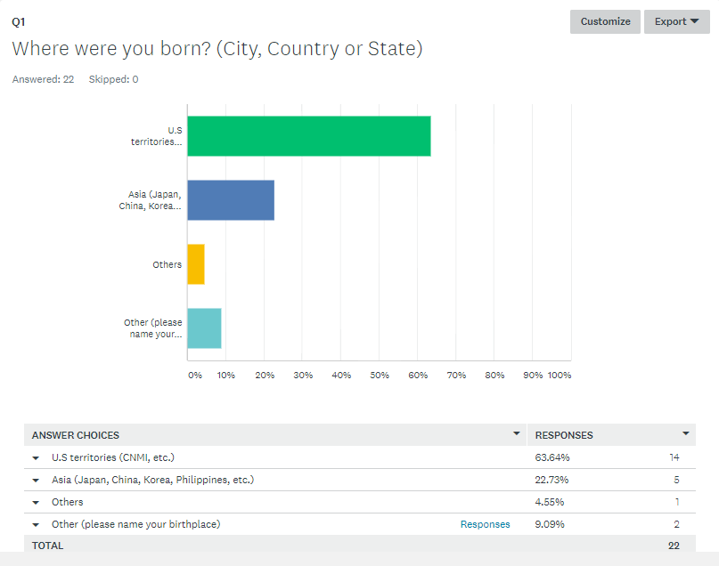
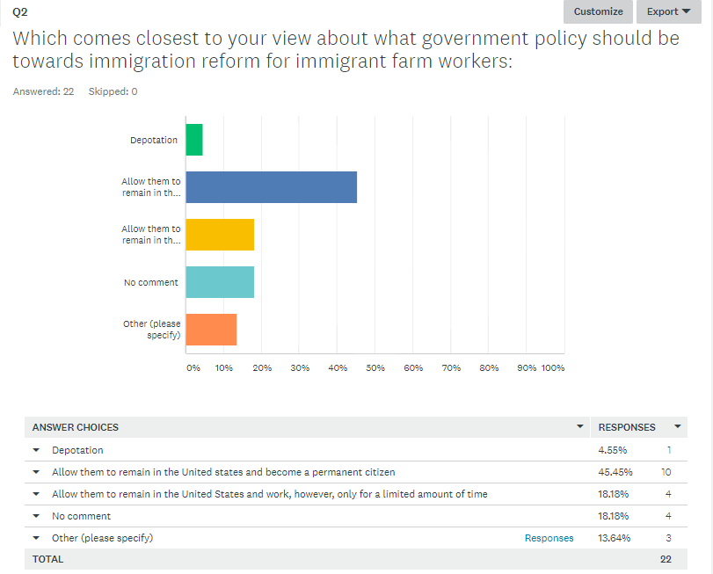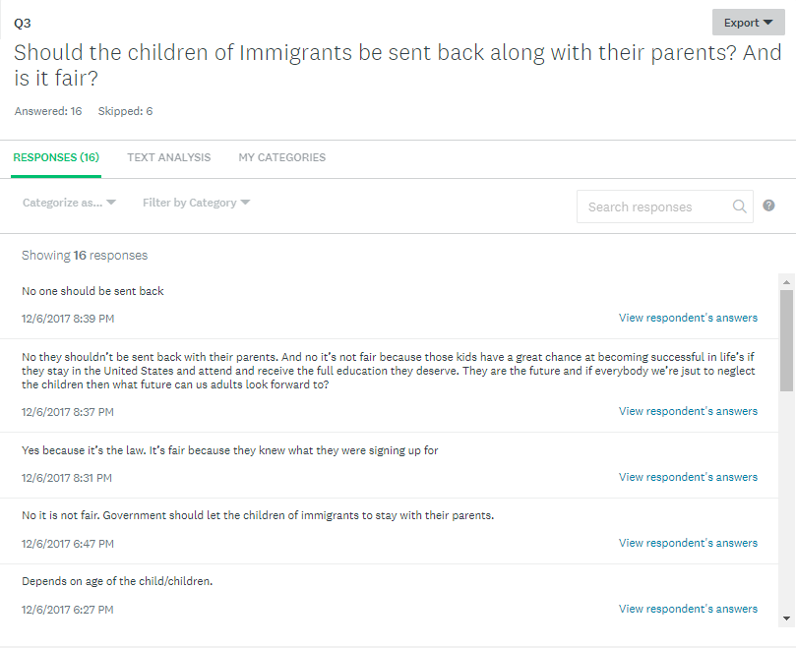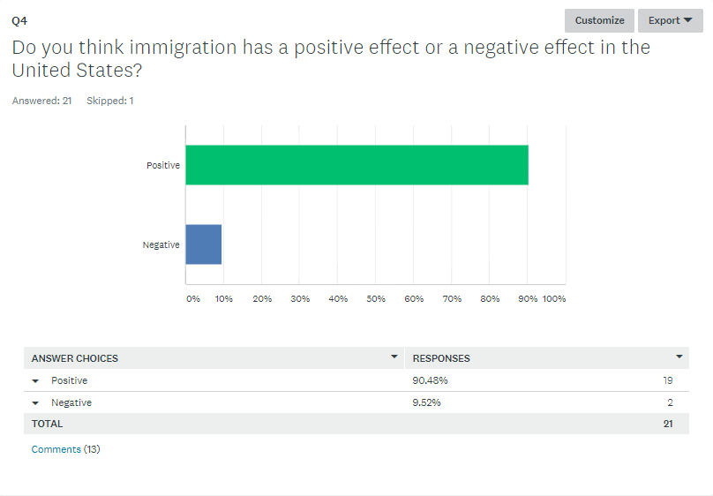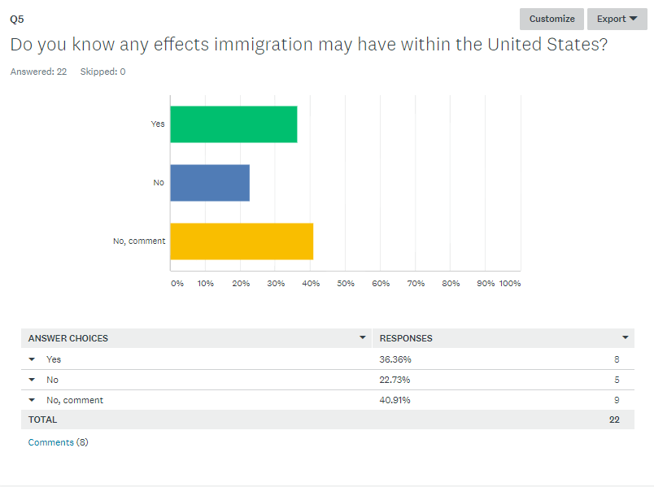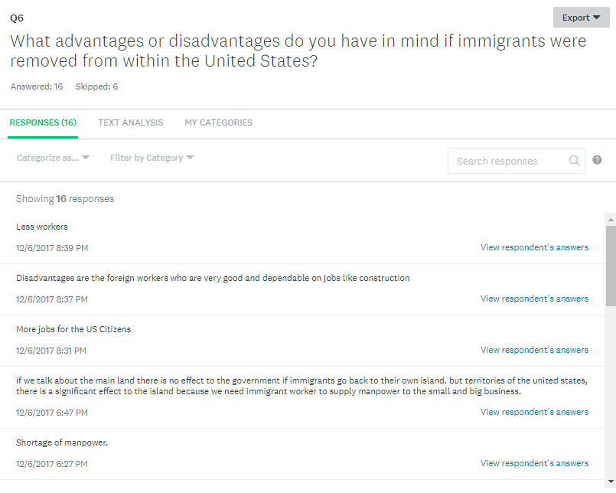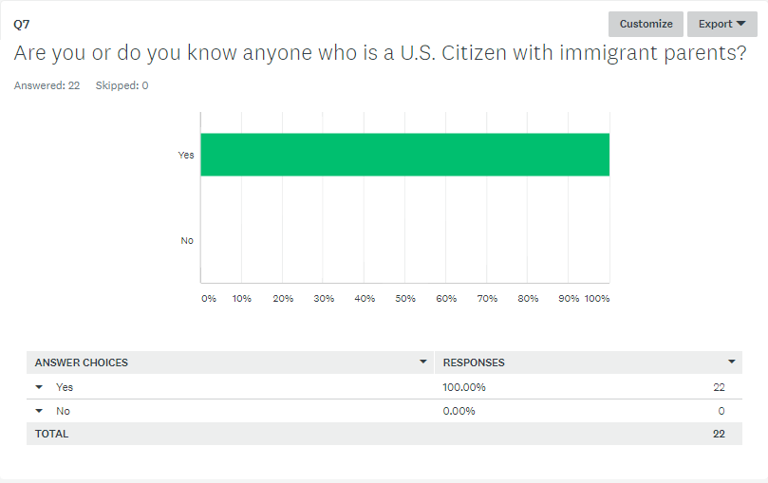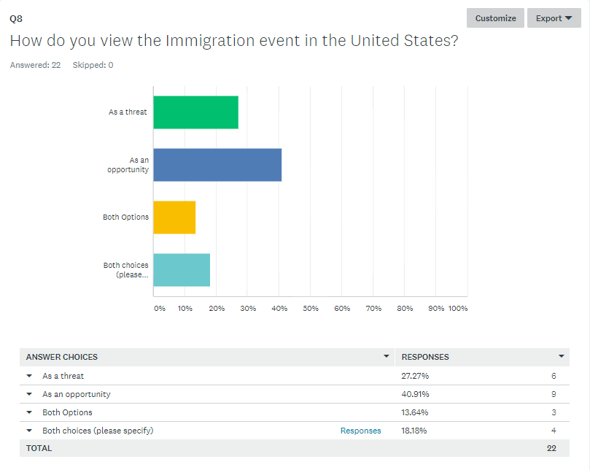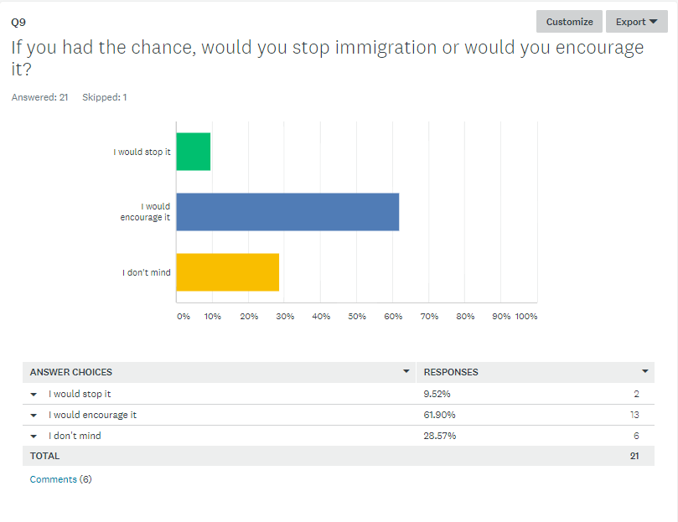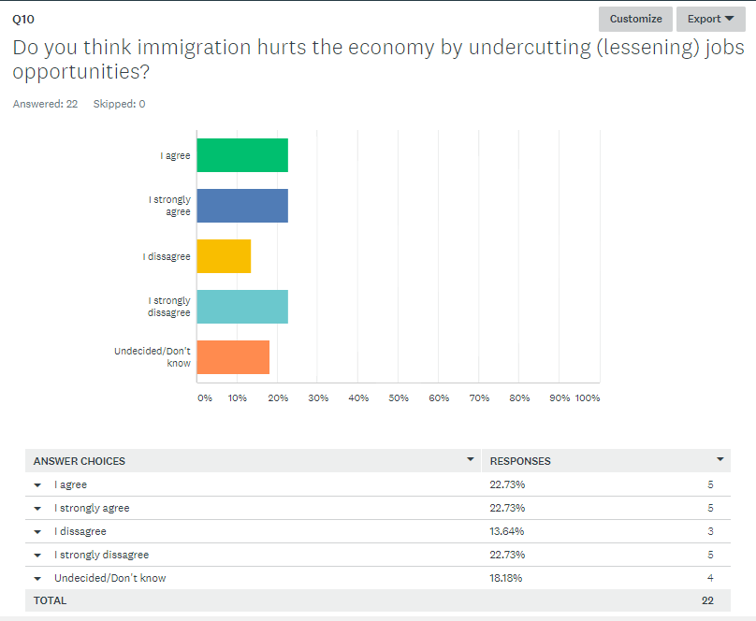

Name: Peter John Anore
______________________________________________________________________________
Topic: Births By Immigrants In The U.S.
______________________________________________________________________________
SCRATCH OUTLINE
- The increase in U.S. births since 1970 has been driven entirely by births to immigrant mothers.
a - Immigration helps with the lack of workers
- Children of immigrant parents born in the united states have better opportunities.
a/c - Immigrant parents of US born children have the same or better opportunities.
b - Immigration prevents locals from obtaining jobs.
b - Children of immigrants have the potential of being homeless of losing their parents and being orphans.
- Children of immigrant parents born in the U.S. should have the same rights.
a - “Birth tourism” is a flourishing business.
a/c (similar to a previous one)- Children of immigrants have the potential of creating a better life.
c - Life in the U.S. territories offer more opportunities.
b - Surrogacy
a - Immigration creates a diverse of culture and race.
a - Giving Citizenship to the Children of Illegal Immigrants Will Help Combat Racism
______________________________________________________________________________
a - Positive Effects
b - Negative Effects
c - Reasons for children of immigrants born in the U.S.

(Letter To Experts)
Peter John D. Anore
P.O. Box 398
San Jose Village, Tinian
peter.anore@my.marianas.edu | (670)-433-6422
Oct. 21, 2017
To whom it may concern,
This letter is regarding questions and findings I may have on a study I am currently conducting about children of immigrants who happen to be born in the United States. My reasons for the research are to understand and clarify whether or not these children should be offered the same rights.
To start things off, what I have found is that children born with in the United States are considered citizens, referring to the 14th amendment that states: “No state shall make or enforce any law which shall abridge the privileges or immunities of citizens of the United States; nor shall any state deprive any person of life, liberty, or property, without due process of law; nor deny to any person within its jurisdiction the equal protection of the laws.” This insures that any and every new born have the same rights and protections, regardless of their ethnic/immigration background. Dose this amendment have significant impact on the future of the U.S territories? What may these impacts be? Another important finding that I have discovered is that here in the CNMI more than 50% of the population is made up of none local ethnicities, some of which are immigrants (CW workers). A question I have is, what is the percent of the population of children (with immigrant parents) are born and raised in the CNMI. Finally, what are your views on this matter and what information may you be able to offer? As well as comments on my survey created for this research? (Link: https://www.surveymonkey.com/analyze/eNOCXlgP96nvpE0iVxdIKwLgU1wAFvJ_2Bhx3Le2HjoF8_3D)
Sincerely,
Peter John D. Anore

Experts:
1. Who is it? ___Professor Min Zhou ___ Why would or should they be helpful to you? ___Zhou is a professor of sociology and an expert immigration, race and ethnicity and Asian Americans having done extensive research on immigrant adaptation, ethnic entrepreneurship, ethnic-language media, and education of immigrant and refugee children. Zhou is also an expert on Asian American youth culture and intergenerational social mobility among immigrants___. Where did you find their information? ___newsroom.ucla.edu___. How confident are you that they will receive and can reply to your letter in a timely manner? _____Fairly Confident_____¬
2. Who is it? __Erika C. Poethig__ Why would or should they be helpful to you? ___Erika Poethig is an Institute fellow and director of urban policy initiatives at the Urban Institute. She leads the Policy Advisory Group, which assembles Urban experts to help leaders draw insights from research and navigate policy challenges facing urban America. She also leads partnerships to develop new programs and strategies, translate research into policy and practice, and align philanthropic investments and federal policy___. Where did you find their information? ___urban.org___. How confident are you that they will receive and can reply to your letter in a timely manner? ___Fairly Confident____
3. Who is it? ___Professor Arthur Ross___ Why would or should they be helpful to you?____ Arthur Ross is a Professor in the Department of Politics and Public Administration, and member of the Yeates School of Graduate Studies, at Ryerson University. He holds a Bachelor of Arts-Honours (BA-Hons) from the University of Winnipeg, a Master of Science (M.Sc.) from the London School of Economics and Political Science and a Ph.D. from the University of Toronto and is an expert on immigration settlement and social welfare____. Where did you find their information? ____network.expertisefinder.com_____. How confident are you that they will receive and can reply to your letter in a timely manner? ______Fairly Confident_____

Abstract
My name is Peter John Dantes Anore and was born on June 15, 1998 which makes me 19 today. I was born on the island of Saipan but raised on the island of Tinian. I have an older sister who was born and raised the same way from a wonderful mother and father. My mother and father originated from the Philippines and by giving birth to both me and my sister in the CNMI they took part in creating the next generation of anchor babies. The reason for my research in the topic question of “what difference do children born from immigrant parents in United States have in our society,” is to understand more on the cause and effects. “Anchor babies,” is a term used to identify children born by noncitizen mothers in a country which has birthright citizenship, especially when viewed as providing an advantage to family members seeking to secure citizenship or legal residency. Anchor babies have many benefits to the economy, parents, and the children themselves. With the 14th amendment in affect it creates diversity in society and brings income to the community or state. With tourist paying high costs for “concierge services” to gain the rights of a U.S. citizen it brings the income needed to sustain the economy. That same survey found that most Americans (87%) said they were aware of the constitutional guarantee of birthright citizenship (Passel & Cohn, 2015). I believe that anchor babies bring opportunities. What will our economy/society in the U.S. be like without the births of children from immigrant parents? Citizenship is viewed as the highest status available under the U.S. immigration laws. As a native-born U.S. citizen, the child in question will be granted all of the rights that every other citizen is entitled to, such as the rights to vote, assume public office, and be immune from deportation (removal). So what effects will the removal of these so called “anchor babies” have on our future as a “free” state?

Running Head: Immigration Page 1

The Benefits & Draw Backs Of New Born Immigrants In The U.S.
Peter John D. Anore
EN 101
Northern Marianas College

Running Head: Immigration Page 2
Introduction:
Children born as undocumented or illegal immigrants, gain no more rights to U.S. citizenship than their parents. Despite all the different proposals offered by our legislative, the immigration laws built in the U.S. contain no special rights regardless of what age a person arrived in the United States.
However, a child born on U.S. soil (Ex: CNMI) is granted U.S. citizenship automatically, regardless of their parental status, obtaining all of the rights that every other citizen is entitled to. Referring to the 14th Amendment of the U.S. Constitution that states:
“No state shall make or enforce any law which shall abridge the privileges or immunities of citizens of the United States; nor shall any state deprive any person of life, liberty, or property, without due process of law; nor deny to any person within its jurisdiction the equal protection of the laws.”-14th Amendment
Dissection:
The opportunity that is offered to new born immigrants on U.S. soil creates new opportunities for their parents as well. The up rise of immigrant from this opportunities increase economic efficiency by reducing labor shortages in low- and high-skilled markets reason be that their educational backgrounds fill holes in the native-born labor market. However, the share of immigrants in the U.S. workforce has declined since its 1991 peak. Increased of immigration expands the American workforce, and encourage more business start-ups. Businesses ranging from Apple Corporation to apple growers are able to find the workers they need in America.
Running Head: Immigration Page 3
However, this form of opportunity creates disadvantages for children with undocumented or illegal immigrant parents. In the United States today, more than 8 million citizens live with one or more undocumented family member; this is often the case for parents. In fact, children make up a huge number of the U.S. citizen population and approximately six million of those children under the age of 18 may live with a parent or garden that may be considered undocumented or an illegal immigrant. The consequence of this immigration policy has greatly increased the physical, emotional, as well as developmental of not only for the individuals required to be removed but as well as for the many children who will stay behind. The deportations of parents, gardens, or even family members have serious consequences that affect our children and the extent of our communities as well as our country as a whole.
Conclusion:
Citizenship among immigrants is often seen as one of the highest status available under the U.S. immigration policy. As a born U.S. citizen, the child who is granted all of the rights and opportunities many other citizens are offered, such as the rights to vote, and be immune from deportation. However, with amazing opportunities come consequences. Children with parents or guardians who are considered undocumented create the risk of hardships for their child who is granted the freedom.

Running Head: Immigration Page 4
Reference Page:
• Should the Undocumented Parents of US Citizen Children Be Allowed to Remain in the United States? - Illegal Immigration - ProCon.org. (2015, August 2). Retrieved September 05, 2017, from https://immigration.procon.org/view.answers.php?questionID=000775
• Should the Children of Illegal Aliens Be U.S. Citizens? (2010, August 27). Retrieved September 05, 2017, from https://www.usnews.com/opinion/articles/2010/08/27/should-the-children-of-illegal-aliens-be-us-citizens
• Spalding, M. (2010, August 30). Should the Children of Illegal Aliens Be U.S. Citizens? Retrieved September 05, 2017, from http://www.heritage.org/immigration/commentary/should-the-children-illegal-aliens-be-us-citizens
• Northern Marianas Island People 2017, CIA world fact book (2017, January 12). Retrieved September 05, 2017, from https://theodora.com/wfbcurrent/northern_mariana_islands/northern_mariana_islands_people.html

Running Head: Anchor Baby 1

U.S. Born Immigrants
Peter John D. Anore
EN 101-ON01
Kimberly Anderson
FA2017
Northern Marianas College

Header: Anchor Baby 2
U.S. Born Immigrants
Children born as undocumented or illegal immigrants, gain no more rights to U.S. citizenship than their parents. Despite all the different proposals offered by our legislative, the immigration laws built in the U.S. contain no special rights regardless of what age a person arrived in the United States. However, a child born on U.S. soil (Ex: CNMI) is granted U.S. citizenship automatically, regardless of their parental status, obtaining all of the rights that every other citizen is entitled to. Referring to the 14th Amendment of the U.S. Constitution states: “No state shall make or enforce any law which shall abridge the privileges or immunities of citizens of the United States; nor shall any state deprive any person of life, liberty, or property, without due process of law; nor deny to any person within its jurisdiction the equal protection of the laws.”-(14th Amendment) With this important information we are able to see why the CNMI immigrant population stands at about 62.7% of the total CNMI population (53,467) as of July 2016. And in the U.S., the immigrant population stands at more than 43.3 million or 13.5% of the total U.S. population (321.4 million) as of 2015. An estimated 5.3 million children live with unauthorized/illegal immigrant parents. However, only 85% of those young men and women are born a U.S. Citizen.

Header: Anchor Baby 3
About every 12 newborns in the United States one can be classified as an “Anchor Baby.” The term, anchor babies is used to identify children born by noncitizen mothers in a country which has birthright citizenship, especially when viewed as providing an advantage to family members seeking to secure citizenship or legal residency. In Pew Research Center, roughly 295,000 children are born to undocumented immigrants in 2013, and while the number of pregnant “birth tourists” who come to the United States legally to take advantage of the opportunities was estimated to be at 36,00 every year.
The opportunity that is offered to new born immigrants on U.S. soil creates new opportunities for their parents as well. The up rise of immigrant from this opportunities increase economic efficiency by reducing labor shortages in low- and high-skilled markets reason is that their educational backgrounds fill holes in the native-born labor market. However, the share of immigrants in the U.S. workforce has declined since its 1991 peak. Increased of immigration expands the American workforce, and encourage more business start-ups. Businesses ranging from Apple Corporation to apple growers are able to find the workers they need in America.
However, this form of opportunity creates disadvantages for children with undocumented or illegal immigrant parents. In the United States today, more than 8 million citizens live with one or more undocumented family member; this is often the case for parents. In fact, children make up a huge number of the U.S. citizen population and approximately six million of those children under the age of 18 may live with a parent or garden that may be considered undocumented or an illegal immigrant. The consequence of this immigration policy has greatly increased the physical, emotional, as well as developmental of not only for the individuals
Header: Anchor Baby 4
required to be removed but as well as for the many children who will stay behind. The deportations of parents, gardens, or even family members have serious consequences that affect our children and the extent of our communities as well as our country as a whole.
In a study, it is estimated that about 295,000 babies were born to unauthorized-immigrant parents in 2013, making up 8% of the 3.9 million U.S. births (Passel & Cohn, 2015) In 2007, an estimated 9% of all U.S. babies were born to unauthorized-immigrant parents, meaning that at least one parent was an unauthorized immigrant. The main source for the rise of anchor babies is tourism. The reason for this action is simple, to gain the rights and benefits of a U.S. citizen. While the number of pregnant 'birth tourists' who come here legally to take advantage of the fact that all persons born in the United States are citizens of the United States was recently estimated at 36,000 a year (Semotiuk, 2016). Anchor babies act as a sponsor for other family members upon reaching the age of adult hood (18). The ultimately offers the same rights and opportunities to immigrant parents. An incidence has occurred where there has been a growing trend, especially amongst Asian and African visitors from Hong Kong, China, South Korea, Taiwan and Nigeria to the United States, to make use of "Birth Hotels" to secure US citizenship for their child and leave open the possibility of future immigration by the parents to the United States (Los Angeles Times, All Africa, Audie Cornish, & Alyssa Newcomb “Wikipedia”). In the U.S., as I pointed out previously, “birth tourism” is a flourishing business, offering benefits to the economy. Pregnant women fly here, stay at special hotels and pay sometimes extraordinarily high costs for “concierge services” designed to facilitate the birth of their children (Semotiuk, 2016).
Header: Anchor Baby 5
During the course of my research I was able to discover important events, facts, and information on the so called anchor babies. My findings began with important events such as the creation of our constitution and the agreement of the 14th amendment. This important discovery led me to the understanding of what immigrants are looking for or hoping to gain. After understanding the law that was created to protect the citizens of the state I turned to another source/experts that helped me discover important facts and effects. By looking for and discovering individuals that are experts on the topic I was able to include data that was gathered over the years like statistics and population data.
Before analyzing my data I gathered my information by brainstorming important dates, facts, and events that has a great effect on my discovery of anchor babies. By using a scratch outline I was able to organize my findings/thoughts. My information/data was gathered from online research, literature and personal survey. I created questions that ask personal thoughts, and knowledge of the event. My survey was conducted by 15 random individuals from my community and my online course. After gathering some rather interesting data I was able to conduct the next step of analyzing my data. To analyze my information I referred back to my brainstorm strategy which is the scratch outline.
Citizenship among immigrants is often seen as one of the highest status available under the U.S. immigration policy. As a born U.S. citizen, the child who is granted all of the rights and opportunities many other citizens are offered, such as the rights to vote, and be immune from deportation. However, with amazing opportunities come consequences. Children with parents or guardians who are considered undocumented create the risk of hardships for their child who is
Header: Anchor Baby 6
granted the freedom. Immigration is a big part of the CNMI. In fact 50 percent of the population in the CNMI are immigrants and make up a big part of our economy, and citizenship among immigrants is often seen as one of the highest status available under the U.S. immigration policy. As a born U.S. citizen, the child who is granted all of the rights and opportunities many other citizens are offered, such as the rights to vote, and be immune from deportation. However, with amazing opportunities come with consequences. Children with parents or guardians who are considered undocumented create the risk of hardships for their child who is granted the freedom. Though this research light will be shined onto why it is important to know the benefits and drawbacks of immigrants giving birth in the United States soil.
The reason for my research in the topic question of “what difference do children born from immigrant parents in United States have in our society,” is to understand more on the cause and effects anchor babies have in our society. “Anchor babies,” is a term used to identify children born by noncitizen mothers in a country which has birthright citizenship, especially when viewed as providing an advantage to family members seeking to secure citizenship or legal residency. Anchor babies have many benefits to the economy, parents, and the children themselves. With the 14th amendment in affect it creates diversity in society and brings income to the community or state. With tourist paying high costs for “concierge services” to gain the rights of a U.S. citizen it brings the income needed to sustain the economy. That same survey found that most Americans (87%) said they were aware of the constitutional guarantee of birthright citizenship (Passel & Cohn, 2015). I believe that anchor babies bring opportunities. What will our economy/society in the U.S. be like without the births of children from immigrant parents? Citizenship is viewed as the highest status available under the U.S. immigration laws.
Header: Anchor Baby 7
As a native-born U.S. citizen, the child in question will be granted all of the rights that every other citizen is entitled to, such as the rights to vote, assume public office, and be immune from deportation (removal). I was able to discover much important information over the duration of my research. This essay will be able to fit in the discovery part of my research. By showcasing my proses it gives the readers a first person view of my discovery.
So what effects will the removal of these so called “anchor babies” have on our future as a “free” state?

Header: Anchor Baby 8
Resources:
• Anchor baby. (2017, October 07). Retrieved November 04, 2017, from https://en.wikipedia.org/wiki/Anchor_baby
• Semotiuk, A. J. (2016, October 10). The Citizenship And Immigration Problems Of Anchor Babies And Surrogacy. Retrieved November 04, 2017, from https://www.forbes.com/sites/andyjsemotiuk/2016/10/05/the-citizenship-and-immigration-problems-of-anchor-babies-and-surrogacy/#5a0baa9155b3
• Passel, J. S., & Cohn, D. (2015, September 10). Number of babies born in U.S. to unauthorized immigrants declines. Retrieved November 04, 2017, from http://www.pewresearch.org/fact-tank/2015/09/11/number-of-babies-born-in-u-s-to-unauthorized-immigrants-declines/
• Should the Undocumented Parents of US Citizen Children Be Allowed to Remain in the United States? - Illegal Immigration - ProCon.org. (2015, August 2). Retrieved September 05, 2017, from https://immigration.procon.org/view.answers.php?questionID=000775
• Should the Children of Illegal Aliens Be U.S. Citizens? (2010, August 27). Retrieved September 05, 2017, from https://www.usnews.com/opinion/articles/2010/08/27/should-the-children-of-illegal-aliens-be-us-citizens
• Spalding, M. (2010, August 30). Should the Children of Illegal Aliens Be U.S. Citizens? Retrieved September 05, 2017, from http://www.heritage.org/immigration/commentary/should-the-children-illegal-aliens-be-us-citizens
• Northern Marianas Island People 2017, CIA world fact book (2017, January 12). Retrieved September 05, 2017, from https://theodora.com/wfbcurrent/northern_mariana_islands/northern_mariana_islands_people.html

