The Need for Mandatory Recycling in the CNMI
Mandatory Recycling in the Commonwealth of the Northern Mariana Islands

Nickles Nelson Salmon
EN202-01 Mrs. Kimberly Bunts-Anderson
Northern Marianas College

Abstract

The CNMI has all the point to benefit from recycling, yet it has not been properly implemented in its waste disposal system. From an island that considers its natural beauty its selling point, Saipan has only recently brought the topic of mandatory recycling up. And while that is a step in the right direction, it needs more pushing. This paper will be discussing the long standing benefits of modernizing the waste disposal system and the roles the community has in this as well as discuss how it should be acted on. With a lack of interviews, this report is mostly based off literature and statistics found about the subject.
Introduction
The island of Saipan, and by extension, the rest of the CNMI, have done a fairly great job in pushing the islands to become more conscious of their trash disposal to ensure that it does not end up on the beaches, out of either respect for their island and/or to keep it from affecting tourism. But as the island population continues to grow and become even more diverse, the islands waste management is due for an upgrade. Recycling is encouraged, but it is not mandated. To have recycling be mandatory would bring a much needed change to the equally changing community. With the influx of tourists as well as the workers coming in from all the new businesses, Saipan in particular has to look into implementing a good recycling system/waste disposal system. Its current state will not be sustainable in the coming years for many factors that this paper will be going through.
Marpi Landfill
Mandatory recycling, defined by the ALS Environmental as “programs which by law require consumers to separate trash so that some or all recyclable materials are recovered for recycling rather than going to landfills” (ALS Environmental, Web). In regards to Saipan’s landfills, its first and largest cell is nearly maxed out almost 13 years ahead of schedule. Several factors are in play here for as to why the landfill filled as fast as it did. One factor would be the economic boom Saipan is currently going through. Tourism has gone up a significant amount with the opening of the Best Sunshine casino (now renamed to Imperial Pacific). Hotels have also been in high demand with the influx of tourists and this number is only projected to go up in the coming years.
-According to developer chart from BECQ this month, developers eye completion dates as early as this year and 2019 and will bring the hotel room count to 8,271 room and require 10,628 employees. The existing hotel room count stands at 3,547. (Chan 2016, Web)
This number more than doubles the amount of current rooms available and highly affects the projected tourists to fill them. Saipan is looking towards a future with more tourism, more workers, and more consumption. With neither homes nor businesses making the effort to separate recyclables, it mostly goes to the landfill.
Another factor as to why the landfills have been filling as fast as they are would be the due to the cleanup efforts during Typhoon Soudelor in August of 2015. Hit with one of the strongest typhoons in the nearly 20+ years, the island was in a state of disarray and many homes and businesses were heavily affected and some even destroyed by the heavy winds. Immediately following the damage assessment and control, the island was in need of a cleanup. Houses, trees, power poles, and other forms of debris strewn all around the island, even illegal dumping sites were exposed and added to the mix. The community as well as off-island volunteers worked to clean up and collected a significant amount of waste that mostly went into the landfill. While the relief efforts were successful, the lack of discretion between recyclables and non-recyclables ended up being very significant. The attitude and waste management of Saipan is not very efficient for the two upcoming cells to be opened in the landfill which are smaller in size to the first cell. Padding out even what the public considers to be little would be a huge benefit.

Survey and Literature Findings
The topic of mandatory recycling is a fairly new topic to bring up on island. Recycling itself is not a new concept, but to have rules setup that would require citizens to actually do it is a different story. In a survey conducted for this research, participants of various ages were asked several questions. The survey found that a majority of the participants were using the trash collection services of private contractors (Appendix A, Question 2). Thankfully, the stats show that none of the participants burned their trash, which would mean that the number has at least gone down over the years. Another question that was asked was whether the implementation would be well received by the island. While not very conclusive as the survey did not reach a sufficient amount of participants, the majority did not believe it would be well received or were unsure. “Not everyone would take it seriously because they aren’t used to it” said one participant. “At first people would complain (a lot), and try to get away with just mixing all the trash as they usually do. But if that mandate stays long enough, people will get used to it as a common practice.” (Appendix A Question 9) said another participant. This being a case of realists vs. optimists or not, Saipan needs more than a few pushes for something like mandatory recycling to be properly accepted like in New York or even Japan.
Japan’s Recycling
Japan is one of the leading countries in terms of recycling plastic. “In 2010, 77% of plastic waste was recycled, up from 73% in 2006 and 39% in 1996, according to the nation's Plastic Waste Management Institute.” (McCurry, Dec. 2011). According to the article, the major movement to recycle in started in 1997 when the country required businesses to separate plastic waste. This along with proper knowledge of the benefits with recycling is what brought about the major change Japan needed. Before the major reform to require plastics to be recycled, most of Japans garbage was separated by whether it was burnable or not and that how they were collected. Nowadays, places in Japan “make[s] at least 12 distinction between trash types--- newspaper, cardboard, milk cartons, books and magazines, other ‘mixed paper, rags, cans, bottles, PET bottles, other plastic, and then whatever doesn’t fit into these categories is separated into burnable or non-burnable. (Hays, J., Web 2009). While Saipan may have less categories or collection days to distinguish trash with, implementing something close to this should be the goal.
Saipans Waste Disposal and discussion of population influx
The current state of trash collection is mostly handled by commercial contractors such as Artman or Ericco among others while transfers to the landfill and disposal is handled by the government facilities like the Lower Base Transfer Station. More than 20 years ago, waste disposal was handled by the Puerto Rico Dump, a military dump that was located on the lagoon on Lower Base. This was not considered a safe or satisfactory way to dispose of garbage so the EPA closed it down. We are far away from the time when trash was just thrown on the mound and left to burn, and there is a lot of merit to be gained by the then new system of the transfer station. But as years have gone by, the island, as stated earlier, is due for an upgrade.
With the arrival of more tourists as well as the surge of new workers for the new businesses, Saipan finds itself in the situation of having its population increasing with more and more people who do not take the value of the island to heart. Beach cleanups and Christmas recycling activities are headed by the local community but in a few years will be overshadowed by the doubling of its tourism industry. Having recycling be mandatory within homes and businesses would remedy the issue of the islands newcomers in a more beneficial way than asking for more beach clean-ups or enforcing litter laws that don’t work. Instilling the sense of responsibility of citizens early will make it easier for the island as the years go by and affect the majority of future generations.
Legislature has recently brought it up thanks to Representative Edwin Propst. According to Propst, this would require funding. It would not just be asking the collection companies to pick up things on different days. There would have to be a more complex system in place as well as fines to be set. “The trash collection fee will be due each month, and families that have difficulty in paying may apply for funding assistance, Propst said.” (Todiño, 2017, Web). There are many layers to this hypothetical system. This would mean having to use more of the recycling facility as well as having to set up the system for fines as well as funding assistance for families. For this fiscal year, The Department of the Interior allocated as much as $193,620 to the Department of Public Works. While not all of this would be used to implement the recycling system, it was encouraged for use to find other solutions. One can only hope for the coming fiscal year for something to be done about it and for Propst’s proposal to be considered.
Conclusion
With the future in set as being more busy and more business oriented, it pays to remember that the island is small, but it is looked at to be one of the representatives of the Marianas. Keeping it clean and beautiful has been advertised nearly to death but if there is something that Saipan also preaches is that good practices are started at home, so recycling should start there as well. Thinking short term is not an option at this point. The island is looking to change drastically within the next 2 years, and not having the proper structure to take care of our garbage spells even worse results for the rest of the changes that Saipan will be looking to make.

References

- ALS Environmental. (n.d.). MANDATORY RECYCLING MEANING. Retrieved December 03, 2017, from http://www.caslab.com/Mandatory_Recycling_Meaning/
- Chan, D. B., & Saipan Tribune. (2016, March 16). Landfill cells maxed out 'in a little over 5 years'. Retrieved December 03, 2017, from https://www.saipantribune.com/index.php/landfill-cells-maxed-little-5-years/
- Hays, J. (2009). RECYCLING IN JAPAN. Retrieved December 03, 2017, from http://factsanddetails.com/japan/cat26/sub162/item869.html
- McCurry, J. (2011, December 29). Japan streets ahead in global plastic recycling race. Retrieved December 03, 2017, from https://www.theguardian.com/environment/2011/dec/29/japan-leads-field-plastic-recycling
- S. H., & T. H. (n.d.). Case Study: Success Of Saipan's Solid Waste Management System Serving As Example To Other South Pacific Islands. Retrieved December 03, 2017, from https://www.solidwaste.com/doc/success-of-saipans-solid-waste-management-sys-0001
- Todiño, J. B. (2017, October 11). Propst pushes mandatory trash collection (Mariana Variety, Ed.). Retrieved December 03, 2017, from http://www.mvariety.com/cnmi/cnmi-news/local/99218-propst-pushes-mandatory-trash-collection
- U.S. Department of the Interior. (2017, July 07). Interior Provides Nearly $ 1 Million in FY 2017 Grant Funding to the Commonwealth of the Northern Mariana Islands. Retrieved December 03, 2017, from https://www.doi.gov/oia/interior-provides-nearly-1-million-fy-2017-grant-funding-commonwealth-northern-mariana-islands
Appendix A (survey)
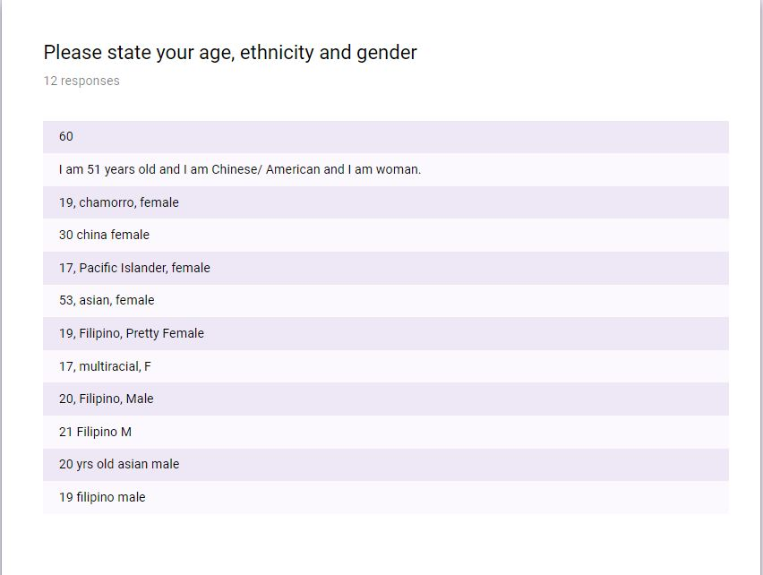
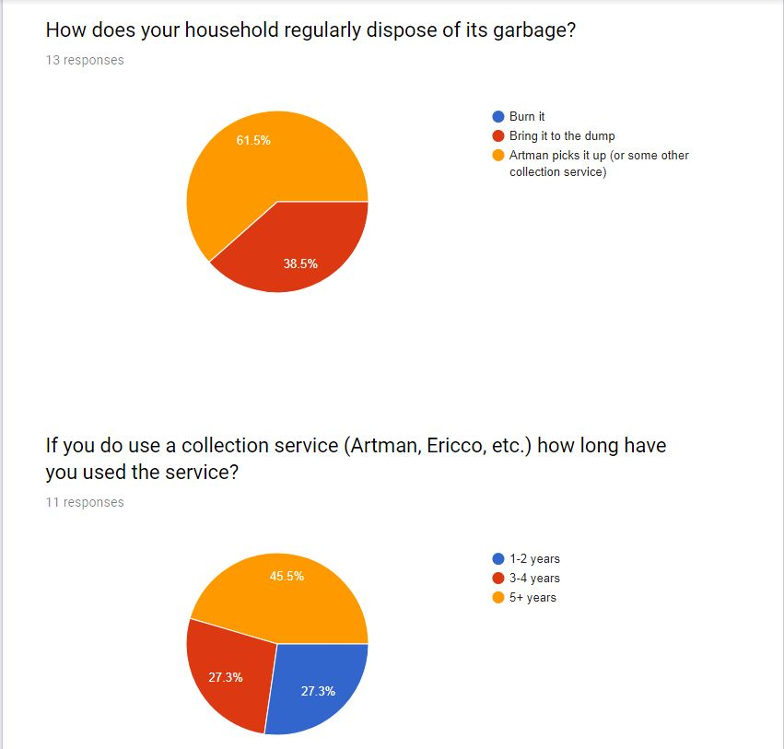
Appendix A cont.

Appendix A cont.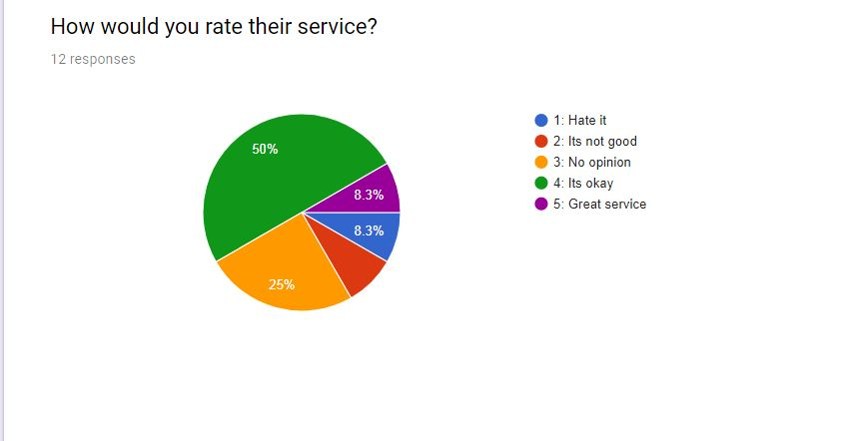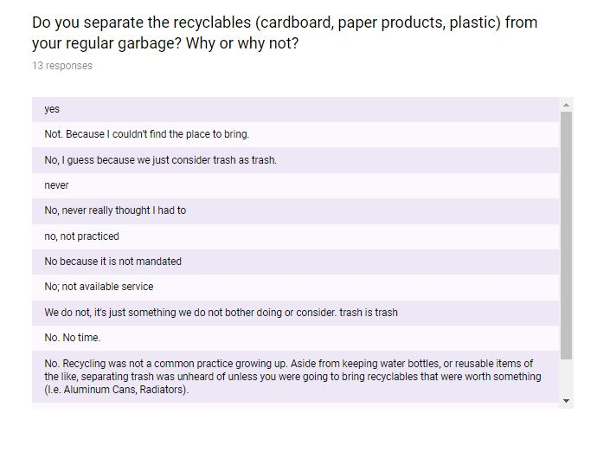
Appendix A cont. 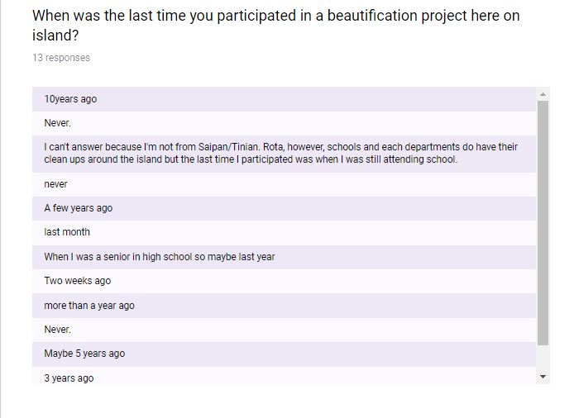

Appendix A cont.
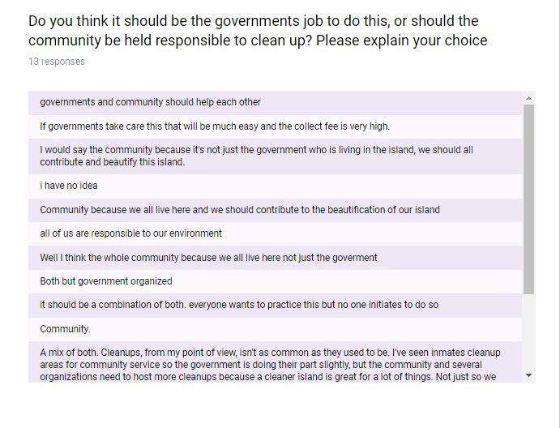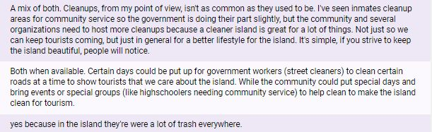

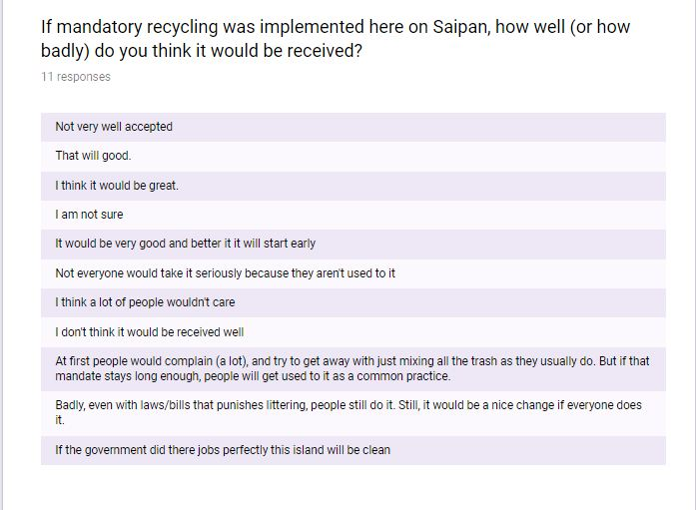
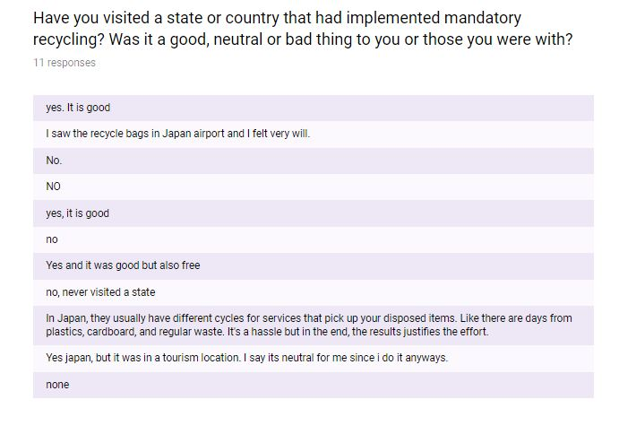
Appendix A cont.

