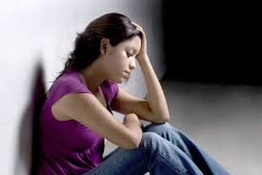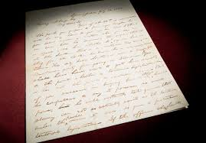

6. Vicky was in a depressed mode when she received a letter from her father. (pg. 130)

*“Vicky sank to her knees. Tears driped from her eyes, spilling into the bottom of the box.”*

5. Vicky felt a need to be strong for her family throughout all that has happened. (Pg. 135)  
*“It was as if she wouldn’t let herself be hurt, not while her family needed her while Dads mess threatened them. “*

2. Vicky gets fed up with Martin and Steve always arguing over her. (Pg. 53)

*“Would you two just quit it! I don’t need anyone to take care of me.”*

6. From pressure to depression, Vicky managed to gain back her self-confidence and strong belief that everything will get better. (Pg. 150)

*“Something new was happening. Something she had never imagined.”*

4. Vicky felt so much stress at home, she wanted to leave. (Pg. 63)

*“Anything to get away from the stress that filled their house, she figured. Vicky wished she could escape too.”*

1. The way Teresa is questioning Vicky about Martin makes her feel like their friendship is going downhill. (Pg. 2)

*“But lately Vicky felt a strange tension between them, especially when Martin Lunas named came up.”*

**Y**

VICKY FALLON

**X**